**East West University**

**Summer-2021**

**Project Report**

**Submitted To:** Dr. Md Samiullah, Adjunct Faculty,

Department of Computer Science and Engineering

**Course Title:** Machine Learning

**Course Code:** CSE475

**Date of Submission:** 08th September, 2021

**Submitted By:**

|  |  |
| --- | --- |
| **Student ID** | **Student Name** |
| 2018-2-60-033 | Bijoy Basak |
| 2018-2-60-036 | Simonta Chakraborty |
| 2018-2-60-111 | Farhan Ahmed |

**Image or Object Classification/Recognition**

**1. Introduction:**

Image or object recognition is the task of identifying objects of interest within an image and recognizing which category they belong to. Image recognition and object recognition are terms that are used interchangeably. Image recognition is the important process of machine learning without involving any human support at any step. In our project we use Convolution Neural Networks (CNN) for recognize an input image. CNN is the class of deep neural networks and it is the most commonly applied to recognizing any visual image. CNN is faster and deliver the best detection result and it can also detect multiple instances of an object from an image. If an image is slightly warped, stretched, or tuned some parameters so, it can also detect object as perfectly.

**2. Background Study**

Human brains are not capable of recognizing patterns or objects. The ability grows with experience or repetition of experience. Semantic memory which is used implicitly and subconsciously if the main type of memory involves with recognition. The outer layer of the brain and development of neural network allowed for better processing of visual and auditory patterns. One of the theories of pattern recognition is feature analysis. According to this theory the nervous system sorts and filters incoming stimuli to allow the human (or animal) to make sense of the information. Individual neurons or groups of neurons at as feature detectors, that encode specific perceptual features. When all sort of simple and complex features repeats or occur in a meaningful sequence, humans are able to identify these patterns.

Similarly, the image/object recognition’s working mechanism is the same as the human brain. The complete neural network works as a human brain. It learns to recognize patterns or objects by extracting features from input image. There are several layers to extract these features. For example, Conv2D and Maxpooling2D etc. These layers extract and simplify the features from the images. Then the data are passed into denser or computational neural network. The neural network learns the patterns and according image label in order to ‘learn’.

**3. Idea and Implementation:**

Our idea is to use TensorFlow (CNN) to train a model to recognize images of objects and animals from a dataset. Then upload our own downloaded image to see the accuracy of the model.

Firstly, we studied our dataset, which is Cifar10 from keras. The dataset contains 60000 32x32 colour images in 10 classes. Each class has 6000 images. The dataset is pre-split into train and test dataset. 50000 images are for training and 10000 images are for testing. In this dataset there are 10 classes of image. Such as airplane, automobile, bird, cat, deer, dog, frog, horse, ship and truck.

The model is a sequential model. In such model we add layers one after another. We used Conv2D Layer. This Layer converts all the pixels in its view field into numbers. It reduces the image size and also create activation areas.

Then we used Maxpooling2D layer. This layer minimizes the amount of parameter to learn and the amount of computation performed in the network. It basically summarises the features present in a region of the feature map generated by the Conv2D layer.

Then we used Flatten layer to convert the image data to 1-dimentional array. It creates a single long feature vector. Also, Dense layer is used to connect these layers to neural network and Dropout layer is to prevent the model from overfitting.

The loss function used for the model is ‘categorical_crossentropy’, optimizer is ‘adam’ and ‘accuracy’ as metrics. The model is fitted and the history is stored in history object.

After these procedures, the model is ready to be tested with user inputs. The user can upload images and run predictions to see how accurate the model recognizes the image.

Accuracy vs val_accuracy graph:

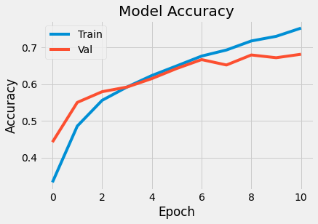

Figure 1: Accuracy vs Val_accuracy

Loss vs val_loss graph:

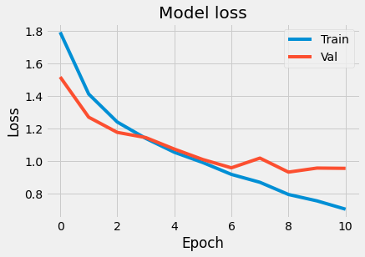

Figure 2: Loss vs val_loss

**4. Experimentation:**

We tried tuning the model in order to increase the accuracy of the model. Initially we used epoch = 3, which resulted the evaluation score of the model = 0.58843. We increased the number of epochs to 10, the score came up to 0.682377. We again increased the number of epochs to 15. The score decreased than before. We found out that 11th epoch was showing the best accuracy score of 0.685699.

To improve the model, we changed the parameters of the layers as well. Initially, both of the Conv2D layers had 32 filters and (5,5) kernel size. We updated the second Conv2D layers filter to 64 and reduced the first Conv2D layers to (3,3). It increased the model’s evaluation score to 0.69870.

The model’s accuracy and val_accuracy also changed significantly.

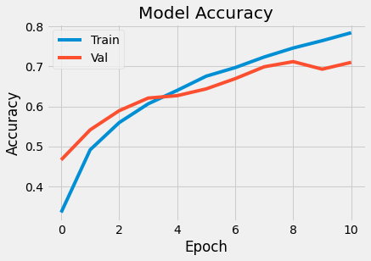

Figure 3: Accuracy vs val_accuracy

The loss and val_loss changed as well.

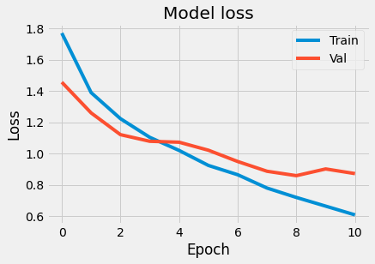

Figure 4: Loss vs val_loss

The fluctuations of the accuracy vs val_accuracy and loss vs val_loss significantly decreased. Though the overall difference between the previous graphs and graphs after updating the Conv2D layers are not very significant, but they have effect.

**5. Conclusion:**

The testing of images from our Cifar10 dataset from keras came out to be successful. In order to improve accuracy, neural network did well. After 11 epochs we found our highest accuracy. We observed that when our provided image matches with the datasets image it showed the highest probability. That means model is correctly specifying the image. The experimental results show that image recognition method based on neural network is effective and feasible, with the development of computer technology and artificial intelligence theory, the image recognition technology in target tracking, cruise control, intelligent instrument, robot vision, and other fields will have wide development and application prospect.

**References**

1. <https://en.wikipedia.org/wiki/Pattern_recognition_(psychology)>
2. <https://thenextweb.com/news/a-beginners-guide-to-ai-computer-vision-and-image-recognition>
3. <https://www.pyimagesearch.com/2018/12/31/keras-conv2d-and-convolutional-layers/>
4. <https://keras.io/api/layers/pooling_layers/max_pooling2d/>
5. <https://www.cs.toronto.edu/~kriz/cifar.html>

**GitHub Repository**

**https://github.com/FarhanMilkCandy/CSE475.git**