SAANS
AI Smog Forecasting & Source Attribution System
Smog Attribution And Nowcasting System for five Pakistani cities
Final Project Report
Data Science
Submitted by: Farhan Bashir (Roll No. 2312407)
Submitted to: Sir Ahsan Nisar
SZABIST University, Karachi
October 2026
Code and notebooks: https://github.com/FarhanRajputFelix/saans
Live dashboard: https://saansgit-uhebsjzld3rfqxupnygsop.streamlit.app/

Contents
Abstract 3
1. Introduction and problem 3
2. Objectives and how they were met 4
3. Data sources and ingestion 5
3.1 Study period 5
3.2 How each source was fetched 5
3.3 Sensors and their date ranges 7
3.4 Fires and news 8
4. Data cleaning 9
4.1 Findings that changed the cleaning rules 10
5. Feature engineering 12
5.1 Upwind Fire Exposure Index 13
5.2 Stagnation Index and other features 14
6. LLM integration 14
6.1 Event extraction from news 14
6.2 AI Smog Explainer 15
7. Modelling and validation 15
7.1 Design 15
7.2 Predicting the change, not the level 16
7.3 Results 16
8. Explainability 17
9. Live forecast 18
10. Dashboard 20
11. Limitations and risks 22
12. Conclusion and future work 22
References 23

Abstract
Every smog season (October to January) Punjab closes schools, restricts traffic and opens emergency counters in hospitals, yet the public tools only report the air quality of the current hour. SAANS (Smog Attribution And Nowcasting System; saans means breath in Urdu) turns this reactive approach into an early warning system. It fuses four free data streams for Lahore, Faisalabad, Multan, Islamabad and Karachi: hourly PM2.5 (and PM10) from OpenAQ sensors, NASA FIRMS satellite fire detections, ERA5 weather from Open-Meteo, and 2,255 Pakistani news headlines. In total 2,048,724 raw records from 1 January 2020 to 31 January 2026 were ingested and passed through a nine-step, fully logged cleaning pipeline into one hourly master table, published as Parquet and as one CSV per city.
Gradient-boosted (LightGBM) models forecast the mean PM2.5 of the next 24 hours and of the 24 hours after that, with an 80% uncertainty band, and a classifier warns when the next 24 hours will exceed AQI 300 (US EPA scale). Trained on data up to September 2024 and tested on two held-out smog seasons, SAANS reduces the 24-hour forecast error of the persistence baseline by 13.7% in the record 2024-25 season and warns of 91.7% of hazardous periods against 75.5% for persistence. On Faisalabad and Multan, cities absent from training, it beats persistence by 15% and 10%. SHAP attributes every forecast to recent pollution, weather, upwind crop fires and calendar effects, and a Large Language Model (Gemini) extracts an event calendar from news and writes English and Urdu advisories under strict numeric guardrails. A live mode, running on the deployed dashboard, fetches today's data, cleans it with the same rules and issues the next 24- and 48-hour forecast; a parity check shows the live code reproduces the training features exactly. Results, limitations and every data-quality decision are reported openly, including where the system does not beat its baseline.

1. Introduction and problem
Punjab's winter smog has become a recurring public-health emergency. In November 2024 Lahore's AQI was reported at 1,165, schools and colleges were closed across 18 districts, and hospitals reported hundreds of smog-related respiratory cases (Dawn, 7 November 2024). Heavy vehicles were banned from Lahore and half of office staff moved to work from home. Every one of these measures came after the air had already become hazardous, because no public system forecasts smog at city level or explains its causes.
SAANS addresses three gaps identified in the proposal:
- No forecast. Citizens and authorities see the current AQI only, not what tomorrow will bring.
- No explanation. Nobody publicly quantifies how much upwind crop burning, stagnant weather or local pollution contributes on a given day, so interventions cannot be targeted.
- No accessible advice. Technical AQI numbers are not translated into clear guidance in Urdu and English.
This report follows the pipeline in the order it was built: data sources and ingestion (Section 3), cleaning (4), feature engineering (5), LLM integration (6), modelling and validation (7), explainability (8), the live forecast (9) and the dashboard (10), followed by limitations (11) and conclusions (12). Every number in the report is produced by the seven notebooks in the project repository.

2. Objectives and how they were met
The proposal set seven measurable objectives. Table 1 states the outcome of each honestly, including where the plan had to change because of what the data allowed.
Table 1. Status of the seven proposal objectives
# | Objective (proposal) | Status | Outcome
1 | Automated ingestion of three free sources, 2020 to 2025 | Met | Four downloaders (Open-Meteo, OpenAQ PM2.5 and PM10, NASA FIRMS, GDELT news), idempotent and rate-limited. The window runs to 31 Jan 2026 so the 2025-26 season is complete. NO2 does not exist in OpenAQ near the five cities.
2 | Clean and integrate 200,000+ raw records; Data Quality Report | Met | 2,048,724 raw records; nine logged cleaning steps; an auto-generated Data Quality Report; one hourly master table of 266,760 city-hours (Parquet and one CSV per city).
3 | Forecast PM2.5 24 h and 48 h ahead for five cities | Met, extended | Evaluated on two held-out seasons; Faisalabad and Multan (data only from June 2025) became an unseen-city test. A live mode forecasts today from freshly fetched data.
4 | Classify hazardous days (AQI > 300) and beat persistence on the 2024 and 2025 seasons | Met | Hit rate 91.7% vs 75.5% and F1 0.779 vs 0.755 (2024-25); 92.1% vs 75.4% and 0.777 vs 0.756 (2025-26). The false alarm rate the proposal names is also reported.
5 | Attribute each forecast to its drivers with SHAP | Met | Grouped SHAP for every forecast (recent pollution, weather, upwind fires, calendar), plus a monotonic what-if on fires.
6 | LLM news event extraction and bilingual advisories | Met | 387 events from 2,255 headlines (76% strict accuracy on a random 50 checked by hand); 930 advisories, 31 written by the LLM for key days and 899 by template, all number-checked.
7 | Interactive dashboard on free hosting | Met | Deployed on Streamlit Community Cloud (https://saansgit-uhebsjzld3rfqxupnygsop.streamlit.app/) with seven tabs, including the live forecast, how the data was made, and a cleaned-data browser with CSV download.

3. Data sources and ingestion
This section answers how every record was obtained: the study period, the endpoint and request pattern of each source, the problems met on the way, and what arrived. All four sources are free; the downloaders are in saans/ingest/, notebook 01 shows each step with real responses, and docs/DATA_PIPELINE.md documents the whole pipeline for reviewers.

3.1 Study period
All historical data covers 1 January 2020 to 31 January 2026. The proposal asks for data covering 2020 to 2025, with models trained on the 2020 to 2023 smog seasons and tested on the 2024 and 2025 seasons. A smog season runs from October to January, so the 2025 season ends on 31 January 2026; stopping there gives two complete test seasons. Data after January 2026 is used by the live forecast (Section 9), which downloads the last four days at the moment it runs. The period is set in one place (START_DATE and END_DATE in saans/config.py), so the history can be extended by changing one line.

3.2 How each source was fetched
All four downloaders follow the same pattern: request the data in small pieces, save every response untouched in data/raw/, skip pieces already saved so an interrupted download resumes where it stopped, respect the provider's rate limit, and then parse everything into one table per source in data/interim/, with every timestamp in UTC. Table 2 gives the details for each source; Table 3 the records received and kept.
Table 2. How each source was fetched: endpoint, request pattern, problems met and output
Weather: Open-Meteo Historical Weather API (ERA5)
Endpoint and access | archive-api.open-meteo.com/​v1/​archive; no key
Request | latitude,​ longitude,​ start_date,​ end_date,​ 13 hourly variables (incl. boundary layer height),​ timezone=​GMT,​ wind_speed_unit=​ms
How requests were split | One request per city and calendar year: 5 cities x 7 years =​ 35 requests,​ 5 s apart (free limit 600 calls per minute)
Problem met | Boundary layer height missing 1 January to 30 June 2024 in every model Open-Meteo serves (W1); imputed in cleaning
Received and saved | 266,​760 hourly rows (53,​352 per city,​ every hour present); data/​raw/​open_meteo/​<city>_<year>.json (35 files),​ parsed to data/​interim/​weather_hourly.parquet
PM2.5 and PM10: OpenAQ API v3
Endpoint and access | api.openaq.org/​v3; free key sent in the X-API-Key header
Step 1: find sensors | /​v3/​locations?coordinates=​<lat>,​<lon>&​radius=​25000 per city (25 km is the API maximum): 248 sensors,​ of which 200 PM2.5 sensors overlap the study period
Step 2: hourly values | /​v3/​sensors/​<id>/​hours?datetime_from=​<month start>&​datetime_to=​<month end>&​limit=​1000
How requests were split | One month per request (at most 744 hours,​ so one page),​ about 1,​300 requests,​ run by four parallel workers paced on OpenAQ's rate-limit headers (60 requests per minute)
Problems met | Whole-year requests needed deep paging,​ which became slow (page 5 took 12 s) and timed out (HTTP 408); 408,​ 429,​ 5xx and dropped connections are retried
Received and saved | 587,​969 PM2.5 sensor-hours from 200 sensors and 5,​904 PM10 sensor-hours from the only 5 PM10 sensors; no NO2 sensor exists. data/​raw/​openaq/​hours/​sensor_<id>.json (205 files),​ parsed to data/​interim/​openaq_hourly.parquet
Fires: NASA FIRMS area API
Endpoint and access | firms.modaps.eosdis.nasa.gov/​api/​area/​csv/​<MAP_KEY>/​<SOURCE>/​66,​24,​78,​34/​<days>/​<date>; free MAP_KEY
Area and sources | 66-78 E,​ 24-34 N (Pakistani and Indian Punjab,​ Haryana,​ Sindh); VIIRS_SNPP_SP (375 m) and MODIS_SP (1 km),​ NASA's standard science-quality archive
How requests were split | At most 5 days per call,​ so each month was fetched in 5-day chunks and saved as one CSV: 73 months x 2 sources =​ 146 files; per source one worker forward from 2020 and one backward from 2026
Problems met | Quota of 5,​000 transactions per 10 minutes; above it FIRMS answers "Invalid MAP_KEY" (observed at 4,​886 of 5,​000),​ so the downloader waits and retries. VIIRS on NOAA-20 was about 3 times slower and was left out
Received and saved | 1,​185,​836 fire detections; data/​raw/​firms/​<source>/​<yyyy-mm>.csv,​ parsed to data/​interim/​firms_fires.parquet
News: GDELT DOC 2.0 API
Endpoint and access | api.gdeltproject.org/​api/​v2/​doc/​doc?mode=​artlist&​format=​json&​maxrecords=​250; no key
Query | (smog OR AQI) (Lahore OR Punjab OR Multan OR Faisalabad OR Islamabad OR Karachi) sourcecountry:pakistan
How requests were split | Two windows per smog season (October-November,​ December-January): 13 requests
Problems met | About one request per 5 s allowed and heavy HTTP 429 throttling: requests spaced 10 s apart and retried after 30 s
Received and saved | 2,​438 articles,​ 2,​255 after removing duplicate links and near-identical headlines; data/​raw/​gdelt/​<window>.json,​ parsed to data/​interim/​news_headlines.csv

Table 3. Records received and kept, by source (1 Jan 2020 to 31 Jan 2026)
Source | Content | Records received | After cleaning
Open-Meteo (ERA5 reanalysis) | 13 hourly weather variables per city, incl. boundary layer height | 266,760 | 266,760
OpenAQ v3, PM2.5 | Hourly PM2.5 from 200 sensors within 25 km of each city | 587,969 | 556,966
OpenAQ v3, PM10 | Hourly PM10 from 5 sensors (context only) | 5,904 | 5,903
NASA FIRMS | VIIRS (Suomi-NPP) and MODIS fire detections, 66-78 E, 24-34 N | 1,185,836 | 815,434
GDELT news index | Pakistani smog headlines, October to January of each season | 2,255 | 2,255
Total |  | 2,048,724

3.3 Sensors and their date ranges
Sensor coverage was the first risk check. Table 4 lists every PM2.5 network in the dataset. Lahore, Islamabad and Karachi have a continuous reference record from 2020 until the US monitor feed stopped on 4 March 2025. Faisalabad and Multan have no data before June 2025. The low-cost networks (AirGradient, Hawanama) are still reporting today, which is what the live forecast uses. The modelling design responds directly: train on the three long-record cities, test on the 2024-25 season, and then test on Faisalabad and Multan as cities the model has never seen. The proposal also planned NO2; no sensor within 25 km of the five cities reports it in OpenAQ (finding A10), and only five report PM10, which is cleaned and kept as context.
Table 4. PM2.5 sensors in the dataset by city and network (inside the study period)
City | Network | Sensors | Hours | From | To
Lahore | US Embassy monitor (StateAir), reference | 1 | 41,304 | 1 Jan 2020 | 4 Mar 2025
Lahore | Clarity | 1 | 15,542 | 28 Nov 2023 | 31 Jan 2026
Lahore | AirGradient (low-cost) | 23 | 88,063 | 24 May 2025 | 31 Jan 2026
Lahore | Hawanama (low-cost) | 49 | 43,680 | 18 Nov 2025 | 31 Jan 2026
Islamabad | US Embassy monitor (StateAir), reference | 1 | 38,403 | 1 Jan 2020 | 4 Mar 2025
Islamabad | Same monitor via AirNow, reference | 1 | 28,544 | 26 Aug 2021 | 31 Jan 2026
Islamabad | AirGradient | 18 | 72,807 | 6 May 2025 | 31 Jan 2026
Islamabad | Hawanama | 16 | 13,381 | 18 Nov 2025 | 31 Jan 2026
Karachi | US Consulate monitor (AirNow), reference | 1 | 41,761 | 1 Jan 2020 | 4 Mar 2025
Karachi | Clarity | 1 | 2,181 | 28 Nov 2023 | 28 Feb 2024
Karachi | AirGradient | 23 | 68,097 | 2 Oct 2024 | 31 Jan 2026
Karachi | Hawanama | 13 | 6,094 | 18 Nov 2025 | 31 Jan 2026
Faisalabad | AirGradient | 29 | 94,427 | 23 Jun 2025 | 31 Jan 2026
Faisalabad | Hawanama | 7 | 347 | 18 Nov 2025 | 31 Jan 2026
Multan | AirGradient | 10 | 29,671 | 16 Jun 2025 | 31 Jan 2026
Multan | Hawanama | 6 | 3,667 | 18 Nov 2025 | 31 Jan 2026

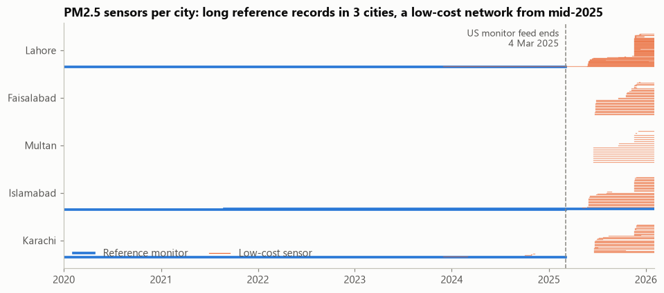
Figure 1. PM2.5 sensors per city over time. Reference monitors (thick) end on 4 March 2025; the low-cost network (thin) starts in mid-2025.
Coverage is uneven within cities too. Figure 2 maps every PM2.5 sensor within 25 km of each city centre. Sensors cluster in a few neighbourhoods, so a city average describes those neighbourhoods best; this is reported as a data-equity finding.
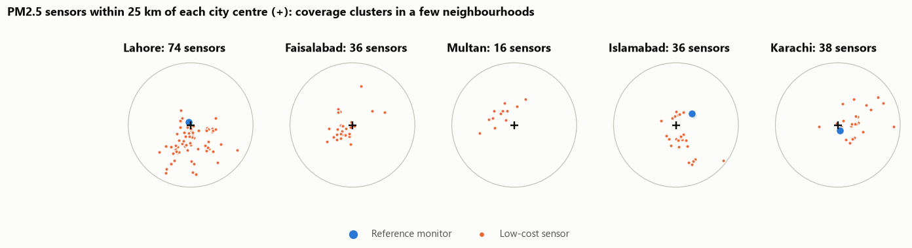
Figure 2. PM2.5 sensors within 25 km of each city centre (+): reference monitors and low-cost sensors.

3.4 Fires and news
Fires. NASA stores detection time as an HHMM integer in UTC (845 means 08:45), which the downloader parses into a timestamp. Most rice-stubble fires burn in Indian Punjab and Haryana, east and south-east of Lahore (Figure 3). One VIIRS month (August 2023, 1,019 detections) that finished downloading after the fire table was first built was added in the re-evaluation, and the whole pipeline was re-run (finding F5).
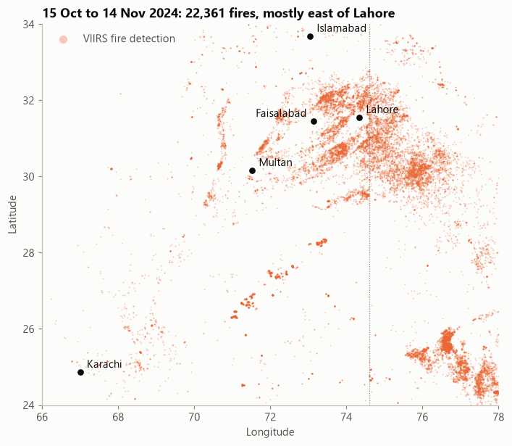
Figure 3. VIIRS fire detections, 15 October to 14 November 2024, with the five study cities.
News. Of the 2,438 articles GDELT returned, duplicate links and near-identical headlines were removed at download, leaving 2,255 headlines for the LLM event calendar (Section 6).

4. Data cleaning
Cleaning is the core of the project. Each of the nine steps in notebook 02 states why it is needed, the rule applied, and the before and after counts; every action is logged through a single function, and the log becomes the Data Quality Report. Table 5 summarises the steps; the most instructive findings follow.
Table 5. The nine cleaning steps and their effect
Step | Rule | Effect
1 Time alignment | All sources in UTC, snapped to the hour; Pakistan time only for local-clock features | 0 off-hour OpenAQ stamps; FIRMS HHMM times parsed
2 Units and AQI | Concentrations in µg/m³; AQI computed from 24 h means with the 2024 US EPA breakpoints | 243 PM2.5 sensors verified in µg/m³; hazardous = 24 h mean of 225.5 or more
3 Duplicates and invalid values | One value per sensor-hour; no nulls, negatives or readings below 1 µg/m³; nothing above 1,000; at least 75% of a sensor's normal readings per hour | 25,555 nulls, 1,020 zero readings and 1,534 incomplete hours removed; 0 duplicates, 0 negatives
4 Sensor faults | Same value for 6+ consecutive hours removed; readings stuck at a sensor's maximum removed | 216 stuck-run hours removed
5 Glitch or real event | Neighbour test (3x the median of sensors within 5 km and 100+ above it); isolated-spike test; dropout test for sudden falls to near zero; a second dropout pass on the city series; fireworks nights protected | 1,564 spikes (1,539 neighbour, 25 isolated), 1,114 sensor dropouts and 6 city-level dropouts removed; extreme events and fireworks nights tagged
6 Humidity correction | EPA correction (Barkjohn et al., 2021) per provider, only where a reference comparison before the test seasons shows it helps | No network corrected: it hurts AirGradient and Clarity, and Hawanama cannot be checked (A11)
7 Fire cleaning | Drop low confidence; keep NASA type 0 (vegetation); merge repeat passes per 1 km cell, day and pass | 149,789 low-confidence and 36,311 static/offshore removed; 184,302 repeats merged
8 Missing values | Interpolate PM2.5 gaps of 3 h or less outside test seasons; flag longer gaps with their length; impute missing boundary layer height | 2,937 city-hours filled; 129,011 city-hours flagged inside long gaps (never filled); 21,840 BLH values imputed
9 Integration | One row per city per hour: weather, PM2.5 (and PM10) with source and flags, fires within 300 km | 266,760 rows x 29 columns; 137,594 city-hours with PM2.5

Table 6 shows what happened to each sensor network. A sensor is kept if at least 24 valid hours survive cleaning; 190 of the 200 PM2.5 sensors were kept and 10 short-lived low-cost sensors rejected.
Table 6. PM2.5 sensors and sensor-hours received, kept and rejected, by provider
Provider | Sensors received | Kept | Rejected | Hours received | Hours kept
AirGradient (low-cost) | 103 | 100 | 3 | 353,065 | 350,469
Hawanama (low-cost) | 91 | 84 | 7 | 67,169 | 66,224
Clarity (low-cost) | 2 | 2 | 0 | 17,723 | 16,125
AirNow (reference) | 2 | 2 | 0 | 70,305 | 60,040
StateAir Lahore (reference) | 1 | 1 | 0 | 41,304 | 32,321
StateAir Islamabad (reference) | 1 | 1 | 0 | 38,403 | 31,787
Total | 200 | 190 | 10 | 587,969 | 556,966

4.1 Findings that changed the cleaning rules
- Empty readings, not negative ones (A3). A first version reported 25,555 negative values. There were none: the filter value >= 0 also drops nulls, and all 25,555 were the reference monitors' missing-hour markers. The rule was split into separate null and negative checks so the report says what actually happened.
- Wrong completeness metadata (A4). OpenAQ's percentComplete assumes 12 readings per hour for every sensor, but Lahore's Clarity monitor reports every 15 to 20 minutes (3 to 4 readings). The standard 75% rule silently deleted all 15,542 of its hours in a first run, Lahore's only reference-quality record after March 2025. Completeness is now judged against each sensor's own typical count.
- A stuck monitor (A5). The US monitor in Lahore reported exactly 67.0 µg/m³ for 105 consecutive hours (29 May to 1 June 2024); the stuck-run rule removes it.
- One monitor published twice (A6). Islamabad's two reference feeds (StateAir and AirNow) agree on 87% of their overlapping hours (r = 0.978). They are one monitor and are averaged.
- Humidity correction must be tested, not assumed (A7, A8). Table 7 compares each low-cost provider with a reference monitor in the same city and hour, outside the test seasons. AirGradient's data already match the reference; the EPA formula would halve them and raise the error from 9.8 to 15.6. Clarity reads about 32% below the reference, and the formula makes it worse. Hawanama has no reference overlap before the test seasons, so it cannot be checked. The rule is therefore to correct a network only where a pre-test check shows the correction helps, and no network qualifies. A first version corrected unchecked networks by default (A11). When 56 Hawanama sensors joined Lahore on 19 November 2025, its cleaned PM2.5 fell from about 250 to 149 µg/m³ overnight, a drop no weather explains. An external review of the repository found it; with the corrected rule the series is continuous (278, 249 and 239 µg/m³ on 18 to 20 November), and every result in this report comes from the corrected data.
Table 7. Humidity-correction check: low-cost providers vs reference monitors (µg/m³, test seasons excluded)
Provider | Overlap hours | Reference mean | Raw mean | Corrected mean | Raw MAE | Corrected MAE
AirGradient | 2,772 | 34.0 | 36.0 | 18.6 | 9.8 | 15.6
Clarity | 6,331 | 122.4 | 83.6 | 43.8 | 43.4 | 78.7

- Dropouts found on the deployed dashboard (A9). The first public dashboard showed Lahore at 0 µg/m³ at 10:00 on 3 November 2024, in the middle of heavy smog: Clarity had reported 0.0 between readings of 374 and 334 while the reference monitor was offline. Three rules were added: readings below 1 µg/m³ are dropped (1,020; urban hourly PM2.5 is never truly zero, a faulting sensor reports 0), a sensor-level test removes sudden one-hour falls to near zero (1,114), and a second pass on the combined city series catches what remains (6).
- Industrial heat and repeat passes (F1, F2). NASA flags 36,311 detections as static land sources (steel mills, kilns, flares) or offshore; 139,394 fires were seen by more than one satellite pass and are counted once, keeping the strongest fire radiative power.
- A six-month hole in the most important weather variable (W1). Boundary layer height, the height of the layer that traps pollution, is missing from January to June 2024 in every city and in every model Open-Meteo serves. It was imputed with a LightGBM model on the 12 complete weather variables, hour and month. Tested first on a hidden January-June 2023, the imputation reaches r = 0.91 with a mean absolute error of 148 m (Figure 4); imputed values carry a flag.
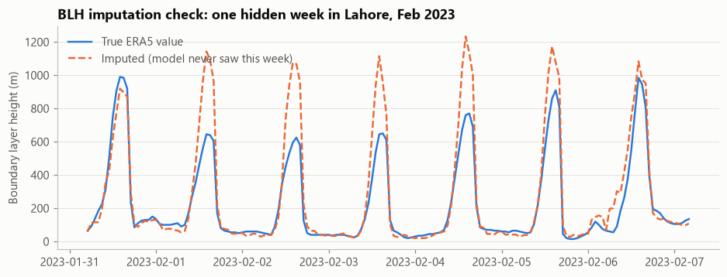
Figure 4. Boundary layer height imputation check: one week of the hidden 2023 test period in Lahore.
Of the 587,969 PM2.5 sensor-hours, 556,966 (94.7%) survived cleaning; of 1,185,836 fire detections, 815,434 distinct fires (68.8%) remain. Every hour also carries flags for interpolation, gap length, extreme events (city PM2.5 of 250 or more) and fireworks nights. Figure 5 shows the cleaned daily PM2.5 of the three long-record cities.
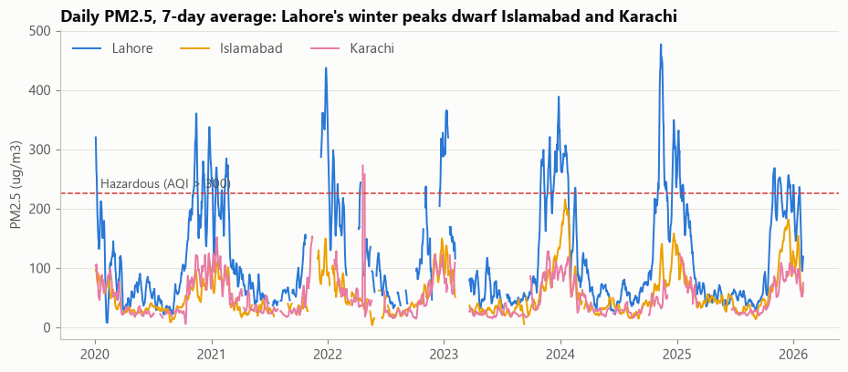
Figure 5. Cleaned daily PM2.5 (7-day average) for the three long-record cities, with the hazardous threshold.
The cleaned dataset. The hourly master table is published as data/processed/master_hourly.parquet and as one CSV per city in data/processed/csv/, with every column described in data/README.md; the LLM event calendar is data/processed/events.json. The dashboard's Cleaned data tab lets anyone browse and download a selection.

5. Feature engineering
No future information. Every feature for hour t uses only what is known at t: past PM2.5, weather observed up to t, fires already detected and events already announced. Using the actual weather of the next day would inflate the scores; a deployed system would use a weather forecast there, which is listed as future work. City identity is deliberately not a feature, so the model must rely on physics and recent pollution and can forecast cities it has not seen. The 44 features form four groups: recent pollution (9), weather (22), upwind fires (3) and calendar (10). All of them are computed by one module (saans/features.py), which the live forecast uses as well.

5.1 Upwind Fire Exposure Index
For each city and hour t, the index sums over every fire detected 24 to 72 hours earlier:
UFI(t) = Σ_{i} FRP_{i} · exp(−d_{i} / L) · max(0, cos θ_{i})
FRP is the fire radiative power reported by NASA, d the distance from the city, L a decay length, and θ the angle between the direction the city's wind blows from (100 m wind at the hour of detection) and the bearing from the city to the fire. Fires directly upwind count fully; crosswind and downwind fires count zero. A second index covers the last 24 hours. The decay length was tuned on training smog seasons only, by the Spearman correlation with next-day PM2.5 (Table 8).
Table 8. Tuning the fire index: Spearman correlation with the next 24-hour PM2.5 (training smog seasons)
Decay length L (km) | Distance only | Distance and wind direction
25 | 0.298 | 0.351
50 | 0.294 | 0.382
100 | 0.234 | 0.365
200 | 0.211 | 0.358
400 | 0.200 | 0.355

The best index uses L = 50 km with wind weighting. Accounting for wind direction raises the correlation from 0.29 to 0.38 at that decay length, the central physical claim of the proposal: smoke from fires upwind of the city matters, fires downwind do not. Figure 6 shows the effect in Lahore.
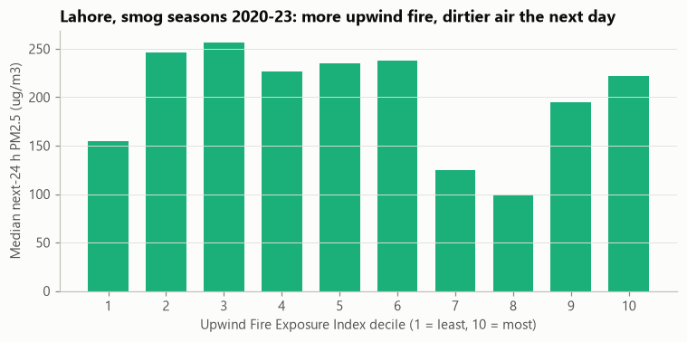
Figure 6. Lahore, smog seasons 2020-23: median next-day PM2.5 by decile of the Upwind Fire Exposure Index.

5.2 Stagnation Index and other features
Wind is encoded as east-west and north-south components, because a raw angle hides that 359 and 1 degrees are neighbours. The ventilation coefficient (boundary layer height times wind speed) measures how fast a city's air is flushed. The Stagnation Index averages three standardised 24-hour signals, low ventilation, high humidity and cold air, using training-period statistics only; next-day PM2.5 rises steadily across its deciles in every city (Figure 7). Recent-pollution features are PM2.5 lags of 1, 3, 6, 24 and 48 hours, the 24-hour mean and maximum and the 24-hour trend. Calendar features cover hour, day of week, season, the rice and wheat stubble-burning windows, and the LLM event calendar (Section 6).
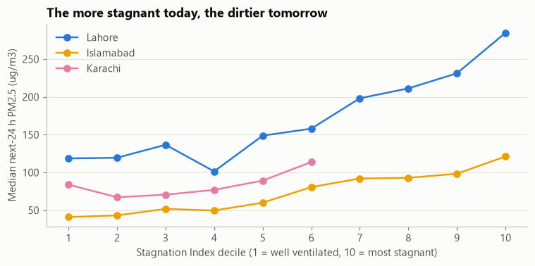
Figure 7. Median next-day PM2.5 by Stagnation Index decile (training smog seasons).

6. LLM integration
The proposal places a Large Language Model at both ends of the pipeline. The implementation uses Google Gemini through its free tier, with Groq (gpt-oss-120b) as an automatic fallback. Free quotas shaped the design: gemini-2.5-flash is closed to new keys and gemini-3.5-flash allows only 20 requests per day, so the client walks a chain of models (Gemini 3.5 Flash-Lite, Gemini 3.1 Flash-Lite, Groq) and caches every answer, which also makes the notebooks reproducible without a key.

6.1 Event extraction from news
The 2,255 headlines were sent in batches of 60 with their publication dates, at temperature 0 with a strict JSON format. For each headline that reports a concrete action, the model returns the event type, place, start date and duration. The output is validated like any raw data (valid IDs, allowed categories, dates in range): 394 extracted events became 387 after validation, led by school closures (117), other measures (80), traffic restrictions (58) and lockdowns or office closures (55). The calendar is published as data/processed/events.json.
Random samples were checked against their headlines under a strict rule: type, place and date must all be supported by the headline text. A first prompt scored 13 of 20 (65%). Its errors fell into three groups: inverted meaning ("Punjab decides to lift smog lockdown" and "schools reopen" read as new closures), a place inferred but not stated, and items that are not smog events (an M-tag toll rule, a kiln technology upgrade, a new fuel lab). Each group became a rule in the prompt, and the check was enlarged to a random 50 so that the estimate is tighter: 38 of 50 (76%, 95% interval 64% to 88%) now pass. The remaining errors are of new kinds: future dates read as the publication day ("close schools from Dec 23", 4), new school timings read as closures (2), a fireworks ban read as a fireworks night (2), and statements that are not concrete measures (4). The event calendar therefore remains a noisy signal. It is converted to yes/no daily flags per city (Punjab-wide measures apply to Lahore, Faisalabad and Multan), so several outlets reporting one closure count once.

6.2 AI Smog Explainer
For a city and day, the LLM receives the forecast, the AQI and its category, the hazard probability and the three strongest SHAP drivers, and writes three short lines in English and the same three in Urdu: the forecast, the reasons in everyday words, and protective advice. Three guardrails apply. The LLM never predicts; it only rewords the model's numbers. Every number in its output (Urdu digits normalised first) must be one that was supplied, otherwise the advisory is replaced by a rule-based bilingual template. Advisories are generated once per city per day and cached. All 930 daily forecasts in the two test seasons have an advisory: 31 written by the LLM for the key days (the dashboard's default dates and each city's highest-forecast days), within the proposal's budget of a few dozen calls, and 899 by the template; all passed the number check. The English advisory for Lahore on 6 November 2024 reads:
"Lahore's forecast 24-hour mean PM2.5 is 392 micrograms per cubic metre with a US EPA AQI of 633 (Hazardous), and there is a 90% chance that the next 24 hours are hazardous (AQI above 300). This is mainly due to the average pm2.5 over the last 24 hours, pm2.5 right now, and upwind crop fires, last 24 hours. Everyone should stay indoors, and children, the elderly, and people with asthma need to take extra care."

7. Modelling and validation

7.1 Design
- Targets. Because AQI is defined on 24-hour means, the targets are the mean PM2.5 of the next 24 hours, the mean of the 24 hours after that (the 48-hour horizon), and whether the next 24-hour mean reaches 225.5 µg/m³ (AQI above 300).
- Time-based split. Training uses every hour from 1 January 2020 to 28 September 2024 (smog seasons 2020-23 plus the months between), with the 2023-24 season held aside inside it for early stopping. Test 1 is the record 2024-25 season (October to January), test 2 the 2025-26 season. A random split would leak tomorrow's air into training through the overlapping 24-hour windows. Test seasons are never interpolated.
- Baselines. Persistence (the next 24 hours equal the last 24) and a seasonal average (the training mean for that city, month and hour; pooled for unseen cities).
- Models. LightGBM regressors (learning rate 0.03, 63 leaves, early stopping; 115 trees for 24 h and 125 for 48 h), 10th and 90th percentile models for an 80% band, and a LightGBM classifier whose threshold (0.30) is chosen by F1 on the validation season, never on test data. The three fire features carry monotone constraints, so that fewer fires can never raise a forecast (Section 8).

7.2 Predicting the change, not the level
The first version predicted the PM2.5 level directly. It beat persistence by only about 6% in 2024-25 and clipped the record days: on 6 November 2024, the day schools closed across 18 districts, it forecast 283 µg/m³ for the next 24 hours when the observed mean was 510. Tree models cannot predict outside the range seen in training, and the 2024 season broke records. Each model therefore predicts the change from the last 24-hour mean, and the forecast is the last 24-hour mean plus that change. This also reduces, but does not remove, the effect of offsets between sensor networks (see Lahore 2025-26 below). The final model beats persistence by 13.7% in 2024-25 and forecast 392 µg/m³ for 6 November 2024, with an 80% band of 333 to 504; the observed 510 lies just above the band, a reminder that a record day sits at the edge of what the model has seen (Figure 8).
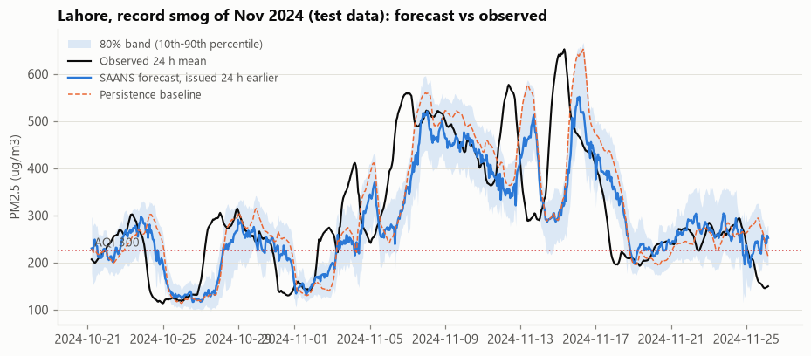
Figure 8. Lahore, October-November 2024 (test data): SAANS forecast issued 24 hours ahead, its 80% band, persistence and the observed 24-hour mean.

7.3 Results
Table 9. Forecast error by test season (MAE in µg/m³, weighted over cities; skill = 1 - MAE(model) / MAE(persistence))
Season | Horizon | SAANS | Persistence | Seasonal average | Skill vs persistence
2024-25 | next 24 h | 28.3 | 32.8 | 48.3 | +13.7%
2024-25 | 24 to 48 h | 37.5 | 44.2 | 48.1 | +15.2%
2025-26 | next 24 h | 25.1 | 26.9 | 61.4 | +6.7%
2025-26 | 24 to 48 h | 34.2 | 37.4 | 62.3 | +8.6%

Table 10. Next-24-hour forecast error by city (MAE in µg/m³)
Season | City | Mean PM2.5 | SAANS | Persistence | Seasonal | Skill
2024-25 | Lahore | 236 | 48.5 | 58.1 | 80.0 | +16.5%
2024-25 | Islamabad | 89 | 14.9 | 16.5 | 25.7 | +9.7%
2024-25 | Karachi | 64 | 15.6 | 16.0 | 31.5 | +2.5%
2025-26 | Faisalabad (unseen) | 219 | 32.9 | 38.8 | 99.2 | +15.2%
2025-26 | Multan (unseen) | 197 | 34.4 | 38.3 | 84.1 | +10.2%
2025-26 | Islamabad | 103 | 12.7 | 15.1 | 36.8 | +15.9%
2025-26 | Karachi | 75 | 16.3 | 16.6 | 24.1 | +1.8%
2025-26 | Lahore | 187 | 29.4 | 26.1 | 62.9 | -12.6%

SAANS beats persistence overall in both test seasons and both horizons, and by a wide margin in the record season. It generalises to Faisalabad and Multan without any training data from either city. Karachi's coastal air is clean and stable, so there is little for any model to add (+2.5% in 2024-25, +1.8% in 2025-26). Lahore in 2025-26 is the weak spot (-12.6%): after the US monitor feed stopped, Lahore's data come only from low-cost networks that read differently from the reference monitor the model learned on, and the model over-forecasts by about 21 µg/m³ on average, against -1.7 in 2024-25 on the monitor (Section 11). The humidity-correction bug (Section 4) had made this look much worse (-33%).
Table 11. Hazard warnings: will the next 24 hours exceed AQI 300?
Season | Method | Hazardous hours | Hit rate | False alarm ratio | False alarm rate | F1
2024-25 | SAANS classifier | 1,332 | 91.7% | 32.3% | 9.5% | 0.779
2024-25 | Persistence | 1,332 | 75.5% | 24.4% | 5.3% | 0.755
2025-26 | SAANS classifier | 2,959 | 92.1% | 32.9% | 15.0% | 0.777
2025-26 | Persistence | 2,959 | 75.4% | 24.1% | 8.0% | 0.756

The classifier catches about nine in ten hazardous periods against three in four for persistence. Two error measures are reported: the false alarm ratio (of the warnings issued, how many did not happen) and the false alarm rate named in the proposal (of the safe periods, how many were wrongly warned), which is 9.5% and 15.0% against 5.3% and 8.0% for persistence. The false alarms were rarely clean days: among the dashboard's daily 08:00 forecasts, 96% of false alarms were still "Very Unhealthy" (median 197 µg/m³). The extra false alarms are a deliberate trade-off. The warning threshold, a probability of 0.30, was chosen by F1 on the 2023-24 validation season (the full curve is in reports/figures/hazard_threshold_choice.png), and among thresholds with similar F1 the one that warns earlier is preferred, because for a public-health warning a missed hazardous day costs more than an unnecessary precaution. F1 is higher than persistence in both seasons.

8. Explainability
SHAP (Lundberg and Lee, 2017) splits each prediction into additive contributions in µg/m³. Because the model predicts the change from the last 24 hours, the forecast decomposes as: typical level + (today's level minus typical level) + contributions of every feature; today's level is counted under recent pollution, so the four driver groups add up exactly to the forecast (the notebook asserts this). Figure 9 shows what moves tomorrow's air away from today's across the 2024-25 test season: recent pollution (mean |SHAP| 14 µg/m³), weather (8), calendar (5) and upwind fires (3). As shares of the whole forecast, recent pollution accounts for 81%, weather 9%, calendar 6% and upwind fires 4%; of the predicted change alone, 45%, 27%, 18% and 10%.
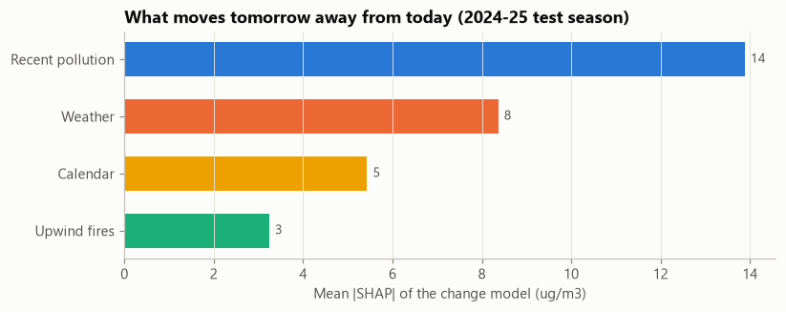
Figure 9. Mean absolute SHAP contribution of each driver group to the 24-hour change model, 2024-25 test season.
For the forecast issued at 08:00 on 6 November 2024 in Lahore, the decomposition is: typical level 70, recent pollution +292 (the last 24 hours averaged 472), upwind fires +18, calendar +9 and weather +3, giving 392 µg/m³ (Figure 10). The what-if tool scales all fire features down and forecasts again: removing all upwind fires lowers this forecast to 324 µg/m³ (-68), while a 50% reduction lowers it only to 389. Much of the smoke's effect is already inside the recent-pollution features, which is why SHAP attributes most of the forecast to them; the what-if is a model-based estimate, not a chemical simulation.
A defect found and fixed (L3). Tree models do not enforce "more fire, more smoke". In the first version, removing 100% of fires raised one Multan 2025-26 forecast by 5 µg/m³. LightGBM monotone constraints on the three fire features now guarantee that fewer fires can never raise a forecast, so the what-if is monotonic (392 to 324 for the example above). The quantile models behind the 80% band cannot take constraints; they only set the range.
Do the fire features add skill? (L6) If SHAP gives fires a small share, do they help at all? The same 24-hour model was retrained without the three fire features and compared on both test seasons. In 2024-25 the fire features made no measurable difference (MAE 28.28 with them, 28.22 without); in 2025-26 they cut the error by 7% (25.13 against 27.11), and by 6% in October and November alone (19.77 against 21.03). The fire signal is real but modest and helps in one test season of two; most of the smoke's effect reaches the model through the recent-pollution features (reports/ablation_fire_features.csv).
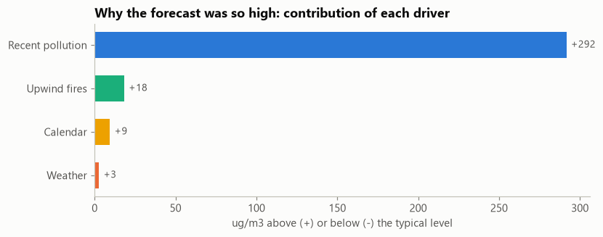
Figure 10. Why the forecast was so high: driver contributions for Lahore, 6 November 2024, 08:00.

9. Live forecast
Evaluating on past seasons shows the method works; a live mode shows it can run today. The module saans/live.py, demonstrated in notebook 07, performs one forecast cycle:
- Fetch. The last four days of hourly PM2.5 from the same OpenAQ sensors, weather from the Open-Meteo forecast API (the ERA5 archive lags by several days), and near-real-time fires from NASA FIRMS (VIIRS and MODIS NRT).
- Clean. The same rules as notebook 02: nulls, zeros, invalid values, incompleteness, stuck runs, spikes and dropouts, the humidity-correction decision saved by notebook 02 (no network corrected), and city aggregation.
- Featurise and forecast. The same feature code as training (saans/features.py), the same models, the same thresholds; then the AI Smog Explainer writes the advisories.
Parity check. Live and training code must agree, or the live forecast would not be the evaluated model. Running the live feature code on the historical master table reproduces the training features exactly: the largest difference over 266,760 rows and 44 features is 0.0. Replaying 6 November 2024 through the live path gives the same Lahore forecast as notebook 05 (392.47 µg/m³, hazard probability 0.903).
First live forecasts. Table 12 shows two live runs on Monday 26 October 2026, both with the corrected cleaning rules. The run on the deployed dashboard at 07:00 Pakistan time used fresh sensor data, fresh weather and near-real-time NASA FIRMS fire detections (Figure 11). The run at 06:00 on the development machine (notebook 07) had the same sensors but no fire data, because NASA FIRMS stopped answering that machine after the archive downloads (finding F6); rather than silently assuming no fires, the dashboard and the notebook say so. With fire data the forecasts are 2 to 13 µg/m³ higher (the runs are also an hour apart), as expected in the rice-burning season. All five cities are forecast Unhealthy or worse, Multan Very Unhealthy, with almost no chance of exceeding AQI 300.
Table 12. Live forecasts of the next 24-hour mean PM2.5, Mon 26 Oct 2026 (µg/m³)
City | Development machine, 06:00, no fire data | Deployed dashboard, 07:00, with fire data | AQI (07:00) | US EPA category (07:00) | Chance AQI > 300
Lahore | 97.1 | 106 | 187 | Unhealthy | 0%
Faisalabad | 76.1 | 86 | 172 | Unhealthy | 0%
Multan | 133.8 | 147 | 223 | Very Unhealthy | 1%
Islamabad | 59.0 | 61 | 155 | Unhealthy | 0%
Karachi | 68.9 | 72 | 163 | Unhealthy | 0%

Live mode differs from the evaluated setting in two inputs: weather comes from the Open-Meteo forecast model instead of ERA5, and the news event calendar is not updated live, so event features are zero. Both are stated on the dashboard (finding L5).
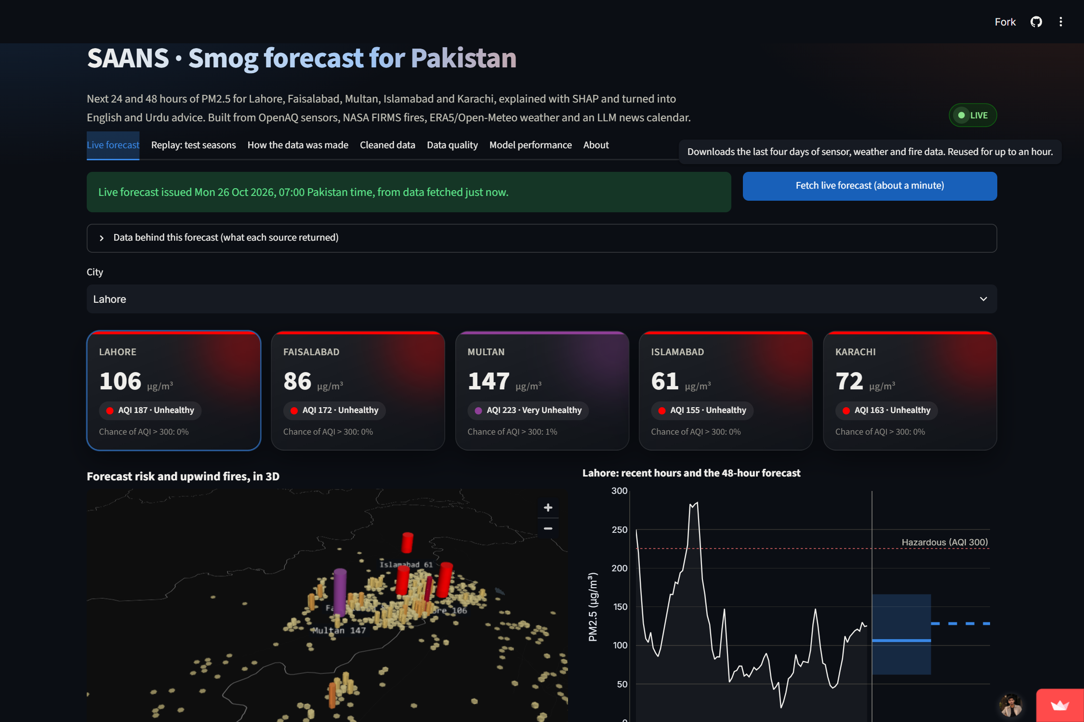
Figure 11. Dashboard, Live forecast tab: the 07:00 run of 26 October 2026 on the deployed dashboard. Column height is the forecast, colour the US EPA category; orange hexagons are NASA FIRMS fire detections from the previous 72 hours.

10. Dashboard
The Streamlit application (app/streamlit_app.py) is deployed on Streamlit Community Cloud at https://saansgit-uhebsjzld3rfqxupnygsop.streamlit.app/. The replay views run from precomputed files and need no API key; the live tab fetches fresh data when the deployment holds the keys, and otherwise shows the latest committed snapshot with its date. It has seven tabs:
- Live forecast: today's forecast for the five cities, with the data behind it and any source that did not answer.
- Replay: test seasons: the daily 08:00 forecasts over both held-out seasons, compared with what actually happened.
- How the data was made: how each source was fetched and cleaned (Sections 3 and 4), for reviewers.
- Cleaned data: the hourly master table, filterable by city and dates, with a CSV download.
- Data quality: the Data Quality Report and the sensor coverage map.
- Model performance: the evaluation tables against both baselines, the fire ablation and the threshold choice.
- About: sources, methods and limitations.
The forecast views share the panels the proposal specified: city tiles with the forecast, AQI, risk level and the chance of exceeding AQI 300; a 3D map where each city's column height is its forecast and its colour the US EPA category, with satellite fire detections drawn as hexagons (tiles, map and advice all use the same six EPA categories, names and colours, and every tile also states the category in words); the 48-hour chart with its 80% band; the "Why this forecast?" SHAP panel; the what-if slider for upwind crop fires; and the English and Urdu advisory with its source labelled. Figure 12 shows the replay of 6 November 2024 and Figure 13 the cleaned-data browser.
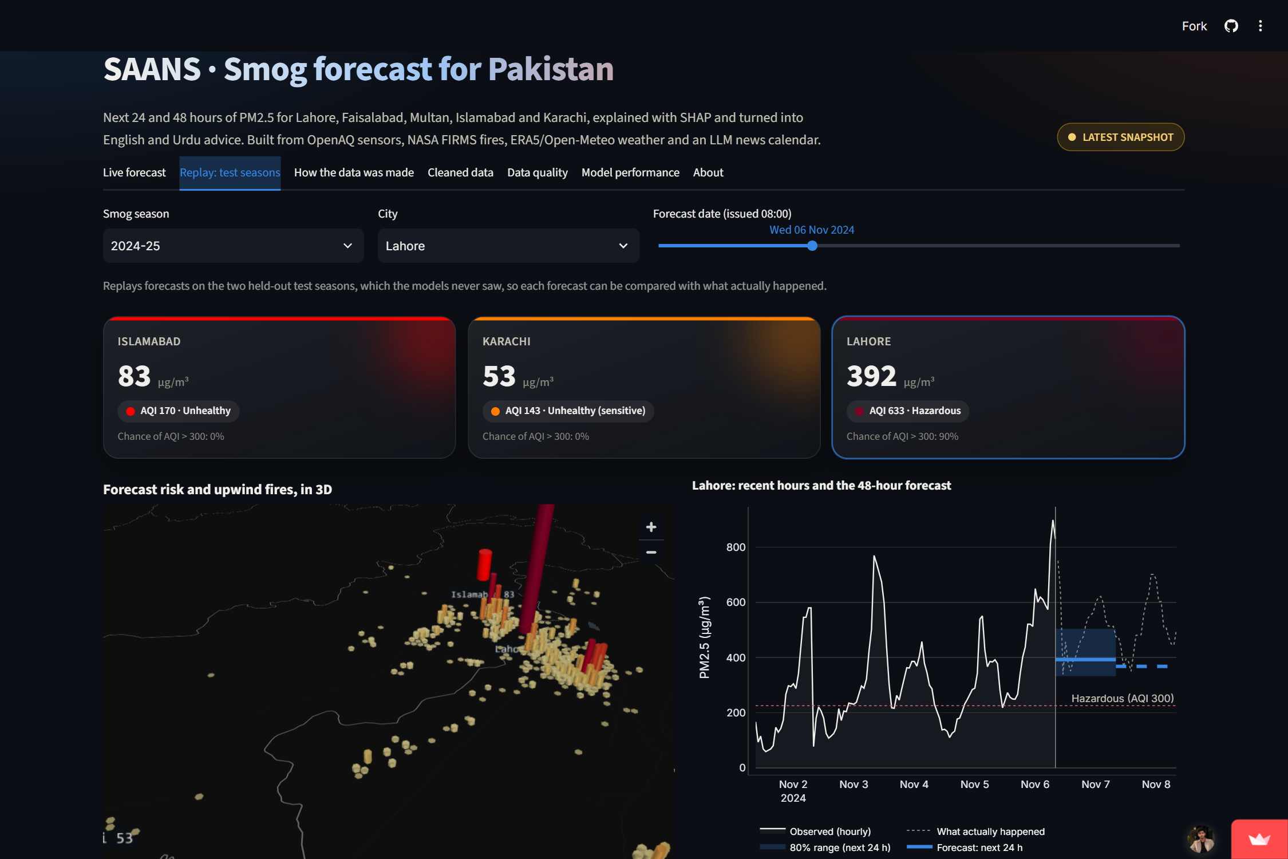
Figure 12. Dashboard, Replay tab: Lahore, 6 November 2024, with the 48-hour forecast, its 80% band and what actually happened.
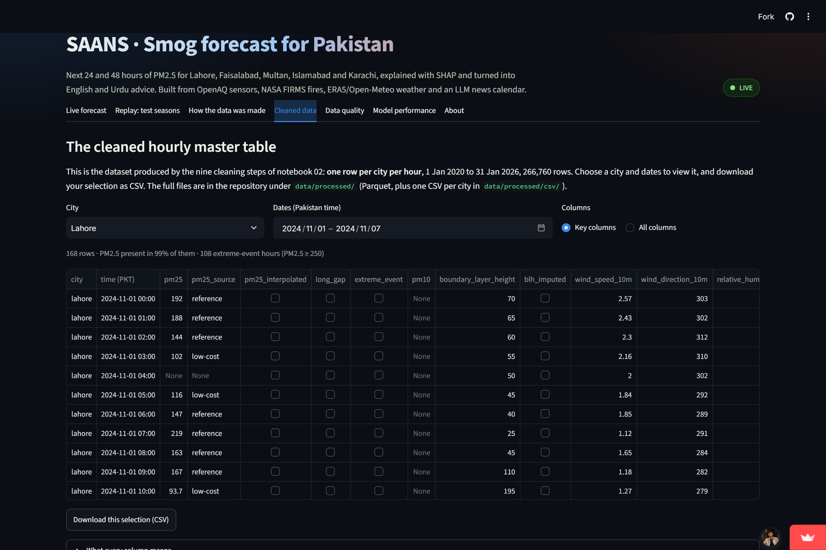
Figure 13. Dashboard, Cleaned data tab: the hourly master table for Lahore, 1-7 November 2024, with flags and a CSV download.

11. Limitations and risks
- Attribution is statistical, not chemical. SHAP shows what the model relied on, which reflects correlations in the data, not measured emission sources. What-if results are estimates.
- Losing a reference monitor degrades forecasts. The US diplomatic-post feed stopped on 4 March 2025. Lahore's 2025-26 data come from low-cost networks; Clarity reads about 32% below the reference, and the model over-forecasts Lahore by about 21 µg/m³ (against -1.7 on the monitor the season before), losing to persistence there by 13%. This is also a data-equity finding: public reference monitoring in Pakistan is thin.
- Faisalabad and Multan have one season of data, from low-cost sensors only, with no reference monitor to validate them.
- ERA5 is a ~25 km grid estimate, not a street-level station, and boundary layer height for January-June 2024 is imputed.
- The event calendar is noisy (76% strict accuracy on a random 50), with errors on announced future dates and on statements that are not concrete measures.
- No weather-forecast inputs in the evaluated models. The models use weather observed up to the forecast time only; real forecasts of tomorrow's wind and mixing height would likely improve skill.
- Live mode has its own limits. Its weather comes from the Open-Meteo forecast model rather than ERA5, the news calendar is not updated live, and each run depends on OpenAQ, Open-Meteo and NASA FIRMS answering; when one does not, the dashboard says so instead of guessing.
- Fireworks-night dates for Shab-e-Barat are approximate (plus or minus one day).

12. Conclusion and future work
SAANS shows that free, open data can support city-level smog forecasts for Pakistan that are both more accurate than the standard baseline and explainable, and that the same pipeline can run on today's data. Over 2 million raw records were cleaned through nine logged steps, several of which corrected problems that would otherwise have passed silently: mislabelled empty readings, wrong completeness metadata that would have erased Lahore's best monitor, a stuck reference sensor, a monitor published twice, a humidity correction that would have halved already-corrected data, the same correction applied by default to an unchecked network (which faked a 40% overnight drop in Lahore and was found by an external review), and sensor dropouts that only showed up on the deployed dashboard. The wind-weighted fire index confirms the proposal's physical premise. In the record 2024-25 season the forecasts beat persistence by 14%, the hazard classifier warns of 92% of hazardous periods, and the model transfers to two cities it never saw. The system is equally clear about where it fails, and why.
Future work, beyond the proposal's list (Sentinel-5P satellite NO2 and aerosol data, a neighbourhood-level hexagon grid, causal evaluation of policies such as the 2024 heavy-vehicle ban, WhatsApp or SMS alerts for schools and hospitals):
- Calibrate each low-cost network against reference monitors, starting with Lahore after March 2025, to remove the network bias.
- Feed numerical weather forecasts (tomorrow's wind and boundary layer height) into the models.
- Improve event extraction further (announced future dates, changed school timings) and update the calendar live.
- Schedule the live forecast through the 2026-27 season and score it against what happens.
- Publish the cleaned hourly dataset on Kaggle, as the proposal planned (not done yet: it needs the author's account; the CSVs are ready).

References
Barkjohn, K. K., Gantt, B., and Clements, A. L. (2021). Development and application of a United States-wide correction for PM2.5 data collected with the PurpleAir sensor. Atmospheric Measurement Techniques, 14, 4617-4637.
Gabol, I. (2024, November 7). Schools, colleges closed across 18 districts as smog reigns in Punjab. Dawn.
GDELT Project. GDELT DOC 2.0 API documentation. https://www.gdeltproject.org/
Ke, G., Meng, Q., Finley, T., Wang, T., Chen, W., Ma, W., Ye, Q., and Liu, T.-Y. (2017). LightGBM: A highly efficient gradient boosting decision tree. Advances in Neural Information Processing Systems 30.
Lundberg, S. M., and Lee, S.-I. (2017). A unified approach to interpreting model predictions. Advances in Neural Information Processing Systems 30.
NASA FIRMS. Fire Information for Resource Management System: active fire data and area API. https://firms.modaps.eosdis.nasa.gov/
Open-Meteo. Historical Weather API (ERA5) and Weather Forecast API. https://open-meteo.com/
OpenAQ. OpenAQ API v3 documentation. https://docs.openaq.org/
United States Environmental Protection Agency (2024). Reconsideration of the National Ambient Air Quality Standards for Particulate Matter: revised PM2.5 Air Quality Index breakpoints. Federal Register, February 2024.
Code and data: https://github.com/FarhanRajputFelix/saans (seven executed notebooks, the cleaned dataset, the Data Quality Report, the evaluation tables and the dashboard). Live dashboard: https://saansgit-uhebsjzld3rfqxupnygsop.streamlit.app/

