

Project Overview

CSE 3110: Database Systems Laboratory

Project name: Personal Healthcare Management System

Submitted by

Farhan Sadaf

Roll: 1707066

Year: 3rd, Term: 1st

Date: 28 November, 2021

Introduction

This project is emphasized on the management of self-health by keeping track of the change in body parameters (e.g. height, weight, blood pressure, etc.). The database of this project also allows the users to choose their preferred doctors for their health conditions, contact and make an appointment to visit the doctor.

The database in this proposed system consists of 5 basic tables:

1. **User**: Keeps track of users and their information.
2. **Doctor**: Keeps track of doctors and their information.
3. **Clinic**: Stores clinic information that is available for facilitating an appointment.
4. **Test**: Keeps track of every parameter of health test taken by the users.
5. **Appointment**: Keeps track of which user made an appointment with which doctor along with the appointment date and clinic.

ER Diagram

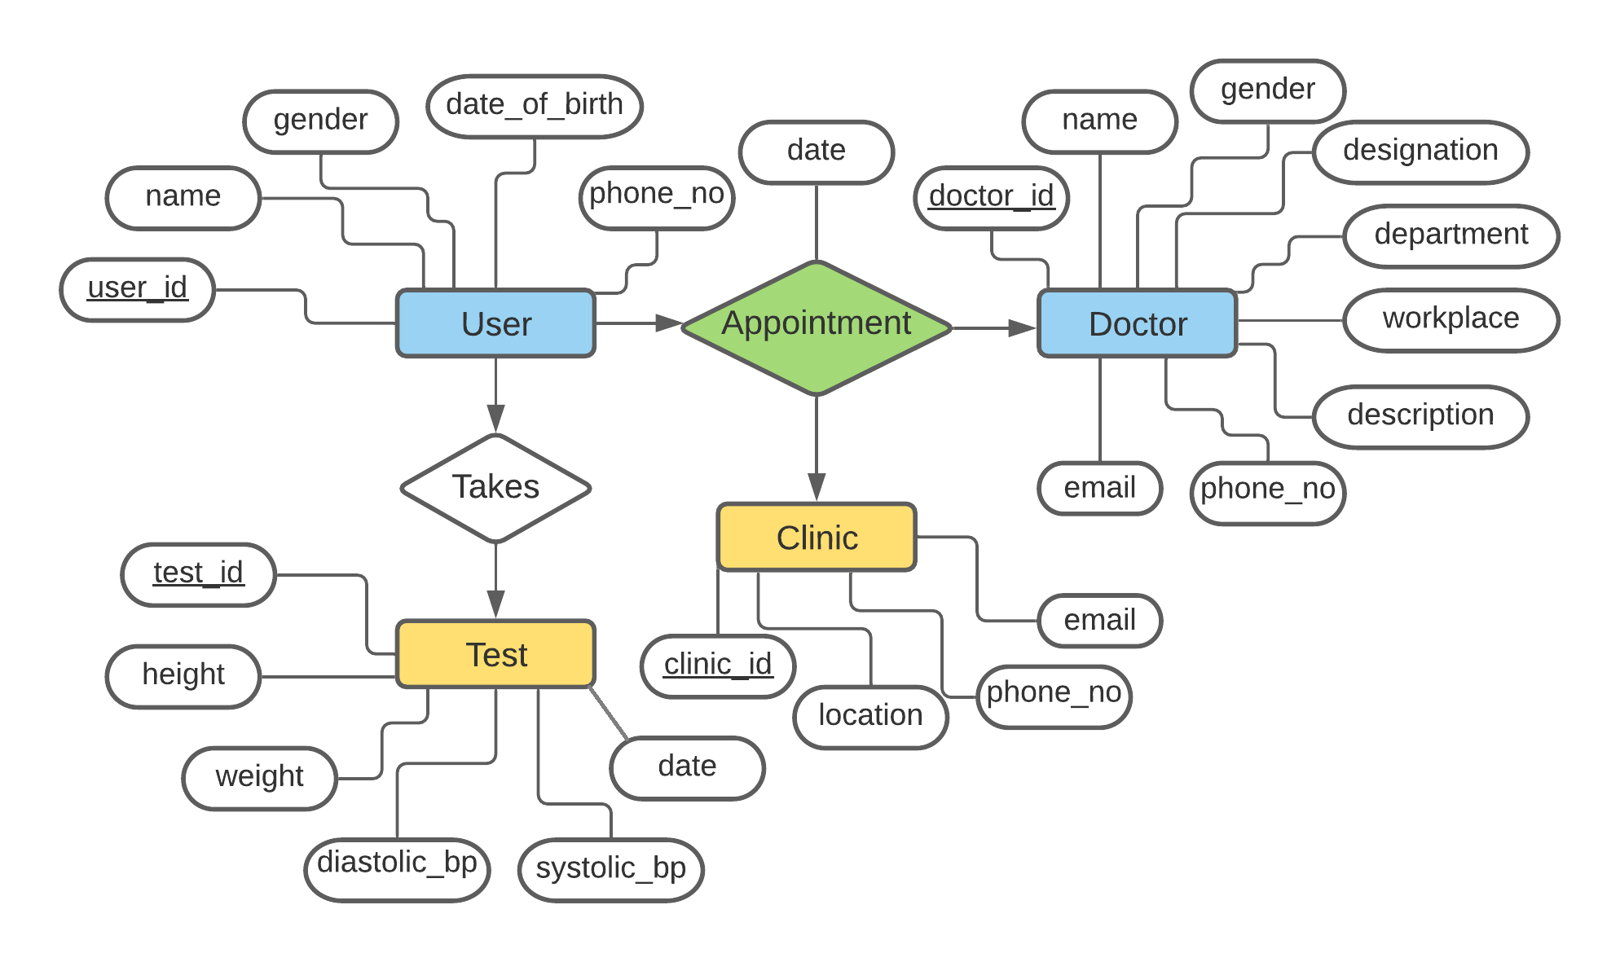

Fig: ER diagram of Personal Healthcare Management.

Schema Diagram

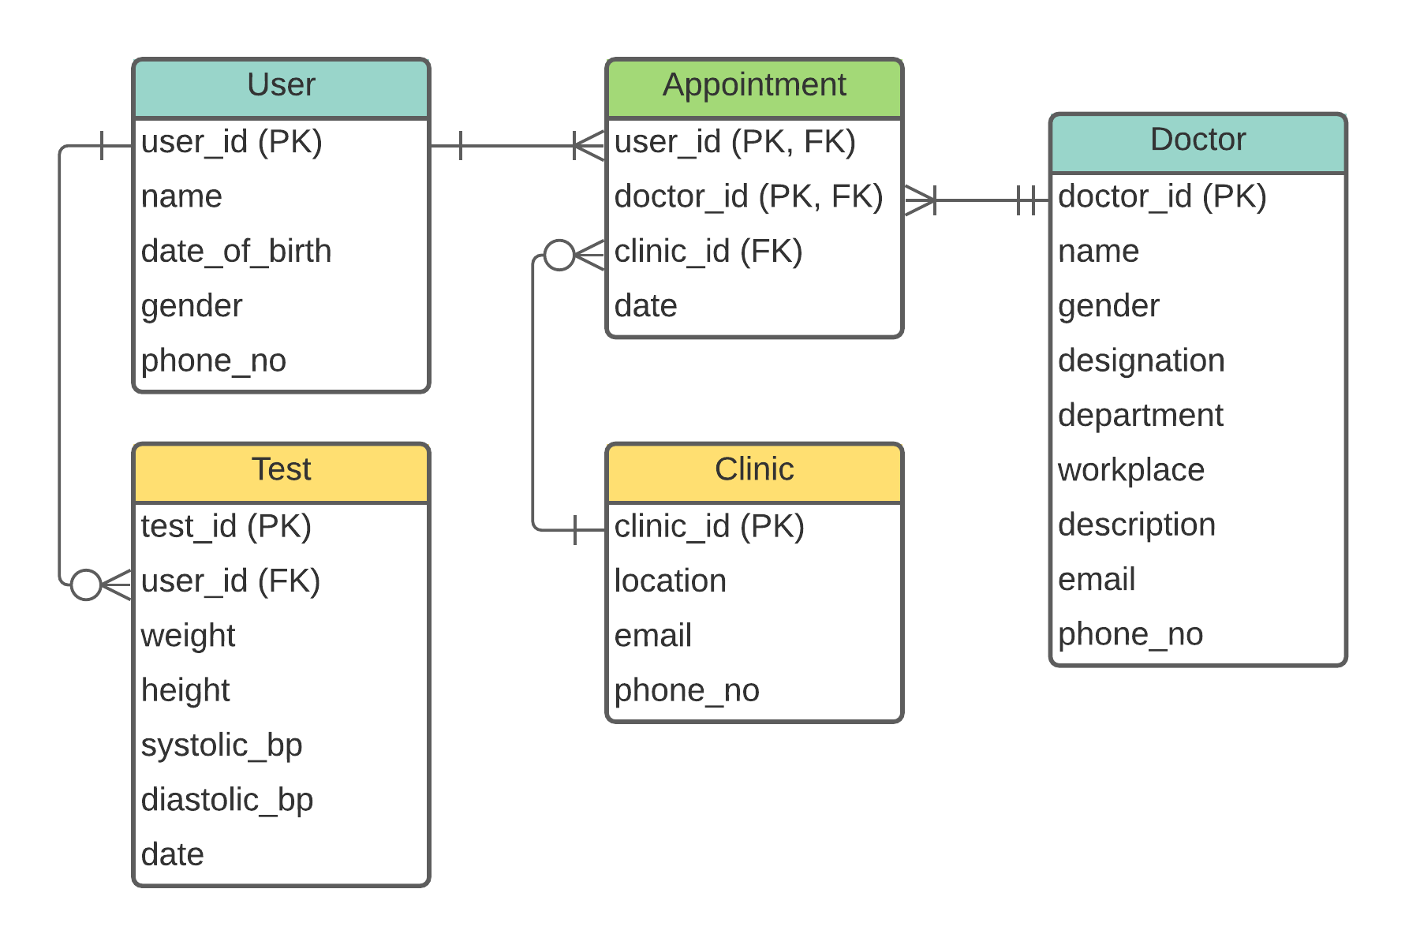

Fig: Schema diagram of Personal Healthcare Management.