MotionMatrix
A Hand Activity Detection System

SE 3105: Software Project Lab II

Submitted by:
Kazi Farhana Faruque - BSSE1506
Md. Mushfiqur Rahman - BSSE1521

Supervised by:
Dr. Mohammad Shoyaib
Professor, IIT DU

Supervisor’s Approval: _________________________

Institute of Information Technology, University of Dhaka
29 January 2026

Table of Contents
Introduction 4
1. Motivation 4
2. Intended Audience 4
Quality function deployment 5
1. Normal Requirements: 5
2. Expected Requirements: 5
3. Exciting Requirements: 5
User Story 6
Use case diagram 7
Level 0: MotionMatrix 8
Level 1: MotionMatrix 9
Level-1.1 : Registration & Login 11
Level-1.2 : Productivity and Payroll Management 13
Level-1.3 : Infrastructure Management 15
Level-1.4 : Activity Detection System 17
Level-1.5 : In-App Message System 19
Activity diagram 21
Level-1: 21
Level-1.1: 22
Level-1.2: 23
Level-1.3: 24
Level-1.4: 25
Level-1.5: 26
Swimlane diagram 26
Level-1: 27
Level-1.1: 28
Level-1.2: 29
Level-1.3: 30
Level-1.4: 31
Level-1.5: 32
Name: In-App Message System 32
Data based modeling 32
Data Modeling Concept 32
Data Objects 32
Data Object Identification 33
ER Diagram 37
Schema Diagram 37
Class Based Modeling 40
Class Based Modeling Concept 40
General Characteristics 40
List of Potential Classes after General Classification: 45
Selection Criteria 46
Analysis 47
Class Cards 48
CRC-Diagram 56
Behavioral Modeling 57
Event Table 57
State Transition Diagram 59
Sequence Diagram 64

Introduction
MotionMatrix (MM) - A Hand Activity Detection System is a web-based application. It is designed to enhance efficiency in garment factories by automating activity tracking and performance monitoring. The system aims to address issues like manual record-keeping and lack of real-time insights by providing tools for worker scheduling, and productivity analysis.

1. Motivation
The Garments sector plays a vital role in the national economy. Despite its massive production, many factories still rely on manual processes for tracking worker productivity, attendance, performance, and efficiency. This often leads to mismanagement and low productivity. Our system will solve this problem. It will assist floor managers track daily activities, analyze worker performance, schedule shifts efficiently and the owner and managers will be provided data-driven insights.
At present many garment factories are mainly traditional and we want to automate the process of tracking productivity of workers. The software below is going to be a prototype to accomplish activity recognition of garment workers in a very controlled environment(e.g. camera being very close to the worker, not having multiple people in the video frame, clear footage), not suitable for production and deployment.

2. Intended Audience
System Admin: Registers and manages all users, defines their roles and access levels.
Owner: Monitors overall production trends, downloads performance reports.
Manager: oversees daily performance; checks attendance and productivity.
Floor Manager: Creates floors, lines, and cameras; Monitors workers’ real-time activities, detects idleness, handles leave requests, and submits end-of-day production data.
Worker: ask for leave via in-app messages to his respective floor manager.

Quality function deployment
Quality Function Deployment (QFD) is a technique that translates the needs of the customer into technical requirements for software. Ultimately the goal of QFD is to translate subjective quality criteria into objective ones that can be quantified and measured and which can then be used to design and manufacture the product. It is a methodology that concentrates on maximizing customer satisfaction from the software engineering process. So, we have followed this methodology to identify the requirements for the project. The requirements, which are given below, are identified successfully by the QFD.
QFD defines three types of requirements:
- Normal Requirements
- Expected Requirements
- Exciting Requirements

Normal Requirements:
The normal requirements are typically the objectives and goals that are identified for a product or system during discussions with the customer. These requirements play a vital role in ensuring customer satisfaction. The standard requirements for our project are:
- Face recognition of workers.
- Worker’s Hand activity detection.
- Time measurement based on whether the worker is active or idle.
- Create or remove profiles for the workers.
- Generate various types of reports.

Expected Requirements:
Certain requirements, though implicit in nature, may not be discussed during meetings due to their fundamental aspect. Even though they are not explicitly stated, their presence must be guaranteed. Otherwise, the product will not meet the customers' expectations. These requirements are known as expected requirements, and they are listed as follows:
- Authentication & Authorization
- Intuitive Interface.

Exciting Requirements:
These requirements are for features that exceed the customer's expectations and provide a high level of satisfaction when included. The following are some of the exceptional requirements of our project:
- Get real-time notification based on workers' inactivity.
- Overtime management.
- Provide messages to reserve workers for replacement if requested.

User Story
System admin logs in using predefined email, password provided by the system developer. After logging into the system with email and password, he can change his own credentials. He registers owner, manager, floor managers and workers into the system by using emails, personal details, one time password and defines their role. Their access level is tied to their role. After getting registered, users receive an email with credentials. At the time of logging in for the first time, he is prompted to change the one-time password set by the admin. After changing the password, he can access the system only after logging in with new credentials. To reset password, users contact the system admin. Only system admin can change the password of users. He can also remove a user. After being removed, the user status becomes deactivated.
In-app message allows users of the system to communicate with other users. But there is authorization over messaging. Workers can only message floor managers. The floor manager can message the manager, system admin, and workers. The manager can message system admin, floor manager and owner. The owner can message system admin and managers.
System admin and floor manager configure the operational layout of the factory. At first the system admin adds a new floor in the system, connects new CCTVs and assigns CCTVs to the floor. A floor can have multiple CCTVs assigned but no CCTV can be assigned to multiple floors. He can also remove any workers and replace any worker.
Floor managers provide the number of units produced by each worker under his management day by day. He can review past production rates on his own floor. In the worker’s profile. Managers and owners download reports of production, these reports can be of various types such as csv, pdf or bar graph, pie graph. These reports highlight the productivity of the institution as a whole. They can ask floor by floor for comparison or historical analysis, if their productivity has increased over time. Every worker profile tracks how much time active/idle they were. Workers look at the CCTV camera at the start of the working shift. Our system recognizes the worker. If any worker asks for overtime and the floor manager approval. So, he then extends the end schedule of the worker by an hour or two by going into the worker’s profile and changing it. Any work done after Standard hour is considered overtime(typically the shift ends at 5:00 PM, configurable by the admin). Overtime done by workers will be tracked by the system as per the end time of each worker and stored in the database. If the system fails to detect a human in the workzone, it is considered the worker is absent. Then it will be shown in the workers profile how much time they overworked in the current month. The system will calculate their overtime working salary by multiplying the time with overtime hourly wage which is also configurable by admin. The floor manager can see this information. The floor manager also manages the leaves of the workers. Almost every garment factory has varying amounts of workers but not every worker is given work by the factory regularly. If any worker wants leave, the worker can send an in-app message to his floor manager asking for leave both for future leave or emergency leave. To approve the leave the floor manager needs to go to the worker’s profile, set leave for the worker. He’ll input starting, ending of the leave and cause of the leave. After the processing, the worker is notified. The floor manager can replace them with the workers reserved in the pool by sending an in-app message to the worker.
Our system assigns one CCTV camera per workstation. CCTV footage tracks attendance of workers by using face recognition. At first the worker will look at the CCTV camera. Then the camera will recognize the face of each worker then store the data into the database. Only one worker works in a workstation, which is a desk with one machine at top. These cameras are connected to a local computer. The computer is fed this footage and can detect idleness among workers from hand movement using a sophisticated ML algorithm. The threshold to define the idleness is set by the admin of the system, which is typically a couple of minutes. If it is detected, the associated floor manager will receive a realtime notification at the dashboard pinpointing the worker who is idle. No activity is detected after the end of the shift or during lunch break, which is also configurable by system admin.

Use case diagram
Use case diagrams give the non-technical view of the overall system. It is a tool for summarizing information about a system and the users within it. It is typically displayed as a graphic representation of how various system components interact with one another. Use case diagrams will detail the system's events and the order in which they occur, but they do not go into detail on how those events are carried out. An approach for identifying, outlining, and organizing system requirements is called a Use Case. The word "system" here refers to a thing that is being created or run, like a website for mail-order product sales and services. A use case diagram encapsulates a certain specification. UML (Unified Modeling Language), a standard language for the modeling of real-world objects and systems, uses use case diagrams.
Primary Actor
Primary actors interact to achieve required system function and derive the intended benefit from the system. They work directly and frequently with the software.
Secondary Actor
Secondary actors support the system so that primary actors can do their work. They either produce or consume information.

Level 0: MotionMatrix
Primary actors : System Admin, Floor Managers.
Secondary actors : Owner, Manager, Workers, CCTV, SMTP.

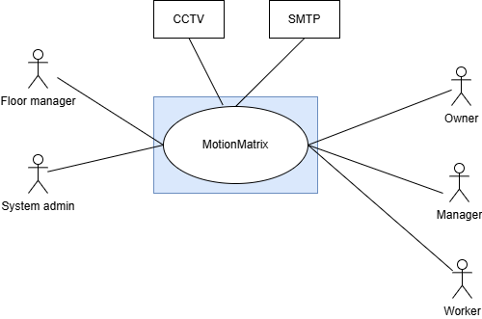

Level 1: MotionMatrix
Primary actors : System Admin, Floor Managers, Worker.
Secondary actors : Owner, Manager, CCTV, SMTP.

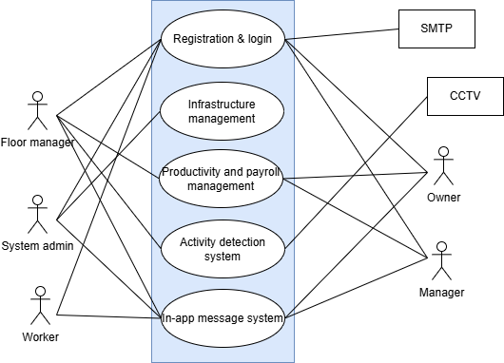

Description :
Registration & Login module
This is the entry point for all users and ensures authentication and authorization. All roles connect to this module, indicating that every user must register and log in before accessing any other system functionality. This module also communicates with the external SMTP service to send emails such as account verification, password reset, or notifications.
Infrastructure management module
The Infrastructure Management module allows higher-level roles such as the System Admin, Floor Manager, Manager, and Owner to monitor and manage physical or digital infrastructure. This can include equipment, facilities, or system resources. The connections show that workers generally do not control infrastructure directly, but supervisors and administrators do.
Productivity and payroll management module
The Productivity and Payroll Management module focuses on tracking worker performance, attendance, and salary-related data. Managers, owners, and floor managers interact with this module to evaluate productivity and process payroll. Workers may indirectly contribute data (such as attendance or task completion), but decision-making and access are primarily reserved for supervisory roles.
Activity detection system
The Activity Detection System integrates monitoring capabilities into the platform. It connects with the external CCTV actor, indicating that video feeds or sensor data are analyzed to detect activities or events. Managers, owners, and admins can access this module to monitor operations, safety, or compliance, helping them make informed decisions based on real-time activity data.
In-app message system
At the bottom is the In-app Message System, which enables communication between users inside the platform. All roles connect to this module, showing that messaging is a shared feature for coordination, notifications, and updates. This supports collaboration between workers, managers, and administrators without relying on external communication tools
External systems interaction
Finally, the diagram shows two external systems: SMTP and CCTV. SMTP supports communication via email, mainly tied to login and notification functions, while CCTV supplies data to the activity detection system. These external actors are not users but essential integrations that extend the system’s functionality beyond the application itself.

Level-1.1 : Registration & Login
Primary actors : System Admin, Floor Managers, Worker.
Secondary actors : Owner, Manager, SMTP.

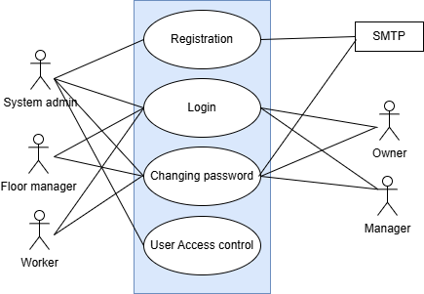

Description :
Registration
- The system shall allow System Admin to register for an account.
- Registration shall collect required user details such as name, email ID, and password.
Log In
- The system shall provide a login facility for all registered users.
- The system shall authenticate users by validating their email ID and password and grant access according to their assigned roles.
Password Management
- The system shall allow users to change their password after successful authentication.
- The system will send a request to the system admin and he will provide a recovery password for users who forget their password and will send it to the registered email address via SMTP.
User Access Control
- The system shall allow the System Admin to manage user access control.
- Access control shall include assigning roles and permissions to users, which determines the features available to them after login.

Action & Reply :
Action 1: For registration, the user provides name, email ID, and password.
Reply 1: The system validates and stores the user information and sends a confirmation email via SMTP.
Action 2: For login, the user provides email ID and password.
Reply 2: The system verifies the credentials and allows the user to access the system based on their assigned role.
Action 3: If the user wants to change or recover the password, the user requests password reset using the registered email ID.
Reply 3: The system will send a request to the system admin then he will generate a password and sends it to the user’s email via SMTP.
Action 4: The System Admin assigns roles and permissions to users.
Reply 4: The system updates user access control, determining which features each user can access after login.

Level-1.2 : Productivity and Payroll Management
Primary actors : Floor Managers.
Secondary actors : Owner, Manager.

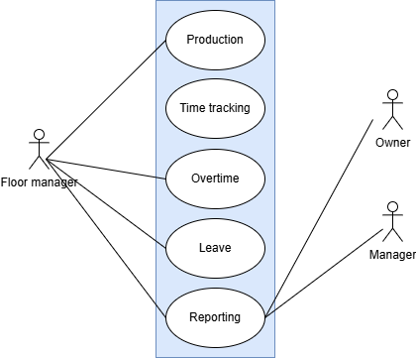

Description :
Production
- The system shall allow the Floor Manager to record and monitor production activities.
- Production data shall be available for review by the Manager and Owner.
Time Tracking
- The system shall provide a time-tracking feature to record working hours of employees.
- Time-tracking information shall support workforce monitoring and performance evaluation.
Overtime Management
- The system shall allow the Floor Manager to record overtime details.
- Overtime data shall be accessible to the Manager and Owner for approval and review purposes.
Leave Management
- The system shall allow the Floor Manager to manage employee leave records.
- Leave information shall be maintained for operational planning and reporting.
Reporting
- The system shall generate reports related to production, time tracking, overtime, and leave.
- Reports shall be accessible to the Floor Manager, Manager, and Owner for decision-making.

Action & Reply :
Action 1: For production tracking, the Floor Manager enters daily production details.
Reply 1: The system stores the production data and makes it available for managerial review.
Action 2: For time tracking, working hours are recorded for employees.
Reply 2: The system logs the time data and links it to productivity and overtime calculations.
Action 3: For overtime, the Floor Manager submits overtime hours worked by employees.
Reply 3: The system records the overtime information and forwards it for Manager/Owner review.
Action 4: For leave management, the Floor Manager updates employee leave details.
Reply 4: The system stores leave records and updates employee availability.
Action 5: For reporting, the Manager or Owner requests operational reports.
Reply 5: The system generates and displays consolidated reports based on stored data.

Level-1.3 : Infrastructure Management
Primary actors : System Admin, Floor Managers.

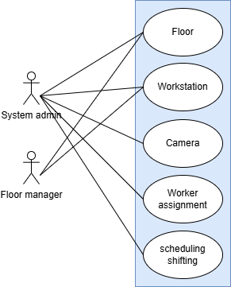

Description :
Floor Management
- The system will allow the System Admin to create and the Floor Manager to manage floor details.
- Floor information will be maintained to support workstation allocation and monitoring.
Workstation Management
- The system shall allow the System Admin to add and Floor Manager to update and manage workstations.
- Workstations shall be linked to specific floors for organized operations.
Camera Management
- The system shall allow the System Admin and Floor Manager to configure and manage cameras.
- Camera details shall support monitoring and activity tracking within work areas.
Worker Assignment
- The system shall allow the System Admin and Floor Manager to assign workers to specific floors and workstations.
- Worker assignments will be maintained to ensure proper resource utilization.
Scheduling and Shifting
- The system shall allow the System Admin and Floor Manager to create and manage work schedules and shifts.
- Scheduling information shall be used to coordinate workforce availability and operations.

Action & Reply :
Action 1: To manage floors, the System Admin or Floor Manager enters floor details.
Reply 1: The system stores the floor information and makes it available for workstation and worker allocation.
Action 2: To manage workstations, the System Admin or Floor Manager adds or updates workstation details.
Reply 2: The system saves the workstation data and links it to the corresponding floor.
Action 3: To manage cameras, the System Admin or Floor Manager configures camera details.
Reply 3: The system records the camera information and associates it with the assigned floor or workstation.
Action 4: For worker assignment, the System Admin or Floor Manager assigns workers to floors or workstations.
Reply 4: The system updates worker assignment records and reflects the changes in scheduling.
Action 5: For scheduling and shifting, the System Admin or Floor Manager defines work schedules and shifts.
Reply 5: The system stores the schedule and shift details and applies them to assigned workers.

Level-1.4 : Activity Detection System
Primary actors : Floor Managers.
Secondary actors : CCTV.

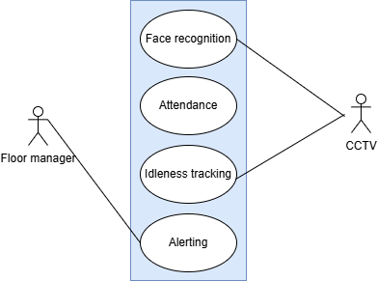

Description :
Face Recognition
- The system shall use CCTV input to perform face recognition.
- Face recognition shall help identify and verify workers on the floor.
Attendance Management
- The system shall automatically record attendance using face recognition data.
- Attendance information shall be accessible to the Floor Manager for monitoring purposes.
Idleness Tracking
- The system shall monitor worker activity through CCTV to detect idle time.
- Idleness data shall support productivity analysis and workforce supervision.
Alerting System
- The system shall generate alerts based on predefined conditions such as prolonged idleness or unauthorized presence.
- Alerts shall be sent to the Floor Manager for timely action.

Action & Reply :
Action 1: CCTV captures live video footage of workers on the floor.
Reply 1: The system processes the video feed and performs face recognition to identify workers.
Action 2: Identified workers enter or exit the workspace.
Reply 2: The system automatically marks attendance based on recognized faces.
Action 3: Worker activity is continuously monitored through CCTV.
Reply 3: The system tracks idle time and records idleness data for each worker.
Action 4: If abnormal behavior or excessive idleness is detected.
Reply 4: The system generates alerts and notifies the Floor Manager for further action.

Level-1.5 : In-App Message System
Primary actors : System Admin, Floor Managers, Worker.
Secondary actors : Owner, Manager.

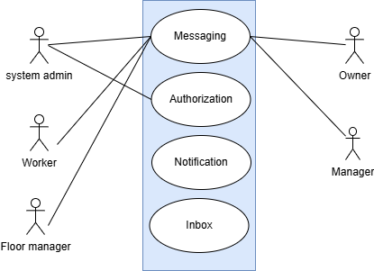

Description:
Messaging
- The system shall provide an in-app messaging feature for System Admin, Floor Manager, Worker, Manager, and Owner.
- Messaging shall enable direct communication between authorized users within the system.
Authorization
- The system shall enforce authorization rules for messaging.
- Only authorized users shall be allowed to send and receive messages based on their roles.
Notification
- The system shall generate notifications for new messages and important updates.
- Notifications shall be delivered to relevant users in real time.
Inbox
- The system shall provide an inbox to store received messages.
- The inbox shall allow users to view, read, and manage their messages.

Action & Reply :
Action 1: A user composes and sends a message to another user through the messaging feature.
Reply 1: The system checks authorization and delivers the message to the intended recipient.
Action 2: A message is successfully delivered to the recipient.
Reply 2: The system generates a notification to inform the recipient of the new message.
Action 3: The recipient opens the inbox to view messages.
Reply 3: The system displays all received messages in the inbox.
Action 4: An unauthorized user attempts to send a message.
Reply 4: The system restricts the action and denies message delivery based on authorization rules

Activity diagram
Activity diagram is an important behavioral diagram in UML diagram to describe dynamic aspects of the system. Activity diagram is essentially an advanced version of flowchart that models the flow from one activity to another activity.

Level-1:
Name: MotionMatrix
Reference: Use case diagram level-1
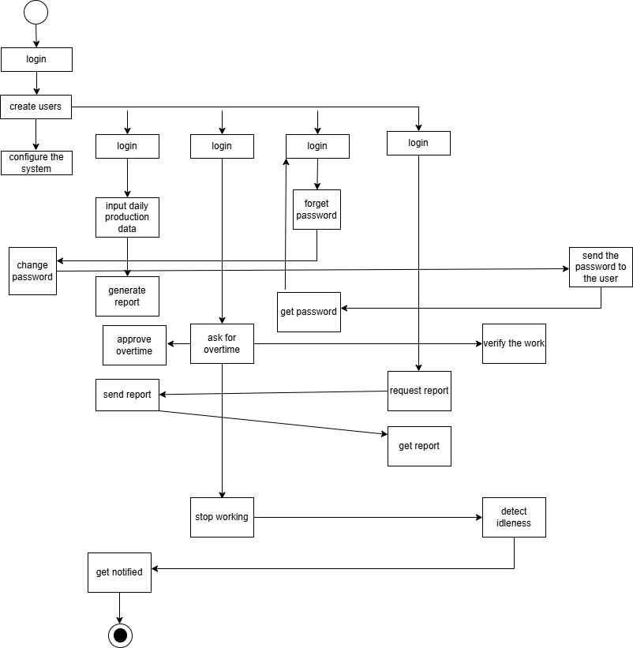

Level-1.1:
Name: Registration & Login
Reference: Use case diagram level-1.1
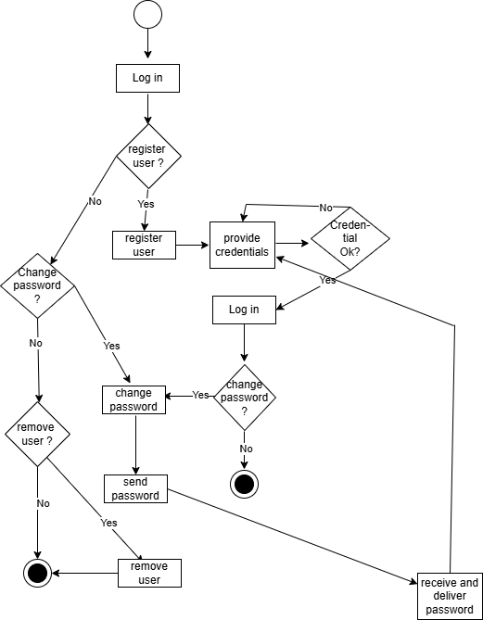

Level-1.2:
Name: Productivity and Payroll Management
Reference: Use case diagram level-1.2

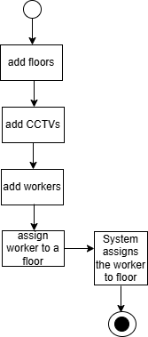

Level-1.3:
Name: Infrastructure Management
Reference: Use case diagram level-1.3

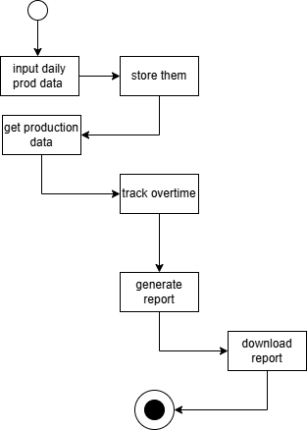

Level-1.4:
Name: Activity Detection System
Reference: Use case diagram level-1.4

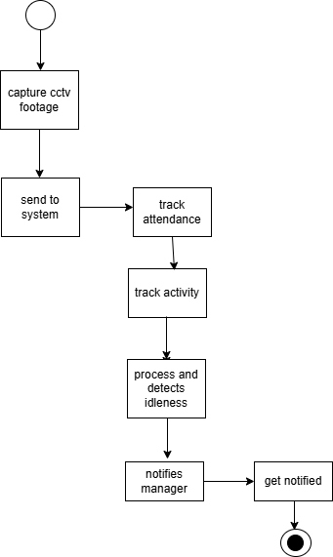

Level-1.5:
Name: In-App Message System
Reference: Use case diagram level-1.5

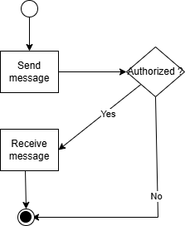

Swimlane diagram
A swimlane diagram is a type of flowchart, which diagrams a process from start to finish, but it also divides these steps into categories to help distinguish which departments or employees are responsible for each set of actions. It is based on the analogy of lanes in a pool, as it places process steps within the horizontal or vertical “swimlanes” of a particular department, work group or employee, thus ensuring clarity and accountability.

Level-1:
Name: Makka Textile Management System
Reference: Use case diagram level-1.1

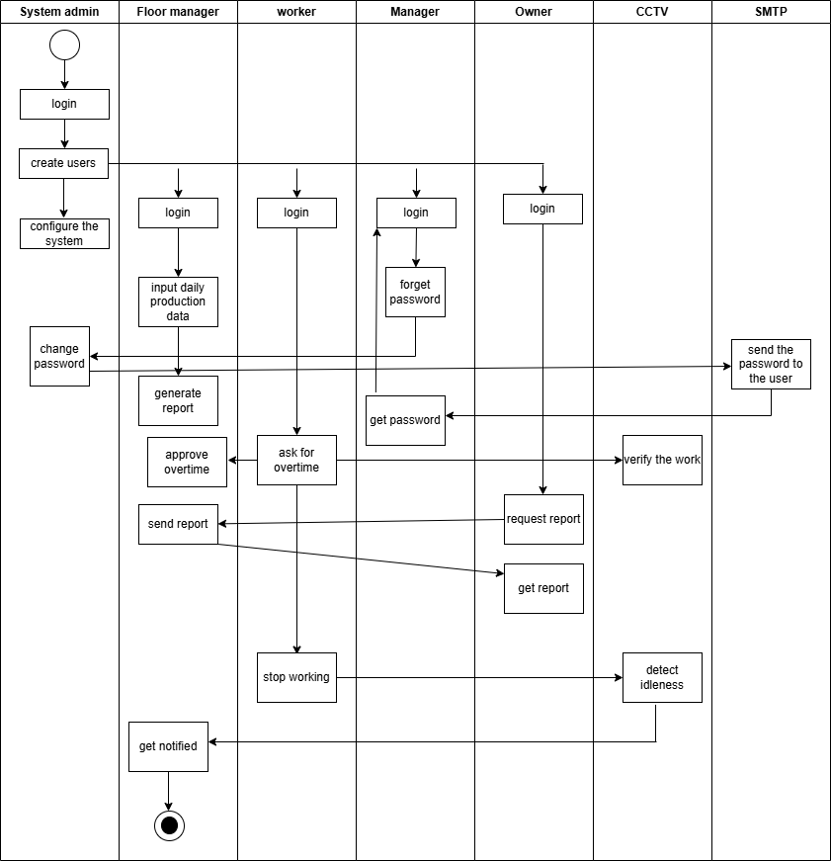

Level-1.1:
Name: Registration & Login
Reference: Use case diagram level-1.1

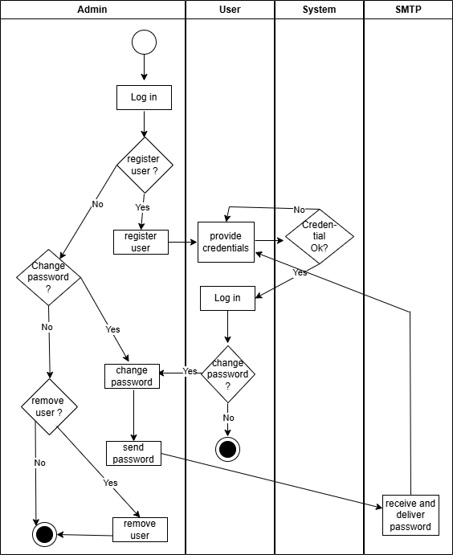

Level-1.2:
Name: Productivity and Payroll Management
Reference: Use case diagram level-1.2

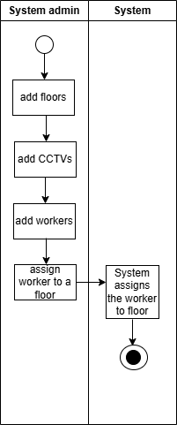

Level-1.3:
Name: Infrastructure Management
Reference: Use case diagram level-1.3

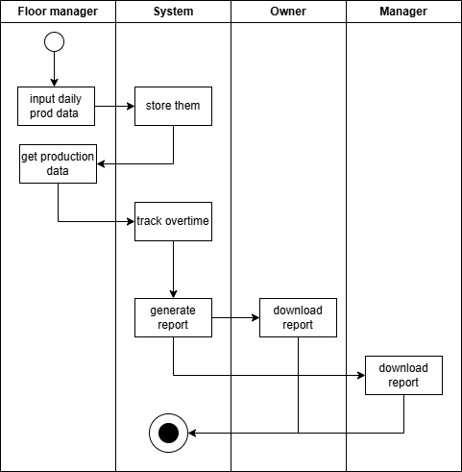

Level-1.4:
Name: Activity Detection System
Reference: Use case diagram level-1.4

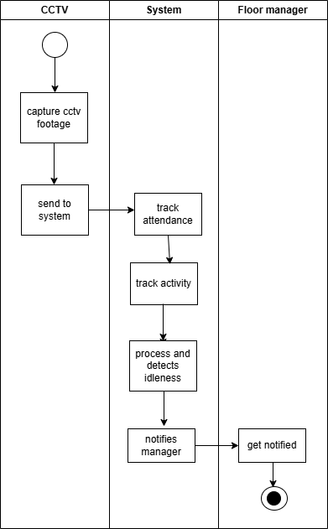

Level-1.5:

Name: In-App Message System
Reference: Use case diagram level-1.5

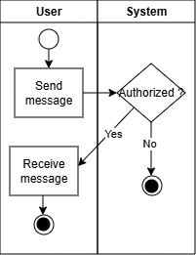

Data based modeling

Data Modeling Concept
If software requirements include the necessity to create, extend or interact with a database or complex data structures need to be constructed and manipulated, then the software team chooses to create data models as part of overall requirements modeling. The entity relationship diagram (ERD) defines all data objects that are processed within the system, the relationships between the data objects and the information about how the data objects are entered, stored, transformed and produced within the system.

Data Objects
A data object is a representation of composite information that must be understood by the software. Here, composite information means information that has several different properties or attributes. A data object can be an external entity, a thing, an occurrence, a role, an organizational unit, a place or a structure.

Data Object Identification
Noun Table
Serial No. | Noun | P/S | Attributes
 | System | S
 | Admin | S
 | Login | S
 | Name | S
 | Email | S
 | Password | S
 | One time password | S
 | Developers | P
 | Owner | S
 | Manager | S
 | Floor manager | S
 | Workers | S
 | Personal details | S
 | Role | S
 | Access Level | P
 | Credentials | P
 | Reset | P
 | Users | S
 | Contact | P
 | Registration | S
 | Working shift | P
 | CCTV camera | P
 | Status | P
 | Deactivation | P
 | In-app message | P
 | Communication | P
 | Authorization | P
 | Configuration | P
 | Operational | P
 | Layout | P
 | Factory | P
 | Overtime | S
 | Schedule | P
 | Standard hour | P
 | End time | P
 | Database | P
 | Workzone | P
 | Detection | P
 | Human | P
 | Absence | P
 | Current month | P
 | Working salary | P
 | Hourly wage | P
 | Information | P
 | Leaves | S
 | Garment | P
 | Emergency | P
 | Notified | P
 | Pool | P
 | Management | P
 | Units | S
 | Production rates | P
 | Attendance | S
 | CCTV footage | P
 | Face recognition | P
 | Data | P
 | Reports | P
 | Production | P
 | CSV | P
 | PDF | P
 | Bar graph | P
 | Pie graph | P
 | Productivity | P
 | Institution | P
 | Comparison | P
 | Historical | P
 | Analysis | P
 | Workstation | P
 | Desk | P
 | One machine | P
 | Local computer | P
 | Idleness | P
 | Sophisticated | P
 | ML algorithm | P
 | Threshold | P
 | Realtime | S
 | Notification | P
 | Pinpoint | P
 | Dashboard | P
 | Idle time | S
 | Lunch break | P
 | Content | S
 | Profile | P
 | Removal | P
 | Replacement | P
 | Floor | P
 | Infrastructure | P
 | Productivity | P
 | Multiplication | P

ER Diagram
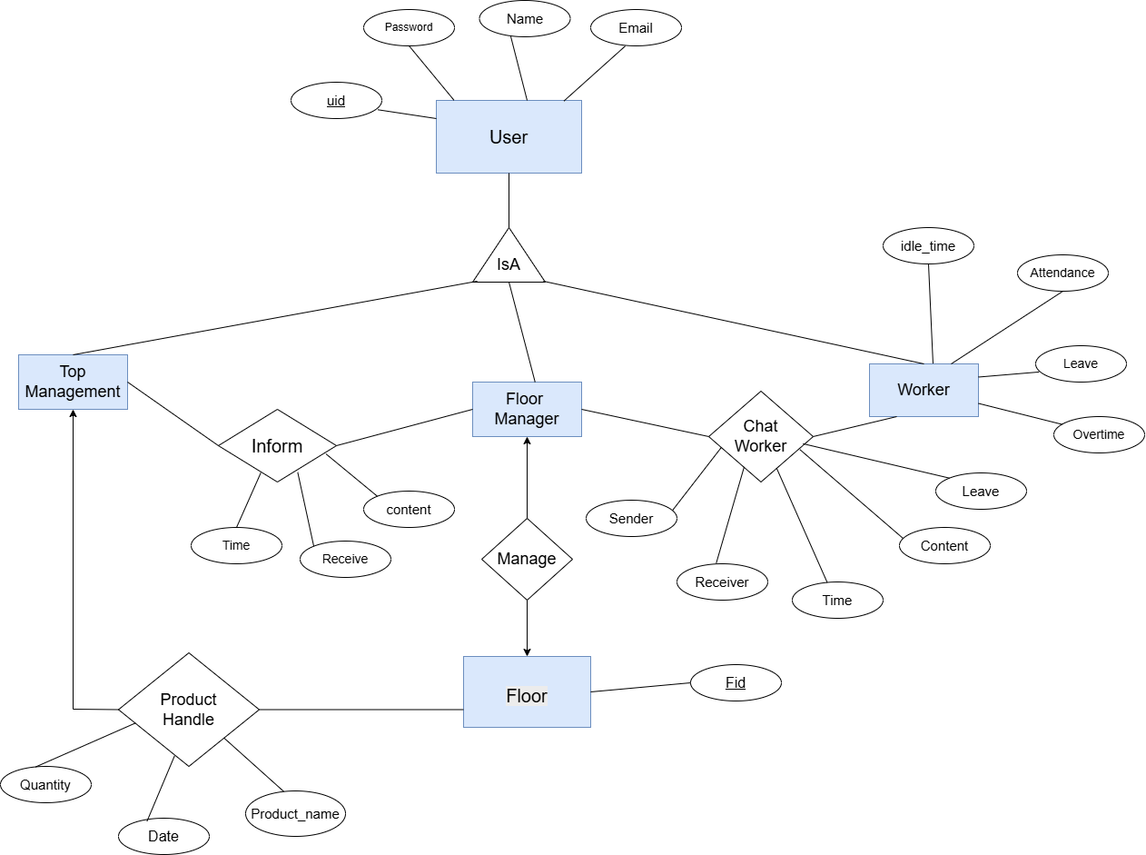

Schema Diagram
User
Attributes | Data Types | Size
uid | NUMBER
Name | VARCHAR
Password | VARCHAR
Email | VARCHAR

Worker
Attributes | Data Types | Size
uid | NUMBER
idle_time | VARCHAR
Attendance | VARCHAR
Overtime | VARCHAR

Chat Worker
Attributes | Data Types | Size
Sender_id (FK from user) | NUMBER
Receiver_id (FK from user) | NUMBER
Time | VARCHAR
Content | VARCHAR

Floor
Attributes | Data Types | Size
Fid | NUMBER
Uid (FK from user) | NUMBER

Production Handle
Attributes | Data Types | Size
Fid (FK from floor) | NUMBER
Uid (FK from user) | NUMBER
Date | VARCHAR
Product_name | VARCHAR
Quantity | NUMBER

Inform
Attributes | Data Types | Size
Time | VARCHAR
Receiver_id (FK from User ) | NUMBER
Content | VARCHAR

Class Based Modeling

Class Based Modeling Concept
The objects that the system will manipulate, the operations (also known as methods or services) that will be applied to the objects to effect the manipulation, relationships between the objects, and interactions that take place between the classes that are defined are all represented by class-based modeling. Classes and objects, attributes, operations, class-responsibility-collaborator (CRC) models, collaboration diagrams, and packages are all components of a class-based model.

General Characteristics
  - External entities: (e.g., ) that produce or consume information to be used by a computer-based system.
  - Things: (e.g., ) that are part of the information domain for the problem.
  - Occurrences or events: (e.g., ) that occur within the context of system operation.
  - Roles: (e.g.,) played by people who interact with the system.
  - Organizational units: (e.g., ) that are relevant to an application.
  - Places: (e.g.,) that establish the context of the problem and the overall function of the system.
  - Structures: (e.g., ) that define a class of objects or related classes of objects.
Serial Number | Noun | General Classification
 | System | 7
 | Admin | 4
 | Login | 3
 | Name | 2
 | Email | 2
 | Password | 2
 | One time password | 2
 | Developers | 1
 | Owner | 4
 | Manager | 4
 | Floor manager | 4
 | Workers | 4
 | Personal details | 7
 | Role | 2
 | Access Level | 2
 | Credentials | 2
 | Reset | 3
 | User | 4, 5
 | Contact | 2
 | Registration | 3
 | Working shift | 2, 5
 | CCTV | 1, 2, 5
 | Status | 2
 | Deactivation | 3
 | Message | 2,3
 | Communication | 3
 | Authorization | 3
 | Configuration | 3
 | Operational | 5
 | Layout | 5
 | Factory | 5, 6
 | Overtime | 3
 | Schedule | 2
 | Standard hour | 2
 | End time | 2
 | Database | 2
 | Workzone | 6
 | Detection | 3
 | Human | 2
 | Absence | 3
 | Current month | 2
 | Working salary | 2
 | Hourly wage | 2
 | Information | 2
 | Leaves | 3
 | Garment | 2
 | Emergency | 3
 | Notified | 3
 | Pool | 5
 | Management | 5
 | Units | 2
 | Production rates | 2
 | Attendance | 3
 | CCTV footage | 2
 | Face recognition | 1,3
 | Data | 2
 | Reports | 2
 | Production record | 2, 5
 | CSV | 2
 | PDF | 2
 | Bar graph | 2
 | Pie graph | 2
 | Productivity | 2
 | Institution | 5
 | Comparison | 3
 | Historical data | 2
 | Analysis | 3
 | Workstation | 6
 | Desk | 2
 | One machine | 2
 | Local computer | 1
 | Idleness | 3
 | ML algorithm | 1
 | Activity detection | 3
 | Notification | 2,3
 | Pinpoint | 3
 | Dashboard | 2
 | Idle time | 3
 | Lunch break | 3
 | Content | 2
 | Profile | 7
 | Removal | 3
 | Replacement | 3
 | Floor | 6
 | Infrastructure | 2, 7
 | Productivity | 2

List of Potential Classes after General Classification:
Admin | Factory
Owner | Detection
Manager | Leaves
Floor manager | Emergency
Worker | Management
Role | Attendance
Credentials | Face recognition
User | Reports
Registration | Production record
CCTV | Workstation
Deactivation | Notification
Message | Floor

Selection Criteria
  - Retained information: The potential class will be useful during analysis only if information about it must be remembered so that the system can function.
  - Needed services: The potential class must have a set of identifiable operations that can change the value of its attributes in some way.
  - Multiple attributes: During requirement analysis, the focus should be on “major” information; a class with a single attribute may, in fact, be useful during design, but is probably better represented as an attribute of another class during the analysis activity.
  - Common attributes: A set of attributes can be defined for the potential class and these attributes apply to all instances of the class.
  - Common operations: A set of operations can be defined for the potential class and these operations apply to all instances of the class.
  - Essential requirements: External entities that appear in the problem space and produce or consume information essential to the operation of any solution for the system will almost always be defined as classes in the requirements model.
Serial Number | Potential Classes | Selection Criteria
 | Admin | 1, 2, 3, 5
 | Owner | 1, 2, 3, 4, 5
 | Manager | 1, 2, 3, 4, 5
 | Floor manager | 1, 2, 3, 4, 5
 | Worker | 1, 2, 3, 4, 5
 | Role | 1, 2, 4, 6
 | Credentials | 1, 2
 | User | 1-6
 | Registration | 2, 6
 | CCTV | 2, 3, 4, 5, 6
 | Deactivation | 2
 | Message | 2, 6
 | Factory | 2
 | Detection | 2, 3, 4, 5, 6
 | Leaves | 1, 2, 4, 6
 | Emergency | 3
 | Management | 2
 | Attendance | 1, 6
 | Face recognition | 4, 6
 | Reports | 1, 3, 6
 | Production record | 2, 3, 4, 5
 | Workstation | 2, 4
 | Notification | 3, 6
 | Floor | 1, 3

Analysis
- User: a class responsible for user lifecycle
- CCTV: a class to handle external cctv system
- Role: a class for role based authorization handling
- Authentication: to handle login and password
- ActivityMonitor: a class to detect idleness.
- AttendanceService: to handle attendance and overtime of workers
- ProductionRecord: a class to handle daily production input from floor manager
- ReportGenerator: a class to generate various types of report from the record
- MessageService: to handle in app messaging
- EmailService: a class to interact with smtp to send emails
- ConfigureService: a class to handle configuration of the system
- LeaveService: a class to streamline the leave application process of workers
- NotificationService: to handle sending notifications
- Registration: a class to register users.

Class Cards
  - User
Attribute | Method
- userId  - username  - email  - phoneNumber  - status  - role | + updatePersonalInfo()  + changeEmail()  + changePhoneNumber()  + isActive()  + assignRole()  + getFullName()  + canBeDeactivated()
Responsibility | Collaborator
Maintain personal and employment information | Role
Maintain account status (active/deactivated) | Authentication
Maintain role association | Registration

  - Role
Attribute | Method
- roleName  - description  - permissions  - messagingScope | + addPermission()  + removePermission()  + hasPermission()  + defineMessagingScope()  + getMessagingScope()  + getPermissions()  + getRoleName()
Responsibility | Collaborator
Define access permissions | User, Authentication
Define messaging scope | MessageService

  - Authentication
Attribute | Method
- passwordHasher  - otpService  - tokenService  - passwordPolicy | + validateCredentials()  + changePassword()  + initiatePasswordReset()  + resetPassword()  + generateOTP()  + validateOTP()
Responsibility | Collaborator
Validate login credentials | User
Manage password changes and resets | Rol
Manage one-time password lifecycle | EmailService

  - Registration
Attribute | Method
- userRepository  - roleRepository  - authentication  - emailService | + registerUser()  + assignRole()  + provisionCredentials()  + deactivateUser()
Responsibility | Collaborator
Create and deactivate user accounts | User, Authentication
Assign roles during user creation | Role
Trigger credential provisioning | Authentication, EmailService

  - Production
Attribute | Method
- productionRepository  - productionRecords | + recordDailyProduction()  + getProductionHistory()  + getProductionHistoryByDateRange()  + getTotalUnitsProduced()  + getDailyProduction()
Responsibility | Collaborator
Record daily production units per worker | User
Maintain production history | ReportGenerator
Support production queries

  - AttendanceService
Attribute | Method
- attendanceRepository  - shiftSchedule  - boundaryTolerance | + checkIn()  + checkOut()  + markAbsent()  + getAttendanceHistory()  + isShiftStart()  + isShiftEnd()
Responsibility | Collaborator
Track presence and absence | User
Maintain attendance timelines | CCTV
Detect shift boundaries | ActivityMonitor

  - LeaveService
Attribute | Method
- leaveRepository  - notificationService  - messageService | + submitLeaveRequest()  + approveLeave()  + rejectLeave()
Responsibility | Collaborator
Manage leave requests | User
Track leave periods and reasons | MessageService
Notify stakeholders of leave decisions | NotificationService

  - CCTV
Attribute | Method
- cameraId  - workstationId  - streamEndpoint  - isActive | + startStream()  + stopStream()  + forwardStream()
Responsibility | Collaborator
Capture and forward video streams | ActivityMonitor
Bind video feed to a workstation | AttendanceService

  - ActivityMonitor
Attribute | Method
- cctv  - configurationService  - idleThreshold  - activityWindow | + analyzeStream()  + detectIdleness()
Responsibility | Collaborator
Analyze video feed for activity | CCTV
Detect idleness based on thresholds | AttendanceService, NotificationService
Report activity outcomes | ConfigurationService

  - NotificationService
Attribute | Method
- notificationChannels  - deliveryGateway | + sendAlert()  + pushDashboardNotification()
Responsibility | Collaborator
Deliver system alerts | ActivityMonitor
Push real-time dashboard notifications | User, LeaveService

  - ReportGenerator

Attribute | Method
- productionService  - attendanceService  - supportedFormats | + aggregateProductivityData()  + generateReport()  + generateHistoricalReport()  + generateComparativeReport()
Responsibility | Collaborator
Aggregate productivity and attendance data | Production
Generate reports in multiple formats | AttendanceService
Support historical and comparative analysis | User

  - ConfigurationService

Attribute | Method
- configurationRepository  - shiftSchedules  - activityThresholds  - wageRates  - passwordPolicies | + getShiftSchedule()  + getActivityThresholds()  + getWageRate()  + getPasswordPolicy()
Responsibility | Collaborator
Maintain system-wide parameters | Authentication
Define schedules, thresholds, and wages | ActivityMonitor
Provide configuration values to services | AttendanceService

  - MessageService

Attribute | Method
- messageRepository  - roleMessagingRules | + sendMessage()  + getMessageHistory()
Responsibility | Collaborator
Manage in-app messaging | User
Enforce role-based messaging constraints | Role
Maintain message history

  - EmailService

Attribute | Method
- emailGateway  - senderAddress | + sendEmail()
Responsibility | Collaborator
Send credentials and notifications via email | Authentication
Deliver password reset messages | Registration

CRC-Diagram

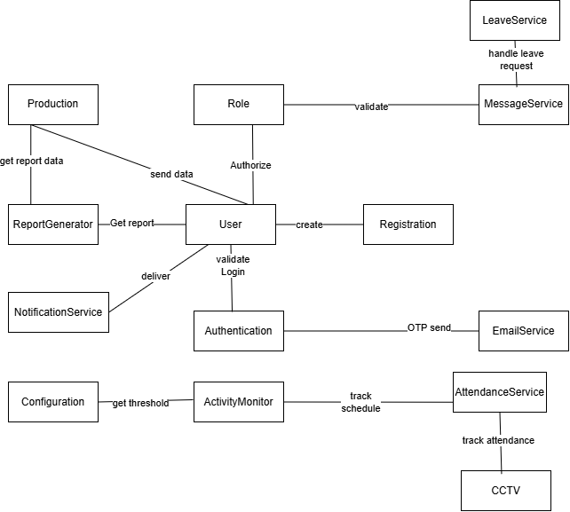

Behavioral Modeling
Behavioral modeling is the process of predicting future behavior using current and relevant data on consumer and company spending. There are two distinct characterizations of states that must be taken into account in behavioral modeling. First, the state of each class as the system executes its task, and then the system's state as seen from the outside while the system executes its task.

Event Table
SN | Events | Initiator | Collaborator
1 | Registration | User
2 | Deactivation | User
3 | Role creation | Role | User
4 | Assignment | Role | User
5 | Report generation | ReportGenerator | ProductionRecord
6 | Report Download | User | ReportGenerator
7 | Removing user | Registration | User
8 | Production recording | ProductionRecord | CCTV
9 | Record drafting | ProductionRecord
10 | Record reviewing | ProductionRecord
11 | Getting notification | Notification
12 | Sending notification | Notification | User
13 | Writing message | MessageService
14 | Sending message | MessageService | User
15 | Requesting leave | LeaveService
16 | Activating leave | LeaveService | Notification
17 | Rejecting leave | LeaveService | Notification
18 | Sending mail | EmailService
19 | Updating config | Configure | User
20 | activating | CCTV
21 | assignment | CCTV
22 | removing | CCTV
23 | Login | Authentication | User
24 | Password expired | Authentication
25 | Face recognition | ActivityMonitor | CCTV
26 | Working overtime | AttendanceService
27 | Not working | ActivityMonitor

State Transition Diagram
A UML state diagram, which depicts the active states for each class and the occasions (triggers) that induce changes between these active states, is part of a behavioral model. Here we’ve listed the most important events that trigger the change of states.
ID No: 1
Name: User

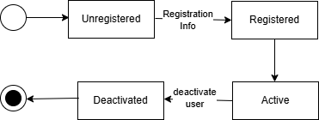

ID No: 2
Name: Role

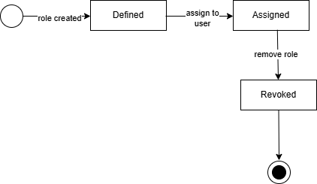
ID No: 3
Name: Authentication

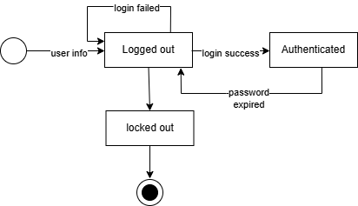
ID No: 4
Name: Registration

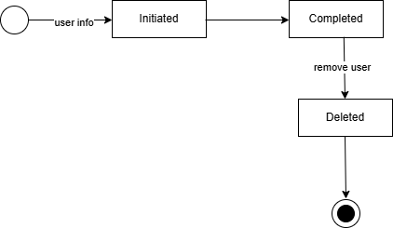

ID No: 5
Name: Production
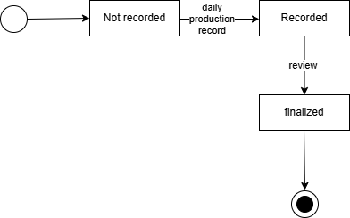
ID No: 6
Name: AttendanceService

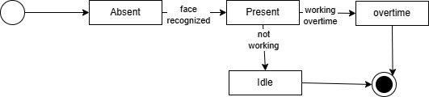

ID No: 7
Name: LeaveService

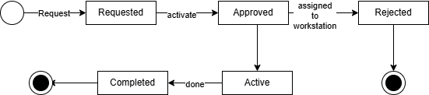
ID No: 8
Name: CCTV

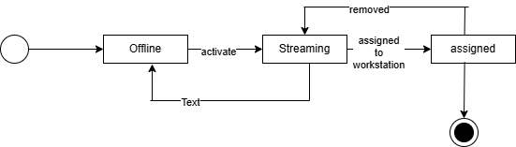

ID No: 9
Name: ActivityMonitor

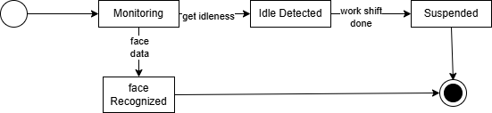

ID No: 10
Name: NotificationService

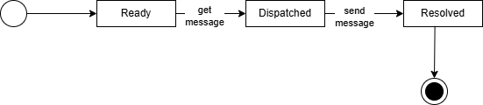
ID No: 11
Name: ReportGenerator

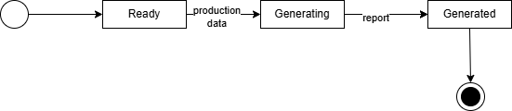
ID No: 12
Name: ConfigurationService

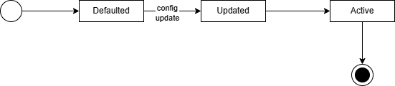
ID No: 13
Name: MessageService

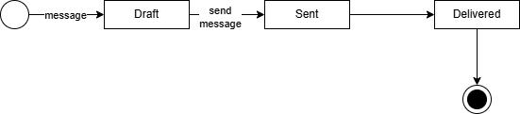
ID No: 14
Name: EmailService

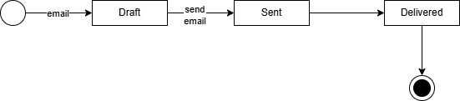

Sequence Diagram

