

**Course Project**

**Project Title**

**Employment Application Review System**

**Course Code:** SWE331

**Course Title:** Object Oriented Software Development

|  |  |
| --- | --- |
| Farhana Alam | 151-35-1048 |
| Section | B |
| Supervisor Name | Md. Alamgir Kabir |
| Department | Software Engineering |

**Date: 05-12-17**

Table of Contents

**Chapter 1: INTRODUCTION** 4

1 Introduction 4

1.1 About the system 4

1.2 Purpose 4

1.3 Scope 4

1.4 Vision 4

1.5 Why This System Necessary?? 5

1.6 Proposed Solution 5

**Chapter 2: SYSTEM ANALYSIS** 6

2 System Analysis 6

2.1 Actor Goal List 6

2.2 Use Case Model 7

2.3 Use Case Description (Brief) 8

2.3.1 Manage Account (success Scenario) 8

2.3.2 Manage Faculty (success Scenario) 9

2.3.3 Upload Job (success Scenario) 10

2.3.4 Apply job (success Scenario) 11

2.3.5 List Applicant (success Scenario) 11

2.4 Use Case Description (Detailed) 12

2.4.1 Manage Account 12

2.4.2 Manage Faculty 13

2.4.3 Upload job 14

2.4.4 Apply job 15

2.4.5 List Applicant 16

2.5 System Sequence Diagram 17

2.5.1 Manage Account (Success Scenario) 17

**2.5.2** Manage Faculty (success Scenario) 18

2.5.3 Upload job(success Scenario) 19

2.5.4 Apply Job(success Scenario) 20

2.5.5 List Applicant (success Scenario) 21

**2.6** Domain Model 22

2.7 Activity Diagram 24

2.7.1 Activity Diagram for Admin 24

2.7.2 Activity Diagram for School Faculty and Applicant 25

**Chapter 3: System Design** 26

3 System Design 26

3.1 Sequence Diagram 26

3.1.1 Manage Account (success scenario) 26

3.1.2 Manage Faculty (success scenario) 27

3.1.3 Upload Job(success scenario) 27

3.1.4 Apply Job(success scenario) 28

3.1.5 List Applicant (success scenario) 28

3.2 Class Diagram 29

# 

# Chapter 1: INTRODUCTION

# Introduction

The name of my system is Employment Application Review System. Using this system applicants will apply for the job. Faculty members will give review the applications of applicants and list the applicant to find the best applicant for the job.

## About the system

EARS is an intranet-based Employment Application Review System is designed for the International School of Software.so that school faculty members can review applicants to find the best applicant for a given job opening .This system will have the following features:

* Log In
* Manage Account
* Apply Job
* Faculty Search
* Add New Faculty
* List All the applications
* Review Applications

## Purpose

The main objective of the proposed system is to computerize the process for school faculty members in order to find the best applicant for a given job opening, by review the applications and list the applicant .And it will also reduce manpower and time consumption.

## Scope

The goal of this project is to establish an integrated School Employment Application Review System which enables us to automate the review application processes of the school and choose the best applicant for the post .Here

Applicant: Applicant can create profile then view new job post and apply for the job.  
School Faculty: They will view applications then, list the best applicants by rating their application they also can post comment.

Admin: Admin will upload, update, delete new jobs view applicant cv. He can also manage the system user by add or delete account.

## Vision

The vision of this system collaborate asynchronously with faculty member and taking their review. to choose the best applicant for the opening job. The system is reducing the overhead of the process and workload for the faculty members.

## Why This System Necessary??

Collaborate with all faculty member then Choose a best applicant for a job post it becomes so difficult and it takes lot time . But by the help of this system faculty can give their review any time via online and list the applicant by rating their application and choose the best application .

## Proposed Solution

* Online collaboration with faculty member
* Online review system
* Online job apply

# Chapter 2: SYSTEM ANALYSIS

# System Analysis

## Actor Goal List

Actor and Goals

|  |  |
| --- | --- |
| Actor | Goals |
| School Faculty | * View applications * Gives Feedback * List best applicant |
| Applicants | * Apply job |
| Admin | * Upload jobs * Manage system user |

## 

## 2.2Use Case Model

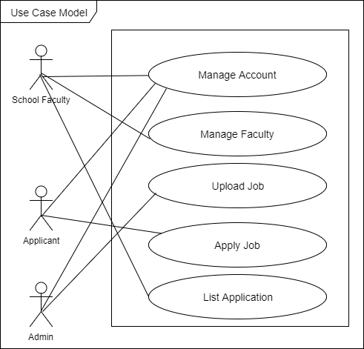

**Fig-1: Use Case Diagram**

## Use Case Description (Brief)

### Manage Account (success Scenario)

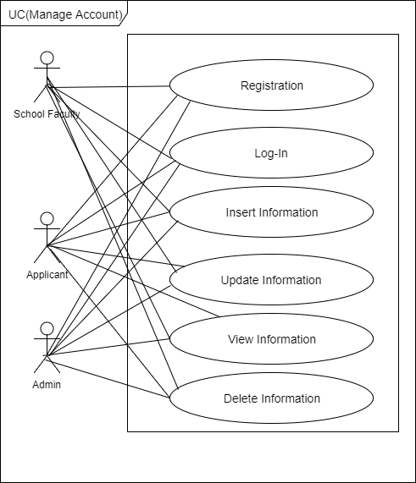

**Fig-2: Use Case Diagram Of Manage Account**

### Manage Faculty (success Scenario)

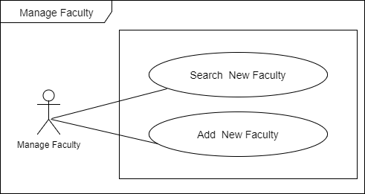

**Fig 3: Use Case Diagram Of Manage Faculty**

### Upload Job (success Scenario)

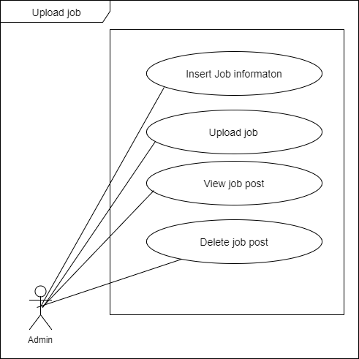

**Fig-4: Use Case Diagram Of Upload Job**

### Apply job (success Scenario)

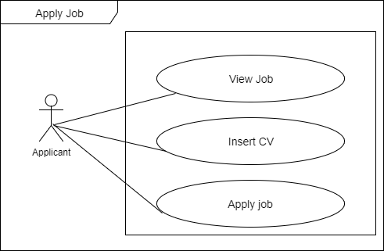

**Fig-5: Use Case Diagram Of Apply Job**

### List Applicant (success Scenario)

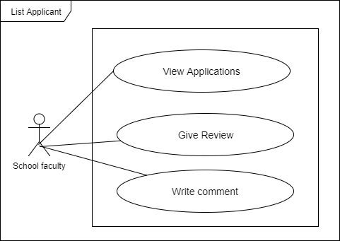

**Fig-6: Use Case Diagram Of List Applicant**

## Use Case Description (Detailed)

In use case description detailed are given for every single use cases. It will everyone to understand what that use case has been used for, for which actor this use case has been used.

### Manage Account

|  |  |  |
| --- | --- | --- |
| **Use Case Name:** | Manage Account | |
| **Scenario:** (success Scenario) | User can manage his/her account settings | |
| **Brief Description:** | User can insert information ,update information also delete his/her profile information | |
| **Actor:** | All User(School Faculty ,Admin ,Applicant) | |
| **Preconditions:** | Must have to create his/her account.  Must log in to his/her account | |
| **Post conditions:** | View information. | |
| **Flow of Events:** | **Actor** | **System** |
| User will insert ,update ,view ,delete information | System will save new user information  Delete user information from database  Show user information |
| **Exception Conditions:** | 1.Without internet user can not able to log in to his/her account | |

### 

### Manage Faculty

|  |  |  |
| --- | --- | --- |
| **Use Case Name:** | Manage Faculty | |
| **Scenario:** (success Scenario) | School faculty member can manage their faculty member | |
| **Brief Description:** | School faculty member can Search for new faculty member and also and add them | |
| **Actor:** | School faculty member | |
| **Preconditions:** | Faculty member must have to an account | |
| **Post conditions:** | Review Applicant | |
| **Flow of Events:** | **Actor** | **System** |
| Faculty member will add new faculty and search new faculty | System will save new faculty member name  Show Search information |
| **Exception Conditions:** | 1. If that searched person does not exist or don’t have any account, then faculty can’t add the person. | |

### Upload job

|  |  |  |
| --- | --- | --- |
| **Use Case Name:** | Upload job | |
| **Scenario:** (success Scenario) | Admin can upload job | |
| **Brief Description:** | Admin can create new job post with job information. Also can update post | |
| **Actor:** | Admin | |
| **Preconditions:** | Must have to insert job information | |
| **Post conditions:** | View job posts | |
| **Flow of Events:** | **Actor** | **System** |
| Admin will insert new job information | System will save new job information |
| **Exception Conditions:** | 1. Without Insert job information can not create any job posts | |

### Apply job

|  |  |  |
| --- | --- | --- |
| **Use Case Name:** | Apply job | |
| **Scenario:** (success Scenario) | Applicant can apply for the opening job | |
| **Brief Description:** | Applicant can drop his/her cv and apply for the job | |
| **Actor:** | Applicant | |
| **Preconditions:** | Must have to have user account  Must have to attached cv | |
| **Post conditions:** | View information | |
| **Flow of Events:** | **Actor** | **System** |
| Applicant will Attached cv | System will save it to database |
| **Exception Conditions:** | 1. Without attached applicant can not apply for any job | |

### List Applicant

|  |  |  |
| --- | --- | --- |
| **Use Case Name:** | List Applicant | |
| **Scenario:** (success Scenario) | School faculty will list applicant | |
| **Brief Description:** | School faculty member will view application of applicant and listed them by giving their review | |
| **Actor:** | School faculty member | |
| **Preconditions:** | Must have to review applications | |
| **Post conditions:** | Write comment to the applicant | |
| **Flow of Events:** | **Actor** | **System** |
| School faculty member will give their review to the application | System will Receive it and save it to database  And listed them on the basis of the review |
| **Exception Conditions:** | Must have to view applicant profile | |

## System Sequence Diagram

### Manage Account (Success Scenario)

User(Admin, School Faculty, Applicant )

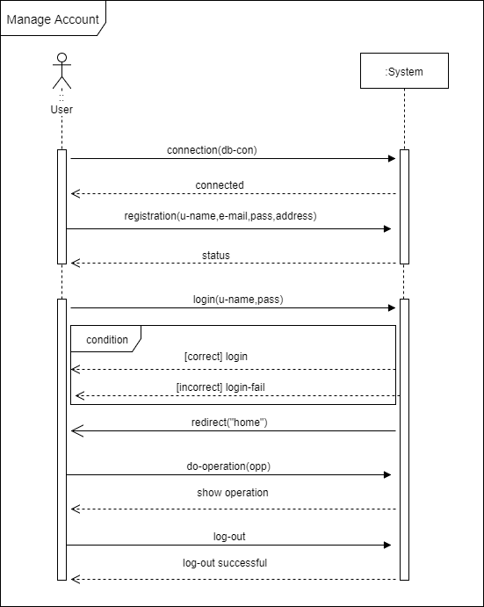

**Fig-7: System Sequence Diagram Of Manage Account**

### Manage Faculty (success Scenario)

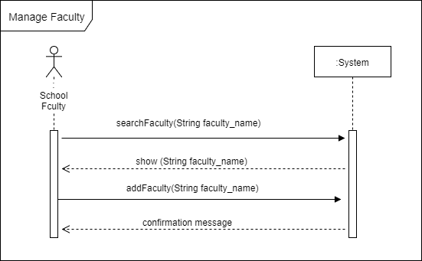

**Fig-8: System Sequence Diagram Of Manage Faculty**

### Upload job(success Scenario)

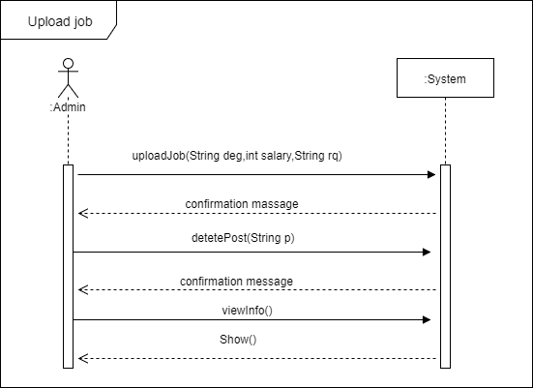

**Fig-9: System Sequence Diagram Of Upload Job**

### Apply Job(success Scenario)

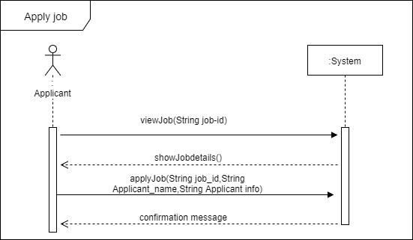

**Fig-10: System Sequence Diagram Of Apply Job**

### List Applicant (success Scenario)

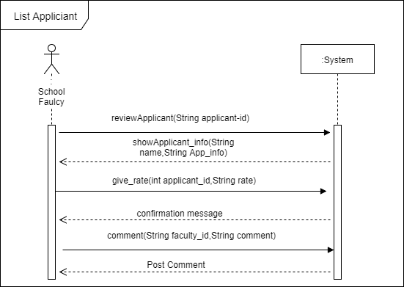

**Fig-11: System Sequence Diagram Of List Applicant**

## Domain Model

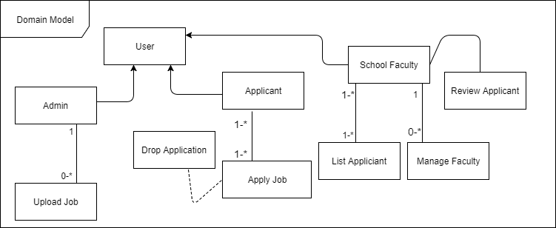

**Fig-12: Domain Model diagram**

## Activity Diagram

### Activity Diagram for Admin

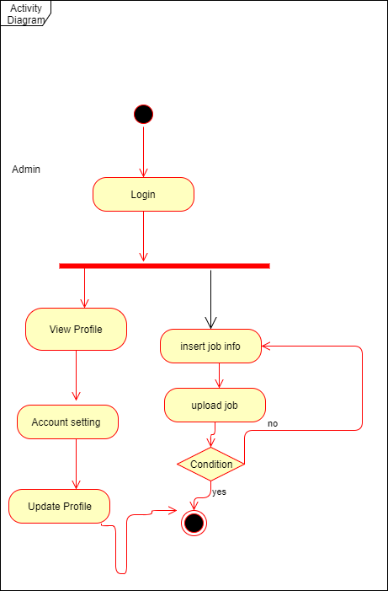

**Fig-13: Activity Diagram for Admin**

### Activity Diagram for School Faculty and Applicant

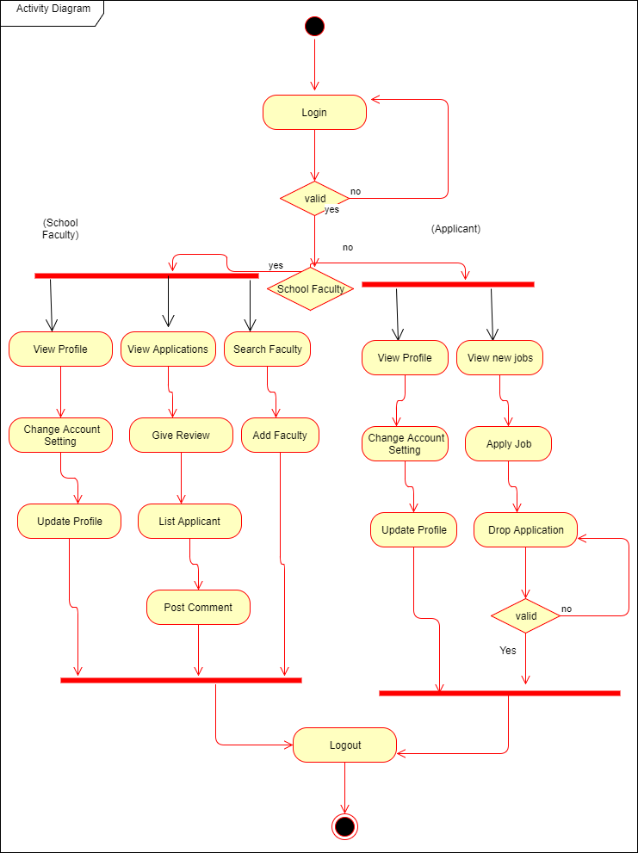

**Fig-14: Activity diagram for school faculty and applicant**

Chapter 3: System Design

System Design

It is a is the process of defining the components, modules, interfaces, and data for a system.it is a logical description of system how a system work.

## Sequence Diagram

Sequence diagrams is vary useful to understand the System behave it describe interactions among classes in terms of an exchange of messages over time.

### Manage Account (success scenario)

Here sUser(Admin, School faculty, Applicant)

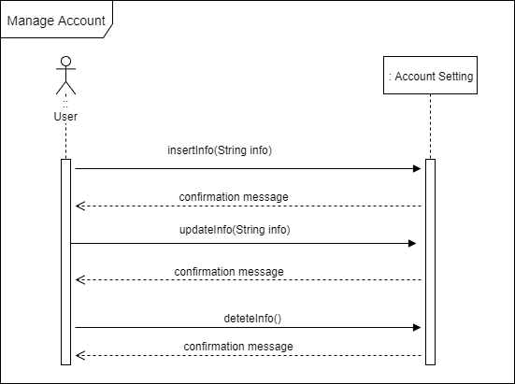

**Fig-15: Sequence Diagram for Manage Account**

### Manage Faculty (success scenario)

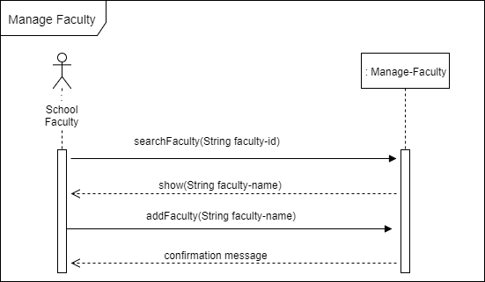

**Fig-16: Sequence Diagram for Manage Faculty**

### Upload Job(success scenario)

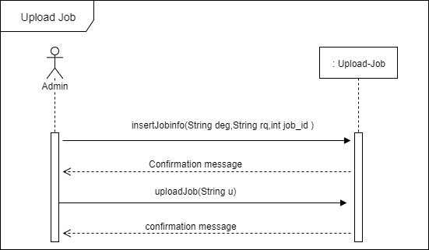

**Fig-17: Sequence Diagram for Upload Job**

### Apply Job(success scenario)

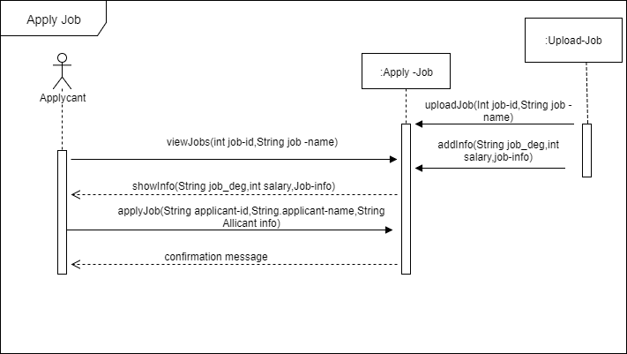

**Fig-18: Sequence Diagram for Apply job**

### List Applicant (success scenario)

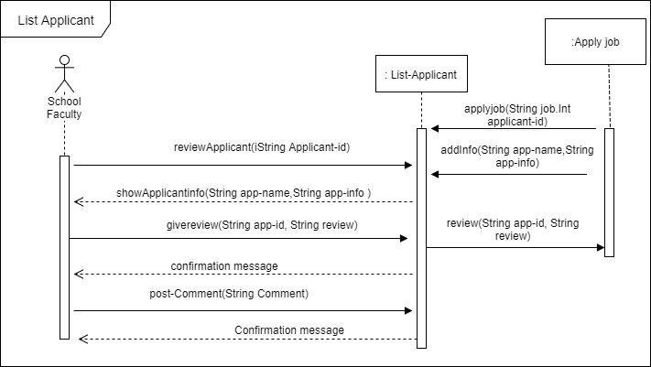

**Fig-19: Sequence Diagram for List Applicant**

## Class Diagram

It describes the structure of a system by showing the system's classes, their attributes, operations (or methods), and the relationships among objects.

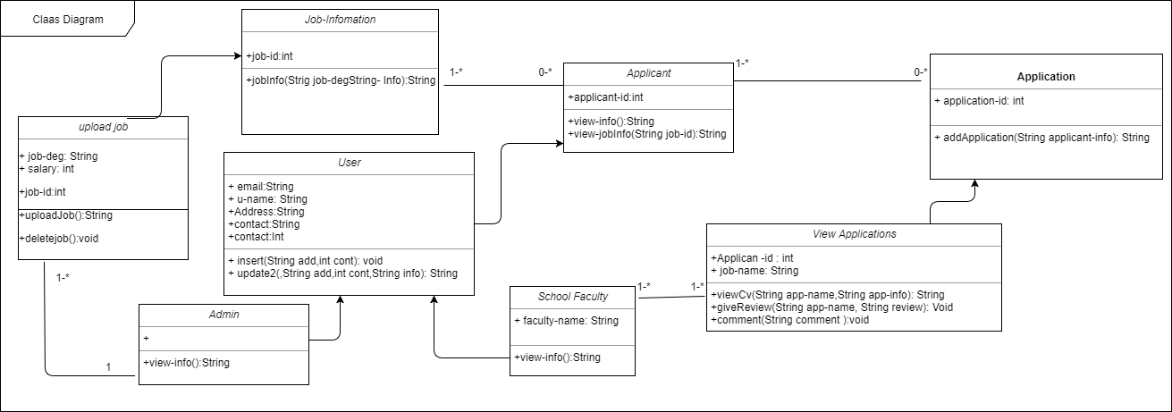

**Fig-20: Class Diagram**