

MAWLANA BHASHANI SCIENCE AND TECHNOLOGY UNIVERSITY

Santosh,Tangail-1902

**LAB REPORT**

Lab Report No : 11

Lab Report name : Implementation of FIFO page replacement algorithm.

Course Title :Operating System Lab

Course Code :ICT-3110

Date of Performance :

Date of Submission : 29/9/2020

Submitted by,

Name : Farhana Afrin Shikha

ID :IT-18038

Session : 2017-18

3rd Year 1stsemester

Dept. of ICT

Submitted to,

Nazrul Islam

Assistant Professor

Dept. of ICT,

MBSTU.

**Lab Report 11: Implementation of FIFO page replacement algorithm .**

**Theory:**This is the simplest page replacement algorithm.In this algorithm the operating system keeps track of all pages in the memory in a queue,the oldest page is in the front of the queue.When a page needs to be replaced page in the front of the queue is selected for removal. For evaluating an algorithm we take a particular string of memory references ,called reference string.

**Corresponding Code:**

#include<stdio.h>

int main()

{

int i,j,n,a[50],frame[10],no,k,avail,count=0;

printf("Enter the number of Pages: ");

scanf("%d",&n);

printf("Enter the page number : ");

for(i=1; i<=n; i++)

scanf("%d",&a[i]);

printf("Enter the number of FRAMES : ");

scanf("%d",&no);

for(i=0; i<no; i++)

frame[i]= -1;

j=0;

printf("\n");

printf("tref string\t page frames\n");

for(i=1; i<=n; i++)

{

printf("%d\t\t",a[i]);

avail=0;

for(k=0; k<no; k++)

if(frame[k]==a[i])

avail=1;

if (avail==0)

{

frame[j]=a[i];

j=(j+1)%no;

count++;

for(k=0; k<no; k++)

printf("%d\t",frame[k]);

}

printf("\n");

}

printf("Page Fault is: %d",count);

printf("\n");

return 0;

}

**Output:**

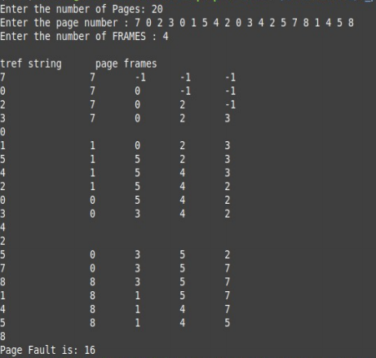

Conclusion:  Page Replacement algorithms play an important role in implementing this memory setting with an aim to accomplish less page fault, high hit ratio and minimum overhead. Over the years many page replacement algorithms were designed and proposed. As the memory types and program designing approaches improved, the need for betterment in algorithms existed as a need.The simple page replacemenrt algorithm is a FIFO page replacement algorithm.The first –in first-out(FIFO) is a low overhead algorithm that requires little bookkeeping on the part pf the operating system.In simple words,pn a page fault,the frame that has been in memory the longest is replaced.For FIFO algorithm we need number of page,number of frame and the page number. Page replacement algorithms choose pages to swap out from the memory when a new page needs memory for allocation. A cluster of algorithms have developed for page replacement. Each algorithm has the objective to minimize the number of page faults. With minimum page faults, the performance of the process is increased. In the above there are number of page is 20 and number of frame is 4 and last I get page fault and that is 16.