

MAWLANA BHASHANI SCIENCE AND TECHNOLOGY UNIVERSITY

Santosh,Tangail-1902

**LAB REPORT**

Lab Report No : 05

Lab Report name :Connecting a database(Mysql) with linux.

Course Title :Operating System Lab

Course Code :ICT-3110

Date of Performance :

Date of Submission :29/9/2020

Submitted by,

Name : Farhana Afrin Shikha

ID :IT-18038

Session : 2017-18

3rd Year 1stsemester

Dept. of ICT

Submitted to,

Nazrul Islam

Assistant Professor

Dept. of ICT,

MBSTU.

**Lab 05 : Connecting a database (MySQL) with linux**

1. Install MySQL on Ubuntu: sudo apt-get install mysql-server

**2**. Log into mysql by linux ubuntu.

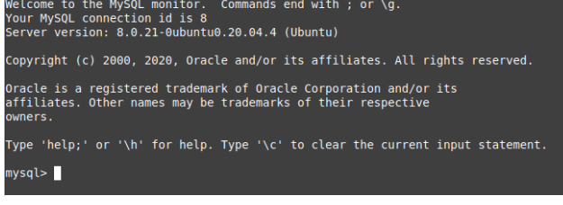

**3**.show and create database :

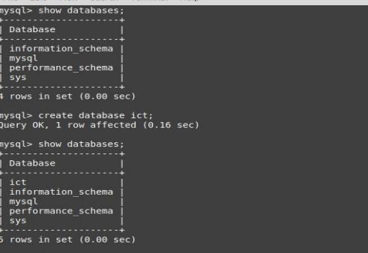

**4**. create table :

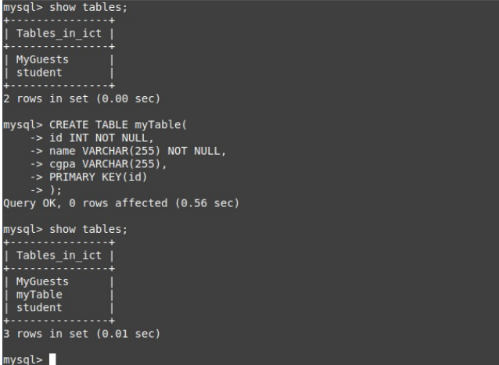

**5**.insert data into table :

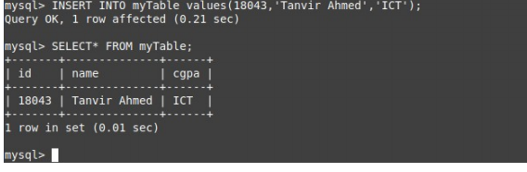

**6.**Describe table:

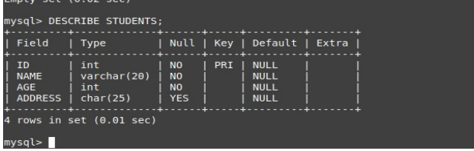

**7**.update data:

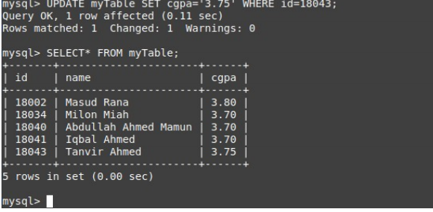

**Conclusion:**MySQL is a very famous database systembuilt upon the SQL standards. MySQL Workbench is a modeling tool that lets you design and generate MySQL databases graphically. It can also be used as an interface to execute SQL queries.Using MySQLcan save a lot of time and effort,since you don’t need to design your own database file structure and searching is quite fast.Not to mention that MYSQL is multiplatform so you can use MYSQL with Windows and Linux.If you already have prior knowledge with programmingin MySQL,you’ll probably notice some differences. MySQL installation is fairly simple.Installation is easy for ubuntu users.I can just install it via apt using :sudo apt install mysql-server.Once the installation starts i will be asked to give a root password of choice.Then I will be asked to re-enter the password.Once this process complets,I can check my connection to the mysql -server by mysql-uroot-proot.I have successfully installed MySQl in my laptop.