

MAWLANA BHASHANI SCIENCE AND TECHNOLOGY UNIVERSITY

Santosh,Tangail-1902

**LAB REPORT**

Lab Report No : 06

Lab Report name :Linux command for process.

Course Title :Operating System Lab

Course Code :ICT-3110

Date of Performance :

Date of Submission :29/9/2020

Submitted by,

Name : Farhana Afrin Shikha

ID :IT-18038

Session : 2017-18

3rd Year 1stsemester

Dept. of ICT

Submitted to,

Nazrul Islam

Assistant Professor

Dept. of ICT,

MBSTU.

**Lab Report 06 : Linux command for process**

**1) top:** The top command is the traditional way to view your system’s resource usage and see the processes that are taking up the most system resources. Top displays a list of processes, with the ones using the most CPU at the top.

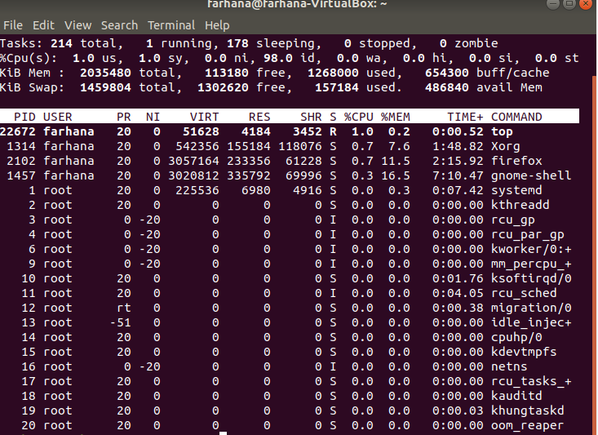

**2) ps -A :** The ps command lists running processes. The following command lists all processes running on your system:

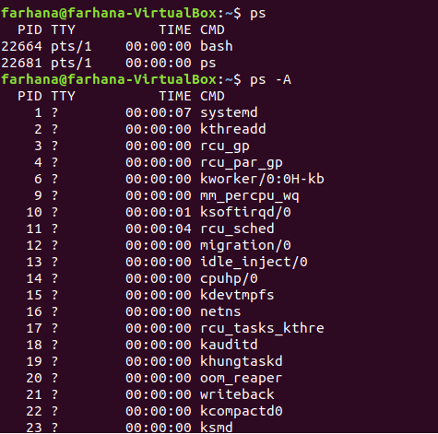

**3) ps -A | less:** ps -A may be too many processes to read at one time, so we can pipe the output through the less command to scroll through them at own pace

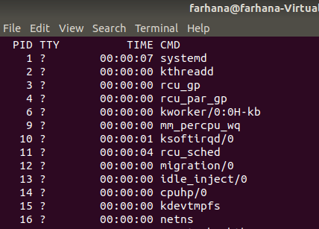

**4) pstree:** The pstree command is another way of visualizing processes. It displays them in tree format.

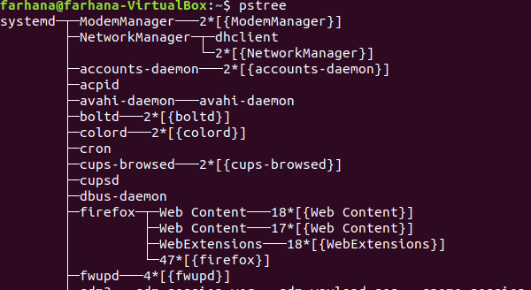

**5) kill :** The kill command can kill a process, given its process ID. You can get this information from the ps -A, top or pgrep commands.

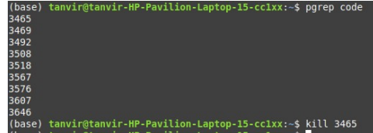

**6) pkill & killall :** The pkill and killall commands can kill a process, given its name. Use either command to kill Firefox: pkill firefox killall firefox

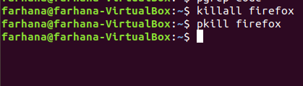

## Conclusion:An instance of a program is called a process.There are two types of processes:foreground processes and background processes.Foreground processes run on the screen and need input from the user.Background processes run in the background and usually do not need user input.Top,ps kill,df its are the name of linux process.Top tells the user about all the running processes on the linux machine.Kill commands terminates running processes on a linux machine.To use these utility I need to know the PID of the process.Linux can run a lot of processes at a time,which can slow down the speed of some high priority processes and result in poor performance.To avoid this,I can tell my machine to prioritize processes as per my equirements. This priority is called Niceness in Linux, and it has a value between -20 to 19. The lower the Niceness index, the higher would be a priority given to that task.DF reports the free disk space(Hard Disk) on all the file systems. Free command shows the free and used memory (RAM) on the Linux system.In the above I have shown top,ps-a,pstree,kill,pkill and killall.These are some important process in linus command.