

MAWLANA BHASHANI SCIENCE AND TECHNOLOGY UNIVERSITY

Santosh,Tangail-1902

**LAB REPORT**

Lab Report No : 07

Lab Report name :Implementation of FCPS scheduling algorithm.

Course Title :Operating System Lab

Course Code :ICT-3110

Date of Performance :

Date of Submission : 29/9/2020

Submitted by,

Name : Farhana Afrin Shikha

ID :IT-18038

Session : 2017-18

3rd Year 1stsemester

Dept. of ICT

Submitted to,

Nazrul Islam

Assistant Professor

Dept. of ICT,

MBSTU.

**Lab Report 07: : Implementation of FCFS Scheduling algorithm .**

**Objectives:**

i. What is FCFS Scheduling algorithm. ii. How to implementation in C.

Theory: First Come First Served (FCFS) is a Non-Preemptive scheduling algorithm. FIFO (First In First Out) strategy assigns priority to process in the order in which they request the processor. The process that requests the CPU first is allocated the CPU first. This is easily implemented with a FIFO queue for managing the tasks. As the process come in, they are put at the end of the queue. As the CPU finishes each task, it removes it from the start of the queue and heads on to the next task.

**Advantages of FCFS**

1. Simple
2. Easy
3. First come, First serve

**Disadvantages of FCFS:**

1.The scheduling method is non preemptive, the process will run to the completion.

2.Due to the non-preemptive nature of the algorithm, the problem of starvation may occur.

3.Although it is easy to implement, but it is poor in performance since the average waiting time is higher as compare to other scheduling algorithms.

**Corresponding Code:**

#include<stdio.h>

int main()

{

int n,bt[20],wt[20],tat[20],avwt=0,avtat=0,i,j;

printf("Enter total number of processes: ");

scanf("%d",&n);

printf("\nEnter Process Burst Time\n");

for(i=0;i<n;i++)

{

printf("P[%d]: ",i+1);

scanf("%d",&bt[i]);

}

wt[0]=0; //waiting time for first process is 0

//calculating waiting time

for(i=1;i<n;i++)

{

wt[i]=0;

for(j=0;j<i;j++)

wt[i]+=bt[j];

}

printf("\nProcess\t\tBurst Time\tWaiting Time\tTurnaround Time");

//calculating turnaround time

for(i=0;i<n;i++)

{

tat[i]=bt[i]+wt[i];

avwt+=wt[i];

avtat+=tat[i];

printf("\nP[%d]\t\t%d\t\t%d\t\t%d",i+1,bt[i],wt[i],tat[i]);

}

avwt/=i;

avtat/=i;

printf("\n\nAverage Waiting Time:%d",avwt);

printf("\nAverage Turnaround Time:%d",avtat);

printf("\n\n");

return 0;

}

**Output:**

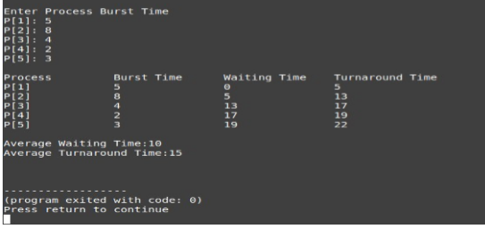

* Conclusion:FCPS means first come first serve .So in this algorithm the data which come first that serves first.This algorithm is not hard. In this algorithm the process which arrives first,gets executed first. First Come First Serve, is just like **FIFO**(First in First out) Queue data structure, where the data element which is added to the queue first, is the one who leaves the queue first. It's easy to understand and implement . .Here I have solved a problem using this algorithm.This problem has 5 processes.The burst time of these processes are given.Then I have asked to find out average waiting time,average turnaround time.I know that waiting time=starting time-arrival time.Here arrival time is 0.So starting time will be the waiting time.Then I have easily find out the average waiting time.Next turnaround time,I know that turnaround time=Burst time+waiting time.In this way I have solved the problem.