

MAWLANA BHASHANI SCIENCE AND TECHNOLOGY UNIVERSITY

Santosh,Tangail-1902

**LAB REPORT**

Lab Report No : 01

Lab Report name : How to install Linux Operating System

Course Title :Operating System Lab

Course Code :ICT-3110

Date of Performance :

Date of Submission :

Submitted by,

Name : Farhana Afrin Shikha

ID :IT-18038

Session : 2017-18

3rd Year 1stsemester

Dept. of ICT

Submitted to,

Nazrul Islam

Assistant Professor

Dept. of ICT,

MBSTU.

**Lab report 1:How to install Linux Operating System**

**i)What is Linux Operating system:**

Just like Windows, iOS, and Mac OS, Linux is an operating system. In fact, one of the most popular platforms on the planet, Android, is powered by the Linux operating system. An operating system is software that manages all of the hardware resources associated with your desktop or laptop. To put it simply, the operating system manages the communication between your software and your hardware. Without the operating system (OS), the software wouldn?t function.

**ii)Different types of Linux distribution**

Popular Linux distributions include:

* LINUX MINT
* MANJARO
* DEBIAN
* UBUNTU
* ANTERGOS
* SOLUS
* FEDORA
* ELEMENTARY OS
* OPENSUSE

**iii) Installing Linux using USB stick**

This is one of the easiest methods of installing Ubuntu or any distribution on your computer. Follow **the** steps.

**[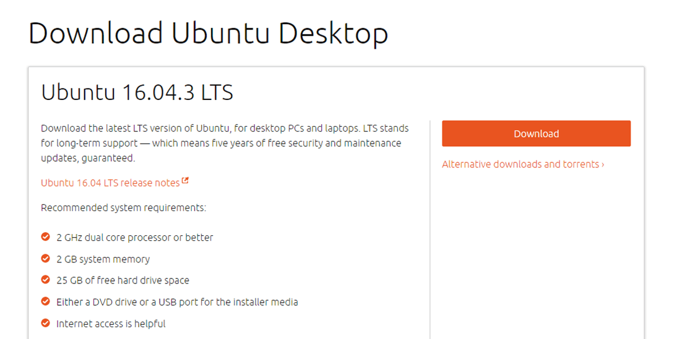](https://www.guru99.com/images/2-2017/092017_0628_HowtoDownlo13.png)**

**Step2)** Download free software like '[Universal USB installer](http://www.pendrivelinux.com/universal-usb-installer-easy-as-1-2-3/) to make a bootable USB stick.

[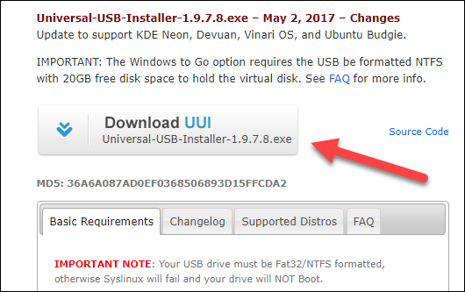](https://www.guru99.com/images/2-2017/092017_0628_HowtoDownlo14.png)

**Step 3)**Select an Ubuntu Distribution form the dropdown to put on your USB

Select your Ubuntu iso file download in step 1. Then select the drive letter of USB to install Ubuntu and Press create button.

[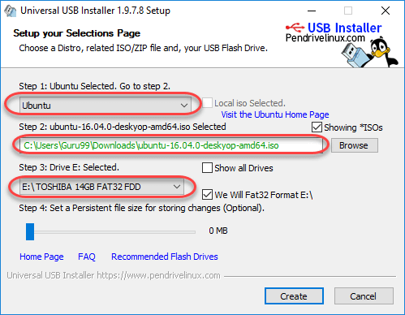](https://www.guru99.com/images/2-2017/092017_0628_HowtoDownlo15.png)

**Step 4)**Click YES to Install Ubuntu in USB.

**[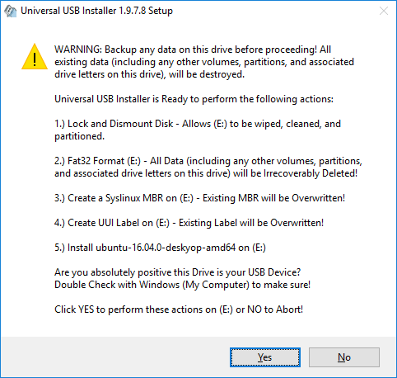](https://www.guru99.com/images/2-2017/092017_0628_HowtoDownlo16.png)  
Step 5)**After everything has been installed and configured, a small window will appear Congratulations! You now have Ubuntu on a USB stick, bootable and ready to go.

[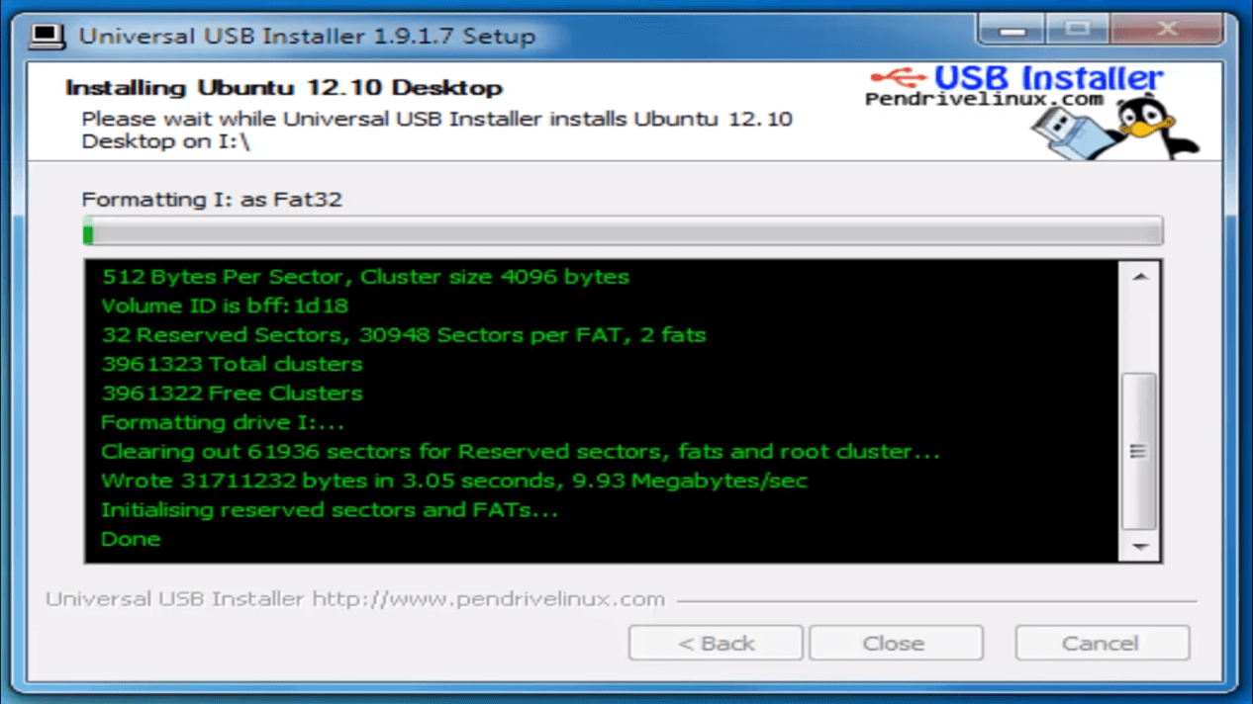](https://www.guru99.com/images/2-2017/092017_0628_HowtoDownlo17.png)

**Step-6)**You have an option to Run Ubuntu WITHOUT installing. In this tutorial will install Ubuntu

[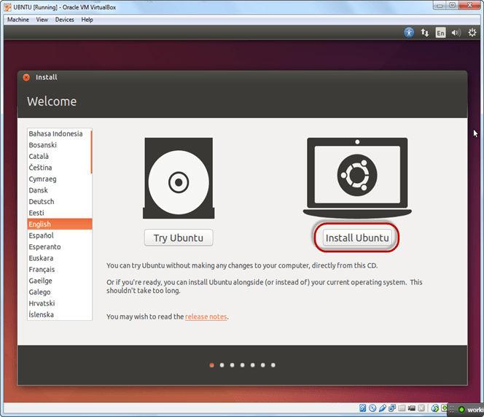](https://www.guru99.com/images/Big_Data/061114_1146_Ubuntuinsta22.png)

**Step-7)**Select option to erase the disk and install Ubuntu and click on install now. This option installs Ubuntu into our virtual hard drive which is we made earlier. It will not harm your PC or Windows installation

[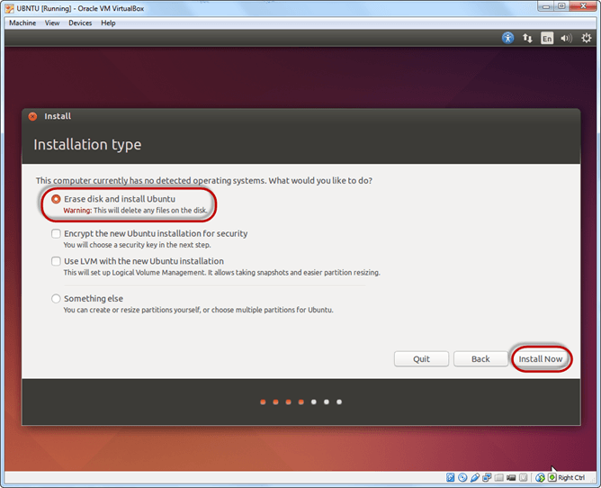](https://www.guru99.com/images/Big_Data/061114_1146_Ubuntuinsta24.png)

**Step-8)**Select your location for setting up time zone, and click on continue

**Step-9)**Select your keyboard layout, by default English (US) is selected but if you want to change then, you can select in the list. And click on continue

**Step-10)**Select your username and password for your Ubuntu admin account. This information has been needed for installing any software package into Ubuntu and also for login to your OS. Fill up your details and tick on login automatically to ignore login attempt and click on continue

[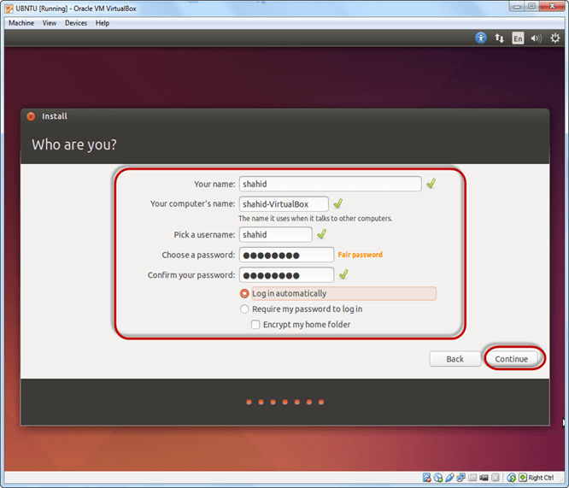](https://www.guru99.com/images/Big_Data/061114_1146_Ubuntuinsta27.png)

**Step-11)**Installation process starts. May take up to 30 minutes. Please wait until installation process completes.

**Step-12)**After finishing the installation, you will see Ubuntu Desktop.

[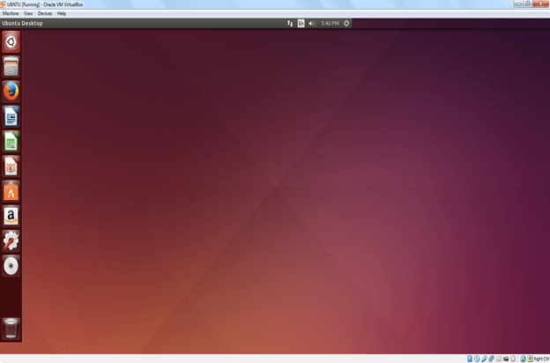](https://www.guru99.com/images/Big_Data/061114_1146_Ubuntuinsta29.png)

**Conclusion**: Linux is one of the most popular and productive operating systems in the world.Linux is becoming increasingly popular as the operating system for servers, gradually eating away at the market share of Windows NT.Getting a Linux installation up and running needn't be a very difficult task. Also, it's a quite interesting exercise for a non–IT person to try because it requires a little thought and a bit of effort.

In the above I have described how to install Linux operating system.I have downloaded ubuntu in my laptop.Nowadays Ubuntu is very popular.To prevent hacking attempts ,many organizations keep their linux operating system private.Many others make their variations of Linux available publicly so the whole world can benefit at large.These versions of linux operating systems are called Distributions.Naming the best Linux distribution is difficult as they are made for different.Ubuntu is such a distribution.We can install Linux using USB stick.we can also install linux using virtual machin and by using live CD.Here I have installed Linux using USB stick.

In reality, Linux doesn't really differentiate between server and workstation but the addition of a GUI certainly makes life easier for anyone learning the operating system. Also, Ubuntu provides a decent choice of GUI depending on your system setup.

There's really no reason why Linux should be considered an expertise outside the range of any programmer. Once you're up and running with a working system, you'll probably wonder what all the fuss is about. It's perfectly possible to use Linux inside the Windows environment. Or you can go the distance and install a native version of Linux.