**Project Name : Procedure**

**By : Farhana Alam**

**Date : 1/10/18**

**Table of Contents:**

1. Requirements
2. Test Cases
3. Create Table, Procedure
4. Batch File
5. Execute Batch File
6. Report

Requirements:

Executed Procedure will INSERT the distinct value to the enum table from temp_area_table.

Flow Chart

Input Process output

temp_business_area call procedure enum table

table with 10 test data use distinct statement with 4 distinct values

**Test Cases:**

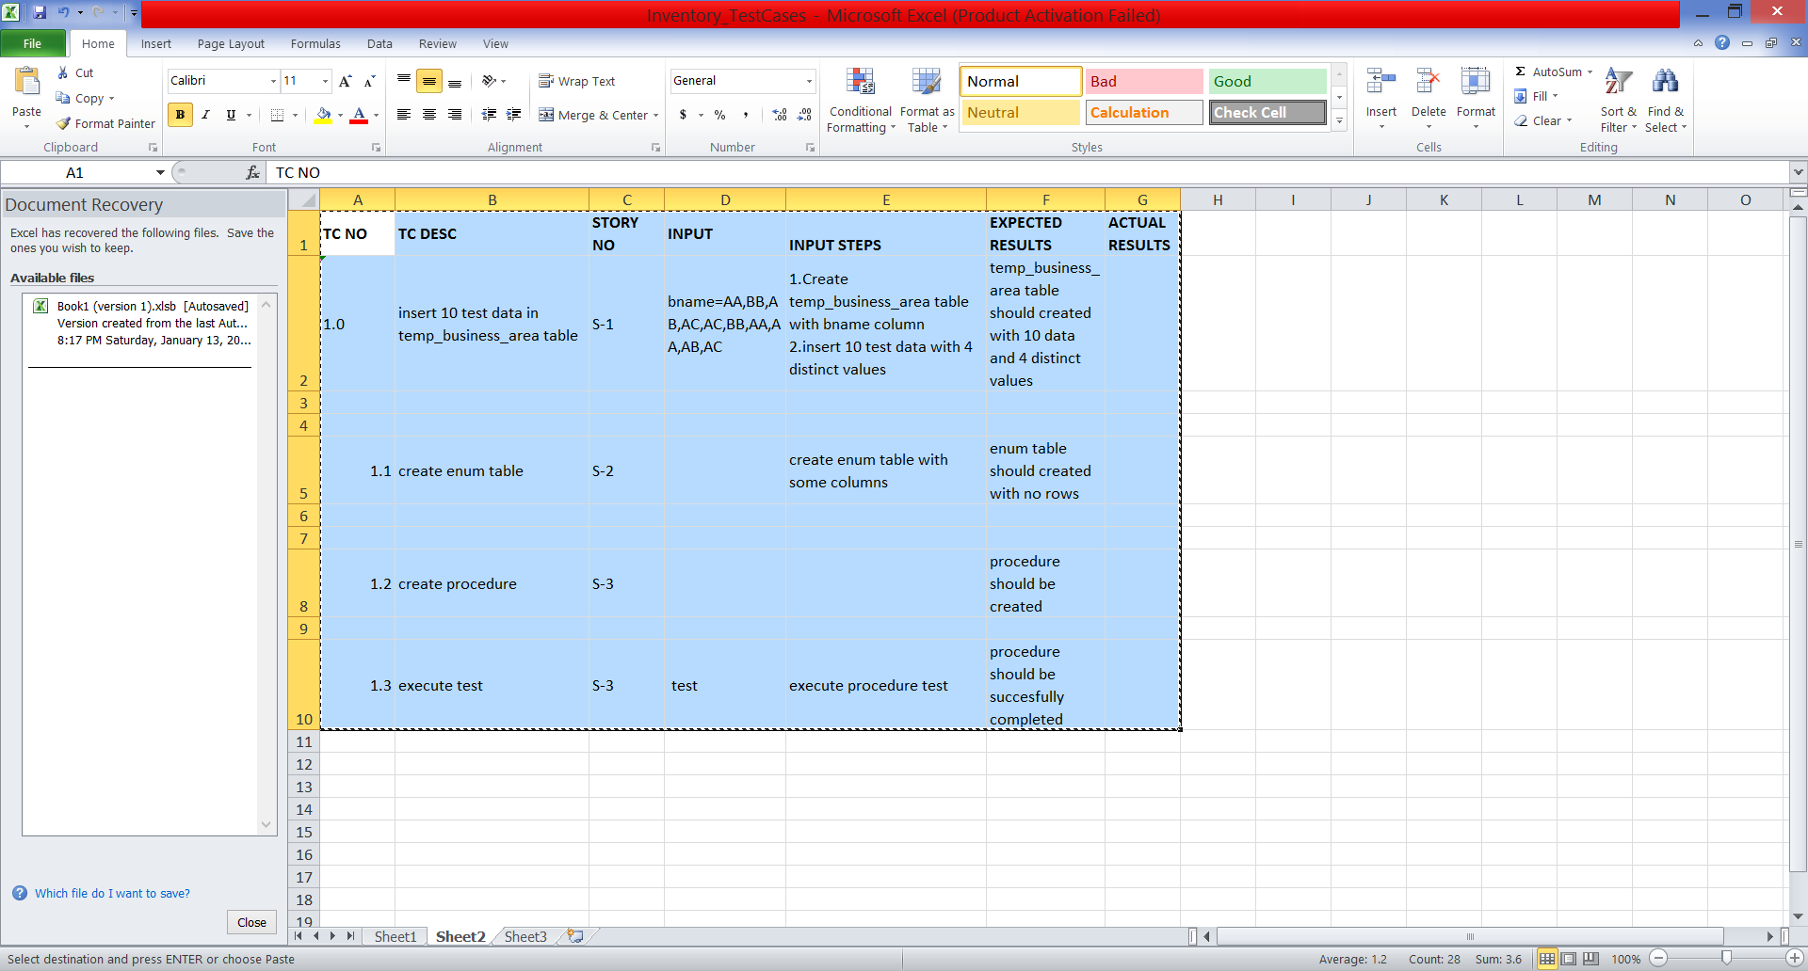

**SQL:**

SQL> set echo on

SQL> connect project/project

Connected.

SQL> DESCRIBE temp_business_area;

Name Null? Type

----------------------------------------- -------- ----------------------------

BNAME CHAR(2)

SQL> SELECT * FROM temp_business_area;

BN

--

AA

BB

AB

AC

AC

BB

AA

AA

AB

AC

10 rows selected.

SQL> SELECT * FROM enum;

no rows selected

SQL> DESCRIBE enum;

Name Null? Type

----------------------------------------- -------- ----------------------------

IDENTIFIER VARCHAR2(30)

LANGUAGE_ID NUMBER(2)

CODE VARCHAR2(10)

DATA VARCHAR2(20)

COMPANY_LIMIT VARCHAR2(30)

SQL> CREATE OR REPLACE test () AS

2 BEGIN

3 i integer := 1;

CREATE OR REPLACE test () AS

*

ERROR at line 1:

ORA-00922: missing or invalid option

SQL> CREATE OR REPLACE test AS

2 BEGIN

3 i integer:=1;

CREATE OR REPLACE test AS

*

ERROR at line 1:

ORA-00922: missing or invalid option

SQL> CREATE OR REPLACE test AS

2 DESCRIBE enum;;

CREATE OR REPLACE test AS

*

ERROR at line 1:

ORA-00922: missing or invalid option

SQL> CREATE OR REPLACE procedure test AS

2 i integer := 1;

3 BEGIN

4 FOR x IN (SELECT DISTINCT bname FROM temp_business_area) LOOP

5 INSERT INTO enum (identifier,language_id,code,data,company_limit)

6 SELECT 'BUSINESS_UNIT',0,i*100,x.bname,126 FROM temp_business_area;

7 i := i+1;

8 END LOOP;

9 END;

10 /

Procedure created.

SQL> SELECT * FROM enum;

no rows selected

SQL> @test

SP2-0310: unable to open file "test.sql"

SQL> show error;

No errors.

SQL> exec test () ==>execute

BEGIN test () ==>execute; END;

*

ERROR at line 1:

ORA-06550: line 1, column 15:

PLS-00103: Encountered the symbol "=" when expecting one of the following:

:= . ( % ;

SQL> show error

No errors.

SQL> exec test

PL/SQL procedure successfully completed.

SQL> SELECT * FROM enum;

IDENTIFIER LANGUAGE_ID CODE DATA

------------------------------ ----------- ---------- --------------------

COMPANY_LIMIT

------------------------------

BUSINESS_UNIT 0 100 AA

126

BUSINESS_UNIT 0 100 AA

126

BUSINESS_UNIT 0 100 AA

126

IDENTIFIER LANGUAGE_ID CODE DATA

------------------------------ ----------- ---------- --------------------

COMPANY_LIMIT

------------------------------

BUSINESS_UNIT 0 100 AA

126

BUSINESS_UNIT 0 100 AA

126

BUSINESS_UNIT 0 100 AA

126

IDENTIFIER LANGUAGE_ID CODE DATA

------------------------------ ----------- ---------- --------------------

COMPANY_LIMIT

------------------------------

BUSINESS_UNIT 0 100 AA

126

BUSINESS_UNIT 0 100 AA

126

BUSINESS_UNIT 0 100 AA

126

IDENTIFIER LANGUAGE_ID CODE DATA

------------------------------ ----------- ---------- --------------------

COMPANY_LIMIT

------------------------------

BUSINESS_UNIT 0 100 AA

126

BUSINESS_UNIT 0 200 BB

126

BUSINESS_UNIT 0 200 BB

126

IDENTIFIER LANGUAGE_ID CODE DATA

------------------------------ ----------- ---------- --------------------

COMPANY_LIMIT

------------------------------

BUSINESS_UNIT 0 200 BB

126

BUSINESS_UNIT 0 200 BB

126

BUSINESS_UNIT 0 200 BB

126

IDENTIFIER LANGUAGE_ID CODE DATA

------------------------------ ----------- ---------- --------------------

COMPANY_LIMIT

------------------------------

BUSINESS_UNIT 0 200 BB

126

BUSINESS_UNIT 0 200 BB

126

BUSINESS_UNIT 0 200 BB

126

IDENTIFIER LANGUAGE_ID CODE DATA

------------------------------ ----------- ---------- --------------------

COMPANY_LIMIT

------------------------------

BUSINESS_UNIT 0 200 BB

126

BUSINESS_UNIT 0 200 BB

126

BUSINESS_UNIT 0 300 AC

126

IDENTIFIER LANGUAGE_ID CODE DATA

------------------------------ ----------- ---------- --------------------

COMPANY_LIMIT

------------------------------

BUSINESS_UNIT 0 300 AC

126

BUSINESS_UNIT 0 300 AC

126

BUSINESS_UNIT 0 300 AC

126

IDENTIFIER LANGUAGE_ID CODE DATA

------------------------------ ----------- ---------- --------------------

COMPANY_LIMIT

------------------------------

BUSINESS_UNIT 0 300 AC

126

BUSINESS_UNIT 0 300 AC

126

BUSINESS_UNIT 0 300 AC

126

IDENTIFIER LANGUAGE_ID CODE DATA

------------------------------ ----------- ---------- --------------------

COMPANY_LIMIT

------------------------------

BUSINESS_UNIT 0 300 AC

126

BUSINESS_UNIT 0 300 AC

126

BUSINESS_UNIT 0 300 AC

126

IDENTIFIER LANGUAGE_ID CODE DATA

------------------------------ ----------- ---------- --------------------

COMPANY_LIMIT

------------------------------

BUSINESS_UNIT 0 400 AB

126

BUSINESS_UNIT 0 400 AB

126

BUSINESS_UNIT 0 400 AB

126

IDENTIFIER LANGUAGE_ID CODE DATA

------------------------------ ----------- ---------- --------------------

COMPANY_LIMIT

------------------------------

BUSINESS_UNIT 0 400 AB

126

BUSINESS_UNIT 0 400 AB

126

BUSINESS_UNIT 0 400 AB

126

IDENTIFIER LANGUAGE_ID CODE DATA

------------------------------ ----------- ---------- --------------------

COMPANY_LIMIT

------------------------------

BUSINESS_UNIT 0 400 AB

126

BUSINESS_UNIT 0 400 AB

126

BUSINESS_UNIT 0 400 AB

126

IDENTIFIER LANGUAGE_ID CODE DATA

------------------------------ ----------- ---------- --------------------

COMPANY_LIMIT

------------------------------

BUSINESS_UNIT 0 400 AB

126

40 rows selected.

**BATCH FILE:**

SQL> TRUNCATE table temp_business_area;

Table truncated.

SQL> TRUNCATE table enum;

Table truncated.

SQL> INSERT INTO temp_business_area VALUES('AA');

1 row created.

SQL> INSERT INTO temp_business_area VALUES('AB');

1 row created.

SQL> INSERT INTO temp_business_area VALUES('AC');

1 row created.

SQL> INSERT INTO temp_business_area VALUES('AD');

1 row created.

SQL> INSERT INTO temp_business_area VALUES('AE');

1 row created.

SQL> INSERT INTO temp_business_area VALUES('AF');

1 row created.

SQL> SELECT * FROM enum;

no rows selected

SQL> exec test();

PL/SQL procedure successfully completed.

SQL> SELECT * from enum;

IDENTIFIER LANGUAGE_ID CODE DATA

------------------------------ ----------- ---------- --------------------

COMPANY_LIMIT

------------------------------

BUSINESS_UNIT 0 100 AA

126

BUSINESS_UNIT 0 100 AA

126

BUSINESS_UNIT 0 100 AA

126

IDENTIFIER LANGUAGE_ID CODE DATA

------------------------------ ----------- ---------- --------------------

COMPANY_LIMIT

------------------------------

BUSINESS_UNIT 0 100 AA

126

BUSINESS_UNIT 0 100 AA

126

BUSINESS_UNIT 0 100 AA

126

IDENTIFIER LANGUAGE_ID CODE DATA

------------------------------ ----------- ---------- --------------------

COMPANY_LIMIT

------------------------------

BUSINESS_UNIT 0 200 AF

126

BUSINESS_UNIT 0 200 AF

126

BUSINESS_UNIT 0 200 AF

126

IDENTIFIER LANGUAGE_ID CODE DATA

------------------------------ ----------- ---------- --------------------

COMPANY_LIMIT

------------------------------

BUSINESS_UNIT 0 200 AF

126

BUSINESS_UNIT 0 200 AF

126

BUSINESS_UNIT 0 200 AF

126

IDENTIFIER LANGUAGE_ID CODE DATA

------------------------------ ----------- ---------- --------------------

COMPANY_LIMIT

------------------------------

BUSINESS_UNIT 0 300 AD

126

BUSINESS_UNIT 0 300 AD

126

BUSINESS_UNIT 0 300 AD

126

IDENTIFIER LANGUAGE_ID CODE DATA

------------------------------ ----------- ---------- --------------------

COMPANY_LIMIT

------------------------------

BUSINESS_UNIT 0 300 AD

126

BUSINESS_UNIT 0 300 AD

126

BUSINESS_UNIT 0 300 AD

126

IDENTIFIER LANGUAGE_ID CODE DATA

------------------------------ ----------- ---------- --------------------

COMPANY_LIMIT

------------------------------

BUSINESS_UNIT 0 400 AE

126

BUSINESS_UNIT 0 400 AE

126

BUSINESS_UNIT 0 400 AE

126

IDENTIFIER LANGUAGE_ID CODE DATA

------------------------------ ----------- ---------- --------------------

COMPANY_LIMIT

------------------------------

BUSINESS_UNIT 0 400 AE

126

BUSINESS_UNIT 0 400 AE

126

BUSINESS_UNIT 0 400 AE

126

IDENTIFIER LANGUAGE_ID CODE DATA

------------------------------ ----------- ---------- --------------------

COMPANY_LIMIT

------------------------------

BUSINESS_UNIT 0 500 AC

126

BUSINESS_UNIT 0 500 AC

126

BUSINESS_UNIT 0 500 AC

126

IDENTIFIER LANGUAGE_ID CODE DATA

------------------------------ ----------- ---------- --------------------

COMPANY_LIMIT

------------------------------

BUSINESS_UNIT 0 500 AC

126

BUSINESS_UNIT 0 500 AC

126

BUSINESS_UNIT 0 500 AC

126

IDENTIFIER LANGUAGE_ID CODE DATA

------------------------------ ----------- ---------- --------------------

COMPANY_LIMIT

------------------------------

BUSINESS_UNIT 0 600 AB

126

BUSINESS_UNIT 0 600 AB

126

BUSINESS_UNIT 0 600 AB

126

IDENTIFIER LANGUAGE_ID CODE DATA

------------------------------ ----------- ---------- --------------------

COMPANY_LIMIT

------------------------------

BUSINESS_UNIT 0 600 AB

126

BUSINESS_UNIT 0 600 AB

126

BUSINESS_UNIT 0 600 AB

126

36 rows selected.

SQL> TRUNCATE table temp_business_area;

Table truncated.

SQL> TRUNCATE table enum;

Table truncated.

SQL> exec test ();

PL/SQL procedure successfully completed.

SQL> SELECT * FROM enum;

no rows selected

SQL> @test

SP2-0310: unable to open file "test.sql"

SQL> spool off

**Report:**