1.

### 1. Total Gross Revenue

SELECT FORMAT(SUM(quantity * unit_price), 2) AS total_gross_revenue

FROM fact_transaction;

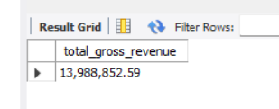

2.

###2. Total Net Revenue (after discount)

SELECT FORMAT(SUM(quantity * unit_price * (1 - discount_perc / 100)), 2) AS total_net_revenue

FROM fact_transaction;

3.

###3. Total Profit

SELECT FORMAT(

SUM(

(quantity * unit_price * (1 - discount_perc / 100)) -

(quantity * unit_manufacturing_cost + quantity * unit_shipping_cost)

), 2

) AS total_profit

FROM fact_transaction;

4. ### 4. Orders by Customer Segment

SELECT customer_segment, COUNT(DISTINCT order_id) AS total_orders

FROM fact_transaction

GROUP BY customer_segment;

5.

### 5. Top 5 Best-Selling Products by Quantity

SELECT product_id, SUM(quantity) AS total_quantity

FROM fact_transaction

GROUP BY product_id

ORDER BY total_quantity DESC

LIMIT 5;

6.

SELECT

DATE_FORMAT(order_date, '%Y-%m') AS month,

FORMAT(SUM(quantity * unit_price), 2) AS gross_revenue

FROM fact_transaction

WHERE YEAR(order_date) = 2015

GROUP BY month

ORDER BY month;

7.

### 7. Sub-Category with Highest Profit Margin

SELECT sub_category,

SUM((unit_price * (1 - discount_perc / 100)) - unit_manufacturing_cost - unit_shipping_cost) /

SUM(unit_price * (1 - discount_perc / 100)) AS profit_margin

FROM fact_transaction

GROUP BY sub_category

ORDER BY profit_margin DESC

LIMIT 1;

8.

### 8. Continents with Most Product Returns (as % of total sold)

SELECT dl.continent,

COUNT(DISTINCT r.`Order ID`) / COUNT(DISTINCT f.order_id) * 100 AS return_rate_pct

FROM fact_transaction f

JOIN dim_location dl ON f.city = dl.city

LEFT JOIN return_table r ON f.order_id = r.`Order ID`

GROUP BY dl.continent

ORDER BY return_rate_pct DESC;

9.

### 9. Products with Negative Profit

SELECT product_id,

SUM(

(quantity * unit_price * (1 - discount_perc / 100)) -

(quantity * unit_manufacturing_cost + quantity * unit_shipping_cost)

) AS total_profit

FROM fact_transaction

GROUP BY product_id

HAVING total_profit < 0;

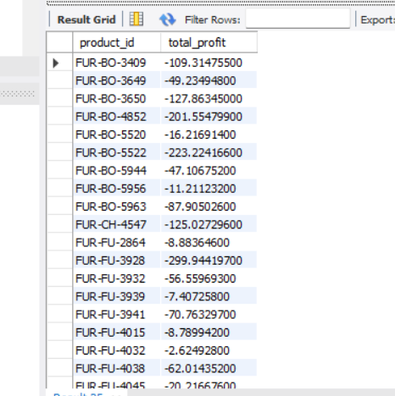

10.

### 10. Correlation Between Discount and Order Volume

SELECT

discount_perc,

ROUND(AVG(unit_price), 2) AS avg_unit_price,

SUM(quantity) AS order_volume

FROM fact_transaction

GROUP BY discount_perc

ORDER BY discount_perc

LIMIT 25;

11.

### 11. Return Rate by Product Category

SELECT category,

COUNT(DISTINCT r.`Order ID`) / COUNT(DISTINCT f.order_id) * 100 AS return_rate_pct

FROM fact_transaction f

LEFT JOIN return_table r ON f.order_id = r.`Order ID`

GROUP BY category;

12.

SELECT

ship_mode,

FORMAT(

SUM(

(quantity * unit_price * (1 - discount_perc / 100)) -

(quantity * unit_manufacturing_cost + quantity * unit_shipping_cost)

), 2

) AS total_profit

FROM fact_transaction

GROUP BY ship_mode

ORDER BY

SUM(

(quantity * unit_price * (1 - discount_perc / 100)) -

(quantity * unit_manufacturing_cost + quantity * unit_shipping_cost)

) DESC

LIMIT 1;

13.

SELECT

CONCAT(

ROUND(

(SUM(CASE

WHEN LOWER(TRIM(REPLACE(REPLACE(order_priority, '\r', ''), '\n', ''))) = 'high' THEN 1

ELSE 0

END) / COUNT(*)) * 100, 2

),

'%'

) AS high_priority_pct

FROM fact_transaction;

14.

SELECT

city,

FORMAT(

SUM(quantity * unit_price) / COUNT(DISTINCT order_id), 2

) AS revenue_per_order

FROM fact_transaction

GROUP BY city

ORDER BY

SUM(quantity * unit_price) / COUNT(DISTINCT order_id) DESC

LIMIT 1;

15.

### 15. Average Profit per Customer Segment

SELECT customer_segment,

AVG(

(quantity * unit_price * (1 - discount_perc / 100)) -

(quantity * unit_manufacturing_cost + quantity * unit_shipping_cost)

) AS avg_profit

FROM fact_transaction

GROUP BY customer_segment;

16.   
SELECT

category,

YEAR(order_date) AS year,

FORMAT(

SUM(quantity * unit_price * (1 - discount_perc / 100)), 2

) AS revenue

FROM fact_transaction

GROUP BY category, year

ORDER BY category, year;

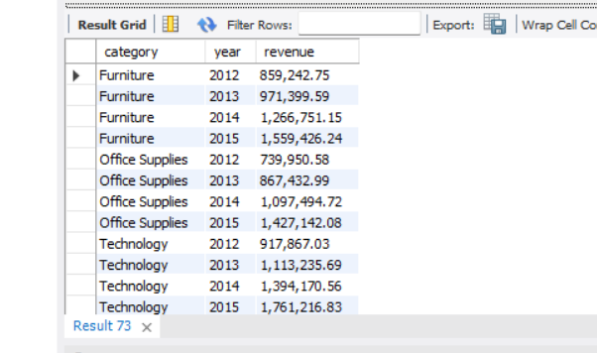

17.  
### 17. Products Frequently Purchased Together

SELECT a.product_id AS product_a, b.product_id AS product_b, COUNT(*) AS times_bought_together

FROM (

SELECT DISTINCT order_id, product_id

FROM fact_transaction

) a

JOIN (

SELECT DISTINCT order_id, product_id

FROM fact_transaction

) b

ON a.order_id = b.order_id AND a.product_id < b.product_id

GROUP BY product_a, product_b

ORDER BY times_bought_together DESC;

18.

SELECT

CONCAT(

ROUND(

(COUNT(CASE WHEN product_count > 1 THEN 1 END) / COUNT(*)) * 100, 2

),

'%'

) AS multi_product_order_pct

FROM (

SELECT order_id, COUNT(DISTINCT product_id) AS product_count

FROM fact_transaction

GROUP BY order_id

) t;

19.

### 19. Orders with Abnormally High Shipping Costs

SELECT order_id,

SUM(unit_shipping_cost * quantity) AS total_shipping_cost

FROM fact_transaction

GROUP BY order_id

HAVING total_shipping_cost > (

SELECT AVG(unit_shipping_cost * quantity) + 2 * STDDEV(unit_shipping_cost * quantity)

FROM fact_transaction

);

20.

SELECT

value_segment,

COUNT(*) AS order_count,

ROUND( COUNT(*) / (SELECT COUNT(DISTINCT order_id) FROM fact_transaction) * 100, 2) AS percentage_of_orders

FROM (

SELECT order_id,

SUM(quantity * unit_price * (1 - discount_perc / 100)) AS total_value,

CASE

WHEN SUM(quantity * unit_price * (1 - discount_perc / 100)) < 100 THEN 'Low'

WHEN SUM(quantity * unit_price * (1 - discount_perc / 100)) < 500 THEN 'Medium'

ELSE 'High'

END AS value_segment

FROM fact_transaction

GROUP BY order_id

) t

GROUP BY value_segment

ORDER BY FIELD(value_segment, 'Low', 'Medium', 'High');

