**1. How many records are there in the dataset?**

SELECT COUNT(*) AS total_records

FROM fact_data;

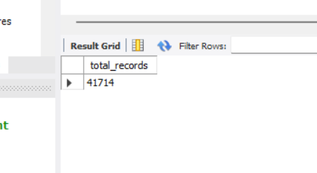

**2. How many unique cities are in the European dataset?**

SELECT COUNT(DISTINCT CITY) AS unique_cities

FROM airbnb_europe_dataset;

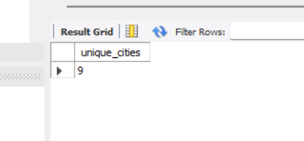

**3. What are the names of the cities in the dataset?**

SELECT DISTINCT CITY

FROM airbnb_europe_dataset;

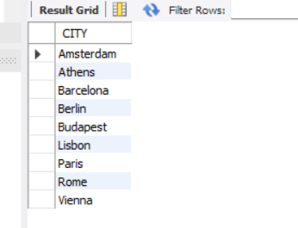

4. **How many bookings are there in each city?**

SELECT CITY, COUNT(*) AS total_bookings

FROM airbnb_europe_dataset

GROUP BY CITY

ORDER BY total_bookings DESC;

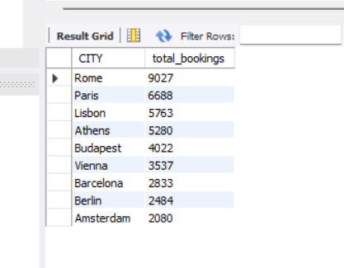

5. **What is the total booking revenue for each city?**

SELECT CITY, ROUND(SUM(PRICE), 2) AS total_revenue

FROM airbnb_europe_dataset

GROUP BY CITY

ORDER BY total_revenue DESC;

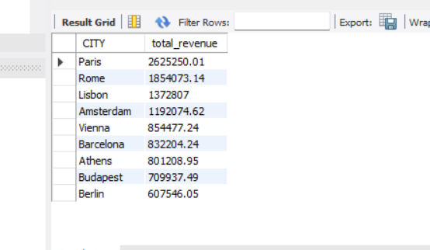

6. **What is the average guest satisfaction score for each city?**

SELECT CITY, ROUND(AVG(Guest_Satisfaction), 2) AS avg_guest_satisfaction

FROM airbnb_europe_dataset

GROUP BY CITY

ORDER BY avg_guest_satisfaction DESC;

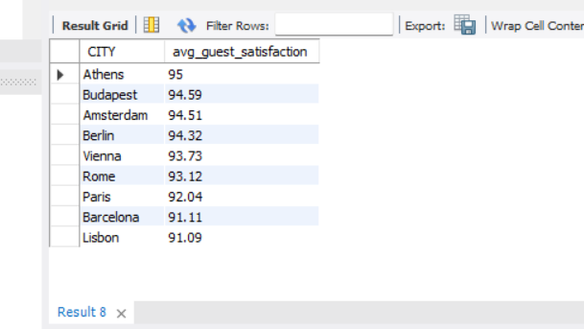

7. **What are the minimum, maximum, average, and median booking prices?**

SELECT

MIN(PRICE) AS min_price,

MAX(PRICE) AS max_price,

ROUND(AVG(PRICE), 2) AS avg_price,

ROUND(

IF(

MOD(COUNT(*), 2) = 1,

-- For odd counts, get the middle value

SUBSTRING_INDEX(SUBSTRING_INDEX(GROUP_CONCAT(PRICE ORDER BY PRICE), ',', (COUNT(*) + 1) / 2), ',', -1),

-- For even counts, average the two middle values

(

SUBSTRING_INDEX(SUBSTRING_INDEX(GROUP_CONCAT(PRICE ORDER BY PRICE), ',', COUNT(*) / 2), ',', -1) +

SUBSTRING_INDEX(SUBSTRING_INDEX(GROUP_CONCAT(PRICE ORDER BY PRICE), ',', COUNT(*) / 2 + 1), ',', -1)

) / 2

),

2

) AS median_price

FROM airbnb_europe_dataset;

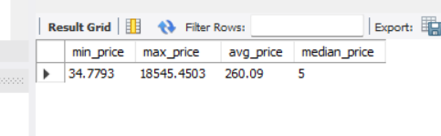

8. **How many outliers are there in the price field?**

WITH PriceQuartiles AS (

SELECT

NTILE(4) OVER (ORDER BY PRICE) AS quartile,

PRICE

FROM airbnb_europe_dataset

),

IQR_Calculation AS (

SELECT

MAX(CASE WHEN quartile = 1 THEN PRICE END) AS Q1,

MAX(CASE WHEN quartile = 3 THEN PRICE END) AS Q3

FROM PriceQuartiles

),

OutlierBounds AS (

SELECT

Q1,

Q3,

Q3 - Q1 AS IQR,

Q1 - 1.5 * (Q3 - Q1) AS lower_bound,

Q3 + 1.5 * (Q3 - Q1) AS upper_bound

FROM IQR_Calculation

)

SELECT

COUNT(*) AS outlier_count

FROM airbnb_europe_dataset, OutlierBounds

WHERE PRICE < lower_bound OR PRICE > upper_bound;

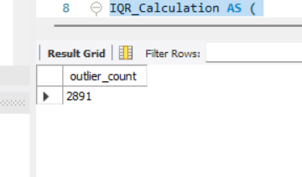

**9. What are the characteristics of the outliers in terms of room type, number of bookings, and price?**

WITH PriceQuartiles AS (

SELECT

NTILE(4) OVER (ORDER BY PRICE) AS quartile,

PRICE

FROM airbnb_europe_dataset

),

IQR_Calculation AS (

SELECT

MAX(CASE WHEN quartile = 1 THEN PRICE END) AS Q1,

MAX(CASE WHEN quartile = 3 THEN PRICE END) AS Q3

FROM PriceQuartiles

),

OutlierBounds AS (

SELECT

Q1,

Q3,

Q3 - Q1 AS IQR,

Q1 - 1.5 * (Q3 - Q1) AS lower_bound,

Q3 + 1.5 * (Q3 - Q1) AS upper_bound

FROM IQR_Calculation

),

Outliers AS (

SELECT *

FROM airbnb_europe_dataset, OutlierBounds

WHERE PRICE < lower_bound OR PRICE > upper_bound

)

SELECT

ROOM_TYPE,

COUNT(*) AS total_outliers,

MIN(PRICE) AS min_price,

MAX(PRICE) AS max_price,

AVG(PRICE) AS avg_price

FROM Outliers

GROUP BY ROOM_TYPE;

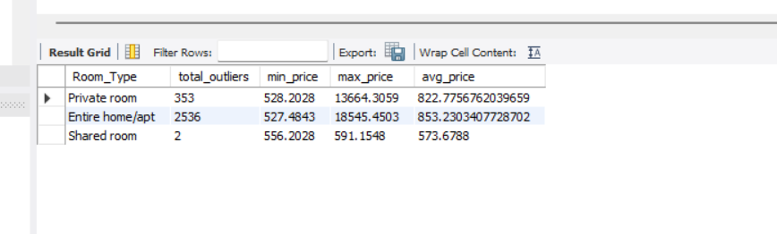

10. How does the average price differ between the main dataset and the dataset with outliers removed?

WITH quartiles AS (

SELECT

Price,

NTILE(4) OVER (ORDER BY Price) AS quartile

FROM airbnb_europe_dataset

),

iqr_bounds AS (

SELECT

MIN(CASE WHEN quartile = 1 THEN Price END) AS Q1,

MIN(CASE WHEN quartile = 3 THEN Price END) AS Q3

FROM quartiles

),

outlier_bounds AS (

SELECT

Q1,

Q3,

Q1 - 1.5 * (Q3 - Q1) AS lower_bound,

Q3 + 1.5 * (Q3 - Q1) AS upper_bound

FROM iqr_bounds

)

SELECT * FROM outlier_bounds;

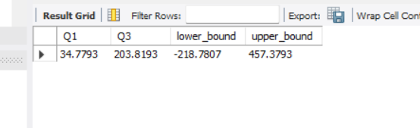

11.

SELECT

ROOM_TYPE,

AVG(PRICE) AS avg_price

FROM airbnb_europe_dataset

GROUP BY ROOM_TYPE;

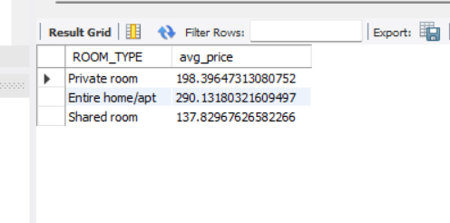

**12. How do weekend and weekday bookings compare in terms of average price and number of bookings?**

SELECT

DAY,

AVG(PRICE) AS avg_price,

COUNT(*) AS total_bookings

FROM airbnb_europe_dataset

GROUP BY DAY;

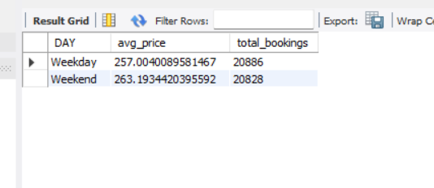

**13. Average Distance for Each City**

SELECT

CITY,

AVG(METRO_DISTANCE_KM) AS avg_metro_distance,

AVG(CITY_CENTER_KM) AS avg_city_center_distance

FROM airbnb_europe_dataset

GROUP BY CITY;

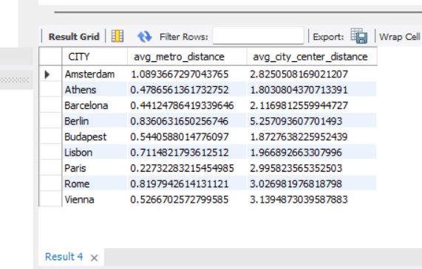

**14. Bookings by Room Type on Weekdays vs Weekends**

SELECT

DAY,

ROOM_TYPE,

COUNT(*) AS total_bookings

FROM airbnb_europe_dataset

GROUP BY DAY, ROOM_TYPE;

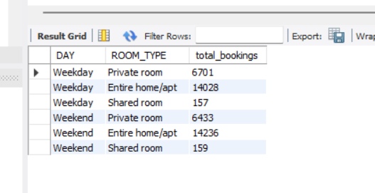

**15. Booking Revenue by Room Type on Weekdays vs Weekends**

SELECT

DAY,

ROOM_TYPE,

SUM(PRICE) AS total_revenue

FROM airbnb_europe_dataset

GROUP BY DAY, ROOM_TYPE;

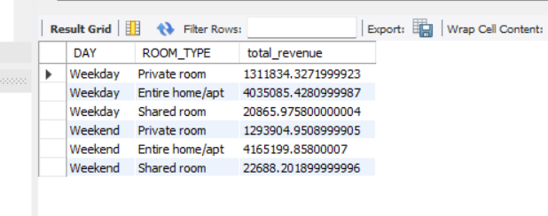

**16. Guest Satisfaction Score Summary**

SELECT

AVG(GUEST_SATISFACTION) AS avg_satisfaction,

MIN(GUEST_SATISFACTION) AS min_satisfaction,

MAX(GUEST_SATISFACTION) AS max_satisfaction

FROM airbnb_europe_dataset;

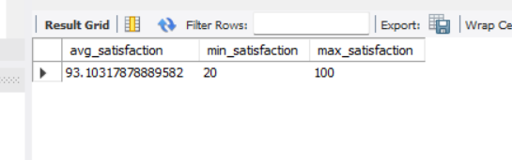

**17. Guest Satisfaction Score by City**

SELECT

CITY,

AVG(GUEST_SATISFACTION) AS avg_satisfaction,

MIN(GUEST_SATISFACTION) AS min_satisfaction,

MAX(GUEST_SATISFACTION) AS max_satisfaction

FROM airbnb_europe_dataset

GROUP BY CITY;

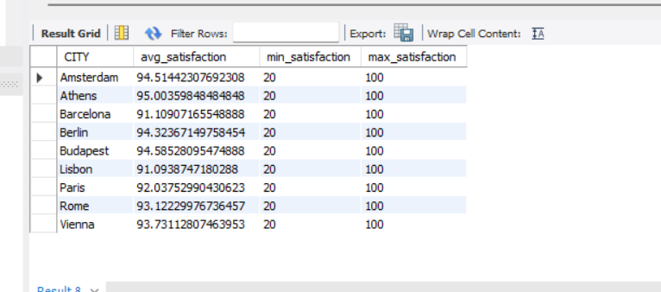

**19. Average Booking Value Across Cleaned Data**

WITH PriceQuartiles AS (

SELECT

NTILE(4) OVER (ORDER BY PRICE) AS quartile,

PRICE

FROM airbnb_europe_dataset

),

IQR_Calculation AS (

SELECT

MAX(CASE WHEN quartile = 1 THEN PRICE END) AS Q1,

MAX(CASE WHEN quartile = 3 THEN PRICE END) AS Q3

FROM PriceQuartiles

),

OutlierBounds AS (

SELECT

Q1,

Q3,

Q3 - Q1 AS IQR,

Q1 - 1.5 * (Q3 - Q1) AS lower_bound,

Q3 + 1.5 * (Q3 - Q1) AS upper_bound

FROM IQR_Calculation

),

CleanedData AS (

SELECT *

FROM airbnb_europe_dataset, OutlierBounds

WHERE PRICE BETWEEN lower_bound AND upper_bound

)

SELECT

AVG(PRICE) AS avg_booking_value

FROM CleanedData;

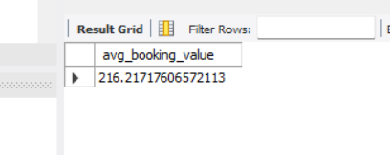

**20. Average Cleanliness Score Across Cleaned Data**

WITH PriceQuartiles AS (

SELECT

NTILE(4) OVER (ORDER BY PRICE) AS quartile,

PRICE

FROM airbnb_europe_dataset

),

IQR_Calculation AS (

SELECT

MAX(CASE WHEN quartile = 1 THEN PRICE END) AS Q1,

MAX(CASE WHEN quartile = 3 THEN PRICE END) AS Q3

FROM PriceQuartiles

),

OutlierBounds AS (

SELECT

Q1,

Q3,

Q3 - Q1 AS IQR,

Q1 - 1.5 * (Q3 - Q1) AS lower_bound,

Q3 + 1.5 * (Q3 - Q1) AS upper_bound

FROM IQR_Calculation

),

CleanedData AS (

SELECT *

FROM airbnb_europe_dataset, OutlierBounds

WHERE PRICE BETWEEN lower_bound AND upper_bound

)

SELECT

AVG(CLEANLINESS_RATING) AS avg_cleanliness_score

FROM CleanedData;

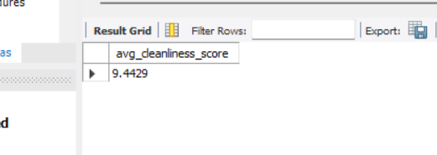

**21. Cities Ranked by Total Revenue**

SELECT

CITY,

SUM(PRICE) AS total_revenue,

ROW_NUMBER() OVER (ORDER BY SUM(PRICE) DESC) AS revenue_rank

FROM airbnb_europe_dataset

GROUP BY CITY

ORDER BY revenue_rank;

