A PROJECT REPORT

on

“SPAM/EMAIL CLASSIFIER”

Submitted to

KIIT Deemed to be University

In Partial Fulfillment of the Requirement for the Award of

BACHELOR’S DEGREE IN

INFORMATION TECHNOLOGY

BY

DIVYANSHI TIWARI
FARHAN JAFFER

2105151
2105714

UNDER THE GUIDANCE OF

ABHINAS PANDA SIR



SCHOOL OF COMPUTER ENGINEERING

KALINGA INSTITUTE OF INDUSTRIAL TECHNOLOGY

BHUBANESWAR, ODISHA - 751024

March 2024

KIIT Deemed to be University

School of Computer Engineering
Bhubaneswar, ODISHA 751024

CERTIFICATE

This is certify that the project entitled

“SPAM/EMAIL CLASSIFIER”

submitted by

DIVYANSHI TIWARI
FARHAN JAFFER

2105151
2105714

is a record of bonafide work carried out by them, in the partial fulfilment of the requirement for the award of Degree of Bachelor of Engineering (Computer Sci-ence & Engineering) at KIIT Deemed to be university, Bhubaneswar. This work is done during year 2023-2024, under our guidance.

Date:30/03/2024

(Guide Name)
Abhinas Panda Sir

Acknowledgements

We are profoundly grateful to Abhinas Panda Sir of Affiliation for his expert guidance and continuous encouragement throughout to see that this project rights its target since its commencement to its completion.

Divyanshi Tiwari

Farhan Jaffer

ABSTRACT

In today's world, communication is essential for both personal and professional relationships. The widespread usage of email communication is due to its accessibility, affordability, ease of use, and popularity. One significant security vulnerability in emails is that anyone may send an email to anybody by simply obtaining their unique user ID. Some companies and ill-intentioned individuals are taking advantage of this security vulnerability for advertising, phishing, criminal intent, and ultimately fraud.This results in the creation of the SPAM email category.

Any email that is often sent, irrelevant, or contains advertisements is referred to as spam. The amount of these emails is growing daily. Research indicates that around 55% of e-mails are spam. The service providers are working very hard on this. Spam is shifting by altering its evident indicators of presence. Furthermore, in order to prevent information loss in the event of a misclassification, service providers' spam detection should never be classified aggressively.

We provide a fresh and effective approach to spam detection that makes use of natural language processing and machine learning to address this issue. A spam classification and detection tool. Furthermore, for the convenience of the user, it also offers information about the text in a fast view manner.

Contents

1 | Introduction |  | 1
2 | Basic Concepts/ Literature Review |  | 2
 | 2.1 | Introduction | 2
 | 2.2 | Related work | 2
 | 2.3 | Summary | 2
3 | Problem Statement / Requirement Specifications |  | 3
 | 3.1 | Problem statement | 3
 | 3.2 | Project objective | 3
 | 3.3 | Requirement specification | 3
 | 3.4 | Workflow | 3
4 | Data Collection Processing |  | 4
 | 4.1 | Data collection | 4
 | 4.2 | Data processing | 4
 | 4.3 | Data splitting | 4
 | 4.4 | Model used | 4
5 | Procedure |  | 6
 | 5.1 | Logistic regression | 6
 | 5.2 | Working Procedure | 6
 | 5.3 | Comparison | 7
 | 5.4 | Summary | 7
6 | Conclusion and Future Scope |  | 8
 | 6.1 | Conclusion | 8
 | 6.2 | Future Scope | 8
Plagiarism Report |  |  | 9

SPAM/EMAIL CLASSIFIER

Chapter 1

Introduction

Spam is become a serious issue when it comes to online communication. Approximately 55% of all emails are reported as spam, and the percentage has been continuously rising. The usage of email is growing as a result of spam, sometimes referred to as unsolicited bulk email, which offers the ideal means of sending unsolicited advertisements or trash newsgroup postings at no expense to the sender. Numerous careless organizations have taken full advantage of these opportunities, clogging millions of people's mail boxes worldwide.

Given the objectionable tone of some communications, spam has been a big worry. Additionally, spam is a time waster. The end user runs the risk of inadvertently deleting valid emails.
Furthermore, spam had an effect on the economy, which prompted several nations to pass laws.

The course of incoming mail or messages—whether they go directly to the spam bin or into the inbox—is determined by text categorization. It is the process of classifying text based on the information it contains. Text is arranged, structured, and classified using it. It can be carried out automatically or manually. Compared to manual approach, machine learning automatically identifies the text considerably more quickly. Pre-labelled text is used by machine learning to discover the many relationships between text segments and their output. Each text was converted to a numerical representation in the form of a vector using feature extraction, which shows the frequency of each word in a specified lexicon.

Text categorization is crucial for efficiently organising the disorganised and disorderly qualities of text, including papers and spam communications. Machine learning may assist to enhance the laborious manual method to much better and quicker large data analysis. It can also produce more exact precisions in real-time. Analysing text data is crucial for businesses in particular since it may automate procedures and even assist guide corporate choices.

In this research, the spam message in an email is identified using machine learning algorithms. Through machine learning, computers may pick up new skills without requiring explicit programming.
It creates a programme using data to carry out tasks like categorization.
Machine learning approaches need communications that have been effectively

pre-classified, in contrast to knowledge engineering. In machine learning
studio, the pre-classified messages comprise the training dataset, which is utilised to match the learning algorithm to the model.

School of Computer Engineering, KIIT, BBSR 1

SPAM/EMAIL CLASSIFIER

Chapter 2

Basic Concepts/ Literature Review

2.1 Introduction

The literature review for the machine learning classifier utilised in earlier studies and projects is covered in this chapter. It is a summary of earlier research that is relevant to current project rather than an information gathering exercise. It entails looking for, reading, analysing, summing, and assessing the reading materials in light of the project.

Machine learning-based spam detection has been extensively studied. However, the suggested solutions are unreliable because of how spam is evolving and how different technologies are developing. As one of the less well-known areas of machine learning, natural language processing is represented here with relatively less effort.

2.2 Related Work

The difficulty of classifying spam is not new, nor is it easy. Numerous studies have been conducted, and numerous useful strategies have been put out.

- M. RAZA, N. D. Jayasinghe, and M. M. A. Muslam have analyzed various techniques for spam classification and concluded that naïve Bayes and support vector machines have higher accuracy than the rest, around 91% consistently [1].
- S. Gadde, A. Lakshmanarao, and S. Satyanarayana in their paper on spam detection concluded that the LSTM system resulted in higher accuracy of 98%[2].

2.3 Summary

Based on several research, we may conclude that different models work better for different kinds of data. Several popular methods for spam detection and classification include Naïve Bayes, random forest, support vector machines, and logistic regression.

School of Computer Engineering, KIIT, BBSR 2

SPAM/EMAIL CLASSIFIER

Chapter 3

Problem Statement / Requirement Specifications

3.1 Problem Statement

Email service providers are at constant fight with spammers. In an effort to keep consumers engaged, email service providers employ a variety of spam filtering techniques. However, spammers constantly adapt their tactics and utilise different embedding techniques to evade detection.
These filters should never be overly strict as even a small misclassification might cause the user to lose out on crucial information. To solve this issue, a strict filtering technique with extra reinforcements is required.

3.2 Project Objectives

The goal of this research is to:
i. Develop an ensemble algorithm for the most accurate categorization of spam.
ii. To research spam detection with machine learning.
iii. Researching the use of natural language processing methods to spam detection.
iv. Using the developed algorithm and natural language processing to deliver the user insights on the text.

3.2 Requirement Specifications

prerequisites Hardware prerequisites
Computer/Tablet
RAM: 8 GB;
Storage: 100–200 Mb; Software needed
Software: Windows 7 and later
Code Editors: VS Code, Pycharm, With packages for nltk, numpy, pandas, sklearn, tkinter, and nltk data, an integrated IDE Anaconda environment is included.supported browsers include Opera, Firefox, Chrome, and so on.

3.3 Workflow

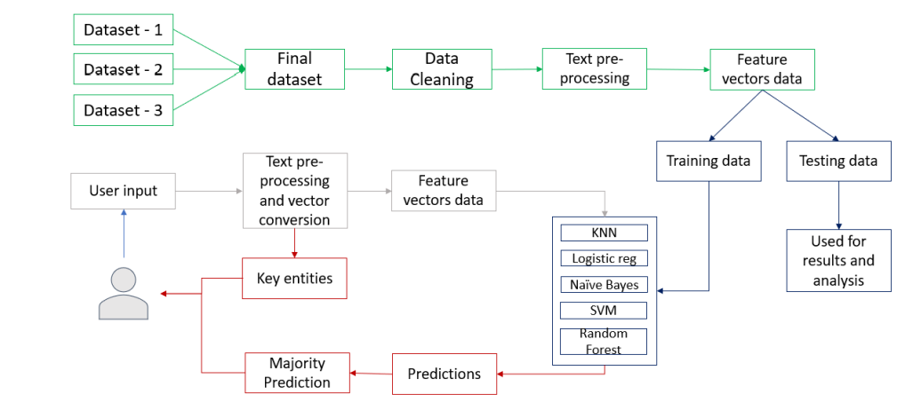

School of Computer Engineering, KIIT, BBSR 3

SPAM/EMAIL CLASSIFIER

Chapter 4

Data collection and processing

4.1 Data Collection

When it comes to categorization and prediction, data is crucial; the more data available, the more accurate the results will be.
● The data utilised in this project comes from a variety of sources, including UCI and Kaggle, and is entirely open-source.
● Several datasets are used to ensure accuracy and diversity in the data.
For training and testing purposes, the programme uses two datasets with around 12,000 emails and their labels. Approximately 6,000 spam emails are included to improve accuracy and help with data generalisation.

4.2 Data Processing

● Cleaning of the dataset
It involves activities like eliminating outliers, null values, and undesirable aspects from data.
● Combining Datasets
The datasets are combined after data cleaning to create a single dataset with just two characteristics (text, label).
Pandas library is used for all phases of data cleaning and data merging.

4.3 Data Splitting

Two types of data are created by data splitting. Data for testing and training.
Machine learning models are trained using training data, and their performance is evaluated and outcomes analysed using testing data. The remaining data is also testing data, with 80% of the overall data being chosen for testing.

4.4 Model Used- Logistic Regression

An approach known as "Supervised machine learning" called logistic regression may be used to estimate the likelihood of a particular class or occurrence. When the outcome is binary or dichotomous and the data is linearly separable, it is employed [17]. The sigmoid function is used to compute the probability.
Consider, for instance, a case where the data includes n characteristics.
The equation can be used to express the line that has to be fitted to the provided data.

z=b_0+b_1 x_1+b_2 x_2+b_3 x_3….+b_n x_n

School of Computer Engineering, KIIT, BBSR 4

SPAM/EMAIL CLASSIFIER

here z = odds generally, odds are calculated as
odds=p(event occurring)/p(event not occurring)

Sigmoid Function: The term "logistic regression" refers to a particular type of logistic function, which is the sigmoid function.
The sigmoid function is used to determine the logarithm of odds and output a continuous probability between 0 and 1.
To compute the logarithm of odds, use

log(odds)=dot(features,coefficients)+intercept

and these log_odds are used in the sigmoid function to get probability.

h(z)=1/(1+e^(-z) )

The class to which the sample belongs is ascertained using the sigmoid function's output, which is an integer in the range of 0 to 1. Generally speaking, 0.5 is seen as the cutoff point, below which a response is regarded as NO, and 0.5 or above in which a response is seen as YES. However, the boundary may be changed to suit the needs.

School of Computer Engineering, KIIT, BBSR 5

SPAM/EMAIL CLASSIFIER

Chapter 5

Procedure

The procedure is as follows: first, data is gathered and processed; next, natural language processing; third, vectorization; and last, machine learning.Following collection and cleaning, the data is put via the natural language processing methods outlined in section IV. After that, the cleansed data is transformed into vectors by applying the TF-IDF and Bag of Words techniques, which work like this. An 80-20 split ratio is used to divide the data into training and testing sets. Bag-of-Words and TF-IDF vectors are created from the training and testing data. While comparing the BoW and TF-IDF models, accuracy is taken into account among other metrics used to evaluate the models. Typically, a model's accuracy is used to assess its efficiency.

5.1 Logistic Regression
Training vectors and training labels are used to generate and train two models: one for TF-IDF and one for Bow. The model's score is then obtained by applying the appropriate testing vectors and labels.

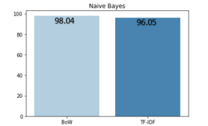

The TF-IDF and Bag-of-Words scores are shown graphically.
Using the logistic regression model yields scores of 98.53 and 98.80 respectively.

5.2 Working Procedure

The internal operations and the application's data flow are included in the functioning method.
i. Certain processes are automated once the programme has been run.
1. Getting information from a file
2. Making the texts cleaner
3. Handling
4. Dividing the information
5. Setting up and conditioning the models
ii. All that is required of the user is some data to be classified in the designated region.
iii. After submission, the given data passes through a number of processes.
1. Understanding Text
2. Conversion of feature vectors
3. Extraction of entities
iv. To obtain predictions, trained models are fed the generated vectors.
v. The majority-predicted category will be chosen following the receipt of forecasts.
vi. A calculation will be made of that prediction's accuracy.

School of Computer Engineering, KIIT, BBSR 6

SPAM/EMAIL CLASSIFIER

vii.The user will receive the entities and accuracy collected from step 3.
The second phase of the process will be carried out again each time the user provides something new.

5.3 Comparison

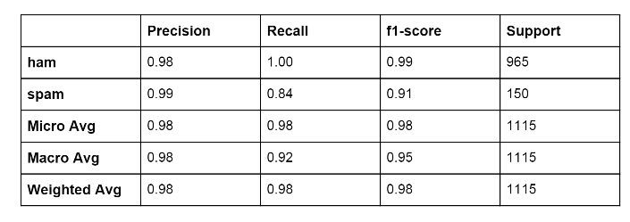

5.3 Summary

The project's implementation consists of two primary responsibilities. Choosing a language model to finish the text processing stage and developing a suggested model with each of the different algorithms. For these two jobs to be more efficient, different models must be compared and different parameters must be chosen.
Two models are compared to choose the best model during the language model selection phase: Bag of Words and TF-IDF. Based on the findings, it is clear that TF-IDF performs better.

To determine the ideal parameters, a variety of methods are evaluated with varying values throughout the construction of the suggested model. The models are combined to create an ensemble algorithm, and the outcomes are shown and contrasted above. The findings show that the suggested model performs better than the others in practically every derived statistic.

School of Computer Engineering, KIIT, BBSR 7

SPAM/EMAIL CLASSIFIER

Chapter 6

Conclusion and Future Scope

6.1 Conclusion

Based on the results, we can say that an ensemble machine learning model performs better than any single method in spam detection and categorization. We may also draw the conclusion that, when coupled with many algorithms, the TF-IDF (term frequency inverse document frequency) language model performs better in the categorization of spam than the Bag of Words model. Lastly, we may conclude that by combining and fine-tuning machine learning methods, spam detection can improve.

6.2 Future Scope

Natural language processing and machine learning have many applications, and when they work together, they may address some of the most difficult issues relating to texts. This programme may be set up to accept text in bulk, which will enable more effective categorization in some public spaces.
The model may be trained in other situations, such as harmful, phishing, negative, etc., to filter items like user comments on different social media platforms. This programme can be readily updated with the most recent spam and other email trends, allowing the system to react to new sorts of spam emails and texts. It can also be transformed to an online machine learning system.

School of Computer Engineering, KIIT, BBSR 8

TURNITIN PLAGIARISM REPORT
(This report is mandatory for all the projects and plagiarism
must be below 25%)

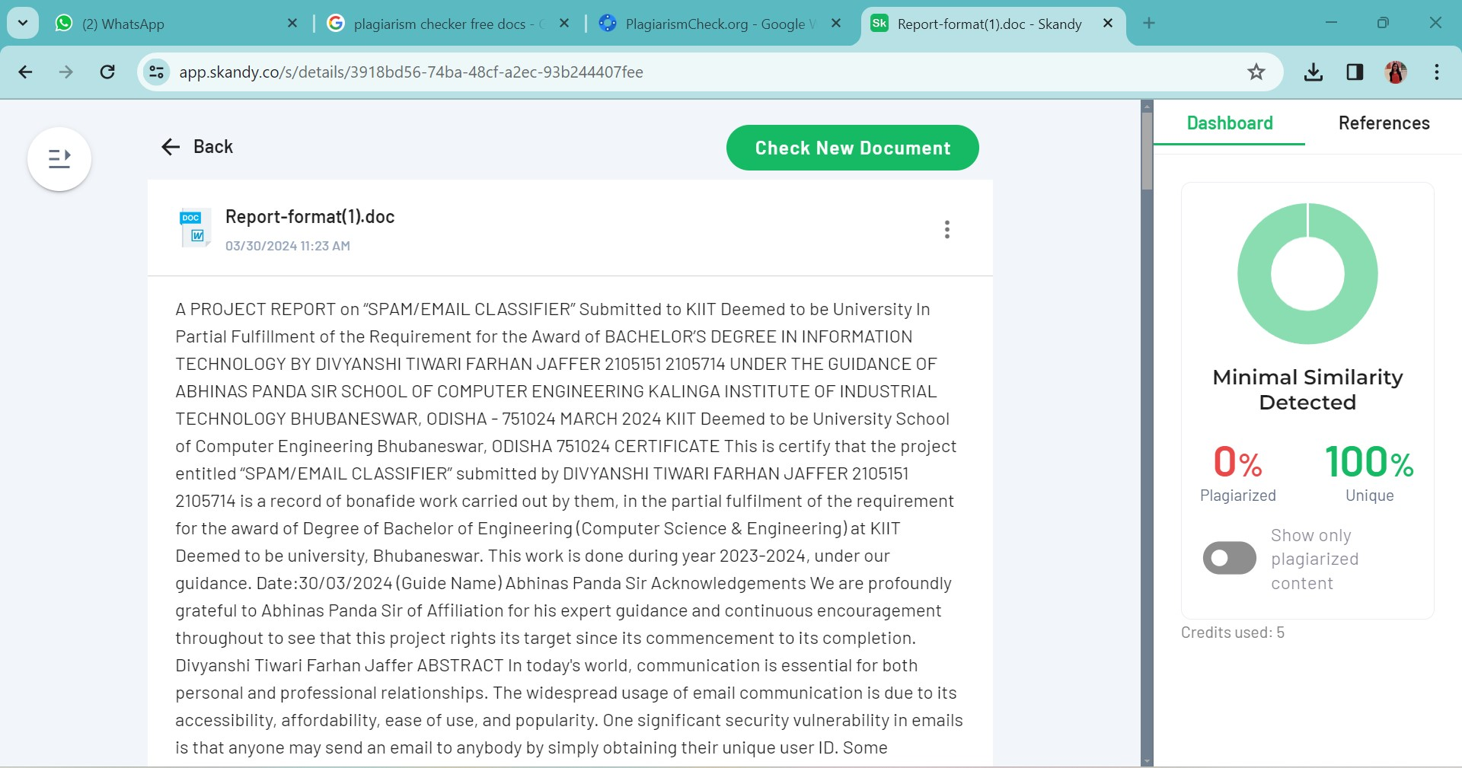

School of Computer Engineering, KIIT, BBSR 9

