TicketVerse
System Design Specification
Architecture · Decision Records · NFRs · Security & Compliance · Cost
Repository: Ticket-Booking-Application-2
Region: AWS ap-south-1 (Mumbai) · Branch: main
Document version 1.0
This document is derived directly from the project's Terraform configuration, Express application source code and GitHub Actions workflow as committed to the repository. Every figure, control and diagram traces to a specific file in the codebase; nothing here is aspirational unless explicitly marked “target” or “roadmap.”

Contents
1. Introduction 3
1.1 How to read this document 3
2. System Architecture Diagrams 4
2.1 System Context (C4 — Level 1) 4
2.2 Container Diagram (C4 — Level 2) 4
2.3 Network Topology 5
2.4 Component-level structure 6
3. Architecture Decision Records (ADRs) 7
4. Non-Functional Requirements (NFR) 13
4.1 Availability 13
4.2 Latency & Throughput 13
4.3 Disaster Recovery 14
5. Security & Compliance Plan 15
5.1 Identity & Access Management (IAM) 15
5.2 Encryption Standards 15
5.3 Network Security 15
5.4 Authentication & Authorization 16
5.5 Secrets Management 16
5.6 Known Security Gaps 17
6. Cost Estimate (AWS ap-south-1) 18
6.1 Monthly cost breakdown 18
6.2 Where the money goes 18
6.3 Cost optimization opportunities (TCO) 19
6.4 Cost of closing the gaps 19
7. Roadmap — Prioritized Gaps 20
7.1 High priority 20
7.2 Medium priority 20
7.3 Lower priority / future scope 20

1. Introduction
TicketVerse is a single Express.js monolith serving a multi-role event ticketing platform — users booking seats, organizers managing events and payouts, admins moderating the platform — backed by MySQL and deployed on AWS as a Dockerized app on an EC2 Auto Scaling Group. This document is the design specification for that system: it makes the architecture, the trade-offs behind it, its non-functional characteristics, its security posture and its running cost explicit and reviewable in one place.
Each section below is grounded in what is actually deployed: diagrams are drawn from the real Express route table and Terraform resources, the Architecture Decision Records document trade-offs visible in the code, the NFR targets are compared honestly against what the current topology can deliver, the security plan states which controls exist today versus which are known gaps, and the cost estimate is built line-by-line from the instance types and counts configured in Terraform.

1.1 How to read this document
- Section 2 — System Architecture Diagrams: C4 Level 1 (Context), Level 2 (Container), and a network topology diagram of the AWS VPC.
- Section 3 — Architecture Decision Records: ten ADRs covering the trade-offs actually encoded in the Terraform, Express app and CI workflow.
- Section 4 — Non-Functional Requirements: availability, latency/throughput and disaster-recovery targets, each paired with the current, honestly-assessed posture.
- Section 5 — Security & Compliance Plan: IAM, encryption, network security, authentication/authorization, secrets management, and known gaps.
- Section 6 — Cost Estimate: a line-item AWS ap-south-1 monthly estimate, optimization levers, and the explicit cost of closing the identified gaps.
- Section 7 — Roadmap: the prioritized list of gaps this document surfaces.

2. System Architecture Diagrams
C4 Model, Levels 1 and 2, plus a network topology view of the AWS deployment. All three are generated directly from the Express route table, Terraform resources, and the app.js/user_data.sh boot sequence in the repository.

2.1 System Context (C4 — Level 1)
TicketVerse as a single black box, its three user roles, and the four external systems it depends on: Razorpay for payments, SMTP for email, Twilio for optional SMS, and S3 for ticket/invoice PDF storage.
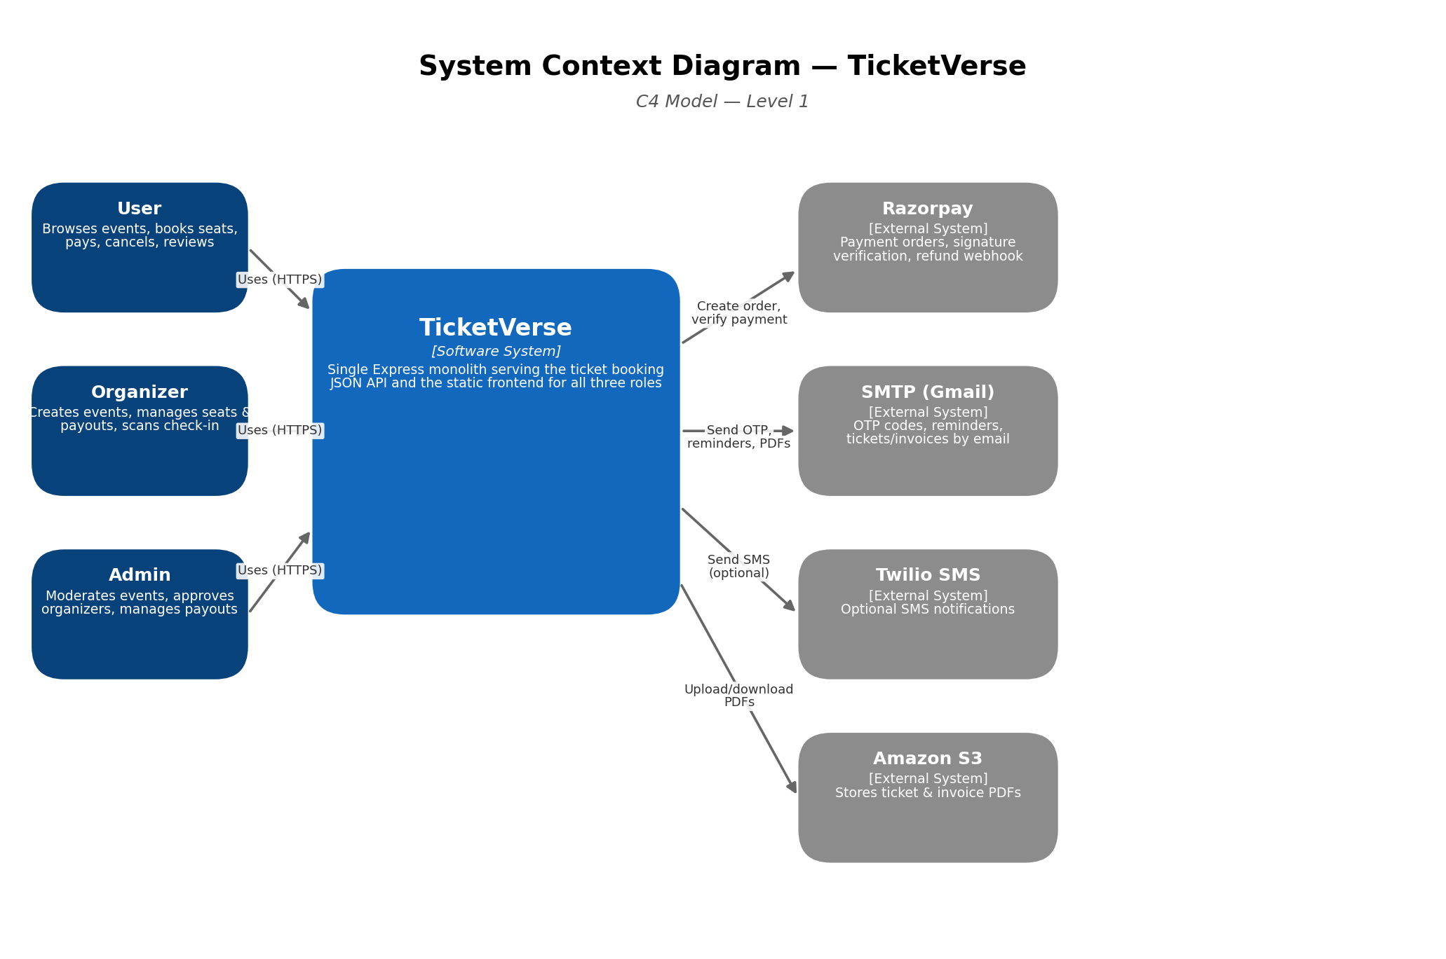
Figure 1 — System Context Diagram

2.2 Container Diagram (C4 — Level 2)
One level down: the ALB, the single Express monolith running inside an EC2 Auto Scaling Group (including its two in-process cron jobs), the RDS primary and read replica, the CloudWatch agent, and the CI/CD path that deploys new code via ECR and SSM rather than an ECS task-definition rollout.
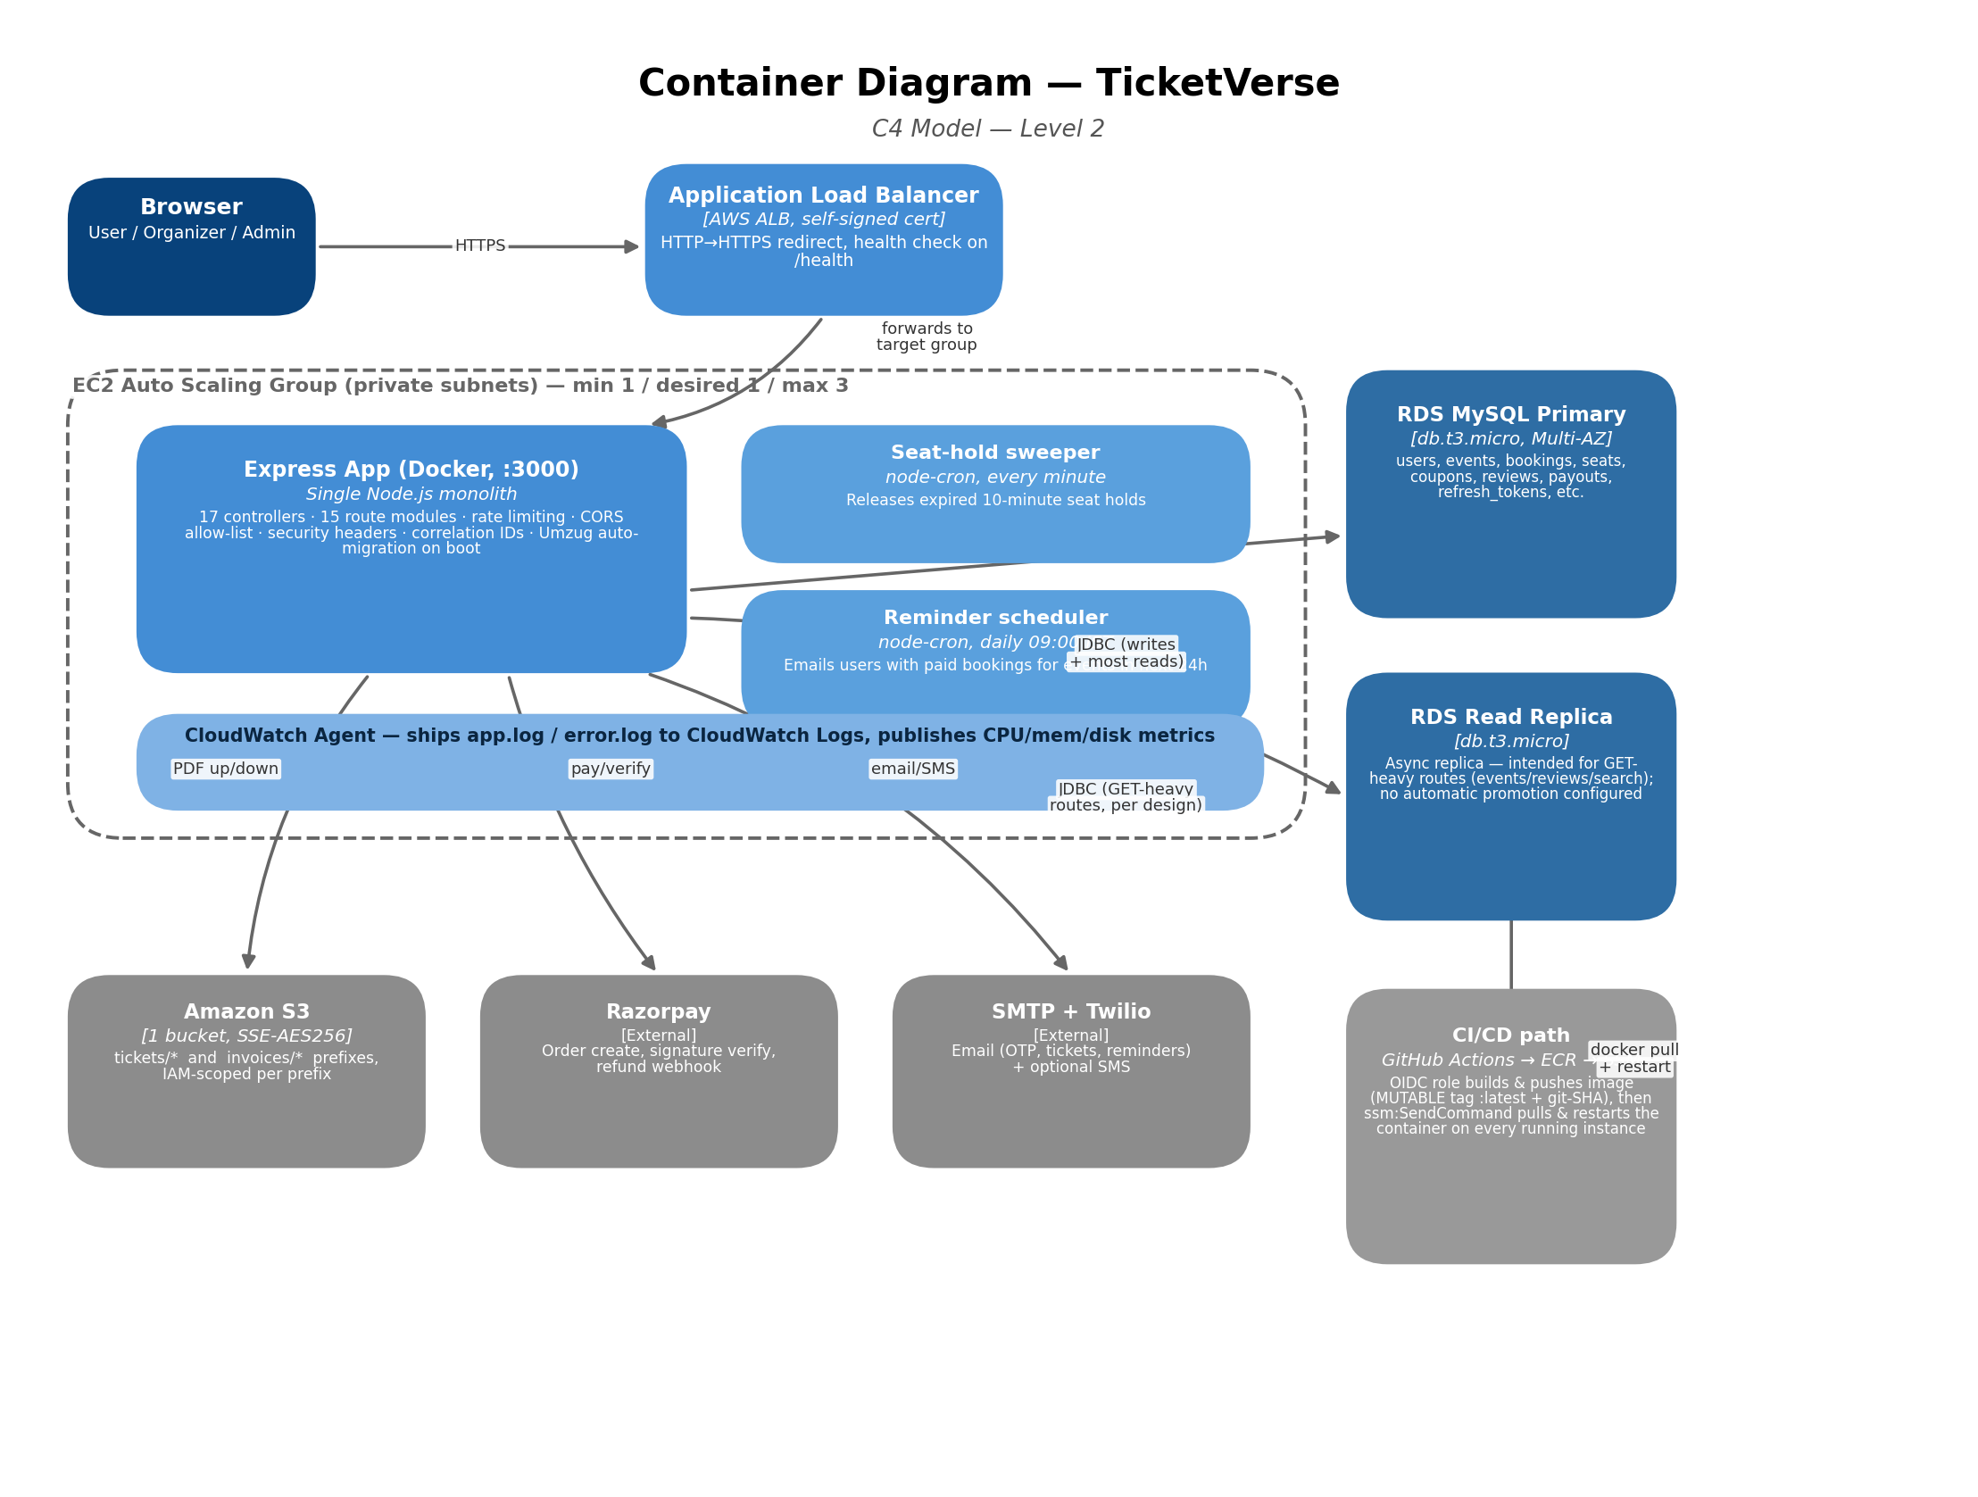
Figure 2 — Container Diagram
Note: unlike a typical containerized deployment, there is no orchestrator (ECS/Fargate/Kubernetes) here — the “container” in the C4 sense is a single Docker container running directly on plain EC2 instances (ADR-002).

2.3 Network Topology
The AWS VPC layout: two Availability Zones, public subnets carrying only the ALB's elastic network interfaces, private subnets carrying the EC2 instance(s) and both RDS instances, and the single NAT Gateway that all private-subnet egress traffic routes through.
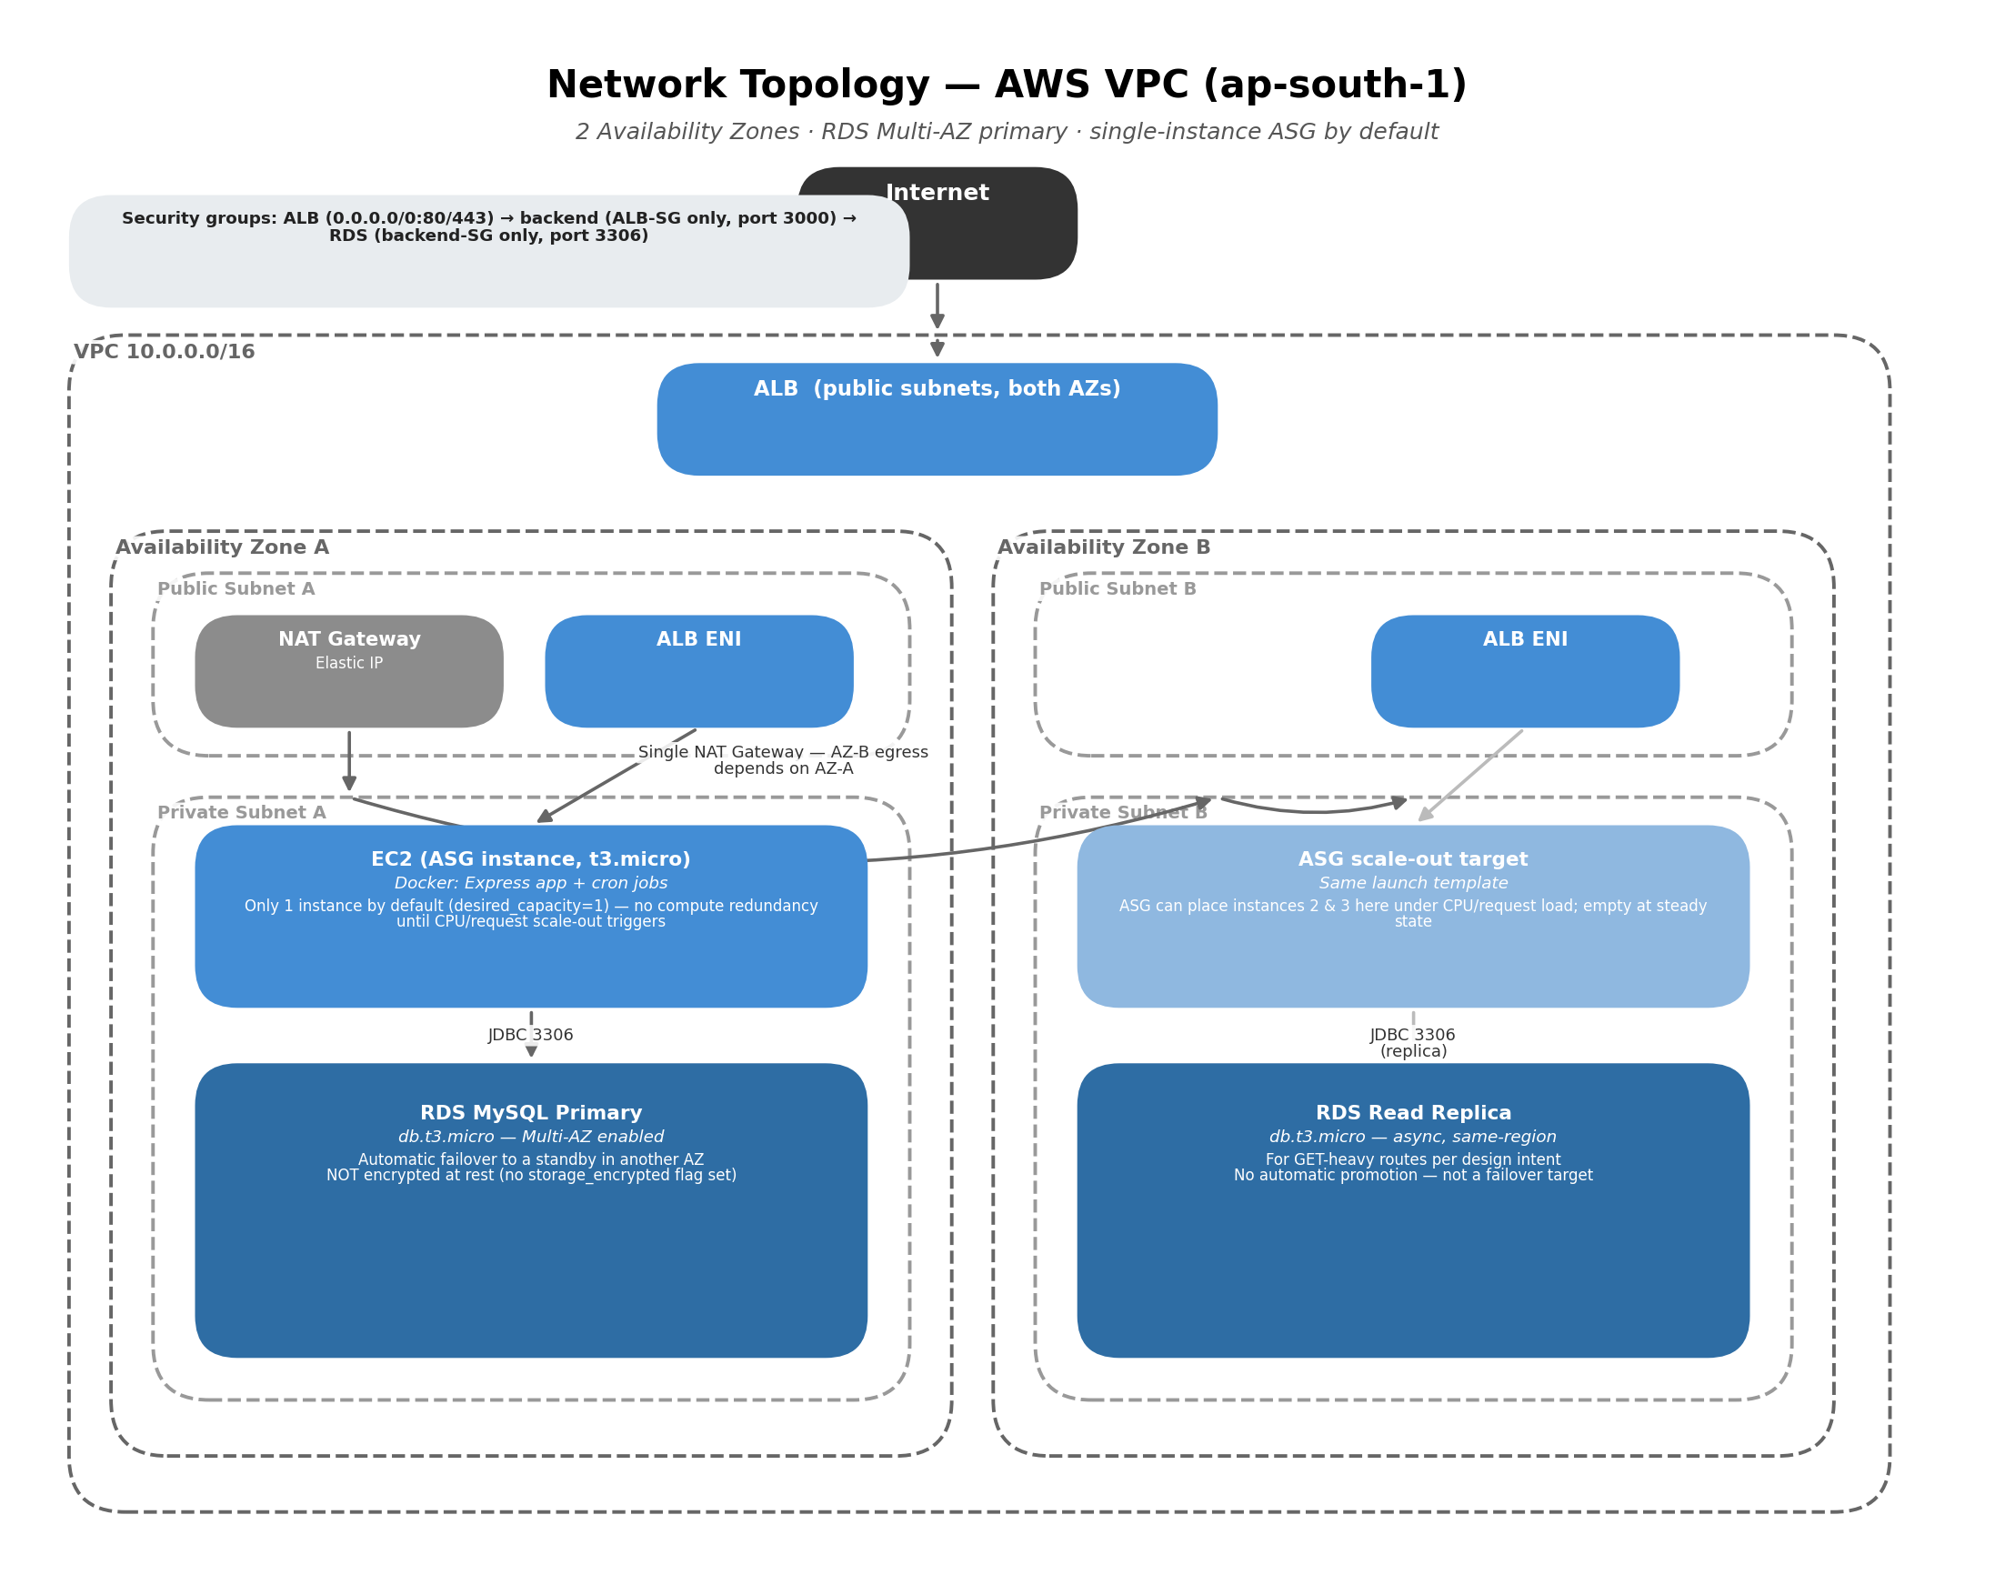
Figure 3 — Network Topology, AWS VPC

2.4 Component-level structure
Not pictured as a fourth C4 diagram, since it is a single process: the Express app follows a conventional layered structure — routes → controllers → services → models — rather than the strict compiler-enforced DDD layering used in some companion services. Concretely, for the booking flow:
- routes — `booking.routes.js`, `payment.routes.js`, `seat.routes.js` wire URLs to controllers behind the `authenticate` middleware.
- controllers — thin handlers (`booking.controllers.js`, `payment.controllers.js`) that parse the request and delegate to services.
- services — `booking.services.js`, `payment.services.js`, `seat.services.js`, `cancellation.services.js` hold the actual business logic: fee calculation, seat locking (row-level DB transactions), Razorpay order/signature handling, refund-tier math.
- models — 13 Sequelize models (`Booking`, `Seat`, `Event`, `User`, `Coupon`, `Review`, `Wishlist`, `WaitlistEntry`, `RefreshToken`, `Payout`, `OrganizerProfile`, `CancellationPolicy`, `EventCategory`) with associations declared centrally in `models/index.js`.

3. Architecture Decision Records (ADRs)
Ten records covering the trade-offs actually encoded in the Terraform, Express app and CI workflow, each reflecting the decision as it stands in the repository today.
ADR-001 · A single Express monolith, not microservices
Status | Accepted
Context
The platform has five distinct concerns — auth, events, bookings/payments, organizer tools, admin tools — that could each be a separate service.
Decision
Ship all of it as one Node.js/Express process (`backend/src/app.js`) with 15 route modules and 17 controllers, sharing one Sequelize connection pool, one deployable Docker image, and one EC2 Auto Scaling Group.
Consequences
- + One build, one image, one deploy pipeline — no service-to-service network calls, no distributed-transaction concerns for a booking flow that touches seats, payments and coupons together
- + Trivial local development: `npm run dev` runs the whole system
- − No independent scaling or deployment per concern — a spike in search traffic scales the same process handling payment webhooks
- − A single unhandled exception in any route can, in principle, affect the whole process (mitigated by the `uncaughtException`/`unhandledRejection` handlers in `server.js`, but the blast radius is still the entire app, not one feature)
Alternatives considered
Microservices per domain (rejected — disproportionate operational overhead for the current traffic and team size); a modular monolith with stricter internal module boundaries was considered but the existing controller/service/model layering already gives most of that benefit without the packaging cost.
ADR-002 · EC2 Auto Scaling Group running Docker via SSM deploy, not ECS/Fargate
Status | Accepted
Context
The app needs a compute layer that can scale out under load and receive new images from CI without manual intervention.
Decision
Run the backend as a plain Docker container on plain EC2 instances (Amazon Linux, `t3.micro`) in an ASG. `user_data.sh` performs the initial `docker run` on boot; the CI workflow's deploy job re-deploys by looping over every running instance and using `ssm:SendCommand` to `docker pull` + replace the container in place.
Consequences
- + No ECS/Fargate control-plane concepts to learn or pay for — the deployment model is literally "SSH-less docker run", which is simple to reason about
- + IAM for the deploy path is narrow: the GitHub Actions role only needs `ecr:*` push permissions and three SSM actions scoped to this project's instances
- − No task-definition abstraction, no built-in rolling-update coordination across instances beyond the deploy script's own loop, and no automatic rollback if a new image crash-loops — ECS/Fargate would have handled all of this natively
- − SSM `RunShellScript` deploys are inherently push-based and best-effort per instance; if an instance is mid-boot or SSM Agent isn't yet registered, that instance silently keeps the old image until the next deploy
Alternatives considered
ECS on Fargate (rejected — more moving parts than justified for a single-container app, and the team wanted direct EC2/CloudWatch agent access for custom log shipping); ECS on EC2 (rejected for the same reason — the task-definition layer buys little when there is only one task type).
ADR-003 · Self-signed IAM certificate on the ALB, not ACM with a real domain
Status | Accepted
Context
The ALB's HTTPS listener needs a TLS certificate. ACM certificates require either a domain you control (for DNS validation) or an already-issued cert; this project has no registered domain.
Decision
Generate a self-signed certificate locally with `mkcert`, upload it to IAM (`aws_iam_server_certificate`), and reference it from the ALB's HTTPS listener (`ELBSecurityPolicy-TLS13-1-2-2021-06`). `terraform.tfvars.example` documents the exact `mkcert` commands needed before `terraform apply` will succeed.
Consequences
- + Zero-cost, works immediately against the raw ALB DNS name with no domain purchase or DNS delegation required
- + Still forces TLS 1.3 at the listener — the connection is encrypted even though the certificate isn't publicly trusted
- − Every browser shows a certificate-warning interstitial on first visit unless the operator's `mkcert` root CA is installed locally — unacceptable for anything beyond a demo/portfolio audience
- − Non-browser clients (mobile apps, server-to-server callers, most HTTP libraries' default TLS verification) will reject the connection outright unless explicitly configured to trust this specific certificate or skip verification — which itself becomes a security anti-pattern if left in place
Alternatives considered
ACM certificate + a real domain (rejected only on cost/ownership grounds, not a technical objection — this is the clear target for anything beyond a demo, see §7 Roadmap); no TLS at the ALB / plain HTTP (rejected outright — credentials and JWTs would be sent in clear text).
ADR-004 · RDS Multi-AZ primary plus a dedicated async read replica
Status | Accepted
Context
The database is a single point of failure by default, and GET-heavy routes (event listings, reviews, search) could compete with transactional writes (bookings, payments) for the same connection pool and I/O.
Decision
Enable `multi_az = true` on the RDS primary (automatic synchronous standby + failover) from day one, and provision a separate single-AZ read replica intended for GET-heavy routes, per the Terraform output note (`rds_replica_endpoint`).
Consequences
- + Automatic failover on primary-node or AZ failure without any manual intervention — a materially stronger availability posture than a single-AZ primary
- + A dedicated replica gives headroom to route read-heavy traffic away from the transactional primary as the app's `DB_HOST_REPLICA` config already anticipates
- − Doubles the always-on RDS compute cost for the primary path (Multi-AZ bills for the standby) plus a third instance for the replica — three `db.t3.micro` instances total for one logical database
- − The application code does not yet consistently route reads to the replica connection (`config/database-replica.js` exists but is not wired into most read-heavy controllers) — the replica is provisioned ahead of the application fully using it
Alternatives considered
Single-AZ primary only (rejected — no failover story at all); Aurora MySQL with Aurora Replicas (rejected as disproportionate operational and cost complexity for the current scale, though it would remove the manual promotion gap noted in ADR-004's consequences).
ADR-005 · Three-token JWT model with a DB-backed, hashed refresh token
Status | Accepted
Context
The app needs both short-lived API access and a way to silently re-authenticate a returning browser session without forcing a full OTP re-login every few hours.
Decision
Issue three JWTs on login: a short-lived access token, an opaque refresh token (wrapped in a signed JWT, with only its SHA-256 hash persisted server-side in `refresh_tokens`), and a session token. All three ride as `HttpOnly` cookies; `POST /auth/refresh` verifies and rotates the refresh token on every use.
Consequences
- + The raw refresh token is never stored server-side — only its hash — so a database read alone can't be used to forge a valid refresh token
- + Refresh-token rotation on every use limits the window in which a stolen refresh token remains useful
- − Three cookies and three secrets to manage instead of one — more surface area for a misconfiguration (e.g. a missing `COOKIE_SECURE=true` in production) to quietly weaken the whole scheme
- − No explicit refresh-token reuse-detection/revocation-cascade logic was found (unlike a full rotation-with-reuse-detection design) — a leaked-and-then-reused old refresh token is only as safe as its short rotation window, not actively detected as a compromise signal
Alternatives considered
A single long-lived JWT with no refresh flow (rejected — forces either frequent re-logins or an unacceptably long-lived access token); server-side session store (e.g. Redis-backed sessions) instead of JWTs (rejected — adds an infrastructure dependency not otherwise needed by a single-instance-by-default deployment).
ADR-006 · Umzug migrations, auto-applied on every boot, baselined from a raw SQL file
Status | Accepted
Context
The schema needs to evolve over time without requiring an operator to remember to run manual `mysql < *.sql` commands against every environment before deploying new code.
Decision
Use Umzug (`config/migrator.js`) with migration files in `src/migrations/`. The first migration reads and executes `db/master_schema.sql` verbatim as the baseline; later migrations are incremental, idempotent DDL changes. `server.js` checks for and applies pending migrations on every server boot, before the app starts accepting traffic.
Consequences
- + A fresh environment is fully self-provisioning — point it at an empty database and boot; no separate manual migration step in the deploy runbook
- + Migrations are idempotent and Umzug-tracked, so re-running on every boot across multiple ASG instances is safe rather than risky
- − Schema changes now ship inside the application boot path rather than as a distinct, independently-reviewable deploy step — a bad migration can block every instance from starting, not just fail a separate migration job
- − Splitting one statement-per-line via `.split(";")` in the baseline migration is a simplification that would break on any SQL statement containing a literal semicolon inside a string or trigger body — acceptable for the current schema, fragile if that ever changes
Alternatives considered
A separate migration step in CI before deploy, decoupled from application boot (rejected for now — more moving parts than the current single-instance-by-default scale justifies, but worth revisiting if the ASG regularly runs multiple instances, since concurrent Umzug runs on boot are technically safe but add boot-time contention on the migrations-lock table).
ADR-007 · In-process node-cron jobs, not a separate worker/queue service
Status | Accepted
Context
Two background jobs are needed: releasing expired seat holds every minute, and sending event reminder emails once a day.
Decision
Run both as `node-cron` schedules inside the same Express process (`seatHold.scheduler.js`, `reminder.services.js`), started from `app.js` whenever `NODE_ENV !== 'test'`.
Consequences
- + Zero additional infrastructure — no queue, no worker fleet, no separate deploy artifact to keep in sync with the API
- − If the ASG ever runs more than one instance (its `max_size = 3`), every instance runs its own copy of both cron schedules — the seat-hold sweep is idempotent and harmless to run redundantly, but the daily reminder job has no distributed lock, so scaling out to multiple instances would send duplicate reminder emails to the same users unless addressed first
- − A slow or stuck cron job runs on the same event loop as request handling, competing for the same process resources
Alternatives considered
A dedicated worker process/container for scheduled jobs (deferred, not rejected — the right move once the ASG runs more than one instance in steady state, since it would also solve the duplicate-reminder risk noted above); AWS EventBridge Scheduler invoking a Lambda (rejected as an unnecessary second compute platform for two lightweight jobs).
ADR-008 · MySQL FULLTEXT search with a LIKE fallback, not a dedicated search engine
Status | Accepted
Context
Users need to search events by title, description, location and city, with reasonable relevance ranking.
Decision
Use MySQL's native `MATCH(...) AGAINST(...) IN BOOLEAN MODE` for ranked full-text search, with a `try/catch` fallback to a plain `LIKE` query across the same columns if the FULLTEXT query fails for any reason (e.g. the index not existing on an older schema).
Consequences
- + No additional infrastructure (Elasticsearch/OpenSearch/Algolia) to run, secure and keep in sync with the primary database — search reads the same MySQL data with no replication lag of its own
- + The LIKE fallback means search never hard-fails even if the FULLTEXT index is ever missing or misconfigured, at the cost of relevance ranking
- − MySQL FULLTEXT relevance ranking is materially weaker than a purpose-built search engine — no typo tolerance, no synonym expansion, no faceted search
- − Search load runs against the primary transactional schema rather than a dedicated read path, competing with booking/payment writes for the same instance's resources (unless routed to the replica, which per ADR-004 is not yet consistently wired in)
Alternatives considered
Elasticsearch/OpenSearch (rejected as disproportionate to current catalog size and query volume); Algolia or a similar hosted search API (rejected — recurring cost and an external data-sync pipeline not justified yet).
ADR-009 · Env-configurable business rate constants with code-level defaults
Status | Accepted
Context
Convenience fee, GST, cancellation fee, cancellation GST, the high-cancellation-tier cutoff, and the organizer platform fee are all business rules that may need to change without a code deploy.
Decision
Read each rate from an environment variable (`CONVENIENCE_FEE_RATE`, `GST_RATE`, `CANCELLATION_FEE_RATE`, `CANCELLATION_FEE_GST_RATE`, `CANCELLATION_HIGH_TIER_CUTOFF_HOURS`, `PLATFORM_FEE_RATE`) with a sensible hardcoded default (e.g. `parseFloat(process.env.GST_RATE || "0.09")`) if unset.
Consequences
- + Changing a fee is an environment/config change, not a code change — no deploy required to adjust pricing
- + Every rate has a safe, working default, so an operator who forgets to set one of these doesn't break the app, only leaves it on the default rate
- − These values aren't visible or auditable anywhere except the process environment — there's no admin UI or database record of "what rate was in effect for this booking," which matters for reconciling historical revenue if a rate ever changes
- − A typo'd env var (e.g. `GST_RATE=9` instead of `0.09`) fails silently into wildly wrong math rather than a validation error at boot
Alternatives considered
Rates stored in and read from a database settings table (rejected for now — more moving parts than justified by how rarely these change, but the better long-term answer for auditability); hardcoded constants in code (rejected — forces a deploy for every pricing change).
ADR-010 · Secrets flow through Terraform variables into EC2 user-data, not a managed secret store
Status | Accepted (revisited)
Context
EC2 instances need database credentials, JWT signing secrets, Razorpay keys, email/SMS credentials at boot to write the app's `.env` file.
Decision
Mark the relevant Terraform variables `sensitive = true`, pass them as `user_data.sh` template variables, and have the boot script write them straight into a `chmod 600` `.env` file in the instance's home directory. No AWS Secrets Manager or SSM Parameter Store SecureString is used for these values.
Consequences
- + Simple, no additional AWS services or IAM permissions needed beyond what the ASG already has
- + `sensitive = true` at least prevents these values from being echoed in Terraform CLI output
- − The rendered user-data (including every secret) is stored in EC2 instance metadata and in Terraform state — both are only as protected as the IAM permissions guarding `ec2:DescribeInstanceAttribute` and the state backend, neither of which is a purpose-built secret store with its own access-audit trail
- − Rotating any one secret means a full `instance_refresh` (or worse, a manual per-instance restart) rather than a scoped credential update — this is a real gap flagged prominently in §5.6 and §7
Alternatives considered
AWS Secrets Manager or SSM Parameter Store SecureString, fetched by the app at boot via the instance's IAM role (rejected for now, but this is the clear intended direction — see §7 Roadmap); baking secrets into the Docker image (rejected outright — secrets would then live in every pulled image layer and in ECR indefinitely).

4. Non-Functional Requirements (NFR)
Targets are stated as design intent (“Target”) alongside an honest read of what the current topology actually delivers today (“Current posture”). Where the two differ, the gap is called out rather than hidden.

4.1 Availability
Layer | Target SLO | Current posture
Database (RDS primary) | 99.95% | Strong — Multi-AZ is enabled on the primary today (ADR-004), giving automatic synchronous-standby failover on instance or AZ failure. This is the one layer where current posture already meets an ambitious target.
Compute (EC2 / ASG) | 99.9% | Not met by default — `desired_capacity = 1` means exactly one instance serves all traffic in steady state. There is no compute redundancy until the CPU (60%) or ALB-request (800/target) scaling policies trigger a scale-out, which only happens under load, not for resilience. A single instance failure is a full outage until the ASG's health check replaces it (health-check grace period 120s, plus new-instance boot/warmup time).
Edge (ALB) | 99.99% (AWS-managed SLA) | Met — the ALB is a regional managed service spanning both AZs by default.
Network egress (NAT) | No single-AZ dependency | Not met by design — one NAT Gateway in AZ-A; if the ASG ever scales an instance into AZ-B's private subnet, that instance loses outbound internet if AZ-A fails.

Composite read: this system inverts the usual failure pattern. The database — normally the hardest layer to make highly available — already has automatic failover, while compute, usually the easy layer to make redundant, runs as a single instance by default. Raising `min_size`/`desired_capacity` to 2 (see §7 Roadmap) is a small Terraform change that would close the largest availability gap in the system.

4.2 Latency & Throughput
No production traffic has been captured yet, so the figures below are design targets, not measured SLIs. The ALB's `ALBRequestCountPerTarget` scaling policy (target 800) gives a rough sense of the per-instance request budget the infrastructure was sized for.
Endpoint class | Target p95 latency | Target throughput | Basis
Auth (OTP request/verify) | < 400 ms | 10 req/s sustained | Bounded by bcrypt (cost factor 10) + outbound SMTP call latency; the auth rate limiter caps this path at 10 req/15 min per IP regardless.
Event browse / search | < 250 ms | 100 req/s sustained | MySQL FULLTEXT query on the primary (ADR-008) — no cache layer in front of it today.
Seat hold / booking | < 500 ms | 15 req/s sustained | Row-level locking transaction against the primary; the payment-limiter caps checkout-adjacent routes at 20 req/15 min per IP.
PDF ticket/invoice download | < 2 s (p95) | 5 req/s sustained | `pdfkit` generation plus an S3 round trip on first request; no evidence of a cached/pre-generated PDF path.

Known latency risks in the current design
- With `desired_capacity = 1`, all request classes above share one `t3.micro` instance's CPU/memory budget — a burst on any one route (e.g. a PDF-generation spike) can degrade latency for every other route on the same box.
- No caching layer exists anywhere in the request path (unlike the Caffeine in-process cache used in a companion project) — every event-browse and search request hits MySQL directly.
- The read replica exists but is not consistently wired into read-heavy controllers (ADR-004) — so today's read load falls on the same primary instance handling writes, rather than being offloaded as the infrastructure was designed to allow.
- `t3.micro` is a burstable-credit instance type; sustained load above baseline throttles CPU once credits are exhausted — a real risk under sustained (not just bursty) traffic given there is normally only one instance in service.

4.3 Disaster Recovery
Data store | RPO (target) | RPO (actual) | RTO (actual)
RDS primary | < 5 min | Automated backups, 7-day retention, point-in-time recovery within that window — RPO effectively minutes for a PITR restore. | For an AZ/instance failure: automatic Multi-AZ failover, typically 60–120 seconds, no manual action needed — a genuinely strong RTO. For data corruption or a bad migration: a manual PITR restore to a new instance is required, with no documented, tested runbook found in the repository.
RDS read replica | N/A (derived) | Continuously replicated from the primary — not an independent backup; primary data loss replicates to the replica too. | No automatic promotion is configured — confirmed by Terraform, which defines it purely as a `replicate_source_db` replica with no promotion tooling. It is not a ready failover target without a manual `aws rds promote-read-replica` step and a subsequent application config change.
S3 (tickets, invoices) | Near-zero | S3 itself is an 11-nines-durability, multi-AZ object store. Versioning is not enabled on this bucket (unlike the images/reports buckets in a companion project), so there is no accidental-overwrite or accidental-delete recovery path beyond S3's base durability. | Effectively immediate for the underlying store; not recoverable at the object level if a PDF is deleted or overwritten by application logic, since versioning is off.
Region-level event (ap-south-1 down) | Not defined | No cross-region backup replication or DR region exists. | Undefined — explicitly out of scope for the current deployment.

Deletion protection is enabled on both the RDS primary and the replica, and a final snapshot is taken on any deliberate teardown — a safety net against accidental `terraform destroy` data loss, though not a substitute for a tested restore runbook or S3 object versioning.

5. Security & Compliance Plan
Reflects controls actually implemented in the Terraform and application code today, not an aspirational target state. This system has a materially different risk profile from a typical cloud-native deployment — several gaps are called out prominently in §5.6, not buried.

5.1 Identity & Access Management (IAM)
Two IAM identities exist — both scoped, though one more broadly than strictly necessary.
Role | Assumed by | Granted permissions
backend-ec2-role | EC2 instances (ASG launch template) | AmazonEC2ContainerRegistryReadOnly (pull images) + AmazonSSMManagedInstanceCore (enables SSM deploy) + CloudWatchAgentServerPolicy, plus an inline policy scoping S3 to exactly `s3:PutObject/GetObject/DeleteObject` on the `tickets/*` and `invoices/*` prefixes of the one ticket-PDF bucket, and a second inline policy for `cloudwatch:PutMetricData` + log-group/stream write actions. No access to any other AWS resource.
github-ecr-push-role (OIDC) | GitHub Actions workflow, via sts:AssumeRoleWithWebIdentity | AmazonEC2ContainerRegistryFullAccess (broader than a push-only policy would need — this grants delete/lifecycle-policy permissions on every ECR repo in the account, not just this project's), plus an inline policy scoping `ec2:DescribeInstances` and `ssm:SendCommand`/`GetCommandInvocation`/`ListCommandInvocations`/`DescribeInstanceInformation` to this account/region. The trust policy's `StringLike` condition pins the subject to `repo:<github_org>/<github_repo>:*`. No long-lived AWS access keys exist in GitHub.

5.2 Encryption Standards

At rest
- S3 (ticket PDFs, invoices): AES-256 server-side encryption enforced via `aws_s3_bucket_server_side_encryption_configuration`; public access fully blocked at the bucket level.
- RDS (primary and read replica): storage encryption is NOT enabled — no `storage_encrypted` argument is set on either `aws_db_instance` resource in `rds.tf`. Every row of user, booking, payment and refresh-token data is stored unencrypted at the storage layer. This is the most significant encryption gap in the system (see §5.6).
- Secrets on disk: the `.env` file written by `user_data.sh` is `chmod 600` (owner-read-only) but is plaintext, not encrypted — file-permission protection only, not encryption at rest.

In transit
- Browser-to-ALB: TLS 1.3 via the `ELBSecurityPolicy-TLS13-1-2-2021-06` policy — strong cipher/protocol enforcement, undermined in practice by the certificate being self-signed rather than publicly trusted (ADR-003).
- ALB-to-EC2 (target group): plain HTTP on port 3000 within the private subnet — TLS is terminated at the ALB, consistent with the `server.js` comment “TLS terminated at ALB.” Traffic never leaves the VPC's private address space on this hop.
- EC2-to-RDS (JDBC/MySQL protocol): not TLS-wrapped; relies entirely on security-group network isolation rather than transport encryption.

5.3 Network Security
A three-tier security group chain, simpler than a defense-in-depth design with inter-service rules, but consistently scoped at each hop:
Security group | Inbound allowed from | Purpose
alb_sg | 0.0.0.0/0 on ports 80 and 443 | The only security group exposed to the public internet.
backend_sg | alb_sg only, port 3000 | EC2 instances are unreachable except via the ALB. Unlike a companion project's design, there is no explicit self-referencing rule for inter-instance calls — not needed here since the app has no service-to-service calls (ADR-001).
rds_sg | backend_sg only, port 3306 | The database is reachable only from application instances — not from the ALB, not from the internet.

- Network segmentation: EC2 instances and both RDS instances sit in private subnets across 2 AZs; only ALB ENIs sit in public subnets.
- No AWS WAF is attached to the ALB — there is no managed-rule-group or rate-based protection at the edge beyond the application's own `express-rate-limit` middleware, which only takes effect once a request has already reached the Node process.
- `app.set('trust proxy', 1)` correctly reads the real client IP from `X-Forwarded-For` set by the ALB, so the in-app rate limiters key off actual client IPs rather than the ALB's own address.

5.4 Authentication & Authorization
- Password storage: bcrypt with a cost factor of 10 — salted, adaptive-cost hashing; no plaintext or reversibly-encrypted passwords.
- Multi-factor by default: every login and signup (user and organizer) requires an OTP verification step before an account is created or a session is issued.
- Token architecture: access / refresh / session JWTs, each `HttpOnly`-cookied; the refresh token is stored server-side only as a SHA-256 hash, never in plaintext (ADR-005).
- Role-based access control: `authorizeAdmin` and `authorizeOrganizer` middleware enforce role checks server-side on every protected route, not just in the frontend. `authorizeOrganizer` additionally checks the organizer's approval status (`pending`/`approved`/`rejected`) before granting access, surfacing a specific rejection reason rather than a generic 403 when applicable.
- CORS is restricted to an explicit allow-list built from `FRONTEND_URL` and known localhost origins, rejecting any other `Origin` header with an explicit error rather than silently reflecting it.
- Security headers are set on every response: HSTS, `X-Frame-Options: DENY`, `X-Content-Type-Options: nosniff`, `X-XSS-Protection`.

5.5 Secrets Management
- Terraform variables for all credentials (`db_password`, three JWT secrets, Razorpay keys, email/Twilio credentials) are marked `sensitive = true`, which suppresses them from Terraform CLI output — but this is a display-only protection, not encryption or access control.
- At deploy time, these values are interpolated directly into `user_data.sh` and written to a plaintext, `chmod 600` `.env` file on each EC2 instance's local disk (ADR-010). No AWS Secrets Manager or SSM Parameter Store SecureString is used anywhere in this flow.
- Because the values pass through EC2 user-data, they are also readable via `ec2:DescribeInstanceAttribute` (user-data) by anyone/anything holding that one IAM permission, and are present in plaintext in the Terraform state file — both are common, well-understood risks of the user-data pattern, not unique to this project, but worth stating plainly rather than assuming state-file access is equivalently protected to a purpose-built secret store.
- CI/CD: GitHub Actions authenticates to AWS purely via OIDC — no long-lived AWS access keys are stored as GitHub secrets.
- `terraform.tfvars` (which holds only non-sensitive bootstrap config — account ID, region, project name, GitHub org/repo) is explicitly un-ignored via a `.gitignore` negation (`!terraform/terraform.tfvars`) so it can be committed; the sensitive variables live in a separate, fully gitignored file, keeping actual secrets out of version control.

5.6 Known Security Gaps
Stated plainly, in priority order of how directly each one exposes user data:
- RDS storage is not encrypted at rest (§5.2) — every users/bookings/payments row sits unencrypted on disk. This is a straightforward, low-risk fix (`storage_encrypted = true` cannot be toggled on an existing instance without a snapshot-and-restore, so this is best scheduled as a planned maintenance change).
- Secrets flow through EC2 user-data and a plaintext on-disk `.env` file rather than a managed secret store (§5.5, ADR-010) — the single most impactful hardening step available for this system.
- Self-signed ALB certificate (ADR-003) — browsers show a trust warning, and non-browser/API clients will reject the connection by default, meaning anything beyond manual browser testing needs a workaround that itself weakens TLS verification.
- No AWS WAF on the ALB — the only protection against credential stuffing, scraping, or L7 abuse is the application's own rate limiter, which only engages after a request has already reached the Node process and consumed compute.
- ECR repository uses MUTABLE image tags with a `:latest` tag still pushed on every deploy — unlike an IMMUTABLE-tag design, `:latest` can be silently overwritten, and there is no registry-level guarantee that a given tag always points at the image that was actually tested in CI.
- EC2-to-RDS traffic is not TLS-wrapped, relying entirely on security-group isolation rather than transport encryption for defense-in-depth.
- No formal data classification, retention schedule, or right-to-erasure workflow exists for user PII (names, emails, phone numbers) or payment metadata — relevant should this move toward formal compliance scope such as India's DPDP Act or PCI-adjacent obligations around the Razorpay integration.

6. Cost Estimate (AWS ap-south-1)
Figures below are indicative On-Demand, Linux, ap-south-1 (Mumbai) monthly estimates built from each resource's actual Terraform configuration. They are planning estimates, not a bill — confirm current rates in the AWS Pricing Calculator before budgeting.

6.1 Monthly cost breakdown — steady state (1 EC2 instance)
Resource | Configuration | Est. monthly (USD) | Est. monthly (INR)
EC2 (ASG host) | 1 × t3.micro, On-Demand — desired_capacity = 1 | $9 | ₹750
EBS (root volume) | 1 × default Amazon Linux gp3 volume | $2 | ₹165
RDS primary | 1 × db.t3.micro, Multi-AZ (bills for primary + standby), 20→100 GB gp3 autoscaling | $34 | ₹2,840
RDS read replica | 1 × db.t3.micro, single-AZ | $17 | ₹1,420
NAT Gateway | 1 × gateway, hourly + est. 60 GB/mo processed | $47 | ₹3,925
Application Load Balancer | 1 × ALB, hourly + est. LCU usage at portfolio traffic | $22 | ₹1,840
S3 (tickets, invoices) | Est. 5 GB stored + requests, no versioning overhead | $1 | ₹85
ECR | 1 repo, MUTABLE tags, untagged-image cleanup at 7 days | $1 | ₹85
CloudWatch (logs, alarms, dashboard) | 3 log groups + 6 alarms + 2 metric filters + 1 dashboard | $8 | ₹670
SNS | 1 topic, email subscription, low volume | < $1 | < ₹85
Data transfer out (internet) | Est. 15 GB/mo at low portfolio traffic | $2 | ₹165
IAM server certificate (self-signed) | No charge — IAM certificate storage is free | $0 | ₹0
Total — steady state (1 instance) |  | ≈ $144 / mo | ≈ ₹12,000 / mo

INR figures use an illustrative ₹83.5/USD rate and exclude 18% GST (GST-registered businesses reclaim this as input tax credit). At the ASG's max_size of 3 instances under sustained load, add roughly $17/mo (2 × t3.micro) to the total above.

6.2 Where the money goes
Two line items dominate this deployment's bill, and neither is compute:
- The NAT Gateway (≈ $47/mo, ≈ 33% of the total) costs more than the EC2 instance it exists to serve — a common pattern for low-traffic single-NAT deployments, since the Gateway's hourly charge is fixed regardless of how little data actually flows through it.
- RDS Multi-AZ (≈ $34/mo primary + $17/mo replica ≈ $51/mo, ≈ 35% of the total) reflects the deliberate choice in ADR-004 to pay for automatic failover from day one, on top of a replica the application doesn't yet fully route reads to (ADR-004 consequences).

6.3 Cost optimization opportunities (Total Cost of Ownership)
Lever | Mechanism | Indicative saving
Remove the read replica until the app uses it | ADR-004 notes the application does not yet consistently route reads to `DB_HOST_REPLICA`. Removing the replica until that wiring lands avoids paying for unused capacity. | ≈ $17/mo (12% of total)
1-year RDS/EC2 Reserved Instances | Commit the always-on primary, replica and steady-state EC2 host to 1-year No-Upfront Reserved pricing. | ≈ 30–40% off those three lines
Graviton (ARM) instances | Move EC2 to `t4g.micro` and RDS to `db.t4g.micro` — the Node.js/Docker image and MySQL are already portable to ARM. | ≈ 10–20% on top of the above
NAT Instance instead of NAT Gateway | At this traffic volume, a small self-managed NAT instance (`t3.nano`) would undercut the NAT Gateway's fixed hourly charge — at the cost of the team owning its patching and HA. | ≈ $35–$40/mo, with added ops burden
S3 lifecycle rules for old PDFs | No expiration policy currently exists on the tickets/invoices bucket — adding one (mirroring the tiered retention used in a companion project) bounds long-run storage growth. | Marginal today; compounds over years

6.4 Cost of closing the availability and security gaps (§4, §5)
For transparency, the changes that would most directly close the gaps identified elsewhere in this document carry a real cost premium:
- Raising the ASG floor to `min_size = 2` / `desired_capacity = 2` (§4.1, §7 Roadmap): an incremental ≈ $9/mo for a second always-on `t3.micro`.
- A second NAT Gateway for true multi-AZ egress resilience: an incremental ≈ $47/mo, roughly matching the existing NAT line.
- Migrating secrets to AWS Secrets Manager (§5.5, ADR-010): Secrets Manager bills ≈ $0.40/secret/month plus API call charges — for the ~10 secrets this app uses, an incremental ≈ $4–$5/mo, a small cost for closing the most significant gap in this document.
- Enabling `storage_encrypted` on RDS (§5.2, §5.6): no direct cost difference for AES-256 storage encryption itself, but requires a snapshot-and-restore to apply to the existing instances, which briefly doubles storage cost during the migration window.
Together, the availability and secrets-management fixes add roughly $60–$65/mo (≈ ₹5,000–₹5,400/mo) to the ≈ $144/mo baseline — a modest premium relative to the risk each one closes.

7. Roadmap — Prioritized Gaps
Every gap below was already surfaced in §4–§6 of this document. Listed here together, in priority order, as the single place to check before the next planning cycle.

7.1 High priority
- Migrate secrets (DB password, JWT secrets, Razorpay/Twilio/email credentials) to AWS Secrets Manager or SSM Parameter Store SecureString, fetched by the app at boot via its existing IAM role, instead of flowing through EC2 user-data into a plaintext `.env` file (§5.5, §5.6, ADR-010). Estimated incremental cost: ≈ $4–$5/mo (§6.4) — the highest-value fix in this document relative to its cost.
- Enable `storage_encrypted` on both RDS instances (§5.2, §5.6) — requires a planned snapshot-and-restore since it cannot be toggled on a live instance.
- Raise the ASG floor to `min_size = 2` / `desired_capacity = 2` (§4.1) — the current single-instance default is the largest availability gap in the system, ironically weaker than the database layer beneath it. Estimated incremental cost: ≈ $9/mo (§6.4).

7.2 Medium priority
- Replace the self-signed ALB certificate with an ACM certificate on a real domain (§5.2, §5.6, ADR-003) — removes the browser trust warning and unblocks non-browser API clients.
- Wire read-heavy controllers (event listing, search, reviews) to the existing `DB_HOST_REPLICA` connection (ADR-004, §4.2) — the replica is already provisioned and paid for; the application does not yet consistently use it.
- Add an AWS WAF Web ACL on the ALB with rate-based rules and managed rule groups (§5.3, §5.6) — currently the only edge protection is the in-app rate limiter, which engages only after a request has already reached the Node process.
- Switch ECR to IMMUTABLE image tags and stop pushing `:latest` (§5.6) — guarantees a given tag always points at the image CI actually tested.

7.3 Lower priority / future scope
- Add a distributed lock (or move to a dedicated worker) for the daily reminder cron job before the ASG regularly runs more than one instance, to avoid duplicate reminder emails (ADR-007).
- Add S3 lifecycle rules for the tickets/invoices bucket (§6.3) — no expiration policy exists today, unlike the tiered retention used in a companion project.
- Move business-rate constants (fees, GST, cancellation rules) from environment variables into an auditable database settings table (ADR-009) — today there is no historical record of which rate was in effect for a given booking if a rate ever changes.
- Evaluate Reserved Instances/Graviton for the EC2 and RDS fleet once traffic patterns stabilize (§6.3).
- Document and rehearse an RDS point-in-time-recovery runbook (§4.3) — the backup capability exists; a tested, written procedure does not.

