InventoryMS
System Design Specification
Architecture · Decision Records · NFRs · Security & Compliance · Cost
Repository: github.com/Farhans-Lair/inventory-system
Region: AWS ap-south-1 (Mumbai) · Branch: master
Document version 1.0
This document is derived directly from the project's Terraform configuration, application source code and CI/CD pipeline as committed to the repository. Every figure, control and diagram traces to a specific file in the codebase; nothing here is aspirational unless explicitly marked “target” or “roadmap.”

Contents
1. Introduction 3
1.1 How to read this document 3
2. System Architecture Diagrams 4
2.1 System Context (C4 — Level 1) 4
2.2 Container Diagram (C4 — Level 2) 4
2.3 Network Topology 5
2.4 Component-level structure (within each service) 6
3. Architecture Decision Records (ADRs) 7
4. Non-Functional Requirements (NFR) 13
4.1 Availability 13
4.2 Latency & Throughput 13
4.3 Disaster Recovery 14
5. Security & Compliance Plan 15
5.1 Identity & Access Management (IAM) 15
5.2 Encryption Standards 15
5.3 Network Security 15
5.4 Authentication & Authorization 16
5.5 Secrets Management 16
5.6 Known Security Gaps 17
6. Cost Estimate (AWS ap-south-1) 18
6.1 Monthly cost breakdown — current architecture 18
6.2 Cost optimization opportunities (TCO) 18
6.3 Cost of closing the availability gap 19
7. Roadmap — Prioritized Gaps 20
7.1 High priority 20
7.2 Medium priority 20
7.3 Lower priority / future scope 20

1. Introduction
InventoryMS is a microservices inventory management system: five independent Spring Boot services, five Module Federation micro-frontends, and an AWS deployment automated end-to-end through Terraform and GitHub Actions. This document is the design specification for that system — it exists to make the architecture, the trade-offs behind it, its non-functional characteristics, its security posture, and its running cost explicit and reviewable in one place.
Each section below is grounded in what is actually deployed: diagrams are drawn from the real service topology and Terraform resources, the Architecture Decision Records document trade-offs that are visible in the code (not hypothetical ones), the NFR targets are compared honestly against what the current single-primary-instance, single-NAT topology can actually deliver, the security plan states which controls are implemented today versus which are known gaps, and the cost estimate is built line-by-line from the actual instance types, counts and storage configured in Terraform.

1.1 How to read this document
- Section 2 — System Architecture Diagrams: C4 Level 1 (Context), Level 2 (Container), and a network topology diagram of the AWS VPC.
- Section 3 — Architecture Decision Records: ten ADRs covering the trade-offs actually encoded in the Terraform and application code.
- Section 4 — Non-Functional Requirements: availability, latency/throughput and disaster-recovery targets, each paired with the current, honestly-assessed posture.
- Section 5 — Security & Compliance Plan: IAM, encryption, network security, authentication/authorization, secrets management, and known gaps.
- Section 6 — Cost Estimate: a line-item AWS ap-south-1 monthly estimate, optimization levers, and the explicit cost of closing the identified availability gaps.
- Section 7 — Roadmap: the prioritized list of gaps this document surfaces, carried over verbatim where they already exist in the project README's Known Gaps section.

2. System Architecture Diagrams
C4 Model, Levels 1 and 2, plus a network topology view of the AWS deployment. All three are generated directly from the service boundaries, Terraform resources and API routing table in the repository.

2.1 System Context (C4 — Level 1)
The system as a single black box, its three user roles, and the three external systems it depends on: an SMTP provider for OTP and alert email, Amazon S3 for image and report storage, and GitHub Actions as the deployment pipeline.
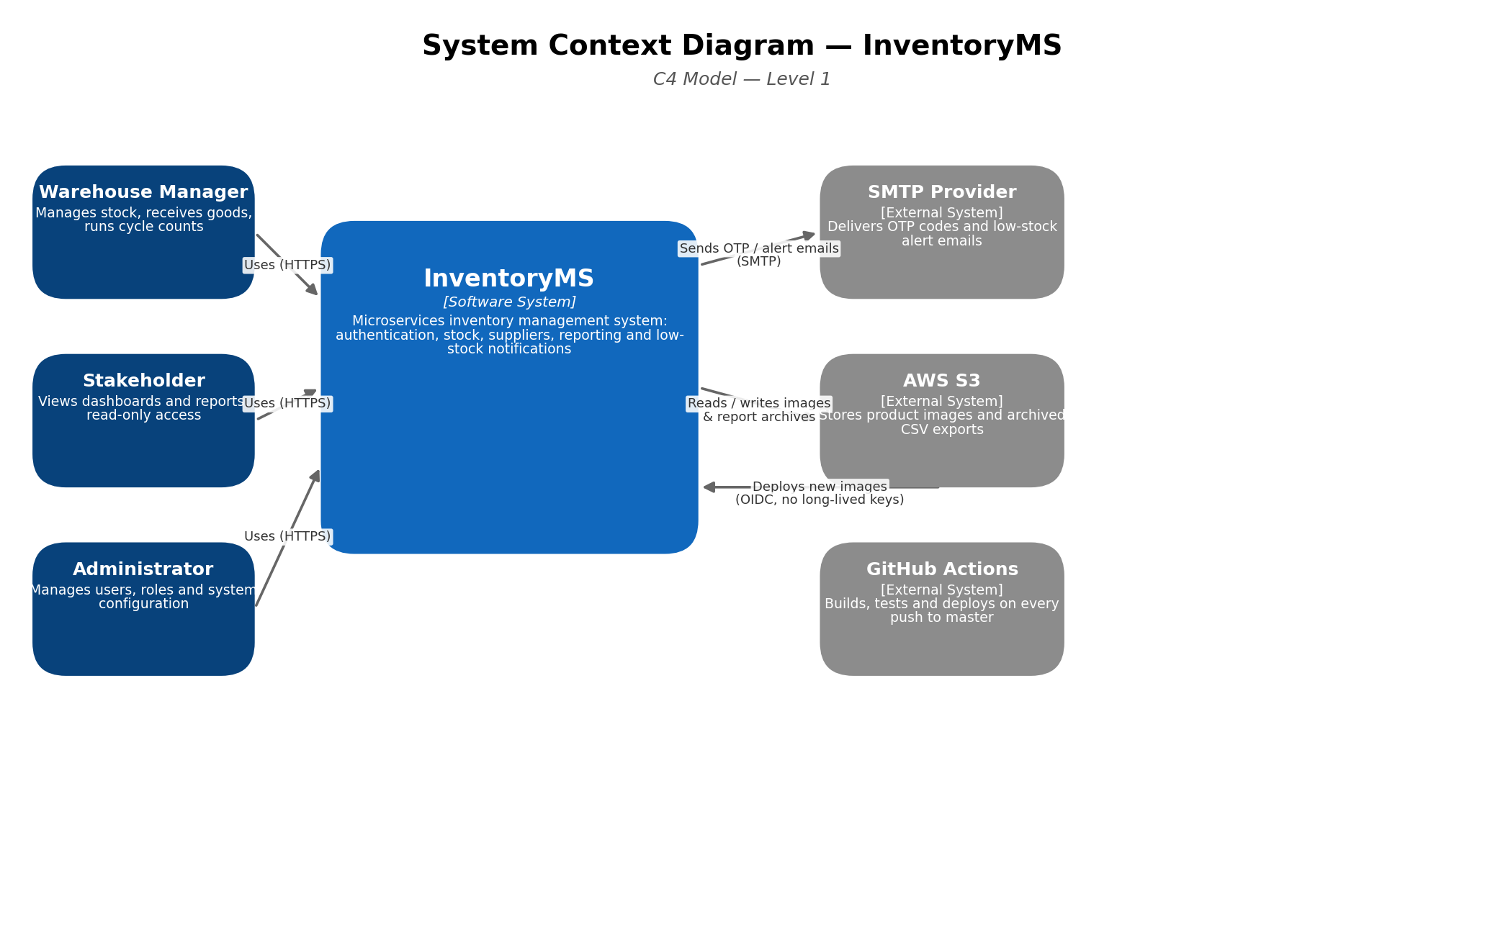
Figure 1 — System Context Diagram

2.2 Container Diagram (C4 — Level 2)
One level down: the frontend shell and its five federated remotes, the ALB/WAF edge, all five backend services with their actual ports and responsibilities, the shared RDS instance and its dedicated reporting read replica, and the three external AWS services each container talks to directly.
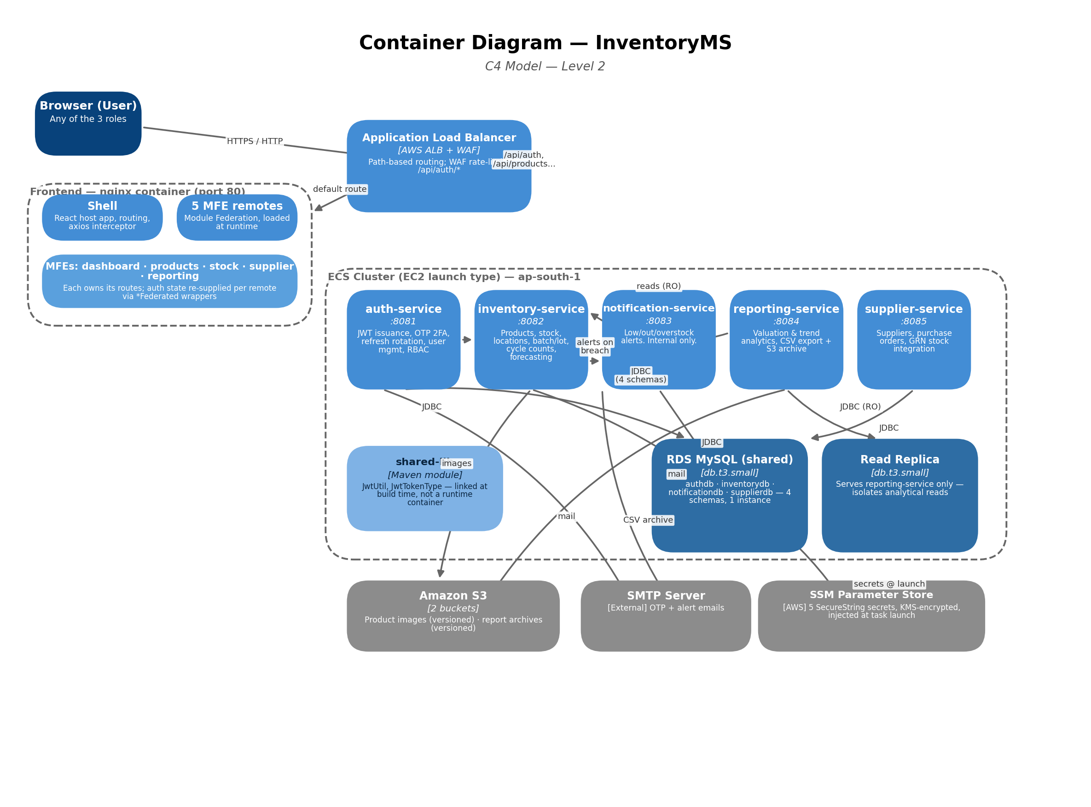
Figure 2 — Container Diagram
Note on shared-lib: it appears in this diagram for completeness but is a compile-time Maven dependency (JwtUtil, JwtTokenType), not a running container — it has no independent deployment footprint.

2.3 Network Topology
The AWS VPC layout: two Availability Zones, public subnets carrying only the ALB's elastic network interfaces, private subnets carrying every ECS task and both RDS instances, and the single NAT Gateway (ADR-003) that both AZs' private subnets route their outbound traffic through.
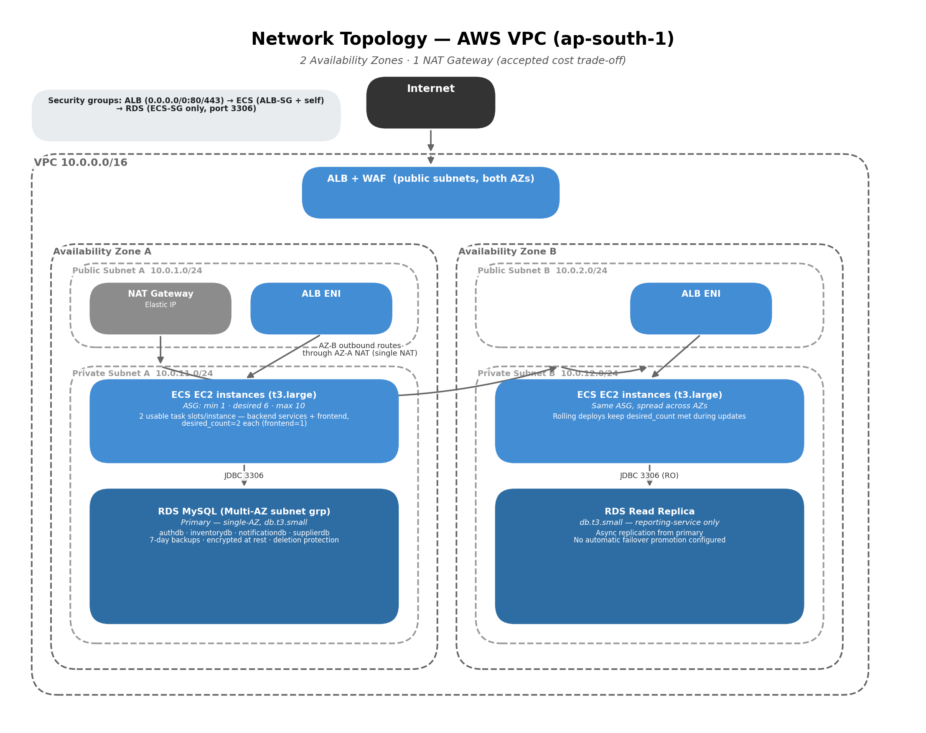
Figure 3 — Network Topology, AWS VPC 10.0.0.0/16

2.4 Component-level structure (within each service)
Not pictured as a fourth C4 diagram, since the pattern is identical across all five backend services and a diagram-per-service would be repetitive: every backend service follows a strict four-layer Domain-Driven Design structure, domain → application → infrastructure → interfaces, with dependency direction enforced at the compiler level — inner layers never import outer layers. Concretely for auth-service:
- domain — User, Role and token domain models; repository interfaces with no framework dependencies.
- application — AuthService orchestrates login/signup/OTP/refresh flows and enforces the 2-admin cap and bootstrap rule.
- infrastructure — JPA repository implementations, JwtAuthFilter, BCryptPasswordEncoder wiring.
- interfaces — AuthController (REST), GlobalExceptionHandler.

3. Architecture Decision Records (ADRs)
Ten records covering the trade-offs actually encoded in the Terraform and application code, each reflecting the decision as it stands in the repository today.
ADR-001 · One shared RDS instance with per-service schemas, not one database per service
Status | Accepted
Context
Five backend services each need a relational store. Running one db.t3.micro per service (the original layout) meant four always-on instances even though none of them individually needed dedicated compute or storage at this traffic level.
Decision
Consolidate auth, inventory, notification and supplier data onto a single db.t3.small RDS MySQL instance using four separate schemas (authdb, inventorydb, notificationdb, supplierdb). Each service still connects only to its own schema/credentials — the consolidation is physical, not logical.
Consequences
- + Single instance to patch, back up and monitor instead of four
- + db.t3.small has real headroom over four separate db.t3.micro instances for the same monthly cost band
- − A single noisy-neighbor schema (e.g. a heavy inventory-service migration) can affect I/O for the other three services
- − Loses the hard failure isolation of fully separate instances — one instance outage affects four services instead of one
Alternatives considered
Per-service RDS instances (rejected — 4× idle capacity cost for no traffic benefit at current scale); Aurora Serverless v2 (rejected — adds cost and operational complexity disproportionate to a single-instance workload); DynamoDB per service (rejected — the domain model is relational: FKs, joins across products/locations/stock, and Flyway-managed schema evolution).
ADR-002 · ECS on EC2 (Auto Scaling Group), not Fargate
Status | Accepted
Context
All six containers (5 backend services + frontend) need a compute layer. Fargate removes host management; EC2 requires operating an ASG but bills for reserved capacity rather than per-task.
Decision
Run ECS on a t3.large EC2 Auto Scaling Group (min 1 / desired 6 / max 10) with an ECS Capacity Provider doing target-tracking at 80% utilization, rather than AWS Fargate.
Consequences
- + t3.large gives 2 usable task slots per instance after the host's own ENI — at desired_count=6 instances, 11 of 12 available slots are used for the steady-state 11-task footprint, materially cheaper than equivalent Fargate vCPU/memory pricing at this always-on scale
- + Burstable T-family CPU credits absorb the intermittent nature of a portfolio-scale workload
- − The team owns AMI patching, ENI/task-slot capacity planning, and ASG health-check tuning that Fargate would have handled
- − Task placement is bin-packed manually via the 2-slot/instance math rather than abstracted away
Alternatives considered
Fargate (rejected — higher effective cost per vCPU-hour at this steady always-on task count, and direct control over instance-level CloudWatch Container Insights was wanted); Fargate Spot (rejected — reduced availability guarantee unsuitable even for a portfolio SLA).
ADR-003 · Single NAT Gateway across both Availability Zones
Status | Accepted
Context
Private-subnet ECS tasks and RDS need outbound internet access (pulling images from ECR, calling SMTP, etc.) without being directly internet-routable. A NAT Gateway is billed per-hour plus per-GB processed, and a highly-available design needs one per AZ.
Decision
Provision exactly one NAT Gateway (in AZ-A) and route both AZs' private subnets through it, instead of one NAT Gateway per AZ.
Consequences
- + Halves the fixed NAT Gateway hourly cost versus a per-AZ NAT design
- − If AZ-A fails, private subnet B loses outbound internet access even though its ECS tasks and RDS read replica may still be otherwise healthy — a known, accepted single point of failure for egress traffic only (inbound ALB traffic to a healthy AZ is unaffected)
Alternatives considered
One NAT Gateway per AZ (rejected on cost grounds for a portfolio-budget deployment — tracked as a documented risk rather than silently accepted); NAT instances (rejected — more operational burden than the cost saved over a managed NAT Gateway).
ADR-004 · Module Federation micro-frontends, not a single SPA bundle
Status | Accepted
Context
The frontend spans five functional domains (dashboard, products, stock, suppliers, reporting) plus a shell. A single monolithic React bundle would couple every feature to one build and one deploy.
Decision
Build five independently versioned Vite + Module Federation remotes, loaded at runtime by a shell application, each exposing its own routed pages and each independently deployable.
Consequences
- + Each MFE can be built, tested and deployed independently of the others
- + A failed remote (e.g. 404 on remoteEntry.js) degrades to a retry-able error card via a per-page MfeErrorBoundary instead of crashing the whole app
- − React Context does not cross remote boundaries, requiring a *Federated.jsx wrapper per component that needs auth state — a missing wrapper silently falls back to canWrite:false
- − Five separate shared-dependency graphs (react, react-dom, react-router-dom, axios) to keep in version lockstep across remotes
Alternatives considered
Single monolithic SPA (rejected — forces one build/deploy for unrelated features); iframes per module (rejected — poor UX, no shared auth/session context); a monorepo with lazy-loaded routes but one deployable bundle (rejected — doesn't achieve independent deployability).
ADR-005 · Three independent JWT signing secrets, one per token type
Status | Accepted
Context
The system issues session tokens (OTP flow), access tokens (API calls) and refresh tokens (silent re-auth). A single shared HS256 secret means any token, regardless of intended purpose, would validate anywhere it's checked.
Decision
Maintain three separate HS256 secrets (JWT_SESSION_SECRET, JWT_ACCESS_SECRET, JWT_REFRESH_SECRET), each bound to its own JwtUtil bean, with every token carrying a typ claim checked at validation time — a token minted for one purpose is cryptographically rejected if replayed as another.
Consequences
- + Defense-in-depth beyond "different secrets" alone: the typ claim check means a secret-confusion bug alone wouldn't be sufficient to misuse a token
- + A compromised refresh secret does not automatically compromise access-token validation and vice versa
- − Three secrets to generate, rotate and keep in sync across every service that validates that token type — rotation is a more involved, coordinated operation than with one shared secret
Alternatives considered
One shared JWT secret for all token types (rejected — no cryptographic separation between purposes); asymmetric RS256 with a single key pair (rejected as unnecessary complexity for a same-organization service-to-service trust boundary; HS256 is sufficient when all validators are internal services).
ADR-006 · Terraform state stored locally, not in an S3 backend
Status | Accepted (revisited)
Context
Terraform needs a state backend. An S3 backend is the standard recommendation for team environments, but requires the target bucket to already exist before terraform init can use it — a bootstrapping chicken-and-egg problem for a from-scratch deployment.
Decision
Use local state (terraform.tfstate) for the current single-contributor deployment. The S3 backend configuration exists commented-out in main.tf, ready to enable once a bootstrap bucket is provisioned out-of-band.
Consequences
- + No bootstrapping dependency — terraform init works immediately on a fresh checkout
- + Zero additional cost or moving parts for a single-operator project
- − No state locking — concurrent applies from two machines could corrupt state (acceptable today with one contributor, not if the team grows)
- − State lives only on the operator's machine, with no automatic backup
Alternatives considered
S3 backend with DynamoDB locking (deferred, not rejected — the intended target once a second contributor joins or a small out-of-band bootstrap script solves the chicken-and-egg problem); Terraform Cloud (deferred — adds an external dependency not currently justified).
ADR-007 · In-process Caffeine caching, not a shared Redis cache
Status | Accepted
Context
inventory-service and reporting-service both serve read-heavy endpoints (product/stock listings, stock valuation) that don't need to reflect every write within milliseconds.
Decision
Use Caffeine, an in-process JVM cache, with short TTLs (30s for products/stock, 60s for valuation) and eviction on write, rather than introducing a shared Redis/ElastiCache layer.
Consequences
- + Zero additional infrastructure, cost, or network hop — cache reads never leave the JVM
- + Sufficient for the current desired_count=2 per service; each task's cache simply serves slightly-stale data for at most one TTL window after a write on a different task
- − Not a coherent cache across replicas: a write on task A doesn't evict task B's cache entry, so a stale read is possible for up to the TTL window on the replica that didn't receive the write
- − Won't scale as a strategy if replica counts grow substantially or strict read-after-write consistency becomes a requirement
Alternatives considered
Amazon ElastiCache for Redis (rejected for now — added cost and operational surface not justified by current read volume; the 30–60s staleness window is an accepted trade-off); no caching at all (rejected — the goal was reducing DB load on the shared RDS instance from ADR-001).
ADR-008 · ECR IMMUTABLE image tags with git-SHA tagging, never :latest
Status | Accepted
Context
The deploy pipeline needs a way to guarantee that the image running in ECS is exactly the image built from a specific commit, and that a re-run of the pipeline for an already-built commit doesn't silently rebuild or overwrite anything.
Decision
All 6 ECR repositories are IMMUTABLE. Every image is tagged with the git commit SHA; Terraform resolves the same SHA independently via a git data source so an apply always targets the image matching the current commit. The pipeline checks for an existing SHA-tagged image before building and skips straight to the ECS deploy step if found.
Consequences
- + A commit's image can never be silently overwritten — IMMUTABLE tags reject the attempt at the registry level
- + Idempotent pipeline re-runs: re-triggering a workflow for a commit that already has an image skips the expensive build/push step entirely
- − Requires an explicit "fetch task def → swap image → register new revision → update service" step in the pipeline, since a bare force-new-deployment would just redeploy the same image — more moving parts than a mutable-tag pipeline
Alternatives considered
Mutable :latest tag with force-new-deployment (rejected — no way to guarantee the running image matches a specific commit, and no protection against accidental overwrite); tagging by build number instead of git SHA (rejected — git SHA gives a direct, verifiable link from a running container back to source).
ADR-009 · Dedicated RDS read replica for reporting-service
Status | Accepted
Context
reporting-service runs CSV export and valuation/trend-analytics queries against inventorydb — potentially expensive, scan-heavy reads that could contend with inventory-service's transactional read/write traffic on the same schema.
Decision
Provision a dedicated db.t3.small read replica of the shared RDS instance, and point reporting-service exclusively at it. reporting-service owns no schema of its own and never writes.
Consequences
- + Analytical query load is fully isolated from transactional load — a slow report export can no longer degrade inventory-service's latency
- + No additional write-path complexity: the replica is purely a read fan-out, requiring no application-level dual-write logic
- − Replica lag means reporting-service's view of the data can be seconds behind the primary — acceptable for valuation/trend reporting, not for read-your-writes use cases
- − Doubles the RDS compute cost for the inventorydb data path (primary + replica, both db.t3.small)
Alternatives considered
Querying the primary directly from reporting-service (rejected — the original motivation was exactly to avoid that contention); a separate OLAP store / data warehouse (rejected as disproportionate to current reporting volume and scope).
ADR-010 · HTTPS gated behind an optional domain_name variable; HTTP-only by default
Status | Accepted
Context
AWS will not issue an ACM certificate for a raw *.elb.amazonaws.com hostname, and registering a custom domain has an ongoing cost outside a free-tier portfolio budget. The ALB needs to serve traffic either way.
Decision
Make every HTTPS-related resource (ACM certificate, Route 53 records, HTTPS listener) conditional on a domain_name Terraform variable. When unset (the default), the ALB serves HTTP-only on the raw ELB hostname; supplying a domain automatically provisions the full HTTPS chain with a TLS 1.3 policy.
Consequences
- + Zero-cost default deployment path that still fully exercises the architecture end-to-end
- + Supplying a domain later requires no code changes — only setting one variable
- − By default, all traffic — including JWT access tokens, refresh cookies and credentials — travels over plain HTTP to the ALB: a real confidentiality gap in the default configuration, not merely a cosmetic limitation
- − COOKIE_SECURE must be manually kept in sync with the active mode; leaving it true against an HTTP-only ALB silently logs every user out once their access token first expires, since the browser never sends a Secure-flagged cookie over plain HTTP
Alternatives considered
Always provision HTTPS with a fixed placeholder domain (rejected — still costs money for a domain nobody uses); self-signed certificate on the ALB (rejected — browsers block or scare-page it, and it doesn't solve the *.elb.amazonaws.com ACM restriction).

4. Non-Functional Requirements (NFR)
Targets are stated as design intent (“Target”) alongside an honest read of what the current single-region, single-primary-instance topology actually delivers today (“Current posture”). Where the two differ, the gap is called out rather than hidden — consistent with the Known Gaps already tracked in the project README.

4.1 Availability
Layer | Target SLO | Current posture
Compute (ECS tasks) | 99.9% (≈ 43 min/mo) | Achievable today — desired_count=2 per service across 2 AZs behind the ALB, with rolling deploys and CloudWatch task-count alarms on 4 of 5 services (inventory-service and frontend currently lack one — tracked as a gap).
Database (RDS primary) | 99.9% | Not currently achievable — the primary is single-AZ (multi_az = false). Engine patching, instance-class changes and any primary-node failure incur real downtime with no automatic failover. This is the single biggest gap between target and current posture.
Network egress (NAT) | No single-AZ dependency | Not met by design (ADR-003) — one NAT Gateway in AZ-A means AZ-B's private subnet loses outbound internet if AZ-A fails. Inbound traffic through the ALB to a healthy AZ is unaffected.
Edge (ALB + WAF) | 99.99% (AWS-managed SLA) | Met — ALB and WAF are regional managed services spanning both AZs by default; no application-level gap here.

Composite estimate: with the database as the binding constraint, the realistic current-state availability for a request that touches RDS is closer to 99.5% (roughly 3.6 hours/month) once planned maintenance windows and patch cycles are accounted for — not the 99.9% target. Closing this gap is a Multi-AZ RDS upgrade (see §7 Roadmap).

4.2 Latency & Throughput
No production traffic has been captured yet via Container Insights, so the figures below are design targets used to size ECS task CPU/memory (see ADR context in the README's infrastructure sizing rationale), not measured SLIs. They should be replaced with real p50/p95/p99 figures once CloudWatch Container Insights has data.
Endpoint class | Target p95 latency | Target throughput | Basis
Auth (login/refresh) | < 300 ms | 50 req/s sustained | Bounded mainly by BCrypt cost factor + one RDS round-trip; WAF rate-limits this path to 100 req / 5 min / IP.
Product / stock reads (cached) | < 150 ms | 200 req/s sustained | Caffeine 30s-TTL cache hit avoids the DB round-trip entirely on repeat reads within the window.
Product / stock writes | < 400 ms | 30 req/s sustained | Includes cache eviction and a synchronous RDS write against the shared primary instance.
Reporting / CSV export | < 3 s (p95), async for large exports | 5 req/s sustained | Served from the dedicated read replica (ADR-009) precisely to keep this class off the transactional path's latency budget.

Known latency risks in the current design
- The shared RDS primary (ADR-001) is the common dependency for 4 of 5 services — a slow query or lock contention in one service's schema can add latency to the others sharing the instance's I/O and connection pool.
- ECS CPU/memory allocations (512/1024 for inventory & reporting, 256/512 for the rest) are starting-point allocations, explicitly flagged in the infrastructure notes as pending real traffic data — they have not been load-tested against the targets above.
- T3 burstable instances rely on CPU credits; a sustained load above baseline for a prolonged period incurs additional per-vCPU-hour charges and, if credits are exhausted, throttles CPU — a latency risk under sustained (not just bursty) load.

4.3 Disaster Recovery
Data store | RPO (target) | RPO (actual) | RTO (actual)
RDS primary (4 schemas) | < 5 min | Point-in-time recovery via automated backups, 7-day retention — RPO effectively minutes (transaction-log granularity within the retention window). | Hours, not minutes — no automatic failover is configured (multi_az = false). Recovery is a manual PITR restore to a new instance, then a DNS/connection-string cutover. No documented, tested runbook exists yet.
RDS read replica | N/A (derived) | Continuously replicated from primary — not an independent backup; a primary-data-loss event is replicated to the replica too. | The replica does not currently have automatic promotion configured, so it is not a ready-made failover target without a manual promotion step.
S3 (images, reports) | Near-zero | S3 is itself an 11-nines-durability, multi-AZ object store; versioning is enabled on both buckets, giving accidental-delete/overwrite recovery, not just disaster recovery. | Effectively immediate — no restore process needed for the object store itself.
Region-level event (ap-south-1 down) | Not defined | No cross-region backup replication or DR region exists today. | Undefined — a full ap-south-1 regional outage is not currently a recoverable scenario for this deployment. Explicitly out of scope for the current portfolio budget.

Deletion protection is enabled on the RDS primary and a final snapshot is taken on any deliberate teardown, which protects against accidental terraform destroy data loss — but this is a safety net, not a DR strategy. Multi-AZ RDS (automatic failover, RTO measured in single-digit minutes) is the highest-value next investment for closing this gap; see §7 Roadmap.

5. Security & Compliance Plan
Reflects controls actually implemented in the Terraform and application code today, not an aspirational target state. Gaps are called out explicitly in §5.6.

5.1 Identity & Access Management (IAM)
The system uses three distinct IAM identities, each scoped to the minimum permissions its job requires — no wildcard resource grants and no shared/human IAM users for automation.
Role | Assumed by | Granted permissions
ecs-execution-role | ECS agent (task launch) | AmazonECSTaskExecutionRolePolicy (pull images, write logs) + ssm:GetParameters scoped to exactly the 5 named SSM parameter ARNs + kms:Decrypt scoped to the single alias/aws/ssm key. Cannot read any other SSM parameter or any other KMS key.
ecs-task-role | Application code at runtime | s3:GetObject/PutObject/DeleteObject/ListBucket scoped to exactly the images bucket ARN, and GetObject/PutObject/ListBucket scoped to exactly the reports bucket ARN. No access to any other bucket, and no IAM, EC2 or database-control-plane permissions of any kind.
github-actions role (OIDC) | GitHub Actions workflow, via sts:AssumeRoleWithWebIdentity | ECR push/pull, ECS describe/update-service/register-task-definition, and iam:PassRole limited to exactly the two ECS roles above. The trust policy's StringLike condition pins the subject to repo:Farhans-Lair/inventory-system:* — no other GitHub repository can assume this role. No long-lived AWS access keys exist in GitHub at all.

5.2 Encryption Standards

At rest
- RDS (primary and read replica): storage_encrypted = true on both instances.
- S3 (images and reports buckets): AES-256 server-side encryption enforced via aws_s3_bucket_server_side_encryption_configuration; both buckets also block all public access (ACLs and bucket policies) at the account level for that bucket.
- SSM Parameter Store secrets: stored as SecureString, encrypted with the AWS-managed alias/aws/ssm KMS key. No plaintext secret values exist in Terraform state variables marked non-sensitive, task definitions, or the git repository.
- VPC Flow Logs: written to S3 in Parquet format with a 90-day expiry lifecycle rule.

In transit
- Service-to-service and browser-to-ALB, when a domain is configured: TLS 1.3 via the ELBSecurityPolicy-TLS13-1-2-2021-06 ACM policy (see ADR-010).
- Default deployment (no domain configured): the ALB serves HTTP only. This is a genuine gap, not a simplification — tracked in §5.6.
- Database connections (ECS → RDS): plain JDBC within the VPC, not TLS-wrapped. Traffic never leaves the private subnets and is restricted by security group to the ECS security group only, but it is not encrypted in transit at the protocol level.

5.3 Network Security
Security groups form a strict three-tier chain — each tier only accepts traffic from the tier immediately in front of it:
Security group | Inbound allowed from | Purpose
sg-alb | 0.0.0.0/0 on ports 80 and 443 only | The only security group exposed to the public internet in the whole architecture.
sg-ecs | sg-alb on each service's container port, plus self-referencing ingress on the same ports for inter-service calls | ECS tasks are unreachable directly from the internet — only via the ALB — and can call each other (e.g. inventory-service → notification-service) without opening ports to anything broader.
sg-rds | sg-ecs on port 3306 only | The database is reachable only from application containers — not from the ALB, not from the internet, not even from an EC2 host process outside the ECS security group.

- Network segmentation: all compute and data resources sit in private subnets across 2 AZs; only the ALB's ENIs sit in public subnets.
- WAF (AWS Managed Rules): CommonRuleSet, SQLiRuleSet and KnownBadInputsRuleSet are attached to the ALB, plus a custom rate-based rule capping /api/auth/* at 100 requests / 5 minutes / source IP to blunt credential-stuffing and brute-force attempts against login and OTP endpoints specifically.
- VPC Flow Logs capture ALL traffic (ACCEPT and REJECT) for network-level audit and incident investigation, retained 90 days.

5.4 Authentication & Authorization
- Password storage: BCryptPasswordEncoder — salted, adaptive-cost hashing; no plaintext or reversibly-encrypted passwords anywhere in the system.
- Multi-factor by default: every login and signup requires an OTP step, gated by a short-lived (10-minute) session token that proves the client completed the request-OTP step for that exact email and purpose before the OTP itself is accepted.
- Token architecture: three independently-secreted, purpose-typed JWTs (session/access/refresh) — see ADR-005. Refresh tokens live in an HttpOnly cookie scoped to path=/api/auth/, are rotated on every use, and reuse of an already-rotated-out token triggers full session revocation for that user (a strong compromise-detection signal).
- Role-based access control: three roles (ADMIN, WAREHOUSE_MANAGER, STAKEHOLDER) enforced with Spring Security's @EnableMethodSecurity at the service layer — not just hidden in the UI. The 2-admin cap and the "first user becomes bootstrap admin" rule are both enforced server-side, independent of what the frontend sends.
- Unauthenticated vs. unauthorized responses are correctly distinguished (401 via a dedicated AuthenticationEntryPoint vs. 403), which the frontend's silent-refresh interceptor depends on to work correctly — a subtle but security-relevant correctness detail, since a wrong status code here could cause silent auth failures or unnecessary logouts.
- CORS is centrally defined once in shared-lib (CorsDefaults) and reused by every service's SecurityConfig, avoiding drift between services' allowed-origin lists.

5.5 Secrets Management
- Production: all 5 sensitive values (DB_PASS, the 3 JWT secrets, MAIL_PASSWORD) are stored in SSM Parameter Store as SecureString and injected into ECS task definitions at container-launch time via the secrets/valueFrom mechanism — never baked into an image or committed to the repository.
- Local development: the same variable names are supplied via a git-ignored .env file (.env.example documents every required key with no real values), keeping the dev and prod configuration surfaces identical in shape.
- CI/CD: GitHub Actions authenticates to AWS purely via OIDC federation — there are no long-lived AWS access keys stored as GitHub secrets to leak, rotate or accidentally log.
- Rotation: because JWT secrets are per-purpose (ADR-005), each can be rotated independently without invalidating tokens of the other two types — though a coordinated rotation across every service validating that token type is still required for it to take effect cleanly.

5.6 Known Security Gaps
Stated plainly, for the same reason the project README tracks infrastructure gaps openly:
- HTTP-only by default (§5.2, ADR-010) — the single most significant gap. Any default deployment without a configured domain transmits credentials, JWTs and refresh cookies unencrypted between the browser and the ALB.
- JDBC traffic between ECS and RDS is not TLS-wrapped, relying entirely on network-layer isolation (security groups + private subnets) rather than transport encryption for defense-in-depth.
- No AWS Secrets Manager rotation schedule is configured for DB_PASS or the JWT secrets — rotation today is a manual operational process, not an automated one.
- No WAF bot-control or CAPTCHA on signup — the OTP requirement raises the bar for automated account creation but doesn't eliminate scripted abuse.
- No formal data classification, retention schedule, or right-to-erasure workflow exists for user PII (emails, names) — relevant if this system were to move from a portfolio project toward handling real personal data under a framework such as GDPR or India's DPDP Act.

6. Cost Estimate (AWS ap-south-1)
Figures below are indicative On-Demand, Linux, ap-south-1 (Mumbai) monthly estimates built from each resource's actual Terraform configuration (instance types, counts, storage sizes). They are planning estimates, not a bill — confirm current rates in the AWS Pricing Calculator before budgeting, since AWS revises pricing periodically and Reserved/Savings Plan pricing can cut the compute lines by up to ~40–72%.

6.1 Monthly cost breakdown — current architecture
Resource | Configuration | Est. monthly (USD) | Est. monthly (INR)
EC2 (ECS hosts) | 6 × t3.large, desired capacity, On-Demand | $406 | ₹33,900
EBS (root volumes) | 6 × 30 GB gp3 | $16 | ₹1,340
RDS primary | 1 × db.t3.small, single-AZ, 30–300 GB gp3 autoscaling | $45 | ₹3,760
RDS read replica | 1 × db.t3.small (reporting-service only) | $45 | ₹3,760
NAT Gateway | 1 × gateway, hourly + est. 100 GB/mo processed | $48 | ₹4,010
Application Load Balancer | 1 × ALB, hourly + est. LCU usage at portfolio traffic | $22 | ₹1,840
WAF | 1 Web ACL + 4 rule groups + est. 1M requests/mo | $9 | ₹750
S3 (images, reports, flow logs) | Est. 15 GB stored + versioning overhead + requests | $1 | ₹85
ECR | 6 repos, lifecycle-limited to last 10 images each | $2 | ₹165
CloudWatch (alarms, logs, Container Insights) | 11 alarms + Container Insights + log ingestion/storage | $12 | ₹1,000
SNS | Alarm notification topic, low volume | < $1 | < ₹85
SSM Parameter Store | 5 SecureString standard-tier parameters | $0 | ₹0
Data transfer out (internet) | Est. 20 GB/mo at low portfolio traffic | $2 | ₹165
X-Ray | Distributed tracing, est. under 100K traces/mo free tier | $0–$3 | ₹0–250
Route 53 / ACM | Not provisioned by default (domain_name unset — ADR-010) | $0 | ₹0
Total — On-Demand |  | ≈ $608 / mo | ≈ ₹50,800 / mo

INR figures use an illustrative ₹83.5/USD rate and exclude 18% GST (GST-registered businesses reclaim this as input tax credit, so the pre-GST figure above is the more useful planning number).

6.2 Cost optimization opportunities (Total Cost of Ownership)
Lever | Mechanism | Indicative saving
1-year EC2 Reserved Instances / Savings Plan | Commit the 6 always-on t3.large ECS hosts to a 1-year No-Upfront Savings Plan instead of On-Demand. | ≈ 35–40% off the EC2 line
Graviton (ARM) instances | Move ECS hosts to t4g.large — Spring Boot / Node builds are already portable to ARM; this is a re-platform, not a re-architecture. | ≈ 20% on top of the above
Right-size the ASG floor | desired_count=6 is sized for steady-state 11 tasks at zero-gap rolling deploys; a lower-traffic off-peak scaling policy could trim 1–2 instances outside business hours. | ≈ $65–$135/mo
S3 lifecycle tuning | Product images already expire noncurrent versions at 30 days; extending Intelligent-Tiering to the reports bucket (currently no expiry) would control long-run growth. | Marginal at current volume; compounds over years
Skip the second NAT Gateway (already done) | ADR-003 — already a deliberate single-NAT design; listed here to make the trade-off's cost impact explicit rather than implicit. | ≈ $32/mo avoided vs. HA-NAT

6.3 Cost of closing the availability gap (§4.3 DR, ADR-003)
For transparency, the two changes that would most directly close the NFR and DR gaps identified in §4 carry a real cost premium over the current architecture:
- Multi-AZ RDS (automatic failover): roughly doubles the RDS line for the primary instance (a standby replica in a second AZ is billed at the same rate as the primary) — an incremental ≈ $45/mo for both the primary and, if applied there too, the reporting replica.
- Second NAT Gateway (removes the AZ-B egress single point of failure from ADR-003): an incremental ≈ $32–$48/mo, roughly matching the existing NAT Gateway's own cost line above.
Together, closing both gaps adds roughly $90–$140/mo (≈ ₹7,500–₹11,700/mo) to the current ≈ $608/mo baseline — a deliberate trade-off the project has so far chosen not to make, consistent with ADR-003's stated cost rationale.

7. Roadmap — Prioritized Gaps
Every gap below was already surfaced in §4–§6 of this document, or already tracked in the project README's Known Gaps section. Listed here together, in priority order, as the single place to check before the next planning cycle.

7.1 High priority
- Enable HTTPS by default (§5.2, ADR-010) — the current HTTP-only default is a real confidentiality gap for credentials and JWTs. Requires accepting the ongoing cost of a registered domain, or investigating a lower-cost path (e.g. a subdomain of an already-owned domain).
- Enable RDS Multi-AZ on the primary (§4.1, §4.3) — closes the single largest availability and DR gap in the system. Estimated incremental cost: ≈ $45/mo (§6.3).
- Add CloudWatch task-count alarms for inventory-service and frontend (§4.1) — currently the only 2 of 6 ECS services with no running-task-count alarm, despite inventory-service being the highest-traffic backend service.

7.2 Medium priority
- Add a second NAT Gateway (§4.1, ADR-003) — removes the AZ-B egress single point of failure. Estimated incremental cost: ≈ $32–$48/mo (§6.3).
- Move Terraform state to an S3 backend with DynamoDB locking (ADR-006) — needed before a second contributor joins the project; the backend config already exists commented-out in main.tf.
- Define and rehearse an RDS PITR restore runbook (§4.3) — the backup retention and PITR capability already exist; a tested, documented recovery procedure does not.
- Capture real production latency/throughput figures via CloudWatch Container Insights (§4.2) — to replace the design-time targets in this document with measured SLIs, and to validate the current ECS CPU/memory allocations against actual load.

7.3 Lower priority / future scope
- Automate secret rotation for DB_PASS and the JWT secrets (§5.5) — currently a manual process.
- Define a data classification and retention policy for user PII, ahead of any move toward formal compliance scope such as GDPR or India's DPDP Act (§5.6).
- Evaluate Reserved Instances / Savings Plans and Graviton instances for the ECS host fleet once traffic patterns stabilize (§6.2).
- Revisit the in-process Caffeine caching strategy (ADR-007) if replica counts grow or stricter read-after-write consistency becomes a product requirement.

