TicketVerse
System Design Specification
Spring Boot Edition
Architecture · Decision Records · NFRs · Security & Compliance · Cost
Repository: ticketapp
Region: AWS ap-south-1 (Mumbai) · Branch: main
Document version 1.0
This document is derived directly from the project's Terraform configuration, Spring Boot application source code and GitHub Actions workflow as committed to the repository. Every figure, control and diagram traces to a specific file in the codebase; nothing here is aspirational unless explicitly marked “target” or “roadmap.”

Contents
1. Introduction 3
1.1 How to read this document 3
2. System Architecture Diagrams 4
2.1 System Context (C4 — Level 1) 4
2.2 Container Diagram (C4 — Level 2) 4
2.3 Network Topology 5
2.4 Component-level structure 6
3. Architecture Decision Records (ADRs) 7
4. Non-Functional Requirements (NFR) 14
4.1 Availability 14
4.2 Latency & Throughput 14
4.3 Disaster Recovery 15
5. Security & Compliance Plan 17
5.1 Identity & Access Management (IAM) 17
5.2 Encryption Standards 17
5.3 Network Security 18
5.4 Authentication & Authorization 18
5.5 Secrets Management 18
5.6 Known Security & Reliability Gaps 19
6. Cost Estimate (AWS ap-south-1) 20
6.1 Monthly cost breakdown 20
6.2 Where the money goes 20
6.3 Cost optimization opportunities (TCO) 21
6.4 Cost of closing the gaps 21
7. Roadmap — Prioritized Gaps 22
7.1 High priority 22
7.2 Medium priority 22
7.3 Lower priority / future scope 22

1. Introduction
TicketVerse (Spring Boot edition) is a single Spring Boot 3.2 / Java 17 application serving a multi-role event ticketing platform — users booking seats, organizers managing events and payouts, admins moderating the platform — backed by MySQL and deployed on AWS as a Dockerized app on an EC2 Auto Scaling Group behind an ALB, with an nginx rate-limiting sidecar on each instance. This document is the design specification for that system: it makes the architecture, the trade-offs behind it, its non-functional characteristics, its security posture and its running cost explicit and reviewable in one place.
This is the second Spring Boot iteration in this portfolio's ticketing-platform line; where relevant, this document notes where its design choices deliberately differ from — and in several cases directly fix gaps found in — a companion Node.js/Express implementation of the same product idea. Each section below is grounded in what is actually deployed: diagrams are drawn from the real Spring MVC route table and Terraform resources, the ADRs document trade-offs visible in the code, the NFR targets are compared honestly against what the current topology delivers, and the security plan states which controls exist today versus which are known gaps — including one genuinely significant gap this document does not soften.

1.1 How to read this document
- Section 2 — System Architecture Diagrams: C4 Level 1 (Context), Level 2 (Container), and a network topology diagram of the AWS VPC.
- Section 3 — Architecture Decision Records: ten ADRs covering the trade-offs actually encoded in the Terraform, Spring application and CI workflow.
- Section 4 — Non-Functional Requirements: availability, latency/throughput and disaster-recovery targets, each paired with the current, honestly-assessed posture — including a production availability gap in the OTP flow that the infrastructure alone doesn't reveal.
- Section 5 — Security & Compliance Plan: IAM, encryption, network security, authentication/authorization, secrets management, and known gaps.
- Section 6 — Cost Estimate: a line-item AWS ap-south-1 monthly estimate, optimization levers, and the explicit cost of closing the identified gaps.
- Section 7 — Roadmap: the prioritized list of gaps this document surfaces.

2. System Architecture Diagrams
C4 Model, Levels 1 and 2, plus a network topology view of the AWS deployment. All three are generated directly from the Spring MVC controller mappings, Terraform resources, and the user_data.sh boot sequence in the repository.

2.1 System Context (C4 — Level 1)
TicketVerse as a single black box, its three user roles, and the four external systems it depends on: Razorpay for payments, SMTP for email, Twilio for optional SMS, and S3 for ticket/invoice/event-image storage.
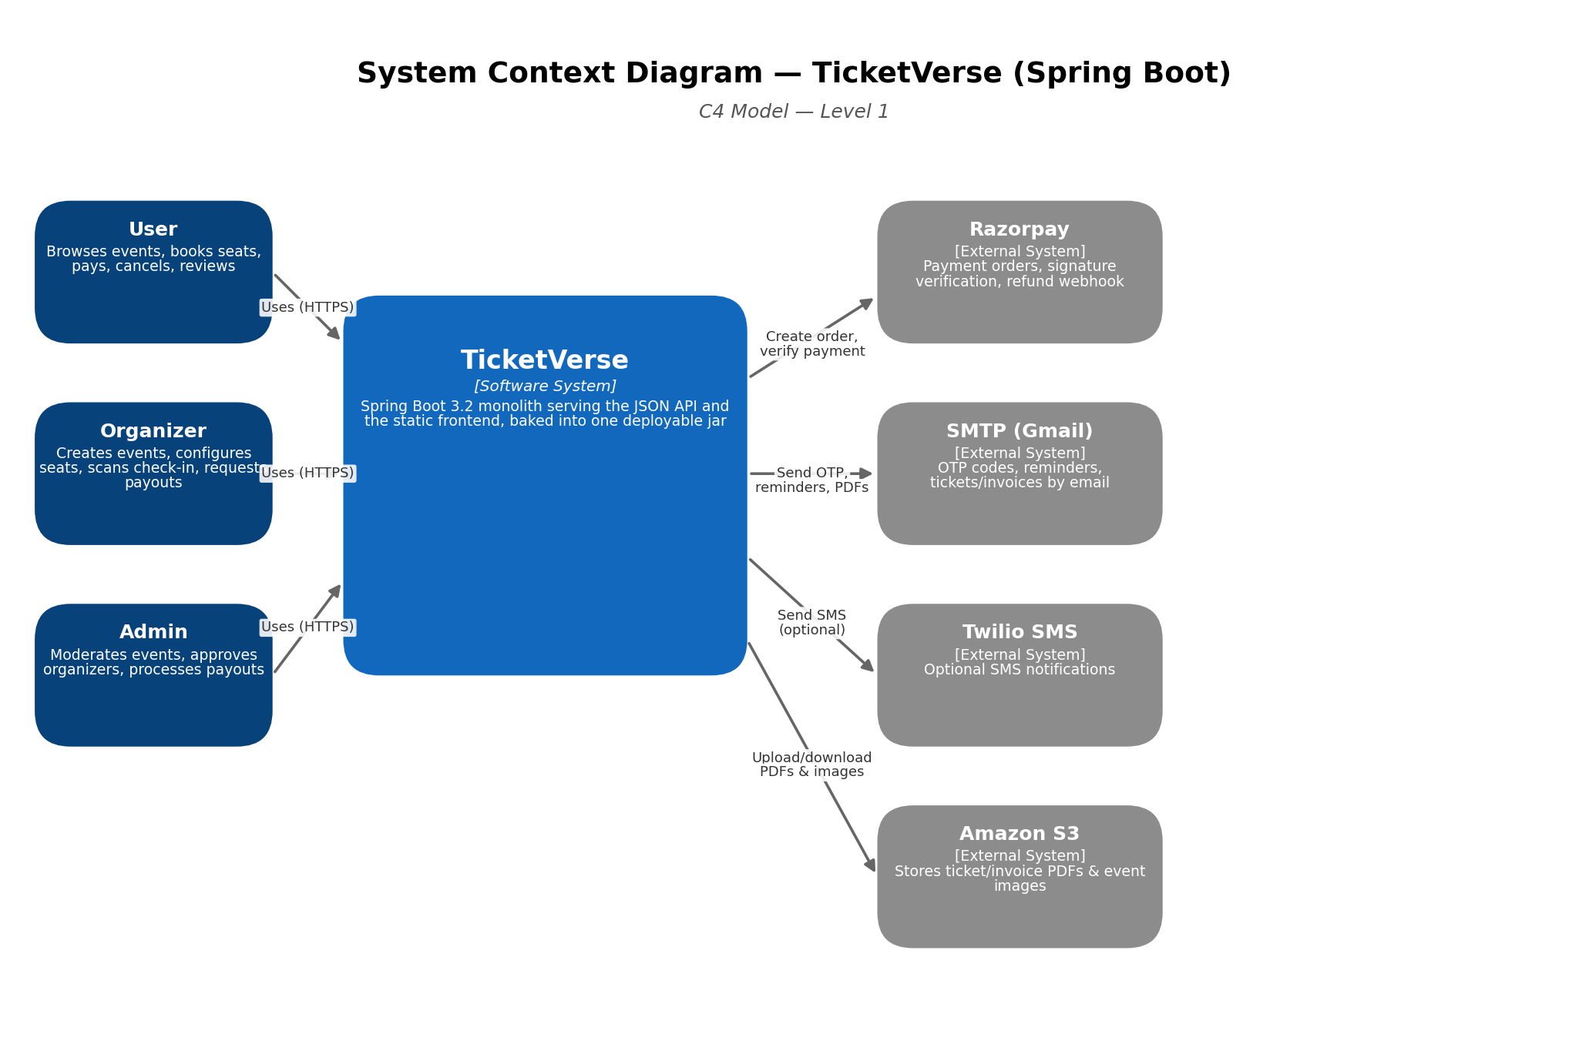
Figure 1 — System Context Diagram

2.2 Container Diagram (C4 — Level 2)
One level down: the ALB, the per-instance nginx rate-limiting sidecar in front of the Spring Boot app (which is not itself reachable from the ALB), the SSM-fetched secrets path, RDS primary/replica, the ElastiCache Redis container that exists in this diagram's design intent but is not actually provisioned (see §4.1 and §5.6), and the CI/CD path.
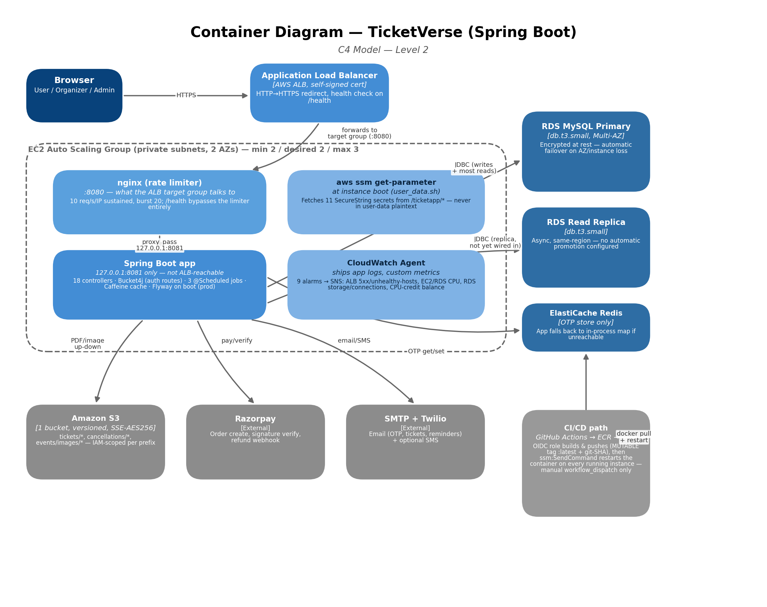
Figure 2 — Container Diagram
Note: the Redis box in this diagram reflects the application's design and the OtpStore code path, not current AWS reality — no ElastiCache resource exists in Terraform today, so this dependency is currently unfulfilled in production (§4.1, §5.6, §7).

2.3 Network Topology
The AWS VPC layout: two Availability Zones, each with its own NAT Gateway (unlike a companion project's single shared NAT), a 2-instance ASG floor spread across both AZs, and RDS Multi-AZ with a same-region read replica.
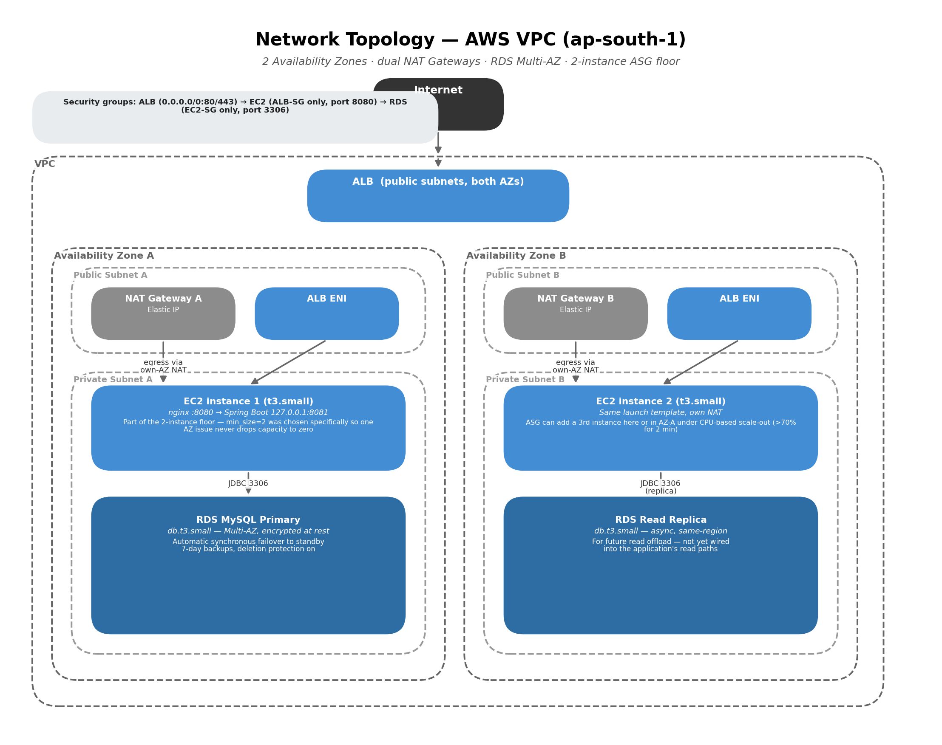
Figure 3 — Network Topology, AWS VPC

2.4 Component-level structure
Not pictured as a fourth C4 diagram, since it is a single process: the Spring Boot app follows a standard layered structure — controller → service → repository → entity. Concretely, for the booking flow:
- controller — `SeatController`, `PaymentController`, `BookingController`, `CancellationController` handle HTTP concerns and delegate to services, gated by `JwtAuthFilter` and, for admin/organizer routes, `AccessControl`.
- service — `SeatService` (pessimistic locking on seat holds), `PaymentService` (Razorpay order + HMAC signature verification), `BookingService` (fee calculation, coupon application), `CancellationService` (tiered refund calculation, waitlist notification trigger) hold the business logic.
- repository — 13 Spring Data JPA repositories (`BookingRepository`, `SeatRepository`, `EventRepository`, etc.), thin interfaces over Hibernate.
- entity — 13 JPA entities including `Booking`, `Seat`, `Event`, `User`, `Coupon`, `Review`, `Wishlist`, `WaitlistEntry`, `RefreshToken`, `OrganizerPayout`, `OrganizerProfile`, `CancellationPolicy`, `EventCategory` — with dead `showtimeId`/`movieId` fields still present on `Seat`, `Booking` and `Review` from a removed cinema vertical (§7 Roadmap).

3. Architecture Decision Records (ADRs)
Ten records covering the trade-offs actually encoded in the Terraform, Spring application and CI workflow, each reflecting the decision as it stands in the repository today.
ADR-001 · Rewrite the Node/Express backend as Spring Boot, keeping the same layered shape
Status | Accepted
Context
The original ticketing backend was a working Node.js/Express + Sequelize application (the companion `Ticket-Booking-Application-2` repo). The goal of this project was hands-on depth with the Java/Spring ecosystem, not a rewrite forced by a technical limitation in Express.
Decision
Port the application to Spring Boot 3.2 / Java 17, mapping the existing Controller → Service → Model → DB layout onto Controller → Service → Repository → Entity directly, feature-for-feature, rather than redesigning the domain model from scratch.
Consequences
- + A working reference implementation (the Node version) meant every behavioral question ("what should this edge case do?") had a known-correct answer to port against, rather than being re-litigated from scratch
- + The 1:1 layer mapping made it possible to validate parity incrementally, service by service
- − Porting surfaced framework-level gaps that don't show up when reading documentation — the codebase's own comments describe a real afternoon lost to `@PreAuthorize` silently returning empty 403 bodies (see ADR-002) before the team understood Spring Security's default exception handling
- − Two codebases with overlapping domain logic now exist in the same organization's repos, with no shared library between them — a bug fixed in one won't automatically appear in the other
Alternatives considered
Stay on Node/Express and invest the same effort in deepening Node expertise instead (rejected — doesn't serve the stated learning goal); a from-scratch Spring Boot redesign not constrained by the existing schema/API shape (rejected — would have made parity validation far harder without a clear correctness baseline).
ADR-002 · Centralized manual role checks (AccessControl), not @PreAuthorize/SpEL
Status | Accepted (revisited)
Context
Ten-plus admin-only and organizer-only endpoints across `EventController`, `RevenueController`, `EventCategoryController`, `OrganizerController` and `PayoutController` each had their own hand-written, near-identical role-check logic — `AccessControl`'s own Javadoc documents the exact duplication. Spring Security's `@PreAuthorize` with SpEL is the idiomatic way to express this, but the codebase deliberately moved away from it.
Decision
Consolidate every role check into one injectable `@Component` (`security/AccessControl`) with three explicit methods — `isAdmin`, `isOrganizerOrAdmin`, `isApprovedOrganizer` — called directly from controller code (`if (!accessControl.isAdmin(user)) ...`) instead of `@PreAuthorize("@accessControl.isAdmin(...)")` annotations.
Consequences
- + Every role check is a plain Java method call — stack traces, breakpoints, and "find usages" all work exactly as they would for any other code, with no SpEL expression evaluation to reason about
- + Consolidation eliminated the duplicate-logic drift risk (the exact bug class the Javadoc describes) without introducing a new abstraction layer to debug
- − `@PreAuthorize` failures return an empty 403 body by default unless explicitly configured otherwise — the manual-check style avoids that specific footgun, but only because `SecurityConfig`'s `accessDeniedHandler`/`authenticationEntryPoint` now handle *all* 401/403 responses centrally; the underlying Spring Security exception-handling behavior that caused the original problem was never itself well understood mid-migration, only worked around
- − `config/RoleCheck.java`, the SpEL-oriented predecessor to `AccessControl`, was left in the codebase unused and unreferenced rather than deleted — see §7 Roadmap
Alternatives considered
`@PreAuthorize("hasRole('ADMIN')")` with Spring Security's role model (rejected — doesn't cleanly express the "approved organizer" compound check, which needs a repository lookup, not just a role string); a custom `AccessDecisionVoter` (rejected as more machinery than justified for three checks).
ADR-003 · An nginx sidecar per EC2 instance for rate limiting, not AWS WAF
Status | Accepted
Context
The ALB itself has no native rate-limiting capability outside AWS WAF, which is a paid, separately-managed service. Something needs to stop abusive traffic before it reaches the JVM.
Decision
Run an `nginx:alpine` container on each EC2 instance (`--network host`), listening on the port the ALB target group actually talks to (8080) and reverse-proxying to Spring Boot, which is rebound to listen only on `127.0.0.1:8081`. nginx enforces 10 req/s sustained per client IP (burst 20), reading the real client IP from the ALB's `X-Forwarded-For` header — safe specifically because the EC2 security group only accepts inbound :8080 from the ALB's security group, so nothing else can reach nginx to spoof that header.
Consequences
- + Zero additional AWS service cost — nginx:alpine is a free, well-understood image, and this reuses compute already being paid for
- + Covers *all* traffic, not just the auth endpoints Bucket4j protects (ADR-007 gap) — broader protection than the in-app limiter alone provides
- − Config lives in a single flat file (`nginx-rate-limit.conf`) deployed by `user_data.sh`, not managed as Terraform-versioned infrastructure the way an AWS WAF Web ACL would be — changing the rate limit means editing a shell-deployed file, not a Terraform variable
- − Like Bucket4j (ADR-007), this limiter is per-instance: two ASG instances each independently allow 10 req/s from the same IP, so the effective platform-wide ceiling for one abusive client is `10 × running_instance_count`, not a hard 10 req/s
Alternatives considered
AWS WAF with a rate-based rule (rejected on cost grounds for a portfolio-budget deployment, and explicitly named as the alternative in the nginx config's own header comment); no rate limiting at all beyond Bucket4j (rejected — leaves every non-auth endpoint, including seat holds and payment creation, fully exposed to abuse).
ADR-004 · Two NAT Gateways (one per AZ), not one shared NAT Gateway
Status | Accepted
Context
Private-subnet EC2 instances and RDS need outbound internet access without being directly internet-routable. A single shared NAT Gateway is cheaper but ties every AZ's egress to whichever AZ hosts that one gateway.
Decision
Provision one NAT Gateway per Availability Zone (`ticketapp_nat_a`, `ticketapp_nat_b`), each with its own Elastic IP, with each AZ's private-subnet route table pointing only at its own AZ's NAT Gateway.
Consequences
- + No cross-AZ egress dependency — unlike a single-NAT design, losing AZ-A does not take down AZ-B's ability to reach ECR, S3, SMTP, or the Razorpay API
- + Matches the same AZ-independence goal already applied to the ASG floor (ADR — min_size=2) and RDS (Multi-AZ) — this system consistently avoids single-AZ dependencies at every layer, not just the database
- − Doubles the fixed NAT Gateway hourly cost versus a shared single-NAT design — the most expensive individual line item in this deployment's monthly bill (see §6.2)
Alternatives considered
Single shared NAT Gateway (rejected — the AZ-independence goal applied elsewhere in this architecture would be undermined by a shared-NAT single point of failure); NAT instances instead of managed NAT Gateways (rejected — doubles the operational burden this ADR is trying to avoid, for a smaller saving than the Reserved-capacity levers already available).
ADR-005 · RDS Multi-AZ, encrypted at rest, plus a read replica — all three from day one
Status | Accepted
Context
The database needs to survive an AZ failure, protect data at rest, and have headroom to offload read-heavy traffic (event listings, search) from the transactional path.
Decision
Enable `multi_az = true` and `storage_encrypted = true` on the RDS primary, and provision a separate `db.t3.small` read replica via `replicate_source_db`, all in the initial Terraform rather than added later.
Consequences
- + Automatic synchronous-standby failover (typically 60–120s) on primary/AZ failure, with storage encryption covering the primary, its automated backups, snapshots, and the replica — all inherited from the primary's encryption setting with no separate configuration needed
- + Doing this from day one avoids the awkward later migration a companion project now has to schedule (enabling `storage_encrypted` on an existing unencrypted instance requires a snapshot-and-restore, not a live toggle)
- − Roughly doubles the primary's compute+storage cost versus a single-AZ instance, plus a third instance for the replica — the largest recurring cost driver in this deployment after the dual NAT Gateways (§6.1)
- − The replica is not yet consistently used by read-heavy controllers — provisioned ahead of the application code that would benefit from it, mirroring the same gap in a companion project's design
Alternatives considered
Single-AZ, unencrypted primary with encryption added later (rejected — deliberately avoids the live-migration problem this creates, informed directly by the gap identified in the companion Node.js project's own security review); Aurora MySQL (rejected as disproportionate operational complexity for the current scale).
ADR-006 · Secrets fetched from SSM Parameter Store at instance boot, not injected via Terraform user-data
Status | Accepted
Context
EC2 instances need database credentials, JWT secrets, Razorpay keys, and email credentials to write their `.env` file. A companion project in this same portfolio interpolates these directly into Terraform-rendered user-data, which ends up readable via `ec2:DescribeInstanceAttribute` and stored in Terraform state.
Decision
Store every secret as an `aws_ssm_parameter` `SecureString` (`ssm_parameters.tf`), and have `user_data.sh` call `aws ssm get-parameter --with-decryption` for each one at boot time, writing the *values* (not the Terraform-rendered secrets) into the local `.env` file. The EC2 instance role is scoped to `ssm:GetParameter*` on exactly `/ticketapp/*`.
Consequences
- + The rendered user-data script itself contains no secret values — only parameter *names* — so reading user-data via `DescribeInstanceAttribute` no longer discloses any credential, closing the exact gap identified in the companion project's security review
- + IAM-scoped at the path level (`/ticketapp/*`), so the EC2 role cannot read any other application's SSM parameters even if this account hosts more than one
- − The GitHub Actions deploy role's `ssm:SendCommand`/`GetCommandInvocation`/`ListCommandInvocations`/`DescribeInstanceInformation` grants use `Resource = "*"` rather than being scoped to this project's instances specifically — broader than strictly necessary, though `ec2:DescribeInstances` and several SSM actions are Describe/List-type calls that IAM cannot scope to a resource ARN in the first place
- − Values are still plaintext in the instance's local `.env` file after being fetched — SSM closes the user-data/state-file disclosure path, but does not itself encrypt secrets at rest on the running instance's disk
Alternatives considered
Terraform user-data injection (rejected — this is precisely the pattern being avoided, informed by the sibling project's own documented gap); AWS Secrets Manager instead of SSM Parameter Store (rejected — SecureString parameters give the same encryption-at-rest and IAM-scoping benefits at no additional per-secret cost, which mattered more than Secrets Manager's automatic-rotation feature that isn't used here anyway).
ADR-007 · Redis for OTP storage with an automatic in-memory fallback
Status | Accepted (partially undermined in production — see §5.6)
Context
OTPs were originally stored in an in-process `ConcurrentHashMap`, which has two failure modes on AWS: OTPs are lost on every restart, and with more than one ASG instance running, an OTP generated on instance A can't be verified if the follow-up request lands on instance B.
Decision
Move OTP storage to Redis (`OtpStore` via `StringRedisTemplate`), with both `generate()` and `verify()` wrapping every Redis call in a try/catch that transparently falls back to the original in-memory map if Redis is unreachable, rather than failing the request.
Consequences
- + When Redis is actually reachable, this fully solves both problems the change set out to fix — OTPs survive restarts and are verifiable from any instance
- + The fallback means a Redis outage degrades OTP behavior rather than taking the entire auth flow down — fail-soft instead of fail-hard
- − No `aws_elasticache_*` resource exists anywhere in this project's Terraform — `REDIS_HOST` defaults to `localhost` in `application.properties` and is never overridden for the EC2 deployment, so in production every request silently uses the in-memory fallback despite Redis being fully implemented in code. With the 2-instance ASG floor this ADR's own context describes, that reintroduces the cross-instance OTP-verification failure this change was written to solve — flagged prominently in §5.6 and §7, this is the single most impactful gap in this document
- − An earlier version of this fallback caught the overly broad `RuntimeException`, which the code comments note was silently swallowing genuine Redis connection errors rather than only the intended "Redis is down" case — since fixed, but indicative of how easy it is for a fail-soft fallback to hide the wrong class of failure
Alternatives considered
ElastiCache for Redis, actually provisioned in Terraform (the clear intended target — see §7 Roadmap); DynamoDB as a shared OTP store (rejected — Redis's native TTL support is a closer fit for a 10-minute-expiry value than DynamoDB's per-item TTL, which is eventually-consistent and can lag actual deletion by minutes).
ADR-008 · Three-secret JWT model with refresh/session tokens in sessionStorage, not cookies
Status | Accepted
Context
The app needs short-lived API access plus silent re-authentication, and needs to support two different accounts being logged in simultaneously in two tabs of the same browser — a scenario cookies handle poorly, since cookies are scoped to the browser (shared across all tabs), not the tab.
Decision
Issue three independently-secreted JWTs (access 15 min, refresh 7 days, session 30 days) on login. Cookies are still set as a fallback/default path, but the primary path returns all three tokens in the response body, and the frontend stores them in `sessionStorage`, which is genuinely per-tab.
Consequences
- + Two different accounts can be logged in simultaneously in two tabs of the same browser without stepping on each other — directly fixes the bug this ADR's context describes, which cookie-based storage could not
- + Refresh-token rotation-with-reuse-detection (ADR-005-equivalent to the companion project's design) still applies fully in this model — sessionStorage vs. cookies is a delivery/storage choice, not a change to the underlying token-security model
- − sessionStorage is readable by any JavaScript running on the page, which is a materially larger XSS blast radius than an `HttpOnly` cookie — a successful XSS against this frontend can exfiltrate the refresh token directly, where a cookie-only design would have required a more involved CSRF-style attack instead
- − Maintaining both a cookie path and a sessionStorage path ("cookies are set above as a fallback/default", per `AuthController`'s own comment) is two token-delivery mechanisms to keep behaviorally consistent, not one
Alternatives considered
Cookies only, accepting the multi-tab-different-accounts limitation (rejected — was the actual bug being fixed); a per-tab identifier appended to a still-cookie-based scheme (rejected as more complex than directly using the browser's own per-tab storage primitive).
ADR-009 · Flyway enabled only in the prod profile; Hibernate ddl-auto=update for local dev
Status | Accepted
Context
The schema needs both fast local iteration (entities changing frequently during active development) and a safe, reviewable, auditable path to production, where an accidental Hibernate auto-DDL mutation could silently drop a column or corrupt data.
Decision
Default (`application.properties`): `spring.flyway.enabled=false`, `ddl-auto=update` — Hibernate derives the schema from JPA entities directly. Prod profile (`application-prod.properties`, active via `SPRING_PROFILES_ACTIVE=prod`): Flyway on, `ddl-auto=validate` — Hibernate only checks the schema matches the entities and fails fast on startup if it doesn't.
Consequences
- + Local development never waits on writing a migration file for every schema tweak, while production gets a reviewable, versioned migration history (V1–V11) and a hard startup-time guardrail against entity/schema drift
- + `ddl-auto=validate` is exactly what caught real INT-vs-BIGINT and DECIMAL/DOUBLE type drift between the early hand-written schema and the JPA entities — not a hypothetical benefit, but the documented reason V7–V11 exist
- − Two schema-authority mechanisms exist in the same codebase (Hibernate-derived locally, Flyway-authoritative in prod) — a developer who only ever runs locally can go a long time without discovering a migration is needed until prod's `ddl-auto=validate` fails the deploy
- − The legacy top-level `db/` folder (pre-Flyway, pre-Spring-Boot hand-written SQL) is not read by the app in any environment but remains in the repository, which is a plausible source of confusion for anyone assuming it's still the schema source of truth
Alternatives considered
Flyway everywhere, including local dev (rejected — would slow down the exact fast-iteration loop this ADR's context calls out as a real need during active schema changes); `ddl-auto=update` in production too (rejected outright — the specific failure mode, silent data-corrupting mutations, is unacceptable once real user data exists).
ADR-010 · Self-signed ALB certificate, and deploy gated behind manual workflow_dispatch only
Status | Accepted
Context
The ALB's HTTPS listener needs a certificate, and there is no registered domain for ACM DNS validation. Separately, the deploy pipeline has a bootstrap ordering problem: the GitHub Actions deploy job needs an OIDC IAM role that only exists after `terraform apply`, but Terraform-first leaves EC2 with no image in ECR to pull on first boot.
Decision
Upload a self-signed certificate to IAM (`aws_iam_server_certificate`) for the ALB's `ELBSecurityPolicy-TLS13-1-2-2021-06` HTTPS listener. Separately, structure the GitHub Actions workflow so a plain push to `main` only ever runs `test`, and `deploy` (build, push to ECR, SSM-deploy to running instances) runs *only* on a manual `workflow_dispatch` — which can never fail trying to assume a not-yet-created OIDC role, because it's the same action that first creates the ECR image the eventual `terraform apply` depends on.
Consequences
- + The bootstrap ordering problem is resolved by construction — there is no special "test-only" flag or separate code path to remember; a plain push to `main` is structurally incapable of triggering the failure mode, both before and after the AWS infrastructure exists
- + Zero-cost, works immediately against the ALB DNS name with no domain purchase required
- − Every browser shows a certificate-warning interstitial on first visit, and non-browser/API clients reject the connection by default unless explicitly configured to trust this specific certificate
- − "Deploy" is now a manual, easy-to-forget action distinct from "push to main" — a merged PR does not ship until someone remembers to dispatch the workflow, which is a deliberate safety trade-off but a real behavioral difference from a typical push-to-deploy pipeline
Alternatives considered
ACM certificate + a real domain (rejected only on cost/ownership grounds — the clear target once a domain exists, see §7 Roadmap); a dedicated one-time bootstrap workflow separate from the main CI file (rejected — the chosen "structurally cannot fail" design needs no separate code path to maintain or forget to remove later).

4. Non-Functional Requirements (NFR)
Targets are stated as design intent (“Target”) alongside an honest read of what the current topology actually delivers today (“Current posture”). This is the most redundantly-architected of the three portfolio deployments — 2-instance ASG floor, dual NAT, RDS Multi-AZ — but one production behavior gap (§4.1) undercuts a headline feature. It's surfaced here rather than glossed over.

4.1 Availability
Layer | Target SLO | Current posture
Compute (EC2 / ASG) | 99.9% | Strong — `min_size=2`/`desired_capacity=2` spread across 2 AZs behind the ALB, specifically chosen (per the Terraform variable's own description) because a floor of 1 “provided no real redundancy despite the ASG spanning two AZs.” The best compute-tier posture of the three portfolio deployments.
Database (RDS primary) | 99.95% | Strong — Multi-AZ with automatic synchronous-standby failover, typically 60–120s (ADR-005).
Network egress (NAT) | No single-AZ dependency | Met — dual NAT Gateways, one per AZ (ADR-004), specifically to avoid the cross-AZ egress dependency present in sibling portfolio projects.
Edge (ALB) | 99.99% (AWS-managed SLA) | Met — regional managed service spanning both AZs by default.
OTP verification (auth availability) | Verifiable from any instance | NOT met, despite the infrastructure being provisioned for it — no ElastiCache/Redis resource exists in this project's Terraform (confirmed: no `aws_elasticache_*` resource, and `REDIS_HOST` is never overridden from its `localhost` default for the EC2 deployment). Every OTP request in production silently uses the in-memory fallback, meaning an OTP generated on one ASG instance is only verifiable if the follow-up request happens to land on that same instance. With 2 running instances behind the ALB's default round-robin-ish routing, this means a meaningful fraction of real login/signup attempts can fail with “OTP not found” for no user-visible reason. See §5.6.

Composite read: at the infrastructure layer, this is the strongest of the three portfolio deployments — every tier from NAT to compute to database was deliberately built to avoid single-AZ dependencies. The one meaningful availability gap is entirely an application-layer omission (Redis was never provisioned) rather than an infrastructure shortcoming, which makes it a comparatively cheap fix (§6.4).

4.2 Latency & Throughput
No production traffic has been captured yet, so the figures below are design targets, not measured SLIs.
Endpoint class | Target p95 latency | Target throughput | Basis
Auth (OTP request/verify) | < 400 ms | 10 req/s per instance | Bucket4j caps this at 10 req/60s per client IP; effective per-request latency is dominated by the outbound SMTP call, not compute.
Event browse / search | < 150 ms (cache hit) | 100+ req/s sustained | Caffeine caches featured (60s), trending (120s) and category (300s) reads — meaningfully better cache coverage than a companion project's uncached MySQL FULLTEXT search.
Seat hold / booking | < 500 ms | 15 req/s sustained | Pessimistic row-level lock on seat rows during the hold window; no rate limiter specifically covers this path beyond the nginx per-IP ceiling.
PDF ticket/invoice download | < 2 s (p95) | 5 req/s sustained | PDFBox generation is synchronous on the ticket-download path; post-booking document generation itself is async (fire-and-forget) so it doesn't block the payment-verify response.

Known latency risks in the current design
- nginx's rate limit (10 req/s/IP, burst 20) and Bucket4j's auth limit (10 req/60s/IP) are both per-instance and in-memory — with 2 running instances, the effective platform-wide ceiling for a single client IP is roughly double the configured per-instance value, not a hard global cap (ADR-003, ADR-007's shared design pattern).
- t3.small is a burstable-credit instance type; sustained load above baseline throttles CPU once credits are exhausted — a real risk under sustained (not just bursty) traffic, though less acute than a t3.micro-based deployment given the larger baseline allocation.
- JVM warm-up (class loading, JIT compilation, Hibernate metadata scanning) means a freshly-launched ASG instance's first requests are meaningfully slower than its steady-state latency — relevant during scale-out events and rolling `instance_refresh` deploys, and mitigated only by the 600-second ASG health-check grace period, not by any JVM-specific warm-up handling.

4.3 Disaster Recovery
Data store | RPO (target) | RPO (actual) | RTO (actual)
RDS primary | < 5 min | Automated backups, 7-day retention, point-in-time recovery within that window. | For an AZ/instance failure: automatic Multi-AZ failover, typically 60–120 seconds, no manual action needed. For data corruption or a bad migration: manual PITR restore, no documented, tested runbook found in the repository.
RDS read replica | N/A (derived) | Continuously replicated from the primary — not an independent backup. | No automatic promotion configured — not a ready failover target without a manual promotion step and application config change.
S3 (tickets, invoices, event images) | Near-zero | Versioning is enabled, with per-prefix lifecycle rules (tickets/cancellations expire at 365 days, event images at 1095 days; noncurrent versions purge at 90 days) — stronger than a companion project's unversioned equivalent bucket. | Effectively immediate for the underlying store; accidental overwrites/deletes are recoverable via versioning, not just protected by S3's base durability.
OTP data (Redis) | N/A — 10-min TTL by design | Not applicable in the intended design (OTPs are meant to be short-lived and re-requestable) — but since Redis is never actually reachable in production (§4.1, §5.6), this is moot: the in-memory fallback means every OTP is lost on every instance restart or deploy today, matching the exact original failure mode Redis was introduced to fix. | N/A
Region-level event (ap-south-1 down) | Not defined | No cross-region backup replication or DR region exists. | Undefined — explicitly out of scope for the current deployment.

Deletion protection is enabled on the RDS primary (not the replica — intentionally, since the replica can be re-created from the primary) and a final snapshot is taken on any deliberate teardown.

5. Security & Compliance Plan
Reflects controls actually implemented in the Terraform and application code today, not an aspirational target state. This deployment closes several gaps identified in sibling portfolio projects (encrypted RDS, secrets via SSM rather than user-data) while introducing one significant gap of its own (§5.6).

5.1 Identity & Access Management (IAM)
Two IAM identities, both scoped, one more broadly than strictly necessary.
Role | Assumed by | Granted permissions
ticketapp-ec2-role | EC2 instances (ASG launch template) | AmazonEC2ContainerRegistryReadOnly (pull images) + AmazonSSMManagedInstanceCore + CloudWatchAgentServerPolicy, plus inline policies scoping: SSM parameter reads to exactly `/ticketapp/*`; S3 to `PutObject`/`GetObject`/`DeleteObject` on exactly the `tickets/*`, `cancellations/*` and `events/images/*` prefixes of one bucket; and `cloudwatch:PutMetricData` + log-group/stream write actions. No access to any other AWS resource.
ticketapp-GitHubActions-Deploy-Role (OIDC) | GitHub Actions workflow, via sts:AssumeRoleWithWebIdentity | AmazonEC2ContainerRegistryFullAccess (broader than a push-only policy needs — grants delete/lifecycle-policy permissions on every ECR repo in the account, not just this project's), plus an inline policy granting `ssm:SendCommand`/`GetCommandInvocation`/`ListCommandInvocations`/`DescribeInstanceInformation` and `ec2:DescribeInstances` with `Resource = "*"` (the last two are Describe/List-type IAM actions that cannot be scoped to a resource ARN regardless of intent), and SSM parameter reads scoped to `/ticketapp/*`. The trust policy's `StringLike` condition pins the subject to `repo:<github_org>/<github_repo>:*`. No long-lived AWS access keys exist in GitHub.

5.2 Encryption Standards

At rest
- RDS (primary and read replica): storage_encrypted = true on the primary, with encryption automatically inherited by its backups, snapshots, and the replica — enabled from initial provisioning (ADR-005), avoiding the snapshot-and-restore migration a sibling project now needs to schedule to add this after the fact.
- S3 (tickets, invoices, event images): AES-256 server-side encryption, versioning enabled, all public access blocked at the bucket level.
- Secrets at rest: every credential is an SSM `SecureString` parameter (KMS-encrypted at rest by AWS), fetched at boot rather than embedded in Terraform-rendered user-data (ADR-006) — closing the plaintext-user-data gap identified in a companion project's security review. The fetched values still land in a local `.env` file on each instance's disk in plaintext after retrieval; SSM protects the transport and the source-of-truth, not the running instance's local filesystem.

In transit
- Browser-to-ALB: TLS 1.3 via `ELBSecurityPolicy-TLS13-1-2-2021-06`, undermined in practice by the certificate being self-signed rather than publicly trusted (ADR-010) — the same trade-off as sibling portfolio projects.
- ALB-to-EC2 (nginx) and nginx-to-Spring Boot (loopback): both plain HTTP, entirely within either the private subnet or the same instance's loopback interface — TLS is terminated at the ALB per design, consistent with `application.properties`'s own comment ("AWS terminates TLS at the ALB").
- EC2-to-RDS (JDBC) and EC2-to-Redis: neither is TLS-wrapped; both rely entirely on security-group network isolation rather than transport encryption. Moot for Redis specifically in production today, since no Redis instance is actually reachable (§5.6).

5.3 Network Security
Security group | Inbound allowed from | Purpose
alb_sg | 0.0.0.0/0 on ports 80 and 443 | The only security group exposed to the public internet.
ec2_sg | alb_sg only, port 8080 (nginx) | EC2 instances are unreachable except via the ALB — not even Spring Boot's own port is exposed, since it binds to 127.0.0.1:8081, one layer beyond what this security group even governs.
rds_sg | ec2_sg only, port 3306 | The database is reachable only from application instances.

- Network segmentation: EC2 instances and both RDS instances sit in private subnets across 2 AZs; only ALB ENIs sit in public subnets.
- No AWS WAF on the ALB — the per-IP nginx layer (ADR-003) is the primary edge-adjacent protection, running on the compute tier rather than at the AWS edge, and only as effective as security-group isolation keeps it from being bypassed directly.
- Rate limiting exists at two independent layers — nginx (all traffic, 10 req/s/IP) and Bucket4j (auth endpoints only, 10 req/60s/IP) — both per-instance and in-memory, so neither is a hard platform-wide ceiling with more than one instance running (§4.2).

5.4 Authentication & Authorization
- Password storage: BCryptPasswordEncoder, cost factor 10 — salted, adaptive-cost hashing.
- Multi-factor by default: every login and signup (user and organizer) requires OTP verification, rate-limited by Bucket4j specifically on those six endpoints.
- Token architecture: access/refresh/session JWTs, each independently secreted (ADR-008); refresh-token rotation with reuse detection revokes the entire session on replay of an already-used token.
- Storage trade-off: refresh/session tokens are delivered in the response body and stored in browser `sessionStorage` (with cookies retained as a fallback), specifically to support two different accounts logged in across two tabs of one browser — at the cost of a materially larger XSS blast radius than an `HttpOnly`-cookie-only design would have (ADR-008 consequences).
- Role-based access control centralized in `AccessControl` (ADR-002), checked server-side on every protected route — not just hidden in the UI — including the compound “approved organizer” check that requires both a role and an approval-status DB lookup.
- Consistent, centralized 401/403 JSON responses via `SecurityConfig`'s `authenticationEntryPoint`/`accessDeniedHandler`, avoiding Spring Security's default empty-body error responses.

5.5 Secrets Management
- All application secrets (DB credentials, 3 JWT secrets, Razorpay keys, email credentials, plus the ALB DNS name and S3 bucket name) are stored as SSM `SecureString`/`String` parameters under `/ticketapp/*`, created by Terraform and fetched by each EC2 instance at boot via `aws ssm get-parameter --with-decryption` (ADR-006).
- Terraform variables backing these parameters are marked `sensitive = true`, suppressing them from CLI output — display-only protection, not encryption; the actual encryption-at-rest guarantee comes from SSM's own SecureString/KMS handling, not from the `sensitive` flag.
- CI/CD: GitHub Actions authenticates to AWS purely via OIDC — no long-lived AWS access keys stored as GitHub secrets. The deploy job itself also fetches secrets from SSM (not from GitHub Secrets) to write each target instance's `.env` file during a redeploy, keeping exactly one source of truth for every credential.

5.6 Known Security & Reliability Gaps
Stated plainly, in priority order of actual production impact:
- No ElastiCache/Redis is provisioned anywhere in this project's Terraform, and REDIS_HOST is never overridden from its localhost default for the EC2 deployment (§4.1, §4.3, ADR-007). This is not a redundancy nice-to-have — it means the in-memory OTP fallback is silently the only OTP store in production today, across a 2-instance ASG floor that was specifically sized for redundancy. The practical effect: some fraction of real login/signup OTP verifications can fail simply because the request landed on a different instance than the one that issued the OTP, and every OTP is lost on any restart or deploy. This is the single highest-impact gap in this document, and the infrastructure to fix it (an `aws_elasticache_cluster` resource plus one Terraform variable override) is small relative to the user-facing impact of leaving it as-is.
- Self-signed ALB certificate (ADR-010) — browser trust warnings, and non-browser/API clients reject the connection by default.
- No AWS WAF on the ALB — edge protection is entirely the per-instance, in-memory nginx layer (§5.3), which is weaker than a managed, platform-wide rate-based rule.
- ECR repository uses MUTABLE image tags with `:latest` still pushed on every deploy — no registry-level guarantee that a tag always points at the image CI actually tested.
- EC2-to-RDS traffic is not TLS-wrapped, relying entirely on security-group isolation rather than transport encryption for defense-in-depth.
- `config/RoleCheck.java` (the pre-`AccessControl` role-check class) remains in the codebase, unused and unreferenced (ADR-002) — not a security risk on its own, but dead authorization-adjacent code is exactly the kind of thing that can be accidentally re-wired in later without anyone noticing it was retired for a reason.
- No formal data classification, retention schedule, or right-to-erasure workflow exists for user PII or payment metadata — relevant should this move toward formal compliance scope such as India's DPDP Act or PCI-adjacent obligations around the Razorpay integration.

6. Cost Estimate (AWS ap-south-1)
Figures below are indicative On-Demand, Linux, ap-south-1 (Mumbai) monthly estimates built from each resource's actual Terraform configuration. They are planning estimates, not a bill — confirm current rates in the AWS Pricing Calculator before budgeting.

6.1 Monthly cost breakdown — steady state (2 EC2 instances)
Resource | Configuration | Est. monthly (USD) | Est. monthly (INR)
EC2 (ASG hosts) | 2 × t3.small, On-Demand — desired_capacity = 2 | $34 | ₹2,840
EBS (root volumes) | 2 × default Amazon Linux gp3 volumes | $4 | ₹335
RDS primary | 1 × db.t3.small, Multi-AZ (bills for primary + standby), 20→100 GB gp3, encrypted | $68 | ₹5,680
RDS read replica | 1 × db.t3.small, single-AZ, encrypted | $34 | ₹2,840
NAT Gateways | 2 × gateway (one per AZ), hourly + est. 100 GB/mo processed combined | $94 | ₹7,850
Application Load Balancer | 1 × ALB, hourly + est. LCU usage at portfolio traffic | $22 | ₹1,840
S3 (tickets, invoices, event images) | Est. 8 GB stored + versioning overhead + requests | $1 | ₹85
ECR | 1 repo, MUTABLE tags, keeps last 20 images / 14-day untagged expiry | $1 | ₹85
CloudWatch (logs, alarms) | 9 alarms + SNS topic + agent-shipped logs/metrics from 2 instances | $10 | ₹835
SNS | 1 topic, email subscription, low volume | < $1 | < ₹85
Data transfer out (internet) | Est. 15 GB/mo at low portfolio traffic | $2 | ₹165
SSM Parameter Store | 11 SecureString/String standard-tier parameters | $0 | ₹0
IAM server certificate (self-signed) | No charge — IAM certificate storage is free | $0 | ₹0
Total — steady state (2 instances) |  | ≈ $271 / mo | ≈ ₹22,600 / mo

INR figures use an illustrative ₹83.5/USD rate and exclude 18% GST (GST-registered businesses reclaim this as input tax credit). At the ASG's max_size of 3 under sustained load, add roughly $17/mo (1 × t3.small) to the total above. This estimate does not include ElastiCache for Redis, which is not currently provisioned (§5.6) — see §6.4 for the cost of adding it.

6.2 Where the money goes
Three deliberate redundancy choices dominate this deployment's bill — the price of being the most AZ-resilient of the three portfolio deployments:
- Dual NAT Gateways (≈ $94/mo, ≈ 35% of the total) cost roughly twice a single-NAT design specifically to remove the cross-AZ egress dependency present in sibling projects (ADR-004).
- RDS Multi-AZ + encrypted + replica (≈ $68/mo primary + $34/mo replica ≈ $102/mo, ≈ 38% of the total) reflects doing encryption and failover right from day one (ADR-005) rather than as a later migration.
- A 2-instance EC2 floor (≈ $34/mo, ≈ 13% of the total) is a comparatively small fraction of the bill for what it buys — real compute-tier redundancy, unlike a single-instance-by-default sibling deployment.

6.3 Cost optimization opportunities (Total Cost of Ownership)
Lever | Mechanism | Indicative saving
Remove the read replica until it's wired in | Like a sibling project, the replica is not yet consistently used by read-heavy controllers. Removing it until that wiring lands avoids paying for unused capacity. | ≈ $34/mo (13% of total)
1-year RDS/EC2 Reserved Instances | Commit the always-on primary, replica and both steady-state EC2 hosts to 1-year No-Upfront Reserved pricing. | ≈ 30–40% off those lines
Graviton (ARM) instances | Move EC2 to `t4g.small` and RDS to `db.t4g.small` — the JVM and MySQL are both fully portable to ARM. | ≈ 10–20% on top of the above
Single NAT Gateway (accept the trade-off) | Revert ADR-004 to a single shared NAT Gateway if the AZ-independence guarantee is judged not worth the premium at current traffic. | ≈ $47/mo, at the cost of the AZ-independence ADR-004 was written to guarantee

6.4 Cost of closing the gaps (§4, §5)
For transparency, the changes that would most directly close the gaps identified elsewhere in this document:
- Provisioning ElastiCache for Redis (§4.1, §5.6) — the single highest-priority fix in this document. A `cache.t3.micro` single-node instance runs ≈ $12–$15/mo in ap-south-1 — small relative to the production OTP-reliability bug it closes.
- Replacing the self-signed ALB certificate with ACM on a real domain (§5.2, §5.6, ADR-010): no direct AWS cost for the certificate itself, only the cost of the domain registration/renewal, typically $10–$15/year for a `.com`.
- Adding an AWS WAF Web ACL to complement or replace the nginx layer (§5.3): ≈ $5/mo base + $1/rule + $0.60 per million requests — a modest addition for platform-managed, Terraform-versioned edge protection.
Together, adding Redis and a WAF Web ACL adds roughly $18–$21/mo (≈ ₹1,500–₹1,750/mo) to the ≈ $271/mo baseline — a small premium relative to the reliability and security gaps each one closes, and proportionally the cheapest fix set of the three portfolio deployments' respective roadmaps.

7. Roadmap — Prioritized Gaps
Every gap below was already surfaced in §4–§6 of this document. Listed here together, in priority order, as the single place to check before the next planning cycle.

7.1 High priority
- Provision ElastiCache for Redis and point REDIS_HOST at it (§4.1, §5.6, ADR-007) — by far the highest-priority item in this document. The OTP store's Redis code path is fully implemented and tested; the only missing piece is the AWS resource and one environment variable. Estimated incremental cost: ≈ $12–$15/mo (§6.4) against a real production reliability bug affecting login/signup today.
- Replace the self-signed ALB certificate with ACM on a real domain (§5.2, §5.6, ADR-010) — removes the browser trust warning and unblocks non-browser API clients.

7.2 Medium priority
- Add an AWS WAF Web ACL on the ALB, either replacing or complementing the nginx rate-limiting layer (§5.3, §5.6) — gives platform-managed, Terraform-versioned edge protection that isn't per-instance/in-memory. Estimated incremental cost: ≈ $5–$8/mo (§6.4).
- Wire read-heavy controllers (event listing, search) to the existing RDS read replica (ADR-005, §4.2) — the replica is already provisioned and paid for; the application does not yet consistently use it, mirroring the same gap in a companion project.
- Switch ECR to IMMUTABLE image tags and stop pushing `:latest` (§5.6) — guarantees a given tag always points at the image CI actually tested.
- Scope the GitHub Actions deploy role's ECR permissions down from AmazonEC2ContainerRegistryFullAccess to a push/pull-only policy on this project's specific repository (§5.1) — the current grant can delete or modify lifecycle policies on every ECR repo in the account, not just this project's.

7.3 Lower priority / future scope
- Delete `config/RoleCheck.java` (§5.6, ADR-002) — confirmed dead code, superseded by `AccessControl`, with no references anywhere in the codebase.
- Drop the dead `showtimeId`/`movieId` columns and the now-unreachable `ReviewRepository.findByMovieId...` query methods left over from a removed cinema/movie vertical (§2.4).
- Document and rehearse an RDS point-in-time-recovery runbook (§4.3) — the backup capability exists; a tested, written procedure does not.
- Evaluate Reserved Instances/Graviton for the EC2 and RDS fleet once traffic patterns stabilize (§6.3).
- Revisit whether both NAT Gateways are still worth the premium once real traffic data exists (§6.3) — currently a deliberate, documented trade-off (ADR-004), not an oversight.

