Roll no. 87

Name. Farhan Dilshad Siddiqui

Practical 1 : introduction and contribution to Wikipedia

1. Description about Wikipedia and its features

What is Wikipedia ?

Wikipedia is a free, open content online encyclopedia created through the collaborative effort of a community of users known as *Wikipedians*. Anyone registered on the site can create an article for publication; registration is not required to edit articles. The site's name comes from [wiki](https://whatis.techtarget.com/definition/wiki), a server program that enables anyone to edit Web site content through their Web browser.

Jimmy Wales and Larry Sanger co-founded Wikipedia as an offshoot of an earlier encyclopedia project, Nupedia, in January 2001. Originally, Wikipedia was created to provide content for Nupedia. However, as the wiki site became established it soon grew beyond the scope of the earlier project. As of January 2015, the website provided well over five million articles in English and more than that number in all other languages combined. At that same time, Alexa ranked Wikipedia as the seventh-most popular site on the Internet. Wikipedia was the only non-commercial site of the top ten.

**Basic features of Wikipedia** :

1.Create a page

2.Edit a page

3.Link between pages

4.Full page search

5.Hierarchical page display

6.A list of the most recently edited pages

7.Searching with tags

1. **creating account on Wikipedia**

## Go to www.wikipedia.org and choose "English"

[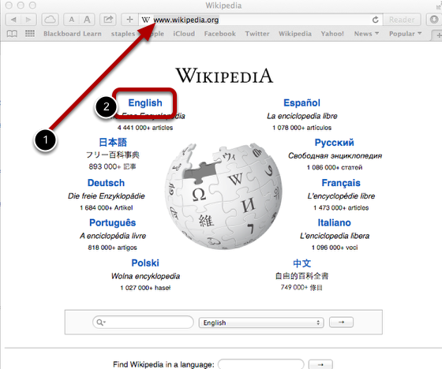](https://suffolk.screenstepslive.com/s/blogs/m/17384/l/174940-how-do-i-sign-up-for-wikipedia/show_image?image_id=9826523)

[www.wikipedia.org](http://www.wikipedia.org/)

## Click "Create account" on the upper right side of your browser

[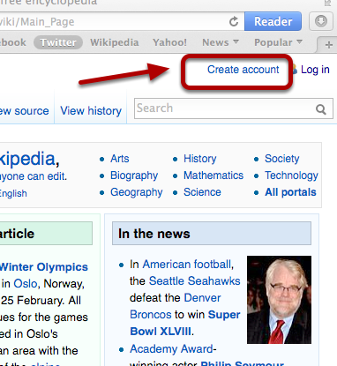](https://suffolk.screenstepslive.com/s/blogs/m/17384/l/174940-how-do-i-sign-up-for-wikipedia/show_image?image_id=9826526)

## Enter your account information and the captcha, and click "Create Account"

[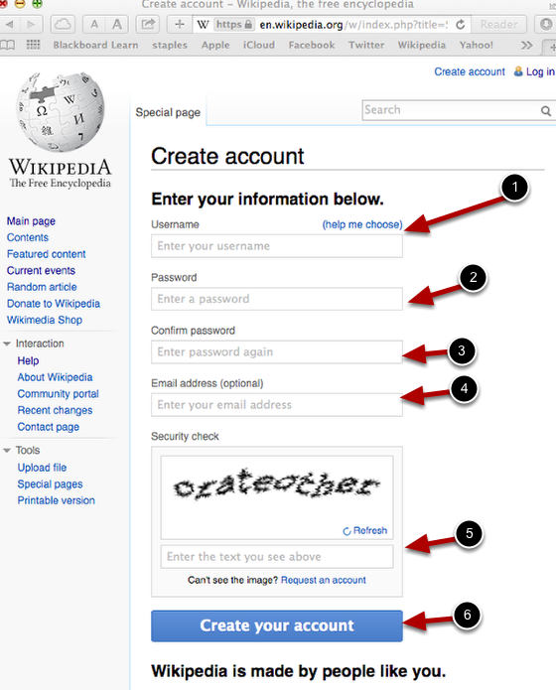](https://suffolk.screenstepslive.com/s/blogs/m/17384/l/174940-how-do-i-sign-up-for-wikipedia/show_image?image_id=9826529)

## Log in to your email and confirm your registration by clicking the link in the email.

[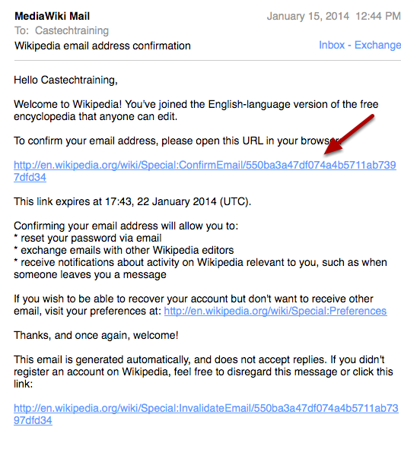](https://suffolk.screenstepslive.com/s/blogs/m/17384/l/174940-how-do-i-sign-up-for-wikipedia/show_image?image_id=9826532)

If you don't see an email from MediaWiki Mail, check your spam or junk folder.

## To log in in the future, return to the main page and click "Log in" in the upper right corner of your browser

[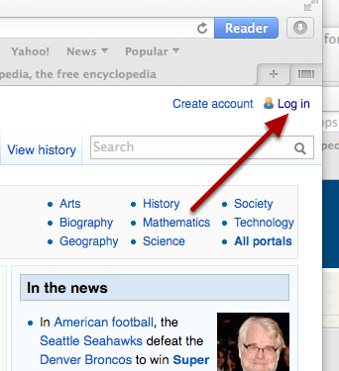](https://suffolk.screenstepslive.com/s/blogs/m/17384/l/174940-how-do-i-sign-up-for-wikipedia/show_image?image_id=9826535)

1. **Creating your page on Wikipedia**

**1. Create an account.** You must be a registered user to make changes to existing Wikipedia pages and articles, as well as to create your own. Creating an account is pretty straightforward. I advise using your real name and email address.

**2. Start small.** It pays to start by making small edits to existing pages to test your skills before trying to create new content. I started with pages with which I was already familiar. My son’s fencing coach, for example, is an Olympic medalist and has a Wikipedia page. I updated it by adding some biographical information I found on the internet and added a link back to his fan club’s website.

By making these small changes, I was able get more familiar with the site’s content management system and build my Wikipedia user profile. Once you create an account, every change you make on Wikipedia is recorded on your user page, which anyone can access — anyone being Wikipedia editors and other users. With enough editing and creating activity under your belt, you can become an “auto-confirmed user.” This gives you permission to perform certain restricted functions, such as uploading images and moving pages to the public space.

**3. Gather your sources.**While you’re feeling your way around Wikipedia, begin gathering sources for the page or article you want to create. This will save you a huge amount of time once you’re ready to create your page.

Sources are tremendously important in Wikipedia. Wikipedia is an encyclopedia (not another marketing channel for promoting your product), and this means everything on your page needs to be verified. I can’t stress this enough.

Even if you’re a notable inventor or a famous person who rowed across the Atlantic in a plastic tub, you can’t simply sit down and write a Wikipedia page based on your experience. Sorry, but you’ll need third-party sources such as printed material (books and magazines) and online material such as websites, articles, or video to support the information you provide.

Your content must be factual and unbiased. When creating my client’s technology page, I had to include information about competitors and their technology, as well as links to their sites. You’ll want your facts to be straight so you’re not accused of any misrepresentation.

Also consider including images. You’re only allowed to use images you own or images not subject to copyright. I learned this the hard way — I had to delay the launch of my client’s page while I walked them through the process of uploading their copyrighted images.

**4. Write the copy.**After all those other steps, you are finally ready to get down to the writing and posting of your Wikipedia content. I wrote my client’s page in Word first, cut and pasted it into the Wikipedia interface and then formatted it from there. You can add your page to the Sandbox, where you can format it or you can add it to your My Talk page (part of your user account), which is what I did. I chose the My Talk page as content is regularly cleared out of the Sandbox; keeping it in My Talk ensured it wouldn’t be deleted.

Formatting the page using “Wiki code” took a little while. It’s a tedious process even if you’re HTML savvy, which I am, so be sure to allow time for this or hire someone to do it for you. You can learn more about Wiki Code by reading Wikipedia’s Help Pages.

**5. Submit the page for review.**Once your page is complete and error-free, you will need to submit it to Wikipedia for review. This process can take as little as a few days or as long as a few weeks or more to get a response.

After waiting about 12 days for a response, I saw that other pages that had been submitted around the same time as mine had gotten their approvals, or challenges, or had been deleted. Eventually, I assumed mine was fine and went ahead and moved it to the public space.

However, shortly after it went live, I noticed that an editor had changed the title of the page and made other edits (but, thankfully, nothing substantial was changed). I now monitor the page and update it as needed (for example, my client recently introduced a new technology-advancing product, which warranted a Wiki page update)

**D. editing your page on Wikipedia**

**Find the article that has a mistake (wrong information, spelling, etc.**)

**1.Click on the "Edit" icon.**

**2.Correct the mistake you have found.**

Take a look again. Did you accidentally remove a word? Is there is anything else could correct?

**3.Click on show preview.** It will give you the chance to take a look at the article with your edits without saving the edit.

**4.Click Publish changes.** When you edited the page and clicked Show preview, click Publish changes to save your edits.

* + Always do your best to leave an edit summary to describe that changes you have made.