**Face Detection on Dataturks Dataset through Mask R-CNN training**

**Dataset:**

The dataset is [freely available in the public domain](https://dataturks.com/projects/devika.mishra/face_detection). It is provided by [Dataturks](https://dataturks.com/), and it is hosted on [Kaggle](https://www.kaggle.com/dataturks/face-detection-in-images). Faces in images marked with bounding boxes. Have around **500 images** with around **1100 faces** manually tagged via bounding box. Some sample images -

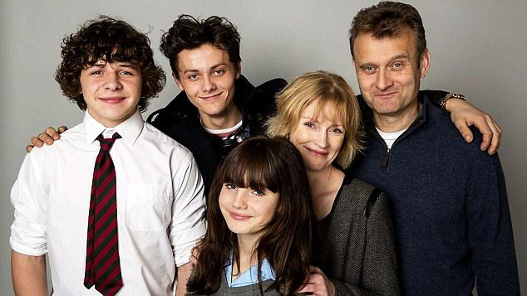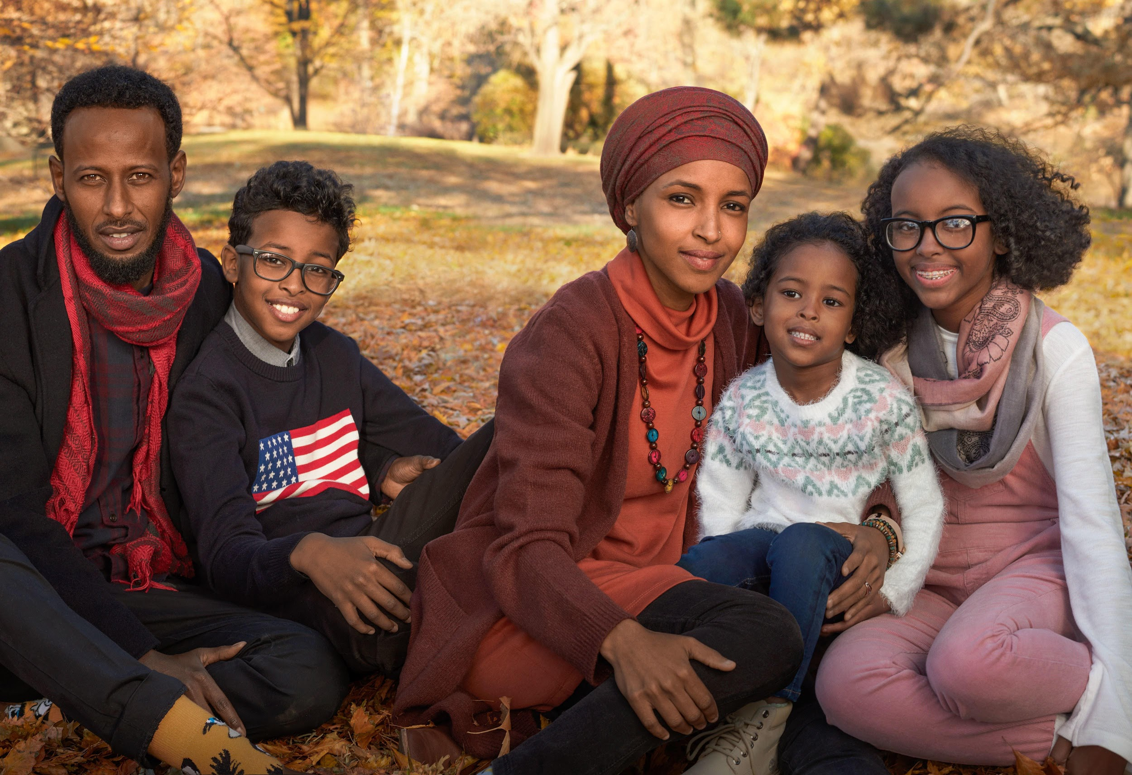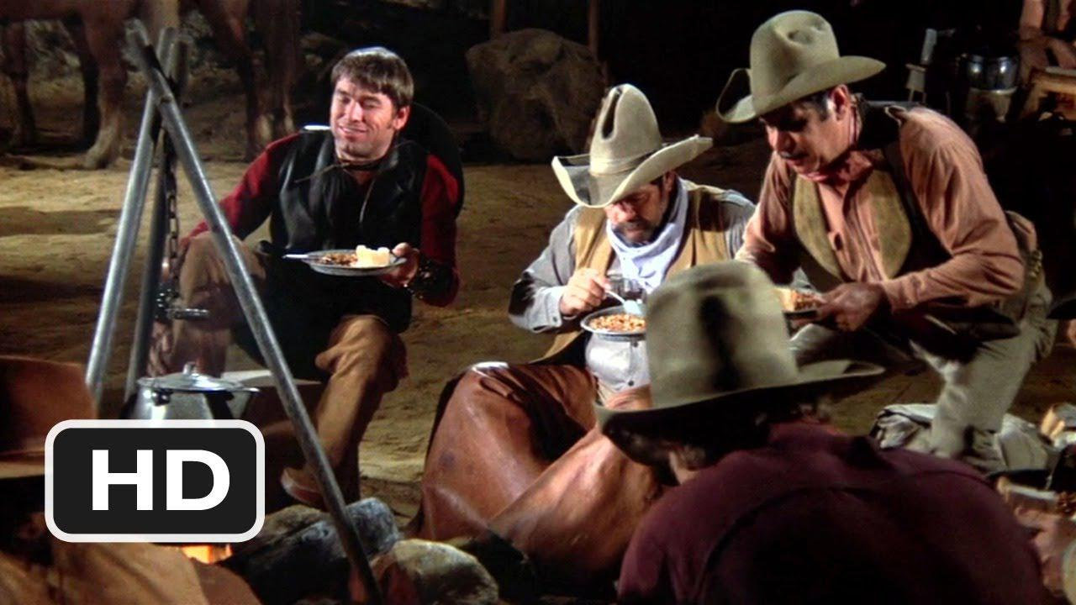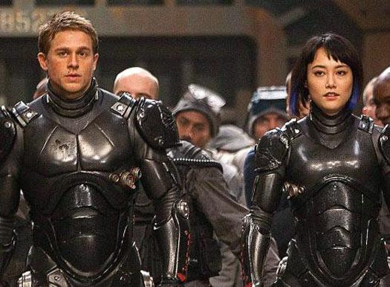

**Framework:**

[Detectron2](https://github.com/facebookresearch/detectron2) is a framework for building state-of-the-art object detection and image segmentation models. It is developed by the Facebook Research team. I have used the [Mask R-CNN](https://arxiv.org/abs/1703.06870) **X101-FPN** model. It is pre-trained on the [COCO dataset](http://cocodataset.org/#home) and achieves very good performance. The downside is that it is slow to train.

**Training:**

I have trained the model for more 500 iterations and got those training matrics.

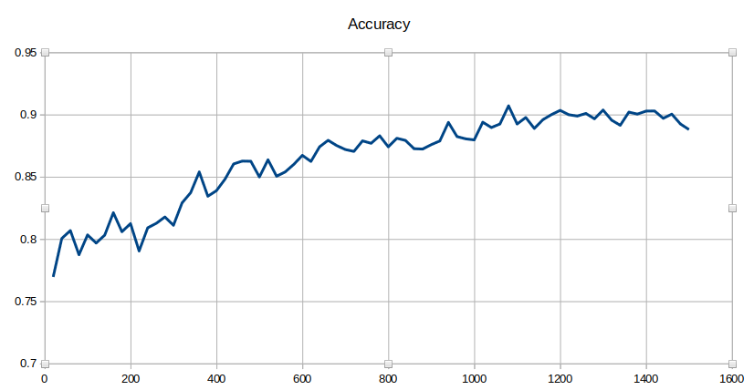

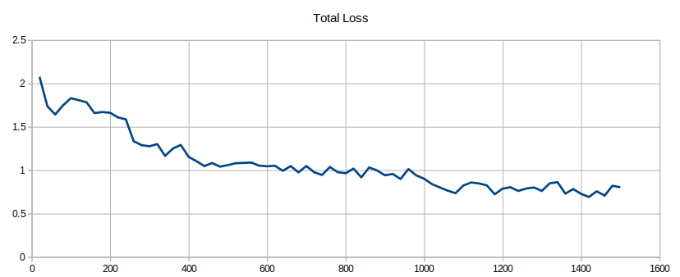

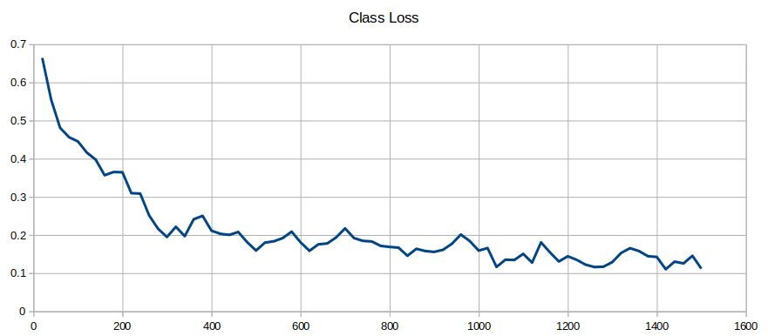

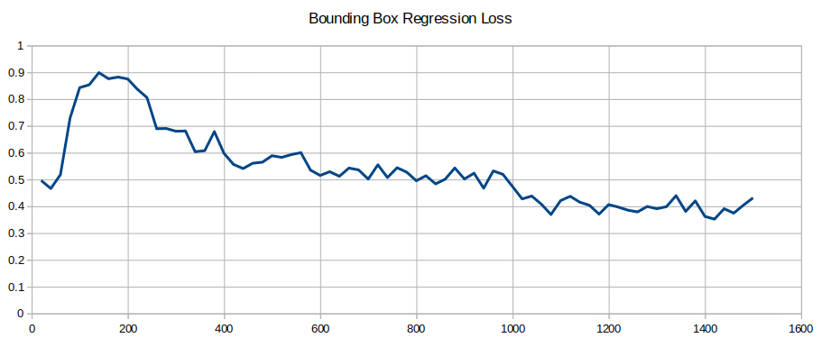

**Test Results:**

* 21 images, 67 Faces (5% of the whole dataset)

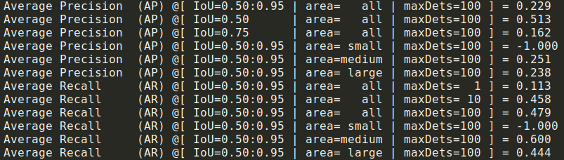

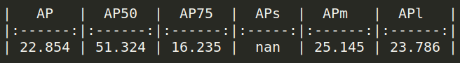

**Annotated Results on Test-set:**

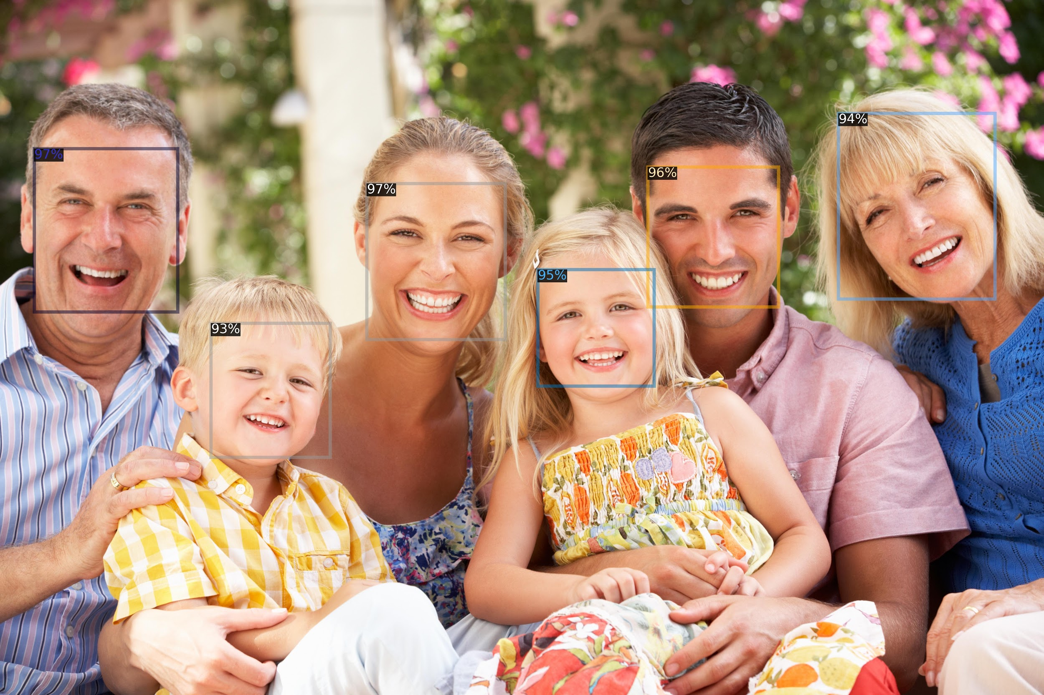

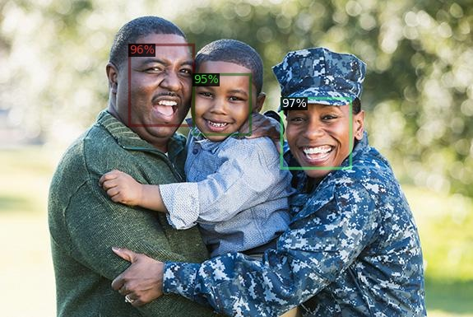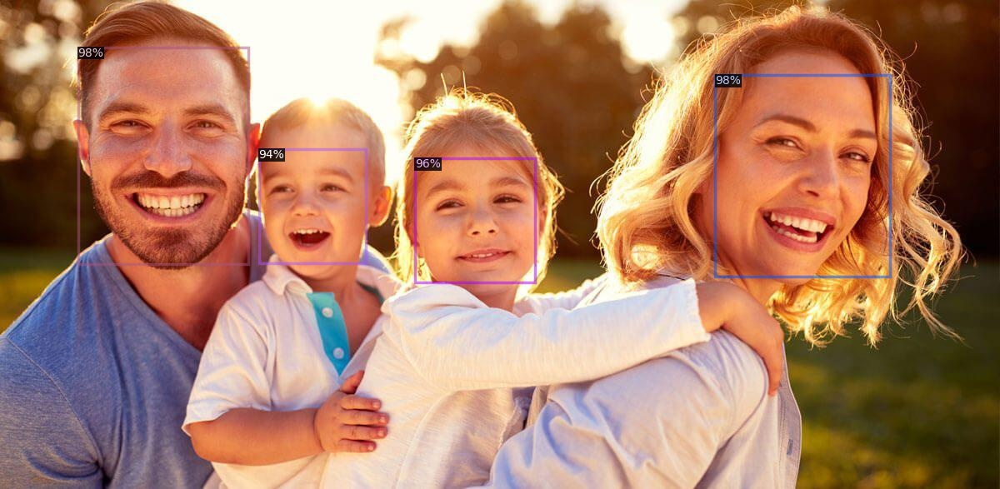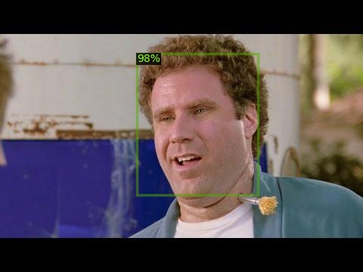

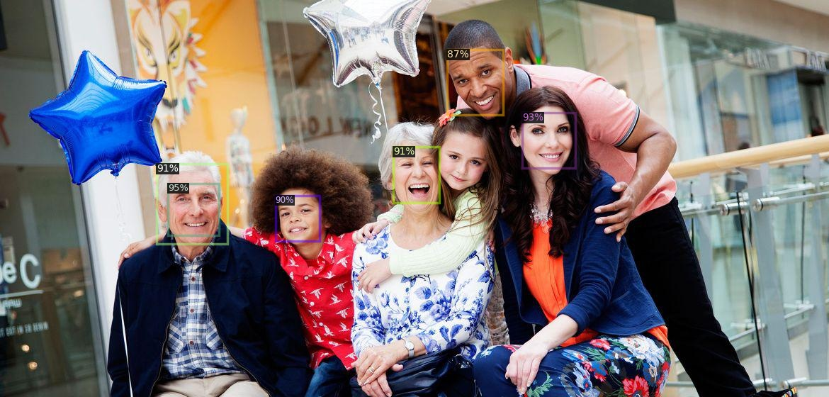

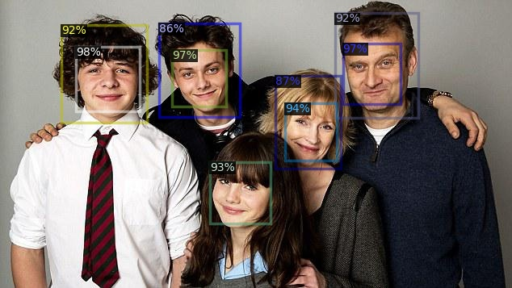

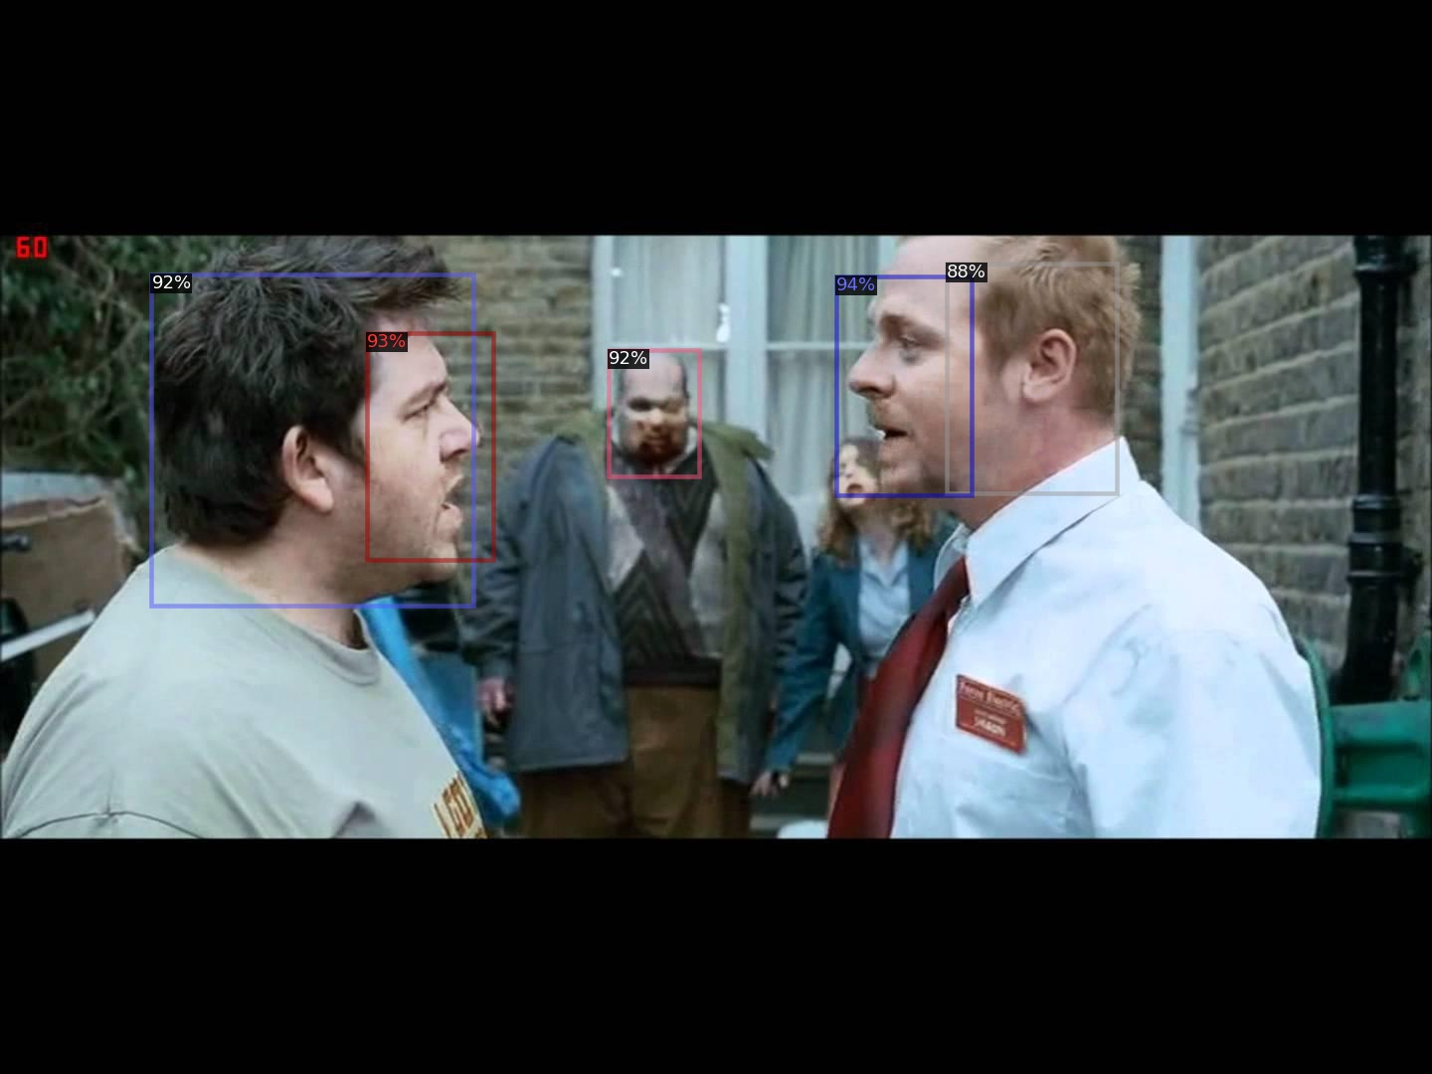

**Query:**

I have some more public datasets for face recognition. Can you please help me choose the best-fit dataset for our motive? I am attaching the details and the samples of those datasets.

1. [**Wider Face**](http://shuoyang1213.me/WIDERFACE/): 32,203 images and label 393,703 faces with a high degree of variability in scale, pose, and occlusion. [Sample Images](http://shuoyang1213.me/WIDERFACE/support/intro.jpg)
2. [**Unconstrained Face Detection Dataset**](https://ufdd.info/): 6424 images with 10895 face annotations that involve these issues such as weather-based degradations, motion blur, focus blur, and several others. [Sample Images](https://ufdd.info/)
3. [**Multi-Attribute Labelled Faces**](http://www.cbsr.ia.ac.cn/faceevaluation/): 5,250 images with 11,931 annotated faces collected from the Internet. Those annotations contain other facial attributes: gender(female, male, unknown), isWearingGlasses, isOccluded and isExaggeratedExpression. [Sample Images](http://www.cbsr.ia.ac.cn/faceevaluation/examples.html)