Test 1
Ht.NO: 2503B05143
Set-3
Q1. Implement a Python class for a stack data structure (push, pop, peek). Use GitHub Copilot to generate code, test its handling of edge cases, and explain any improvements made. (Each question carries 5 marks)
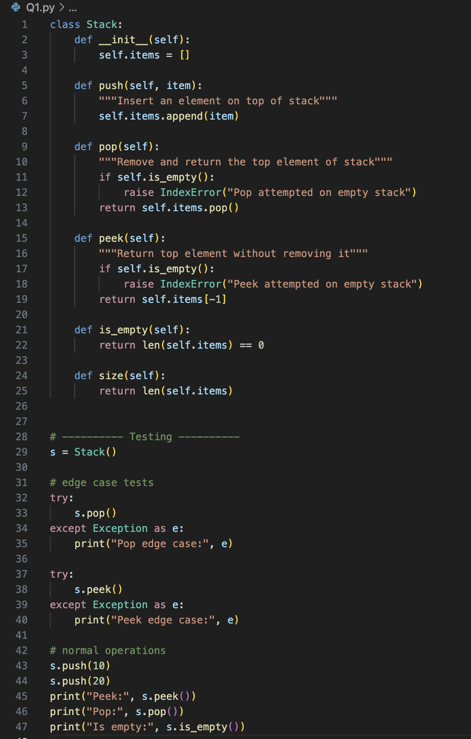

Output:
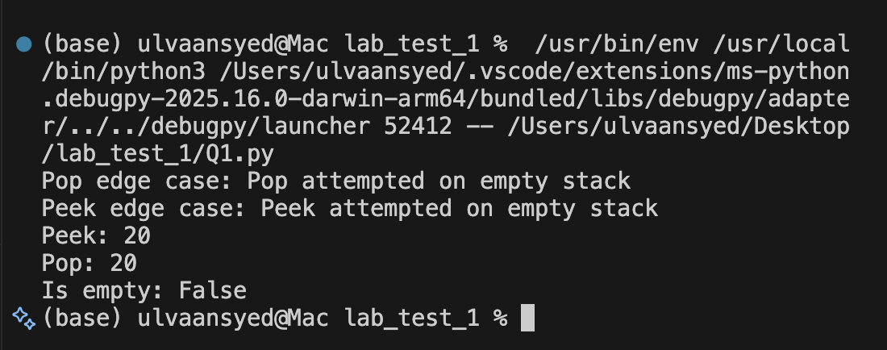

Q2. Refactor a poorly commented Python function using an AI assistant for automatic documentation. Evaluate clarity and completeness versus manual comments. (Each question carries 5 marks) python codes
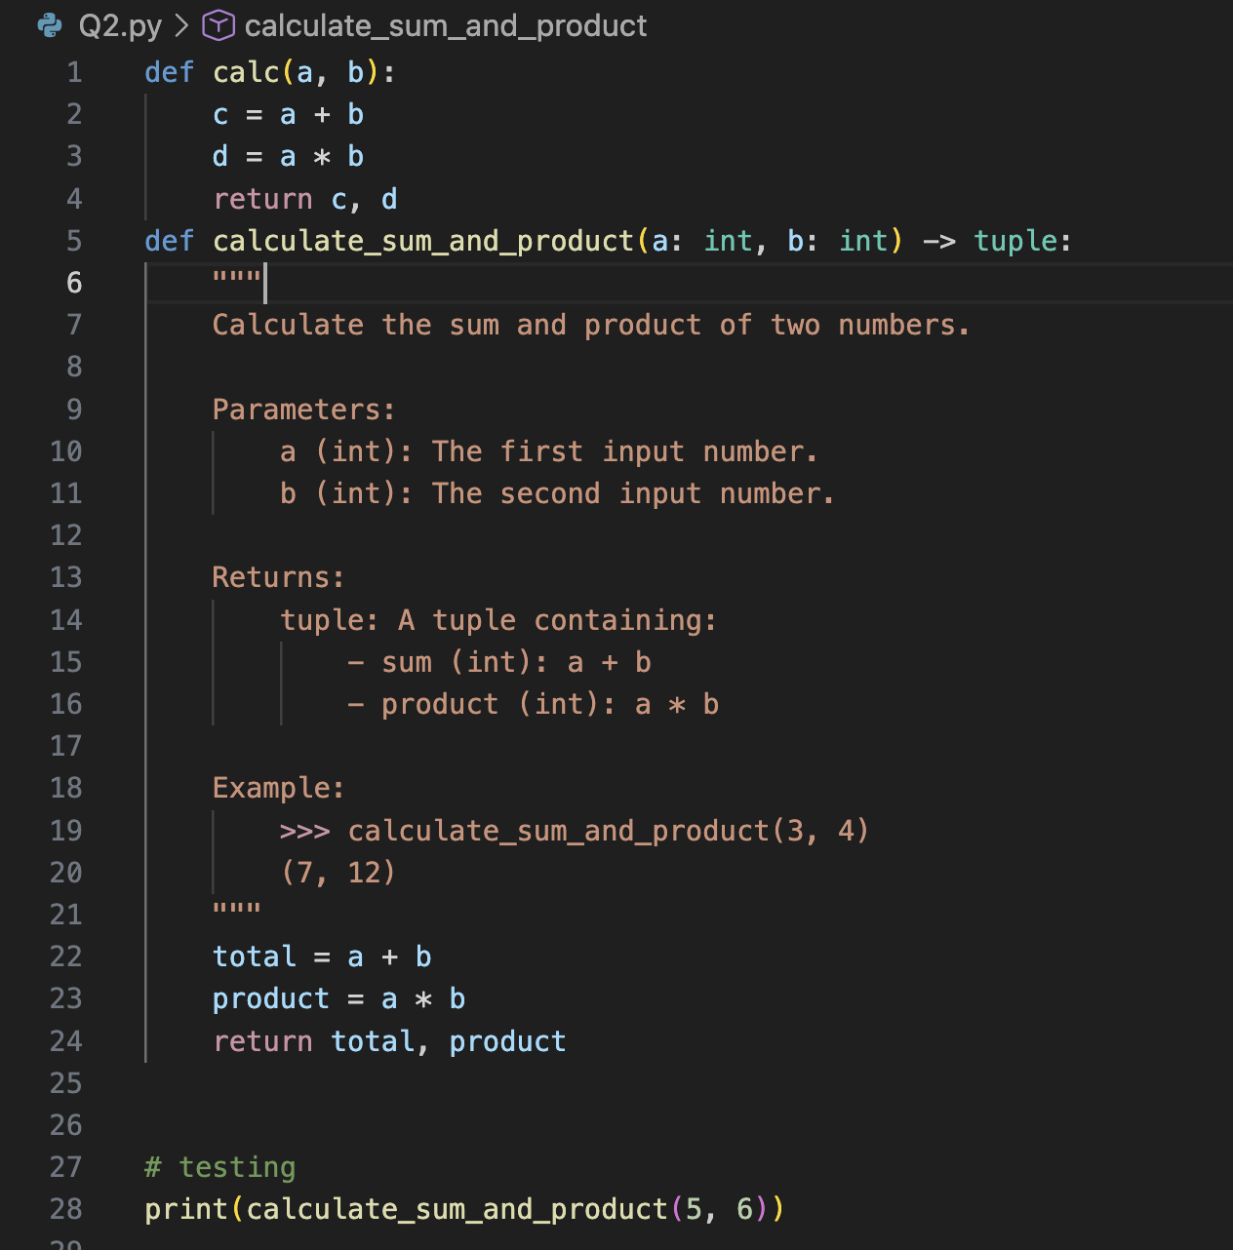
Output:
