AI Assisted Problem Solving Using Python

NAME : SYEDA FARHATH UMAMA
HT.NO : 2503B05143
Program Name: M.Tech (CSE)
Lab 2: Exploring Additional AI Coding Tools – Gemini (Colab) and Cursor AI
Task Description#1
● Use Google Gemini in Colab to write a function that reads a CSV file and calculates
mean, min, max.
Expected Output#1
●Functional code with output and screenshot
Prompt_1:
Write a function that reads a CSV file and calculates mean, min, max. Create the CSV file.
CODE: 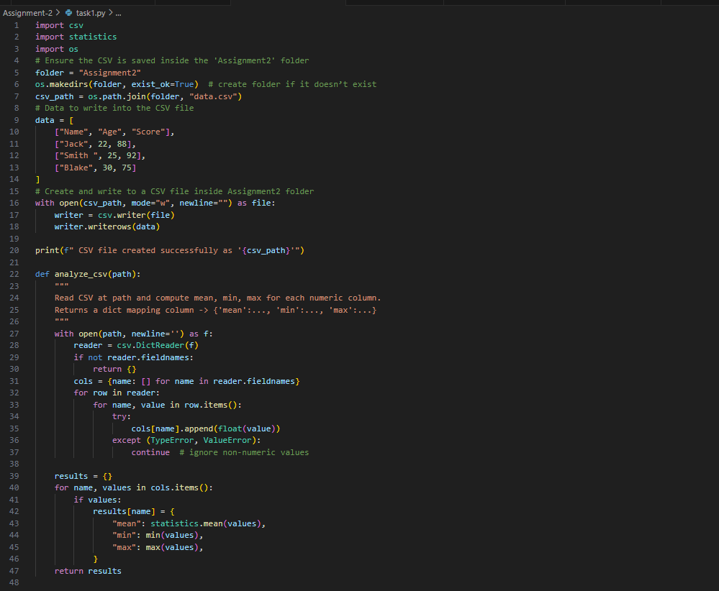
OUTPUT:
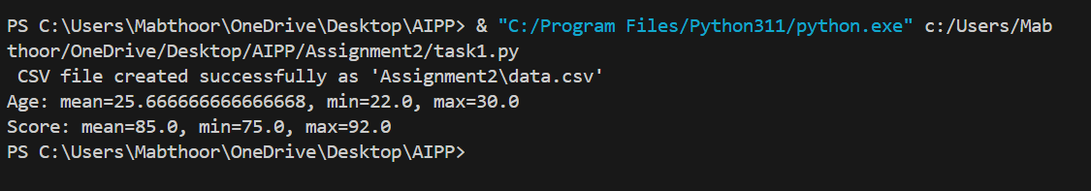
Task Description#2
● Compare Gemini and Copilot outputs for a palindrome check function.
Expected Output#2
● Side-by-side comparison and observations
Prompt_1: Generate the code to check whether the given string is palindrome or not.

CODE:
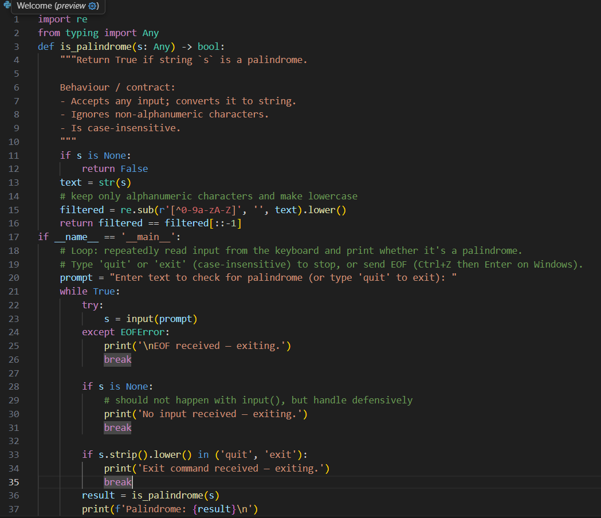
OUTPUT:

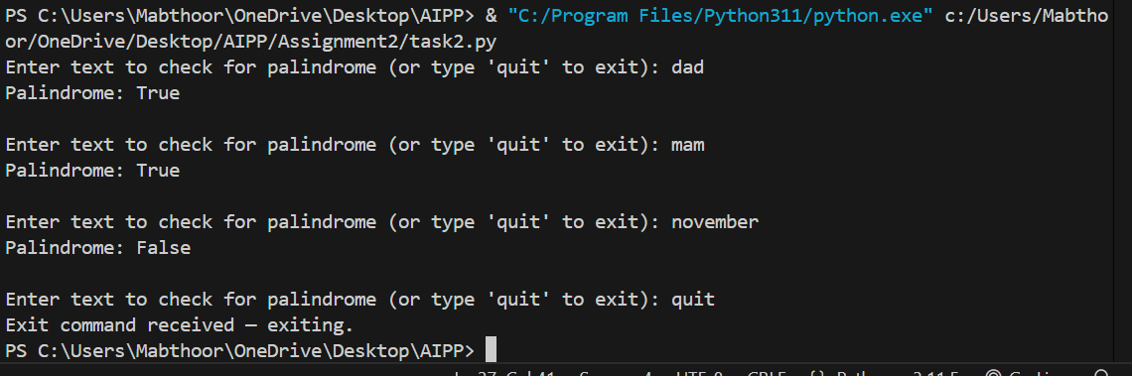

Task Description#3
● Ask Gemini to explain a Python function (to calculate area of various shapes) line by
line..
Expected Output#3
● Detailed explanation with code snippet
Prompt : Create a python function to calculate area of various shapes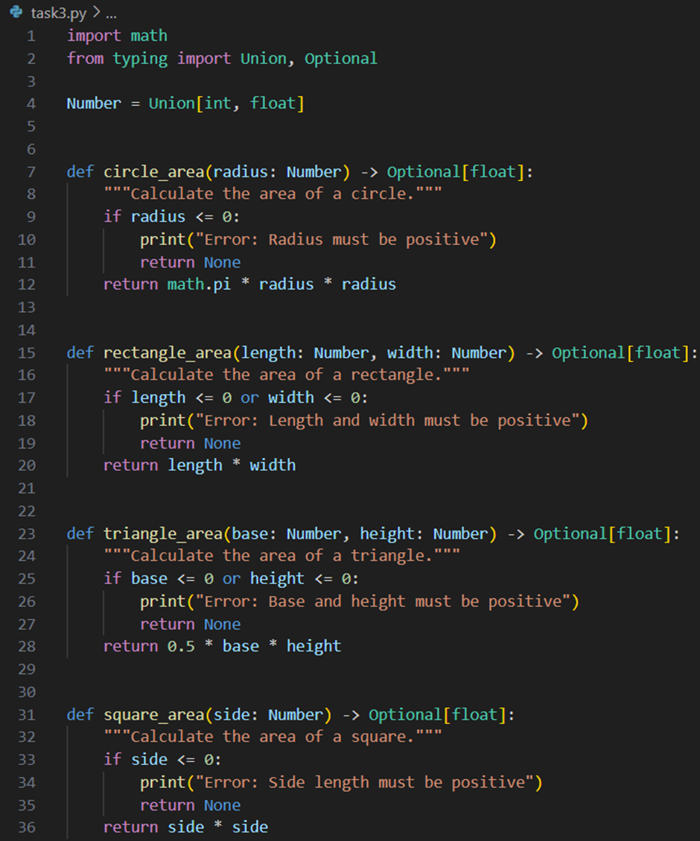

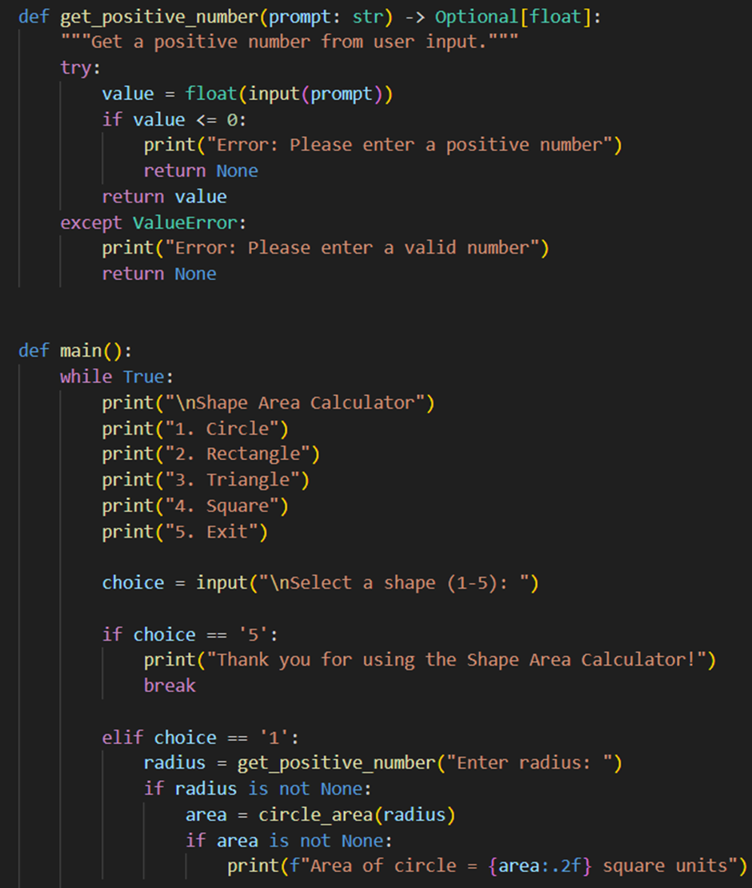
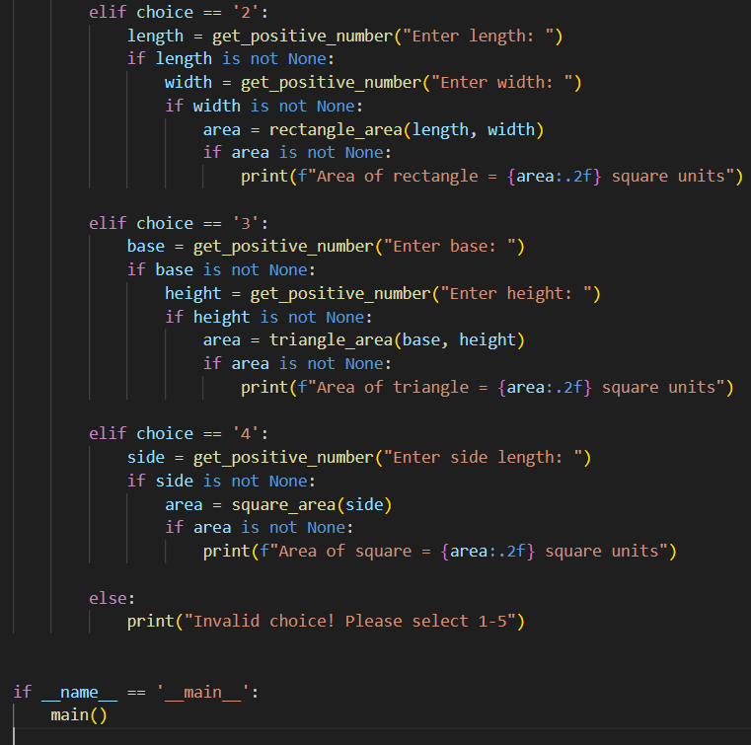

OUTPUT:

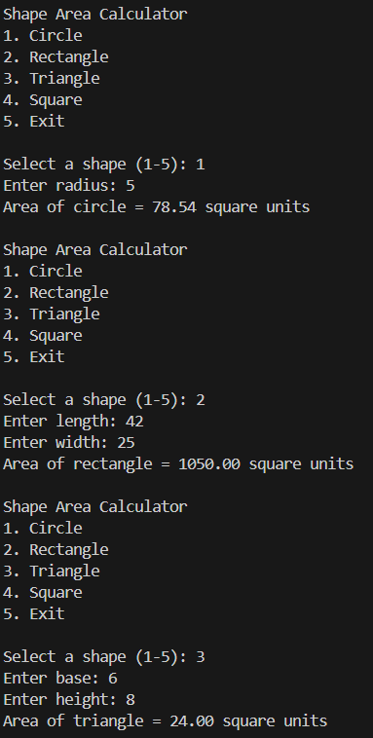
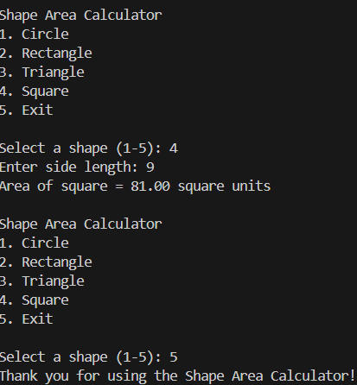

Task Description#4
● Install and configure Cursor AI. Use it to generate a Python function (e.g., sum of
squares).
Expected Output#4
● Screenshots of working environments with few prompts to generate python code
Prompt : Generate a python function to calaculate sum of squares
CODE :
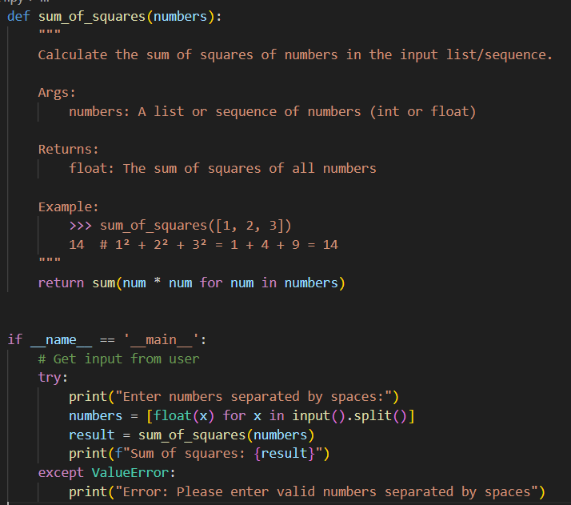
OUTPUT:
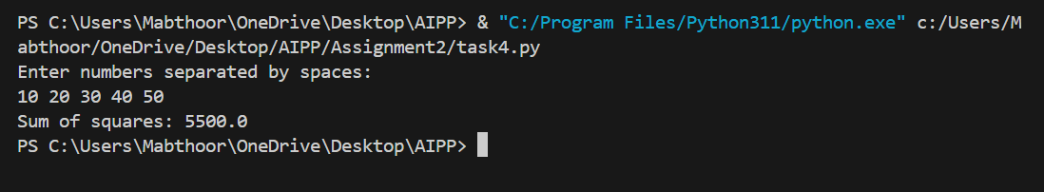

Task Description#5
● Student need to write code to calculate sum of odd numbers and even numbers in the
list
Expected Output#5
● Refactored code written by student with improved logic
Prompt: Generate the python code to calculate sum of odd numbers and even numbers in the list
CODE :
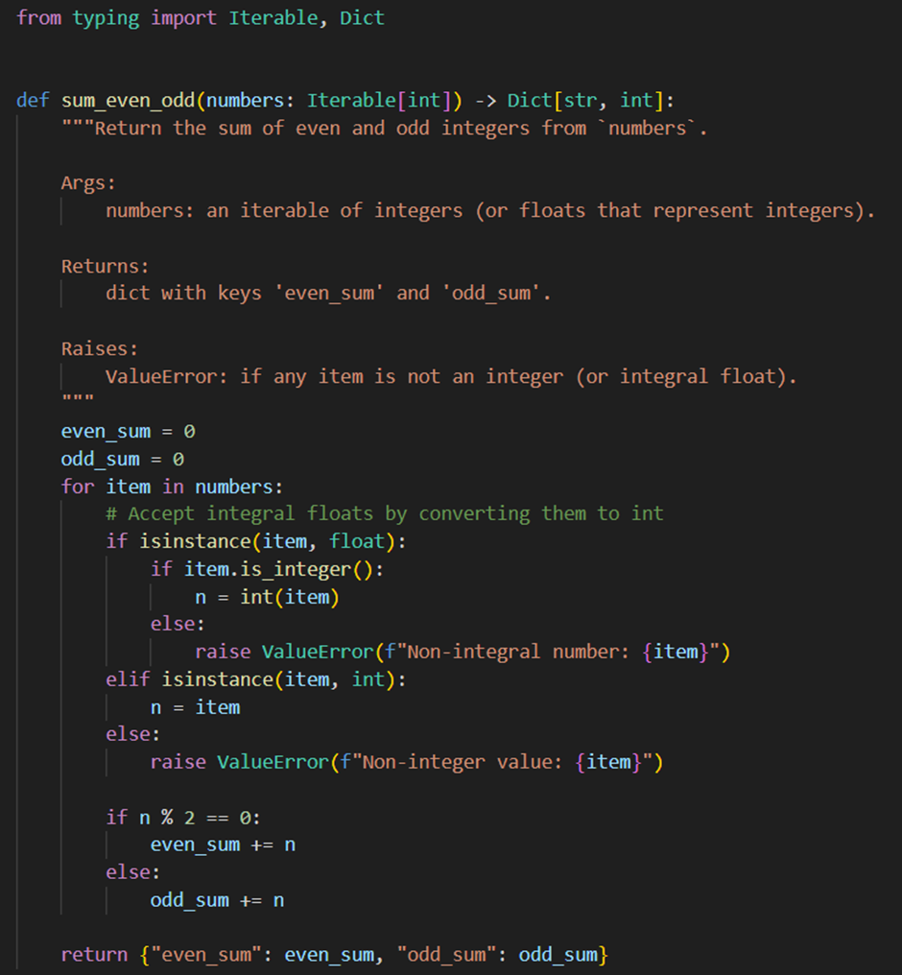
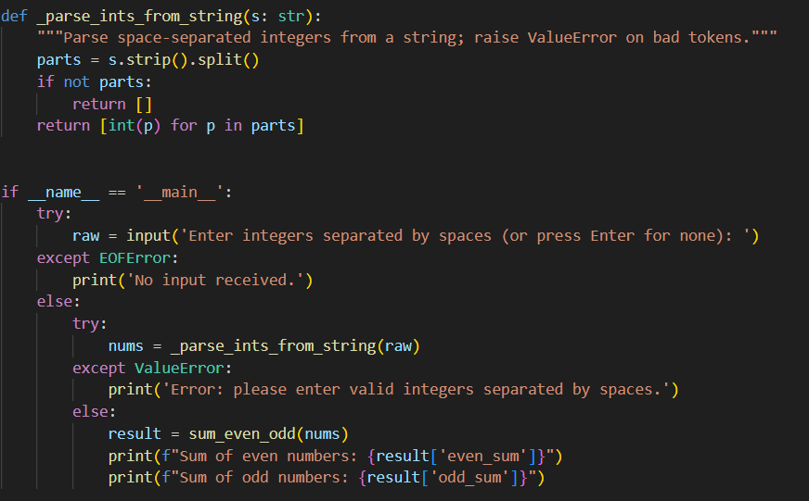
OUTPUT:
