COIT20254 Information Systems Project

AI-Powered HR Policy Knowledge Management System

  - Project Final Report

  - Group 4 (Postgraduate), Term 2, 2026
Name | Role
Farhaz Khondoker | AI and Technical Lead
Isuru Koswaththa | Project Manager and Business Analyst
Dineli Jayandee Gampolage | Business Analyst and Quality Assurance Lead

Submitted to: Dr Ahsan Morshed
Campus: Sydney, Melbourne
Word Count: 6050 words (Except Cover page, Reference, and Appendix)
Date of submission: 13 October 2026
Live prototype: https://hr-policy-qa-assistant.onrender.com
Source code: https://github.com/Farhazprojects/HR-Policy-Q-A-Assistant
Demonstration video: https://youtu.be/TMELcPipzYI

Table of Contents
Executive summary 4
1 Introduction 5
1.1 Background 5
1.2 Purpose and scope of this report 5
2 Project overview and problem definition 5
2.1 The business problem 5
2.2 Objectives as delivered 6
2.3 Final scope 6
2.4 Stakeholders 7
3 Evolution of requirements and design decisions 8
3.1 How the requirements changed 8
3.2 Stakeholder consultation and its effect on the design 8
3.3 Technical feasibility analysis 9
3.4 Traceability 9
4 Technical artefacts: architecture and design 10
4.1 System architecture 10
4.2 Data model 11
4.3 The retrieval pipeline and the refusal rule 12
4.4 Explainability design 12
4.5 Security, privacy and risk controls 13
5 Implementation and prototype 13
5.1 Technology stack as built 13
5.2 What the prototype does 13
5.3 Deployment 15
5.4 Demonstration video 16
6 Evaluation 16
6.1 Test strategy 16
6.2 Measured outcomes 16
6.3 Evaluation against non-functional requirements 17
6.4 Evaluation of candidate solutions 18
6.5 Limitations 19
7 Ethical and professional considerations 19
7.1 Privacy and data handling 19
7.2 Fairness, transparency and accountability 20
7.3 Intellectual property and licensing 20
7.4 Professional standards and academic integrity 20
8 Project management 21
8.1 Planning and execution 21
8.2 Coordination and tools 21
8.3 Risk and change management 22
8.4 Quality assurance 23
9 Recommendations 23
10 Conclusion 24
References 25
Legislation 26
Appendix A: Requirements traceability matrix 27
Appendix B: Test suite summary 28
Appendix C: Test cases 28
Appendix D: Final risk register 33
Appendix E: User stories 34
Appendix F: Gantt chart 36
Appendix G: Meeting log 39
Appendix H: Declaration of AI use 39
Appendix I: Evidence and access 40

Executive summary
HR teams answer the same policy questions week after week, although the answers are already in approved policies. Few employees read those documents, and a general chatbot answers from its training data, not the employer’s rules. In HR, a confident wrong answer about leave or conduct is a compliance problem. Group 4 built and deployed a prototype that answers HR policy questions from an organisation’s approved documents only. It uses retrieval-augmented generation (RAG), and each answer names the document, page and section it came from. Confidence is calculated from retrieval scores which is never self-reported by the model. When no passage is relevant enough, the application refuses before any model is called. The live prototype holds six fictional policies in 49 passages and separates employee, HR officer and administrator access. Answers come from Google Gemini, with Ollama Cloud and a local mode as fallbacks. 72 automated tests run on every push. After a Week 9 instruction fix, everyday-wording questions were answered in 15 of 15 runs. Four proposed features, including policy drafting and review reminders, were dropped after feasibility analysis, and no real employee data was used. The main recommendation is to test the assistant on a labelled question set from a real policy library, and on every model in its fallback chain, before staff rely on it.

1 Introduction

1.1 Background
Most routine employee questions are answered somewhere in an HR policy. The Australian HR Institute and Queensland University of Technology (2024) found that HR professionals generally rate their understanding of AI as basic or average, and that most HR departments have not yet given their organisations strategic guidance on its use. Employees, meanwhile, already put workplace questions to general AI tools that cannot see the employer’s policies. Enterprise platforms offer AI self-service for HR. ServiceNow (2026) reports large efficiency gains for HR agents using its HR Service Delivery product, and Workday Inc. (2026) builds conversational agents into its human capital management suite. Both cost more than many small and medium organisations can justify (Deloitte 2026). In Week 1 the team saw room for a lightweight assistant that does the most useful part of that job, answering policy questions accurately and showing its sources, at a price a small organisation could afford.
For the technical approach, the team chose retrieval-augmented generation, introduced by Lewis et al. (2020) and since extended into many variants (Gao et al. 2023). No language model is asked to recall an answer. Instead, the system searches a set of approved documents, picks the passages that match the question, and asks the model to answer from those passages alone. Explainability was the second design commitment. Simpson, Ermovick and Sloane (2026) describe HR AI systems that work as black boxes, leaving HR professionals unable to check recommendations or spot bias. How the system shows its reasoning to users was guided by the transparency and accountability characteristics in the NIST AI Risk Management Framework (2023).

1.2 Purpose and scope of this report
This report covers what was delivered, how the requirements and design changed between the Week 4 proposal and the Week 12 build, how the prototype was implemented and evaluated, the ethical questions the team faced, and how the work was managed. Departures from the proposal are explained where they occur.

2 Project overview and problem definition

2.1 The business problem
HR staff spend much of their time on enquiries that a policy already answers, and that time comes out of higher-value work (Australian HR Institute & Queensland University of Technology 2024). This repetition was the first problem the team identified during business analysis in Weeks 1 to 3. Finding the answer is the second problem. Policies are published, but employees struggle to locate the clause that applies to them, and they ask in words the policy does not use. A policy that calls the entitlement “personal and carer’s leave” never mentions “sick leave”. That mismatch later caused the most serious defect the team fixed (Section 3.2). Trust is the third problem. If an assistant answers without showing its source, neither the employee nor the HR officer can check the answer, and the tool adds risk to the process it was meant to improve (Simpson, Ermovick & Sloane 2026).
For these reasons, the problem statement from the proposal was narrowed. The system answers the questions that the organisation’s approved policies actually cover, shows the evidence, and declines everything else.

2.2 Objectives as delivered
Four objectives guided the final build.
- Answer everyday HR questions using only the organisation’s approved policy documents.
- Show the source of every answer by document, page and section, with a confidence figure the user can interpret.
- Refuse to answer when the policies do not cover the question.
- Run the whole system at no cost, so a small team can trial it.
Evaluation showed that the first three were met (Section 6). For the fourth, the team used the free tiers of Google Gemini, Ollama Cloud, Render and Neon PostgreSQL, at the cost of slower responses and cold starts (Section 5.3).

2.3 Final scope
Compared with the proposal, the delivered scope differs in four places, all of them features dropped during the term (Table 1).
Table 1: Final project scope
Status | Items
Delivered | - Conversational policy assistant using RAG.  - Explainability panel showing document.  - Page, section, similarity score and confidence.  - Refusal before generation when no passage qualifies.  - Keyword policy search.  - HR policy library with version tracking,  - PDF upload and indexing and electronic policy acknowledgement.  - Leave request submission and review.  - Separate access for employees, HR officers and administrators.  - AI governance dashboard with usage and retrieval charts.  - Audit logging.  - Three answering modes with automatic fallback
Descoped during the term | - AI-assisted drafting of new policies.  - Automated annual policy review reminders.  - Usage trend analytics beyond the governance dashboard.  - In-app notifications.  All four remain in the HR dashboard as labelled placeholders. It was left for future work.
Section 3.1 maps these changes to the eleven functional requirements.

2.4 Stakeholders
In Week 2, Isuru Koswaththa and Dineli Jayandee Gampolage prepared the stakeholder analysis, and they revised it in Week 5 after the unit coordinator’s feedback. Table 2 shows the final version with the way the delivered system meets each group’s needs.
Table 2: Stakeholder analysis
Stakeholder | What they need | How the delivered system responds
Employees | A fast, correct answer to a policy question, asked in their own words | Ask AI answers from indexed policy passages and shows the clause it used. The search page offers keyword lookup for users who prefer to browse
HR officers | Fewer repeat enquiries, and confidence that answers given in their name are correct | Every answer can be traced to a document, page and section; the policy library shows what is indexed and at which version
HR managers | Visibility of policy coverage and compliance | The governance dashboard reports the most cited policies, retrieval confidence bands, refusal rate and acknowledgement completion
System administrator | A secure, maintainable system with an audit trail | Role-based access control, hashed credentials, audit logging of questions, uploads and refused access, and health endpoints for monitoring
Executives and the unit coordinator | Evidence that the AI behaves responsibly | Refusals, retrieval-based confidence and model fallback are all shown in the interface itself

3 Evolution of requirements and design decisions

3.1 How the requirements changed
Of the eleven functional requirements in the proposal, seven were implemented in full, two in a narrower form and two not at all. These changes came from the unit coordinator’s feedback, from feasibility testing during development, and from the team’s own testing. Two requirements were narrowed. Policy summaries (FR4) are entered at upload and shown in the library instead of being generated. FR8 changed more. The proposal described leave requests started “through conversational workflows”, with the assistant collecting the dates and leave type and lodging the request itself. Doing that safely would mean letting the assistant change an employee’s record on the strength of its own reading of a free-text message. For a prototype with no payroll link and no way to check leave balances, this was ruled out. In the delivered system the assistant explains and cites the leave policy, and a structured form with a review step lodges the request. The leave page states that no payroll connection exists and that no entitlement is calculated.
FR5 (generative policy drafting), FR7 (automated review reminders) and the analytics and notification features were dropped in Week 9. Drafting new policy text carries a different kind of risk from answering out of existing text. A draft has no source document to be checked against, so the check that the rest of the system depends on cannot run at all. These features were kept as labelled placeholders in the HR dashboard, where a reviewer can see what was planned but not built.

3.2 Stakeholder consultation and its effect on the design
In Week 5 the unit coordinator asked for clearer links between the requirements and the artefacts that demonstrate them. In response, the team added the traceability matrix in Appendix A, mapping each requirement to its implementation, its test and its evidence, and later organised the test suite around it.
In Week 9, internal testing with Isuru and Dineli changed the assistant’s behaviour more than any other input. Both testers asked questions in everyday words, and the assistant refused several it should have answered, most often “How many days of sick leave do I get?”. Retrieval was working and returned the Personal and Carer’s Leave section. Instead, the fault lay in the instructions. They told the model to answer only from wording in the retrieved text, so it treated the synonym as an inference it was not allowed to make. The fix is described in Section 6.2.
Once the prototype went online in Week 9, two more changes followed. Early users of the live site sometimes waited close to a minute for an answer, because a slow Gemini request had no time limit and quota errors were being retried. After that, each attempt was given a 15-second limit, only temporary failures were retried, and anything else passed down the fallback chain. Answers were also arriving with raw Markdown symbols, such as asterisks around bold text, until the web interface was changed to render them.
The dashboard charts changed for a smaller reason. In the first version, green and amber separated grounded answers from refusals, but a colour-vision check showed the two were almost indistinguishable under a protanopia simulation. Purple from the interface and a caution amber replaced them.

3.3 Technical feasibility analysis
Feasibility testing during development changed five technical decisions, listed in Table 3 with the option each one replaced.
Table 3: Design decision register
Decision | Alternative considered | Reasoning
Custom retrieval pipeline in TypeScript | LangChain or n8n, as named in the proposal | A framework adds a dependency and a layer of abstraction over a four-step pipeline. Writing the chunking, embedding and scoring directly kept the retrieval logic easy to inspect, and the explainability panel reports on that logic
Google Gemini free tier with an Ollama Cloud fallback | OpenAI paid API, as named in the proposal | The budget allowed no paid services. Two free providers with automatic failover proved more reliable than one, because free quotas hit rate limits at unpredictable times
Ollama Cloud instead of a local install | Local model download | A local install needs several gigabytes of disk and a capable machine. Ollama Cloud needs neither and keeps the deployment portable
Per-model relevance thresholds | A single global threshold | Similarity scores from different embedding models are not comparable. A threshold of 0.72 suited the lexical scorer but rejected valid Gemini matches scoring between 0.61 and 0.73. Each provider now has its own calibrated threshold
One Render service hosting both API and web interface | Separate frontend and backend services | Combining them removed a cross-origin configuration and left one service to wake from sleep instead of two
Two of these decisions reversed the proposal, which had named LangChain and the OpenAI API before any code existed.

3.4 Traceability
Appendix A traces each of the eleven functional requirements to the module that implements it, the test that checks it and the evidence in this report. Non-functional requirements are evaluated separately in Section 6.3.

4 Technical artefacts: architecture and design

4.1 System architecture
The architecture has one web application, one API, one database and an AI layer that can call an external model or work without one (Figure 1).
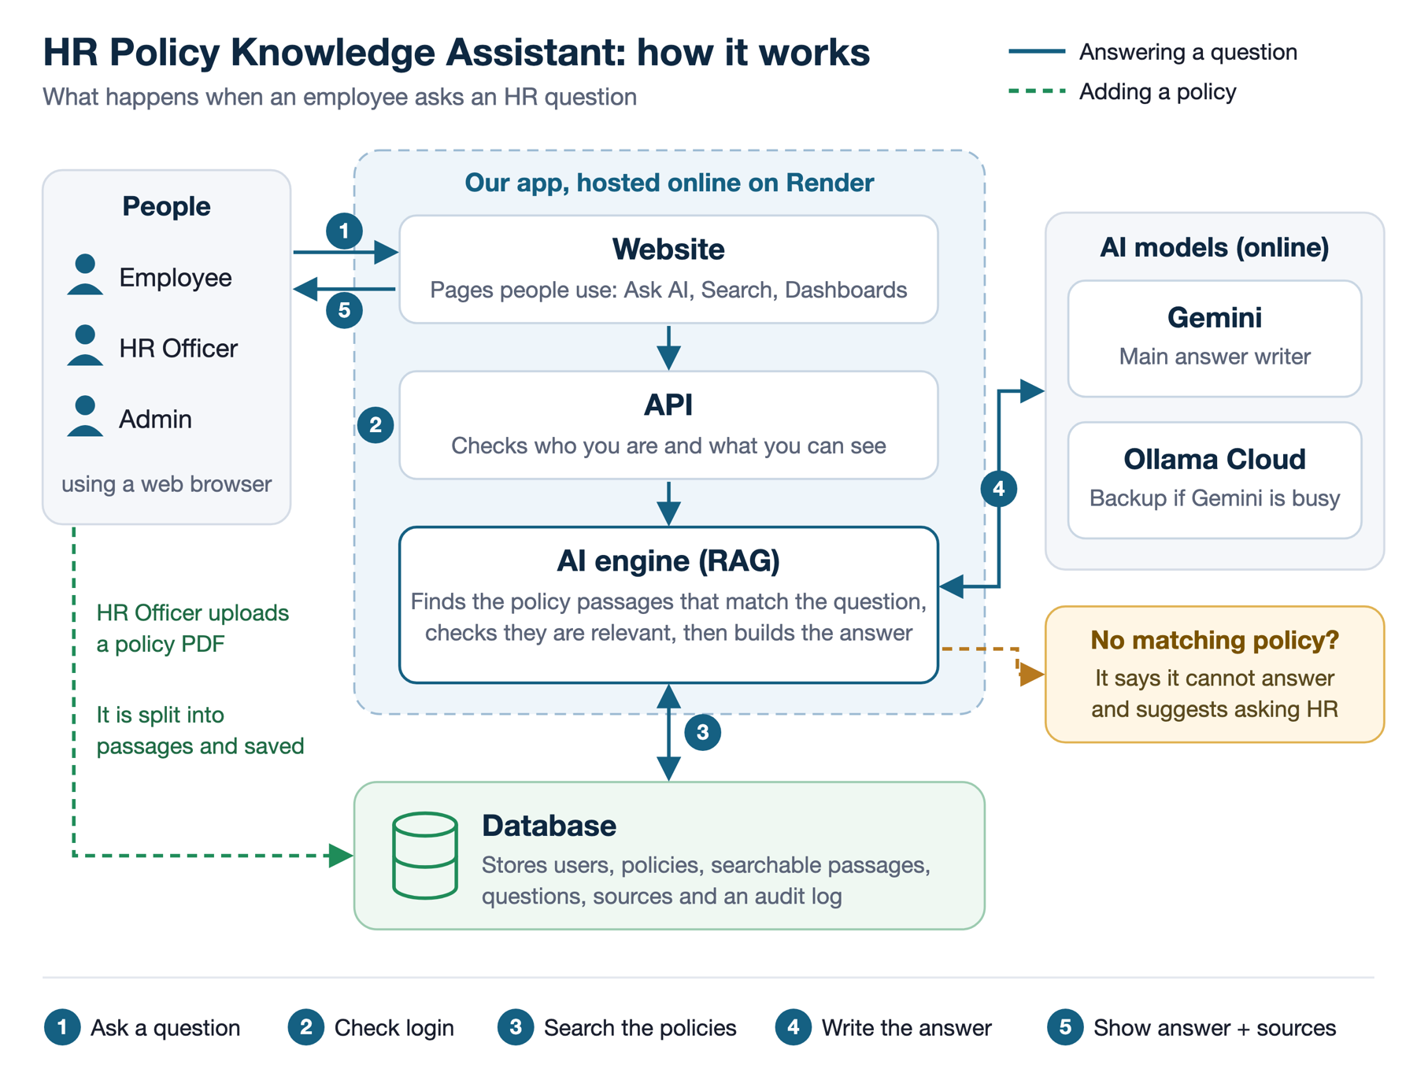
Figure 1: System architecture as built. Solid lines follow a question from an employee to an answer; dashed lines follow a policy document from HR upload to indexed passages.
Users reach the system through a browser, and the pages they see depend on their role. Employees get Ask AI, policy search, leave requests and acknowledgements. HR officers also get the policy library, the upload page and the governance dashboard, and administrators get system status and the governance log. Before a request reaches any service, the API checks who the user is and what they may see. The AI engine finds the passages that match a question, checks that they are relevant enough, and only then asks a model to write the answer. Users, policies, passages, questions, citations, leave requests, acknowledgements and the audit log are all stored in the database.
During design in Weeks 5 and 6, the team prepared the use case diagram in Figure 2. It shows five actors and the functions planned for each. Because the prototype has three roles, the HR Manager and Executive actors were not built as separate accounts. Policy drafting and review reminders were later descoped (Section 3.1).
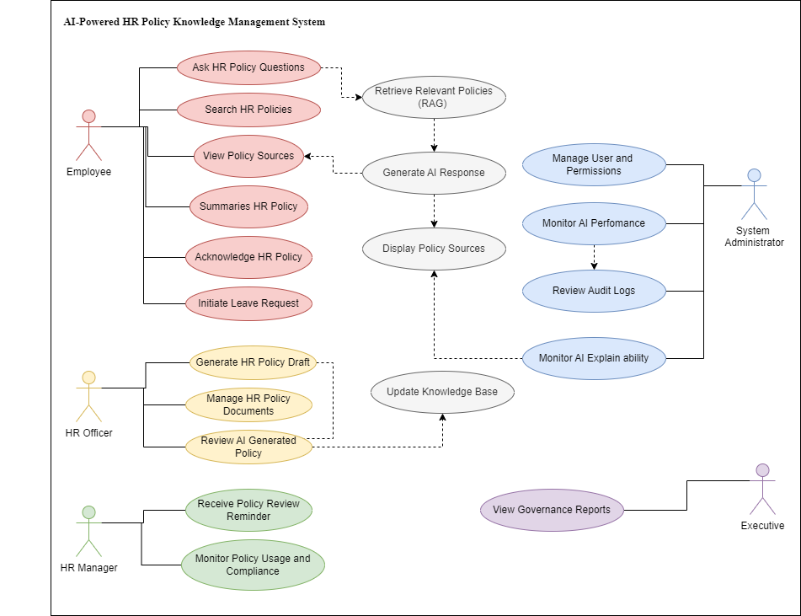
Figure 2: Use case diagram from the design phase (Weeks 5 and 6).

4.2 Data model
The database has eight tables, built with Prisma on PostgreSQL. User holds credentials and role. PolicyDocument holds an uploaded policy with its version, category, page count, checksum and indexing status. PolicyChunk holds the searchable passages cut from each document, with page number, section heading and embedding vector. Question records each question and answer with the mode used and the confidence, and Citation links an answer to the passages behind it. LeaveRequest and PolicyAcknowledgement support the two workflow features, and AuditLog records security events, including refused access attempts.
A checksum stops an unchanged document from being embedded a second time and spending free-tier quota for nothing. Each citation also stores its similarity score at the moment the answer was produced. The explainability panel therefore shows the evidence exactly as it stood then, even if the index changes later.
At the design stage, the entity-relationship diagram (Figure 3) had six of these tables. PolicyAcknowledgement and AuditLog were added during development. LeaveRequest also changed from a free-text request to structured dates and leave type when FR8 was narrowed.
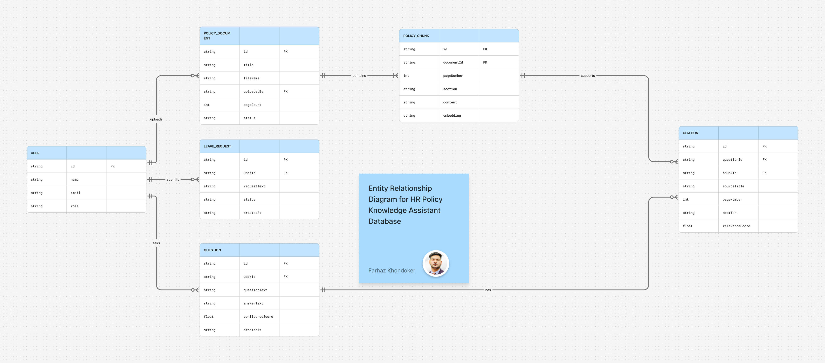
Figure 3: Entity-relationship diagram from the design phase, showing six of the eight tables.

4.3 The retrieval pipeline and the refusal rule
A question goes through five steps.
- Ask. The employee types a question in their own words.
- Search. The system compares the question with every stored policy passage and scores each one.
- Check. Only passages that score above the relevance threshold for the active model may be used.
- Answer. A model writes the answer from those passages alone.
- Show. The answer appears with its sources and a confidence figure.

4.4 Explainability design
Every answer carries four pieces of evidence. These are the documents and sections used, the similarity score of each passage, a confidence figure, and the time taken for retrieval and generation. Confidence is calculated from how strongly the evidence matched, and the model is never asked to rate itself. This follows the transparency and accountability characteristics of the NIST AI Risk Management Framework (2023) and responds to the contextual transparency problem described by Simpson, Ermovick and Sloane (2026). A model’s own estimate of its certainty tends to follow how fluent its answer sounds, not how good its evidence is.
Refusals show the same kinds of evidence (Figure 5), including the best score reached, the threshold it missed and a note that no model was called.

4.5 Security, privacy and risk controls
Users sign in with hashed credentials and signed session cookies. Authorisation is checked in middleware before any handler runs, so an employee cannot open an HR or administrator route by guessing its address. Eight of the 72 automated tests attempt cross-role access and expect it to be refused. Uploaded documents are stored on the server and never served by direct path, HTTP hardening and rate limiting are applied at the edge, and the deployed service runs over HTTPS.
The strongest privacy control is that the prototype holds no real employee data. All six policies are fictional, written for this project, and the demonstration accounts are seeded. Questions are stored because HR needs to see what staff ask and because an audit trail is part of responsible AI governance. No employee records are sent to an external model. Only the question text and the passages needed to answer it leave the application.

5 Implementation and prototype

5.1 Technology stack as built
The system is a TypeScript application in one repository, split into the four modules agreed in Week 1 (ai, backend, database and frontend). Next.js and React are used for the web interface. The API runs on Express, with Zod for request validation, JSON Web Tokens for sessions, bcrypt for password hashing and Prisma for database access. Uploaded PDFs are read page by page, so each citation can name its page. No framework is used in the AI layer. Embedding and generation providers sit behind two small interfaces, and this is why Ollama Cloud could be added in Week 9 without touching the retrieval code.
Compared with the proposal, the frontend adds Next.js, the RAG pipeline is written by hand instead of with LangChain or n8n, and Gemini and Ollama Cloud replace OpenAI and OpenRouter (Section 3.3).

5.2 What the prototype does
Figure 4 shows an answer to a question about annual leave. As the policy states it, the entitlement is set out by employment type, and the panel on the right lists the retrieved policy sections with their similarity scores and the overall confidence.
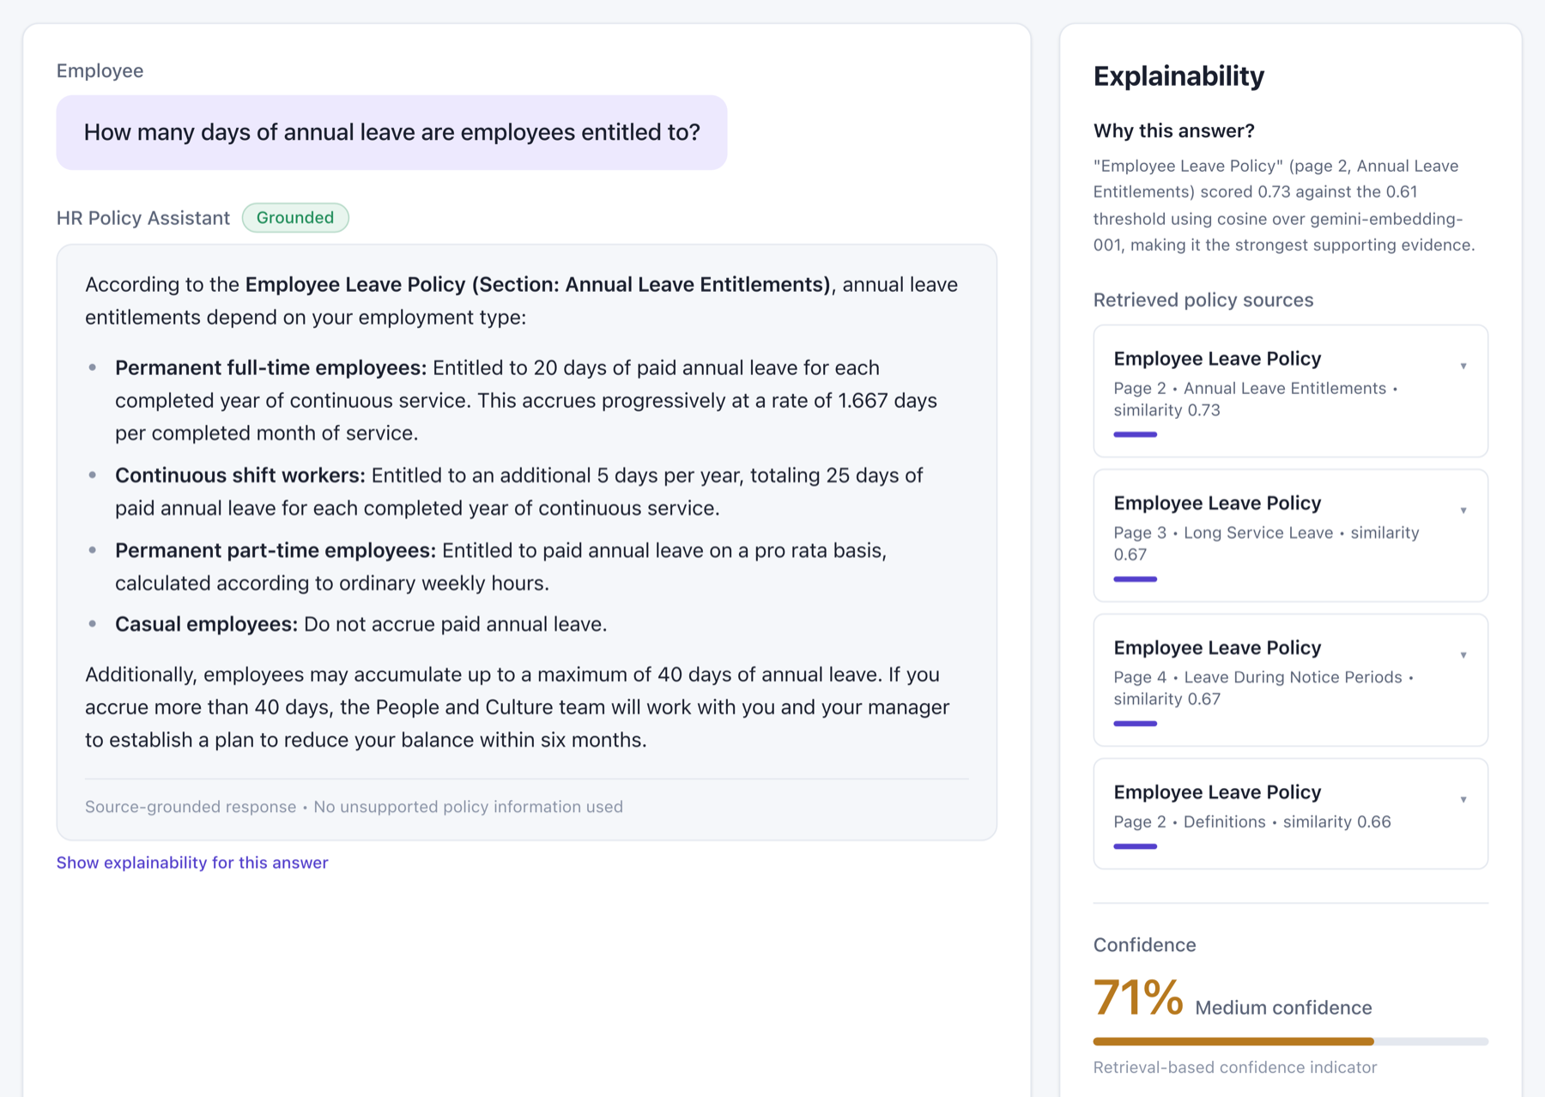
Figure 4: An answered question. The explainability panel names every policy section used, its similarity score and the resulting confidence.
In Figure 5 the same interface refuses a question the policies do not cover. The best passage scored 0.60 against a threshold of 0.61, so nothing qualified, no model was called, and the employee was referred to the People and Culture team.
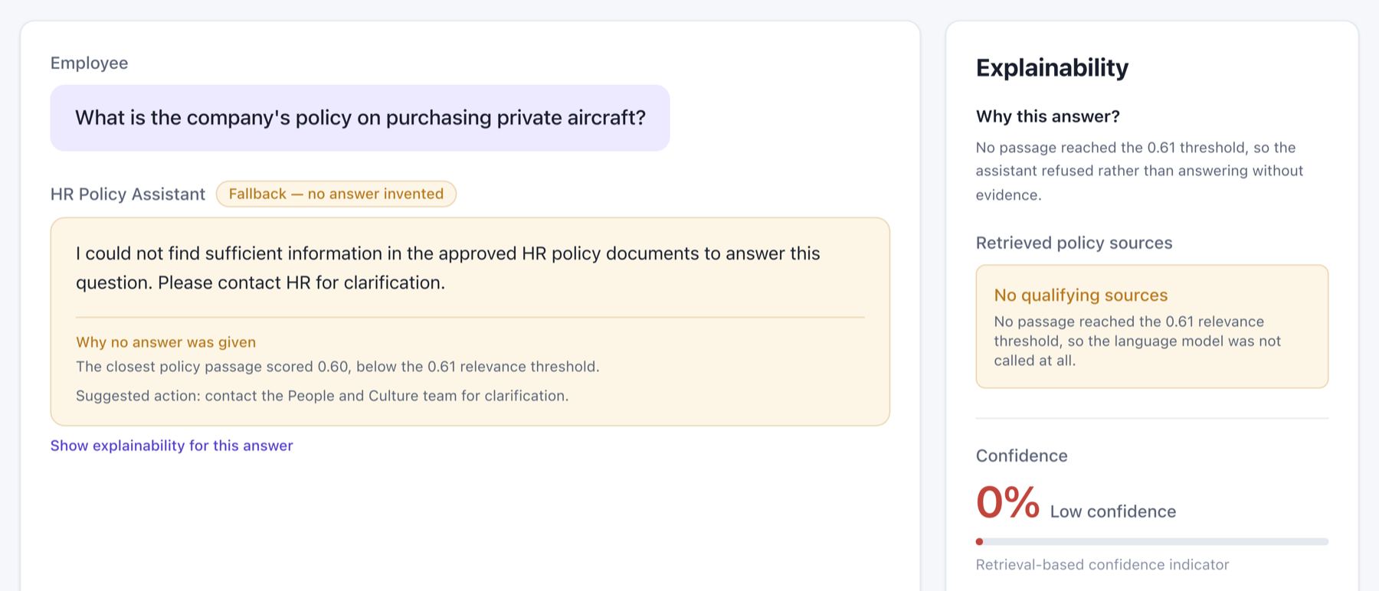
Figure 5: A refused question. The application states the best score, the threshold it failed to reach, and that no model was called.
On the HR governance dashboard (Figure 6), HR officers see the size of the knowledge base, the number of questions asked, acknowledgement completion and mean retrieval confidence. Its charts cover answer outcomes, confidence bands, the most-cited policies and coverage by category, all calculated from questions employees actually asked and the evidence retrieved for them.
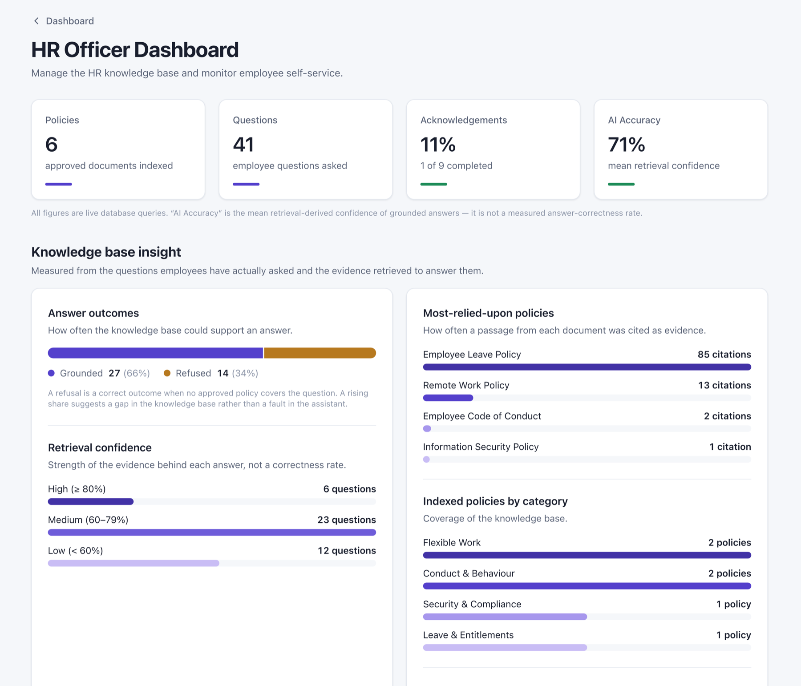
Figure 6: The HR governance dashboard, reporting answer outcomes, retrieval confidence, most-cited policies and coverage.
The other pages are the HR policy library and upload screen, keyword search, the leave form with its review step, the acknowledgement screen and the administrator views. All of them can be opened on the live prototype (Appendix I).

5.3 Deployment
The prototype runs as one Render web service serving both the API and the web interface, with a Neon PostgreSQL database in the same Singapore region as the app. Each push to the main branch deploys automatically. A health endpoint reports the running version, migrations run on release, and demonstration data is seeded only into an empty database, so a redeploy cannot overwrite existing records. Both services are on free tiers. An idle instance goes to sleep, and the first request after that takes about fifty seconds while it starts up again.

5.4 Demonstration video
A three-minute demonstration is available at https://youtu.be/TMELcPipzYI. It shows sign-in, an answered question with its sources, an everyday-wording question, a refused question, a leave request, a policy acknowledgement, the HR dashboard, a policy upload and the administrator audit log.

6 Evaluation

6.1 Test strategy
The team tested in three ways. Automated tests cover behaviour that must not break. Measured probes cover behaviour that can vary between runs, such as whether a question asked in everyday words gets answered. Internal user testing shows whether the system makes sense to someone who did not build it. Test cases for all three roles are listed in Appendix C. The automated suite has 72 tests in six files and runs on every push through GitHub Actions, with external AI services switched off so that the results do not depend on the network. There are 11 tests for document ingestion, 16 for the retrieval pipeline including thresholds and refusal, 8 for authentication, 8 for role-based access, 8 for answering-mode selection and fallback, and 21 for the feature endpoints (Appendix B).

6.2 Measured outcomes
Measurements from Weeks 9 to 12 are summarised in Table 4.
Table 4: Measured outcomes
Measure | Result | How it was obtained
Knowledge base | 6 policy documents, 49 searchable passages | Indexing report in the policy library
Automated tests | 72 tests in 6 suites, passing on every push | GitHub Actions run history
Everyday-wording questions answered | 15 of 15, up from 9 of 15 | Three everyday-wording questions, five runs each, before and after the instruction change
Unrelated questions refused | 10 of 10 | 10 questions with no policy coverage, several of them deliberately pushed past the relevance check
Time to answer | About 5 seconds, measured between 4.9 and 6.7 seconds | Retrieval and generation timings reported by the application
Relevance thresholds | 0.61 (Gemini embeddings), 0.72 (local lexical) | Calibration run over the indexed corpus
Fallback under load | Ollama Cloud answered when Gemini returned “high demand” errors, in 5 to 18 seconds | Demonstration video recording, 1 October 2026
Chart palette contrast | Colour difference improved from 5.9 to 31.8 under protanopia simulation | Colour-vision deficiency check of the dashboard palette
In Week 9, the sick-leave defect (Section 3.2) was fixed by one added rule. It states that recognising an everyday term for a policy term counts as reading the policy. Everyday-wording questions then succeeded in 15 of 15 runs, and refusals of unrelated questions stayed at 10 of 10, so the refusal rule was not weakened.
On 1 October 2026, while the demonstration video was being recorded, real conditions tested the fallback chain. Gemini’s free tier returned “high demand” errors for most requests, and Ollama Cloud answered in its place. In one recording attempt, Ollama refused the same sick-leave question that Gemini answers correctly.

6.3 Evaluation against non-functional requirements
Table 5 compares the delivered system with the quality attributes in the proposal, grouped under the ISO/IEC 25010:2023 product quality characteristics (International Organization for Standardization 2023).
Table 5: Non-functional requirement evaluation
Attribute | Target from the proposal | Outcome
Functional suitability | Implement the approved functional requirements | Seven of eleven implemented in full, two narrowed and two descoped with visible placeholders (Section 3.1)
Reliability | Answers generated only from approved documents | Met. Enforced by the threshold check before generation and verified by the refusal tests
Security | Authentication, HTTPS, role-based access | Met. Hashed credentials, signed sessions, middleware authorisation, audit logging and HTTPS in deployment
Performance efficiency | Response within about three seconds | Partly met. Retrieval takes under a second, but total time is about five seconds because free-tier generation is slow. Cold starts add about fifty seconds
Usability | Conversational interface needing little training | Met in internal testing, but not tested with users outside the team
Maintainability | HR can add policies without redevelopment | Met. Policies are uploaded, indexed and versioned in the policy library
Explainability | Show the policy sections supporting each answer | Met, and extended to refusals
Compliance | Align with workplace legislation and responsible AI principles | Addressed through design and scope. The assistant reports what policies say and does not determine entitlements (Section 7)
Performance is the one target the system missed. When the three-second figure was written, no model had yet been called, and free-tier generation cannot meet it.

6.4 Evaluation of candidate solutions
Three approaches were compared before development began, and again in Week 9 once the assistant’s behaviour could be measured (Table 6).
Table 6: Comparison of candidate solutions
Criterion | General-purpose chatbot | Commercial HR platform | RAG assistant over approved policies (selected)
Answers from the employer’s own policies | No | Yes | Yes
Traceable to a document, page and section | No | Partly, and usually not shown to the employee | Yes
Behaviour when the policy is silent | Answers anyway | Escalates to a human | Refuses before any model is called
Cost to a small organisation | Low | High (Deloitte 2026) | Low
Effort to implement within a 12-week term | Very low | Not feasible | Feasible, and delivered
Governance evidence for HR | None | Extensive | Usage, confidence and refusal reporting in the dashboard
Fine-tuning a model on the policies was a fourth possibility, and it was ruled out on two counts. Every policy change would mean retraining the model, and a fine-tuned model cannot point to the clause it learned an answer from. Retrieval keeps the knowledge in documents that can be updated and cited (Lewis et al. 2020; Gao et al. 2023).

6.5 Limitations
1. The corpus is small and invented. Six fictional policies are enough to show retrieval and refusal working, but they cannot show how the system copes with a real library of overlapping, outdated and contradictory documents.
2. Answer quality was checked with targeted probes, not a labelled evaluation set. The probes show that the mechanism works. They do not give an accuracy rate. Usability was judged by two teammates who already knew the system.
3. The system also depends on free external services. Their response times vary, the hosting tier adds cold starts, and, as the October recording showed, the fallback model does not always behave like the primary one.
4. Finally, the assistant reports what policies say. It does not decide entitlements, which for Australian employees are set by the National Employment Standards in the Fair Work Act 2009 (Cth) as well as by the employer’s own policies, and it has no link to payroll or to any HR system of record.

7 Ethical and professional considerations

7.1 Privacy and data handling
Because the system deals with employment conditions, a real deployment would receive questions that reveal personal circumstances. Asking about carer’s leave or a workplace incident discloses something sensitive. Under the Australian Privacy Principles in the Privacy Act 1988 (Cth), such information may be collected only where reasonably necessary and used only for the purpose it was collected for, and it must be protected from misuse. Stored questions support the audit trail, but the governance dashboard reports totals, not individual histories. Only question text and retrieved passages reach an external model (Section 4.5), and the prototype holds no real personal information.
For an organisation adopting the system, the remaining risk is that question text leaves its boundary whenever a third-party model is used. A production deployment should either host the model inside that boundary or ask for informed consent and should say which of the two applies in the interface, where employees will see it.

7.2 Fairness, transparency and accountability
Australia’s AI Ethics Principles (Department of Industry, Science and Resources 2019) set out eight principles. Transparency and explainability, contestability, and accountability shaped this design most directly. The explainability panel names the evidence for every answer. It also makes answers contestable, because an employee who thinks an answer is wrong can open the cited clause and take a specific point to HR. Accountability rests on the audit log, and a person remains the decisionmaker for anything with consequences. Bias works differently here than in the recruitment and evaluation tools examined by Simpson, Ermovick and Sloane (2026), since this assistant makes no judgements about people. The likely failure is uneven coverage. If the policies explain one group’s entitlements in more detail than another’s, answer quality will differ between the groups without anyone noticing. The coverage chart on the governance dashboard is there partly to make that visible.
Refusal is the default whenever the evidence is weak. An assistant that always answers would look better in a demonstration and would mislead staff more often in daily use.

7.3 Intellectual property and licensing
All of the source code was written by the team and is published under the repository’s licence. Dependencies are open source under permissive licences and listed in the project manifest. Because the policy documents were written for the project, no employer’s copyrighted material is used. External sources are cited in CQU Harvard style. The AI services are used within the terms of their free tiers, and no model was trained or fine-tuned on project data.

7.4 Professional standards and academic integrity
The ACS Code of Professional Ethics (Australian Computer Society 2023) requires members to put the public interest first and to act with competence, honesty and professionalism. Honesty about capability came up when the team decided how to show the descoped features. Removing the placeholders would have made the prototype look more complete. The team kept them, labelled, and this report records the same gaps. Competence was tested by the first relevance threshold, which had been chosen by intuition and quietly broke semantic retrieval by rejecting valid matches. Instead of guessing again, the team measured, and the per-model thresholds in Section 4.3 came out of that measurement.

8 Project management

8.1 Planning and execution
The project ran over the twelve weeks of Term 2, 2026, against the work breakdown structure and Gantt schedule prepared in Week 3 (Appendix F). Its phases were initiation, business analysis, planning, proposal submission, analysis and design, development, testing, documentation and final delivery. The first half went to plan, and the second half was tight. Weeks 1 to 4 produced the topic, research collection, requirements and proposal. Weeks 5 and 6 produced the architecture diagram, database design, use cases and wireframes. On 27 August, in Week 7, the minimum viable prototype was merged as one pull request of 126 files. Week 8 went on documentation, and Week 9 on accuracy work, the extra answering modes, the dashboard charts and deployment. Testing, the project wiki, the poster and this report filled Weeks 10 to 12. Most development fell in Weeks 7 to 9, as the proposal’s schedule intended. That left no slack. If the sick-leave defect had surfaced in Week 11, there would not have been time to diagnose and fix it properly.

8.2 Coordination and tools
Trello held the task board, with each card assigned to a member and tracked to Done against its due date. GitHub held the code, documentation and wiki, and every change reached the main branch through a pull request. Shared documents lived on OneDrive. Weekly Zoom meetings were minuted with attendance, decisions and action items, and nine meetings are documented for Weeks 1 to 9 (Appendix G). As the unit requires, the team leader role rotated during the term.
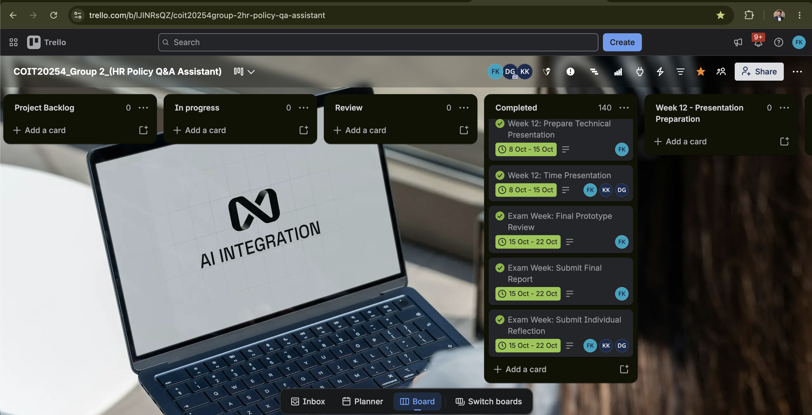
Figure 7: The final Trello Board structure after completing all the task.
Responsibilities followed the RACI matrix in the proposal. Farhaz Khondoker led the AI architecture, development, deployment and technical documentation. Isuru Koswaththa led planning, requirements and use case documentation and kept the board up to date. Dineli Jayandee Gampolage led requirements refinement, user stories (Appendix E), wireframes, quality assurance and testing support. Major decisions were made together in the weekly meeting and recorded in the minutes.

8.3 Risk and change management
At each weekly meeting, the risk register from the proposal was reviewed. Table 7 shows what became of each risk.
Table 7: Outcome of the proposal’s risks
Risk from the proposal | What happened | How it was handled
AI-generated incorrect or misleading responses | No hallucination was observed. The opposite happened, with correct evidence refused | Instruction set corrected and re-measured (Section 6.2). The threshold control that prevents hallucination was kept
Third-party AI API limitations or outages | Occurred. Free-tier quota limits and slow responses affected the live site and the video recording | A fallback chain across three answering modes, with per-request timeouts and disclosure of which model answered
Schedule delays from academic workload | Partly occurred. Development was compressed into Weeks 7 to 9 | Scope was cut on purpose and quality was kept. Four features were descoped with placeholders
Data privacy and confidentiality | Controlled by design | Fictional policies and seeded accounts. No real employee data at any stage
Insufficient team collaboration | Did not occur | Weekly meetings with minutes, Trello ownership and pull request reviews

8.4 Quality assurance
Quality assurance worked at four levels. Each pull request was reviewed before merge, the automated suite ran on every push, measured probes covered behaviour that tests cannot assert, and teammates tested the system in Week 9 against a twelve-step checklist kept in the project wiki. The checklist covers sign-in, supported and unsupported questions, policy upload and indexing, acknowledgement, leave submission, role separation and the dashboard.

9 Recommendations
- Test against a labelled question set before staff use the assistant. Fifty to one hundred questions taken from real enquiry records.
- Re-run the phrasing and refusal probes on every model in the fallback chain.
- Try the assistant on a real policy library, where overlapping, superseded and contradictory documents are normal.
- Alert HR when a policy changes under an answer people already rely on. Because the system already records which passages supported which answers, the affected questions can be found with a query against existing data.
- For production, move generation inside the organisation’s boundary or get explicit consent for question text to leave it, and tell employees which applies.
- Track refusal rates by policy category. A category that refuses far more often than the others is either under-documented or poorly indexed.

10 Conclusion
The prototype does what the team set out to build. It answers from approved documents, shows its sources and declines when the policies are silent, and 72 automated tests hold that behaviour in place. The term also showed where a system like this is fragile. In every test, the retrieval and refusal logic held up. Its weak points were outside that logic. The instruction set was too literal for everyday language, the free-tier services were slow or unavailable on the day of recording, and the fallback model had not been re-tested after the instructions changed. The first problem surfaced because teammates asked questions in their own words, and the third came to light only during the video recording. Neither appeared in the proposal’s risk register in that form. The next stage should focus on evidence. A labelled question set, testing on each model and a real policy library would show whether the accuracy measured with six fictional policies holds up against an organisation’s actual documents.

References
Australian Computer Society (ACS) 2023, ACS Code of Professional Ethics, Australian Computer Society, Sydney.
Australian HR Institute (AHRI) & Queensland University of Technology (QUT) 2024, The State of AI in Australian Human Resources 2024 Report, Australian HR Institute, Melbourne.
Deloitte 2026, Human capital: making humans better at work and work better for humans, Deloitte Global, viewed 23 July 2026, https://www2.deloitte.com/global/en/services/human-capital.html.
Department of Industry, Science and Resources 2019, Australia’s AI ethics principles, Australian Government, viewed 24 September 2026, https://www.industry.gov.au/publications/australias-ai-ethics-principles.
Gao, Y, Xiong, Y, Gao, X, Jia, K, Pan, J, Bi, Y, Dai, Y, Sun, J, Wang, M & Wang, H 2023, ‘Retrieval-augmented generation for large language models: a survey’, arXiv preprint, arXiv:2312.10997, viewed 24 September 2026, https://arxiv.org/abs/2312.10997.
International Organization for Standardization (ISO) 2023, ISO/IEC 25010:2023 Systems and software engineering — Systems and software Quality Requirements and Evaluation (SQuaRE) — Product quality model, ISO, Geneva.
Lewis, P, Perez, E, Piktus, A, Petroni, F, Karpukhin, V, Goyal, N, Küttler, H, Lewis, M, Yih, W, Rocktäschel, T, Riedel, S & Kiela, D 2020, ‘Retrieval-augmented generation for knowledge-intensive NLP tasks’, Advances in Neural Information Processing Systems, vol. 33, pp. 9459–9474.
National Institute of Standards and Technology (NIST) 2023, Artificial intelligence risk management framework (AI RMF 1.0), NIST AI 100-1, U.S. Department of Commerce, Gaithersburg, MD, viewed 23 July 2026, https://www.nist.gov/itl/ai-risk- management-framework.
ServiceNow 2026, HR service delivery — HR management, ServiceNow, viewed 23 July 2026, https://www.servicenow.com/products/hr-service-delivery.html.
Simpson, E, Ermovick, R & Sloane, M 2026, ‘Human resource management and AI: a contextual transparency database’, arXiv preprint, arXiv:2511.03916, University of Virginia, viewed 23 July 2026, https://arxiv.org/abs/2511.03916.
Workday Inc. 2026, Human capital management | Workday Australia & New Zealand, Workday, viewed 23 July 2026, https://www.workday.com/en-au/products/human- capital-management.html.

Legislation
Fair Work Act 2009 (Cth).
Privacy Act 1988 (Cth).

Appendix A: Requirements traceability matrix
ID | Requirement (from the proposal) | Status | Implemented in | Verified by
FR1 | Users submit HR policy questions in natural language | Delivered | Ask AI page; chat API | Retrieval suite; Figure 4
FR2 | System responds using retrieval-augmented generation | Delivered | AI module: chunking, embedding, scoring, generation | Retrieval suite (16 tests)
FR3 | Users search policies using text input | Delivered | Search page; policy search endpoint | Feature suite
FR4 | System summarises lengthy policy documents | Narrowed | Policy summaries stored and displayed in the library; entered at upload, not generated | Feature suite
FR5 | HR staff generate draft policies with generative AI | Descoped | Labelled placeholder in HR dashboard | Section 3.1
FR6 | Employees acknowledge policies electronically | Delivered | Acknowledgements page and endpoints | Feature suite
FR7 | Managers receive automated policy review reminders | Descoped | Labelled placeholder in HR dashboard | Section 3.1
FR8 | Employees initiate leave requests through conversational workflows | Narrowed | Policy guidance from the assistant; structured leave form with review step | Feature suite
FR9 | Responses personalised by user role and permissions | Delivered | Authorisation middleware; role-based pages | Access control suite (8 tests)
FR10 | System explains how each answer was generated | Delivered | Explainability panel: sources, similarity, confidence, timings | Retrieval suite; Figures 4 and 5
FR11 | Administrators monitor AI performance on a governance dashboard | Delivered | HR and admin governance pages; governance service | Feature suite; Figure 6

Appendix B: Test suite summary
Suite | Tests | Coverage
Ingestion (unit) | 11 | Page-aware PDF extraction, section-detecting chunking, checksum handling
Retrieval (unit) | 16 | Scoring, per-model thresholds, refusal before generation, citation assembly
Authentication (integration) | 8 | Sign-in, session handling, invalid credentials, sign-out
Access control (integration) | 8 | Cross-role access attempts refused for employee, HR and admin routes
Answering modes (integration) | 8 | Mode availability, provider resolution, fallback chain, disclosure of handoffs
Features (integration) | 21 | Policies, upload, leave, acknowledgements, dashboard and governance endpoints
Total | 72 | Run on every push through GitHub Actions with external AI services disabled

Appendix C: Test cases
Employee Test Cases

Test ID | Test Area | Test steps | Expected Result | status
EMP-01 | Employee Login | Enter valid employee username and password | Employee successfully logs in and is directed to the employee dashboard | 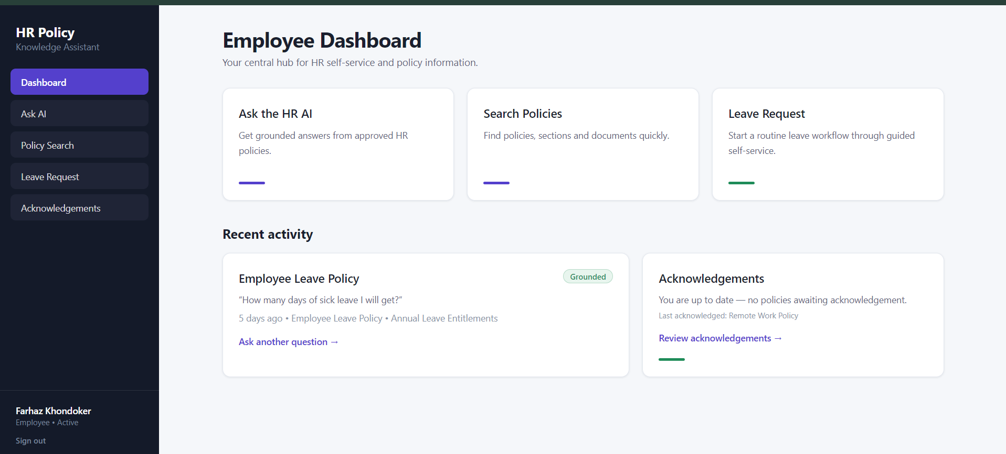Response time: ≤ 3 seconds
EMP-02 | Invalid Employee Login | Enter incorrect username or password | Login is rejected and an appropriate error message is displayed (“That email address or password is incorrect.”) | 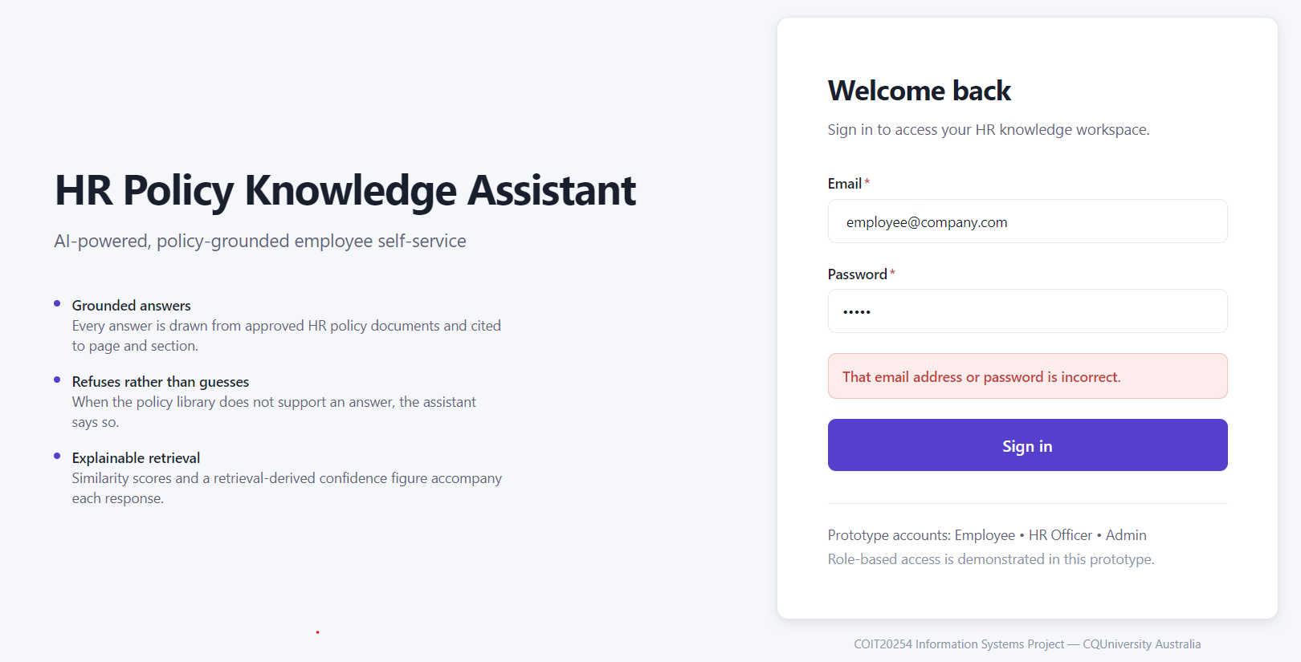  Response time: ≤ 3 seconds
EMP-03 | Ask HR Policy Question | Login then Enter “How many days of annual leave can I take?” | System provides an accurate answer based on the approved HR policy | 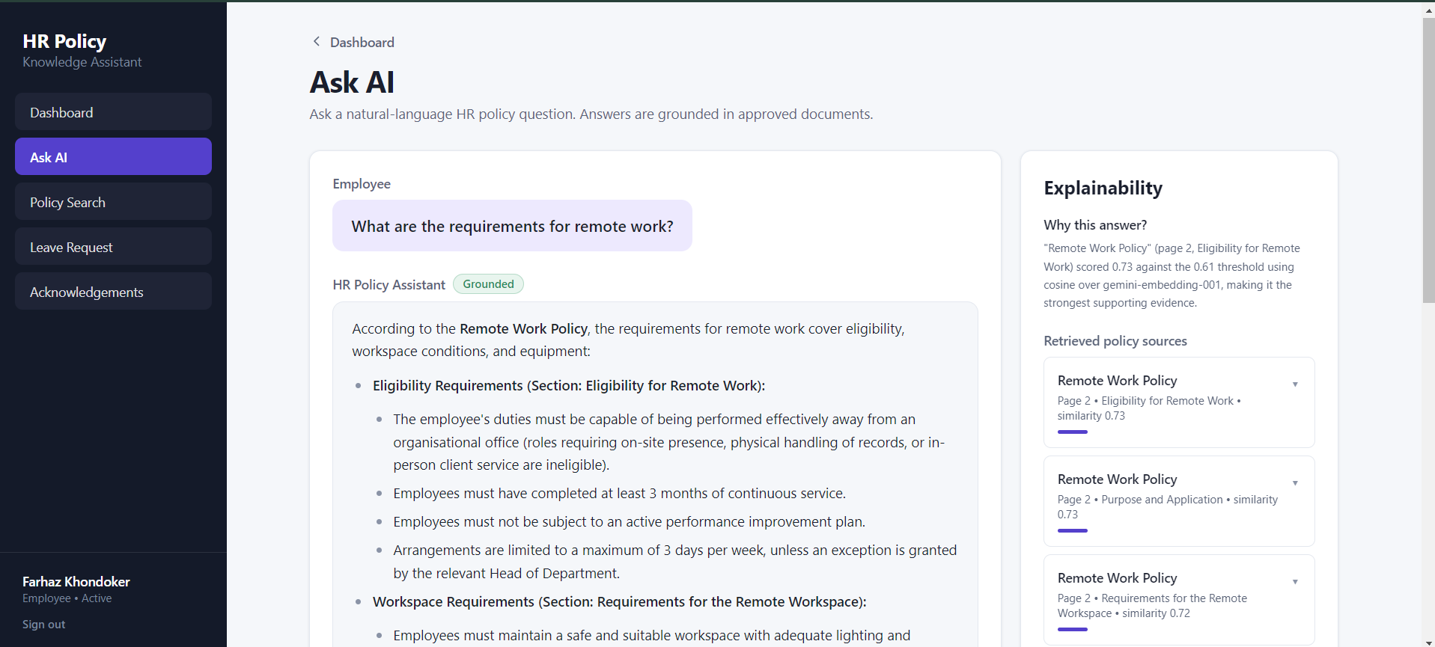  Response time: ≤ 5 seconds
EMP-04 | Search HR Policy | Login then Search “Annual Leave” | Relevant HR policy information is displayed | 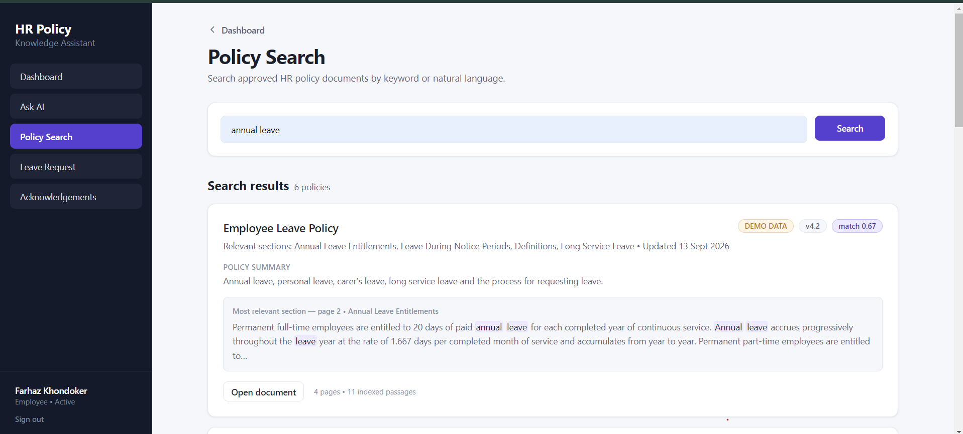  Response time: ≤ 3 seconds
EMP-05 | View Policy Source | Ask a policy question and select/view source | Supporting HR policy document/source is displayed | 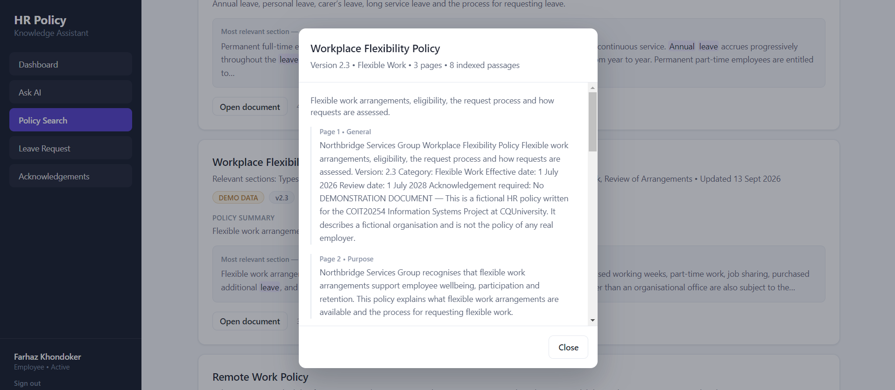  Response time: ≤ 3 seconds
EMP-06 | Summaries Policy | Search any HR policy | System provides a clear and concise summary | 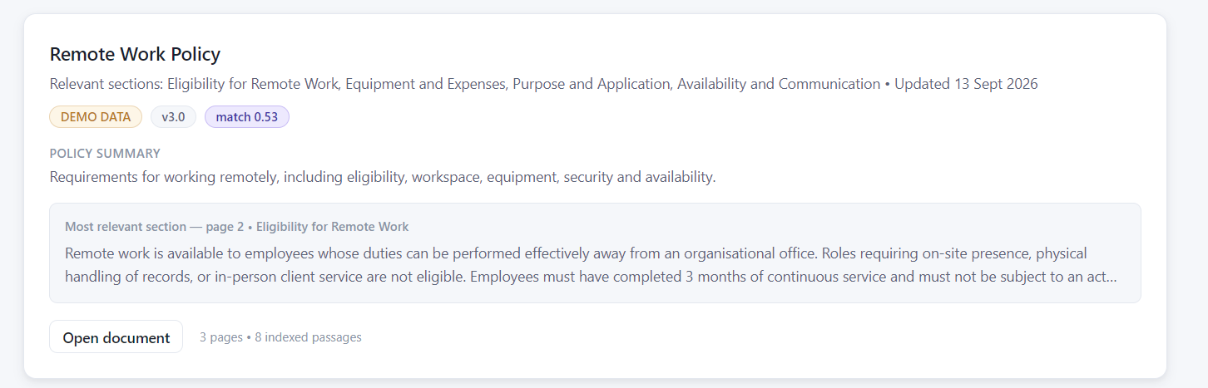  Response time: ≤ 5 seconds
EMP-07 | Policy Acknowledgement | Login then Open Acknowledgements and Click Acknowledge | Policy acknowledgement is successfully recorded | 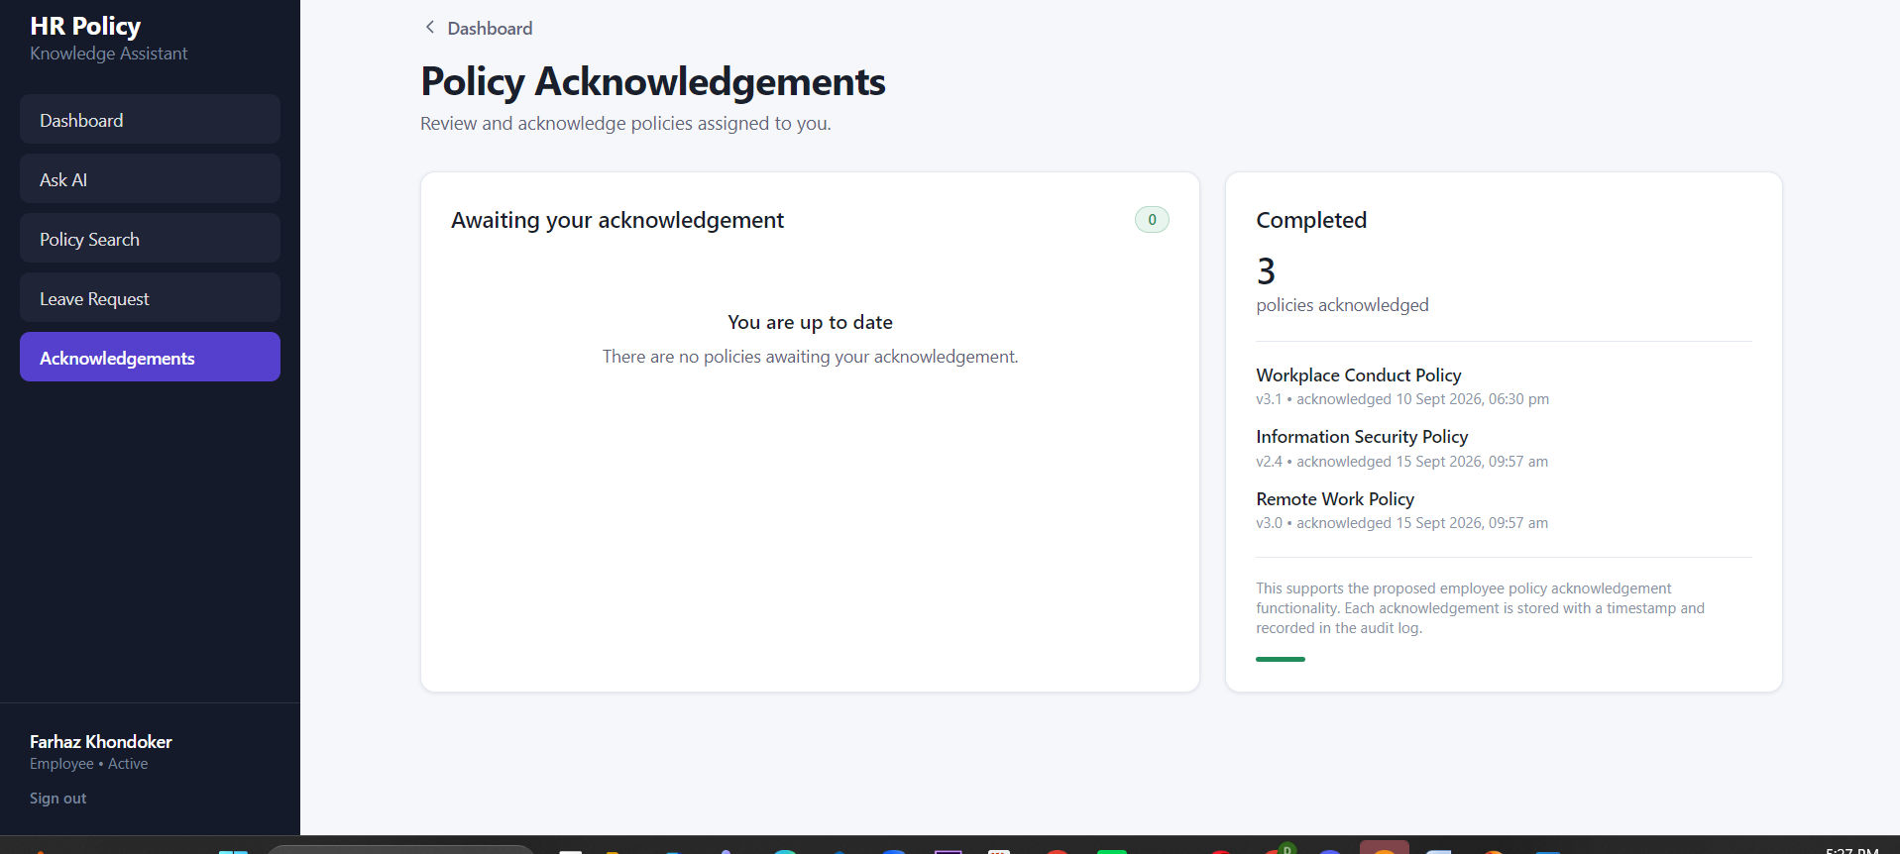  Response time: ≤ 3 seconds
EMP-08 | Initiate Leave Request | Login and click leave request then start a leave request and fill the form | System guides the employee through the leave request workflow | 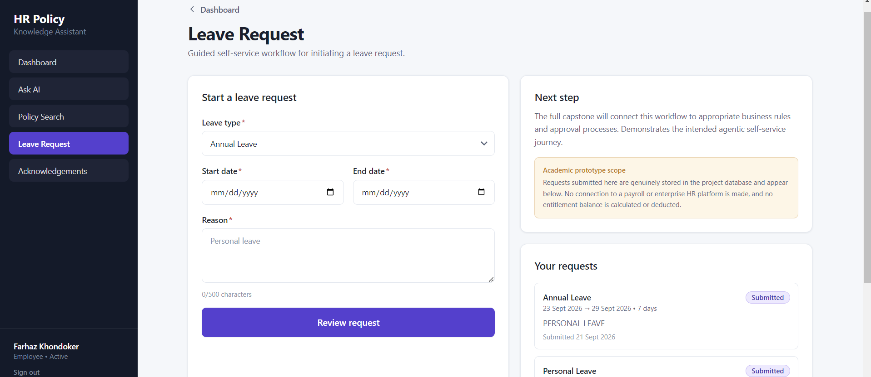  Response time: ≤ 3 seconds
EMP-09 | Unrelated Question | Ask a question outside the available HR policies | The system does not provide unsupported information and responds appropriately (“I could not find sufficient information in the approved HR policy documents to answer this question. Please contact HR for clarification.”) | 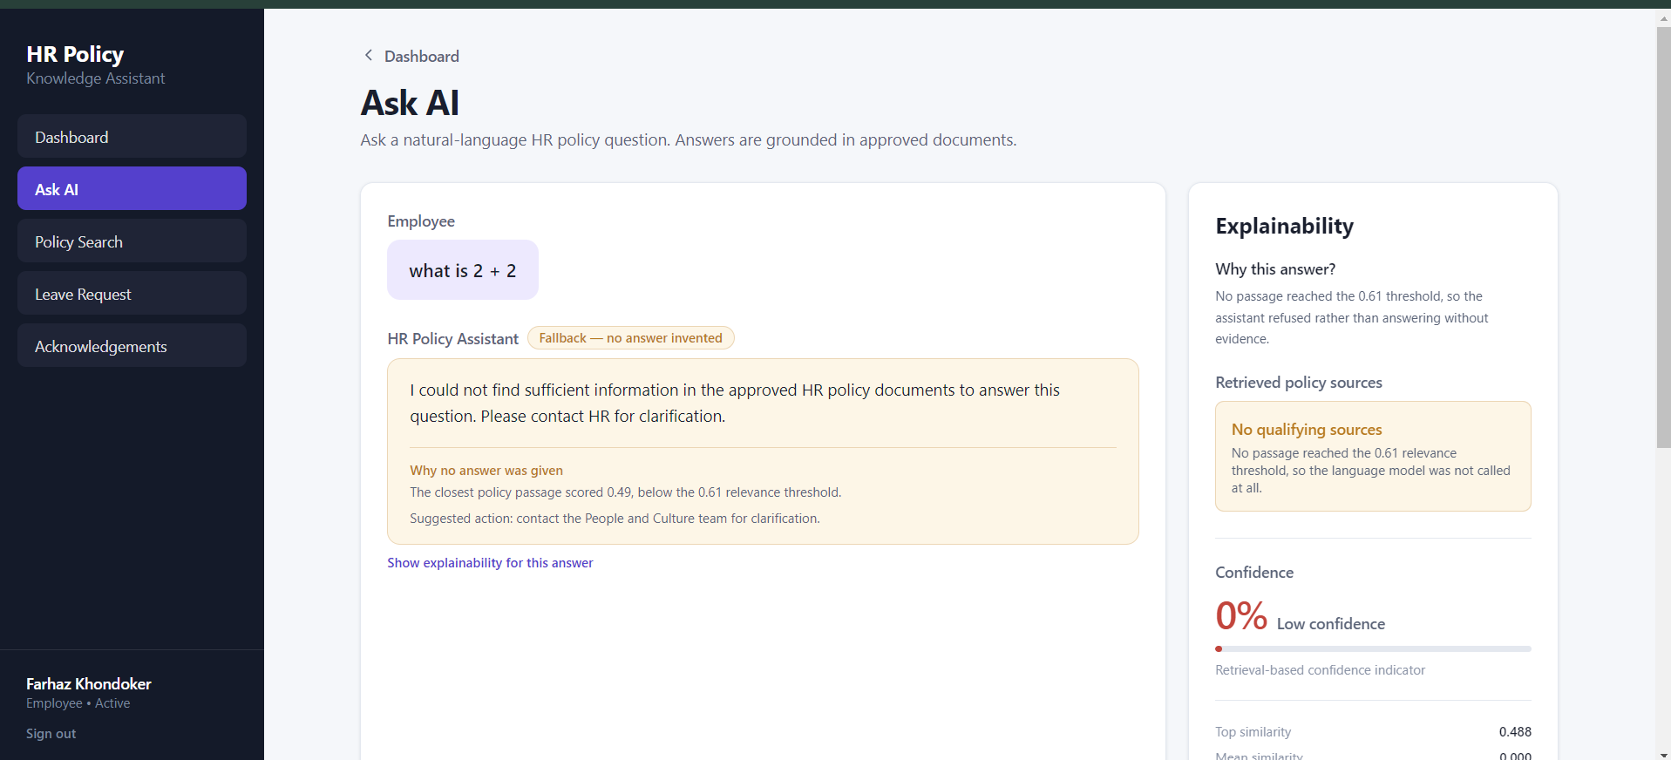Response time: ≤ 5 seconds

HR officer Test Cases
Test Case ID | Test Area | Test Steps | Expected Result | Status
HR-01 | HR Officer Login | Enter valid HR officer credentials to Login | HR officer successfully logs in and accesses the HR dashboard | 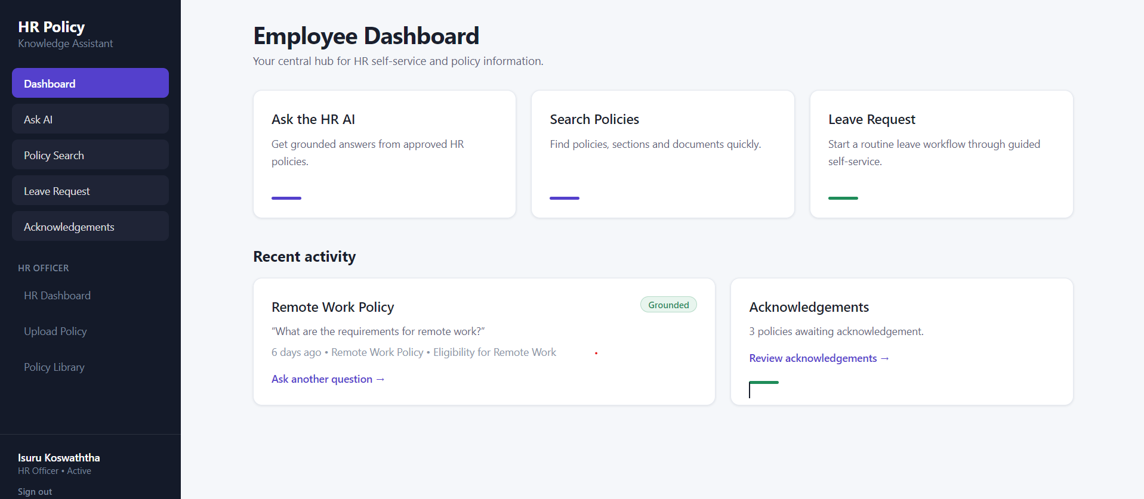  Response time: ≤ 3 seconds
HR-02 | Invalid Login | Enter incorrect details then Click Login | Login is rejected with an appropriate error message (“That email address or password is incorrect.”) | Response time: ≤ 3 seconds  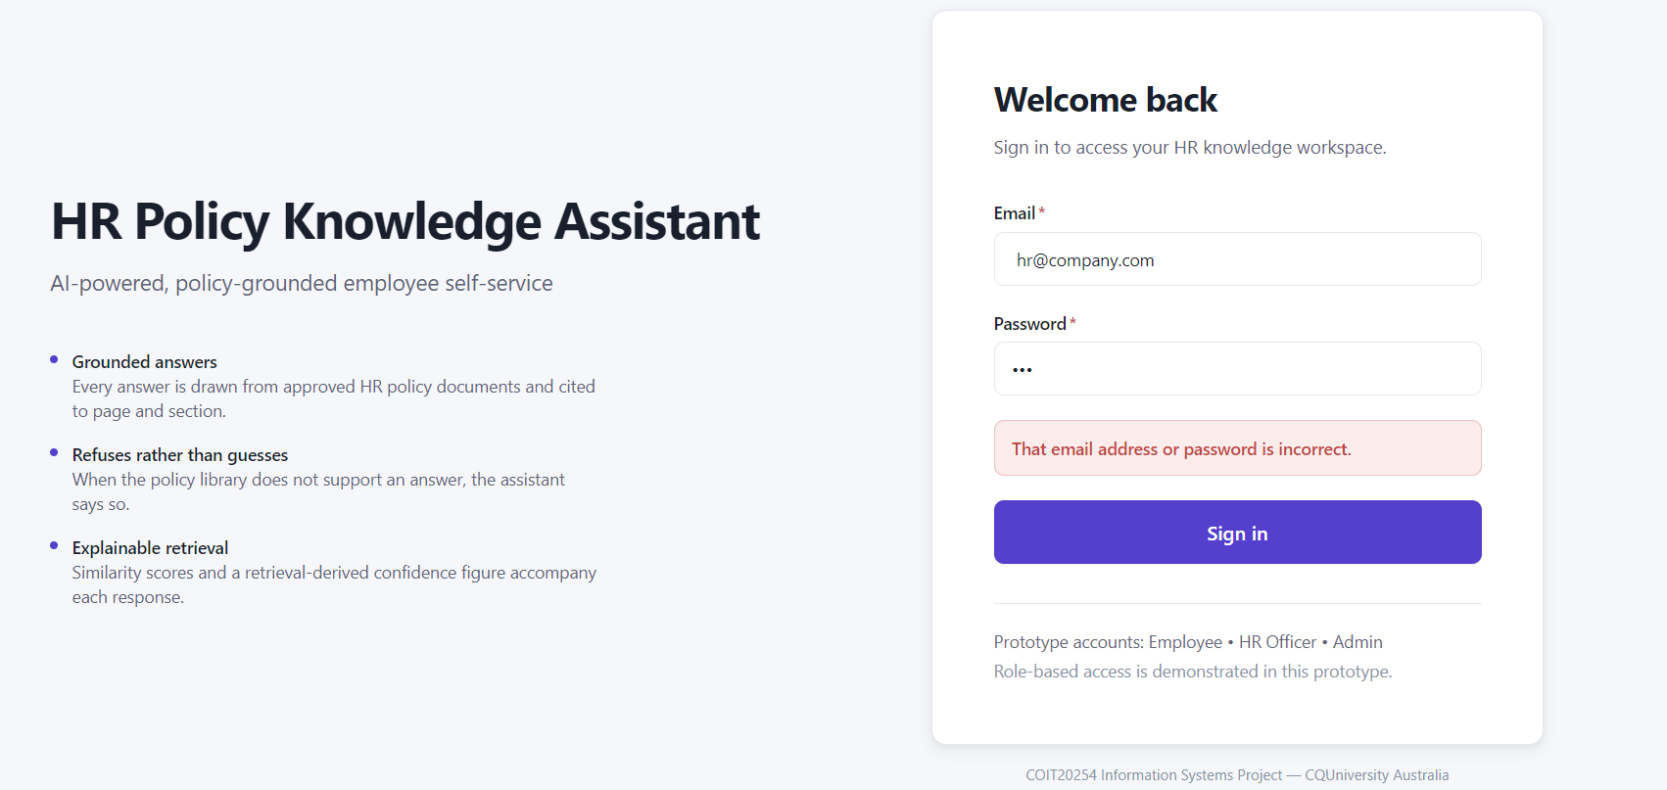
HR-03 | Ask HR Policy Question | Login and ask a policy-related question | System provides an accurate response from approved HR documents | 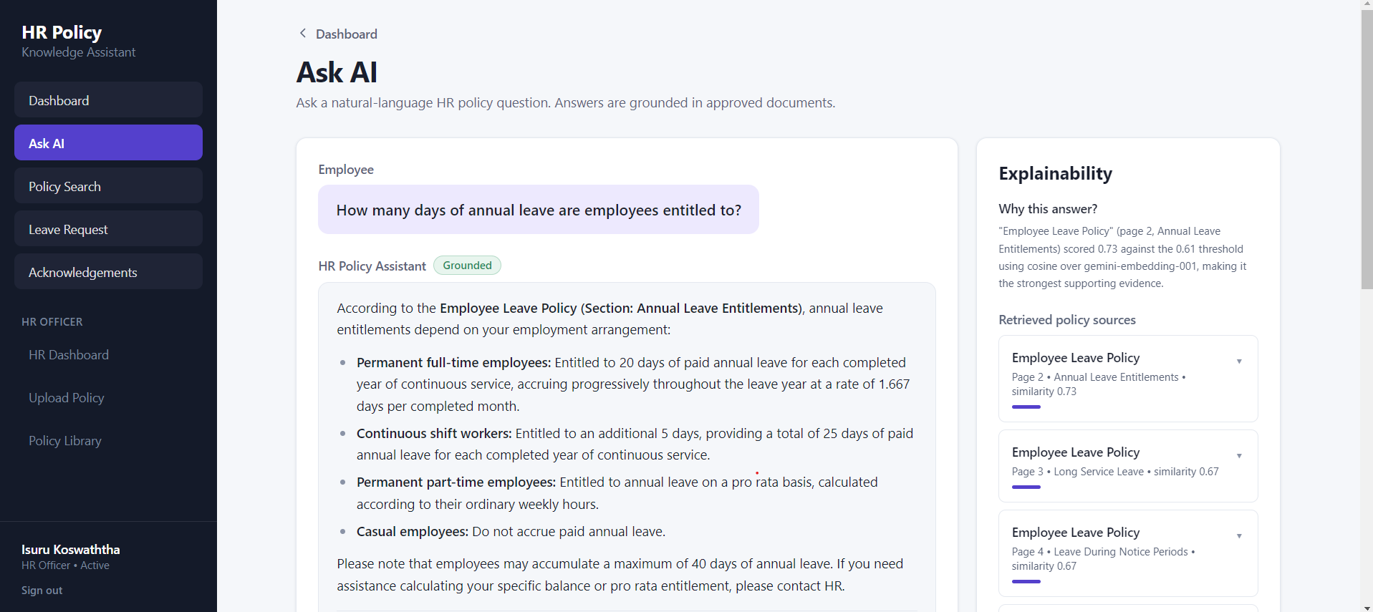  Response time: ≤ 5 seconds
HR-04 | Search Policies | Login and Search for a policy using keywords | Relevant policy information is displayed | 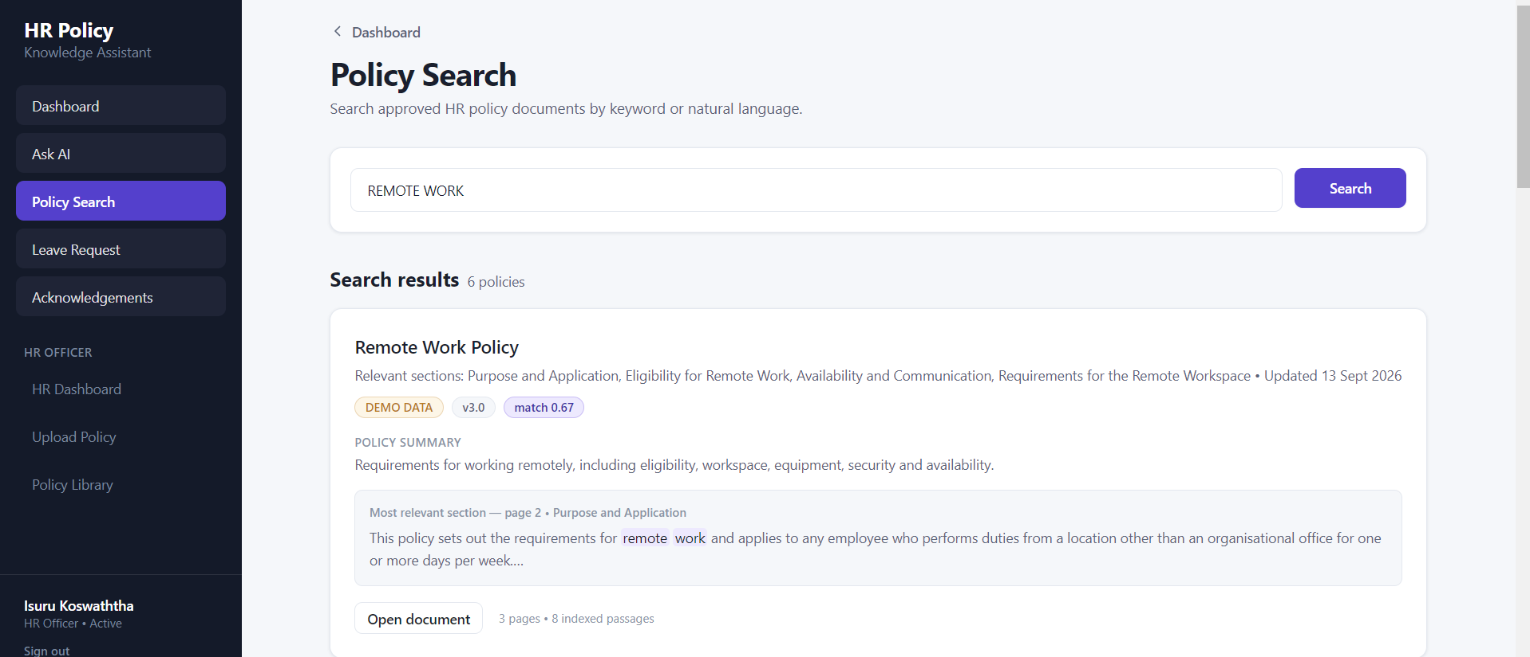  Response time: ≤ 3 seconds
HR-05 | Verify AI Response Source | Ask a policy question and check supporting source | System displays the relevant policy source/explanation | 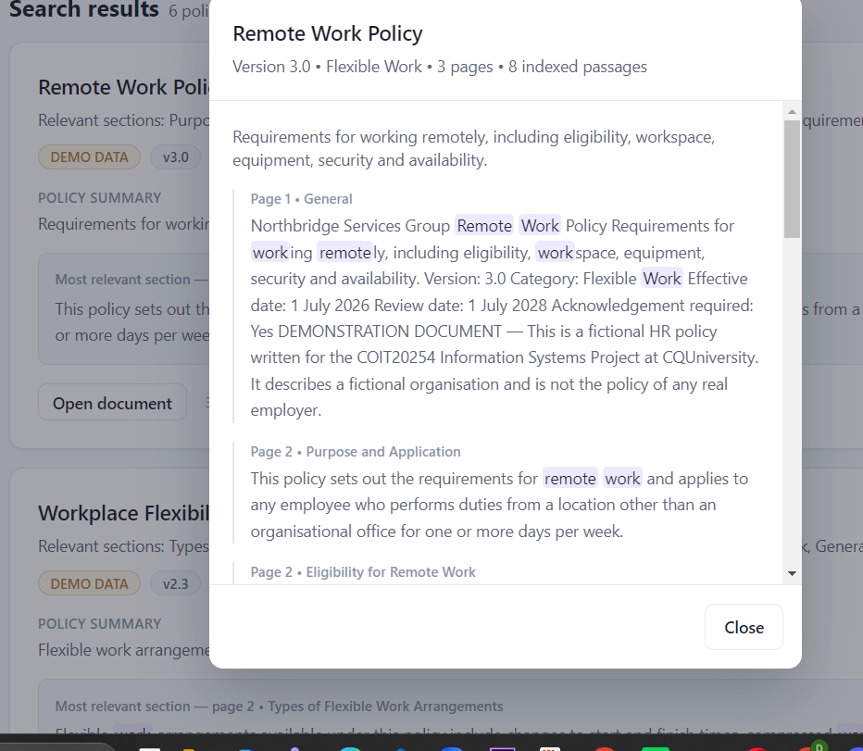  Response time: ≤ 5 seconds
HR-06 | Upload Policy | Login and go to upload policy then Upload/update an approved HR policy document | Policy repository is updated successfully | 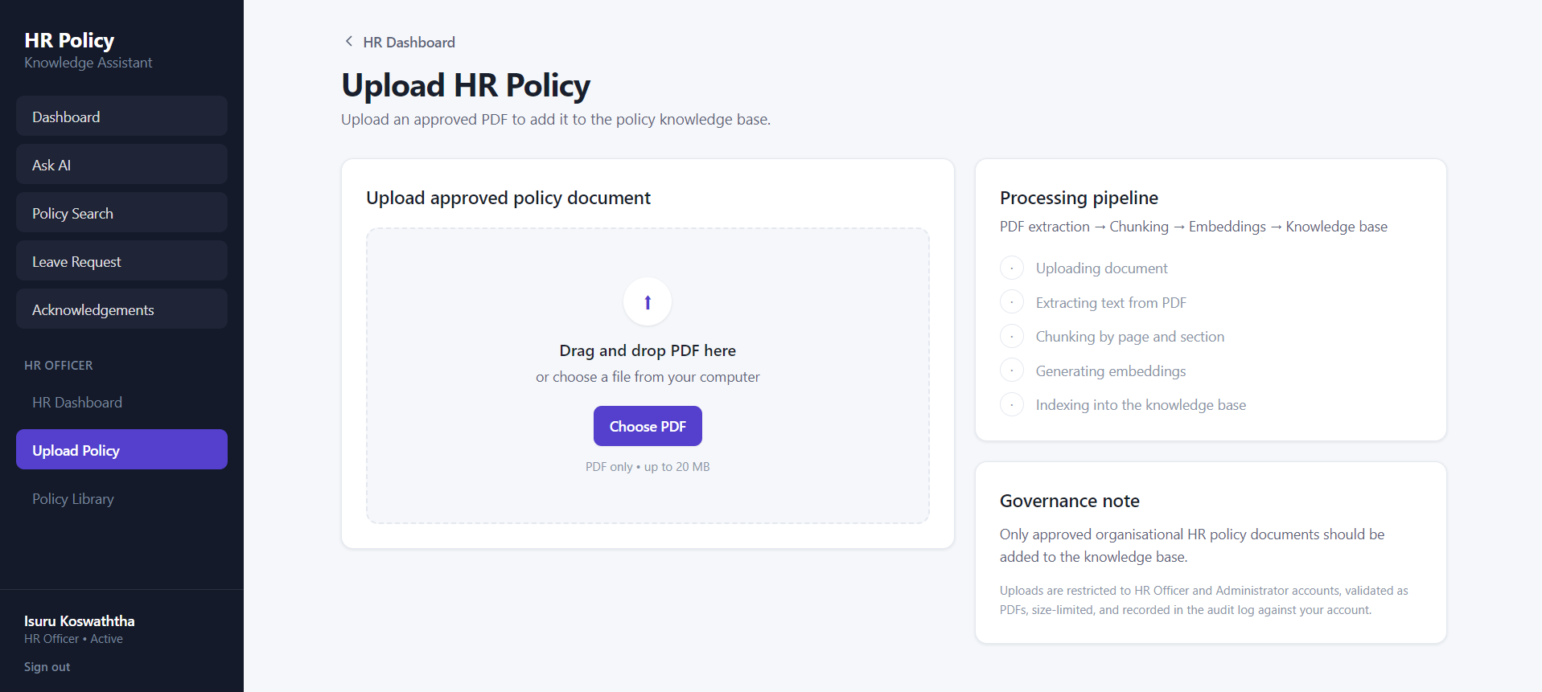  Response time: ≤ 5 seconds
HR-07 | Restricted Information Access | Attempt to access information outside HR officer permissions | Does not provide any information. (“Fallback — no answer invented”) | 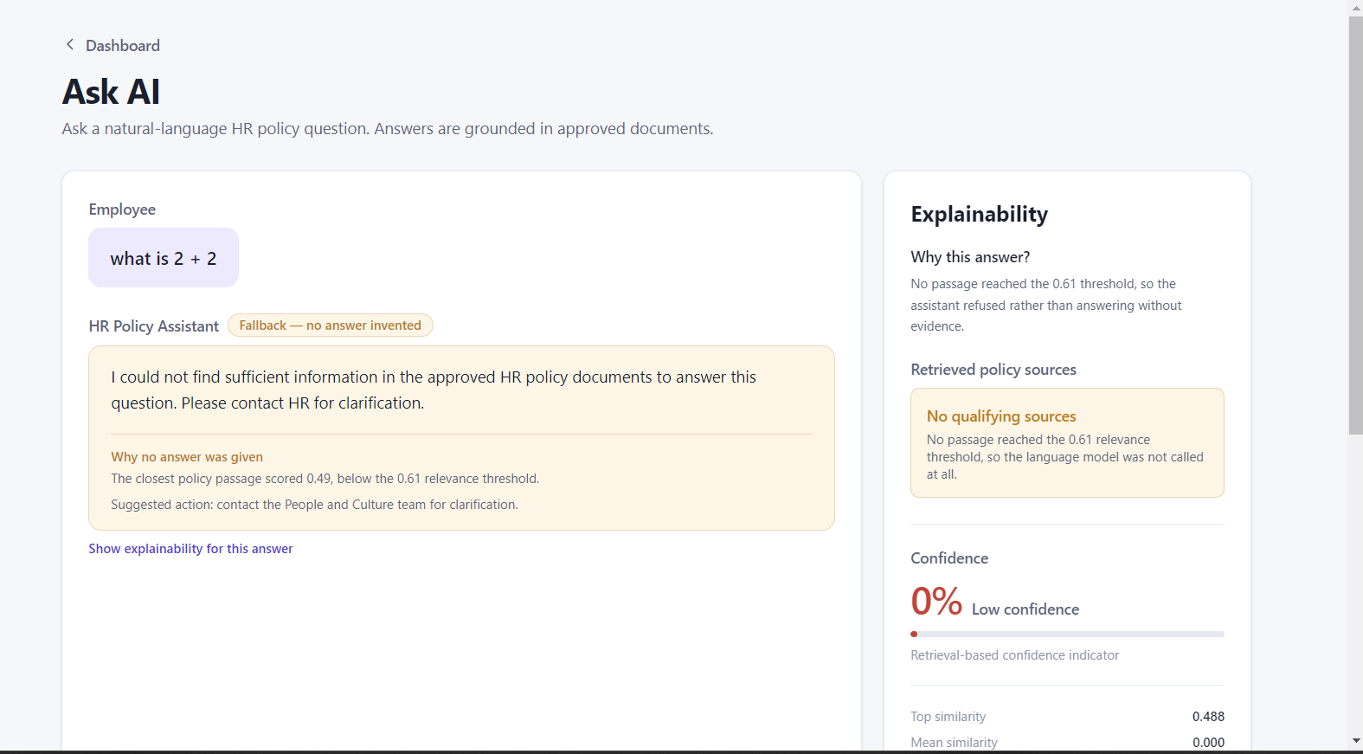  Response time: ≤ 5 seconds

Administrator Test Cases
Test Case ID | Test Scenario | Test Steps | Expected Result | Status
ADM-01 | Administrator Login | Enter valid administrator inputs to Login | Administrator successfully logs in and accesses the admin dashboard | 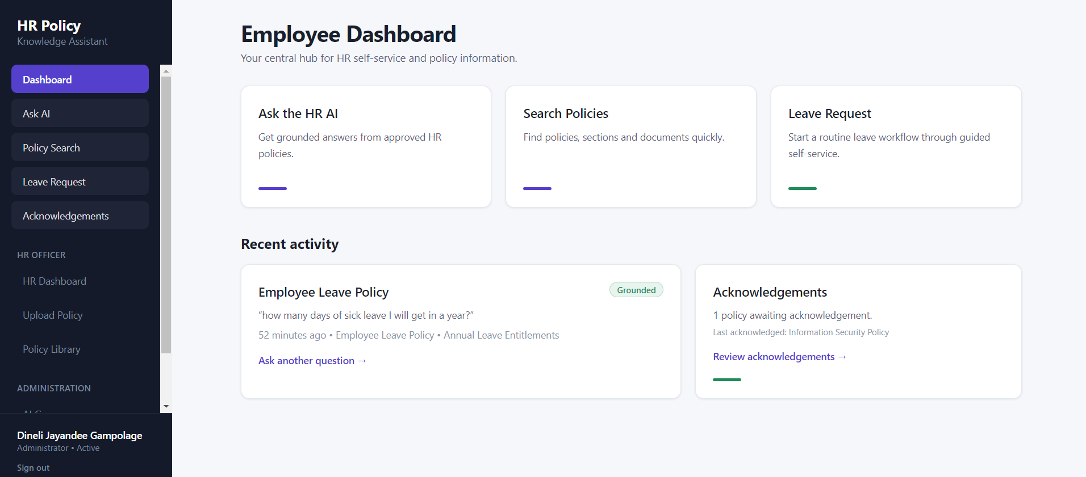  Response time: ≤ 3 seconds
ADM-02 | Invalid Admin Login | Enter incorrect details then Click Login | Login is rejected and an error message is displayed (“That email address or password is incorrect.”) | 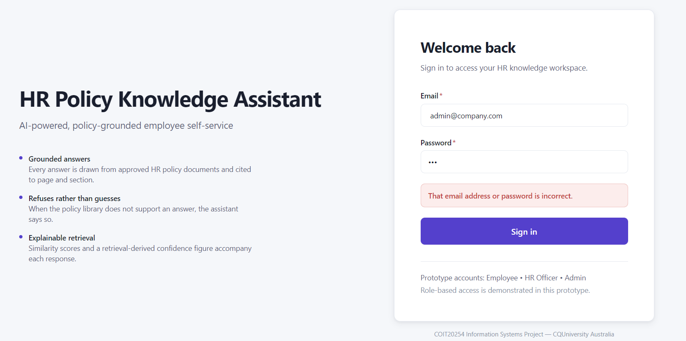  Response time: ≤ 3 seconds
ADM-04 | Monitor AI Performance | Login and Open AI Governance Dashboard | AI performance information is displayed | 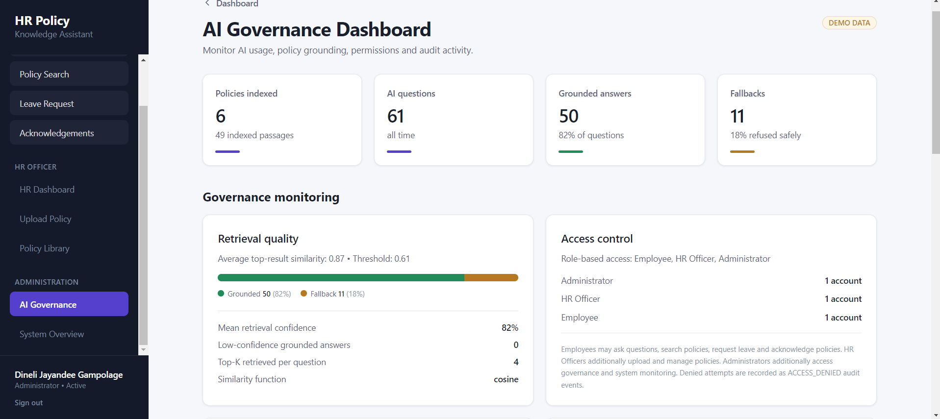  Response time: ≤ 5 seconds
ADM-05 | Review Audit Logs | Login and go to AI governance then Open audit logs | Relevant system/user activity logs are displayed | 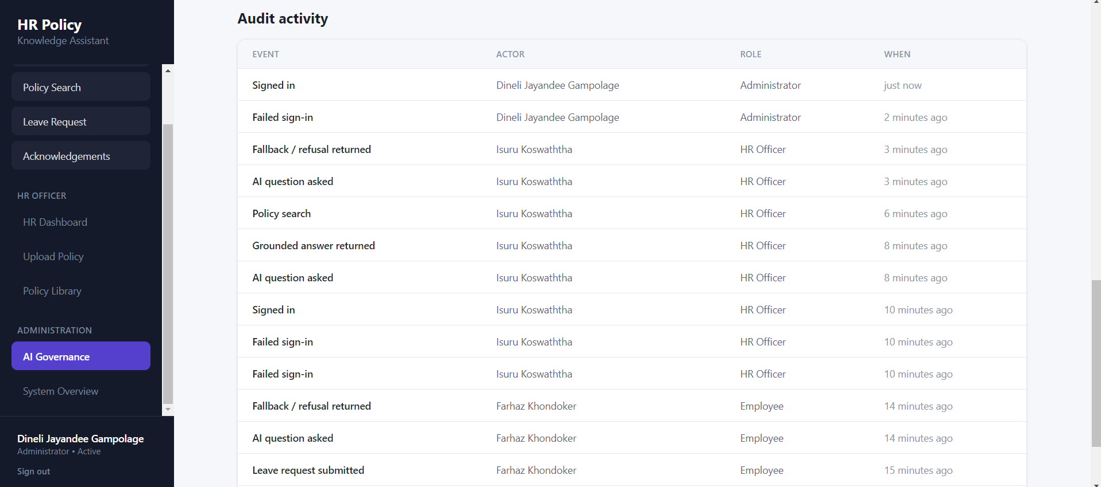  Response time: ≤ 5 seconds
ADM-06 | Monitor System Usage | Login and Open Governance Dashboard | System usage information is displayed correctly | 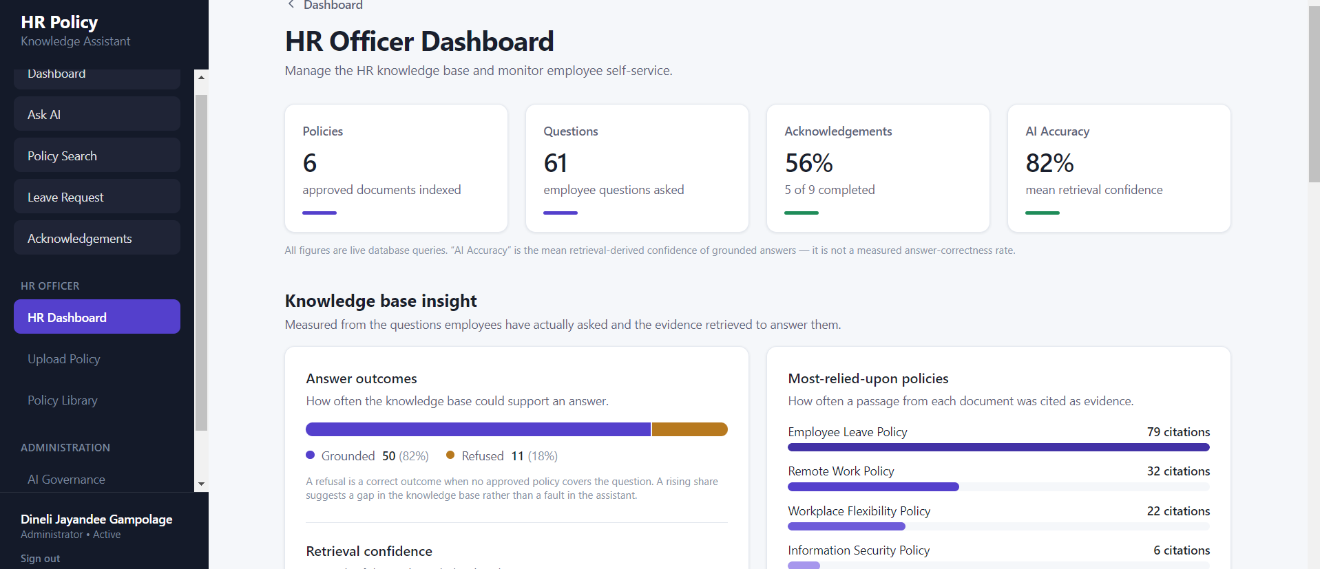  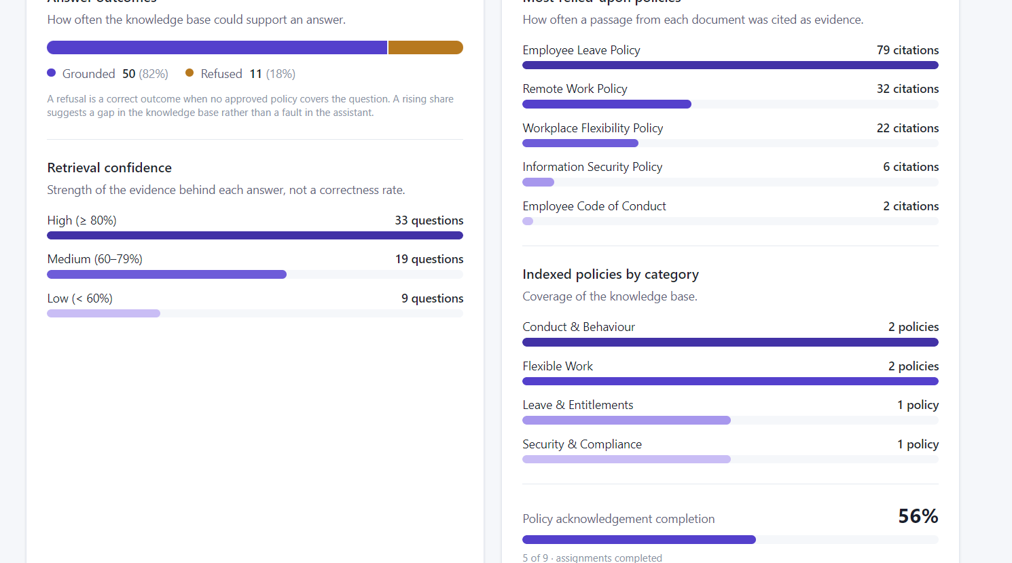  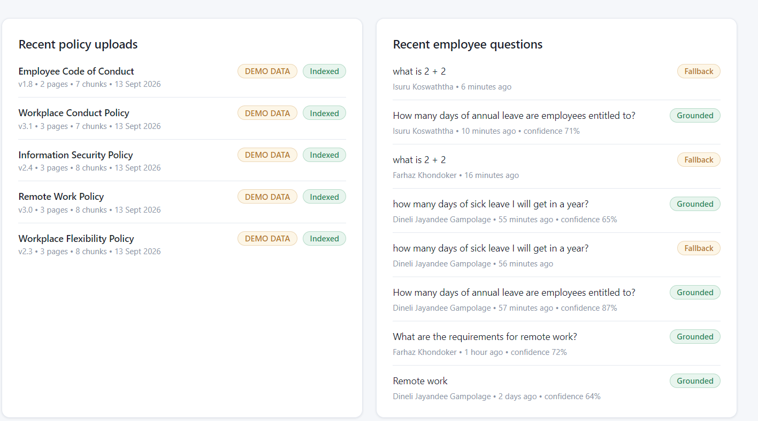  Response time: ≤ 5 seconds
ADM-08 | Response Time | Login then Ask an HR policy question | System provides the response under normal conditions | Response time: ≤ 5 seconds  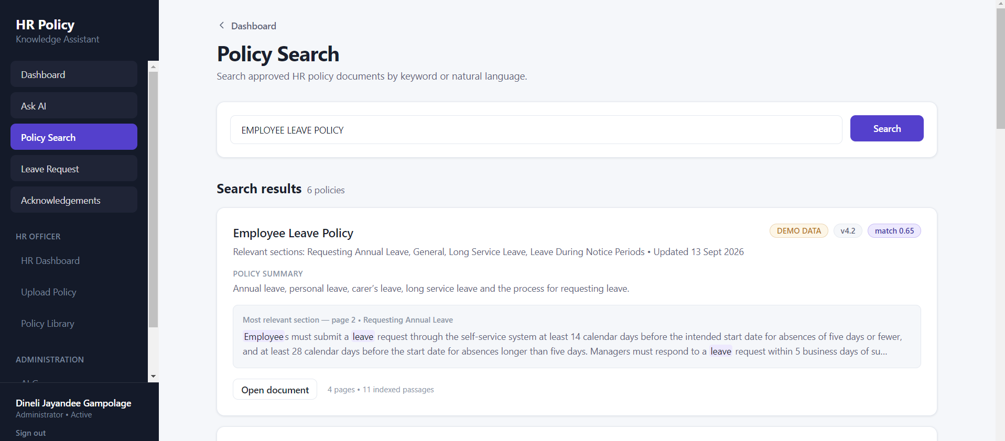
ADM-09 | Secure Authentication | Attempt to access protected functions without logging in | Protected functions cannot be accessed | 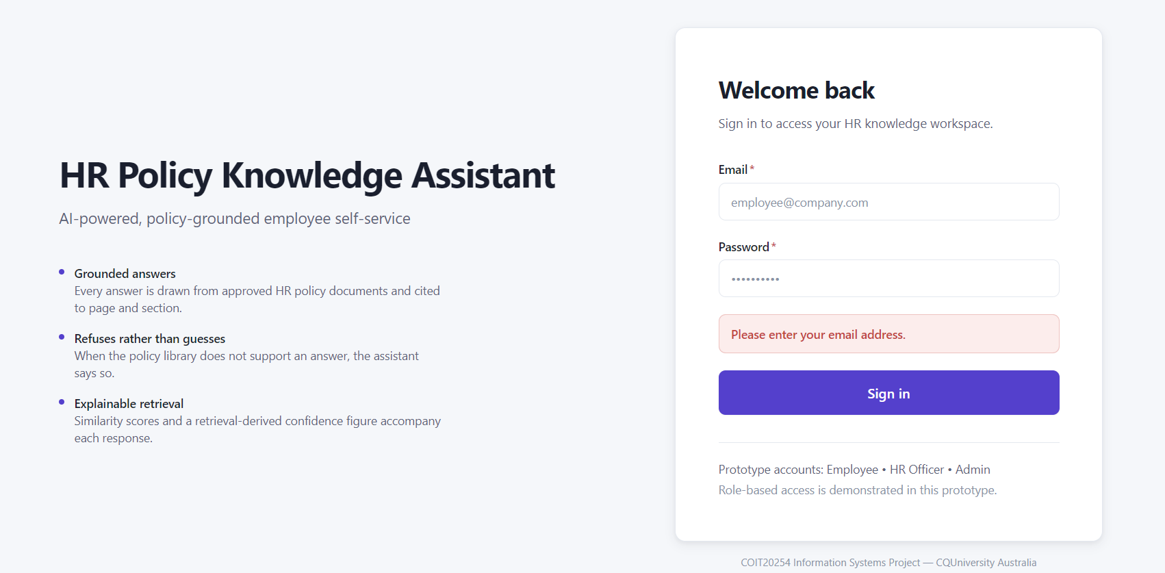  Response time: ≤ 3 seconds

Appendix D: Final risk register
Risk | Likelihood | Impact | Status at close | Control in place
AI-generated incorrect or misleading responses | Medium | High | Controlled | Threshold check before generation; refusal written by the application
Over-refusal of valid questions | Medium | Medium | Resolved for Gemini; fallback model still to be re-tested | Instruction set corrected; 15 of 15 on Gemini after the change
Third-party AI API limits or outages | Medium | Medium | Occurred and controlled | Three answering modes with automatic fallback and per-request timeouts
Schedule compression | Medium | High | Occurred and managed | Deliberate descoping of four features; weekly board review
Data privacy and confidentiality | Low | High | Controlled | Fictional policies, seeded accounts, minimal data sent to external models
Credential exposure in the repository (added Week 9) | Low | High | Occurred and resolved | Secret scan of staged changes before every commit; credentials held in platform environment variables
Insufficient team collaboration | Low | Medium | Did not occur | Weekly meetings with minutes, Trello ownership, pull request review

Appendix E: User stories
Employee:
ID | User Story | Priority
User01 | I want to ask HR policy questions using natural language so that I can quickly get the information I need. | High
User02 | I want to receive answers based on approved HR policies so that I can trust the information provided. | High
User03 | I want to search HR policies using text input so that I can easily find relevant policies. | High
User04 | I want to see the policy sources supporting an AI response so that I can understand where the information came from. | High
User05 | I want lengthy HR policies to be summarised so that I can understand important information quickly. | Medium
User06 | I want to acknowledge HR policies electronically so that my acknowledgement is recorded. | Medium
User07 | I want to initiate a leave request through the conversational assistant so that I can start the process without contacting HR directly. | High
User08 | I want the assistant to provide information relevant to my role and permissions so that I only receive appropriate information. | High

HR Officer:
ID | User Story | Priority
User09 | I want to generate draft workplace policies using Generative AI so that I can reduce the time spent preparing policy documents. | High
User10 | I want to update HR policy documents in the knowledge repository so that employees receive information from current policies. | High
User11 | I want to review AI-generated policy drafts before they are used so that inaccurate information can be corrected. | High

HR Manager:
ID | User Story | Priority
User12 | I want to receive automated reminders for policy reviews so that policies can be reviewed and maintained on time. | High
User13 | I want to monitor policy usage and compliance information so that I can identify areas requiring attention. | Medium

System Administrator:
ID | User Story | Priority
User14 | I want to manage user permissions and access so that confidential HR information is protected. | High
User15 | I want to monitor AI performance through the AI Governance Dashboard so that I can identify system issues and performance problems. | High
User16 | I want to review system audit logs so that AI activity and system usage can be monitored. | High
User17 | I want to monitor AI-generated responses and their supporting sources so that the system remains transparent and trustworthy. | High

Executive:
ID | User Story | Priority
User18 | I want to view AI governance and performance information so that I can understand the system's organisational impact and risks. | Medium

Employee:
ID | User Story | Priority
User19 | I want the system to respond within a few seconds so that I can obtain HR information without unnecessary delays. | Medium

All Users:
ID | User Story | Priority
User20 | I want an intuitive conversational interface so that I can use the HR assistant with minimal training. | High

Appendix F: Gantt chart
The baseline schedule runs from project selection on 16 July to final submission on 13 October 2026. Initiation, stakeholder analysis and the literature review fill the first two weeks, and proposal submission was planned for 7 August. Design and the interface prototype follow until 16 August. AI integration and RAG development were scheduled for 17 to 25 August, and the prototype was merged on 27 August, two days after that window. Integration testing, user acceptance testing and final documentation then overlap until submission.
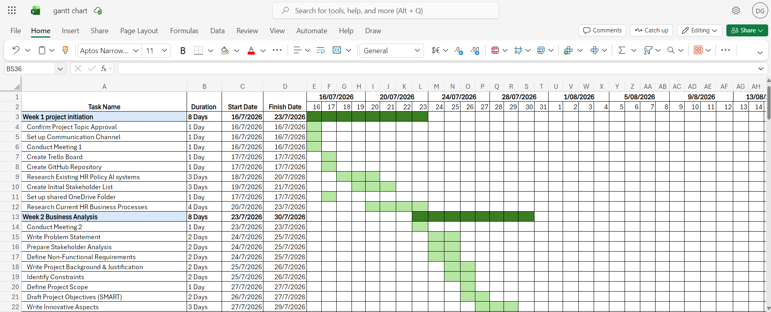
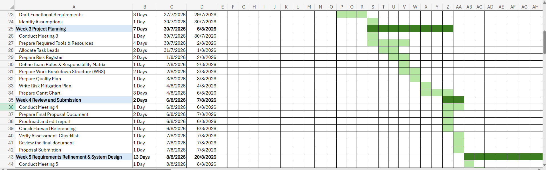
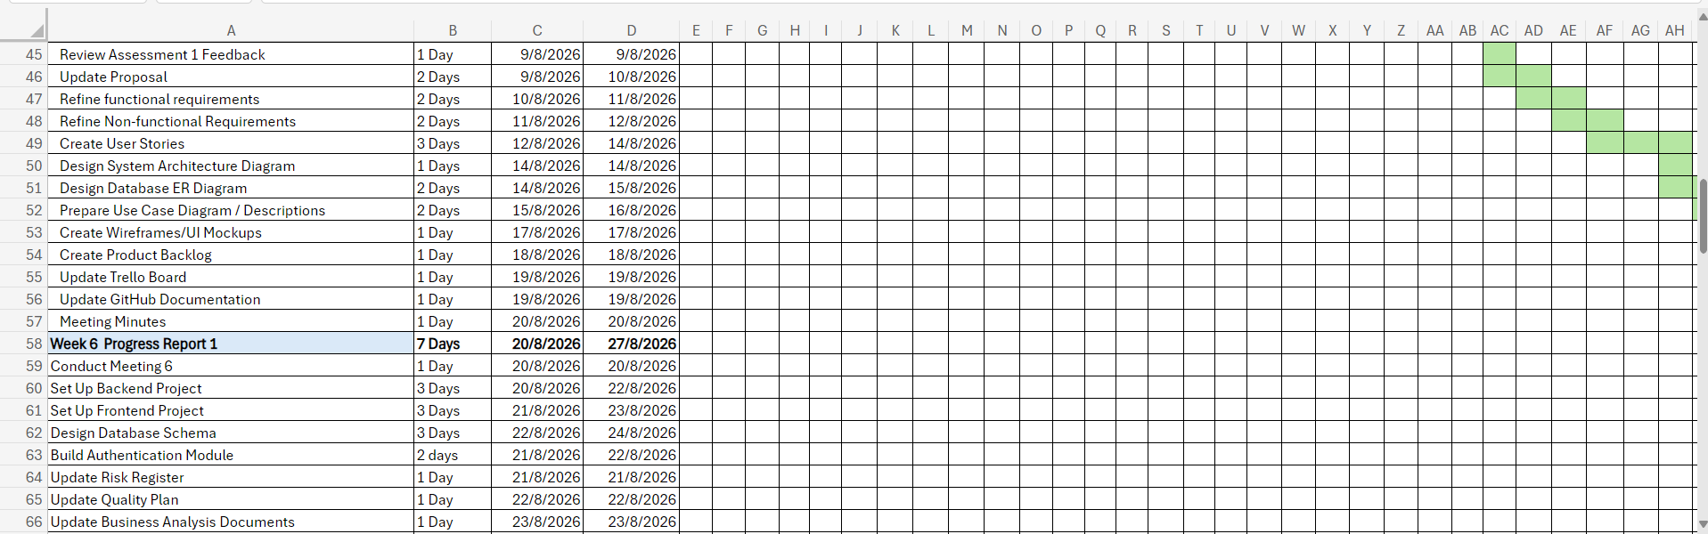
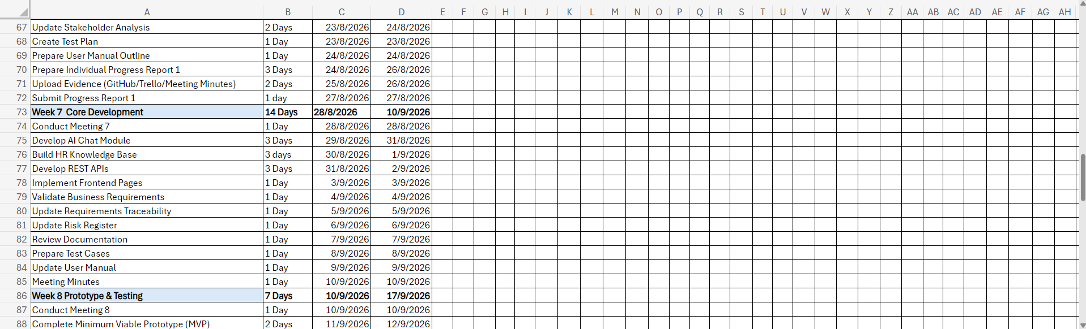
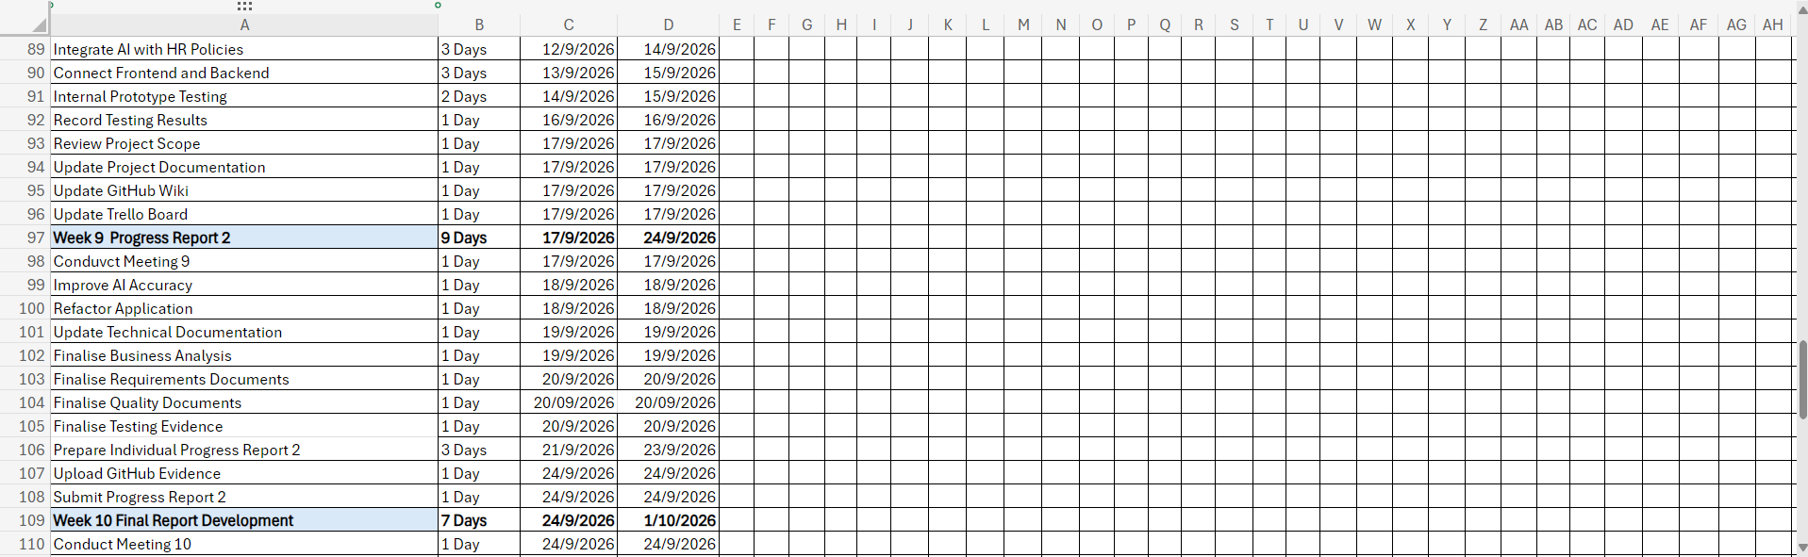
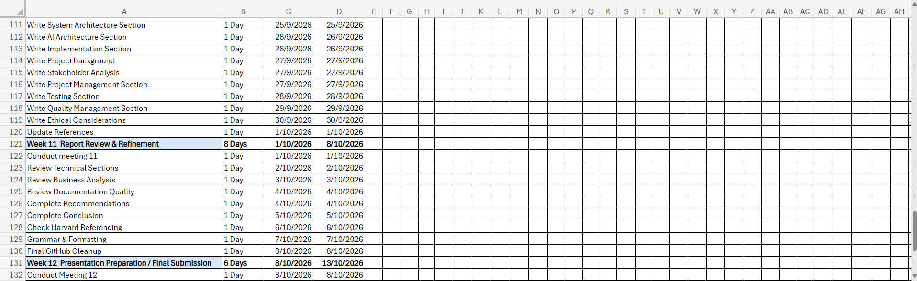
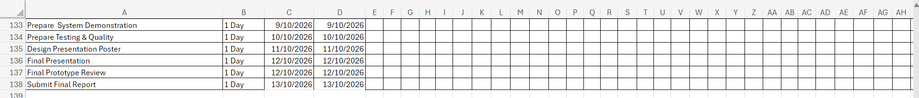

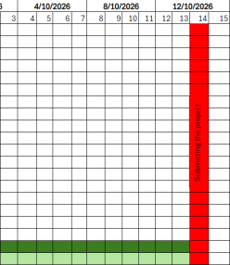
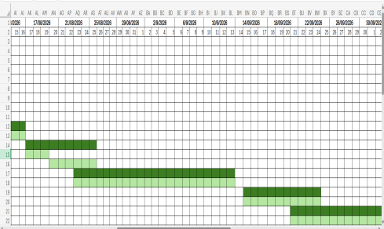
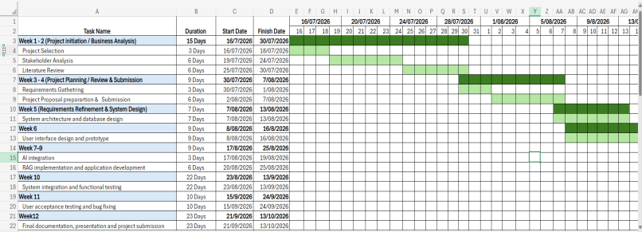
Gantt chart summary:

Appendix G: Meeting log
Meeting | Date | Focus | Minute taker
1 | 16 July 2026 | Project initiation, topic selection, tool selection | Farhaz Khondoker
2 | 23 July 2026 | Business analysis, review of research findings | Farhaz Khondoker
3 | 31 July 2026 | Project planning, WBS, Gantt, risk register | Farhaz Khondoker
4 | 6 August 2026 | Assessment 1 review and finalisation | Farhaz Khondoker
5 | 14 August 2026 | Requirements refinement and system design | Farhaz Khondoker
6 | 21 August 2026 | Development planning, backlog adoption | Farhaz Khondoker
7 | 4 September 2026 | MVP review, integration status | Farhaz Khondoker
8 | 11 September 2026 | Documentation review | Farhaz Khondoker
9 | 18 September 2026 | Internal testing, deployment, Assessment 2 | Farhaz Khondoker
Full minutes, with attendance, decisions and action items, are held in the team’s meeting minutes document and are available on request.

Appendix H: Declaration of AI use
Generative AI tools were used during this project as follows.
Use | Detail | Verification by the team
Idea generation and research framing | Market comparison and terminology during Weeks 1 to 3 | All claims checked against the cited sources
Code assistance | Drafting and refactoring of application code | All code reviewed, tested by the automated suite and run in the deployed system
Report drafting and review | Drafting help, editing and review of this report and other project documents | All content checked by the team against the repository, test output and cited sources, and revised before submission
Within the product | Google Gemini and Ollama Cloud generate answers from retrieved policy passages at run time | Answers are limited to retrieved evidence, cited, and refused when the evidence is insufficient
No AI tool was used to fabricate results, sources or evidence. The measurements reported in Section 6 were produced by running the system. The app footage in the demonstration video was recorded from the working prototype, with waiting periods sped up and labelled on screen.

Appendix I: Evidence and access
Artefact | Location
Live prototype | https://hr-policy-qa-assistant.onrender.com
Source code and documentation | https://github.com/Farhazprojects/HR-Policy-Q-A-Assistant
Project wiki (architecture, AI design, testing, deployment) | Wiki tab of the github repository
Demonstration video | https://youtu.be/TMELcPipzYI
Demonstration sign-in details | EMPLOYEE: employee@company.com  HR_OFFICER: hr@company.com  ADMIN: admin@company.com  Password: Capstone#2026

