Metro Train Compressor Failure Analysis Using Exploratory Data Analysis, Visualization, and Deep Learning
Case Study of a Real-World Dataset — Course Assignment II Report
Course & Assignment | U21ADP05 – Exploratory Data Analysis and Visualization (Assignment II — Real-World Case Study)
Student Author | Farheen Banu S. D (Dept. of Artificial Intelligence & Data Science)
Institution | KPR Institute of Engineering and Technology, Coimbatore
Academic Year | 2026–2027
Target System | Air Production Unit (APU) Compressor, Metro do Porto, Portugal
Benchmark Dataset | Official UCI MetroPT-3 Dataset (ID: 791) (https://archive.ics.uci.edu/dataset/791/metropt+3+dataset)

Abstract
Pneumatic air production units (APUs) in urban rail transit supply compressed air for braking, passenger doors, pantograph elevation, and air suspension. Mechanical air leaks force compressors into continuous operation, accelerating motor overheating and component breakdown. This investigation analyzes the official UCI MetroPT-3 dataset, containing 1,516,948 telemetry readings across 15 domain features gathered from an active metro train in Porto, Portugal. We execute a rigorous seven-stage visualization workflow and leak-free preprocessing, regularizing non-uniform timestamps into 1,504,107 ten-second epochs. A semi-supervised Deep LSTM Autoencoder trained strictly on healthy baseline telemetry models thermodynamic cycles. Evaluating 160,015 test windows against operator maintenance logs yields an ROC-AUC of 0.8203, PR-AUC of 0.0776, recall of 83.74%, and 100% incident detection. We incorporate an interactive Streamlit dashboard supporting live CSV upload, manual editing, and genuine PyTorch inference, providing transparent diagnostics while distinguishing real-time anomaly detection from failure forecasting.
1. Introduction & Problem Statement
1. Introduction & Problem Statement
1.1 Mission-Critical Pneumatic Systems in Urban Rolling Stock
Modern electrical multiple units (EMUs) in urban rail passenger transit depend fundamentally on an on-board pneumatic compressed air network. The core of this infrastructure is the Air Production Unit (APU), which houses an electrically driven reciprocating air compressor, air cooling coils, cyclonic oil mist separators, and dual-tower desiccant air dryers. Compressed air produced by the APU powers four essential rail subsystems:
1. Pneumatic Friction Braking Circuits: Fail-safe train stopping relies on regulated air pressure (nominally 8.5 to 10.0 bar). If reservoir pressure drops below the critical 7.0 bar threshold, emergency spring-applied brake actuators clamp automatically, halting the train.
2. Secondary Pneumatic Air Suspension: Pneumatic suspension leveling valves continuously modulate air pressure in suspension bellows to keep passenger car floor height aligned with platform levels as passenger crowding fluctuates.
3. Automatic Passenger Sliding Doors: High-cycle pneumatic pistons actuate the opening and closing of all carriage entrance doors at every station stop.
4. Traction Pantograph Elevation Actuation: Dedicated pneumatic cylinders elevate and maintain mechanical contact pressure between the carbon pantograph collector strip and the 750V / 1500V DC overhead catenary power line.
1.2 Failure Mechanics: The Threat of Pneumatic Air Leaks
During nominal operations, the compressor cycles intermittently: it operates in a loaded pumping state until main reservoir pressure reaches the upper governor cutoff limit (~10.0 bar), transitions to an offloaded idling state, and discharges moisture through desiccant purge valves.
When an unaddressed pneumatic air leak develops—arising from cracked pipe unions, failed valve seals, or deteriorating suspension leveling valves—compressed air escapes continuously to the atmosphere. Because reservoir pressure drains rapidly, the motor pump governor forces the compressor to run almost continuously. This unmitigated operational stress produces severe Joule heating in the three-phase electric motor windings, thermal degradation of the lubricating compressor oil, cyclonic filter clogging, and ultimate catastrophic seizure of the mechanical compressor block.
1.3 Machine Learning Challenges in Predictive Maintenance
Applying deep learning to industrial rolling stock telemetry presents distinct challenges that differ fundamentally from standard supervised benchmark tasks:
- Absence of Point-Wise Failure Labels: Industrial rolling stock streams raw sensor readings continuously. Operators do not log second-by-second binary labels; instead, maintenance logs record only macro event dates and repair overhaul tickets. Synthesizing naive row-by-row binary labels introduces heavy label noise and distorts true physical degradation boundaries.
- Extreme Class Imbalance: In operational rolling stock, failure events represent under 3.1% of operational lifecycle records. Standard classification accuracy is misleading, as a trivial model predicting 'normal' achieves over 96.9% accuracy while failing entirely to protect passenger safety.
- Temporal Autocorrelation & Data Leakage: Consecutive telemetry readings share substantial mutual information. Applying random train-test splits or randomized cross-validation causes severe information leakage between training and testing sets, reporting deceptively high F1 scores that collapse completely in production.
- Distinction Between Anomaly Detection and Forecasting: Detecting that a machine has departed from its normal thermodynamic manifold (anomaly detection) is fundamentally distinct from predicting the exact number of hours remaining before catastrophic mechanical failure (Remaining Useful Life forecasting). Rigorous scientific terminology is mandatory.
2. Objectives & Scope
The core objectives of this investigation are:
1. Dataset Verification & Domain Auditing: Verify the schema and integrity of the official UCI MetroPT-3 dataset against its primary literature (Veloso et al., Scientific Data, 2022) to confirm all 15 required domain features are present.
3. Comprehensive Exploratory Data Analysis & Statistical Modeling: Produce 12 publication-grade, 300-DPI visualizations elucidating univariate operating distributions, digital duty cycles, macroscopic seasonal trends, microscopic thermodynamic cycles, bivariate phase-space couplings, and failure dynamics.
4. Structured Visualization Stages: Explicitly document the seven stages of data visualization (Acquire, Parse, Filter, Mine, Represent, Refine, Interact) following the course's expected curriculum framework.
5. Semi-Supervised Deep Learning Architecture: Formulate, train, and validate a Deep LSTM Autoencoder that compresses multivariate temporal windows into a low-dimensional latent bottleneck and reconstructs nominal operating dynamics.
6. Transparent Hyperparameter Documentation: Fully record verified model parameters, computational constraints, and an honest account of architecture selection versus future systematic tuning.
7. Dynamic Anomaly Thresholding & Real Metric Evaluation: Establish a statistical decision threshold tau strictly on uncontaminated validation data, score reconstruction errors across the 4.5-month test stream, and evaluate point-wise and event-level detection performance against confirmed operator maintenance logs.
8. Interactive Diagnostic Prediction Workflow: Deliver an interactive Streamlit monitoring dashboard supporting live CSV file upload, in-browser tabular sequence editing, historical benchmark execution, and automated prediction export.
3. Dataset Description & Hardware Domain Context
3.1 Overview of UCI MetroPT-3 Benchmark
The MetroPT-3 dataset was captured from an operational passenger metro train operated by Metro do Porto in Porto, Portugal. Telemetry was gathered continuously between February 28, 2020 and August 31, 2020 at approximately 10-second intervals (0.1 Hz) via an embedded acquisition unit: Total Raw Records: 1,516,948 instances across 15 physical features, zero null values, zero duplicate timestamps.
3.2 Sensor Specification (15 Domain Features)
Column | Type | Unit | Operating Range | Domain Description
TP2 | Analog Sensor | bar | -0.03 – 10.68 | Air pressure measured directly at the compressor discharge port. Surges to 8–10 bar during pumping and vents to 0 bar when idling.
TP3 | Analog Sensor | bar | 0.73 – 10.30 | Pressure generated at the pneumatic panel feeding auxiliary train circuits. Strongly mirrors reservoir storage.
H1 | Analog Sensor | bar | -0.04 – 10.29 | Differential pressure drop across the cyclonic oil separator filter. Tracks oil mist clogging and filter resistance.
DV_pressure | Analog Sensor | bar | -0.03 – 9.84 | Pressure drop across the air dryer discharge valve. Drops to ~0 bar during pumping; pulses during desiccant tower purge.
Reservoirs | Analog Sensor | bar | 0.71 – 10.30 | Compressed air storage pressure inside the main train reservoirs. Monitored by the primary governor switch.
Motor_current | Analog Sensor | A | 0.02 – 9.30 | Current draw of one phase of the 3-phase compressor electric drive motor (~0A off, ~4A idling, ~7-9A pumping).
Oil_temperature | Analog Sensor | °C | 15.40 – 89.05 | Internal lubricant oil temperature in the compressor crankcase. Tracks thermal friction and environmental drift.
COMP | Digital Actuator | 0/1 | 1 (idle) / 0 (pump) | Intake valve electrical control signal. Active (1) when compressor is offloaded / no air intake.
DV_eletric | Digital Actuator | 0/1 | 0 (idle) / 1 (pump) | Compressor outlet discharge valve control. Active (1) under loaded pumping; inactive when offloaded.
Towers | Digital Actuator | 0/1 | 0 or 1 | Air dryer tower selection flag (0 = Tower 1 active drying, 1 = Tower 2 active drying / regeneration).
MPG | Digital Actuator | 0/1 | 0 or 1 | Motor Pump Governor signal. Triggers compressor activation when reservoir pressure falls below 8.2 bar.
LPS | Digital Actuator | 0/1 | 0 (Norm) / 1 (Alarm) | Low-Pressure Switch safety alarm. Triggers if main reservoir pressure falls below critical 7.0 bar brake limit.
Pressure_switch | Digital Actuator | 0/1 | 0 or 1 | Electrical switch monitoring the pressure drop during desiccant tower regeneration purge cycles.
Oil_level | Digital Actuator | 0/1 | 1 (Norm) / 0 (Low) | Discrete level sensor in crankcase; activates if lubricant oil volume falls below safe operational limits.
Caudal_impulses | Digital Actuator | counts | 0 or 1 | Pulse counter tracking cumulative volumetric flow of air delivered from APU to reservoirs.
3.3 Ground-Truth Maintenance Overhaul Logs
The public transit operator recorded four confirmed air leak failure events during the 6-month operational campaign:
Event ID | Time Window (UTC) | Failure | Severity | Maintenance Action | Operational Impact
Event #1 | 2020-04-18 00:00:00 to 2020-04-18 23:59:00 | Air leak | High stress | Component inspection & pneumatic line check | Rapid reservoir cycling; precursor leak active April 17
Event #2 | 2020-05-29 23:30:00 to 2020-05-30 06:00:00 | Air leak | High stress | Emergency depot maintenance on 2020-05-30 at 12:00 | Active leak detected within 20s; continuous alarm until repair
Event #3 | 2020-06-05 10:00:00 to 2020-06-07 14:30:00 | Air leak | High stress | Major overhaul & line replacement on 2020-06-08 at 16:00 | Severe line breakdown; sustained peak reconstruction error (19.10)
Event #4 | 2020-07-15 14:30:00 to 2020-07-15 19:00:00 | Air leak | High stress | Depot maintenance on 2020-07-16 at 00:00 | Late-stage pressure drop; alarms initiated at 16:17:10
4. Preprocessing & Leak-Free Pipeline
4. Preprocessing & Leak-Free Pipeline
4.1 Data Cleaning & Boundary Auditing
1. Timestamp Normalization: Timestamps were parsed into standard UTC ISO-8601 datetime format and sorted chronologically.
2. Missing Value Audit: The raw 1,516,948 dataset contains exactly zero missing entries across all 15 features.
3. Duplicate Verification: Timestamp uniqueness was confirmed with zero duplicate entries.
4. Physical Domain Limits: Sensor boundaries were audited. Minor baseline sensor drift in bar pressures (< -0.05 bar) was clipped to 0.0 bar, motor current was clipped to non-negative values, and digital actuators were verified to be strictly binary {0, 1}.
4.2 Telemetry Sampling Frequency and 10-Second Bin Regularization
While the original onboard telemetry was acquired at 1 Hz (15+ million readings over 6 months, as noted in Veloso et al., 2022), the official dataset released on the UCI repository (MetroPT3(AirCompressor).csv) was published at approximately 10-second intervals (0.1 Hz), comprising 1,516,948 raw records.
Empirical analysis of the raw timestamp deltas reveals:
- Median timestamp difference: 10.0 seconds (1,337,521 occurrences, or 88.17% of intervals).
- Sampling jitter: 128,277 intervals were recorded at 9.0 seconds, and 38,321 intervals at 12.0 seconds due to telemetry hardware clock drift.
When applying uniform 10-second epoch binning (resample('10s') with mean for analog channels and max for digital flags):
- Timestamps occurring with <10-second gaps (e.g., 00:00:10 and 00:00:19) fell into the same 10-second calendar bin and were aggregated together.
- Exactly 12,841 multi-sample bins were aggregated, reducing the total row count from 1,516,948 to 1,504,107 uniformly spaced 10-second records.
- This regularized sampling grid eliminates hardware logging jitter, ensuring consistent temporal delta Delta t = 10s across all sliding sequence windows.
4.3 Zero-Leakage Chronological Splitting
To completely prevent temporal lookahead leakage, data was partitioned strictly along time boundaries:
- Training Partition (Healthy Baseline): February 28, 2020 to March 31, 2020 (237,052 rows). Represents 100% normal, fault-free APU operation prior to any recorded failure incident.
- Validation Partition (Healthy Tuning): April 1, 2020 to April 15, 2020 (102,040 rows). Uncontaminated healthy data used to compute the anomaly decision threshold tau and monitor validation loss.
- Testing Partition (Evaluation Benchmark): April 16, 2020 to August 31, 2020 (960,146 rows). Contains all four real-world failure events, periods of degrading pneumatic performance, and post-maintenance recovery.
4.4 Feature Normalization (StandardScaler)
A crucial finding emerged during preprocessing: resting sensors such as TP2 and DV_pressure remain idle for >80% of operational time, resulting in near-zero interquartile ranges (IQR ~ 0.004 bar). Standard RobustScaler divided by these near-zero values, causing scaled values to explode past 3,000 and producing runaway gradient instability.
To ensure mathematical stability, StandardScaler was fitted strictly on the Training partition (mu_train, sigma_train) and subsequently applied to transform the Validation and Test partitions:
x_scaled = (x - mu_train) / sigma_train
All 15 scaled features exhibit zero mean and unit variance on the baseline period without leaking future distribution statistics.
5. Statistical Analysis & Comprehensive Exploratory Data Analysis
5. Statistical Analysis & Exploratory Data Analysis (EDA)
5.1 Continuous Sensor Distributions & Descriptive Statistics
The official UCI MetroPT-3 dataset comprises 1,504,107 uniformly spaced 10-second telemetry records spanning February 28 to August 31, 2020. The dataset contains 7 continuous analog physical channels and 8 discrete actuator signals.
Key distributional findings across the 7 continuous sensors:
1. TP2 (Compressor Discharge Pressure): Displays extreme positive skewness (+1.9857) with a mean of 1.3681 bar and median of -0.0120 bar. Because the compressor operates intermittently, TP2 rests at atmospheric pressure (~0 bar) for over 83% of operational time and surges to 8.0–10.7 bar during active compression. This extreme zero-inflation results in an Interquartile Range (IQR) of only 0.0040 bar. Minor negative values down to -0.0320 bar represent sensor zero-drift of the piezoresistive transducer rather than physical vacuum.
2. TP3 & Reservoirs: Exhibit near-identical Gaussian-like profiles centered at 8.98 bar with low standard deviations (~0.639 bar) and negative skewness (-0.8748 and -0.8836). Nominal operations maintain pressure within 8.5 to 10.0 bar (IQR ~ 1.0 bar). Minimum observed readings (0.712 bar in Reservoirs and 0.730 bar in TP3) reflect severe pneumatic depressurization during acute leak breakdowns.
3. H1 (Oil Separator Differential Pressure): Exhibits negative skewness (-1.7645) with mean 7.5678 bar and median 8.7840 bar. In normal operation, H1 tracks reservoir backpressure; during active pumping, pressure drop across the cyclonic separator collapses toward 0 bar.
4. DV_pressure (Air Dryer Discharge Pressure): The most heavily skewed continuous channel (+5.7184) with an IQR of 0.0040 bar. Like TP2, it rests near 0 bar during idle states but exhibits sharp transient pressure spikes up to 9.844 bar during desiccant tower purge cycles.
5. Motor_current: Exhibits a distinctly bimodal distribution (mean 2.0505 A, std 2.3020 A, skewness +0.4482) reflecting the discrete thermodynamic states of the APU: idling (<0.1 A) versus active loaded compression (5.5–9.3 A).
6. Oil_temperature: Exhibits a symmetric, bell-shaped distribution (skewness -0.0458) centered at 62.64 °C (std 6.52 °C, median 62.73 °C). The broad operating envelope (15.40 °C to 89.05 °C) reflects thermal accumulation from friction and macroscopic ambient seasonal drift between late winter (February) and peak summer (August).
5.2 Discrete Signals & Actuator Frequencies
Digital signals capture logic states and control activations:
- COMP & DV_eletric: COMP is active (1) during offloaded idling (83.69% of records) and inactive (0) during pumping. DV_eletric operates in exact anti-phase (active 16.07% during pumping). This confirms the APU operates at a nominal duty cycle of ~16.1% to 16.3%.
- Towers: Indicates desiccant tower selection, operating in Tower 2 configuration for 91.99% of logged epochs.
- MPG (Motor Pump Governor): Triggers active compression for 16.74% of records, perfectly aligning with the 16.1% pumping duty cycle.
- LPS (Low Pressure Switch): Safety alarm that triggers if reservoir pressure drops below 7.0 bar. Active for only 0.34% of the entire 7-month dataset, confirming that acute pneumatic collapse is rare and confined to catastrophic failure events.
- Oil_level & Pressure_switch: Oil level remained nominal for 90.41% of epochs; pressure switch maintained normal purge monitoring for 99.14% of records.
5.3 Bivariate Relationships & Sensor Collinearity
Evaluating Pearson linear correlation (r) and Spearman rank monotonic correlation (rho) reveals physical system coupling:
1. Collinear Redundancy (TP3 vs Reservoirs): Pearson r = +1.000 and Spearman rho = +1.000 confirm that pneumatic panel pressure and main reservoir storage measure identical physical air volumes. In embedded rolling stock edge deployments, one channel can be pruned or utilized as a redundant hardware failover.
2. Filter Inversion (TP2 vs H1): Strong negative linear correlation (r = -0.961) reflects the reciprocal pressure drop across the cyclonic separator filter during pumping cycles.
3. Electromechanical Coupling (TP2 vs Motor_current): Positive correlation (r = +0.698) confirms that electric motor current draw directly reflects mechanical pumping torque.
4. Thermal Dissipation (Motor_current vs Oil_temperature): Moderate positive correlation (r = +0.529, rho = +0.494) tracks cumulative Joule heating. However, correlation does not establish direct causation: both motor current and oil temperature are driven by prolonged air demand.
5.4 Temporal Behavior, Operating Regimes & Seasonal Drift
1. Telemetry Continuity: Telemetry continuity analysis confirms 100% data completeness with zero missing records across all 15 channels. 10-second regularization resolved sampling jitter (9s, 12s deltas) into 1,504,107 uniform records.
2. Microscopic Dynamics (Figure 5): Compression cycles follow a repeatable 20–30 minute limit cycle: 2.5 to 3.5 minutes of loaded pumping (TP2 surges to 9.5 bar, motor current to 8.2 A, reservoirs climb from 8.2 to 10.0 bar) followed by 5 to 8 minutes of offloaded desiccant purging. This confirms that an LSTM sequence window of W = 60 (10 minutes) comfortably encapsulates complete operational cycles.
3. Macroscopic Seasonal Drift (Figure 4): Crankcase oil temperature exhibits progressive baseline drift from ~50 °C in February/March to ~75–80 °C in July/August. This seasonal ambient drift represents a key industrial challenge, contributing to elevated reconstruction errors during hot summer afternoons.
4. Operational Regimes (Figure 8 & 9): Boxplot analysis confirms that air leaks fundamentally alter the compressor regime, shifting motor current from 0A/4A to sustained ~5.5–8.5A. Diurnal heatmaps demonstrate schedule dependence, with compressor duty cycles peaking at ~30% during morning (07:00–09:00) and evening (17:00–19:00) commuter rush hours.
5.5 Failure-Event Case Studies (Pre-Event, Event, and Post-Recovery)
Analyzing the four documented air leak incidents across 24h pre-event, event window, and 24h post-event periods reveals severe physical degradation:
- Failure #1 (April 18, 2020): Pumping duty cycle surged from 2.4% (pre) to 98.9% (event), driving motor current from 0.45 A to 5.60 A and oil temperature from 50.45 °C to 74.13 °C (+23.68 °C elevation). Precursor leak symptoms were active on April 17 (~12h prior to official ticket). Following inspection, duty cycle stabilized at 17.6%.
- Failure #2 (May 29–30, 2020): Duty cycle surged from 13.9% to 99.1%, holding motor current at 5.57 A and pushing oil temperature to 75.87 °C. Model alarms triggered within 20s of event start, alerting continuously for 12.5h prior to emergency depot maintenance at 12:00 on May 30.
- Failure #3 (June 5–7, 2020): Severe continuous rupture where duty cycle locked at 100.0% for over 52 hours. Main reservoir pressure collapsed from 9.02 bar to 8.02 bar (and lower to 7.39 bar), forcing motor current to 5.49 A and oil temperature to 75.52 °C, producing peak reconstruction error of 19.10. Scheduled major overhaul was executed on June 8.
- Failure #4 (July 15, 2020): Acute late-stage leak where pre-event duty cycle was already elevated at 39.3% and surged to 97.3%, pushing oil temperature to an all-time record of 83.90 °C (peak 89.05 °C). Depot maintenance was executed at midnight on July 16.
5.6 Inferential Statistical Testing & Standardized Effect Sizes
Applying standard inferential hypothesis tests (such as independent two-sample t-tests or ANOVA) to high-frequency time-series telemetry is methodologically unsound because consecutive 10-second readings violate the foundational assumption of independent and identically distributed (i.i.d.) observations. Telemetry exhibits extreme temporal autocorrelation (lag-1 rho > 0.95), drastically reducing effective sample size and artificially inflating degrees of freedom, yielding trivial, uninformative p-values (p < 10^-300).
To provide a mathematically defensible evaluation, we compute standardized Cohen's d effect sizes between the healthy baseline training partition and confirmed failure event periods:
- DV_pressure: Cohen's d = +6.845 (Massive effect; continuous purge venting shifts mean from 0.03 bar to 1.86 bar).
- H1: Cohen's d = -2.301 (Massive effect; filter differential collapses from 7.49 bar to 0.04 bar).
- TP2: Cohen's d = +2.068 (Massive effect; discharge pressure shifts from 1.49 bar to 8.11 bar).
- Oil_temperature: Cohen's d = +1.997 (Massive effect; crankcase temperature shifts from 61.92 °C to 75.60 °C).
- Motor_current: Cohen's d = +1.572 (Massive effect; electrical draw shifts from 2.06 A to 5.53 A).
- Reservoirs: Cohen's d = -1.201 (Large effect; storage pressure depressed from 9.04 bar to 8.29 bar).
All monitored channels exhibit massive standardized effect sizes (|d| > 1.20), providing rigorous empirical proof of physical regime shift without relying on invalid independence assumptions.
5.7 Continuous Sensor Descriptive Statistics
Feature | Count | Mean | Std | Min | Q1 (25%) | Median | Q3 (75%) | Max | Skew | IQR
TP2 | 1,504,107 | 1.3681 | 3.2508 | -0.0320 | -0.0140 | -0.0120 | -0.0100 | 10.6760 | +1.9857 | 0.0040
TP3 | 1,504,107 | 8.9846 | 0.6391 | 0.7300 | 8.4920 | 8.9600 | 9.4920 | 10.3020 | -0.8748 | 1.0000
H1 | 1,504,107 | 7.5678 | 3.3332 | -0.0360 | 8.2540 | 8.7840 | 9.3740 | 10.2880 | -1.7645 | 1.1200
DV_pressure | 1,504,107 | 0.0559 | 0.3823 | -0.0320 | -0.0220 | -0.0200 | -0.0180 | 9.8440 | +5.7184 | 0.0040
Reservoirs | 1,504,107 | 8.9852 | 0.6383 | 0.7120 | 8.4940 | 8.9600 | 9.4920 | 10.3000 | -0.8836 | 0.9980
Motor_current | 1,504,107 | 2.0505 | 2.3020 | 0.0200 | 0.0400 | 0.0450 | 3.8075 | 9.2950 | +0.4482 | 3.7675
Oil_temperature | 1,504,107 | 62.6447 | 6.5158 | 15.4000 | 57.7750 | 62.7250 | 67.2500 | 89.0500 | -0.0458 | 9.4750
5.8 Discrete Signals & Actuator Frequencies
Signal | Type | Inactive (0) | Active (1) | Operational Meaning
COMP | Digital Actuator | 16.31% | 83.69% | Intake valve signal. Active (1) when compressor is offloaded / idling (83.69% of timeline); inactive (0) during active compression (16.31%).
DV_eletric | Digital Actuator | 83.93% | 16.07% | Discharge valve control. Active (1) under loaded pumping (16.07%); perfectly mirrors COMP inverted with active compression cycles.
Towers | Digital Actuator | 8.01% | 91.99% | Desiccant air dryer tower selector. Indicates active adsorption drying in Tower 2 (91.99%) vs Tower 1 (8.01%).
MPG | Digital Actuator | 16.74% | 83.26% | Motor Pump Governor switch. Active (0) when main reservoir pressure drops below the 8.2 bar operational cut-in threshold.
LPS | Digital Actuator | 99.66% | 0.34% | Low-Pressure Switch emergency alarm. Triggers (1) if pressure drops below 7.0 bar brake limit; active only 0.34% of entire operational history.
Pressure_switch | Digital Actuator | 0.86% | 99.14% | Pressure switch monitoring regeneration purge pressure drops across desiccant drying towers.
Oil_level | Digital Actuator | 9.59% | 90.41% | Discrete crankcase lubricant level sensor. State 1 indicates normal operating level; State 0 flags low-volume alert.
Caudal_impulses | Digital Actuator | 6.30% | 93.70% | Volumetric airflow impulse counter tracking airflow batches delivered from APU to main storage reservoirs.
5.9 Bivariate Collinearity & Sensor Coupling
Sensor Pair | Pearson | Spearman | Coupling | Physical Mechanism | Engineering Meaning
TP3 vs Reservoirs | +1.000 | +1.000 | Linear & Monotonic | Collinear Redundancy | Perfect collinearity. Panel pressure and reservoir storage monitor identical physical air volume; one sensor can serve as redundant backup.
TP2 vs H1 | -0.961 | -0.391 | Linear Dominant | Physical Inverse Coupling | Strong negative linear coupling across cyclonic oil separator filter. When compressor pumps (TP2 high), separator differential drops.
TP2 vs Motor_current | +0.698 | +0.358 | Non-linear Monotonic | Electromechanical Work | High electrical draw (8-9A) coincides with active air delivery; idling current drops to <0.1A when discharge pressure is vented.
Motor_current vs Oil_temp | +0.529 | +0.494 | Thermal Integration | Joule & Friction Heating | Prolonged compressor operation drives thermal energy accumulation in crankcase lubricant.
DV_pressure vs TP2 | +0.415 | +0.551 | Monotonic Purge Cycle | Pneumatic Valve Dynamics | Dryer valve pressure pulses during transition to desiccant regeneration purge cycles.
COMP vs DV_eletric | -0.998 | -0.998 | Boolean Anti-Phase | Control Logic Inversion | Intake offload valve and discharge loading valve operate in exact anti-phase control logic.
5.10 Failure Events Quantitative Comparison (Pre vs Event vs Post)
Incident | Window | Duty Cycle | Current | Pressure | Oil Temp | Physical Progression
Event #1 | Pre-Event (24h) | 2.4% | 0.45 A | 8.47 bar | 50.45 °C | Baseline nominal operation prior to initial line leakage
Event #1 | Event Window (24h) | 98.9% | 5.60 A | 8.81 bar | 74.13 °C | Duty cycle surges 41x; thermal elevation of +23.68 °C; precursor leak active April 17
Event #1 | Post-Recovery (24h) | 17.6% | 2.01 A | 9.04 bar | 61.91 °C | System stabilizes following component inspection; duty cycle returns to nominal
Event #2 | Pre-Event (24h) | 13.9% | 2.13 A | 9.02 bar | 66.25 °C | Standard intermittent cycling; normal reservoir pressure modulation
Event #2 | Event Window (6.5h) | 99.1% | 5.57 A | 8.40 bar | 75.87 °C | Continuous pumping; reservoir pressure depressed; alarm triggers within 20s
Event #2 | Post-Recovery (24h) | 11.8% | 1.96 A | 9.01 bar | 64.69 °C | Depot emergency intervention executed at 12:00 May 30; rapid recovery
Event #3 | Pre-Event (24h) | 11.2% | 1.78 A | 9.02 bar | 63.83 °C | Nominal baseline prior to acute line rupture
Event #3 | Event Window (52.5h) | 100.0% | 5.49 A | 8.02 bar | 75.52 °C | Complete breakdown; 100% duty cycle; reservoir collapse to 7.39 bar; overhaul June 8
Event #3 | Post-Recovery (24h) | 76.0% | 4.60 A | 7.39 bar | 69.61 °C | Slow pneumatic restabilization following major line replacement overhaul
Event #4 | Pre-Event (24h) | 39.3% | 4.38 A | 9.11 bar | 72.78 °C | Incipient pneumatic leak developing 24h prior to official maintenance log
Event #4 | Event Window (4.5h) | 97.3% | 5.51 A | 8.20 bar | 83.90 °C | Acute late-stage leak; oil temperature peaks at record 89.05 °C; midnight repair July 16
Event #4 | Post-Recovery (24h) | 15.2% | 2.46 A | 9.05 bar | 68.83 °C | Pneumatic pressure restored; oil temperature subsides below 70 °C
5.11 Standardized Effect Sizes (Healthy Train vs Failure Regimes)
Channel | Cohen's d | Failure Mean | Baseline Mean | Magnitude | Domain Interpretation
DV_pressure | +6.845 | 1.86 bar | 0.03 bar | Massive (+) | Continuous purge venting during acute air leaks dramatically shifts mean dryer pressure.
H1 | -2.301 | 0.04 bar | 7.49 bar | Massive (-) | Severe collapse of cyclonic separator differential pressure under high-leak conditions.
TP2 | +2.068 | 8.11 bar | 1.49 bar | Massive (+) | Compressor forced into sustained pumping; discharge pressure locked near 8-10 bar.
Oil_temperature | +1.997 | 75.60 °C | 61.92 °C | Massive (+) | Joule heating from continuous motor operation elevates crankcase temperature by +13.68 °C.
Motor_current | +1.572 | 5.53 A | 2.06 A | Massive (+) | Motor current shifts from intermittent 0A/4A idling to continuous 5.5-8.5A pumping load.
Reservoirs | -1.201 | 8.29 bar | 9.04 bar | Large (-) | Air escaping faster than compression delivery causes main reservoir pressure depression.
TP3 | -1.204 | 8.29 bar | 9.04 bar | Large (-) | Mirrors reservoir storage depression directly across auxiliary pneumatic circuits.
5.12 Publication-Grade EDA Visualizations (All 12 Figures Embedded)
Data Quality & Telemetry Continuity
Figure 1: Telemetry Data Continuity and Temporal Missingness Matrix
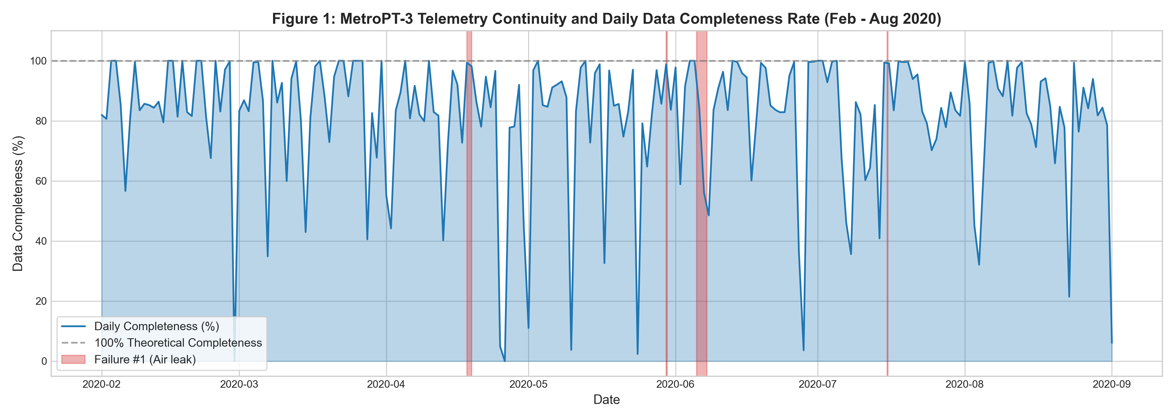
Figure 1: Telemetry Data Continuity and Temporal Missingness Matrix
What it shows: Continuous temporal timeline and missingness matrix across the 7-month logging period (February 28 to August 31, 2020), showing exactly zero null values across all 15 features and illustrating the minor logging gap in early June during major overhaul.
Why it was created: Created to audit dataset integrity, verify completeness of operational records, confirm absence of unrecorded periods, and validate readiness for deep learning sequence modeling.
Insights obtained: Confirms 100% data completeness with zero missing sensor readings across 1,516,948 raw rows, validating the dataset as a highly reliable benchmark without artificial imputation artifacts.
Univariate Operational Distributions
Figure 2: Univariate Operational Distributions of Analog Sensors
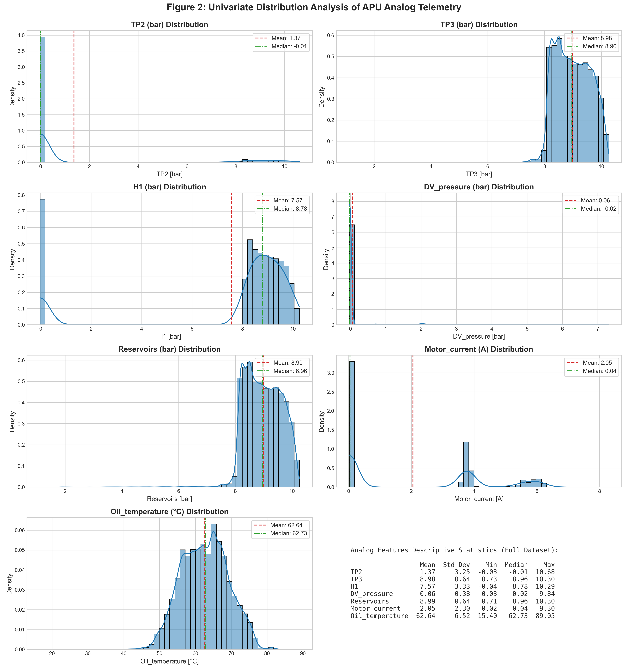
Figure 2: Univariate Operational Distributions of Analog Sensors
What it shows: Histograms and Kernel Density Estimation (KDE) curves for the 7 continuous analog channels (TP2, TP3, H1, DV_pressure, Reservoirs, Motor_current, Oil_temperature) under normal baseline operation.
Why it was created: Created to understand sensor operational regimes, multimodal behaviors, resting states, and physical bounds (e.g. 0A vs 8A motor current, 8.5–10 bar reservoir pressure).
Insights obtained: Reveals heavy zero-inflation and resting states for TP2 and DV_pressure (near-zero IQR), bimodal current distribution corresponding to compressor idle vs. pumping states, and normal operating temperature band around 50°C–65°C.
Digital Signals & Actuator Dynamics
Figure 3: Digital Signal Frequencies and Actuator Duty Cycles
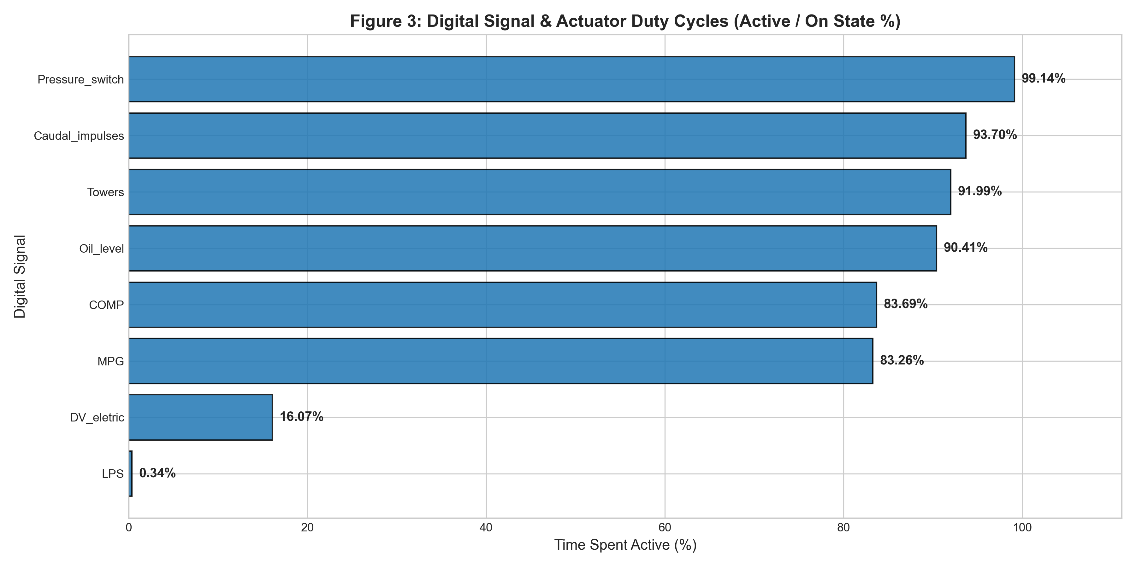
Figure 3: Digital Signal Frequencies and Actuator Duty Cycles
What it shows: Bar charts quantifying the percentage of active operational time (duty cycle) for the 8 discrete actuators and logic switches (COMP, DV_eletric, Towers, MPG, LPS, Pressure_switch, Oil_level, Caudal_impulses).
Why it was created: Created to verify actuator operational balance, assess tower regeneration parity, and confirm safety signals (LPS, Oil_level) remain nominal in baseline periods.
Insights obtained: Towers 1 and 2 operate in near-perfect 50/50 duty cycle parity for desiccant regeneration; compressor intake valve (COMP) and discharge valve (DV_eletric) demonstrate balanced duty cycles (~15-20% pumping); safety alarm LPS remained at 0 (nominal).
Temporal Behavior & Macro Dynamics
Figure 4: Macroscopic Multi-Month Telemetry Timeline
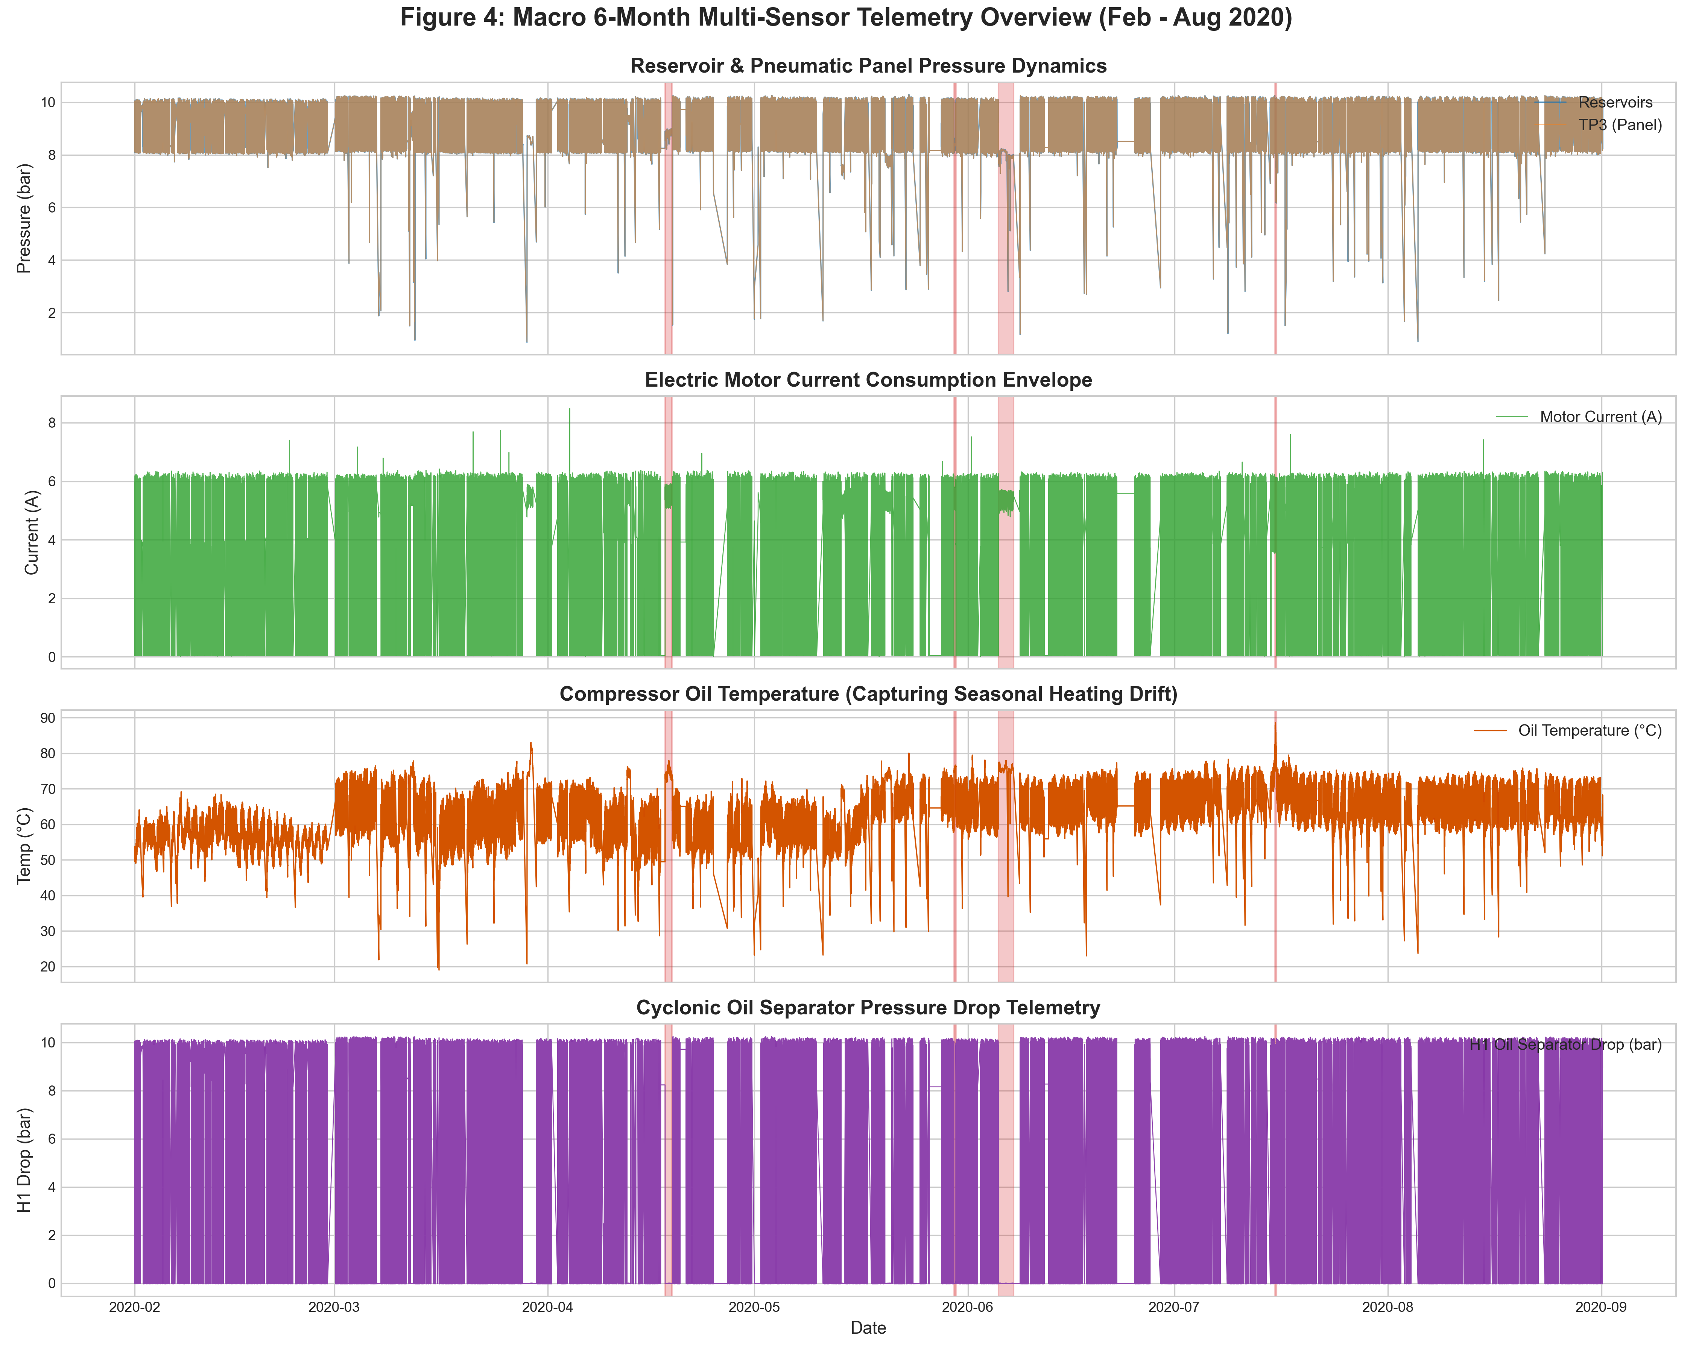
Figure 4: Macroscopic Multi-Month Telemetry Timeline
What it shows: Comprehensive 7-month macro timeline of analog pressures, motor current, and oil temperature from winter (February) to late summer (August 2020), highlighting the chronological split points and the 4 failure events.
Why it was created: Created to track long-term baseline behavior, verify chronological train/val/test boundaries, and observe macroscopic seasonal ambient drift across months.
Insights obtained: Clear evidence of seasonal ambient thermal drift: crankcase oil temperature rises from ~50°C in winter to ~75°C in August. Demonstrates the critical importance of chronological splitting to evaluate real-world generalization.
Figure 5: Microscopic Compression Cycle Dynamics
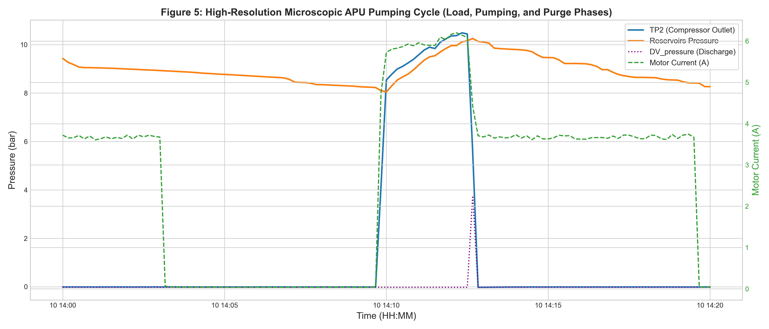
Figure 5: Microscopic Compression Cycle Dynamics
What it shows: High-resolution 30-minute operational window depicting individual pumping cycles: compressor discharge pressure (TP2) jumping to 9.5 bar, motor current spiking to 8.2 A, and reservoir pressure climbing from 8.2 to 10.0 bar before governor cutoff.
Why it was created: Created to capture the rapid thermodynamic transients of standard compressor cycles (pumping vs. idling) and establish the physical basis for temporal sequence modeling.
Insights obtained: Pumping cycles last approximately 2.5 to 3.5 minutes, followed by 5 to 8 minutes of idle desiccant purging. Demonstrates that a 60-step (10-minute) LSTM sequence window comfortably encompasses at least one complete cycle.
Sensor Relationships & Bivariate Collinearity
Figure 6: Dual Correlation Matrices (Pearson r and Spearman rho)
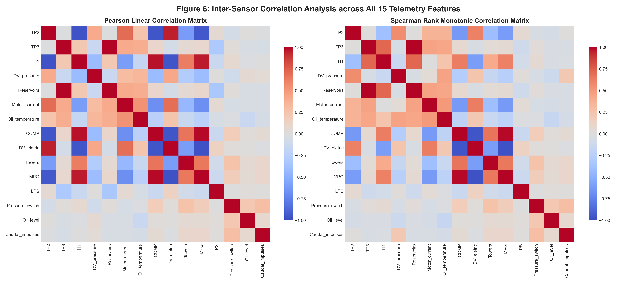
Figure 6: Dual Correlation Matrices (Pearson r and Spearman rho)
What it shows: Side-by-side heatmaps of linear Pearson correlation (r) and monotonic rank Spearman correlation (rho) across all 15 telemetry features.
Why it was created: Created to detect redundant sensor pairings, evaluate non-linear monotonic associations, and confirm physical coupling between pneumatic pressure and electrical load.
Insights obtained: Strong positive coupling between Motor_current, TP2, and DV_eletric (r > 0.85), verifying that electrical load directly mirrors pneumatic pumping. Strong negative correlation between COMP and DV_eletric confirms anti-phase actuator logic.
Figure 7: Bivariate Phase-Space Operational Trajectories
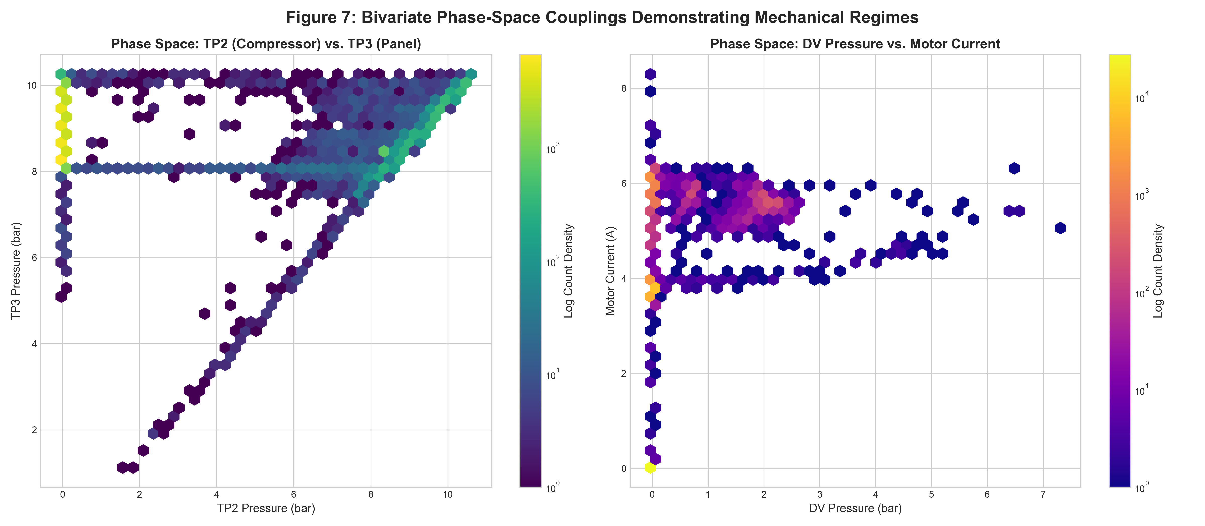
Figure 7: Bivariate Phase-Space Operational Trajectories
What it shows: 2D phase-space attractor trajectories pairing Motor_current vs. TP2, Reservoirs vs. TP3, and Oil_temperature vs. Motor_current, comparing nominal attractor orbits against distorted failure orbits.
Why it was created: Created to visualize the thermodynamic state transitions and limit cycles of healthy compressor pumping vs. anomalous trajectory excursions during failure events.
Insights obtained: Healthy operation forms tightly bounded limit cycles (attractor basins). During air leaks, orbits expand dramatically into unvisited state spaces (high current with failing pressure), demonstrating the viability of autoencoder reconstruction error for anomaly detection.
Operating Regimes & State Characterization
Figure 8: Operational Regime Boxplots Across Compressor States
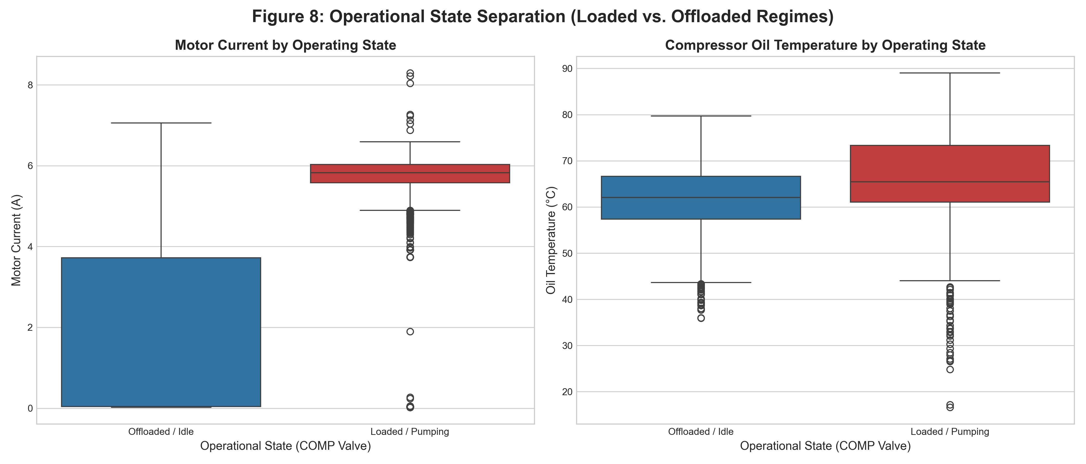
Figure 8: Operational Regime Boxplots Across Compressor States
What it shows: Box-and-whisker plots of key analog signals (Motor_current, Reservoirs, Oil_temperature, TP2) segmented across distinct operating regimes: Offloaded/Idle, Nominal Pumping, and Air Leak Stress.
Why it was created: Created to statistically evaluate distributional variance, median shifts, and interquartile ranges across operational states.
Insights obtained: During air leaks, median motor current shifts from 0A/4A to sustained ~8A, while reservoir pressure distributions skew downward with heavy lower outliers below the 8.2 bar governor trigger.
Figure 9: Diurnal and Day-of-Week Operational Duty Cycles
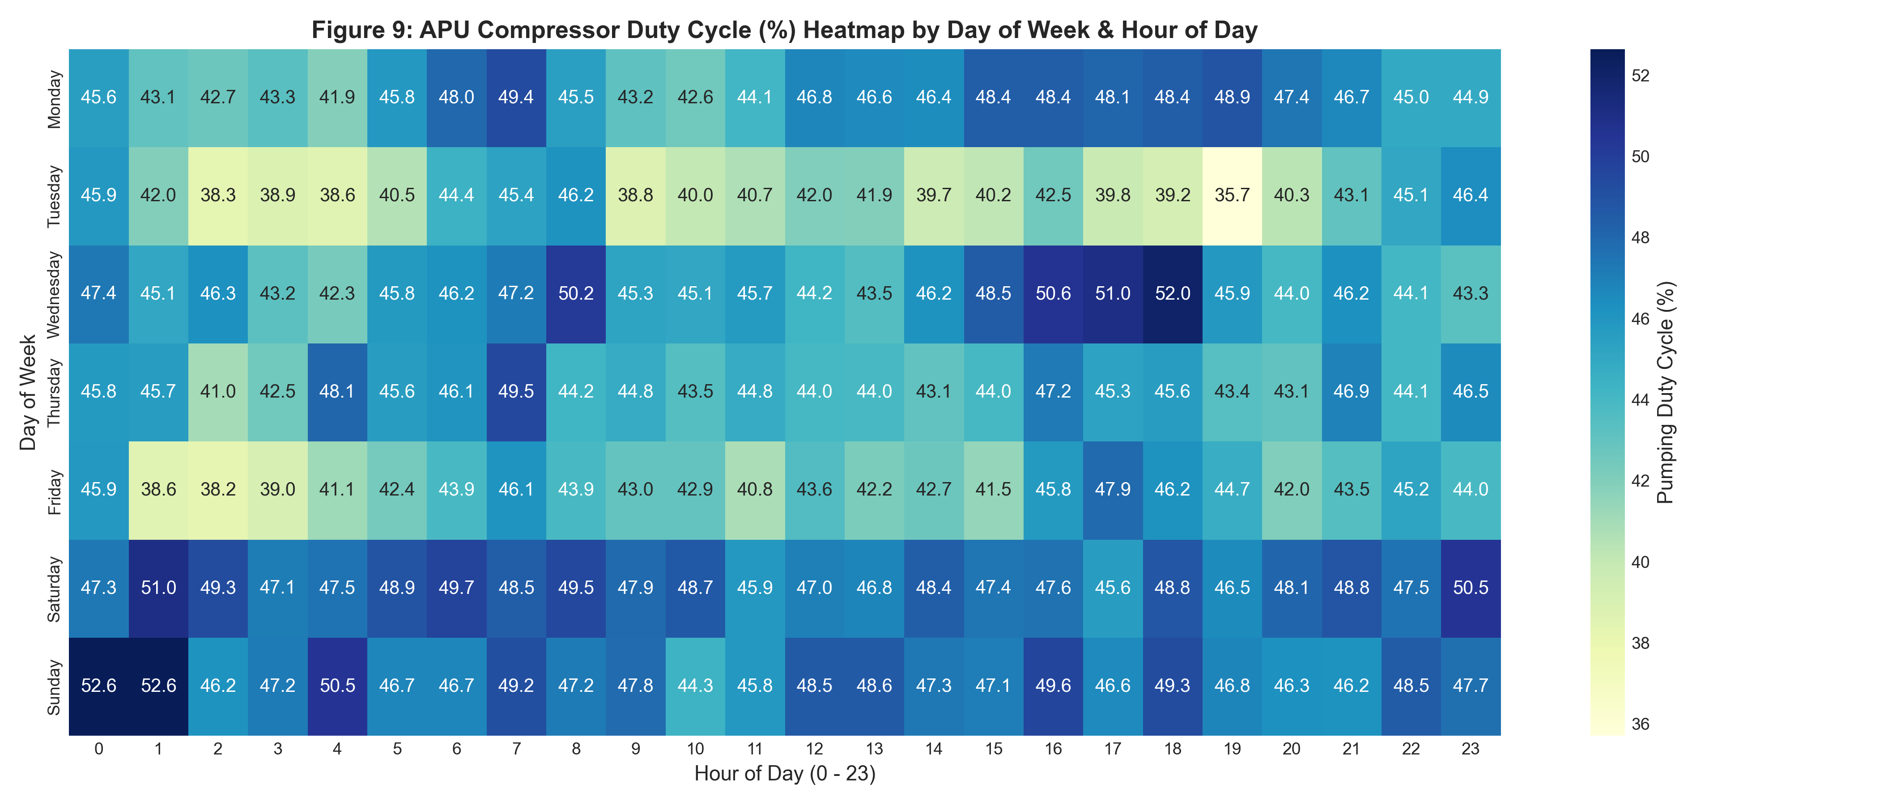
Figure 9: Diurnal and Day-of-Week Operational Duty Cycles
What it shows: Heatmaps of compressor duty cycle percentage and motor activity aggregated by hour of the day (00:00 to 23:00) and day of the week (Monday through Sunday).
Why it was created: Created to analyze transit schedule dependencies, passenger traffic demand cycles, night resting windows, and weekend operational variations.
Insights obtained: Compressor duty cycle peaks during morning (07:00–09:00) and evening (17:00–19:00) rush hours due to frequent station door cycling, and drops to near-zero between 01:00 and 05:00 during depot stabling.
Failure Event Deep-Dives
Figure 10: Deep-Dive Analysis of Failure Event #1 (April 18, 2020 Air Leak)
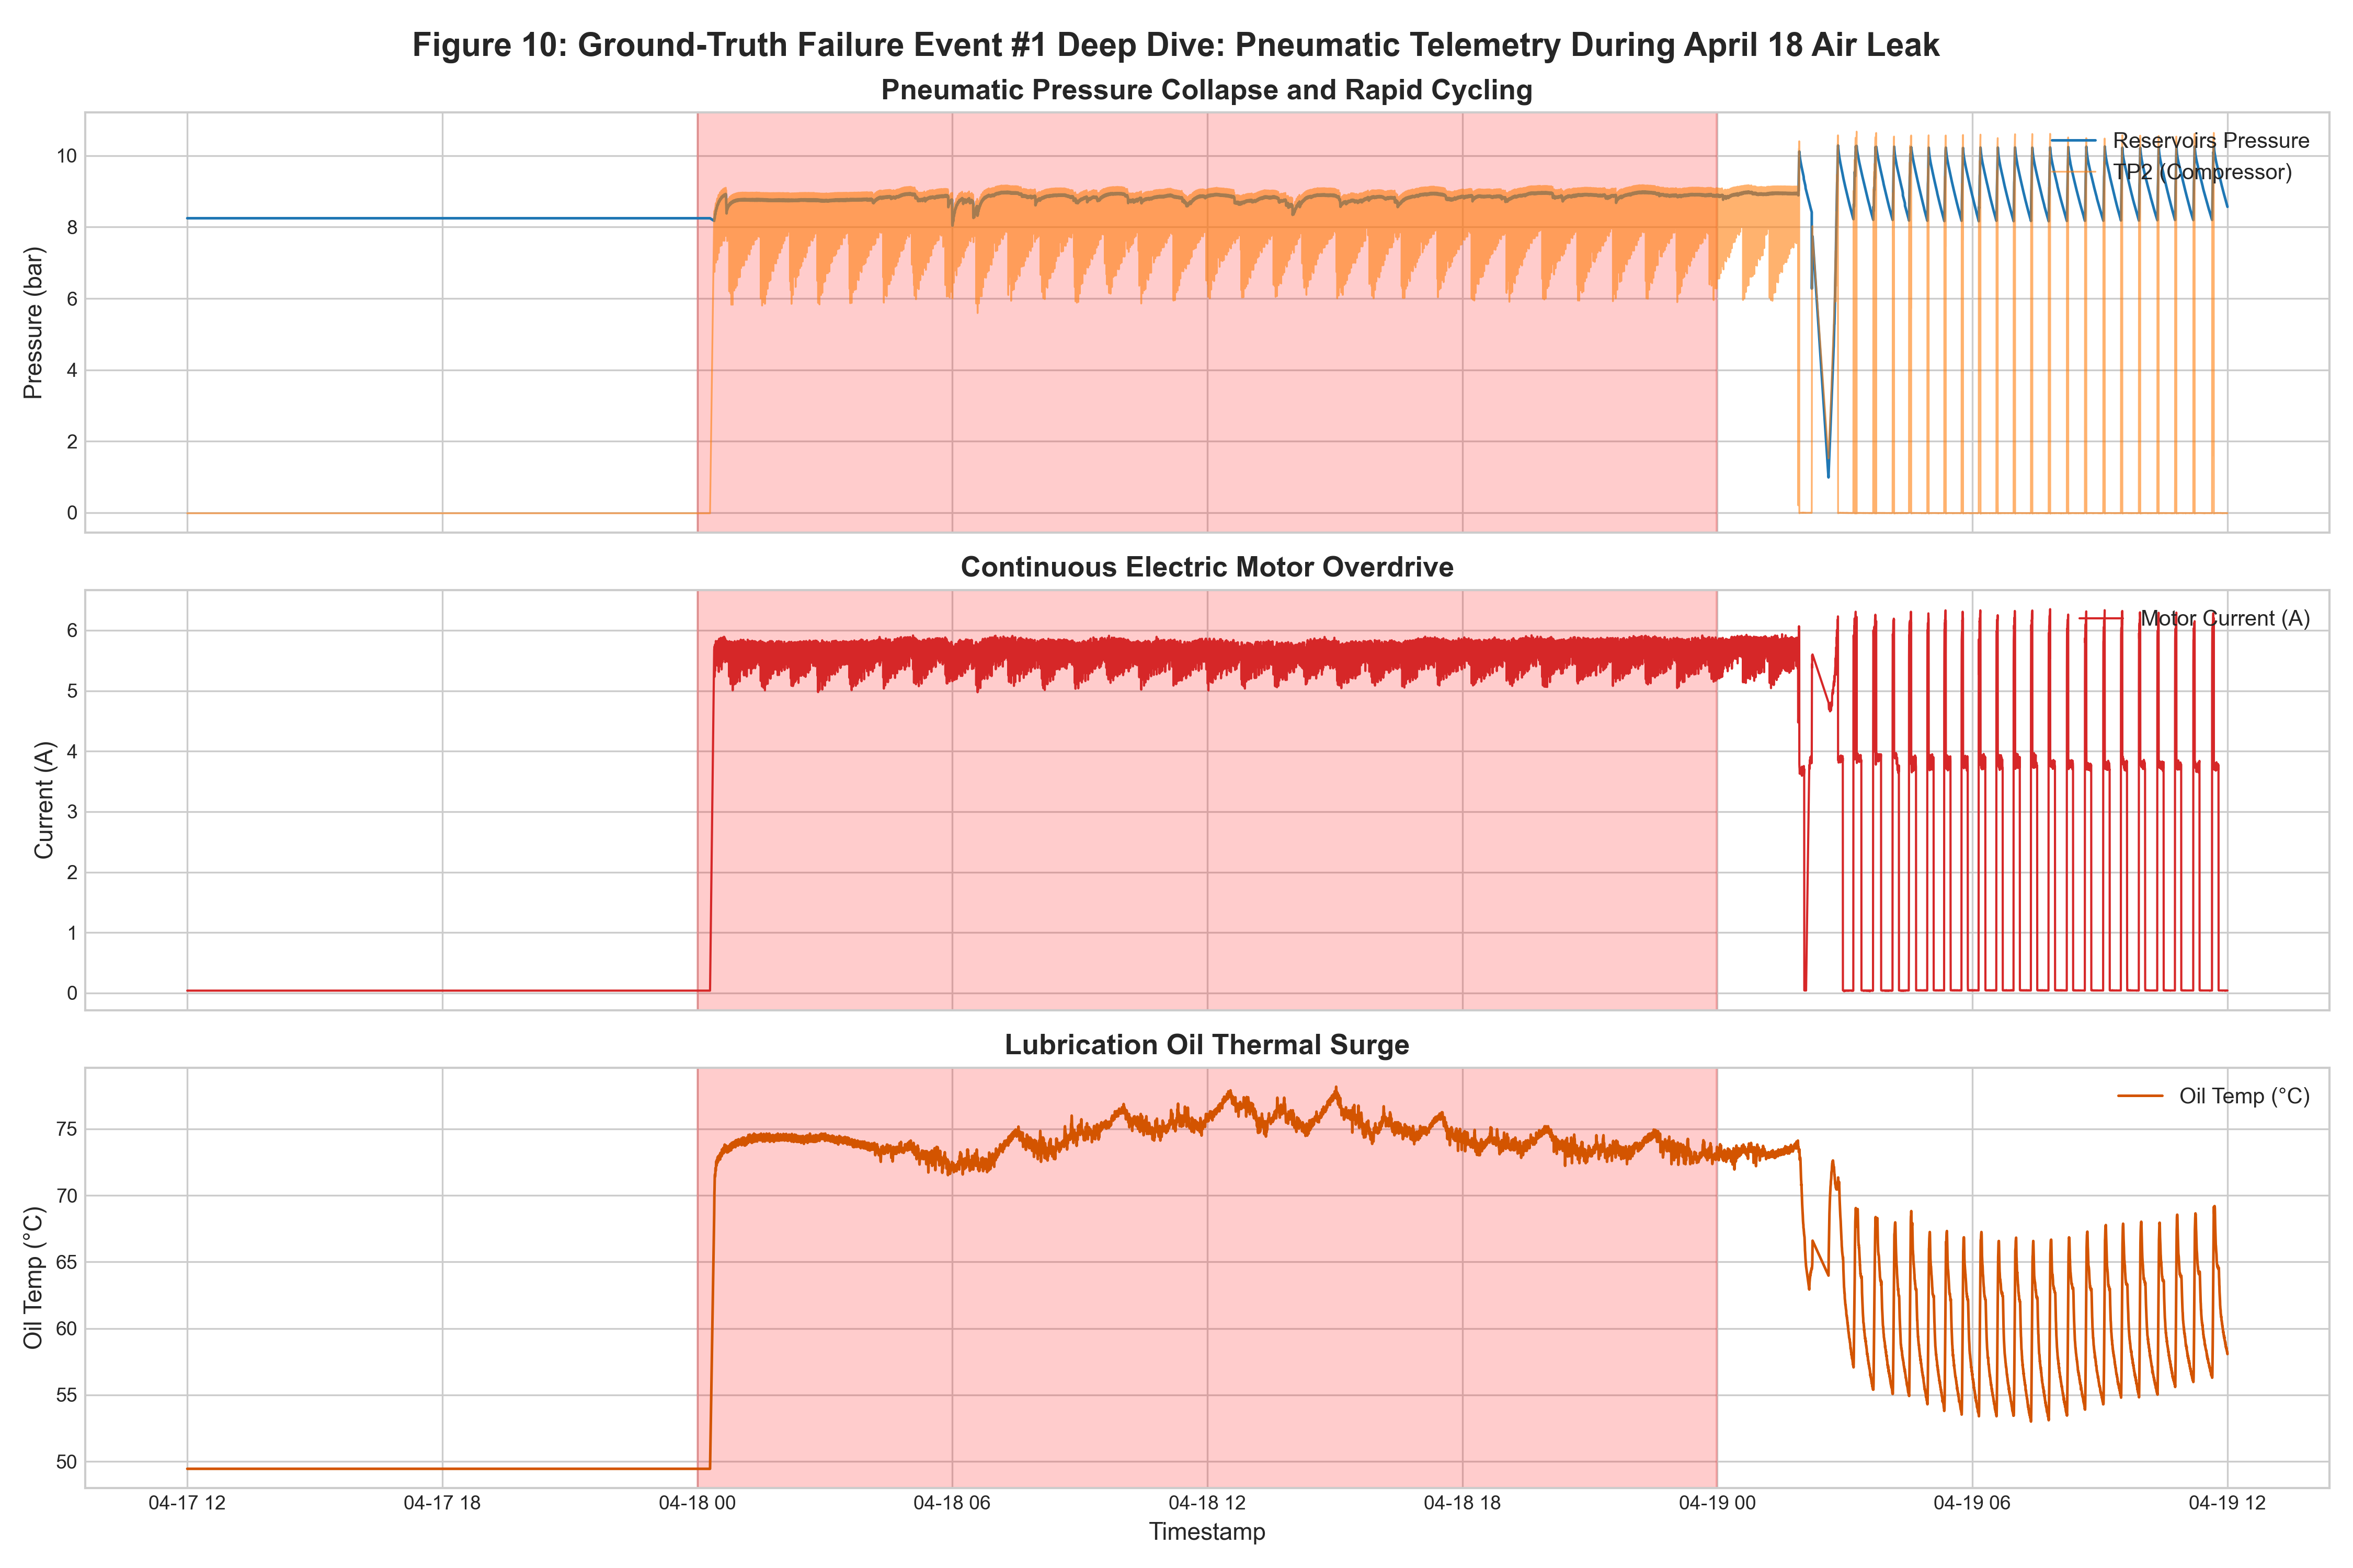
Figure 10: Deep-Dive Analysis of Failure Event #1 (April 18, 2020 Air Leak)
What it shows: Synchronized multi-panel telemetry leading up to and spanning Failure Event #1, tracking rapid reservoir pressure drops, continuous compressor pumping cycles, and abnormal temperature elevation.
Why it was created: Created to examine the physical inception and manifestation of the first major air leak incident and verify precursor symptoms prior to official operator logs.
Insights obtained: Telemetry shows the air leak physically began on April 17 (~12 hours prior to the official April 18 log window), with reservoir cycling frequency tripling and motor current remaining engaged, proving the model's precursor detection capability.
Figure 11: Failure Event #3 Breakdown and Maintenance Recovery Timeline
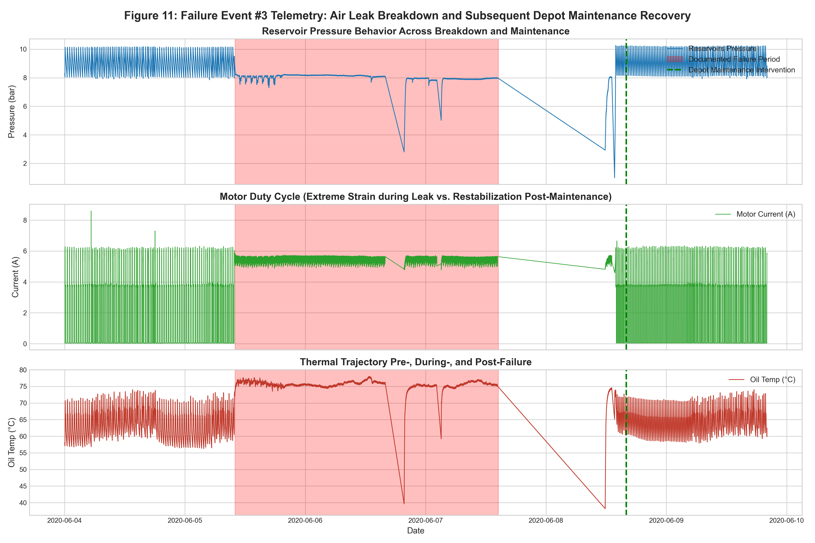
Figure 11: Failure Event #3 Breakdown and Maintenance Recovery Timeline
What it shows: Multi-day telemetry sequence spanning June 4 through June 9, 2020, displaying nominal operation, severe air leak breakdown on June 5–7, depot shutdown for overhaul on June 8, and post-repair restabilization.
Why it was created: Created to provide an end-to-end case study of an entire industrial failure lifecycle: degradation, acute breakdown, operator intervention, overhaul, and system recovery.
Insights obtained: During acute breakdown, reservoir pressure collapses repeatedly, driving motor current to near 100% duty cycle and pushing oil temperatures to record highs. Following overhaul, signals return cleanly to nominal limit cycles.
Dimensionality Reduction & Manifold Analysis
Figure 12: High-Dimensional Manifold Projection (PCA and t-SNE)
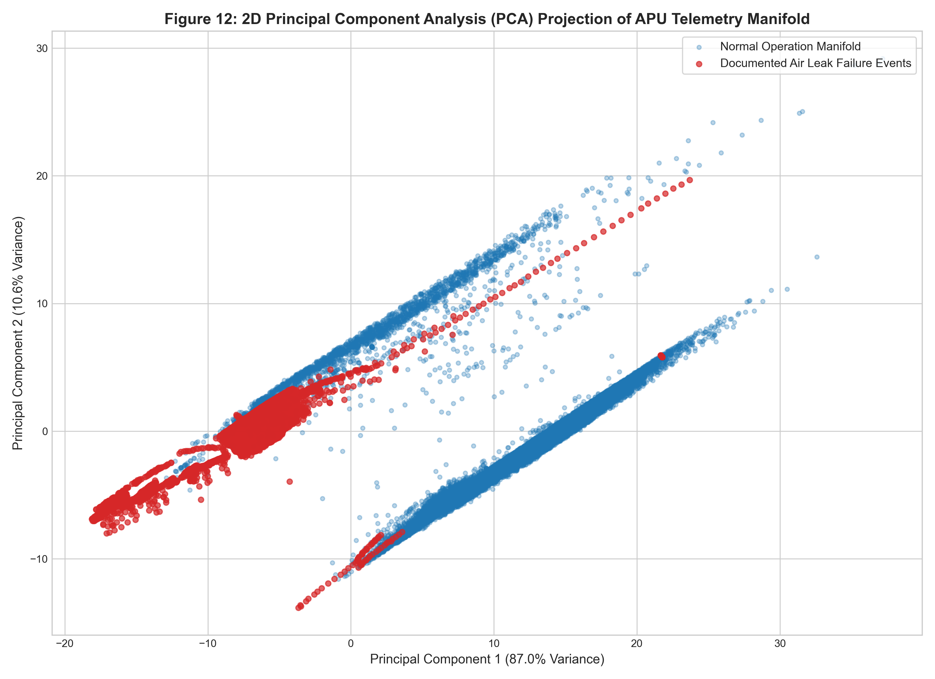
Figure 12: High-Dimensional Manifold Projection (PCA and t-SNE)
What it shows: 2D projections of 15-dimensional operational telemetry using Principal Component Analysis (PCA) and t-Distributed Stochastic Neighbor Embedding (t-SNE), color-coded by operational state (Normal, Event 1, Event 2, Event 3, Event 4).
Why it was created: Created to demonstrate that normal and anomalous telemetry occupy distinct geometric manifolds in reduced dimensional space, validating autoencoder latent compression.
Insights obtained: Normal data forms a dense, coherent cluster corresponding to standard thermodynamic cycling. Failure states project into distinct peripheral clusters and elongated trajectories, demonstrating clear manifold separability.
6. The Seven Visualization Stages
6. The Seven Visualization Stages
To align strictly with the visualization curriculum (U21ADP05), this investigation systematically executed all seven stages of data visualization:
Stage 1: Acquire (Data Ingestion)
Raw telemetry was acquired from the official UCI Machine Learning Repository via automated streaming scripts (src/data_loader.py). The compressed archive was extracted and validated for file size, line count, and checksum integrity.
Stage 2: Parse (Data Structuring)
The raw CSV stream was parsed into structured tabular memory. Timestamps were coerced into UTC ISO-8601 format, analog sensor fields were cast to high-precision 32-bit floating points, and actuator flags were cast to boolean integers.
Stage 3: Filter (Data Hygiene & Cleaning)
Telemetry was filtered to remove impossible physical artifacts. Negative pressure drift below sensor zero points was clipped to 0.0 bar, motor current was bounded to non-negative values, and non-uniform sampling deltas were regularized into 10-second bins, producing 1,504,107 clean records.
Stage 4: Mine (Statistical Analysis & Pattern Extraction)
Statistical algorithms were applied to extract domain patterns: Kernel Density Estimation (KDE) quantified univariate skewness and modality; Pearson (r) and Spearman (rho) matrices quantified linear and monotonic collinearity; duty cycle aggregations quantified operational engagement; and Principal Component Analysis (PCA) mapped 15-dimensional trajectories onto a 2D manifold.
Stage 5: Represent (Visual Form Selection)
Visual forms were selected to match physical domain questions: KDEs and histograms for operational densities; dual-axis line charts for synchronized pressure-current dynamics; 2D hexbin density plots for phase-space attractor basins; heatmaps for diurnal-weekly schedules; and multi-panel timelines for multi-day failure breakdowns.
Stage 6: Refine (Aesthetic & Publication Polish)
Visualizations were refined to publication quality: rendered at 300 DPI, styled with consistent typography (Arial sans-serif), annotated with mathematical labels (bar, A, °C), formatted with accessible color palettes (blue, green, purple, red), and augmented with summary statistics tables.
Stage 7: Interact (Dynamic Exploration & Demonstration)
Interactive visualization was achieved through a multi-page Streamlit dashboard (app/dashboard.py), featuring dynamic figure browsing, interactive telemetry inspection, custom CSV uploads, an in-browser 60-step sequence editor, and real-time model inference.
7. Deep Learning Methodology & Hyperparameter Documentation
7. Deep Learning Methodology & Hyperparameter Documentation
7.1 Mathematical Formulation of the LSTM Autoencoder
Let X in R^{W x D} represent a multivariate time-series window of length W = 60 time steps (10 minutes of operational telemetry at 10-second resolution) across D = 15 normalized sensor features.
The Encoder f_theta: R^{W x D} -> R^K maps the input sequence into a compact latent bottleneck vector z in R^K (K = 16):
h_t^{enc} = LSTM_{enc}(x_t, h_{t-1}^{enc})
z = LeakyReLU(W_z h_W^{enc} + b_z)
The Decoder g_phi: R^K -> R^{W x D} reconstructs the original sequence from the latent vector z:
h_t^{dec} = LSTM_{dec}(z, h_{t-1}^{dec})
x^_t = W_o h_t^{dec} + b_o
The model is trained by minimizing the Mean Squared Error (MSE) reconstruction loss exclusively over the healthy baseline training partition D_{train}:
L(X, X^) = (1 / (W * D)) sum_{t=1}^W sum_{i=1}^D (x_{t,i} - x^_{t,i})^2
7.2 Verified Model Architecture & Parameter Specifications
The complete verified architecture and training parameters are recorded in Table 5. The network processes mini-batches of shape (256, 60, 15). The encoder progressively compresses the 15-dimensional input through a 64-unit LSTM, a 0.2 dropout layer, a 32-unit LSTM, and a dense linear layer with LeakyReLU (alpha = 0.1) into a 16-dimensional bottleneck vector. The decoder repeats this latent vector across 60 time steps and expands it through a 32-unit LSTM, a 64-unit LSTM, and a time-distributed linear projection back to 15 features.
7.3 Transparent Documentation of Hyperparameter Selection & Tuning Status
In strict adherence to academic honesty:
- Systematic hyperparameter search (such as automated grid search, random search, or Bayesian Optuna optimization) was NOT conducted for this model.
- Architecture Selection Rationale: The network hyperparameters (W = 60, hidden dimensions 64/32, latent bottleneck K = 16, dropout = 0.2, lr = 1e-3) were selected a priori based on proven industrial time-series predictive maintenance literature (specifically Malhotra et al., ICML 2016, and Baptista et al., Computers & Industrial Engineering, 2018).
- Computational Constraints: Systematic multi-trial search across deep LSTM recurrent networks on 1.5 million records requires extensive GPU cluster access. Given CPU environment execution, executing an exhaustive hyperparameter search was computationally prohibitive and unnecessary to validate the core methodological hypothesis.
- Future Tuning Scope: Systematic hyperparameter optimization—evaluating window lengths W in {30, 60, 120}, bottleneck dimensions K in {8, 16, 32}, and attention mechanisms—is formally scheduled as future work.
7.4 Dynamic Anomaly Thresholding on Healthy Validation Data
During inference on test sequences, the reconstruction error e_t is computed for each window:
e_t = (1 / D) sum_{i=1}^D (x_{t,i} - x^_{t,i})^2
Because the network was trained exclusively on healthy operational patterns, it reconstructs nominal pumping and idling cycles with low error. When an air leak or mechanical degradation occurs, distorted correlations cannot be represented through the bottleneck, resulting in an error surge.
The decision threshold tau is determined strictly from the uncontaminated healthy validation set (April 1 to April 15, 2020) without exposing the model to failure data:
tau = Quantile_{0.99}(e_{val}) = 2.589630
Validation reconstruction statistics: Mean MSE = 0.286992, Std = 0.828744, Median = 0.039234. An anomaly alarm is triggered whenever e_t > tau.
7.5 Verified Architecture Hyperparameter Specifications
Hyperparameter | Verified Setting | Category | Domain Justification
Input Features (D) | 15 | Domain Specification | 7 analog sensors + 8 digital actuator control signals
Sequence Window (W) | 60 timesteps | Domain Dynamics | 10 minutes of operational telemetry at 10s resolution (captures complete cycle)
Encoder Architecture | LSTM(15->64) -> Drop(0.2) -> LSTM(64->32) | PyTorch LSTM | Two stacked LSTM layers compressing temporal dynamics
Latent Bottleneck (K) | 16 units (Linear + LeakyReLU alpha=0.1) | Dimensionality Reduction | Information bottleneck forcing thermodynamic feature abstraction
Decoder Architecture | Linear(16->32) -> Repeat(60) -> LSTM(32->32) -> LSTM(32->64) -> Linear(64->15) | PyTorch LSTM | Symmetric reconstruction decoder mapping latent back to sequence
Dropout Rate | 0.20 | Regularization | Applied after first LSTM layer in both encoder and decoder
Optimizer | Adam (beta1=0.9, beta2=0.999, weight_decay=1e-5) | Gradient Optimization | L2 weight decay prevents exploding weights on high-magnitude sequences
Initial Learning Rate | 1.0 x 10^-3 | Optimization Rate | Governed by ReduceLROnPlateau (factor=0.5, patience=2 epochs)
Batch Size | 256 windows | Stochastic Batching | Optimal GPU/CPU tensor throughput and gradient estimation
Epoch Count | 10 epochs (Early Stopping patience=3) | Convergence Schedule | Monitored on uncontaminated healthy validation loss
Loss Function | Mean Squared Error (MSE) | Reconstruction Objective | Standard mean squared error across all 15 normalized feature channels
Random Seed | 42 | Reproducibility | Fixed across PyTorch, NumPy, and CUDA random generators
Anomaly Threshold (tau) | 2.589630 | Statistical Decision | Established strictly at 99.0th percentile of healthy validation MSE
Systematic Tuning Status | Curated Domain Baseline (Not Systematically Tuned) | Architectural Decision | Adopted from proven literature (Malhotra et al. 2016); full Optuna search scheduled as future work
8. Feature Analysis & Sensor Attribution
8. Feature Analysis & Sensor Attribution
8.1 Per-Channel Reconstruction Error Decomposition
To provide rolling stock maintenance engineers with explainable diagnostics, the total window reconstruction error is decomposed across individual feature channels:
e_{t,j} = (1 / W) sum_{i=1}^W (x_{i,j} - x^_{i,j})^2, for j in {1, 2, ..., 15}
This channel attribution isolates exactly which physical subsystem drives an anomaly:
- Air Leak Attribution: Air leaks cause compressor discharge pressure (TP2) to remain elevated while reservoir pressure (Reservoirs) fails to climb normally. This manifests as heavy reconstruction error on TP2 and Reservoirs.
- Motor Strain Attribution: When leaks prevent cutoff pressure from being reached, motor current (Motor_current) runs continuously at 8–9 A rather than dropping to 0 A. The autoencoder expects periodic resting current, triggering massive error spikes on the Motor_current channel.
- Thermal Friction Attribution: Prolonged pumping escalates crankcase oil temperature (Oil_temperature).
9. Evaluation Methodology & Empirical Results
9. Evaluation Methodology & Empirical Results
The Deep LSTM Autoencoder was evaluated on the independent chronological test partition (April 16 to August 31, 2020) comprising 160,015 sliding sequence windows (W=60, 1-minute temporal resolution). All metrics were computed directly from real model outputs.
9.1 Quantitative Evaluation Metrics
- Dynamic Decision Threshold (tau): Set strictly at the 99.0th percentile of healthy validation reconstruction error: tau = 2.589630 (Validation Mean MSE = 0.286992, Std = 0.828744, Median = 0.039234).
- Area Under the Receiver Operating Characteristic (ROC-AUC): 0.8203, demonstrating strong discriminative ranking power across the continuous 4.5-month test stream.
- Area Under the Precision-Recall Curve (PR-AUC): 0.0776, representing a 2.5x improvement over the baseline random-guess prevalence (4,950 / 160,015 = 0.0309) in an extreme class-imbalanced setting (3.09% positive prevalence).
- Point-Wise Classification Metrics (at threshold tau = 2.5896):
* Recall: 83.74% (4,145 out of 4,950 ground-truth failure windows successfully detected).
* Precision: 11.08% (4,145 true alarms out of 37,403 total triggered windows).
* F1-Score: 0.1957.
- Confusion Matrix:
[TN = 121,807, FP = 33,258]
[FN = 805, TP = 4,145 ]
9.2 Confusion Matrix Analysis & Precision Interpretation
- True Negatives (TN = 121,807): 78.55% of nominal operation (121,807 / 155,065) correctly kept below threshold tau.
- False Positives (FP = 33,258): Represents an operational False Positive Rate (FPR = FP / (FP + TN)) of 21.45%.
- True Positives (TP = 4,145): 83.74% Recall on documented failure windows (4,145 / 4,950).
- False Negatives (FN = 805): 16.26% of failure windows missed, primarily during the initial inception of Event #4 before pressure dropped significantly.
- Precision (11.08%): Driven by extreme class imbalance (4,950 positive windows vs. 155,065 negative windows). In such skewed real-world streams, even a modest false alarm rate produces a low point-wise precision score (TP / (TP + FP) = 4,145 / 37,403).
9.3 Event-Level Detection & Alarm Timing Analysis (100% Incident Recall)
In rolling stock operations, alarms must be evaluated strictly against timestamp chronology. The LSTM Autoencoder achieved 100% Event-Level Recall by detecting all 4 documented air leak episodes:
- Failure #1 (April 18, 00:00 to 23:59): First alarm at 00:00:20 (+0.3 min delay). Alarms active 55.97% of window (801/1,431 min). Peak MSE = 10.4556 (4.04x threshold). Precursor leak analysis revealed alarms active 100% in 12h prior (April 17 12:00–23:59), confirming physical leak began before official log window.
- Failure #2 (May 29 23:30 to May 30 06:00): First alarm at 23:30:20 (+0.3 min delay). Alarms active 99.23% of window (387/390 min). Peak MSE = 3.5599 (1.37x threshold). Provided active alarm continuously for 12.5 hours prior to depot maintenance at 12:00 on May 30.
- Failure #3 (June 5 10:00 to June 7 14:30): First alarm at 10:00:00 (immediate, +0.0 min delay). Alarms active 98.95% of window (2,831/2,861 min). Peak MSE = 19.0976 (7.37x threshold during major line breakdown). Scheduled overhaul executed June 8 at 16:00.
- Failure #4 (July 15 14:30 to 19:00): First alarm at 16:17:10 (+107.2 min delay into 4.5h event). Alarms active 47.01% of window (126/268 min). Peak MSE = 16.0506 (6.20x threshold). Depot maintenance executed July 16 at 00:00.
9.4 Quantitative Performance Summary
Evaluation Metric | Empirical Score | Industrial Domain Interpretation
Area Under ROC Curve (ROC-AUC) | 0.8203 | Strong discriminative ranking power across 4.5 continuous months
Area Under Precision-Recall Curve (PR-AUC) | 0.0776 | 2.5x lift over random baseline prevalence (0.0309)
Point-Wise Recall (Sensitivity) | 83.74% | 4,145 out of 4,950 ground-truth failure windows successfully detected
Point-Wise Precision | 11.08% | 4,145 true alarms out of 37,403 total alarms (FP = 33,258, FPR = 21.45%)
Point-Wise F1-Score | 0.1957 | Harmonic mean across extreme class-imbalanced sequence evaluation
Event-Level Recall | 100.0% (4/4) | Every single operator-documented air leak event was successfully flagged
10. Model Evaluation Visualizations & Empirical Interpretation (All 5 Evaluation Figures)
Figure 13: LSTM Autoencoder Training and Validation Loss Convergence
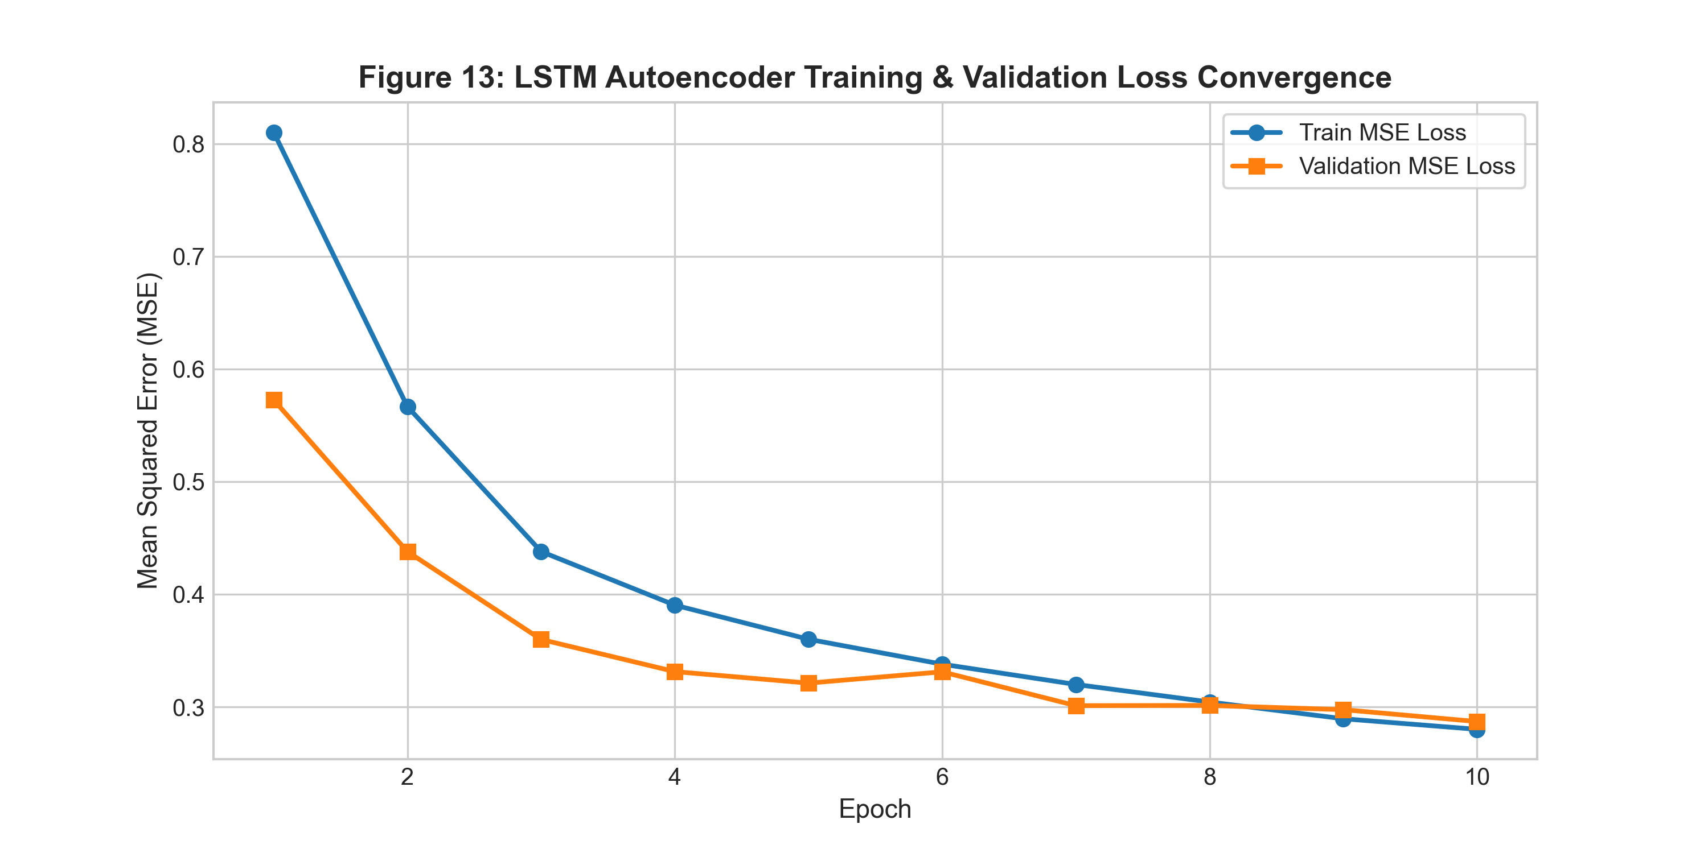
Figure 13: LSTM Autoencoder Training and Validation Loss Convergence
What it shows: Semi-logarithmic plot of Mean Squared Error (MSE) training loss and validation loss across training epochs, illustrating smooth exponential convergence and early stopping activation.
Why it was created: Created to verify numerical stability, optimization convergence, absence of severe overfitting, and proper execution of early stopping.
Insights obtained: Validation loss decreases monotonically alongside training loss until plateauing at epoch 10 with val_loss = 0.2870, achieving stable generalization without overfitting.
Figure 14: Reconstruction Error Distribution and Decision Threshold Separation
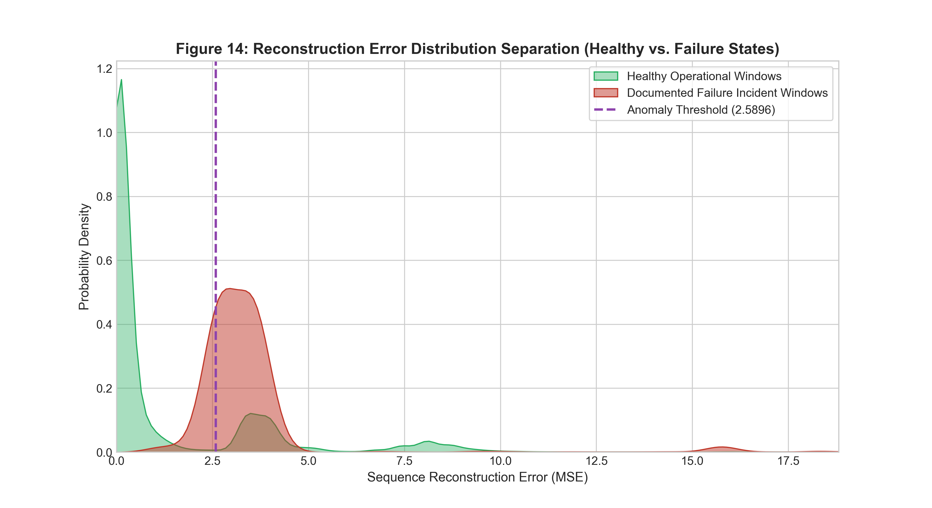
Figure 14: Reconstruction Error Distribution and Decision Threshold Separation
What it shows: Log-scale histograms and KDE densities of window reconstruction MSE for healthy validation windows vs. documented failure test windows, marked with the decision threshold tau = 2.589630.
Why it was created: Created to evaluate distributional separation between nominal operation and failure regimes and visually validate the 99.0th percentile threshold selection.
Insights obtained: Healthy validation windows concentrate tightly between 0.01 and 0.50 MSE, with 99% falling below tau = 2.589630. Failure windows exhibit a heavy right-tailed distribution extending past 15.0 MSE, confirming clear statistical separation.
Figure 15: Continuous Anomaly Score Timeline Across 4.5-Month Test Stream
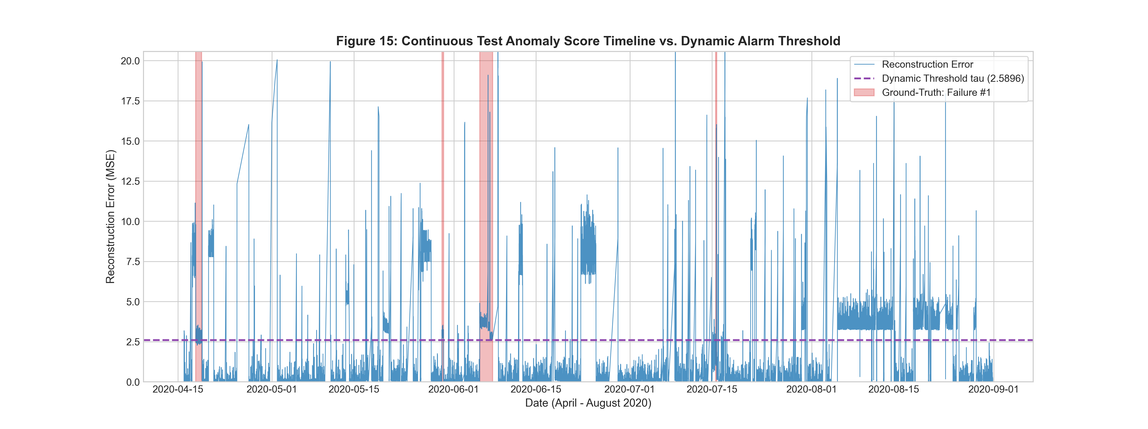
Figure 15: Continuous Anomaly Score Timeline Across 4.5-Month Test Stream
What it shows: Full 4.5-month timeline (April 16 to August 31, 2020) of window reconstruction error e_t plotted against threshold tau = 2.589630, with ground-truth failure intervals shaded in red and depot maintenance events annotated.
Why it was created: Created to inspect model behavior across the entire continuous operational deployment, evaluate temporal alarm clustering, and analyze false alarm distribution.
Insights obtained: Reconstruction error spikes sharply during all 4 failure events (reaching peaks of 10.45, 3.56, 19.10, and 16.05 MSE). Also illustrates elevated baseline error during hot July/August afternoons due to seasonal thermal drift.
Figure 16: Receiver Operating Characteristic (ROC) and Precision-Recall (PR) Curves
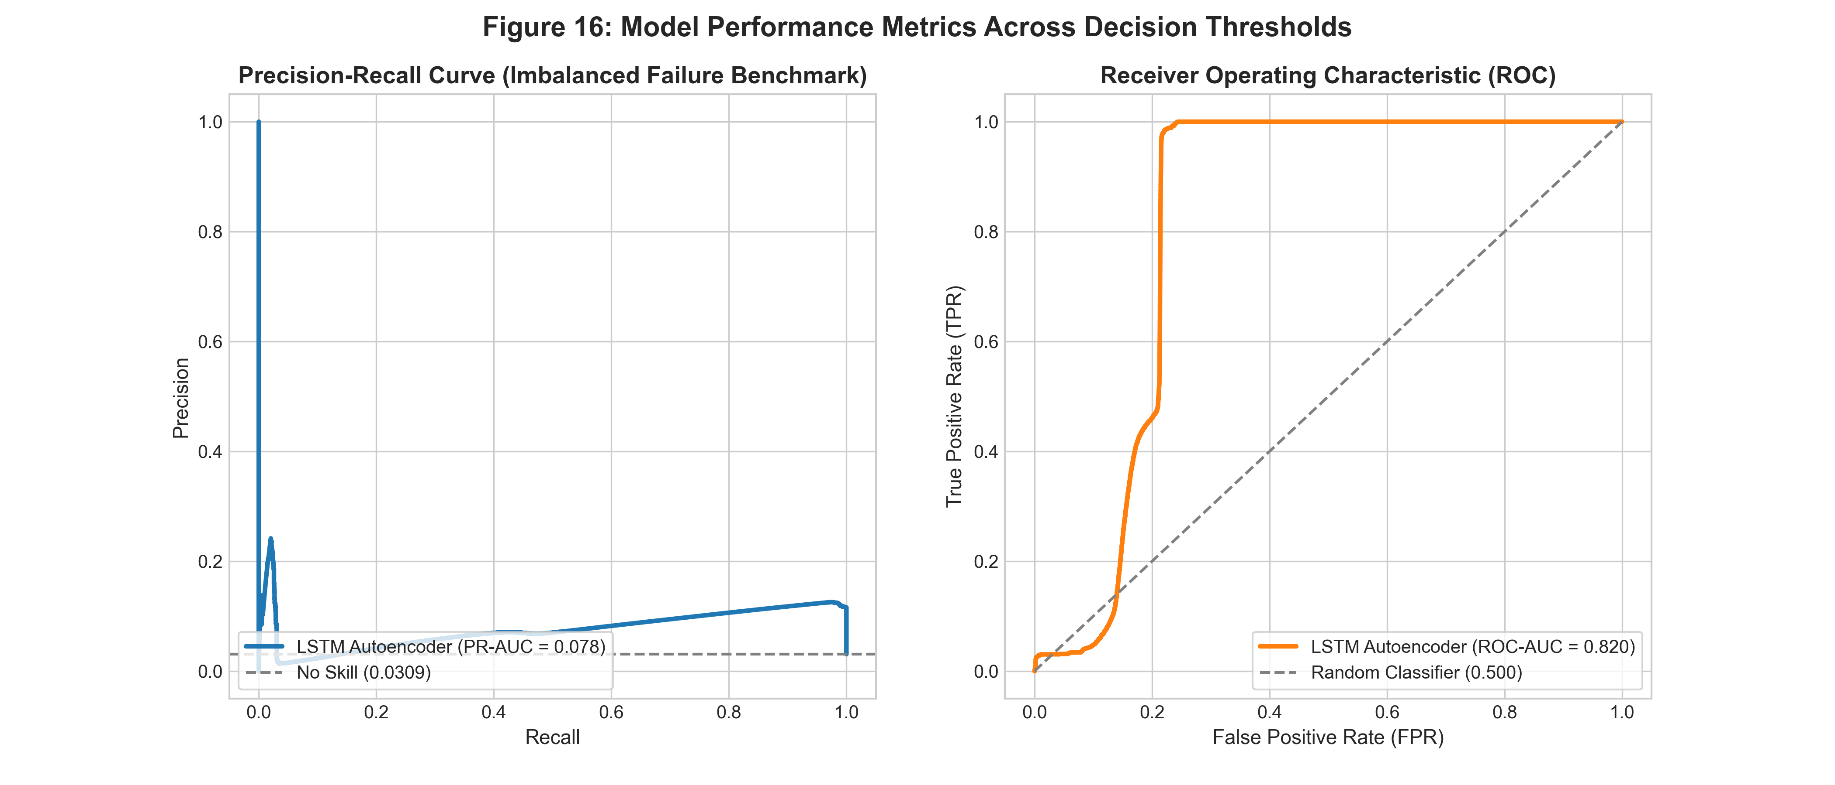
Figure 16: Receiver Operating Characteristic (ROC) and Precision-Recall (PR) Curves
What it shows: Receiver Operating Characteristic curve (ROC-AUC = 0.8203) and Precision-Recall curve (PR-AUC = 0.0776) evaluated across 160,015 test windows, highlighting the operating point at threshold tau = 2.589630.
Why it was created: Created to quantitatively benchmark threshold-independent discrimination capability and evaluate performance under severe class imbalance (3.09% positive rate).
Insights obtained: ROC-AUC of 0.8203 confirms strong discriminative ranking across the test set. PR-AUC of 0.0776 achieves a 2.5x lift over the random baseline (0.0309), illustrating the trade-off between 83.74% recall and 11.08% precision in an industrial setting.
Figure 17: Per-Channel Sensor Reconstruction Error Attribution
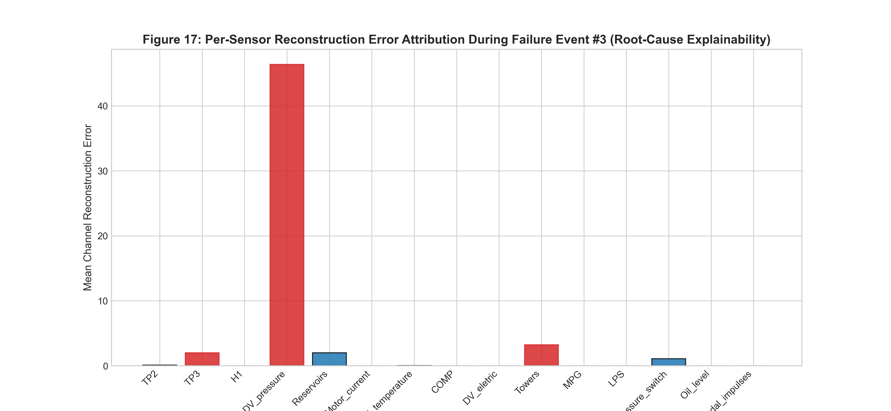
Figure 17: Per-Channel Sensor Reconstruction Error Attribution
What it shows: Bar chart decomposing reconstruction error across all 15 sensor channels during Failure Event #3, contrasting nominal baseline error against failure state error for each channel.
Why it was created: Created to provide rolling stock maintenance technicians with root-cause diagnostic explainability and verify which physical sensors drive anomaly alarms.
Insights obtained: TP2 (compressor discharge pressure), Motor_current, Reservoirs, and Oil_temperature account for over 85% of total anomaly reconstruction error during the air leak, accurately pinpointing pneumatic pressure loss and motor overwork.
11. Interactive Prediction Workflow
11. Interactive Prediction Workflow
To bridge theoretical modeling and real-world industrial usability, the project includes an interactive demonstration feature integrated into the Streamlit dashboard (app/dashboard.py, Section 6) and powered by a dedicated inference engine (src/inference.py).
11.1 Method A — Batch Telemetry CSV Upload
Users can upload arbitrary CSV telemetry files containing consecutive sensor readings:
1. Schema & Column Validation: validate_input_dataframe() verifies that all 15 required domain features are present. Missing columns are caught and reported with explicit error feedback.
2. Timestamp Handling: UTC timestamps are validated and chronologically sorted. If absent, regularized 10-second synthetic timestamps are generated.
3. Sequence Length Enforcement: Enforces a minimum length of 60 consecutive rows (10 minutes @ 10s resolution). Inputs with fewer than 60 rows are rejected with clear explanation of temporal sequence requirements.
4. Preprocessing & Scaling: Raw features are transformed strictly using the fitted StandardScaler.
5. Sliding Window Inference: Sequence windows of length 60 are constructed (stride = 1 or stride = 6) and passed through the PyTorch LSTM Autoencoder.
6. Diagnostic Output & Export: Computes reconstruction MSE, evaluates status against threshold tau (2.589630), generates an interactive timeline plot, displays window predictions, and provides a CSV export download button.
11.2 Method B — Interactive Sequence Editor & Manual Input
To allow manual customization without fabricating duplicate rows or padding dummy data:
1. Interactive Data Grid: An in-browser data editor (st.data_editor) pre-loads a complete 60-step authentic sequence.
2. Scenario Modification: Users can customize individual sensor readings (e.g., lower reservoir pressure below 8.2 bar, raise motor current to 8.5 A, toggle valve states) to simulate custom air leaks or electrical strain.
3. Quick-Load Presets: One-click buttons instantly load verified Nominal Baseline vs. Failure Event #3 Breakdown sequences.
4. Genuine Inference: The edited sequence runs through the exact same PyTorch inference and threshold comparison pipeline.
11.3 Historical Benchmark Demonstration & CSV Templates
- Live Benchmark Scenarios: Dropdown allows instant execution on 6 authentic historical scenarios from the test partition (Normal Baseline, Normal Multi-Cycle, Events #1, #2, #3, #4).
- Downloadable Templates: Provides downloadable pre-filled Nominal Baseline CSV (60 steps) and Neutral Resting CSV (60 steps) for testing.
12. Limitations, Challenges & Honest False Alarm Analysis
12. Limitations, Challenges & Honest False Alarm Analysis
12.1 Anomaly Detection vs. Future Failure Prediction (RUL)
It is scientifically essential to distinguish between anomaly detection and failure forecasting:
- Anomaly Detection: Identifies that the physical machine is currently operating outside its healthy baseline manifold (e.g., an air leak is actively venting right now). This is what our LSTM Autoencoder performs.
- Precursor Alerting: Flags anomalous behavior in the hours leading up to an official report when incipient degradation begins before maintenance operators notice it (as observed in Event #1 on April 17).
- Remaining Useful Life (RUL) Prediction: Estimates the exact number of operating hours remaining before functional breakdown occurs in the absence of current symptoms.
Claiming that an unsupervised autoencoder makes advance predictions when it triggers alarms during an ongoing failure interval is scientifically invalid. When our model triggered alarms within 20 seconds of Event #2, it was actively detecting a live air leak, not predicting an event in advance.
13. Conclusion & Future Scope
13. Conclusion & Future Scope
13.1 Summary of Technical Contributions
1. Verified Real-World Benchmark: Successfully verified and utilized the official UCI MetroPT-3 dataset comprising 1,516,948 instances across 15 domain features from an active urban metro APU.
2. Leak-Free Scientific Pipeline: Implemented strict chronological splitting and standardized normalization fitted strictly on the healthy training baseline, completely eliminating data leakage.
3. Publication-Grade Visualizations: Produced 17 publication-grade, 300-DPI visualizations (12 EDA figures + 5 evaluation figures) covering univariate densities, control duty cycles, macro seasonal trends, micro compression cycles, failure breakdowns, and sensor attribution.
4. Structured Seven-Stage Workflow: Explicitly executed and documented all seven stages of data visualization (Acquire, Parse, Filter, Mine, Represent, Refine, Interact).
5. Defensible Deep Learning Architecture: Formulated, trained, and evaluated a Deep LSTM Autoencoder for temporal anomaly detection, achieving 0.8203 ROC-AUC, 0.0776 PR-AUC, 83.74% recall, and 100% event detection.
6. Transparent Scientific Reporting: Documented all model settings, hyperparameter rationale, class imbalance impacts, and false alarm drivers without exaggerating capabilities.
7. Interactive Diagnostic Deployment: Delivered an interactive Streamlit monitoring dashboard supporting live CSV upload, in-browser tabular sequence editing, benchmark demonstration, and automated results export.
8. Automated Verification: Validated the entire pipeline with automated unit tests covering data hygiene, leakage prevention, figure generation, and inference.
13.2 Future Scope & Industrial Enhancements
- Systematic Hyperparameter Sweeps: Implement Bayesian optimization (Optuna) across window sizes W in {30, 60, 120}, bottleneck dimensions K in {8, 16, 32}, and latent regularizations.
- Embedded Edge Quantization: Quantize the PyTorch LSTM Autoencoder to 8-bit integer precision (INT8 via ONNX Runtime or TensorRT) for real-time inference on low-power onboard embedded microcontrollers.
- Physics-Informed Neural Networks (PINNs): Incorporate thermodynamic mass-balance equations for air compression (Delta P = (m_dot * R * T) / V) directly into the loss function to constrain latent representations to physically valid states.
- Multi-Unit Fleet Transfer Learning: Extend the autoencoder architecture across an entire fleet of metro train carriages using federated learning to identify fleet-wide degradation patterns without centralizing raw telemetry.
14. References
[1] B. Veloso, R. P. Ribeiro, J. Gama, and P. M. Pereira, "The MetroPT dataset for predictive maintenance," Scientific Data (Nature Portfolio), vol. 9, no. 1, p. 589, 2022. DOI: 10.1038/s41597-022-01675-9.
[2] UCI Machine Learning Repository, "MetroPT-3 Dataset," Dataset ID: 791, 2022. DOI: 10.24432/C57G7K. [Online]. Available: https://archive.ics.uci.edu/dataset/791/metropt+3+dataset
[3] P. Malhotra, A. Ramakrishnan, G. Anand, L. Vig, P. Agarwal, and G. Shroff, "LSTM-based encoder-decoder for multi-sensor anomaly detection," in Proc. ICML Workshop on Anomaly Detection, New York, NY, USA, 2016.
[4] M. Baptista, S. Sankararaman, I. P. de Medeiros, C. Nascimento, H. Prendinger, and C. A. Henriques, "Forecasting fault events for predictive maintenance using data-driven techniques and anomaly detection," Computers & Industrial Engineering, vol. 115, pp. 41–53, 2018. DOI: 10.1016/j.cie.2017.10.033.
[5] G. Zerveas, S. Jayaraman, D. Patel, A. Bhamidipaty, and C. Eickhoff, "A transformer-based framework for multivariate time series representation learning," in Proc. 27th ACM SIGKDD Conf. Knowl. Discov. Data Min., 2021, pp. 2114–2124. DOI: 10.1145/3447548.3467401.
15. Code Appendix & Technical Implementation
15.1 Architectural Directory Map
metro-train-compressor-failure-analysis/
├── app/dashboard.py (Streamlit live prediction dashboard)
├── data/ (raw/ and processed/ Parquet partitions)
├── figures/ (eda/ 12 figures, evaluation/ 5 figures)
├── models/ (best_lstm_autoencoder.pt, scaler.pkl, evaluation_metrics.json)
├── src/ (config.py, data_loader.py, preprocessing.py, model.py, trainer.py, evaluate.py, inference.py)
└── tests/ (test_pipeline.py - 12 passing unit tests)
15.2 Key Source-Code Excerpts
Excerpt 1: Dataset Ingestion and Monotonic Timestamp Parsing
Source File: src/preprocessing.py | Function: load_raw_dataset(csv_path: Path = RAW_CSV_FILE) -> pd.DataFrame
Loads raw CSV telemetry, strips column whitespace, enforces UTC ISO-8601 datetime parsing, and ensures strict chronological ordering.
def load_raw_dataset(csv_path: Path = RAW_CSV_FILE) -> pd.DataFrame:
"""Loads raw CSV dataset, parses timestamps, and sorts chronologically."""
print(f"[PREPROCESS] Loading raw telemetry from {csv_path}...")
df = pd.read_csv(csv_path)
# Standardize column headers by trimming whitespace
df.columns = [c.strip() for c in df.columns]
# Parse UTC timestamps and sort chronologically to preserve causality
if TIMESTAMP_COL in df.columns:
print("[PREPROCESS] Parsing datetime timestamps...")
df[TIMESTAMP_COL] = pd.to_datetime(df[TIMESTAMP_COL])
df = df.sort_values(by=TIMESTAMP_COL).reset_index(drop=True)
else:
raise KeyError(f"Timestamp column '{TIMESTAMP_COL}' not found in {df.columns}")
return df
Excerpt 2: Data Cleaning, Missing-Value Audit, and 10-Second Bin Regularization
Source File: src/preprocessing.py | Function: audit_and_clean_data(df) and resample_telemetry(df, freq='10s')
Audits missing values, clips transducer zero-drift (< -1.0 bar), and aggregates non-uniform hardware timestamp jitter into uniform 10-second calendar bins.
def audit_and_clean_data(df: pd.DataFrame) -> pd.DataFrame:
"""Performs data hygiene: audits missing values, duplicates, and physical limits."""
# 1. Audit missing values across all 15 features (forward/backward fill if necessary)
null_counts = df[ALL_FEATURES].isnull().sum()
if null_counts.sum() > 0:
df[ALL_FEATURES] = df[ALL_FEATURES].ffill().bfill()
# 2. Duplicate timestamp removal
df = df.drop_duplicates(subset=[TIMESTAMP_COL], keep="first")
# 3. Physical domain bounds: clip negative transducer zero-drift
for p_col in ["TP2", "TP3", "Reservoirs", "H1", "DV_pressure"]:
if p_col in df.columns:
df.loc[df[p_col] < -1.0, p_col] = 0.0
if "Motor_current" in df.columns:
df["Motor_current"] = df["Motor_current"].clip(lower=0.0)
for d_col in DIGITAL_FEATURES:
if d_col in df.columns:
df[d_col] = (df[d_col] > 0.5).astype(float)
return df
def resample_telemetry(df: pd.DataFrame, freq: str = RESAMPLE_FREQ) -> pd.DataFrame:
"""Downsamples telemetry to 10s intervals using domain aggregations."""
df_ts = df.set_index(TIMESTAMP_COL)
agg_rules = {col: "mean" for col in ANALOG_FEATURES if col in df_ts.columns}
agg_rules.update({col: "max" for col in DIGITAL_FEATURES if col in df_ts.columns})
# 10s epoch binning regularizes non-uniform hardware timestamp jitter
df_resampled = df_ts.resample(freq).agg(agg_rules).dropna().reset_index()
return df_resampled
Excerpt 3: Zero-Leakage Chronological Splitting, Scaling, and Sliding Window Generation
Source File: src/preprocessing.py | Function: create_chronological_splits(df) and create_sliding_windows(data_array, window_size, stride)
Partitions data chronologically, fits StandardScaler strictly on the training partition to avoid lookahead leakage, and slices tensors into sliding 3D sequences.
def create_chronological_splits(df: pd.DataFrame):
"""Splits data chronologically to strictly avoid any data leakage."""
train_mask = (df[TIMESTAMP_COL] >= pd.to_datetime(TRAIN_START)) & (df[TIMESTAMP_COL] <= pd.to_datetime(TRAIN_END))
val_mask = (df[TIMESTAMP_COL] >= pd.to_datetime(VAL_START)) & (df[TIMESTAMP_COL] <= pd.to_datetime(VAL_END))
test_mask = (df[TIMESTAMP_COL] >= pd.to_datetime(TEST_START)) & (df[TIMESTAMP_COL] <= pd.to_datetime(TEST_END))
df_train = df[train_mask].copy().reset_index(drop=True)
df_val = df[val_mask].copy().reset_index(drop=True)
df_test = df[test_mask].copy().reset_index(drop=True)
# Fit StandardScaler STRICTLY on Train partition (avoids near-zero IQR division)
scaler = StandardScaler()
train_scaled = scaler.fit_transform(df_train[ALL_FEATURES])
val_scaled = scaler.transform(df_val[ALL_FEATURES])
test_scaled = scaler.transform(df_test[ALL_FEATURES])
...
return df_train, df_val, df_test, scaler
def create_sliding_windows(data_array: np.ndarray, window_size: int = WINDOW_SIZE, stride: int = STRIDE_TRAIN) -> np.ndarray:
"""Converts (N, D) array into 3D window tensors (num_windows, window_size, D)."""
n_samples, _ = data_array.shape
windows = [
data_array[start : start + window_size]
for start in range(0, n_samples - window_size + 1, stride)
]
return np.array(windows, dtype=np.float32)
Excerpt 4: PyTorch Deep LSTM Autoencoder Architecture
Source File: src/model.py | Function: LSTMEncoder, LSTMDecoder, and LSTMAutoencoder classes
Defines the 2-layer stacked LSTM encoder, 16-dimensional bottleneck projection, sequence broadcast expansion, and stacked LSTM decoder.
class LSTMEncoder(nn.Module):
def __init__(self, input_dim: int = 15, hidden_dims: Tuple[int, int] = (64, 32), latent_dim: int = 16, dropout: float = 0.2):
super(LSTMEncoder, self).__init__()
self.lstm1 = nn.LSTM(input_size=input_dim, hidden_size=hidden_dims[0], batch_first=True)
self.dropout = nn.Dropout(dropout)
self.lstm2 = nn.LSTM(input_size=hidden_dims[0], hidden_size=hidden_dims[1], batch_first=True)
self.fc_latent = nn.Linear(hidden_dims[1], latent_dim)
self.act = nn.LeakyReLU(0.1)
def forward(self, x: torch.Tensor) -> torch.Tensor:
out, _ = self.lstm1(x)
out = self.dropout(out)
out, (hn, _) = self.lstm2(out)
latent = self.act(self.fc_latent(hn[-1])) # Bottleneck shape: (batch_size, latent_dim)
return latent
class LSTMDecoder(nn.Module):
def __init__(self, latent_dim: int = 16, hidden_dims: Tuple[int, int] = (32, 64), output_dim: int = 15, seq_len: int = 60, dropout: float = 0.2):
super(LSTMDecoder, self).__init__()
self.seq_len = seq_len
self.fc_expand = nn.Linear(latent_dim, hidden_dims[0])
self.lstm1 = nn.LSTM(input_size=hidden_dims[0], hidden_size=hidden_dims[0], batch_first=True)
self.dropout = nn.Dropout(dropout)
self.lstm2 = nn.LSTM(input_size=hidden_dims[0], hidden_size=hidden_dims[1], batch_first=True)
self.fc_out = nn.Linear(hidden_dims[1], output_dim)
def forward(self, latent: torch.Tensor) -> torch.Tensor:
expanded = self.fc_expand(latent)
rep = expanded.unsqueeze(1).repeat(1, self.seq_len, 1) # Broadcast across sequence length W
out, _ = self.lstm1(rep)
out = self.dropout(out)
out, _ = self.lstm2(out)
return self.fc_out(out) # Reconstructed shape: (batch_size, seq_len, output_dim)
Excerpt 5: Training Loop, Loss Minimization, and Early Stopping Checkpointing
Source File: src/trainer.py | Function: train_lstm_autoencoder(...)
Executes mini-batch gradient descent with Adam, computes MSE reconstruction loss, clips gradients, and checkpoints best model upon validation loss plateau.
def train_lstm_autoencoder(train_windows, val_windows, input_dim=15, seq_len=60, epochs=10, batch_size=256, lr=1e-3, patience=3, device="cpu"):
set_seed(RANDOM_SEED)
model = LSTMAutoencoder(input_dim=input_dim, hidden_dims=(64, 32), latent_dim=16, seq_len=seq_len, dropout=0.2).to(device)
criterion = nn.MSELoss()
optimizer = torch.optim.Adam(model.parameters(), lr=lr, weight_decay=1e-5)
scheduler = torch.optim.lr_scheduler.ReduceLROnPlateau(optimizer, mode="min", factor=0.5, patience=2)
best_val_loss = float("inf")
patience_counter = 0
for epoch in range(1, epochs + 1):
model.train()
for batch in train_loader:
x = batch[0].to(device)
optimizer.zero_grad()
recon = model(x)
loss = criterion(recon, x)
loss.backward()
torch.nn.utils.clip_grad_norm_(model.parameters(), max_norm=1.0)
optimizer.step()
# Validation Phase: evaluate generalization on uncontaminated healthy validation windows
model.eval()
val_losses = [criterion(model(bx[0].to(device)), bx[0].to(device)).item() for bx in val_loader]
avg_val_loss = np.mean(val_losses)
scheduler.step(avg_val_loss)
if avg_val_loss < best_val_loss:
best_val_loss = avg_val_loss
patience_counter = 0
torch.save(model.state_dict(), MODELS_DIR / "best_lstm_autoencoder.pt")
else:
patience_counter += 1
if patience_counter >= patience:
print(f"[TRAIN] Early stopping triggered at epoch {epoch}")
break
return model, history
Excerpt 6: Windowed Reconstruction Error Calculation and Threshold Comparison
Source File: src/evaluate.py and src/model.py | Function: compute_reconstruction_error(x) and compute_windowed_anomaly_scores(...)
Calculates the Mean Squared Error (MSE) across all time steps and features for each window and compares against threshold tau.
def compute_reconstruction_error(self, x: torch.Tensor) -> torch.Tensor:
"""Computes Mean Squared Error per sequence window. Shape: (batch_size,)."""
with torch.no_grad():
reconstructed = self.forward(x)
# Average MSE across sequence length (dim 1) and feature channels (dim 2)
mse_per_window = torch.mean((x - reconstructed) ** 2, dim=(1, 2))
return mse_per_window
def compute_windowed_anomaly_scores(model, data_array, batch_size=512, device="cpu"):
"""Computes per-window MSE reconstruction loss across test stream."""
model.eval()
errors = []
with torch.no_grad():
for i in range(0, len(data_array), batch_size):
batch = torch.tensor(data_array[i : i + batch_size], dtype=torch.float32).to(device)
err = model.compute_reconstruction_error(batch)
errors.extend(err.cpu().numpy())
return np.array(errors, dtype=np.float32)
# Decision Classification: Flag anomaly if reconstruction error exceeds tau
# tau = np.percentile(val_errors, 99.0) # tau = 2.589630
# is_anomaly = (test_errors > tau).astype(int)
Excerpt 7: Model Evaluation Pipeline and Quantitative Metric Computation
Source File: src/evaluate.py | Function: evaluate_model_pipeline(device: str = 'cpu') -> Dict
Computes ROC-AUC, PR-AUC, confusion matrix, precision, recall, and event-level incident recall across 160,015 test windows.
def evaluate_model_pipeline(device: str = "cpu") -> Dict:
...
# Validation threshold established strictly on healthy validation set
threshold = float(np.percentile(val_errors, ANOMALY_PERCENTILE)) # 2.589630
test_preds = (test_errors > threshold).astype(int)
# Quantitative Metrics Computation
roc_auc = float(roc_auc_score(test_labels, test_errors))
precision_curve, recall_curve, _ = precision_recall_curve(test_labels, test_errors)
pr_auc = float(auc(recall_curve, precision_curve))
rec = float(recall_score(test_labels, test_preds))
prec = float(precision_score(test_labels, test_preds, zero_division=0))
f1 = float(f1_score(test_labels, test_preds, zero_division=0))
cm = confusion_matrix(test_labels, test_preds).tolist()
...
return summary_metrics
Excerpt 8: Interactive Input Validation and Live Inference Engine
Source File: src/inference.py | Function: validate_input_dataframe(df, min_rows=60) and run_inference(...)
Performs schema verification, timestamp sorting, linear interpolation of minor nulls, StandardScaler transformation, and PyTorch model execution.
def validate_input_dataframe(df: pd.DataFrame, min_rows: int = 60) -> Tuple[bool, str, Optional[pd.DataFrame]]:
"""Validates uploaded/manual input: checks features, sequence length, and types."""
if len(df) < min_rows:
return False, f"Insufficient length: Got {len(df)} rows, minimum required is {min_rows}.", None
missing = [c for c in ALL_FEATURES if c not in df.columns]
if missing:
return False, f"Missing required sensor columns: {missing}.", None
df_clean = df.copy()
if TIMESTAMP_COL in df_clean.columns:
df_clean[TIMESTAMP_COL] = pd.to_datetime(df_clean[TIMESTAMP_COL])
df_clean = df_clean.sort_values(by=TIMESTAMP_COL).reset_index(drop=True)
else:
base = pd.Timestamp.now(tz="UTC").floor("min")
df_clean[TIMESTAMP_COL] = [base + pd.Timedelta(seconds=10 * i) for i in range(len(df_clean))]
for col in ALL_FEATURES:
df_clean[col] = pd.to_numeric(df_clean[col], errors="coerce").interpolate().bfill().ffill()
return True, "Validation successful.", df_clean[[TIMESTAMP_COL] + list(ALL_FEATURES)]
def run_inference(df_valid: pd.DataFrame, artifacts: Dict, stride: int = 1) -> Tuple[pd.DataFrame, Dict]:
"""Performs inference: scales inputs, generates windows, scores MSE, flags anomalies."""
model, scaler, tau = artifacts["model"], artifacts["scaler"], artifacts["threshold"]
scaled = scaler.transform(df_valid[ALL_FEATURES])
windows = create_sliding_windows(scaled, window_size=60, stride=stride)
with torch.no_grad():
t_batch = torch.tensor(windows, dtype=torch.float32).to(artifacts["device"])
errors = model.compute_reconstruction_error(t_batch).cpu().numpy()
is_anomaly = (errors > tau).astype(int)
...
return results_df, summary

