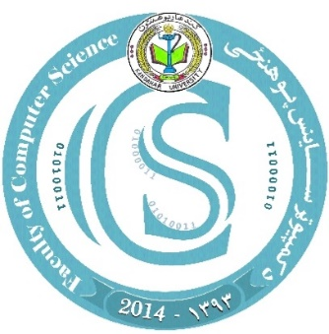 Kandahar University

Faculty of Computer Science

Second Year

Shape Creator

Prepared by Group A: - Farid Gull Shakir, Mirwais Hemet, Nasibullah Burhan, Muhammad Mohammadi, Aminullah Yousufi

Teacher: - Naveed Ahmad Himatmal

Year: - 2022-11-24

بسم الله الرحمن الرحیم

Shape:

Shape is collations of angles and edges. For example, Tringle, Rectangle and more.

Shape creator:

Is a project in python by which we can draw different type of shapes such as circle, tringle and more

Libraries Which used in this project are:

1. Numpy: by Numpy we can import matrices in our project.
2. Matplotlib: is for draw shapes, graphs, plots and more in our project
3. import matplotlib.pyplot as plt
4. import numpy as np

our build in functions in my project :

def draw_line function:

This function is for drawing just one line.

the python language syntax is that you will write def keyword to define a function

x and y is our parameters

plt.plot is used to plot the line

plt.show is used to give a collar to the line

def draw_line():

    x = np.linspace(0, 10, 100)

    y =  x + 1

    plt.plot(x, y, color='red')  # Red color

    plt.show()

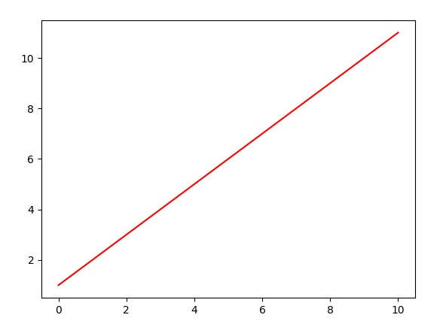

def draw parallel_lines function:

we can use this function for drawing parallel lines.

In this function the y1 and y2 are also the parameters,

the “ colour = to green” give the colour into the lines

def draw_parallel_lines():

    x = np.linspace(0, 10, 100)

    y1 = 2 * x + 1

    y2 = 2 * x + 3

    plt.plot(x, y1, label='y = 2x + 1', color='green')  # Green color

    plt.plot(x, y2, label='y = 2x + 3', color='blue')  # Blue color

    plt.legend()

    plt.show()

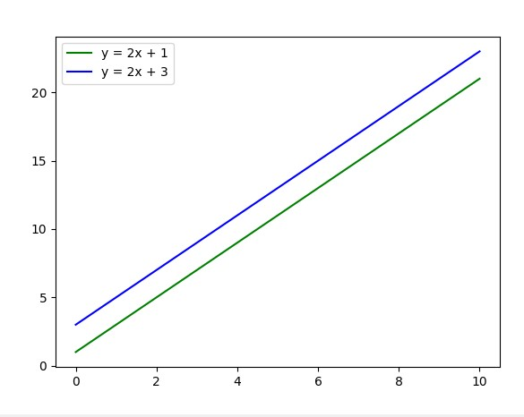

Def draw_tringle function:

This function is for drawing tringle and give colour to the triangle

def draw_triangle():

    x = [1, 3, 2, 1]

    y = [1, 1, 3, 1]

    plt.fill(x, y, color='yellow')  # Yellow color

    plt.show()

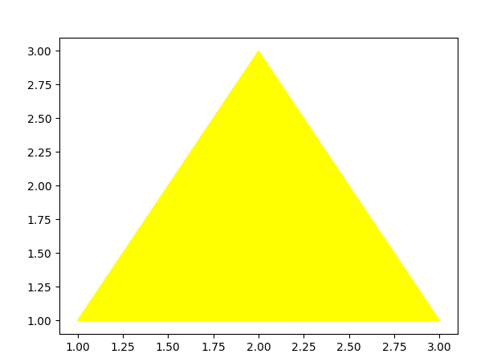

Def draw_rectangle function:

By this function we can draw rectangle and give a specific colour to the rectangle.

def draw_rectangle():

    x = [1, 3, 3, 1, 1]

    y = [1, 1, 3, 3, 1]

    plt.fill(x, y, color='cyan')  # Cyan color

    plt.show()

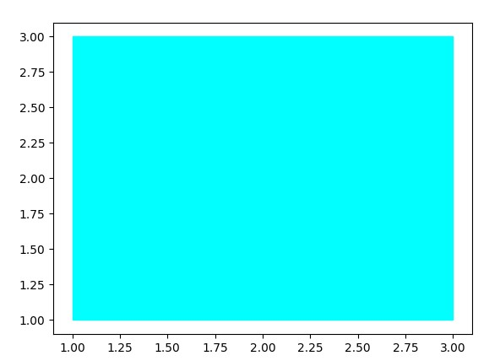

def draw_polygen function:

this function is for drawing polygens like pentagon Hexagon and more.

5 for pentagon

6 for hexagon

And so on….

And give a colour to it.

def draw_polygon(num_sides):

    angles = np.linspace(0, 2*np.pi, num_sides+1)

    x = np.cos(angles)

    y = np.sin(angles)

    plt.fill(x, y, color='magenta')  # Magenta color

    plt.gca().set_aspect('equal', adjustable='box')

    plt.show()

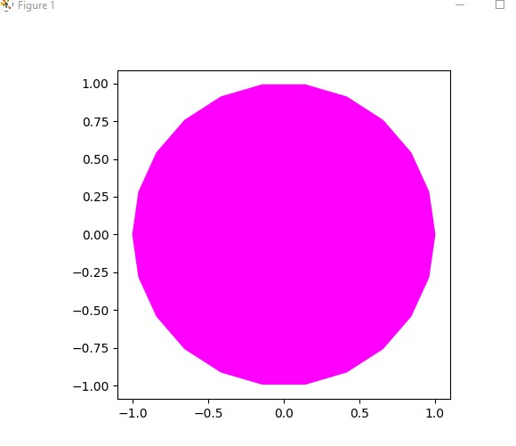

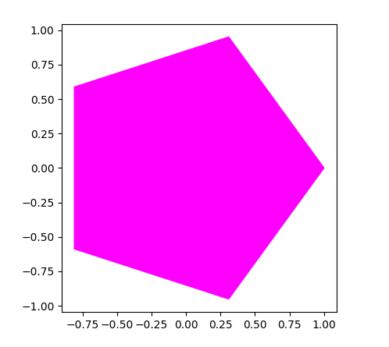

Def daw_circle function:

we make this function for drawing a circle, it require the count of dots of circle and reduce of circle it will print a circle that have a colour and reduce

def draw_circle(radius):

    angles = np.linspace(0, 2*np.pi, 100)

    x = radius * np.cos(angles)

    y = radius * np.sin(angles)

    plt.fill(x, y, color='black')  # Black color

    plt.gca().set_aspect('equal', adjustable='box')

    plt.show()

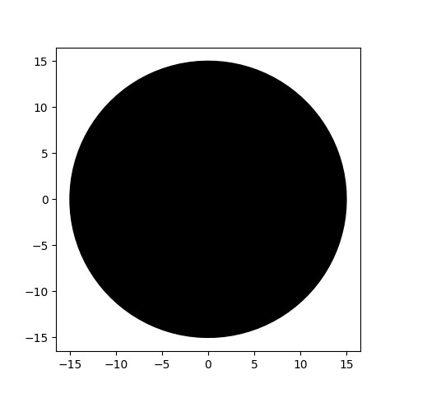

Main Function

And finally we called all the functions that we create in the main function we def a function by name main and then we call the main in the python main method

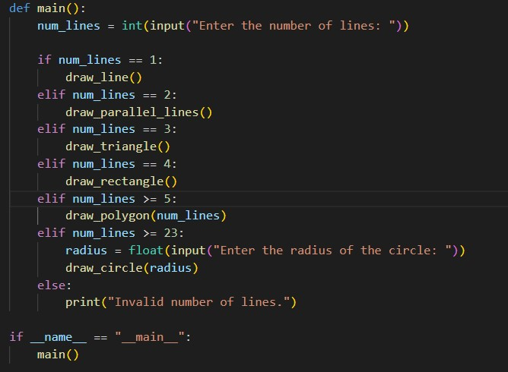

د استاد نوید احمد همتمل صاحب په لارښوونه

د ګروپ لیډر : فرید ګل “شاکر”

دګروپ ملکري :

نوم : پلار نوم

فریدګل زمین ګل

نصیب الله محمد شریف

امین الله روح الله

محمد عبدالباري

میرویس عبدالظاهر