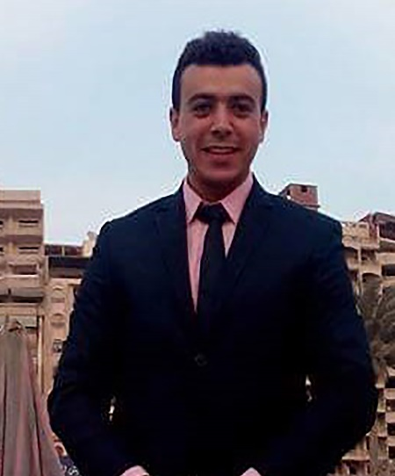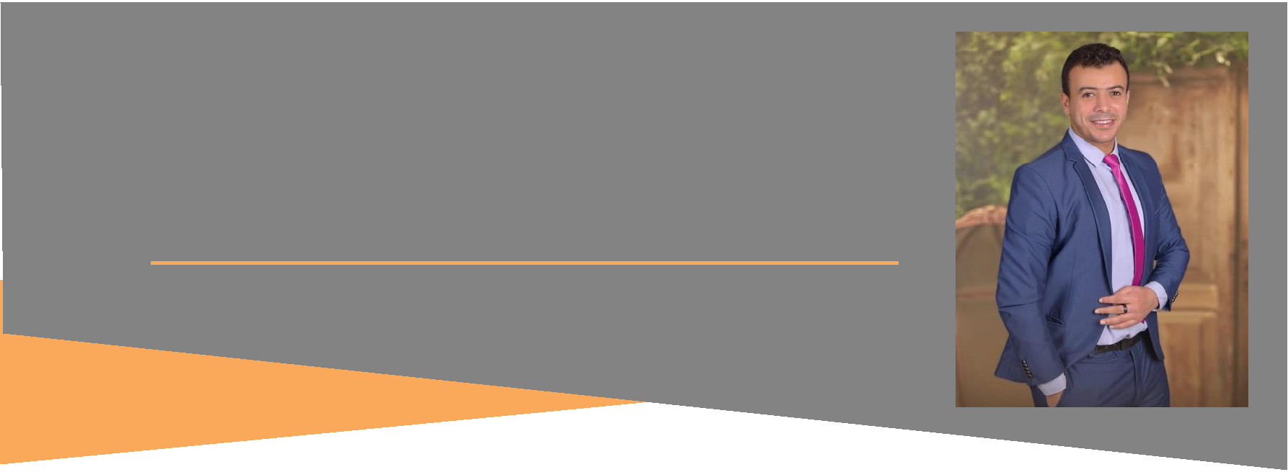

FARID NEGM

Web Developer & Web Designer

CAREER OBJECTIVE

I am willing to work and do unique roles in order to keep abreast of new developments in the field of programming and web design that will help develop myself and the company

ACADEMIC BACKGROUND

BACHELOR DEGREE

BS- Faculty of Physical Education. University of **El-Mansoura**



• Graduated at 2013

COURSES



1- Web Design 2- Web Development

4- Graphic Design Basics 3- Self Study – Oop – Laravel

– React Js

– Vue Js

– WordPress

NEXT PLAN

* Completing ReactJ JS With Laravel.
* and learning node.js to develop web app from server side.
* and Completing wordpress to Create a blog in few minutes , As well as create of educational sites and social networks ……

MY WORKS

* [*http://zwdwebsite.000webhostapp.com/zwd*](http://zwdwebsite.000webhostapp.com/zwd)
* *https://faridnegm.000webhostapp.com/realestate*
* *http://masralarabya.com*
* [http://zwdwebsite.000webhostapp.com/portfolio/](http://zwdwebsite.000webhostapp.com/portfolio/?fbclid=IwAR02BWvKTS10SDKw-D2eSD77S53OmYRMF-LxRfG_Si3g2SNb5SWxrUZne44)

My Portfolio

INTERESTS



ABOUT ME

Date of Birth: July 27, 1991

Age: 27

Gender: Male

Birth of Place: El-mansoura

Height: 1.72 cm



010.1277.5704 & 011.1790.3055

 Egypt – Cairo – El-mokatem City

 faridnegm44@gmail.com

SKILLS

**Html Css**

**Css3 Java Script**

**Jquery Bootstrap**

**Php Mysql Pdo**

**Oop Laravel**

**React.js** Basics **Vue.js** Basics

**Wordpress** Basics

**Photoshop** Basics

LANGUAGES



**Arabic**

**English**

