## horizontal line

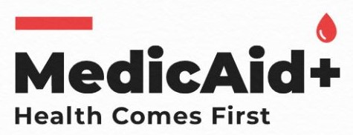

Project Report

MedicAid+

Submitted By

Farida Yeasmin Mim (1911653642)

Kazi Ramisa Rifa (1911019642)

Zarin Tasnim (1831423642)

Course: CSE327.4

Date: 28 May, 2021

**Table of Contents** **2**

**Tables** **2**

**Introduction**

About Health Line

Purpose and benefits of Health Line

**Requirements** **2**

Functional Requirements

Non-functional Requirements

Elicitation Technique

**User Story**

Use case 1:

Use case2:

Use case 3:

**Solution Description**

* Front-End Plan:
* Back-End plan:

**Advantages:**

**Screenshots of Project:**

**Conclusion:**

# Table of Contents

# Tables

# Introduction

1. About Health Line
2. Purpose and benefits of Health Line

# Requirements

## **Functional Requirements**

1. **Non-functional Requirements**
2. **Elicitation Technique**

**User Story**

**Use case 1:**

**Use case2:**

**Use case 3:**

**Solution Description**

* **Front-End Plan:**
* **Back-End plan:**

**Advantages:**

**Screenshots of Project:**

**Conclusion:**