Mega lab

ccna

## **Network Engineer:- Farida Ahmed Mahmoud**

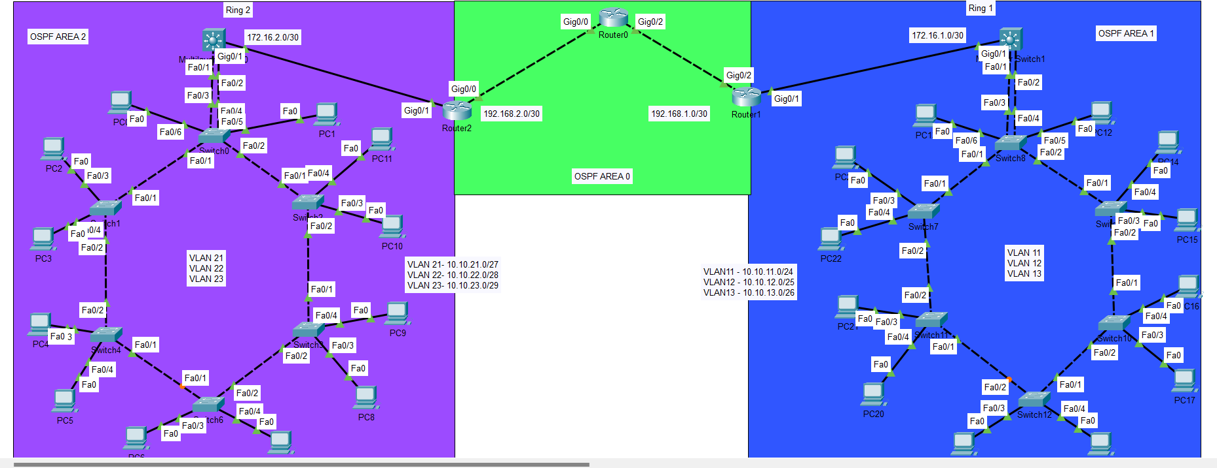**Network Topology:-**

**Topics used in the network :-**

**1-Ring topology 7-ABR**

**2-VLANS 8-Port Channel**

**2-INTER-VLAN 9-PVST**

**3-DHCP 10-SVI**

**4-DHCP-Relay**

**5-OSPF**

**6-MultiLayer-OSPF**

***Configurations network.[RING 1]***

|  |  |  |
| --- | --- | --- |
| ***department*** | ***Network*** | ***VLAN*** |
| ***Customer11*** | ***10.10.11.0/24*** | ***VLAN 11*** |
| ***Customer12*** | ***10.10.12.0/25*** | ***VLAN 12*** |
| ***Customer13*** | ***10.10.13.0/26*** | ***VLAN 13*** |

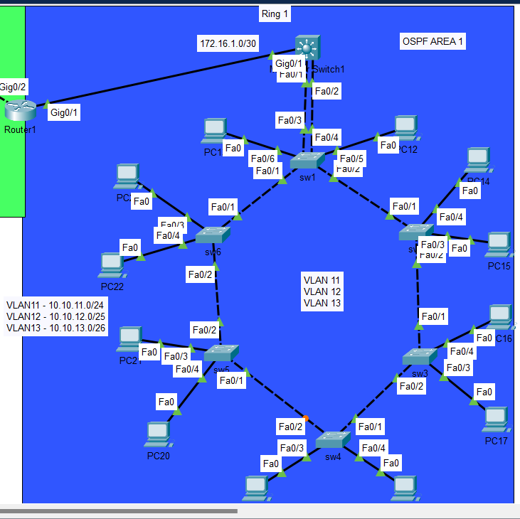

Create VLANs and operate protocol turnk in all switches

**Ring1-SW1**

Ring1-SW1(Config)#vlan 11

Ring1-SW1 (config-vlan)#name Customer11

Ring1-SW1config-vlan)#vlan 12

Ring1-SW1 (config-vlan)# name Customer12

Ring1-SW1 (config-vlan)#vlan 13

Ring1-SW1 (config-vlan)# name Customer13

* PVST ( Ring1-SW1 is root all vlans) & LACP

Ring1-SW1(Config)#spanning-tree vlan 11 root primary

Ring1-SW1(Config)#spanning-tree vlan 12 root primary

Ring1-SW1(Config)#spanning-tree vlan 13 root primary

Ring1-SW1(Config)#spanning-tree vlan 1 root primary

Ring1-SW1(Config)#int range f 0/3-4

Ring1-SW1(Config-if-range)# channel-group 1 mode active

* Port access/trunk – acc vlan 11

Ring1-SW1(Config)#int range f 0/5-6

Ring1-SW1(Config-if-range)#switchport mode access

Ring1-SW1(Config-if-range)#switchport access vlan 11

Ring1-SW1(Config-if-range)#exit

Ring1-SW1(Config)#int range f 0/1-2

Ring1-SW1(Config-if-range)#switchport mode trunk

* Port channel (trunk)

Ring1-SW1(config)#int port-channel 1

Ring1-SW1(Config-if)#switchport mode trunk

**Ring1-SW2**

Ring1-SW2(Config)#vlan 11

Ring1-SW2 (config-vlan)#name Customer11

Ring1-SW2 (config-vlan)#vlan 12

Ring1-SW2 (config-vlan)# name Customer12

Ring1-SW2 (config-vlan)#vlan 13

Ring1-SW2 (config-vlan)# name Customer13

* Port access/trunk – acc vlan 11

Ring1-SW2(Config)#int range f 0/3-4

Ring1-SW2(Config-if-range)#switchport mode access

Ring1-SW2(Config-if-range)#switchport access vlan 11

Ring1-SW2(Config-if-range)#exit

**Ring1-SW3**

Ring1-SW3(Config)#vlan 11

Ring1-SW3 (config-vlan)#name Customer11

Ring1-SW3 (config-vlan)#vlan 12

Ring1-SW3 (config-vlan)# name Customer12

Ring1-SW3 (config-vlan)#vlan 13

Ring1-SW3 (config-vlan)# name Customer13

* Port access/trunk – acc vlan 12

Ring1-SW3(Config)#int range f 0/3-4

Ring1-SW3(Config-if-range)#switchport mode access

Ring1-SW3(Config-if-range)#switchport access vlan 12

Ring1-SW3(Config-if-range)#exit

Ring1-SW3(Config)#int range f 0/1-2

Ring1-SW3(Config-if-range)#switchport mode trunk

**Ring1-SW4**

Ring1-SW4(Config)#vlan 11

Ring1-SW4 (config-vlan)#name Customer11

Ring1-SW4 (config-vlan)#vlan 12

Ring1-SW4 (config-vlan)# name Customer12

Ring1-SW4 (config-vlan)#vlan 13

Ring1-SW4 (config-vlan)# name Customer13

* Port access/trunk – acc vlan 12

Ring1-SW4(Config)#int range f 0/3-4

Ring1-SW4(Config-if-range)#switchport mode access

Ring1-SW4(Config-if-range)#switchport access vlan 12

Ring1-SW4(Config-if-range)#exit

**Ring1-SW5**

Ring1-SW5(Config)#vlan 11

Ring1-SW5 (config-vlan)#name Customer11

Ring1-SW5 (config-vlan)#vlan 12

Ring1-SW5 (config-vlan)# name Customer12

Ring1-SW5 (config-vlan)#vlan 13

Ring1-SW5 (config-vlan)# name Customer13

* Port access/trunk – acc vlan 13

Ring1-SW5(Config)#int range f 0/3-4

Ring1-SW5(Config-if-range)#switchport mode access

Ring1-SW5(Config-if-range)#switchport access vlan 13

Ring1-SW5(Config-if-range)#exit

Ring1-SW5(Config)#int range f 0/1-2

Ring1-SW5(Config-if-range)#switchport mode trunk

**Ring1-SW6**

Ring1-SW6(Config)#vlan 11

Ring1-SW6 (config-vlan)#name Customer11

Ring1-SW6 (config-vlan)#vlan 12

Ring1-SW6 (config-vlan)# name Customer12

Ring1-SW6 (config-vlan)#vlan 13

Ring1-SW6 (config-vlan)# name Customer13

* Port access/trunk – acc vlan 13

Ring1-SW6(Config)#int range f 0/3-4

Ring1-SW6(Config-if-range)#switchport mode access

Ring1-SW6(Config-if-range)#switchport access vlan 13

Ring1-SW6(Config-if-range)#exit

**Multilayer SW**

MLS-Ring1(Config)#vlan 11

MLS-Ring1 (config-vlan)#name Customer11

MLS-Ring1config-vlan)#vlan 12

MLS-Ring1 (config-vlan)# name Customer12

MLS-Ring1 (config-vlan)#vlan 13

* LACP

MLS-Ring1 (Config)#int range f 0/1-2

MLS-Ring1 (Config-if-range)# channel-group 1 mode active

* INTER-VLAN

MLS-Ring1 (Config)#ip routing

MLS-Ring1 (Config)#int vlan 11

MLS-Ring1 (Config-if)#no shutdown

MLS-Ring1 (Config-if)#description GW-VL-11

MLS-Ring1 (Config-if)#ip address 10.10.11.1 255.255.255.0

MLS-Ring1 (Config-if)#exit

MLS-Ring1 (Config)#int vlan 12

MLS-Ring1 (Config-if)#no shutdown

MLS-Ring1 (Config-if)#description GW-VL-12

MLS-Ring1 (Config-if)#ip address 10.10.12.1 255.255.255.128

MLS-Ring1 (Config-if)#exit

MLS-Ring1 (Config)#int vlan 13

MLS-Ring1 (Config-if)#no shutdown

MLS-Ring1 (Config-if)#description GW-VL-13

MLS-Ring1 (Config-if)#ip address 10.10.13.1 255.255.255.192

MLS-Ring1 (Config-if)#exit

* DHCP

MLS-Ring1 (Config)# ip dhcp pool Ring1-VL11

MLS-Ring1 (dhcp-Config)# network 10.10.11.0 255.255.255.252

MLS-Ring1 (dhcp-Config)# default-router 10.10.11.1

MLS-Ring1 (dhcp-Config)# dns-server 1.1.1.1

MLS-Ring1 (dhcp-Config)# exit

MLS-Ring1 (Config)# ip dhcp pool Ring1-VL12

MLS-Ring1 (dhcp-Config)# network 10.10.12.0 255.255.255.128

MLS-Ring1 (dhcp-Config)# default-router 10.10.12.1

MLS-Ring1 (dhcp-Config)#dns-server 1.1.1.1

MLS-Ring1 (dhcp-Config)#exit

MLS-Ring1 (Config)# ip dhcp pool Ring1-VL13

MLS-Ring1 (dhcp-Config)# network 10.10.13.0 255.255.255.192

MLS-Ring1 (dhcp-Config)# default-router 10.10.13.1

MLS-Ring1 (dhcp-Config)#dns-server 1.1.1.1

MLS-Ring1 (dhcp-Config)#exit

MLS-Ring1 (Config)# ip dhcp excluded-address 10.10.11.1

MLS-Ring1 (Config)# ip dhcp excluded-address 10.10.12.1

MLS-Ring1 (Config)# ip dhcp excluded-address 10.10.13.1

* DHCP-Relay

MLS-Ring1 (Config)# ip dhcp pool Ring1-VL21

MLS-Ring1 (dhcp-Config)# network 10.10.21.0 255.255.255.224

MLS-Ring1 (dhcp-Config)# default-router 10.10.21.1

MLS-Ring1 (dhcp-Config)# dns-server 1.1.1.1

MLS-Ring1 (dhcp-Config)# exit

MLS-Ring1 (Config)# ip dhcp pool Ring1-VL22

MLS-Ring1 (dhcp-Config)# network 10.10.22.0 255.255.255.240

MLS-Ring1 (dhcp-Config)# default-router 10.10.22.1

MLS-Ring1 (dhcp-Config)#dns-server 1.1.1.1

MLS-Ring1 (dhcp-Config)#exit

MLS-Ring1 (Config)# ip dhcp pool Ring1-VL23

MLS-Ring1 (dhcp-Config)# network 10.10.23.0 255.255.255.248

MLS-Ring1 (dhcp-Config)# default-router 10.10.23.1

MLS-Ring1 (dhcp-Config)#dns-server 1.1.1.1

MLS-Ring1 (dhcp-Config)#exit

MLS-Ring1 (Config)# ip dhcp excluded-address 10.10.21.1

MLS-Ring1 (Config)# ip dhcp excluded-address 10.10.22.1

MLS-Ring1 (Config)# ip dhcp excluded-address 10.10.23.1

* Port channel (trunk)

MLS-Ring1 (Config-if)#switchport trunk encapsulation dot1q

MLS-Ring1 (Config-if)#switchport mode trunk

* Ip interfaces

MLS-Ring1 (Config)# int gig 0/1

MLS-Ring1 (Config-if)#no switchport

MLS-Ring1 (Config-if)# ip add 172.16.1.1 255.255.255.252

* OSPF

MLS-Ring1 (Config)# router ospf 1

MLS-Ring1 (Config-router)# network 10.10.11.0 0.0.0.255 area 1

MLS-Ring1 (Config-router)# network 10.10.12.0 0.0.0.127 area 1

MLS-Ring1 (Config-router)# network 10.10.13.0 0.0.0.63 area 1

MLS-Ring1 (Config-router)# network 172.16.1.0 0.0.0.3 area 1

**3 Routers Used**

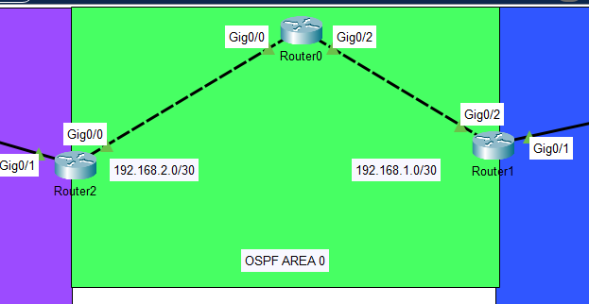

**ROUTER 1 [Ring 1]**

ABR1 (config )# int gig 0/1

ABR1 (config -if)# ip add 172.16.1.2 255.255.255.252

ABR1 (config -if)# no shutdown

ABR1 (config -if)# exit

ABR1 (config )# int gig 0/2

ABR1 (config -if)# ip add 192.168.1.2 255.255.255.252

ABR1 (config -if)# no shutdown

ABR1 (config -if)# exit

* OSPF

ABR1 (config )# router ospf 1

ABR1 (config - router)# network 172.16.1.0 0.0.0.3 area 1

ABR1 (config - router)# network 192.168.1.0 0.0.0.3 area 0

**ROUTER 0 [ CORE ]**

Core-Router(config)# int gig 0/2

Core-Router(config-if)# ip add 192.168.1.1 255.255.255.252

Core-Router(config-if)#no shutdown

Core-Router(config-if)#exit

Core-Router(config)# int gig 0/0

Core-Router(config-if)# ip add 192.168.2.1 255.255.255.252

Core-Router(config-if)#no shutdown

Core-Router(config-if)#exit

* OSPF

Core-Router (config )# router ospf 1

Core-Router (config - router)# network 192.168.1.0 0.0.0.3 area 0

Core-Router (config - router)# network 192.168.2.0 0.0.0.3 area 0

**ROUTER 2 [Ring 2]**

ABR2 (config )# int gig 0/0

ABR2 (config -if)# ip add 192.168.2.2 255.255.255.252

ABR2 (config -if)# no shutdown

ABR2 (config -if)# exit

ABR2 (config )# int gig 0/1

ABR2 (config -if)# ip add 172.16.2.2 255.255.255.252

ABR2 (config -if)# no shutdown

ABR2 (config -if)# exit

* OSPF

ABR2 (config )# router ospf 1

ABR2 (config - router)# network 172.16.2.0 0.0.0.3 area 2

ABR2 (config - router)# network 192.168.2.0 0.0.0.3 area 0

***Configurations network.[ RING 2 ]***

|  |  |  |
| --- | --- | --- |
| ***department*** | ***Network*** | ***VLAN*** |
| ***Customer21*** | ***10.10.21.0/27*** | ***VLAN 21*** |
| ***Customer22*** | ***10.10.22.0/28*** | ***VLAN 22*** |
| ***Customer23*** | ***10.10.23.0/29*** | ***VLAN 23*** |

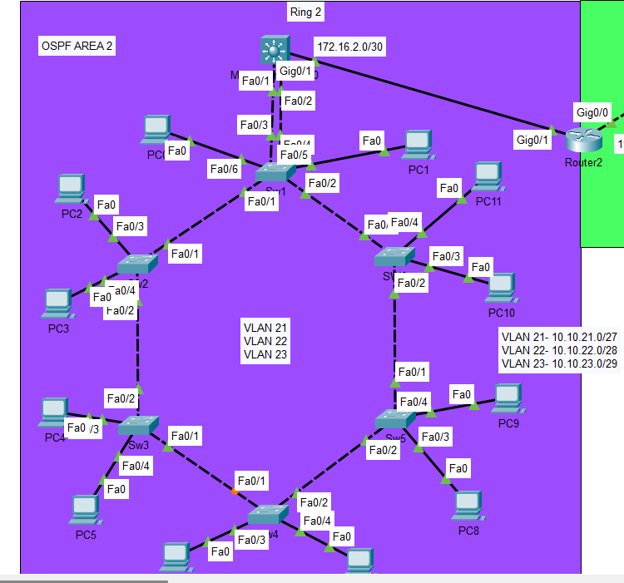

Create VLANs and operate protocol turnk in all switches

**Ring2-SW1**

Ring2-SW1(Config)#vlan 21

Ring2-SW1 (config-vlan)#name Customer21

Ring2-SW1config-vlan)#vlan 22

Ring2-SW1 (config-vlan)# name Customer22

Ring2-SW1 (config-vlan)#vlan 23

Ring2-SW1 (config-vlan)# name Customer23

* PVST ( Ring1-SW1 is root all vlans) & LACP

Ring2-SW1(Config)#spanning-tree vlan 11 root primary

Ring2-SW1(Config)#spanning-tree vlan 12 root primary

Ring2-SW1(Config)#spanning-tree vlan 13 root primary

Ring2-SW1(Config)#spanning-tree vlan 1 root primary

Ring2-SW1(Config)#int range f 0/3-4

Ring2-SW1(Config-if-range)# channel-group 1 mode active

* Port access/trunk – acc vlan 21

Ring2-SW1(Config)#int range f 0/5-6

Ring2-SW1(Config-if-range)#switchport mode access

Ring2-SW1(Config-if-range)#switchport access vlan 21

Ring2-SW1(Config-if-range)#exit

Ring2-SW1(Config)#int range f 0/1-2

Ring2-SW1(Config-if-range)#switchport mode trunk

* Port channel (trunk)

Ring2-SW1(config)#int port-channel 1

Ring2-SW1(Config-if)#switchport mode trunk

**Ring2-SW2**

Ring2-SW2(Config)#vlan 21

Ring2-SW2 (config-vlan)#name Customer21

Ring2-SW2 (config-vlan)#vlan 22

Ring2-SW2 (config-vlan)# name Customer22

Ring2-SW2 (config-vlan)#vlan 23

Ring2-SW2 (config-vlan)# name Customer23

* Port access/trunk – acc vlan 21

Ring2-SW2(Config)#int range f 0/3-4

Ring2-SW2(Config-if-range)#switchport mode access

Ring2-SW2(Config-if-range)#switchport access vlan 21

Ring2-SW2(Config-if-range)#exit

**Ring2-SW3**

Ring2-SW3(Config)#vlan 21

Ring2-SW3 (config-vlan)#name Customer21

Ring2-SW3 (config-vlan)#vlan 22

Ring2-SW3 (config-vlan)# name Customer22

Ring2-SW3 (config-vlan)#vlan 23

Ring2-SW3 (config-vlan)# name Customer23

* Port access/trunk – acc vlan 22

Ring2-SW3(Config)#int range f 0/3-4

Ring2-SW3(Config-if-range)#switchport mode access

Ring2-SW3(Config-if-range)#switchport access vlan 22

Ring2-SW3(Config-if-range)#exit

Ring2-SW3(Config)#int range f 0/1-2

Ring2-SW3(Config-if-range)#switchport mode trunk

**Ring2-SW4**

Ring2-SW4(Config)#vlan 21

Ring2-SW4 (config-vlan)#name Customer21

Ring2-SW4 (config-vlan)#vlan 22

Ring2-SW4 (config-vlan)# name Customer22

Ring2-SW4 (config-vlan)#vlan 23

Ring2-SW4 (config-vlan)# name Customer23

* Port access/trunk – acc vlan 22

Ring2-SW4(Config)#int range f 0/3-4

Ring2-SW4(Config-if-range)#switchport mode access

Ring2-SW4(Config-if-range)#switchport access vlan 22

Ring2-SW4(Config-if-range)#exit

**Ring2-SW5**

Ring2-SW5(Config)#vlan 21

Ring2-SW5 (config-vlan)#name Customer21

Ring2-SW5 (config-vlan)#vlan 22

Ring2-SW5 (config-vlan)# name Customer22

Ring2-SW5 (config-vlan)#vlan 23

Ring2-SW5 (config-vlan)# name Customer23

* Port access/trunk – acc vlan 23

Ring2-SW5(Config)#int range f 0/3-4

Ring2-SW5(Config-if-range)#switchport mode access

Ring2-SW5(Config-if-range)#switchport access vlan 23

Ring2-SW5(Config-if-range)#exit

Ring2-SW5(Config)#int range f 0/1-2

Ring2-SW5(Config-if-range)#switchport mode trunk

**Ring2-SW6**

Ring2-SW6(Config)#vlan 21

Ring2-SW6 (config-vlan)#name Customer21

Ring2-SW6 (config-vlan)#vlan 22

Ring2-SW6 (config-vlan)# name Customer22

Ring2-SW6 (config-vlan)#vlan 23

Ring2-SW6 (config-vlan)# name Customer23

* Port access/trunk – acc vlan 23

Ring2-SW6(Config)#int range f 0/3-4

Ring2-SW6(Config-if-range)#switchport mode access

Ring2-SW6(Config-if-range)#switchport access vlan 23

Ring2-SW6(Config-if-range)#exit

**Multilayer SW2**

MLS-Ring2(Config)#vlan 21

MLS-Ring2 (config-vlan)#name Customer21

MLS-Ring2config-vlan)#vlan 22

MLS-Ring2 (config-vlan)# name Customer22

MLS-Ring2 (config-vlan)#vlan 23

* LACP

MLS-Ring2 (Config)#int range f 0/1-2

MLS-Ring2 (Config-if-range)# channel-group 1 mode active

* INTER-VLAN

MLS-Ring2 (Config)#ip routing

MLS-Ring2 (Config)#int vlan 21

MLS-Ring2 (Config-if)#no shutdown

MLS-Ring2 (Config-if)#description GW-VL-21

MLS-Ring2 (Config-if)#ip address 10.10.21.1 255.255.255.224

MLS-Ring2 (Config-if)#exit

MLS-Ring2 (Config)#int vlan 22

MLS-Ring2 (Config-if)#no shutdown

MLS-Ring2 (Config-if)#description GW-VL-22

MLS-Ring2 (Config-if)#ip address 10.10.22.1 255.255.255.240

MLS-Ring2 (Config-if)#exit

MLS-Ring2 (Config)#int vlan 23

MLS-Ring2 (Config-if)#no shutdown

MLS-Ring2 (Config-if)#description GW-VL-23

MLS-Ring2 (Config-if)#ip address 10.10.23.1 255.255.255.248

MLS-Ring2 (Config-if)#exit

* **Port channel (trunk)**

MLS-Ring2 (Config-if)#switchport trunk encapsulation dot1q

MLS-Ring2 (Config-if)#switchport mode trunk

* **Ip interfaces**

MLS-Ring2 (Config)# int gig 0/1

MLS-Ring2 (Config-if)#no switchport

MLS-Ring2 (Config-if)# ip add 172.16.2.1 255.255.255.252

* **OSPF**

MLS-Ring2 (Config)# router ospf 1

MLS-Ring2 (Config-router)# network 172.16.2.0 0.0.0.3 area 2

MLS-Ring2 (Config-router)# network 10.10.21.0 0.0.0.31 area 2

MLS-Ring2 (Config-router)# network 10.10.22.0 0.0.0.15 area 2

MLS-Ring2 (Config-router)# network 10.10.23.0 0.0.0.7 area 2

MLS-Ring2 (Config-router)# end

MLS-Ring2 (Config)# int vlan 21

MLS-Ring2 (Config-if)# ip helper-address 172.16.1.1

MLS-Ring2 (Config-if)# exit

MLS-Ring2 (Config)# int vlan 22

MLS-Ring2 (Config-if)# ip helper-address 172.16.1.1

MLS-Ring2 (Config-if)# exit

MLS-Ring2 (Config)# int vlan 23

MLS-Ring2 (Config-if)# ip helper-address 172.16.1.1

MLS-Ring2 (Config-if)# end

**Testing**

*Operate dhcp all departments [in two Ring]

1-Ring 1:-

* Customer11 network 10.10.11.0/24

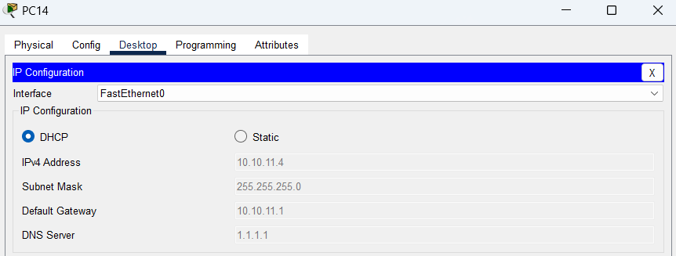

* Customer12 network 10.10.12.0/25

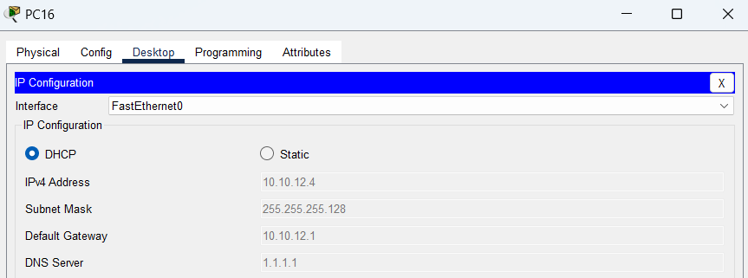

* Customer13 network 10.10.13.0/26

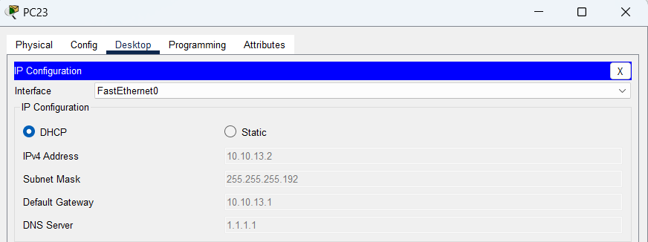

1-Ring 2:-

* Customer21 network 10.10.21.0/27

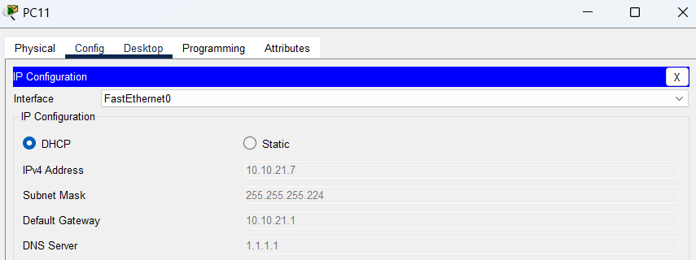

* Customer22 network 10.10.22.0/28

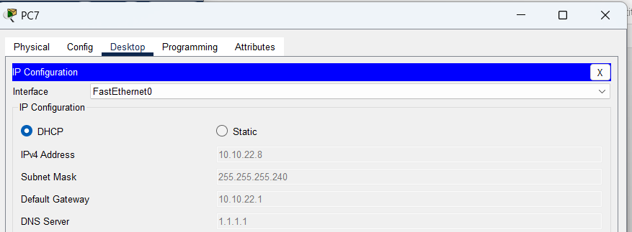

* Customer23 network 10.10.23.0/29

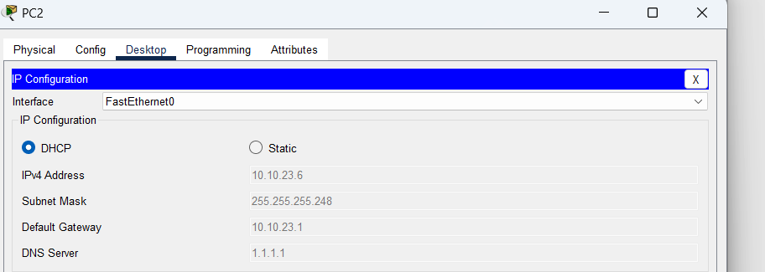

* Ping From PC14[Ring1] to PC11[Ring 2]

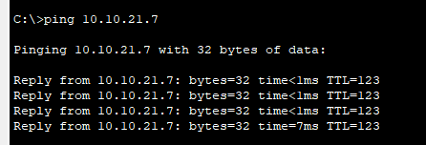

* Ping From PC2[Ring2] to PC23[Ring 1]

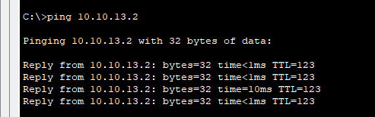

***THANK YOU***