**Faculty Of Engineering**

**Alexandria University**

**Programming I**

**Tele-Phone Book Project**

**By:-**

**Ahmed Mohamed El-Halawany**

**2689**

**Farida Adham Abd El-Hady**

**2616**

**1-Project Description :-**

A telephone book (also called a telephone directory and phone book) is a listing of telephone subscribers in a geographical area or subscribers to services provided by the organization that publishes the directory. It consists of the name-last and first , the address , city and the telephone number of people added as contact in the directory. All the data of all the contacts are displayed in alphabetical order.

The main objective of this project is to load , query , add , delete , modify , print and save various contacts.

2-Program Design :-

* **Program Structure ( Functions included in the program ) :-**

1. void start()
2. void commands( int c )
3. void load()
4. void query()
5. void add()
6. void del()
7. void modify()
8. void print()
9. void save()

10. void main()

* **What each function do !! :-**
* **void start()**

It is a function that displays the main menu of the program to allow the user to choose from the different commands which one to execute.

* **void commands( int c )**

It is a function that takes from the user the number of the chosen command and by switch cases function it call the functions according to the number of each function in the main menu.

* **void load()**

It is a function that reads and loads the phone directory from the file.

* **void query()**

It is a function that allows the user to search for a contact in the phone directory by entering the last name of the contact then by using linear search it will provide the user with a list having all the data for all contacts of that last name.

* **void add()**

It is a function that allows the user to add a new contact to the phone directory.

* **void del()**

It is a function that allows the user to delete a contact from the phone directory by entering the last name and the first name of the contact then it will provide the user with a list having all the data for all contacts of that last name and first name and let the user choose which contact he want to delete then it deletes it from the phone directory.

* **void modify()**

It is a function that allows the user to edit a contact in the directory by entering the last name of the contact then it will provide the user with a list having all the data for all contacts of that last name and let the user choose which contact he want to edit then it edits it in the phone directory.

* **void print()**

It is a function that prints the entire phone directory in alphabetical order using bubble sort according to last name the first name then phone number then address then city and it allows the user to see the list of all contacts in the phone directory.

* **void save()**

It is a function that saves the entire modified phone directory by writing it out on an external file.

* **void main()**

1. By using : system("COLOR 1E");

The color of the desktop changes to BLUE and the font color changes to LIGHT YELLOW.

1. By using : start();

The main menu will appear to the user to make him choose from different commands according to the number he will enter :-

1-Load 2-Query

3-Add 4-Delete

5-Modify 6-Print

7-Save 8-Exit

1. After the user enter the number of his choice from the main menu , This number will pass by a while loop to repeat the commands by using commands(cn);

Which take this number and execute the commands having this number.

1. This step will repeat until the user enters number ‘8’ which will end the program without saving.

3-Algorithms And Decisions :-

* **Linear Search :-**
* **Flow Chart :-**

i=1

(a1,a2,……,an : array of contacts)

( b : contact )

Print ai

i=i+1

**ai=b**

i<n

False

True

True

**Stop**

False

* **Bubble Sort :-**
* **Flow Chart :-**

(a1,a2,……,an : array of contacts)

(b : contact)

j<n

i<n

i=1 , j=1

j=j+1



True



True

aj+1>aj

True

b=aj

aj=aj+1

aj+1=b

**4-Features:-**

**Stop**

**Stop**

i=i+1

* **Change Colors :-**

**By using this function---> system(“COLOR FC”);**

**F : code for the color of the desktop.**

**C : code for the font color.**

**Color Codes:**

**0 = Black 8 = Gray**

**1 = Blue 9 = Light Blue**

**2 = Green A = Light Green**

**3 = Aqua B = Light Aqua**

**4 = Red C = Light Red**

**5 = Purple D = Light Purple**

**6 = Yellow E = Light Yellow**

**7 = White F = Bright White**

**5-Sample Run :-**

* **Start Function :-**

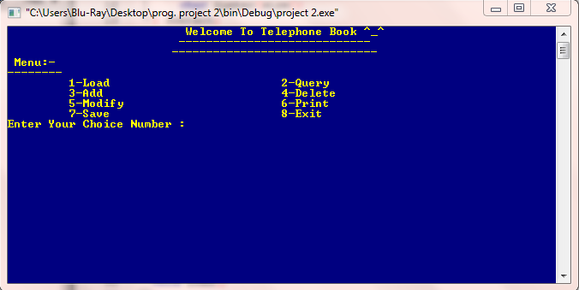

* **Load Function :-**

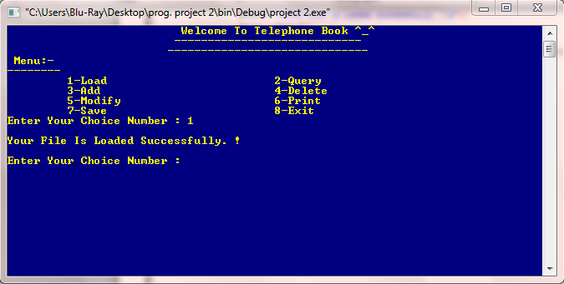

* **Query Function :-**

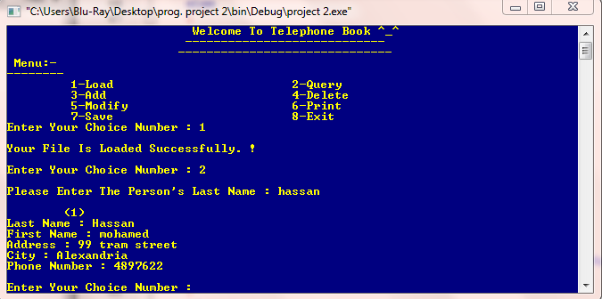

* **Add Function :-**

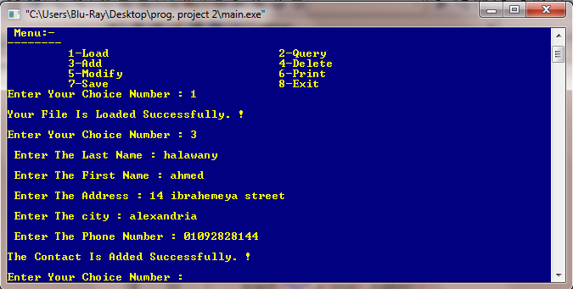

* **Delete Function :-**

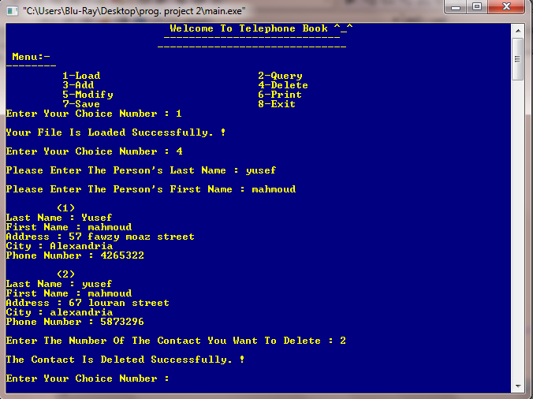

* **Modify Function :-**

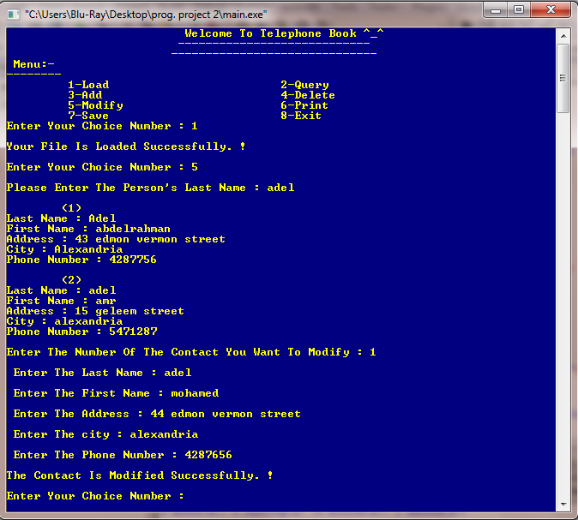

* **Print Function :-**

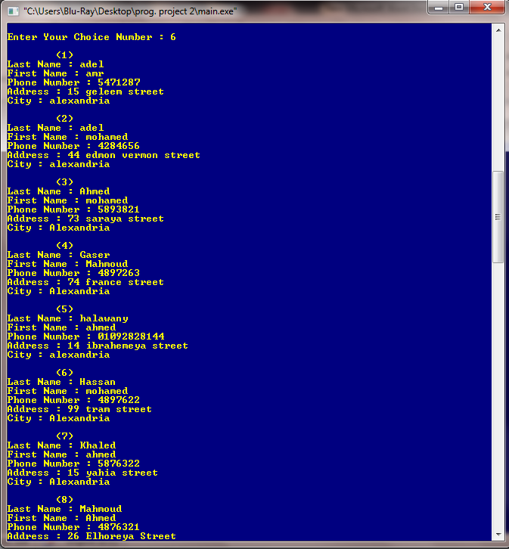

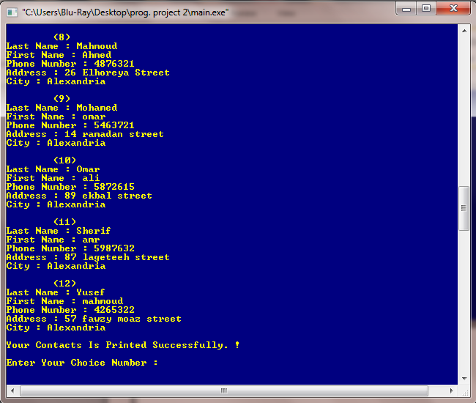

* **Save Function :-**

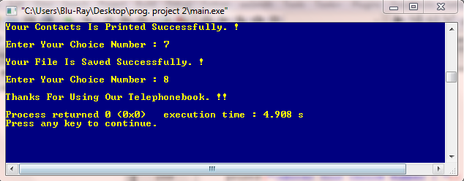

**6-User Guide :-**

* **Load the phone directory from the file :-**

1. Press 1 then enter.
2. A message will appear telling you that your file have been loaded.
3. You will return to main menu.

**\*\* You must load the contacts from the file every time you open the program. \*\***

* **Query for a contact :-**

1. Press 2 then enter.
2. A message will appear telling you to enter the person’s last name you want to look up to.
3. Press enter.
4. The screen (system) will show you a list of all the data for all the users of that last name.
5. You will return to main menu.

* **Add a new contact :-**

1. Press 3 then enter.
2. The screen (system) will require you to enter the information ( last name , first name , address , city , phone number ) of the contact you want to add to the directory.
3. Press enter.
4. A message will appear telling you that your contact has been added.
5. You will return to main menu.

* **Delete a contact :-**

1. Press 4 then enter.
2. The screen (system) will require you to enter the information ( last name & first name) of the contact you want to delete.
3. Press enter.
4. The screen (system) will show you a list of all the data for all the users of that ( last name & first name).
5. A message will appear telling you to choose a number from this list to delete the contact you have chosen.
6. Press the number of your choice then enter.
7. A message will appear telling you that the contact you choose has been deleted.
8. You will return to main menu.

* **Modify a contact :-**

1. Press 5 then enter.
2. A message will appear telling you to enter the person’s last name you want to modify.
3. Press enter.
4. The screen (system) will show you a list of all the data for all the users of that last name.
5. A message will appear telling you to choose a number from this list to modify the contact you have chosen.
6. Press the number of your choice then enter.
7. The screen (system) will require you to enter the modified information ( last name , first name , address , city , phone number ) of the contact you have chosen from the list.
8. Press enter.
9. A message will appear telling you that your contact has been modified.
10. You will return to main menu.

* **Print all the contacts in sorted order :-**

1. Press 6 then enter.
2. The screen (system) will print , in sorted order , all the data for all the users in the directory sorted according to last name then first name then phone number then address the city.
3. You will return to main menu.

* **Save the updated directory to a file :-**

1. Press 7 then enter.
2. A message will appear telling you that all your contacts have been saved.
3. You will return to main menu.

* **Exit without saving :-**

1. Press 8 then enter.
2. A message will appear to thanks you for using the phone book , then the program ends.