Laboratory / Practical Task (Virtual/Research Based)
Title: DNA Extraction from Banana Research Based Experiment

1. Aim
To perform a virtual/home-based DNA extraction from banana using simple household reagents and understand the scientific principle behind each step of the procedure.

2. Introduction
DNA extraction is the process of isolating DNA from cells. Fruits like bananas are ideal because they contain soft tissue and large amounts of DNA. Household materials such as detergent, salt, and cold alcohol can break open cells, release DNA, and make it visible as white, stringy strands.

3. Materials Used
- Ripe banana
- Dishwashing liquid (detergent) 1 tablespoon
- Table salt ½ to 1 teaspoon
- Water 1 cup
- White vinegar (optional) 1 teaspoon
- Cold rubbing alcohol / ethanol (kept in freezer)
- Zip-lock bag or bowl for mashing
- Coffee filter / strainer
- Transparent glass
- Wooden stick or skewer

4. Procedure
- Peel and mash the banana thoroughly in a bag or bowl to break the cell walls.
- Prepare extraction buffer by mixing:1 cup water + 1 tbsp detergent + ½ tsp salt + 1 tsp vinegar.
- Add this extraction buffer to the mashed banana and mix gently for 1–2 minutes.
- Filter the mixture through a coffee filter into a clean glass to remove solid debris.
- Take cold alcohol from the freezer and gently pour it down the side of the glass to form a separate layer on top of the filtrate.
- Wait for 1-5 minutes; white, stringy DNA begins to appear at the alcohol filtrate interface.
- Use a wooden stick to spool/collect the DNA strands.
- Record observations
5. Observation
- A clear separation of two layers (filtrate below and alcohol above).
- White, cloudy, thread-like material appearing at the interface.
- The DNA clumped together and could be spooled around a stick.
- The precipitate looked slimy and fibrous typical for high-molecular-weight plant DNA.

6. Results
The experiment successfully extracted visible DNA from banana.
The DNA appeared as white, stringy, mucous-like fibers, which could be collected on a stick.
This confirms that DNA can be isolated using simple at-home materials.

7. Conclusion
A home based DNA extraction from banana was successfully performed.
The procedure effectively demonstrated:
- Cell lysis,
- DNA release, and
- DNA precipitation
Pictures and screenshots
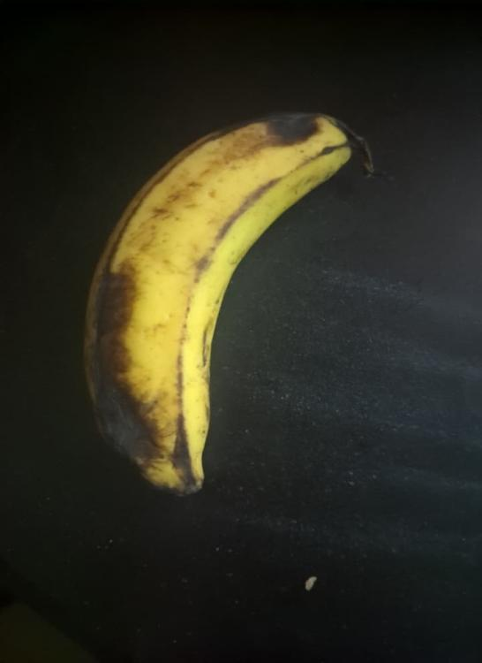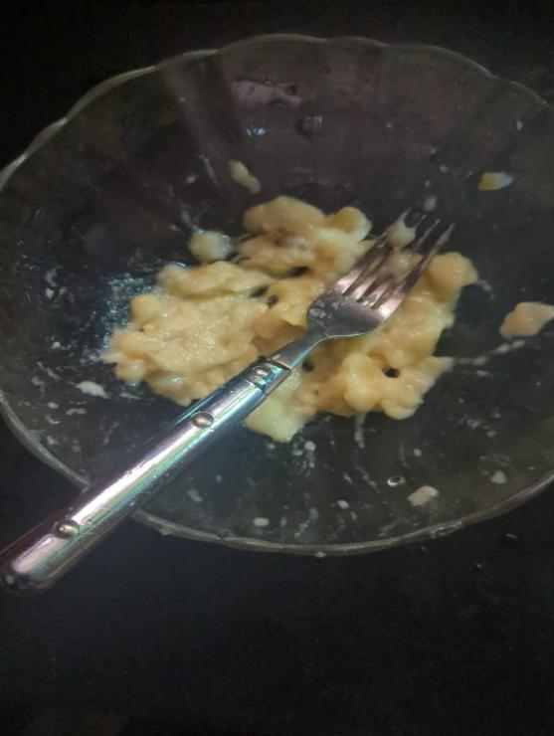
A ripe banana Mashed Banana in Bowl
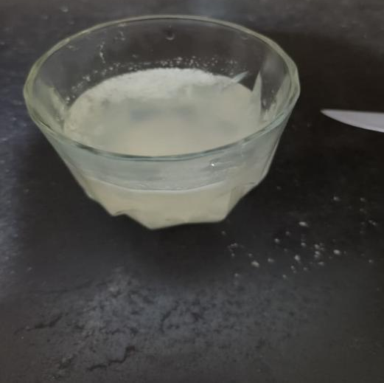
a Glass containing extraction mixture (water + salt + dish soap),whitish, cloudy mixture.
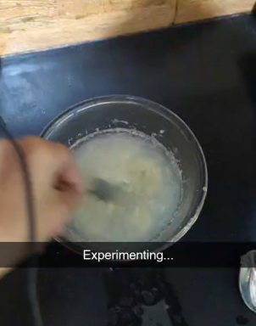
Banana mash being mixed with extraction buffer to dissolve cell membranes
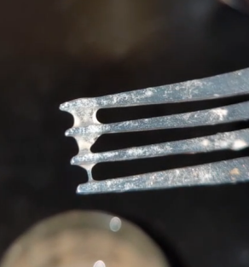
Stringy white banana DNA precipitated and collected on fork.

