

**UCAC-ICAM X1-2025: GROUP 4**

**DONE ON THURSDAY; 27thOF MAY, 2021**

  UCAC-ICAM

GIT-REPORTS

**SUMMARY**

1. PULSE
2. CONTRIBUTORS
3. COMMUNITY
4. TRAFFIC
5. COMMITS
6. CODE FREQUENCY
7. DEPENDENCY GRAPH
8. NETWORK
9. FORKS

PULSE

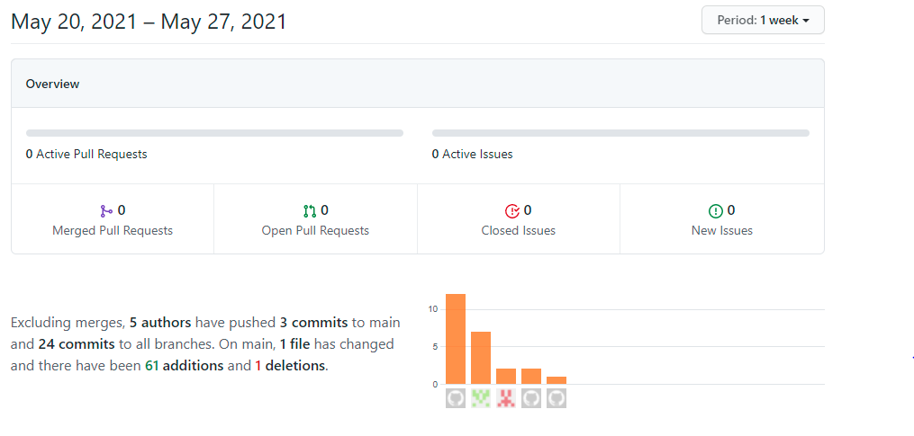

CONTRIBUTORS

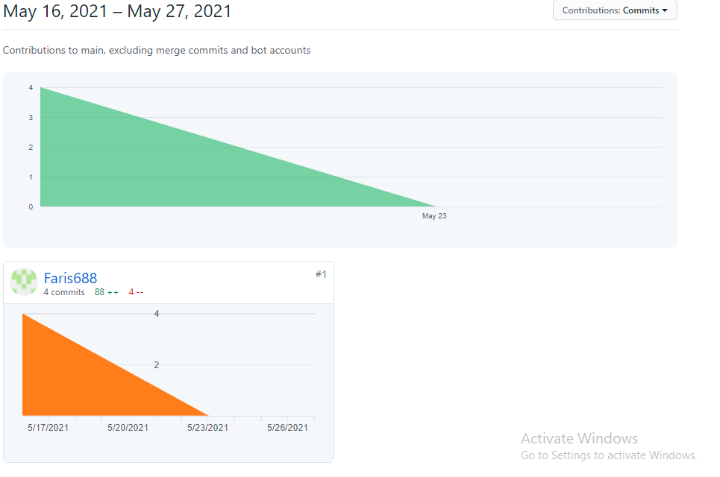

TRAFFIC

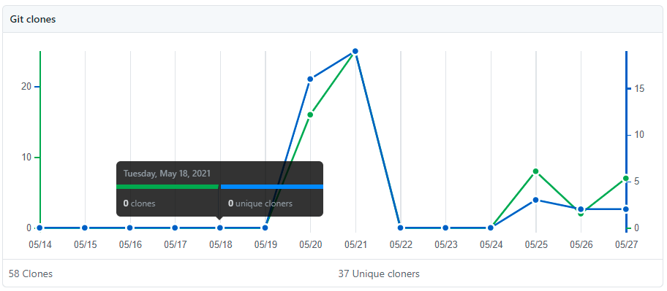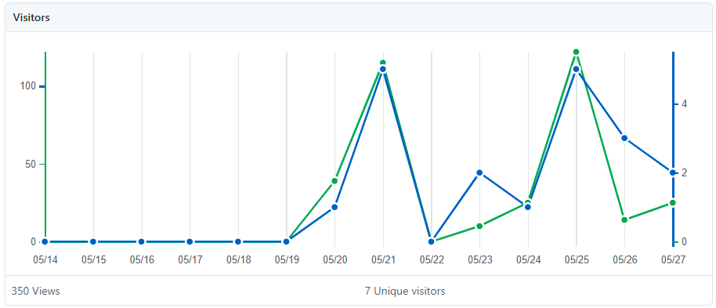

COMMITS

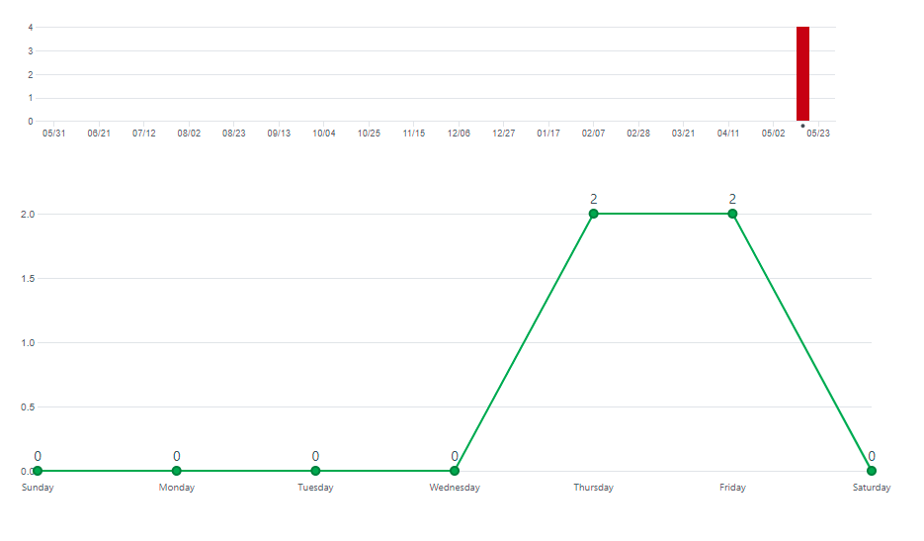

CODE FREQUENCY

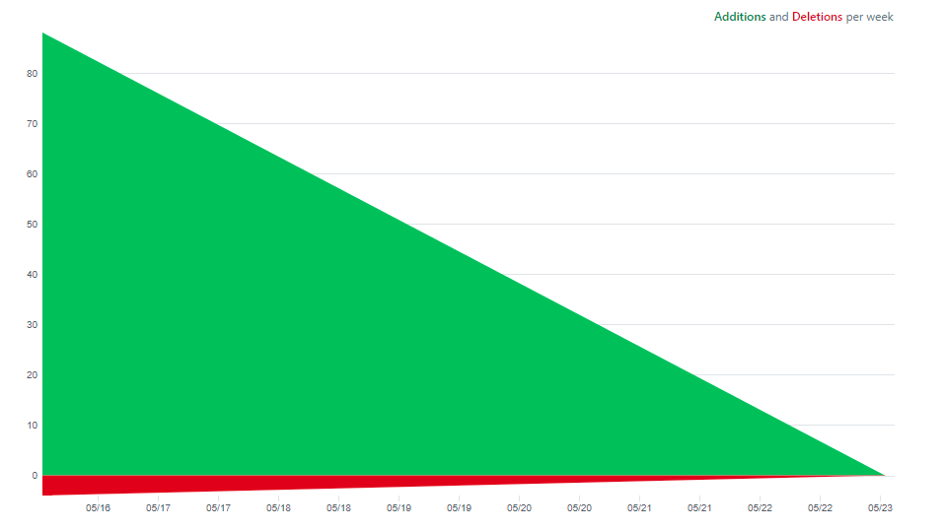

NETWORK

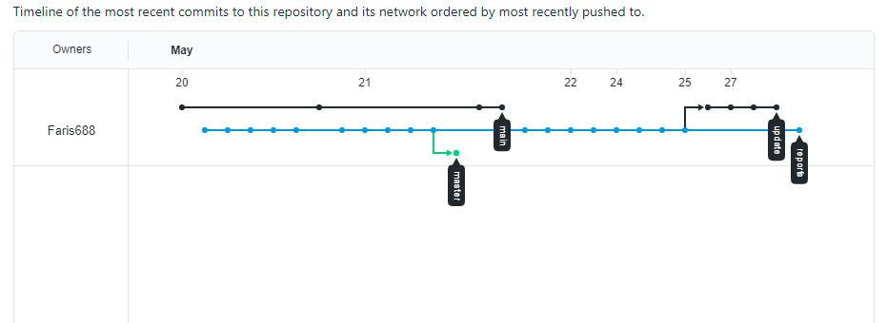

FORKS

