IRON MIND

ICT Lab Project Report
Group Members:
Muhammad Hasan Dad Khan (24K-0525)
Ali Zeeshan (24K-0749)
Faris Altaf (24K-0879)

1. Title
IRON MIND - A Fitness Website

2. Introduction
The project, IRON MIND, is a fitness-oriented website designed to provide users with valuable resources on exercises, workouts, and fitness tips. It serves as a one-stop platform for anyone looking to improve their physical health and well-being. The website incorporates multimedia content, including videos and images, to ensure users can easily understand and follow the instructions.

3. Background
The concept of IRON MIND emerged from the increasing demand for accessible and reliable fitness resources. Many individuals struggle to find proper guidance on exercises and fitness techniques, which can lead to improper workouts or injuries. This website aims to address this issue by offering a comprehensive and user-friendly platform for fitness enthusiasts of all levels.

4. Project Specification
The website consists of multiple HTML pages dedicated to different muscle groups, such as abs, arms, chest, shoulders, and legs. It also includes a BMI calculator to help users track their health metrics. Each exercise page features instructional videos, making it easier for users to learn proper techniques. The website is designed with simplicity and accessibility in mind, ensuring it caters to a wide audience.

5. Problem Analysis
Fitness-related information is often scattered across various platforms, making it difficult for users to find comprehensive and credible guidance. Additionally, the lack of visual aids in many fitness resources can make it challenging for users to understand and follow instructions. IRON MIND addresses these issues by centralizing high-quality content in a single platform with easy-to-follow visuals.

6. Solution Design
The IRON MIND website is organized into the following sections:
1. Homepage: Provides an overview of the website and its purpose.
2. Exercise Pages: Dedicated pages for abs, arms, chest, shoulders, and legs, each featuring instructional videos and descriptions.
3. BMI Calculator: Allows users to calculate their Body Mass Index based on their weight and height.
4. Multimedia Content: High-quality videos demonstrate proper exercise techniques.

7. Implementation & Testing
The website was developed using HTML and multimedia integration. Testing involved verifying the functionality of links, the accuracy of the BMI calculator, and the proper loading of multimedia content. User feedback was collected to ensure the website met usability and accessibility standards.

8. Project Breakdown Structure
The project was divided into the following phases:
1. Research and Planning: Identifying user needs and gathering resources.
2. Content Creation: Compiling instructional videos and writing exercise descriptions.
3. Website Development: Designing and coding the website.
4. Testing: Ensuring all features work as intended and addressing feedback.
Timeline: The project was completed over a span of four weeks.

9. Results
The final output is a fully functional website that includes detailed exercise pages, a BMI calculator, and high-quality instructional videos. Screenshots of the website are provided below:
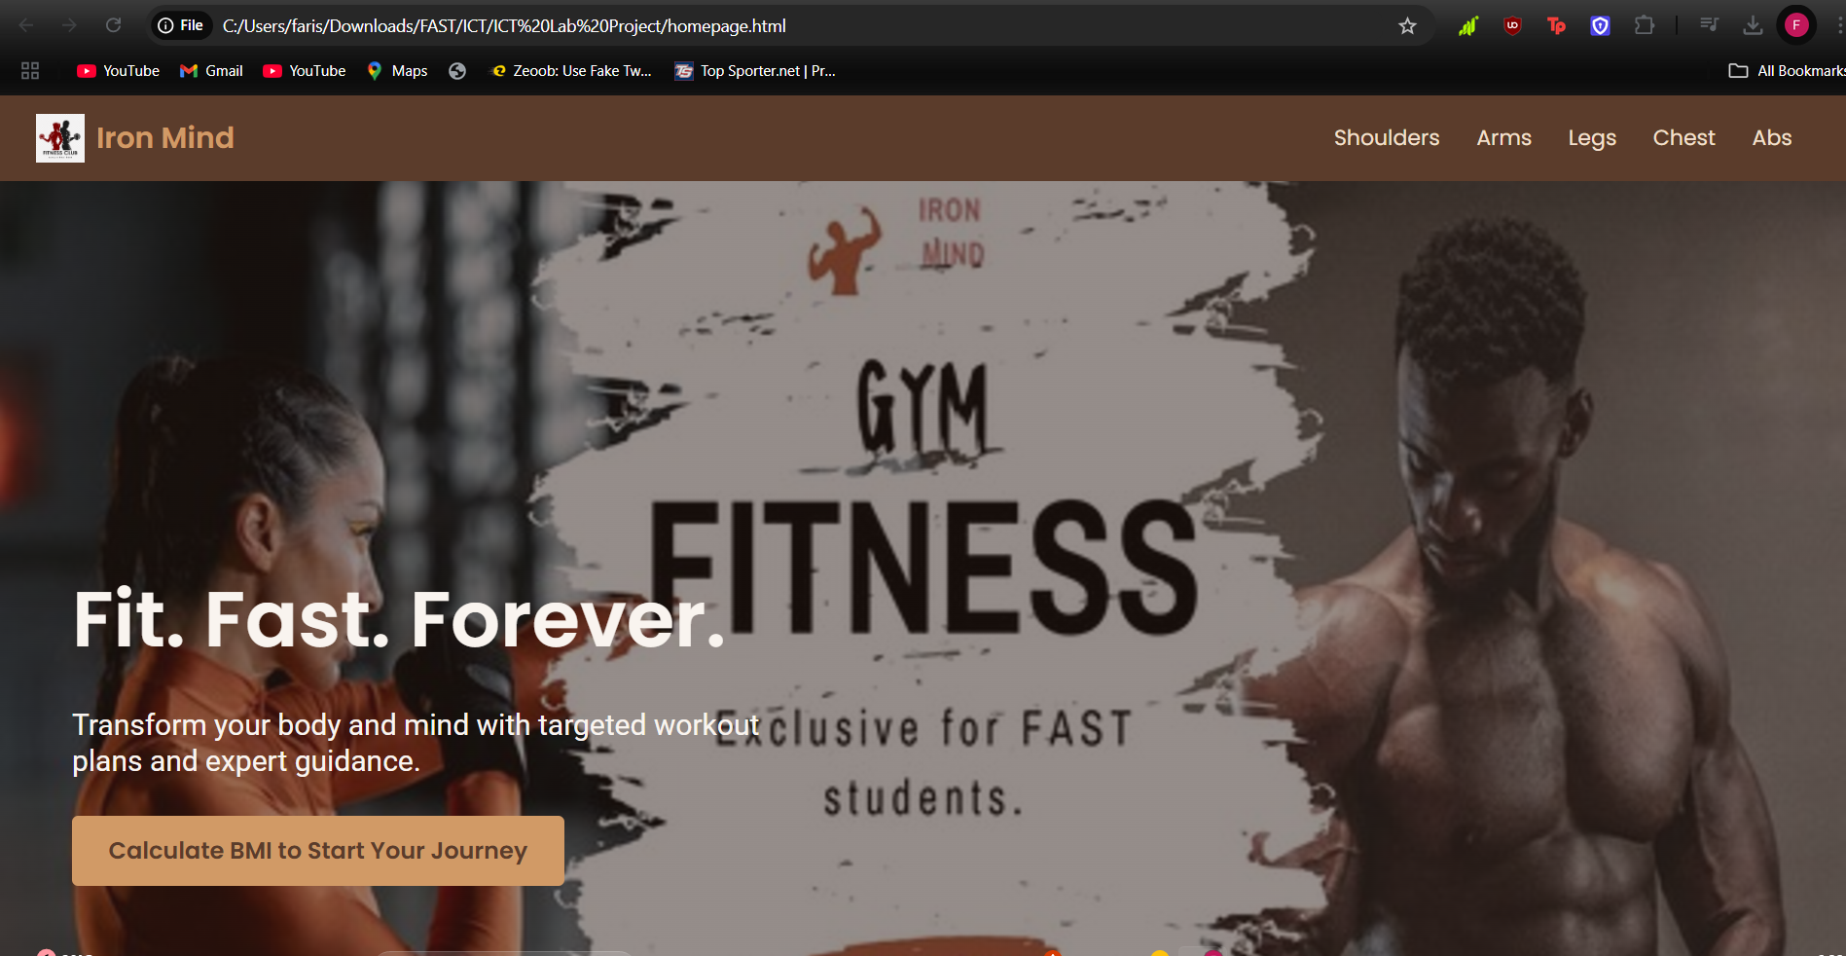
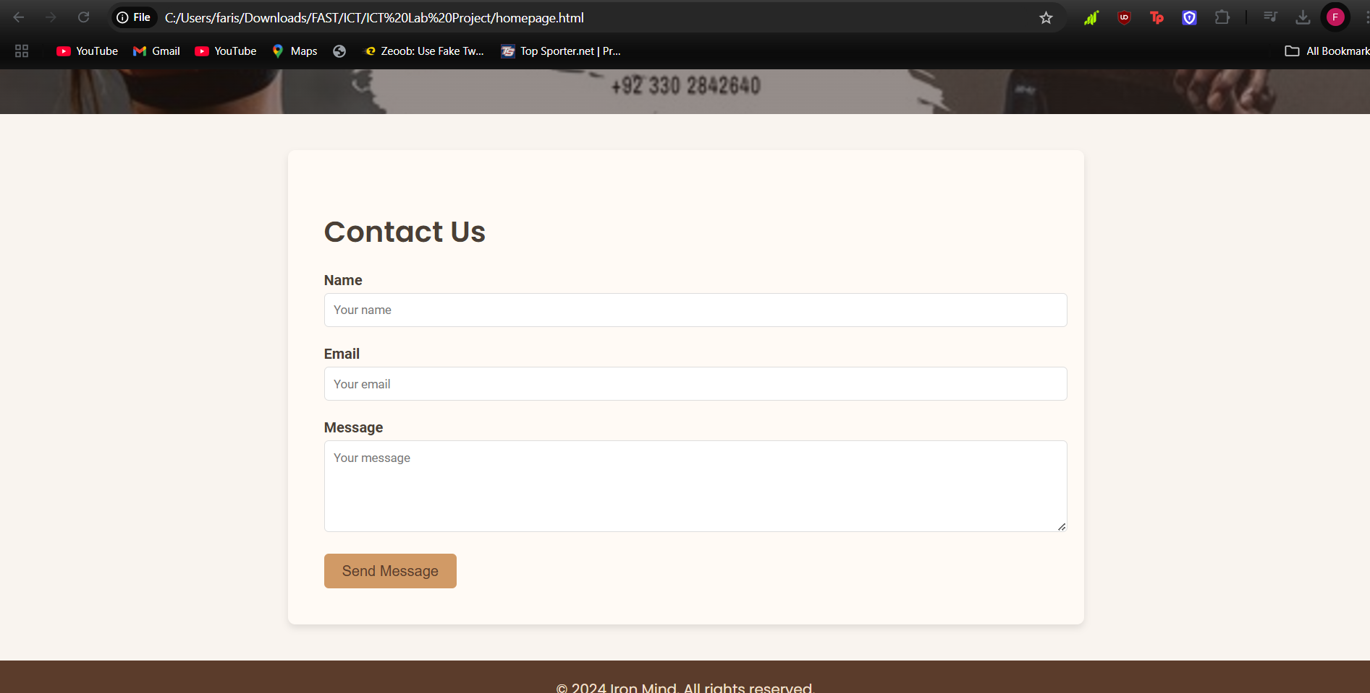
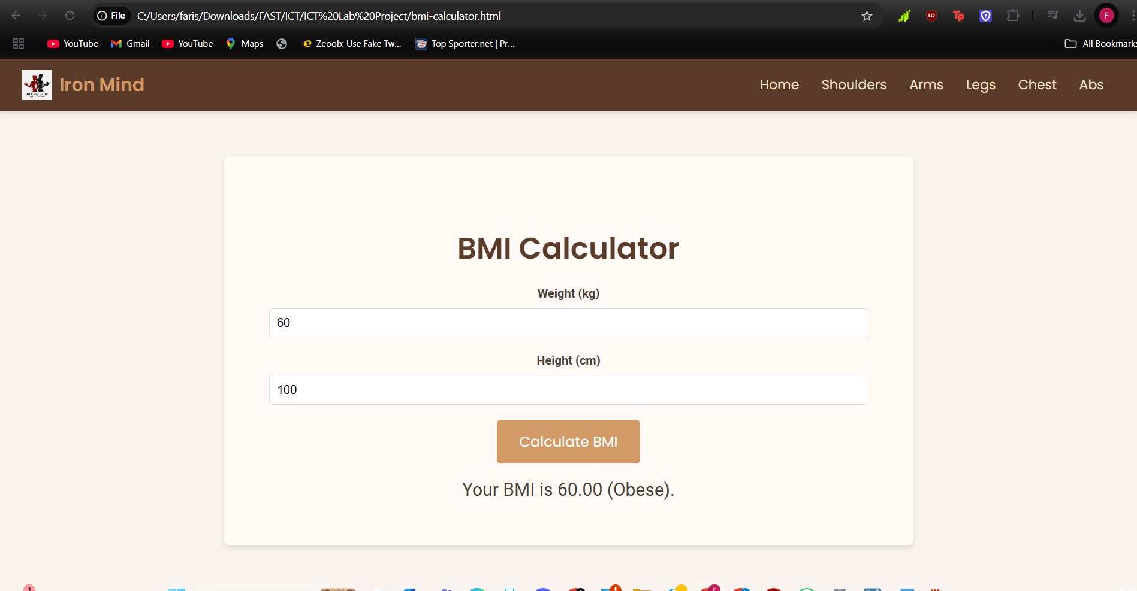
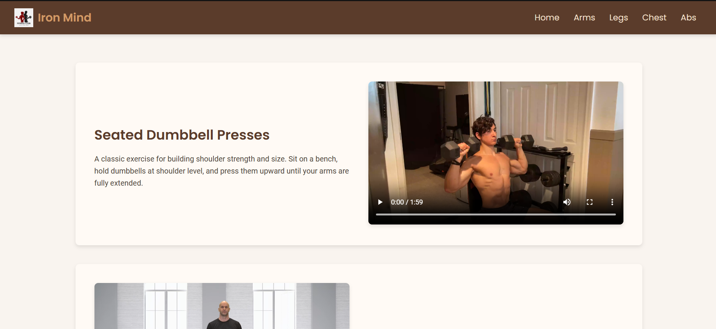
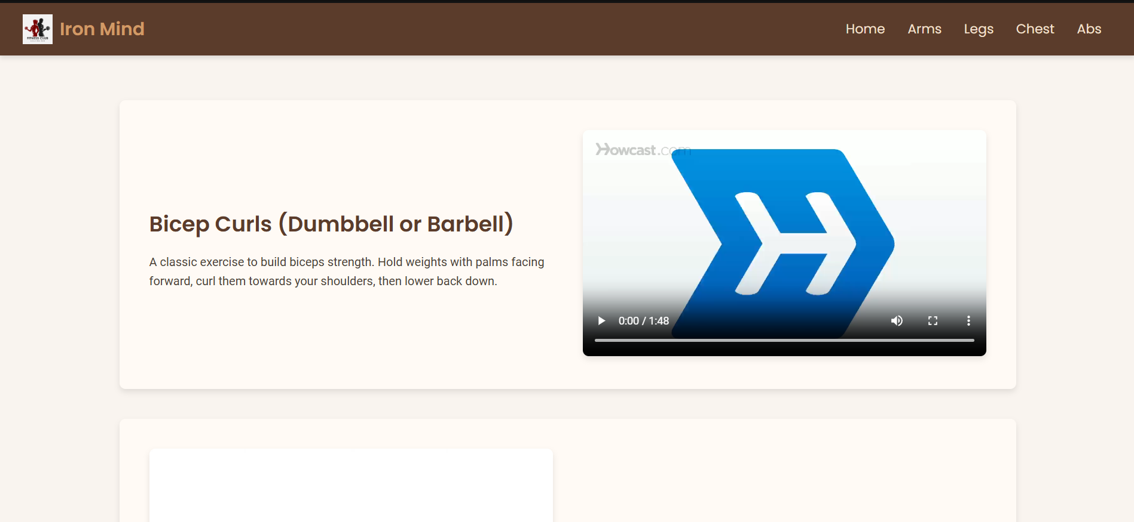
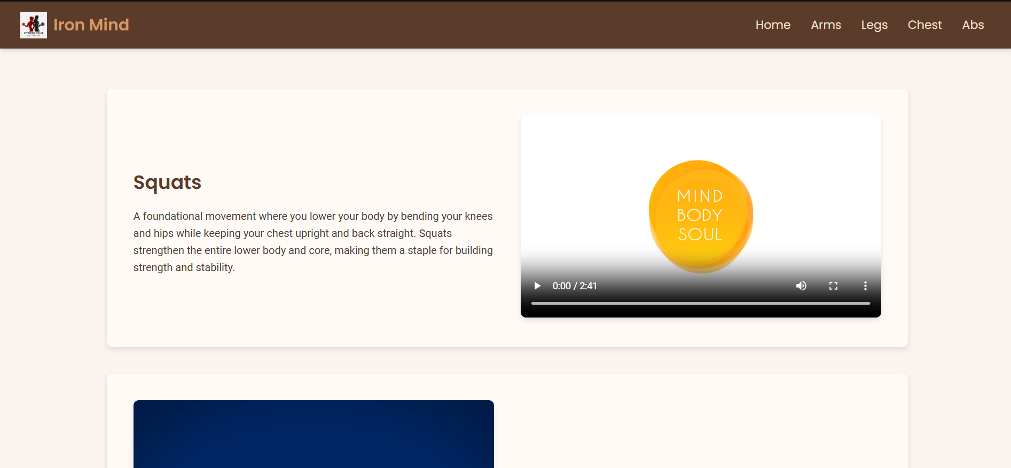
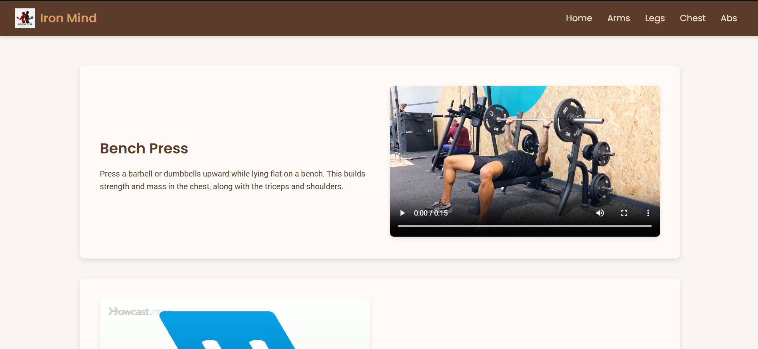
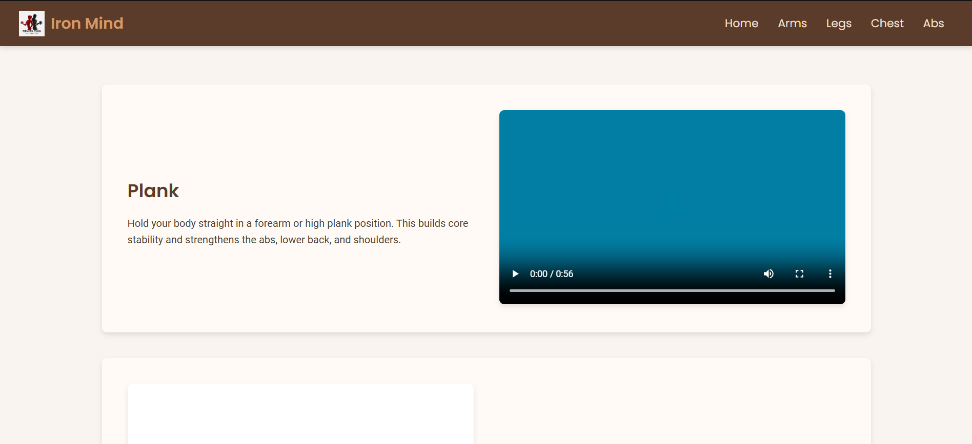

10. Conclusion
The IRON MIND project successfully addresses the need for a centralized fitness resource platform. By providing users with high-quality content and easy-to-use features, it promotes healthier lifestyles and encourages proper exercise techniques. Future improvements could include adding more exercises, a diet planner, and mobile optimization.

