Title of game: Lamborghini Love

High Concept: This is a space shooter that deals with bullets instead of lives

Player Experience Goals: I want you players to experience shooting valentine hearts with a Lamborghini Veneno

I want to score as many points as you can while you have a finite amount of bullets as fuel for the Lamborghini

Genre: This a shooter with endless runner and survival mechanics

Gameplay: Instead of being a typical space shooter like invaders, this game deals with survival.

As you shoot bullets from the car, you are losing them by 1. You gain a bullet each time that bullet hits a heart.

The goal is to reach the highest score possible while the bullets are depleting

Press spacebar to shoot the bullets

up - move the car up

down - move the car down

left - move the car left

right - move the car right

The game will end when the car runs out of bullets to shoot.

Prototype Goal: The prototype is evaluating shooting.

Features:

Unique Aspects

Shooting until your bullets run out

Hitting balloons for extra points

I have just made a game that no one else has made just yet.

Story:

This game is about a fuel efficient Lamborghini Veneno

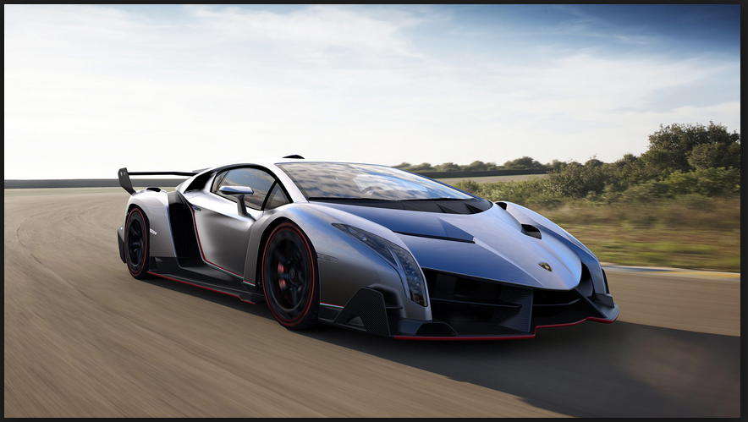

This is a Lamborghini Veneno

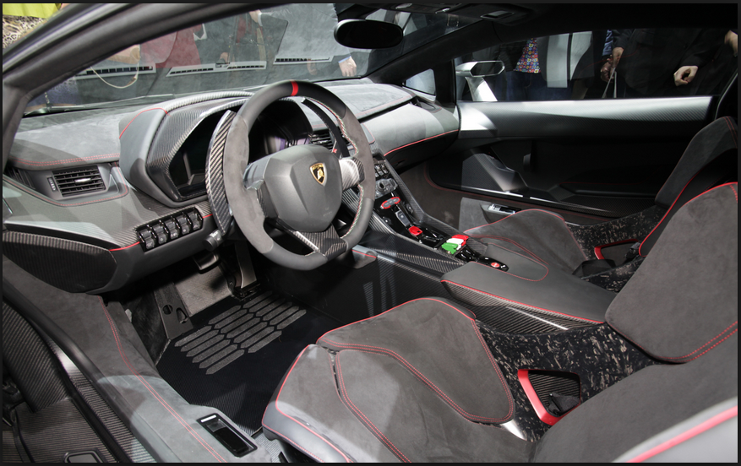

Story:

The car is using ammunition as fuel for its batteries

Let's assume that the car is running on alternative fuel source as well as electric power

In the year 2017, the armies of many countries, including the United States, have decided to cease fire and live in peace.

Also, Obama is no longer President of the United States and things in the United States have been going pretty well.

These armies have fighting many wars for so many decades, including World War I, World War II, Cold War, Vietnam War, the wars in Iraq and Afghanistan, and the recent wars in Syria and Lebanon.

The countries that were fighting for centuries have suffered immense amounts of poverty and of civilian casualties.

These armies have lost so many of their good comrades and have been starting to fight wars when possible.

Most of these armies have decided that enough was enough. The countries of the world have signed a peace treaty with the countries that have been at war for centuries.

In the May of 2017, peace has been brought to all of the warring countries.

Most of the world has been living in peace since then.

There has also been a severe reduction in crimes such as rape, murder, theft, and kidnappings.

Since then, the armies of the world have been stockpiling their weapons and stopped fighting altogether.

It is now February 13, 2018 and it’s Valentines’ day. Lots of dating and married couples are having fun and living their own lives. They decided to do something that was never really done before. They decided to make heart balloons out of helium and send them into outer space. They have also attached Go-Pro cameras to them. Each of these couples uses the oculus rift to have the immersive feeling of riding on each of these balloons. These balloons weigh about 400 pounds each. These balloons will fall down to Earth after being shot at.

In the year 2018, ammunition from military weapons such as assault rifles and pistols, are used as renewable fuel in most vehicles. People decided to stop violence against other people and direct this ammunition to better and more fun uses.

Setting/Premise

Just recently, NASA made a version of the Lamborghini Veneno that can be driven in space. This car is equipped with some ammunition that was delivered from the U.S. Navy Seals. Also, this car has weapons that can shoot ammunition rounds. These weapons are miniguns that were used in battle by the U.S. Navy Seals. These miniguns are mounted at the front bumper of the Veneno. To make this car fly in space, NASA equipped it with hovering wheels and a $1 million rocket at the back exhaust of the car. This Lamborghini travels at a supersonic 650 miles per hour and also is able to float in space. This was the first supercar to overcome Earth’s gravitational force of 9.8 m/s.

NASA had decided to give one of their astronauts to drive this modified Lamborghini Veneno. So, this astronaut takes off in the Lamborghini and leaves Earth’s orbit in about 10 minutes. Then, he sees the stars and other planets as he drives the Lamborghini. But suddenly, he sees the balloons and goes for them. He starts shooting the weapons and fires at the balloons just for fun. There is a finite amount of balloons floating near Earth. The hearts are filled with helium and when shot at, they vanish into thin air.

In this game called “Lamborghini Love,” you play as this astronaut. Sorry, but he is not in the game.

Prototype Assets:

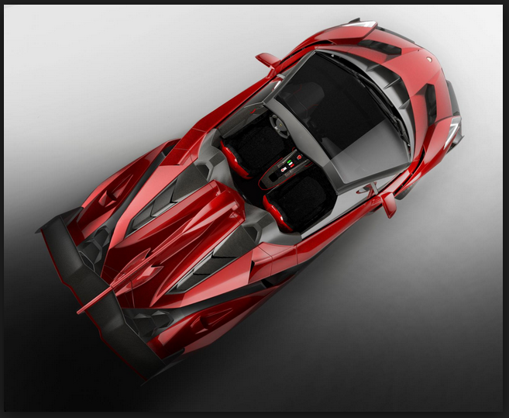

Borrowed from Google Images. I used this to make my Lamborghini sprite in the game

The red color makes sense for a game about shooting hearts.

In my assets, I borrowed all images from Google except that I made the hearts using a sprite creator

Play Time: this game takes about 3-5 minutes to play

Strategies:

Hit the balloons for 50 extra points but you can only hit up to 30 balloons. After 30 balloons the game ends.

When the Lamborghini takes too many hits, it drops down into space and explodes silently.

Use your bullets wisely

Dodge against the hearts when you need to