**Scientific Methods for Health Sciences: Applied Inference (HS851): Fall 2014**

[**http://www.socr.umich.edu/people/dinov/2014/Fall/HS851**](http://www.socr.umich.edu/people/dinov/2014/Fall/HS851)

**Homework 1 Solutions**

**Problem 1**: Suppose we have obtained the following measurements. Calculate the corresponding [power, specificity and sensitivity](http://wiki.socr.umich.edu/index.php/SMHS_PowerSensitivitySpecificity).

|  |  |  |  |
| --- | --- | --- | --- |
|  | | **Actual Condition** | |
| **Absent (Ho is true)** | **Present (H1 is true)** |
| **Test Result** | **Negative(fail to reject Ho)** | 0.983 | 0.0025 |
| **Positive (reject Ho)** | 0.0085 | 0.0055 |

Power: 1−(*FN/(* TP+FN*))*= 0.6875

Specificity: TN/(TN+FP) = 0.983/(0.983+0.0085) = 0.9914271

Sensitivity: TP/(TP+FN) = 0.0055/(0.0055+0.0025) = 0.6875

R calculations

dat <- matrix(c(0.983, 0.0025, 0.0085, 0.0055), byrow=T, nrow=2)

dat

colnames(dat) <- c('H0 true', 'H1 true')

rownames(dat) <- c('Neg test results', 'Pos test result')

power <- 1-dat[1,2]

specificity <- dat[1,1]/(dat[1,1]+dat[2,1])

sensitivity <- dat[2,2]/(dat[2,2]+dat[1,2])

**Problem 2**: Using [R](http://wiki.socr.umich.edu/index.php/SMHS_ParamInference#Random_number_generation) and [SOCR](http://wiki.socr.umich.edu/index.php/SOCR_EduMaterials_Activities_RNG), generate 100 random observations from [uniform(-1,1)](http://wiki.socr.umich.edu/index.php/AP_Statistics_Curriculum_2007_Uniform#Uniform_Distribution), [normal(0,1)](http://wiki.socr.umich.edu/index.php/AP_Statistics_Curriculum_2007_Normal_Std) and [exponential(1)](http://wiki.socr.umich.edu/index.php/AP_Statistics_Curriculum_2007_Exponential) distributions. Then Use the [SOCR QQ Data-Data Plot](http://wiki.socr.umich.edu/index.php/SOCR_EduMaterials_Activities_QQChart) to compare the paired samples, i.e., for each distribution, plot the quantiles of the R-generated sample against the SOCR generated sample. What do you expect and what do you see? Explain.

In all cases ([uniform(-1,1)](http://wiki.socr.umich.edu/index.php/AP_Statistics_Curriculum_2007_Uniform#Uniform_Distribution), [normal(0,1)](http://wiki.socr.umich.edu/index.php/AP_Statistics_Curriculum_2007_Normal_Std) and [exponential(1)](http://wiki.socr.umich.edu/index.php/AP_Statistics_Curriculum_2007_Exponential) distributions) we expect to see the QQ plots to be

Very linear with the scatter plot of the (R, SOCR) data evenly distributed over the range and close following the line bisecting the [0,1]x[0,1] domain. There should not be S-shape (snake) patterns emerging, which would be indicative of differences in the quantile distributions (which is not expected as both software tools sample from the same distributions, albeit using different sampling methods). See Appendix for random samples.

**Using SOCR QQ Data to Data Plot (**<http://www.socr.umich.edu/html/cha/SOCR_Charts.html>**)**

Copy-paste pairs of data (randomly generated samples from R and SOCR) for each of the 3 distributions.

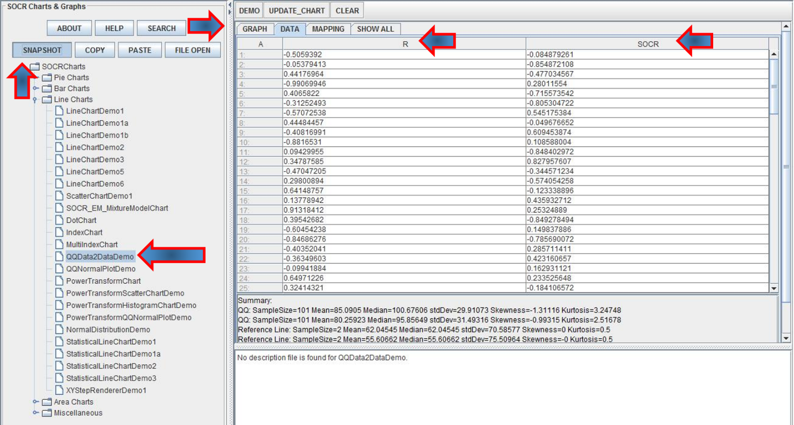

Then click the mapping tab and map the R and SOCR column headings into the 2 bins (X and Y axes). Finally click “Update Chart” to plot the QQ plot (quartiles of R and SOCR data are on the X and Y axes, respectively). We can change the Chart Titles and label the axes (using right-click and setting the chart properties), however we did not do that here to avoid possible confusion.

Uniform QQ Plot

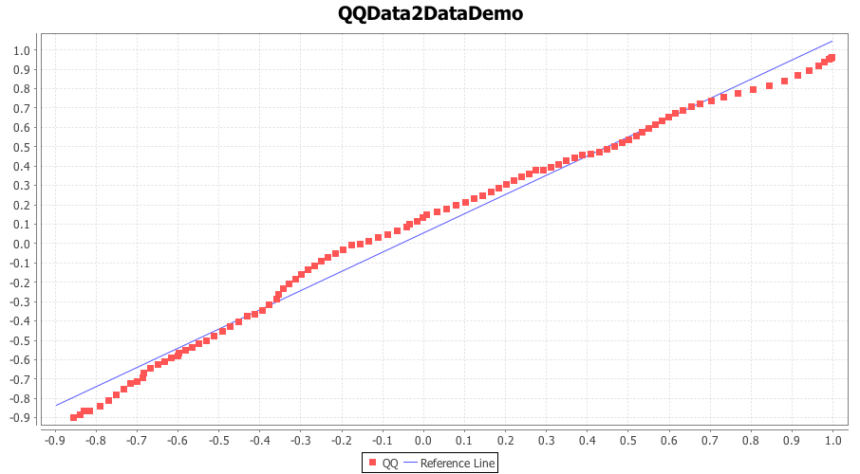

Normal QQ plot

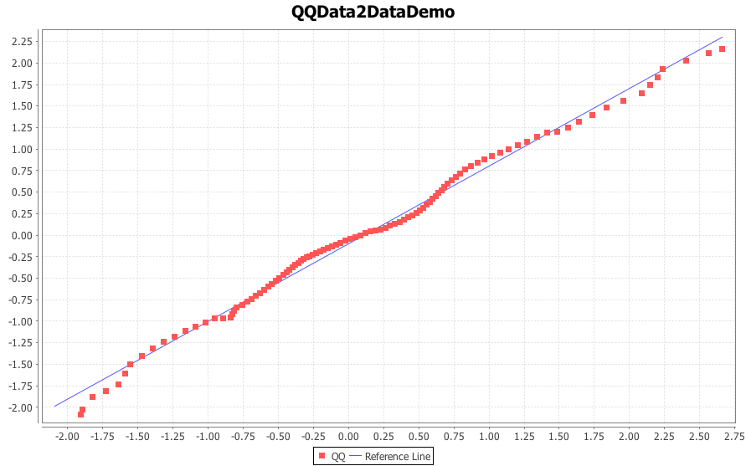

Exponential QQ plot

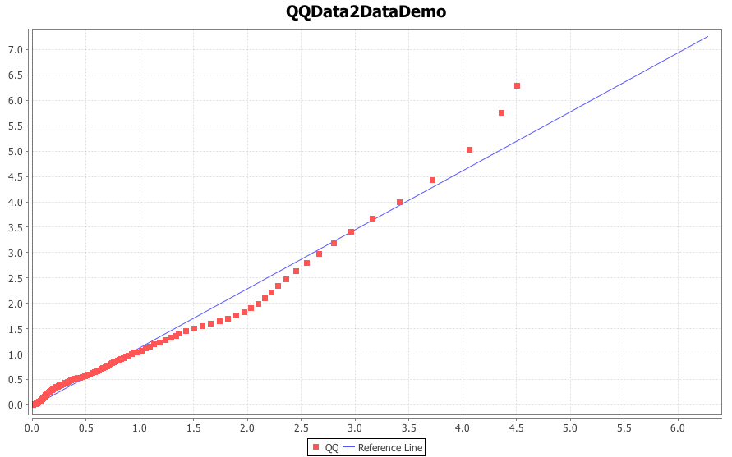

Notes:

* For SOCR RNG see this activity: <http://wiki.socr.umich.edu/index.php/SOCR_EduMaterials_Activities_RNG>
* For R random number generation:

unif.gen <- runif(100, -1, 1)

norm.gen <- rnorm(100, 0, 1)

exp.gen <- rexp(100, 1)

dat.gen<-cbind(unif.gen, norm.gen, exp.gen)

write.csv(dat.gen, 'hw_dat_gen.csv')

# QQ plot in R

data <- read.csv(''hw_dat_gen.csv',header=T)

attach(data)

colnames(data)=c('U_R','U_S','N_R','N_S','E_R','E_S')

par(mfrow=c(1,3))

qqplot(U_R,U_S,xlab='Uniform sampled from R',ylab='Uniform sampled from SOCR')

abline(0,1,col='red')

qqplot(N_R,N_S,xlab='Normal sampled from R',ylab='Normal sampled from SOCR')

abline(0,1,col='red')

qqplot(E_R,E_S,xlab='Exponential sampled from R',ylab='Exponential sampled from SOCR')

abline(0,1,col='red')



**Problem 3**: The [Poisson distribution with parameter λ](http://wiki.socr.umich.edu/index.php/AP_Statistics_Curriculum_2007_Distrib_Poisson) can be [approximated with normal when λ is large](http://wiki.socr.umich.edu/index.php/AP_Statistics_Curriculum_2007_Limits_Norm2Poisson). Suppose patients arrive at a hospital at a rate of 50 per day. Let’s assume that the process is a Poisson random variable with λ=50. Compute the probability that in the next day the number of patients that arrive at this hospital will be between 54 and 62. Use the SOCR [Normal](http://socr.ucla.edu/htmls/dist/Normal_Distribution.html) (N(μ=50,σ=7.071)) and [Poisson](http://socr.ucla.edu/htmls/dist/Poisson_Distribution.html) (Poisson(λ=50))distribution calculators.

Using the normal distribution, the probability is P(53.5<X<62.5| N(μ=50,σ=7.071))= 0.**271759** (see the [continuity correction section of the EBook](http://wiki.socr.umich.edu/index.php/AP_Statistics_Curriculum_2007_Limits_Norm2Poisson)).

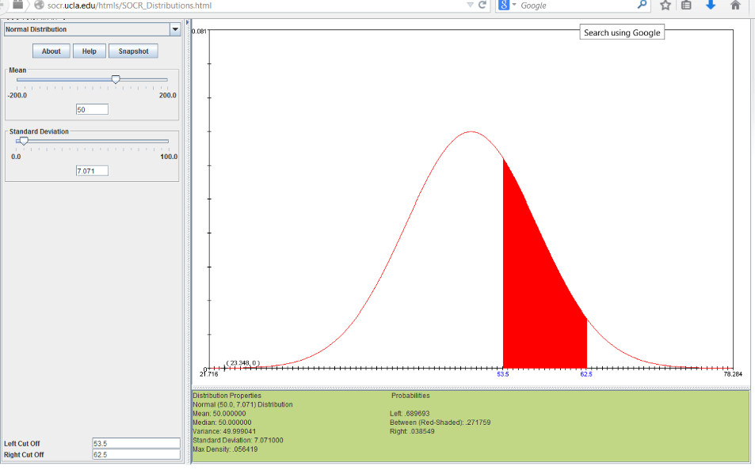

Using the Poisson distribution, the probability is P(54≤X≤62| P(λ=50)) = **0.248**. I do not include 62 because in the continuous normal distribution we only include values up to 62.0

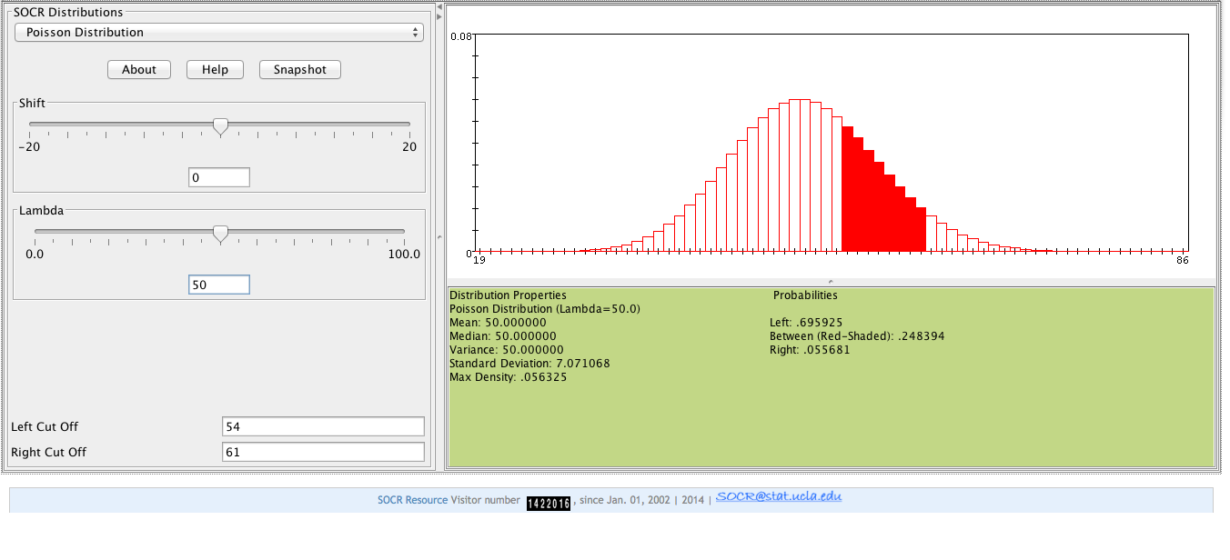

R Code:

ppois(q=61, lambda=50, lower.tail=T) -

ppois(q=53, lambda=50, lower.tail=T)

#I used 61 and 53 to match the results from SOCR.

#I'm not sure what values are being included here...

pnorm(q=62, mean=50, sd=7.071, lower.tail=T) -

pnorm(q=54, mean=50, sd=7.071, lower.tail=T)

**Problem 4**: Use the [Vitamin K shots Neonate Infant Pain Score (NIPS) dataset](http://wiki.socr.umich.edu/index.php/SOCR_Data_NIPS_InfantVitK_ShotData) and [SOCR Charts](http://www.socr.umich.edu/html/cha) to generate a box plot, a scatter plot, a line plot, a dot plot, a boxplot, a histogram plot and a pie chart for some of the variables [(Immediate, 30_Sec_Later, 60_Sec_Later, 120_Sec_Later, Total_Cry_Time)](http://wiki.socr.umich.edu/index.php/SOCR_Data_NIPS_InfantVitK_ShotData#Data_Description).

Histogram of variable ‘immediate’

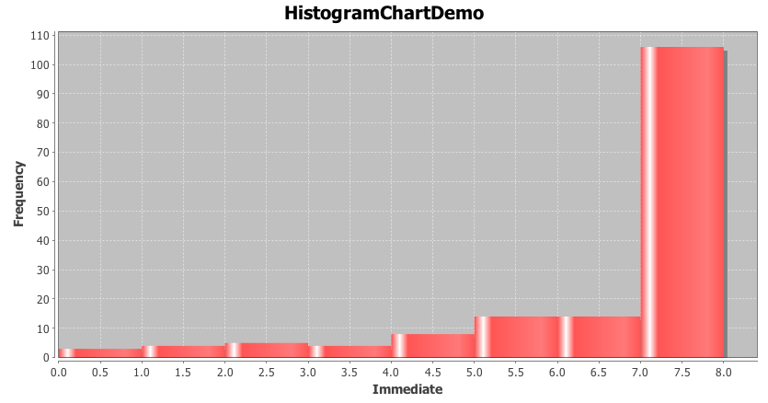

Boxplot of the control group for various variables.

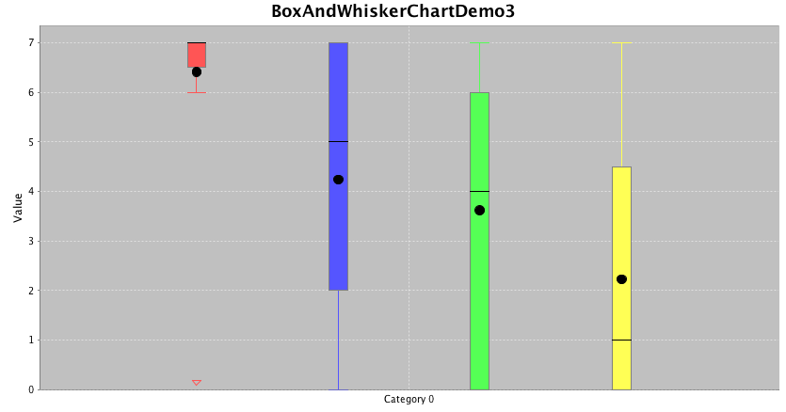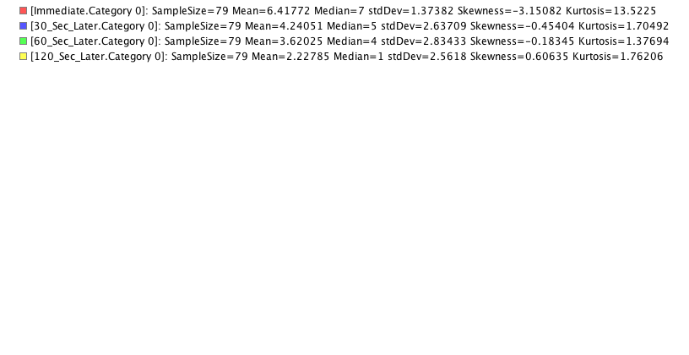

Line chart

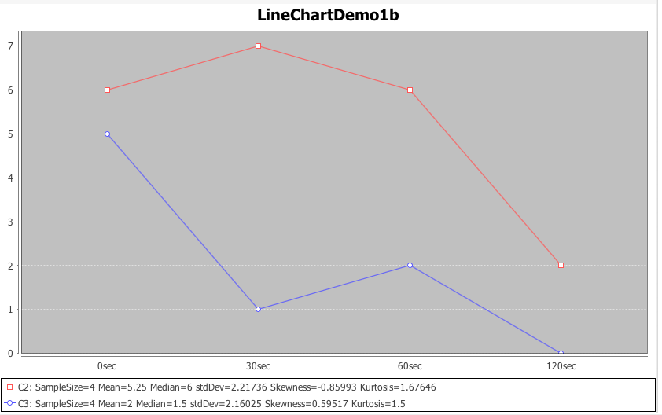

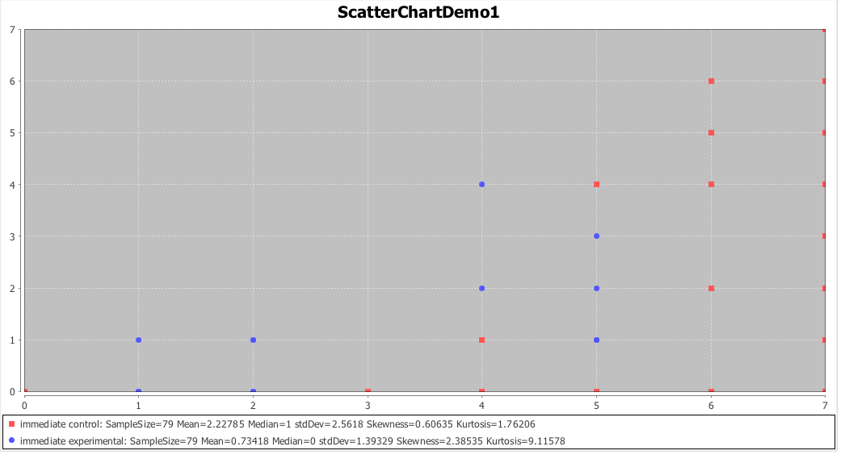

Dot chart of total cry time

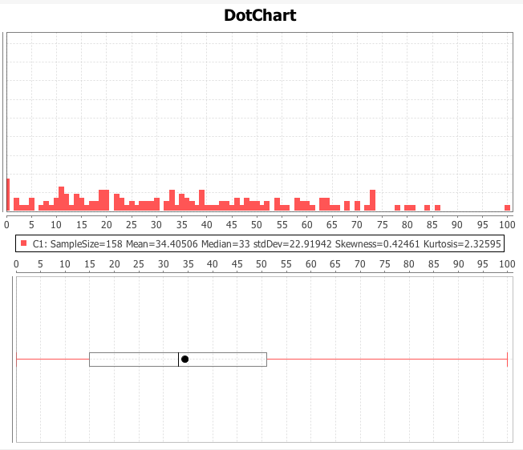

Pie chart of clusters

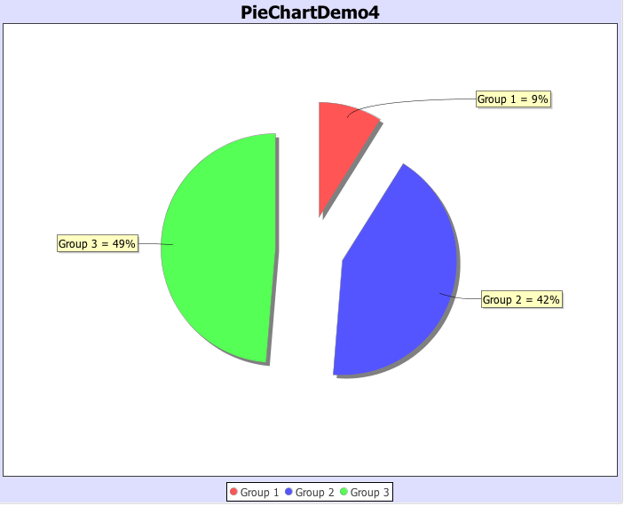

R Code:

nips.dat<-read.csv('NIPS_data.csv')

head(nips.dat)

hist(nips.dat$Immediate)

boxplot(nips.dat[nips.dat$Group_NC1_Interv2==1,3:6])

plot(1:4,unlist(nips.dat[1,3:6]), col=1, type='b', ylim=c(0,7))

points(1:4, unlist(nips.dat[2,3:6]), col=2, type='b')

#calculate proportions for pie chart of variable 'cluster'

cluster.tab<-table(nips.dat$Cluster)

cluster.props<-cluster.tab/sum(cluster.tab)

pie(cluster.props, labels=paste('group',names(cluster.props)))

**Appendix**: Problem 2: Random Number generation results (SOCR and R)

| **Index** | **unif.gen.r** | **norm.gen.r** | **exp.gen.r** | **unif.gen.socr** | **norm.gen.socr** | **exp.gen.socr** |
| --- | --- | --- | --- | --- | --- | --- |
| 1 | -0.03421 | 2.146162 | 1.340007 | 0.460332 | 1.20057 | 1.041762 |
| 2 | -0.72205 | 0.629507 | 1.099317 | -0.86515 | -0.22798 | 1.243426 |
| 3 | -0.67383 | -0.66391 | 0.312262 | -0.05886 | 0.997939 | 0.589069 |
| 4 | -0.83861 | -0.36714 | 0.114022 | 0.654992 | 1.013191 | 0.771458 |
| 5 | -0.12954 | -0.31342 | 0.709416 | -0.07565 | 0.774204 | 0.493172 |
| 6 | 0.547198 | 0.591664 | 0.894984 | 0.32987 | 1.547096 | 3.501474 |
| 7 | 0.20275 | -0.72866 | 0.216729 | 0.45734 | -0.65392 | 0.292094 |
| 8 | 0.689725 | -0.25386 | 2.546228 | -0.71675 | 0.549533 | 0.385044 |
| 9 | 0.932319 | -0.50089 | 0.037871 | 0.449293 | 0.039298 | 0.101861 |
| 10 | -0.23215 | -0.37405 | 2.265916 | 0.005879 | 0.155565 | 0.450133 |
| 11 | -0.05471 | 0.71512 | 0.070696 | 0.301959 | -0.81355 | 0.633944 |
| 12 | -0.60256 | -0.07206 | 0.870941 | -0.08382 | 1.665624 | 0.258207 |
| 13 | 0.309499 | 0.390936 | 0.151744 | -0.52922 | 0.221251 | 4.207319 |
| 14 | -0.88687 | 0.151597 | 2.180663 | 0.540384 | -0.2561 | 2.889952 |
| 15 | -0.70833 | -0.35227 | 0.200772 | -0.51099 | -0.34571 | 0.084309 |
| 16 | -0.55618 | -1.27415 | 0.738722 | 0.734095 | 0.691379 | 0.510943 |
| 17 | 0.997966 | -0.37241 | 0.723516 | 0.108784 | -0.07839 | 2.84049 |
| 18 | -0.31476 | -0.74948 | 0.725648 | 0.753113 | -0.21449 | 0.938006 |
| 19 | 0.648257 | -1.48634 | 2.746657 | 0.399 | -0.93579 | 0.872644 |
| 20 | -0.2527 | 1.636721 | 0.711131 | -0.53996 | -1.57178 | 0.005215 |
| 21 | 0.488616 | -0.23512 | 3.036433 | -0.60762 | 0.274927 | 0.845941 |
| 22 | -0.62573 | 0.613624 | 1.974556 | 0.229866 | 0.916813 | 5.327805 |
| 23 | 0.546316 | 0.092615 | 0.105033 | -0.77381 | -0.70757 | 0.466315 |
| 24 | -0.17407 | -0.43698 | 0.578787 | -0.32124 | -0.18651 | 1.501219 |
| 25 | -0.3447 | -1.88449 | 0.270065 | 0.737515 | -1.6356 | 0.603368 |
| 26 | 0.308256 | -0.73031 | 3.337005 | -0.04694 | -0.06189 | 1.905998 |
| 27 | -0.26303 | 0.663724 | 0.219036 | 0.750205 | 0.232279 | 0.186334 |
| 28 | 0.531543 | 1.71799 | 0.407216 | 0.529095 | 0.073917 | 3.151731 |
| 29 | 0.602814 | 0.717651 | 4.511306 | 0.453735 | 1.249572 | 1.568328 |
| 30 | 0.978829 | 0.293492 | 0.114425 | 0.118894 | -2.02146 | 0.081836 |
| 31 | -0.85019 | -1.4763 | 1.124781 | -0.51768 | -0.28394 | 0.340263 |
| 32 | 0.23253 | 1.475606 | 0.599163 | 0.963082 | -2.97734 | 1.290559 |
| 33 | -0.28099 | 1.494191 | 1.223023 | 0.745283 | 0.44355 | 0.923142 |
| 34 | -0.30193 | -0.28436 | 0.700383 | -0.5863 | 0.064641 | 1.869083 |
| 35 | 0.548397 | -0.20229 | 0.086656 | -0.54248 | 0.093079 | 6.278972 |
| 36 | 0.995536 | -0.70494 | 0.285405 | 0.939171 | -0.40414 | 0.447815 |
| 37 | -0.01905 | -0.17924 | 0.071937 | -0.07612 | -0.31802 | 0.937193 |
| 38 | -0.96642 | -0.68723 | 2.111835 | -0.523 | 2.167942 | 0.843612 |
| 39 | 0.107123 | 0.545174 | 0.974293 | 0.726575 | 0.941747 | 0.08351 |
| 40 | -0.06 | 0.790998 | 0.68405 | 0.153013 | -0.17526 | 0.39209 |
| 41 | -0.70203 | 1.298077 | 0.969277 | 0.365026 | -1.14691 | 0.034582 |
| 42 | -0.4387 | -0.21428 | 3.832193 | -0.20345 | 0.156672 | 0.315035 |
| 43 | -0.45316 | 0.332357 | 4.407625 | 0.948052 | -1.34833 | 0.131123 |
| 44 | 0.655648 | -1.86569 | 1.429922 | 0.208282 | -0.28243 | 0.153636 |
| 45 | 0.3256 | -1.34245 | 0.843509 | 0.116541 | -0.25856 | 0.881637 |
| 46 | 0.983889 | 2.12348 | 0.857802 | -0.13949 | -0.85751 | 1.545764 |
| 47 | 0.300022 | -1.83606 | 2.056815 | -0.61146 | -2.41567 | 0.071218 |
| 48 | -0.73311 | -0.38427 | 0.09266 | 0.491245 | -0.81568 | 0.728199 |
| 49 | 0.509772 | 0.748845 | 2.212804 | -0.99243 | 1.052579 | 3.929189 |
| 50 | 0.173622 | 2.657411 | 0.0562 | -0.9653 | -0.82528 | 0.968741 |
| 51 | -0.76479 | -2.28273 | 2.791011 | 0.109822 | -0.27364 | 0.01077 |
| 52 | -0.22208 | 0.472962 | 0.840846 | -0.56335 | -0.97879 | 0.402135 |
| 53 | 0.426459 | -1.13678 | 0.115148 | 0.608226 | -0.57152 | 0.770245 |
| 54 | -0.34607 | 0.567162 | 3.128469 | 0.337765 | -0.75563 | 1.20417 |
| 55 | -0.34911 | -0.61365 | 0.050545 | -0.84481 | 0.649193 | 0.308639 |
| 56 | 0.927089 | 0.297586 | 1.114771 | -0.64119 | 1.228224 | 0.355358 |
| 57 | 0.743263 | -0.41333 | 2.130998 | -0.54559 | -0.50897 | 0.712986 |
| 58 | -0.78684 | -0.10762 | 1.592749 | 0.054734 | 0.528545 | 0.238807 |
| 59 | -0.53026 | 1.182324 | 0.634011 | -0.85744 | -0.09481 | 0.362151 |
| 60 | -0.75019 | -1.67929 | 0.027767 | 0.570614 | 0.077227 | 1.966582 |
| 61 | 0.441064 | -1.34327 | 0.203299 | 0.579498 | 1.803817 | 0.02477 |
| 62 | 0.115574 | 0.946397 | 0.356205 | 0.959642 | -0.77776 | 1.339688 |
| 63 | -0.72323 | 1.002117 | 0.280054 | -0.1695 | 0.30471 | 0.229536 |
| 64 | 0.207033 | 1.174052 | 0.795948 | -0.87549 | 0.276103 | 0.744773 |
| 65 | 0.922349 | 0.312329 | 0.636844 | -0.41622 | -1.11926 | 1.287061 |
| 66 | 0.555111 | 0.254074 | 1.743359 | 0.810238 | -1.2959 | 0.401478 |
| 67 | -0.21242 | 0.784066 | 2.296724 | 0.943708 | 1.687488 | 2.583519 |
| 68 | -0.58894 | -0.05484 | 0.169041 | 0.183287 | -0.26602 | 0.368145 |
| 69 | -0.56253 | -0.86096 | 1.51277 | 0.224716 | 0.605233 | 0.645768 |
| 70 | 0.607497 | 2.554486 | 0.274575 | -0.26691 | 0.978547 | 1.891233 |
| 71 | -0.30391 | 0.590389 | 0.148642 | -0.17202 | -0.03424 | 1.640018 |
| 72 | -0.11632 | -2.20915 | 0.469799 | -0.23503 | -1.02101 | 0.052416 |
| 73 | -0.5117 | 0.017043 | 0.212306 | 0.825396 | 1.275137 | 1.560863 |
| 74 | -0.59448 | -1.49431 | 0.277172 | 0.134829 | -0.16892 | 1.63781 |
| 75 | 0.644255 | -0.96206 | 0.517558 | -0.64993 | -1.72645 | 0.61451 |
| 76 | -0.36739 | -2.30136 | 0.751569 | -0.59528 | 0.902601 | 0.564951 |
| 77 | -0.57243 | 0.132685 | 0.772659 | 0.675575 | -0.37315 | 2.474797 |
| 78 | -0.42413 | 1.738395 | 2.428733 | 0.855513 | -0.57194 | 0.259538 |
| 79 | 0.216546 | 1.358673 | 0.036986 | 0.866471 | 0.209621 | 0.394872 |
| 80 | 0.4865 | -0.1048 | 0.392775 | -0.86183 | -0.22841 | 0.19988 |
| 81 | 0.307922 | 0.466571 | 0.43465 | -0.96086 | -0.04075 | 2.756624 |
| 82 | 0.83845 | 0.195562 | 0.024099 | -0.57759 | 2.051262 | 0.812336 |
| 83 | 0.054557 | -0.63174 | 0.029043 | -0.94467 | 0.444667 | 0.013513 |
| 84 | 0.991523 | -0.02751 | 0.698759 | 0.134421 | 1.801101 | 0.881565 |
| 85 | 0.237425 | 0.492225 | 0.240529 | 0.383753 | 0.742141 | 0.842572 |
| 86 | 0.222587 | -0.56496 | 0.159572 | 0.467906 | 0.517282 | 0.466636 |
| 87 | 0.142296 | -0.56339 | 1.770333 | -0.06051 | 2.049387 | 1.304635 |
| 88 | 0.025827 | -0.4032 | 1.077106 | -0.70687 | 0.025195 | 1.042272 |
| 89 | 0.644079 | 0.820375 | 0.414582 | 0.012978 | 1.379224 | 1.554755 |
| 90 | -0.93367 | 1.666928 | 0.531248 | 0.642531 | 0.378679 | 2.141496 |
| 91 | -0.13577 | 0.570079 | 0.236922 | 0.523789 | -1.9216 | 3.945831 |
| 92 | 0.47481 | 1.215485 | 2.132891 | 0.169072 | -2.78431 | 0.476985 |
| 93 | 0.734987 | 0.964138 | 0.10621 | 0.407978 | 0.897581 | 1.821299 |
| 94 | -0.41119 | -0.92193 | 0.888887 | 0.684376 | -0.60674 | 0.461348 |
| 95 | 0.393878 | 0.709595 | 1.286282 | 0.128438 | -1.09462 | 0.024869 |
| 96 | 0.062104 | -0.38311 | 0.428636 | -0.30117 | -0.61066 | 0.893323 |
| 97 | 0.332088 | -0.81415 | 0.12951 | 0.275516 | 0.505129 | 1.127407 |
| 98 | -0.93 | 0.624815 | 1.035004 | -0.30138 | -1.29674 | 0.784496 |
| 99 | -0.33118 | 2.19848 | 0.328307 | -0.27936 | 0.052262 | 0.533495 |
| 100 | -0.59948 | -1.3648 | 2.060017 | 0.378161 | -1.26381 | 0.177867 |