**Scientific Methods for Health Sciences: Applied Inference (HS851): Fall 2014**

[**http://www.socr.umich.edu/people/dinov/2014/Fall/HS851**](http://www.socr.umich.edu/people/dinov/2014/Fall/HS851)

**Homework 3 Solutions**

Use the [SOCR Neuroimaging dataset](http://wiki.socr.umich.edu/index.php/SOCR_Data_April2011_NI_IBS_Pain) of visceral pain, irritable bowel syndrome, ulcerative colitis, and Crohn's disease [1],[2].

**Problem 1**: Investigate the effect of the grouping (Group), separating the 3 cohorts, on the gray matter brain volume (GMV), i.e., you can take group as a categorical variable and the GMV values as the observations. Use the [http://www.socr.ucla.edu/htmls/ana/ANOVA1Way_Analysis.html](http://www.socr.ucla.edu/htmls/ana/ANOVA1Way_Analysis.htmlS) SOCR 1-Way ANOVA applet, or [R](http://wiki.socr.umich.edu/index.php/SMHS_ANOVA#Software) to carry the calculations. Provide all results and explicitly state your inference.

Step 1: Generate null and alternative hypotheses and choose a confidence level. We will choose an *a priori* false-positive rate α=0.05.

H0: µ1-µ2=0, where µi represents the population mean of group *i*. There is no difference in gray matter volume (GMV) among the 3 groups, i.e., there is no relationship between the presence of ulcerative colitis or IBS and GMV.

HA: µ1-µ2≠0. There is a relationship between the presence of ulcerative colitis and/or IBS and GMV.

Step 2: Visually explore the data.

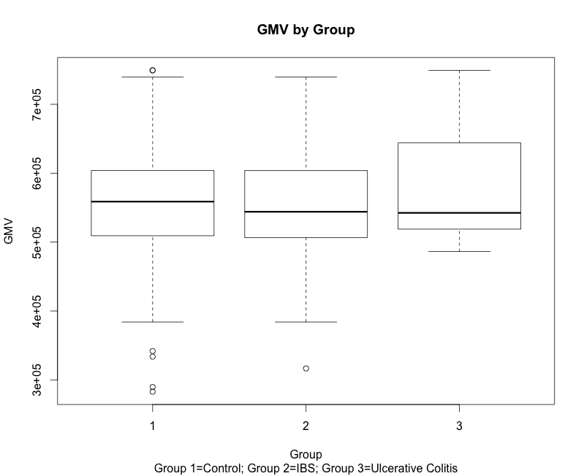

Step 3: Quantitative analysis

This side-by-side boxplot does not indicate much difference among the groups with respect to GMV. Does a quantitative analysis agree with this intuitive conclusion? We will use an ANOVA to find out.

> anova.gmv<-aov(GMV~Group, data=neuro.dat)

> summary(anova.gmv)

Df Sum Sq Mean Sq F value Pr(>F)

Group 2 6.918e+09 3.459e+09 0.583 0.559

Residuals 332 1.968e+12 5.928e+09

Below are the parallel results from SOCR:

Sample Size = 335

Independent Variable = Group

Dependent Variable = GMV

Results of One-Way Analysis of Variance:

Standard 1-Way ANOVA Table. See:

http://wiki.stat.ucla.edu/socr/index.php/AP_Statistics_Curriculum_2007_ANOVA_1Way

===========================================================================================

VarianceSource DF RSS MSS F-Statistics P-value

TreatmentEffect (B/w Groups) 2 6917851866.852 3458925933.426 .583 0.558545154841116

Error 332 1968253851160.922 5928475455.304

Total: 334 1975171703027.774

==============================================================================================

Model:

Degrees of Freedom = 2

Residual Sum of Squares = 6917851866.852

Mean Square Error = 3458925933.426

Error:

Degrees of Freedom = 332

Residual Sum of Squares = 1968253851160.922

Mean Square Error = 5928475455.304

Corrected Total:

Degrees of Freedom = 334

Residual Sum of Squares = 1975171703027.774

F-Value = .583

P-Value = 0.558545154841116

R-Square = .004

Step 4: Interpret the results.

The quantitative analysis does agree with our visual assessment. We fail to reject the null hypothesis. There is not sufficient evidence to conclude that there is a difference in GMV among groups. Assuming the null hypothesis is true (i.e., the mean GMVs of the groups are equal), if we repeated this experiment many times, we would expect to see results this rare or rarer 55.9% of the time.

**Problem 2**: Use [2-way ANOVA](http://wiki.socr.umich.edu/index.php/SMHS_ANOVA#Two-way_ANOVA) (using *gender* and *group* as the 2 factors) on the *R_insular_cortex* volume (insular shape has been reported to be associated with visceral pain, irritable bowel syndrome, and ulcerative colitis). Repeat the analysis using the counterlateral *L_insular_cortex* volume. Report your findings and interpret the results.

Step 1: Generate null and alternative hypotheses and choose a confidence level. We will choose α=0.05.

H01: (Factor 1: Group) There is no difference in right insular cortex volume among the 3 intestinal condition groups.

H02: (Factor 2: Gender) There is no difference in right insular cortex volume between the sexes.

H03: (Interaction) There is no interaction between the two factors (i.e., group and sex) that affects right insular cortex volume.

HA1: (Factor 1: Group) There is a difference in right insular cortex volume among the 3 groups.

HA2: (Factor 2: Gender) There is a difference in right insular cortex volume between the sexes.

HA3: (Interaction) There is an interaction between group and sex that affects right insular cortex volume.

Step 2: Visually explore the data. Here, I provide a depiction of the mean of each group (where group is determined by the combination of sex and intestinal condition, i.e., there are 6 groups) along with a 95% confidence interval for each estimate (i.e., estimate ± 1.96 * SE(estimate)).

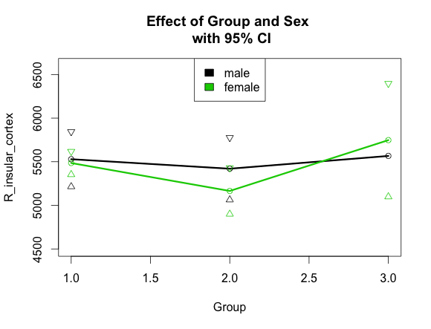

To consider the factor of sex, we look within each Group (i.e., compare the three pairs of points that lie above Groups 1, 2, and 3). We see that sex does not seem to have much effect because the points are close to each other, and the confidence intervals have a great deal of overlap.

Next we can examine the effect of Group by looking at the vertical distance between points of the same color. There seems to be a bit more difference here. Group 2 looks lower than both Groups 1 and 3; although, when we look at the confidence interval, it is not clear that this will be significant.

Finally, we see that the two lines are not parallel to each other, they diverge and then cross. This is indicative of the possibility of an interaction between sex and Group.

Step 3: Quantitative analysis:

> anova.r.ins<-aov(R_insular_cortex~Group*Sex, data=neuro.dat)

> summary(anova.r.ins)

Df Sum Sq Mean Sq F value Pr(>F)

Group 2 5691085 2845542 2.768 0.0643 .

Sex 1 680373 680373 0.662 0.4165

Group:Sex 2 631837 315918 0.307 0.7356

Residuals 329 338228335 1028050

---

Signif. codes: 0 ‘***’ 0.001 ‘**’ 0.01 ‘*’ 0.05 ‘.’ 0.1 ‘ ’ 1

The quantitative analysis shows us that there are no significant effects for α=0.05. The main effect of group has the smallest p-value, at 0.06, but is not below our threshold of α=0.05. We therefore fail to reject the null hypothesis and conclude that these data do not provide evidence for a difference in the mean right insular cortex volume by sex, bowel disorder or an interaction of the two.

Here are the parallel results from SOCR (See below for the settings used in SOCR for left insular cortex):

Sample Size = 335

Dependent Variable = R_insular_cortex

Independent Variable(s) = Group Sex Interaction Group:Sex

*** Two-Way Analysis of Variance Results ***

Standard 2-Way ANOVA Table. See:

http://wiki.stat.ucla.edu/socr/index.php/AP_Statistics_Curriculum_2007_ANOVA_2Way

===========================================================================================

VarianceSource DF RSS MSS F-Statistics P-value

MainEffect:Group 2 5691084.745 2845542.373 2.768 .064

MainEffect:Sex 1 352425.403 352425.403 .343 .559

Interaction Group:Sex 2 699037.743 349518.871 0.307 0.7356

Error 329 338228335.151 1028049.651

Total: 334 345231629.182

===========================================================================================

Variable: Group

Degrees of Freedom = 2

Residual Sum of Squares = 5691084.745

Mean Square Error = 2845542.373

F-Value = 2.768

P-Value = .064

Variable: Sex

Degrees of Freedom = 1

Residual Sum of Squares = 352425.403

Mean Square Error = 352425.403

F-Value = .343

P-Value = .559

Variable: Interaction Group:Sex

Degrees of Freedom = 2

Residual Sum of Squares = 699037.743

Mean Square Error = 349518.871

F-Value = 659.216

P-Value = .000

Residual: Degrees of Freedom = 329

Residual Sum of Squares = 338228335.151

Mean Square Error = 1028049.651

F-Value = 1.362

P-Value = 0.23805506448165337

R-Square = .017

We can repeat the procedure for the data from the left side (left insular cortex). The hypotheses are identical except that ‘right’ is replaced by ‘left’.

Here is the parallel graphical representation of the data:

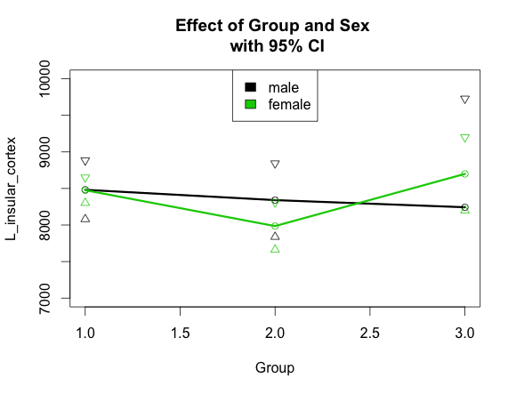

The data appear to be very similar to the right side. Perhaps there is slightly more difference among groups for females in this one. Also, we can note that for males, the pattern is slightly different; group 3 is lower than group 2 rather than higher. However, given the confidence intervals, we would not make much of this observation.

Here are the results of the ANOVA:

> anova.l.ins<-aov(L_insular_cortex~Group*Sex, data=neuro.dat)

> summary(anova.l.ins)

Df Sum Sq Mean Sq F value Pr(>F)

Group 2 12389470 6194735 3.695 0.0259 *

Sex 1 806426 806426 0.481 0.4885

Group:Sex 2 1899498 949749 0.566 0.5681

Residuals 329 551643332 1676727

---

Signif. codes: 0 ‘***’ 0.001 ‘**’ 0.01 ‘*’ 0.05 ‘.’ 0.1 ‘ ’ 1

This time, we find that the effect of Group is in fact significant at the chosen confidence level (i.e., α=0.05). We therefore reject H01 and conclude that there is enough evidence to support HA1. The data suggest that intestinal condition is associated with left insular cortex volume. We note from the pattern in the plot above that group 2 (the IBS group) has the smallest left insular cortex volume. We fail to reject the other null hypotheses and conclude that there is not significant evidence to suggest that there is a relationship between sex and left insular cortex volume, nor does there appear to be a significant interaction between group and sex.

And here are the settings used in SOCR:

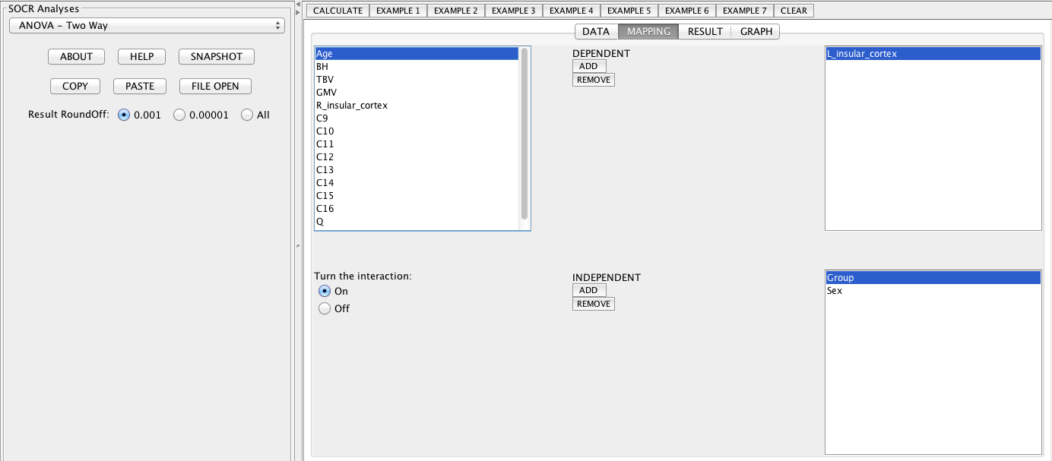

Some graphical output

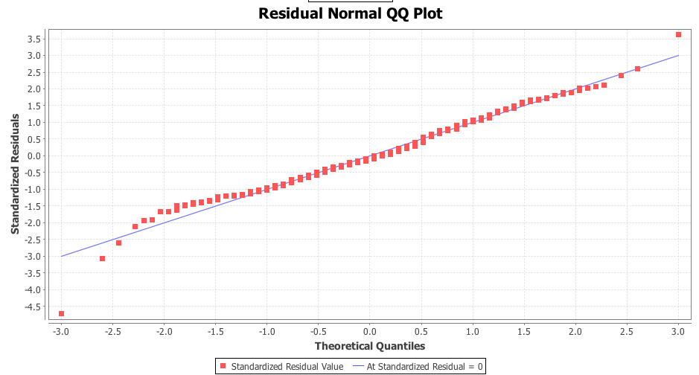

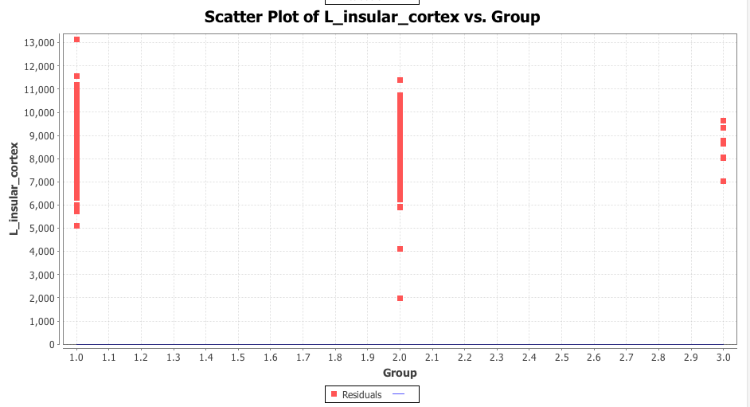

And the numerical results:

Sample Size = 335

Dependent Variable = L_insular_cortex

Independent Variable(s) = Group Sex Interaction Group:Sex

*** Two-Way Analysis of Variance Results ***

Standard 2-Way ANOVA Table. See:

http://wiki.stat.ucla.edu/socr/index.php/AP_Statistics_Curriculum_2007_ANOVA_2Way

===========================================================================================

VarianceSource DF RSS MSS F-Statistics P-value

MainEffect:Group 2 12389469.895 6194734.948 3.695 .026

MainEffect:Sex 1 230366.224 230366.224 .137 .711

Interaction Group:Sex 2 2086365.301 1043182.650 0.58 0.57

Error 329 551643331.746 1676727.452

Total: 334 566738725.415

===========================================================================================

Variable: Group

Degrees of Freedom = 2

Residual Sum of Squares = 12389469.895

Mean Square Error = 6194734.948

F-Value = 3.695

P-Value = .026

Variable: Sex

Degrees of Freedom = 1

Residual Sum of Squares = 230366.224

Mean Square Error = 230366.224

F-Value = .137

P-Value = .711

Variable: Interaction Group:Sex

Degrees of Freedom = 2

Residual Sum of Squares = 2086365.301

Mean Square Error = 1043182.650

F-Value = 0.58

P-Value = 0.57

Residual: Degrees of Freedom = 329

Residual Sum of Squares = 551643331.746

Mean Square Error = 1676727.452

F-Value = 1.801

P-Value = 0.11220599895301875

R-Square = .022

**Problem 3**: Determine a [linear model](http://wiki.socr.umich.edu/index.php/AP_Statistics_Curriculum_2007_GLM_MultLin) of association between the response (Total Brain Volume, TBV) and the following predictors (Group, Sex, and Age). Explain your findings and interpret your model results.

Here is a graphical representation of the data:

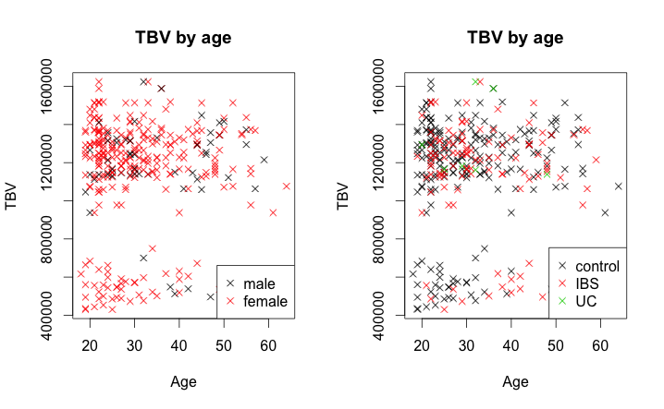

There does not appear to be a strong linear relationship between the two continuous variables (i.e., TBV and Age) nor do any patterns between males and females immediately strike me. I do notice that there are two clusters in the data, one of high total brain volumes and one of low. When looking at the second panel, in which the points are colored according to their group affiliation, we can note that there are no green points (associated with ulcerative colitis) in the bottom cluster. However, there are also very few green points in general, so this pattern might occur frequently by chance. We will now explore these observations quantitatively using a linear model.

> fit2.tbv<-lm(TBV~Group + Age + Sex, data=neuro.dat)

> summary(fit2.tbv)

Call:

lm(formula = TBV ~ Group + Age + Sex, data = neuro.dat)

Residuals:

Min 1Q Median 3Q Max

-709562 -52621 77056 170578 488564

Coefficients:

Estimate Std. Error t value Pr(>|t|)

(Intercept) 1104030 67894 16.261 <2e-16 ***

Group2 -1758 33866 -0.052 0.959

Group3 149347 109664 1.362 0.174

Age 1908 1550 1.231 0.219

Sex2 -10384 43301 -0.240 0.811

---

Signif. codes: 0 ‘***’ 0.001 ‘**’ 0.01 ‘*’ 0.05 ‘.’ 0.1 ‘ ’ 1

Residual standard error: 283600 on 330 degrees of freedom

Multiple R-squared: 0.0112, Adjusted R-squared: -0.0007876

F-statistic: 0.9343 on 4 and 330 DF, p-value: 0.4442

The only coefficient with a significant p-value is the intercept. This means that the intercept for the linear model is significantly different from 0 – a result that is not particularly surprising or interesting. None of the independent variables significantly predict TBV (e.g., all p-values are greater than 0.1). Additionally, looking at the coefficient of determination, R-squared, we can see that very little of the variation in the data is explained by the model (i.e., the number is quite close to 0). In fact, the adjusted R-squared, which takes into account the fact that additional parameters may not actually be providing useful additional information, is negative.

Here is the parallel analysis and its results in SOCR:

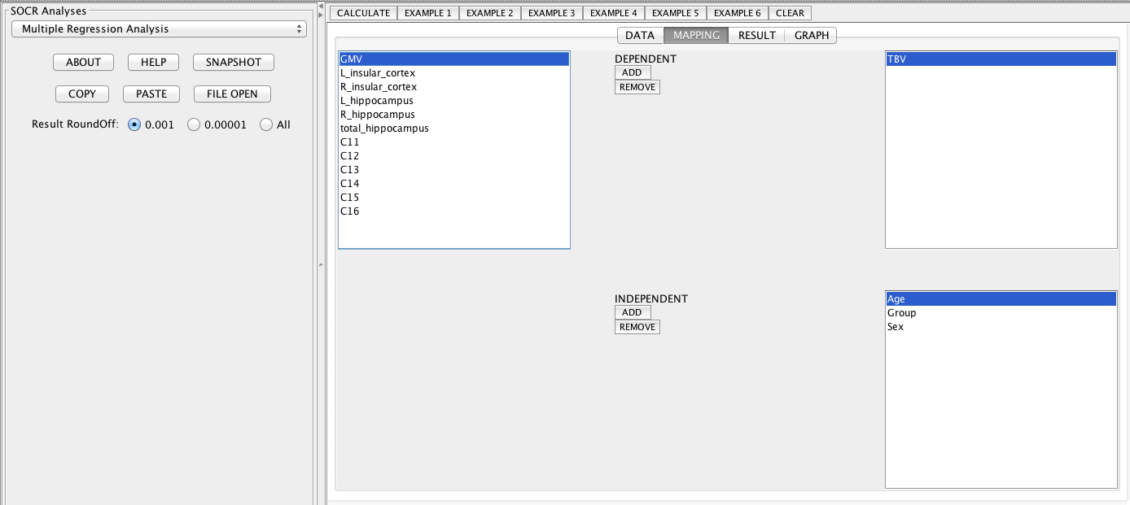

A useful scatter plot (one of several):

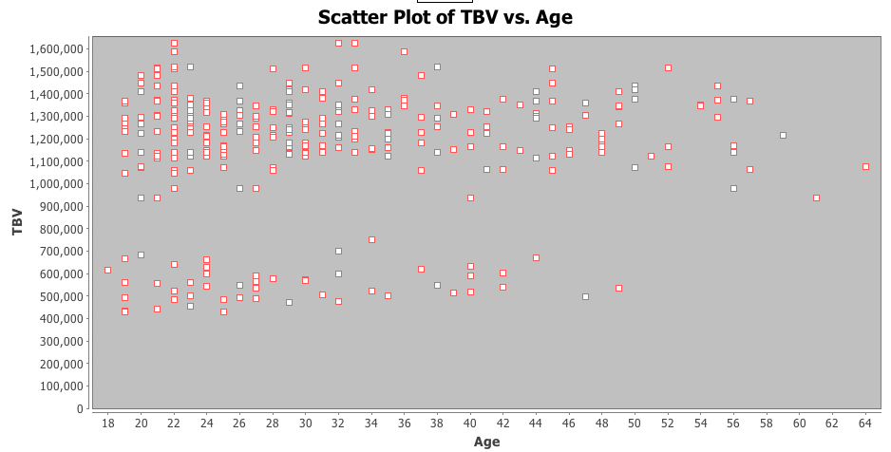

And the numerical results:

Number of Independent Variable(s) = 3

Sample Size =335

Dependent Variable = TBV

Independent Variable(s) = Sex Group Age

Regression Model:

TBV = 1101253.901 +1794.449*Age +17419.881*Group -12801.616*Sex + E.

INTERCEPT:

Estimate = 1101253.901

Standard Error = 111651.598

T-Value = 9.863

P-Value = .000

Age:

Estimate = 1794.449

Standard Error = 1548.471

T-Value = 1.159

P-Value = .247

Group:

Estimate = 17419.881

Standard Error = 30223.589

T-Value = .576

P-Value = .565

Sex:

Estimate = -12801.616

Standard Error = 43294.901

T-Value = -.296

P-Value = .768

R-Square = .007

**Problem 4**: Do people with larger brains necessarily have bigger hippocampal volumes (e.g., L_hippocampus + R_hippocampus)? Formulate a research hypothesis, propose an appropriate statistical technique, apply the corresponding software tool, and report your findings.

H0: Larger brains are not associated with larger hippocampal volumes.

HA: Hippocampal volumes are associated with total brain sizes.

To assess this hypothesis, we can generate a linear model of the form:

*Brain size = intercept + β * total hippocampal volume + ε*

We can then assess whether the slope of the best fit line is significantly different from 0. Assume again α=0.05.

Graphically, we can represent the data and model as follows.

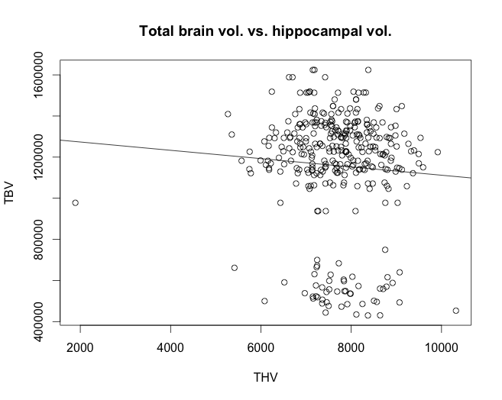

We note a few things about the data. (1) There appears to be a THV outlier. (2) There are two clusters of points with respect to TBV.

> fit.tbm.thv <- lm(TBV~THV, data=neuro.dat)

> summary(fit.tbm.thv)

Call:

lm(formula = TBV ~ THV, data = neuro.dat)

Residuals:

Min 1Q Median 3Q Max

-719034 -46161 75305 176718 481169

Coefficients:

Estimate Std. Error t value Pr(>|t|)

(Intercept) 1319948.47 132670.25 9.949 <2e-16 ***

THV -21.12 17.15 -1.232 0.219

---

Signif. codes: 0 ‘***’ 0.001 ‘**’ 0.01 ‘*’ 0.05 ‘.’ 0.1 ‘ ’ 1

Residual standard error: 283300 on 333 degrees of freedom

Multiple R-squared: 0.004535, Adjusted R-squared: 0.001546

F-statistic: 1.517 on 1 and 333 DF, p-value: 0.2189

The results suggest that the slope is not significantly different from 0. We therefore fail to reject our null hypothesis and conclude that there is not sufficient evidence to suggest that a relationship exists between hippocampal volumes and brain size. The sign of the coefficient tells us that there is a slight negative relationship between THV and TBV. In particular, an increase of 1 unit of THV is associated with a decrease of 20 units in TBV. However, this relationship is not significant. Additionally, we note the very small R-squared value, indicating that the model does not explain much of the variation in the data.

Here is the parallel analysis and its results from SOCR:

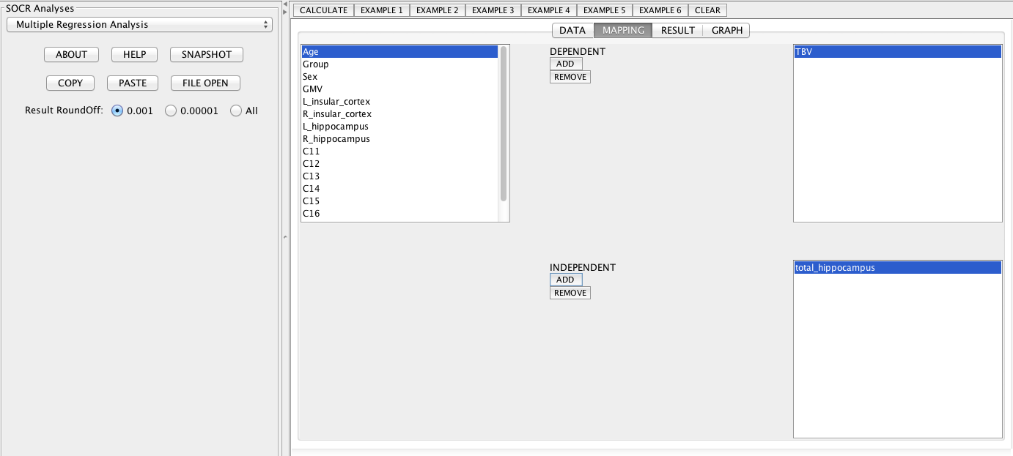

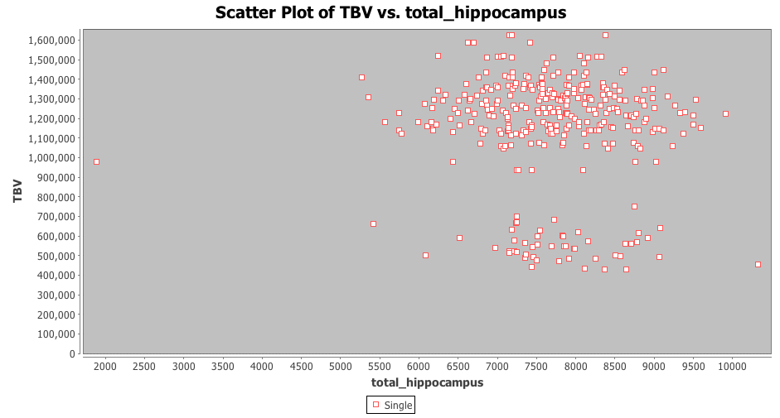

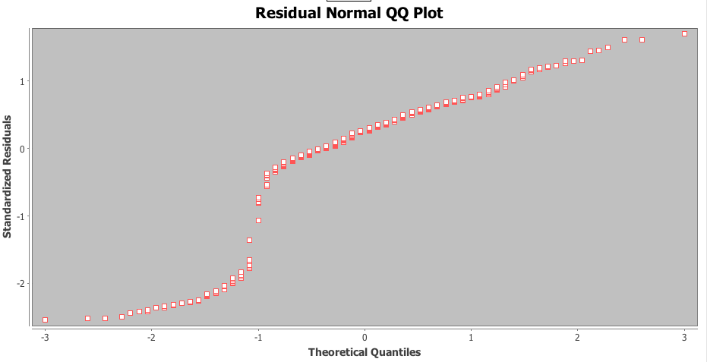

The lack of a match between the normal distribution and the distribution of the residuals (i.e., the points do not fall on the 1-to-1 line but are instead S-shaped) suggests that perhaps this model is not the most appropriate. For now, however, we will continue with the analysis as is. In the future, we will consider other types of linear model formulations that might better capture the variation in the data.

Here are the numerical results:

Number of Independent Variable(s) = 1

Sample Size =335

Dependent Variable = TBV

Independent Variable(s) = total_hippocampus

Regression Model:

TBV = 1319948.469 -21.119*total_hippocampus + E.

INTERCEPT:

Estimate = 1319948.469

Standard Error = 132670.254

T-Value = 9.949

P-Value = .000

total_hippocampus:

Estimate = -21.119

Standard Error = 17.146

T-Value = -1.232

P-Value = .219

R-Square = .005

Appendix: R Code

#####################

# SMHS851 HW 3

# 10.1.14

# Jennie Lavine

#####################

setwd('~/hw3_851')

neuro.dat<-read.csv('neuroimage.csv',header=T)

#######################

#clean data of interest

######################

neuro.dat$Group<-as.factor(neuro.dat$Group)

table(neuro.dat$Group)

neuro.dat<-subset(neuro.dat, neuro.dat$Group!=5)

#Remove unused levels from the factor 'Group'

neuro.dat$Group<-factor(neuro.dat$Group)

############################

#Take a look at your data

############################

#Side by side boxplots

boxplot(GMV~Group, data=neuro.dat, xlab='Group', ylab='GMV',

main='GMV by Group',

sub='Group 1=Control; Group 2=IBS; Group 3=Ulcerative Colitis'

)

#Histograms of each group

par(mfrow=c(3,1))

hist(neuro.dat$GMV[neuro.dat$Group=='1'])

hist(neuro.dat$GMV[neuro.dat$Group=='2'])

hist(neuro.dat$GMV[neuro.dat$Group=='3'])

#Run an ANOVA

anova.gmv<-aov(GMV~Group, data=neuro.dat)

summary(anova.gmv)

#Fit a linear model, then show ANOVA results (same results as above)

fit.gmv<-lm(GMV~Group, data=neuro.dat)

anova(fit.gmv)

#######################

#Problem 2

########################

neuro.dat$Sex<-factor(neuro.dat$Sex)

anova.r.ins<-aov(R_insular_cortex~Group*Sex, data=neuro.dat)

summary(anova.r.ins)

anova.l.ins<-aov(L_insular_cortex~Group*Sex, data=neuro.dat)

summary(anova.l.ins)

##########################

#Problem 3

#########################

#This is a full model with all possible interactions

fit.tbv<-lm(TBV~Group*Sex*Age, data=neuro.dat)

par(mfrow=c(1,2))

plot(TBV~Age, data=neuro.dat, col=neuro.dat$Sex, pch=4, main='TBV by age')

legend('bottomright', legend=c('male','female'), pch=4, col=1:2)

plot(TBV~Age, data=neuro.dat, col=neuro.dat$Group, pch=4, main='TBV by age')

legend('bottomright', legend=c('control','IBS', 'UC'), pch=4, col=1:3)

summary(fit.tbv)

anova(fit.tbv)

#This is a model that considers the effect of each variable independently

#It does not take interactions into account

fit2.tbv<-lm(TBV~Group + Age + Sex, data=neuro.dat)

summary(fit2.tbv)

###########################

#Problem 4

#########################

neuro.dat$THV<-neuro.dat$L_hippocampus + neuro.dat$R_hippocampus

par(mfrow=c(1,1))

fit.tbm.thv <- lm(TBV~THV, data=neuro.dat)

summary(fit.tbm.thv)

plot(TBV~THV, data=neuro.dat, main='Total brain vol. vs. hippocampal vol.')

abline(fit.tbm.thv)

#####################

#Extra code: Calculating summary statistics and plotting for 2-way ANOVA

#####################

sum.stats<-matrix(NA, ncol=6, nrow=11)

colnames(sum.stats)<-c('mean','sd','n','SEM', 'ci90.lo','ci90.hi')

rownames(sum.stats)<-c('group1','group2','group3','male','female',

'group1:male','group2:male','group3:male',

'group1:female','group2:female','group3:female')

for(i in 1:3){

sum.stats[i,'mean']<-mean(neuro.dat$R_insular_cortex[neuro.dat$Group==i])

sum.stats[i,'sd']<-sd(neuro.dat$R_insular_cortex[neuro.dat$Group==i])

sum.stats[i,'n']<-sum(neuro.dat$Group==i)

sum.stats[i,'SEM']<-sum.stats[i,'sd']/sqrt(sum.stats[i,'n'])

}

for(i in 1:2){

sum.stats[3+i,'mean']<-mean(neuro.dat$R_insular_cortex[neuro.dat$Sex==i])

sum.stats[3+i,'sd']<-sd(neuro.dat$R_insular_cortex[neuro.dat$Sex==i])

sum.stats[3+i,'n']<-sum(neuro.dat$Sex==i)

sum.stats[3+i,'SEM']<-sum.stats[3+i,'sd']/sqrt(sum.stats[3+i,'n'])

}

for(i in 1:3){

sum.stats[5+i,'mean']<-mean(

neuro.dat$R_insular_cortex[neuro.dat$Group==i & neuro.dat$Sex==1])

sum.stats[5+i,'sd']<-sd(

neuro.dat$R_insular_cortex[neuro.dat$Group==i& neuro.dat$Sex==1])

sum.stats[5+i,'n']<-sum(neuro.dat$Group==i & neuro.dat$Sex==1)

sum.stats[5+i,'SEM']<-sum.stats[5+i,'sd']/sqrt(sum.stats[5+i,'n'])

}

for(i in 1:3){

sum.stats[8+i,'mean']<-mean(

neuro.dat$R_insular_cortex[neuro.dat$Group==i & neuro.dat$Sex==2])

sum.stats[8+i,'sd']<-sd(

neuro.dat$R_insular_cortex[neuro.dat$Group==i& neuro.dat$Sex==2])

sum.stats[8+i,'n']<-sum(neuro.dat$Group==i & neuro.dat$Sex==2)

sum.stats[8+i,'SEM']<-sum.stats[8+i,'sd']/sqrt(sum.stats[8+i,'n'])

}

sum.stats[,'ci90.lo']<-sum.stats[,'mean']-1.64*sum.stats[,'SEM']

sum.stats[,'ci90.hi']<-sum.stats[,'mean']+1.64*sum.stats[,'SEM']

#Plot effect of group

par(mfrow=c(1,2))

plot(as.factor(1:3),sum.stats[1:3,'mean'], ylim=c(4000,7100),

xlab='Group', ylab='R_insular_cortex', main='Effect of Group', type='n')

points(sum.stats[,'ci90.lo'], col=2)

points(sum.stats[,'ci90.hi'], col=2)

plot(as.factor(1:2),sum.stats[4:5,'mean'], ylim=c(5000,6000),

xlab='Sex', ylab='R_insular_cortex', main='Effect of Sex')

points(sum.stats[4:5,'mean']+1.96*sum.stats[4:5,'SEM'], col=2)

points(sum.stats[4:5,'mean']-1.96*sum.stats[4:5,'SEM'], col=2)

par(mfrow=c(1,1))

plot(1:3,sum.stats[6:8,'mean'], ylim=c(4500,6600),

xlab='Group', ylab='R_insular_cortex', main='Effect of Group and Sex \n with 90% CI', type='b')

points(sum.stats[6:8,'mean']+1.64*sum.stats[6:8,'SEM'], col=1, pch=6)

points(sum.stats[6:8,'mean']-1.64*sum.stats[6:8,'SEM'], col=1, pch=2)

lines(1:3, sum.stats[6:8,'mean'], lwd=3)

points(as.factor(1:3),sum.stats[9:11,'mean'],col=3)

points(sum.stats[9:11,'mean']+1.64*sum.stats[9:11,'SEM'], col=3, pch=6)

points(sum.stats[9:11,'mean']-1.64*sum.stats[9:11,'SEM'], col=3, pch=2)

lines(1:3, sum.stats[9:11,'mean'], lwd=3,col=3)

legend('top',legend=c('male','female'),fill=c(1,3))

1. Note 1: The full R code is included as an appendix at the end.
2. Note 2: The lines in the dataset corresponding to Group=5 were removed. There were only 2 individuals in this group.