**Scientific Methods for Health Sciences: Applied Inference (HS851): Fall 2014**

[**http://www.socr.umich.edu/people/dinov/2014/Fall/HS851**](http://www.socr.umich.edu/people/dinov/2014/Fall/HS851)

**Homework 4 Solutions**

Use the [SOCR Neuroimaging dataset](http://wiki.socr.umich.edu/index.php/SOCR_Data_April2011_NI_IBS_Pain) of visceral pain, irritable bowel syndrome, ulcerative colitis, and Crohn's disease.

**Problem 1**: Is there evidence of hippocampal volume asymmetry in the IBS cohort? Formulate an appropriate research hypothesis, identify a suitable statistical technique, apply the corresponding software tool, and report your findings.

H0: The mean difference between right and left hippocampal volumes is equal to 0.

HA: The mean difference between right and left hippocampal volumes is not 0.

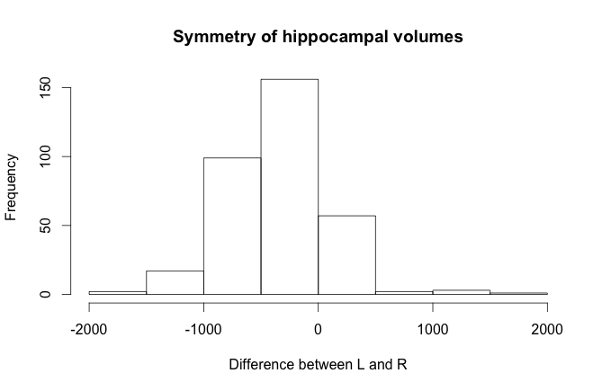

A histogram of the difference between the two data sets reveal that the right hippocampus is a bit larger on average. The differences appear relatively normally distributed. We apply a paired t-test to assess our hypothesis.

We find a t-value of -14.74 with 336 df, which results in a p-value of less than 2.2E-16. We therefore reject the null hypothesis and conclude that there is significant evidence to suggest that the right and left hippocampi have different volumes.

**Problem 2**: Assume the gender distributions of the participants in this study accurately represents the 4 cohorts (Normals, IBS, Ulcerative Colitis and Crohn's disease). Let's say we wish to compare the proportions of males in the Normals and IBS groups. Use the [Methods of Moments](http://wiki.socr.umich.edu/index.php/SMHS_CIs#Method_of_Moments_.28MOM.29_Estimation) to compute estimates (p1 and p2) of the probabilities that a randomly selected male is from the asymptomatic normal control group (p1) and a randomly selected male is from the IBS control group (p2). Once you find the point estimates (p1 and p2), perform a statistical test to assess the differences between the proportions of males in the Normals and IBS groups. Note that you need to invert the conditioning: p'1=P(male|NC), and p'2=P(male|IBS). What is the [confidence interval](http://wiki.stat.ucla.edu/socr/index.php/AP_Statistics_Curriculum_2007_Estim_Proportion#Confidence_intervals_for_proportions) of the difference p'1 - p'2?

|  |  |  |  |
| --- | --- | --- | --- |
|  | Male | Female | **Totals** |
| Normal | 27 | 194 | **221** |
| IBS | 24 | 83 | **107** |
| **Totals** | **51** | **277** | **328** |

H0 : The difference between the proportions of males in the normal and control groups equals 0.

HA : The difference between the proportions of males in the normal and control groups is not equal to 0.

α = 0.05

Assume a binomial model, X~Bin(n,p), where n is the number of trials (i.e., total number of males) and p is the number of successes (i.e., asymptomatic for p1 and symptomatic for p2).

$$p_{1}=P\left(NC | male\right)=\frac{27}{51}=0.53$$

$$p_{2}=P\left(IBS | male\right)=\frac{24}{51}=0.47$$

E[X] = n*p

n*p1 = 27

n*p2 = 24

n=51

p1=27/51 = 0.53

p2=24/51 = 0.47

We ca use the inversion of conditioning to compute p’1 and p’2 (or we can compute it directly from the given data in the table).

${{p'}_{1}}^{}=P\left(male | NC\right)=P\left(NC | male\right)\frac{P\left(male\right)}{P\left(NC\right)}=\frac{27}{51}\frac{51/328}{221/328}=\frac{27}{51}\frac{51}{221}=0.1221719$,

${{p'}_{2}}^{}=P\left(male | IBS\right)=P\left(IBS | male\right)\frac{P\left(male\right)}{P\left(IBS\right)}=\frac{24}{51}\frac{51/328}{107/328}=\frac{24}{51}\frac{51}{107}=0.2242991.$

${p'}_{1}$ = Proportion of males in normal group: 27/221 = 0.122

${p'}_{2}$ = Proportion of males in IBS group: 24/107 = 0.224

Difference in proportions: (27/221)-(24/107) = -0.102

n1=248

n2=131

SE(p’1-p’2) = (sqrt(p’1*(1-p’1)/n1 + (p’2*(1-p’2)/n2))

Z-score: Zo = -0.102 / SE(p’1-p’2) = -2.22

P(Z<Zo) = 0.0132

Since 0.0132*2=0.0264<0.05

The p-value is less than α; therefore, we reject the null hypothesis and conclude that there is a significant difference between the proportion of males in the IBS group and that in the control group.

95% CI: [(p’1-p’2)-1.96*SE; (p’1-p’2)+1.96*SE)]= [-0.01207; -0.19218]

This interval does not include 0, so our confidence interval agrees with our test that the difference is significant.**Problem 3**: Use the [SOCR Fligner-Killeen test](http://wiki.socr.umich.edu/index.php/SMHS_NonParamInference#Fligner-Killeen_test) to investigate if the variances of the white matter volume (WMV) between the 3 cohorts (Normals, IBS, Ulcerative Colitis) are significantly different. Why is this important? Repeat this analysis looking for differences in the variability of the gray matter volume (GMV) in the controls group between genders. Elaborate on your findings.

It is important to know whether variances among groups are similar because many other statistical tests (e.g., ANOVA) rely on the assumption that variances among groups are equal.

WMV in 3 groups

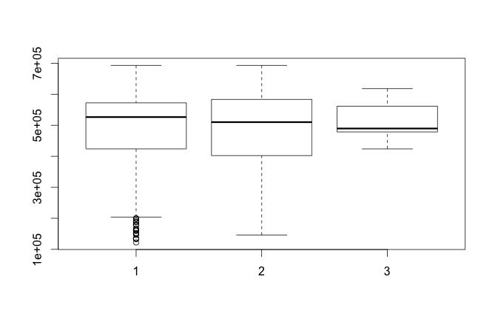

Group 1: Controls

Group 2: IBS

Group 3: Ulcerative colitis

R code:

fligner.test(list(wmv.1, wmv.2, wmv.3))

Fligner-Killeen test of homogeneity of variances

data: list(wmv.1, wmv.2, wmv.3)

Fligner-Killeen:med chi-squared = 3.0595, df = 2, p-value = 0.2166

The high p-value (0.2166) suggests that the variances in WMV among the three groups are not significantly different.

The parallel results from SOCR:

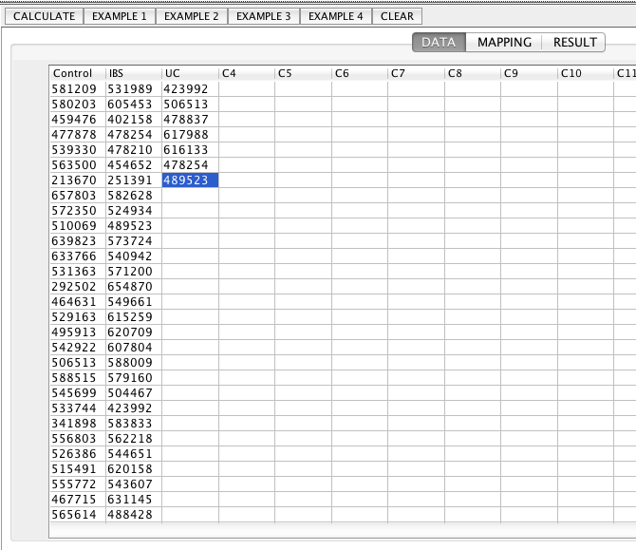

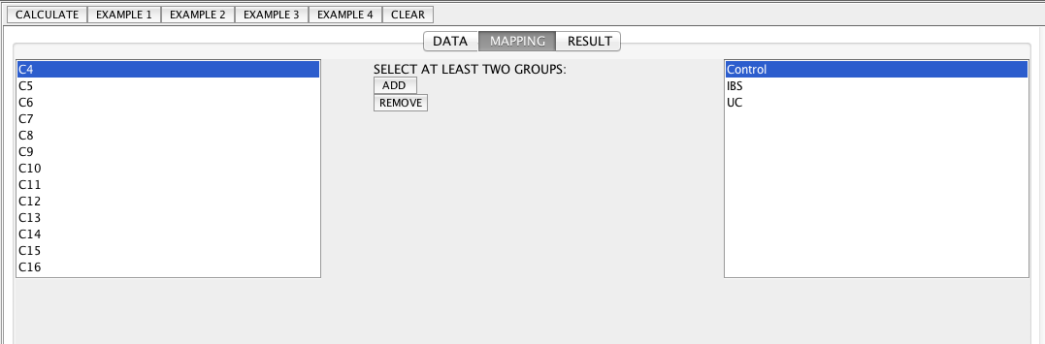

Group Control

median = 526386.0

Group IBS

median = 510069.0

Group UC

median = 489523.0

Total Size = 335

Total Mean Score = .795

Total Variance = .354

Degrees of Freedom = 2

Chi-Square Statistic = 3.060

P-Value = .217

GMV among groups

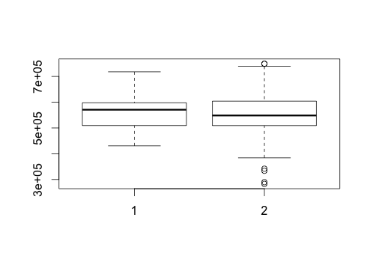

> fligner.test(list(gmv.1, gmv.2))

Fligner-Killeen test of homogeneity of variances

data: list(gmv.1, gmv.2)

Fligner-Killeen:med chi-squared = 0.277, df = 1, p-value = 0.5987

The high p-value (0.5987) suggests that the variances in GMV among the two groups are not significantly different.

The parallel analysis and results in SOCR:

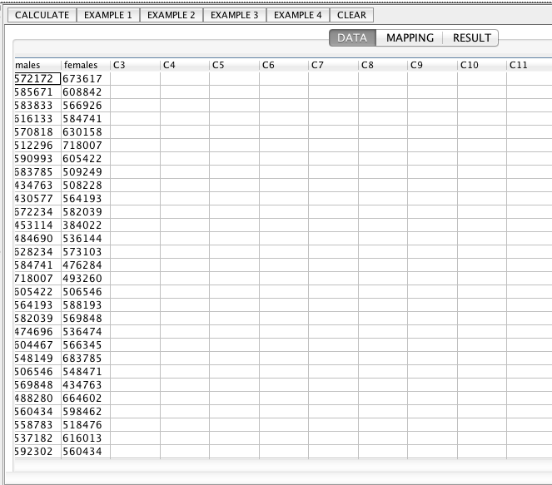

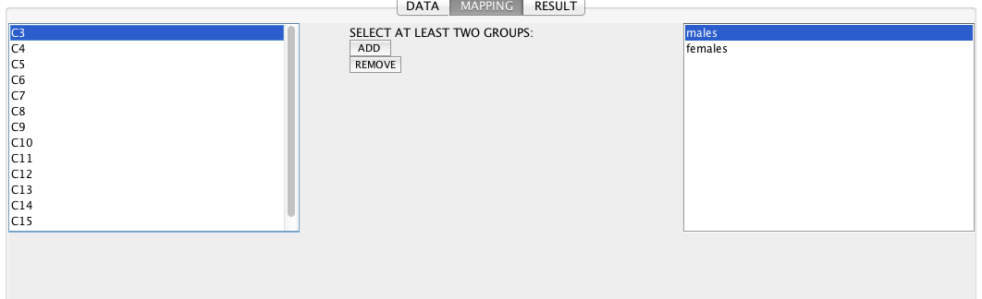

Results:

Group C1

median = 553466.0

Group C2

median = 548471.0

Total Size = 337

Total Mean Score = .795

Total Variance = .354

Degrees of Freedom = 1

Chi-Square Statistic = .277

P-Value = .599

**Problem 4**: Complete the following table, where *patients* indicates all study participant except the asymptomatic controls.

|  |  |  |  |
| --- | --- | --- | --- |
| Groups | Patients | Controls | Total |
| Female | 89 | 194 | 283 |
| Male | 27 | 27 | 54 |
| Total | 221 | 116 | 337 |

Compute a [point estimate and a 95% CI for the Odds Ratio](http://wiki.socr.umich.edu/index.php/SMHS_AssociationTests) of controls relative to gender. Next, apply the [χ2 association test](http://wiki.socr.umich.edu/index.php/SMHS_AssociationTests#Chi-square_test) to investigate for association between participants' gender and diagnosis.

Odds of being female given being a patient compared to the odds of being female given being a control.

OR: (89/27) / (194 / 27) = 0.46

log(OR) = -0.78

SE(log(OR)) = sqrt(1/89 + 1/27 + 1/194 + 1/27)

CI(log(OR)) = [log(OR) – 1.96 * SE, log(OR)+1.96*SE] = [-1.37, -0.19]

CI(OR) = exp (CI(log(OR)) = [0.25, 0.83]

The 95% confidence interval does not include 1, so we can conclude that the odds of being female is higher among controls than among patients.

Chi-squared test

> chisq.test(tab, correct=F)

Pearson's Chi-squared test

data: tab

X-squared = 6.9136, df = 1, p-value = 0.008554

The low p-value of 0.009 suggests that the distribution of gender is not independent of disease status.

The parallel results from SOCR:

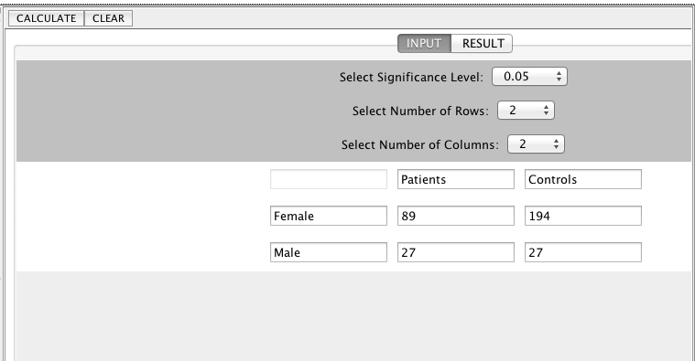

Results of Chi-Square Test for Independent or Homogeneity

Number of Rows = 2

Number of Columns = 2

Patients Controls Row Total

------------------------------------------------------------------------------------------

Female 89.0 (97.412) 194.0 (185.588) 283

Male 27.0 (18.588) 27.0 (35.412) 54

------------------------------------------------------------------------------------------

Col Total 116 221 337

Degrees of Freedom = 1

Pearson Chi-Square Statistics = 6.914

P-Value = 0.008554158887597696

**Appendix: R code**

##################################

# HW 4

# Jennie Lavine

# 10.29.14

##################################

#The data, hw4.csv, was imported by copying the data from

#<http://wiki.socr.umich.edu/index.php/SOCR_Data_April2011_NI_IBS_Pain>,

#pasting it into an Excel spreadsheet,

#and saving as a comma-separated (i.e., .csv) file.

setwd('~/hw4_851')

dat<-read.csv('hw4.csv')

##########################################

# Problem 1

##########################################

mean(dat$L_hippocampus)

mean(dat$R_hippocampus)

par(mfrow=c(2,1))

hist(dat$L_hippocampus)

hist(dat$R_hippocampus)

par(mfrow=c(1,1))

hist(dat$L_hippocampus-dat$R_hippocampus, main='Symmetry of hippocampal volumes',

xlab='Difference between L and R')

hippo_t.test <- t.test(x=dat$L_hippocampus, y=dat$R_hippocampus, paired=T)

hippo_t.test

################################################

#Problem 2

################################################

datsub<-subset(dat, dat$Group==1 | dat$Group==2)

datsub<-datsub[,c('Group','Sex')]

margin.table(table(datsub), 1)

margin.table(table(datsub), 2)

prop.table(table(datsub))

p1 <- 27/51

p2 <- 24/51

p1=27/221

p2=24/107

n1=27+221

n2=24+107

zscore = (p1-p2 / (sqrt( p1*(1-p1)/n1 + (p2*(1-p2)/n2)))

pnorm(zscore, 0, 1)

conf.int.95<- c(

(p1-p2)-1.96*(sqrt( p1*(1-p1)/n1 + (p2*(1-p2)/n2))),

(p1-p2)+1.96*(sqrt( p1*(1-p1)/n1 + (p2*(1-p2)/n2)))

)

################################################

#Problem 3

################################################

wmv.1<-dat$WMV[dat$Group==1]

wmv.2<-dat$WMV[dat$Group==2]

wmv.3<-dat$WMV[dat$Group==3]

datsub<-subset(dat, dat$Group!=5)

datsub$Group<-factor(datsub$Group)

boxplot(WMV~as.factor(Group), data=datsub)

fligner.test(list(wmv.1, wmv.2, wmv.3))

gmv.1<-dat$GMV[dat$Group==1]

gmv.2<-dat$GMV[dat$Group==2]

gmv.3<-dat$GMV[dat$Group==3]

datsub<-subset(dat, dat$Group!=5)

datsub$Group<-factor(datsub$Group)

boxplot(GMV~as.factor(Group), data=datsub)

fligner.test(list(gmv.1, gmv.2, gmv.3))

#######################################

#Problem 4

#######################################

datsub<-dat[, c('Group','Sex')]

datsub$group.bin<-NA

datsub$group.bin[datsub$Group==1]<-1

datsub$group.bin[datsub$Group!=1]<-2

tab<-table(datsub[,2:3])

margin.table(tab,1)

margin.table(tab,2)

sum(tab)

OR <- (89*27)/(194*27)

log(OR)

se.log.or <- sqrt(sum(1/c(tab)))

ci.log.or<- c(log(OR)-1.96*se.log.or, log(OR)+1.96*se.log.or)

exp(ci.log.or)

chisq.test(tab, correct=F)