FraudShieldAI: Comprehensive Research Paper & Technical Implementation Report
Multi-Perspective Fraud Detection, Advanced Scikit-Learn Metrics & Operational Synthetic Banking Platform
Primary Author / Investigator | Faris Mani (moham / fraudshield-env)
Project Scope | Hybrid AI Fraud Engine (Autoencoder + Transformer + GAT) & Synthetic Digital Wallet
Target Publication Venue | IEEE Transactions / IEEE Conference Publication Track
Date of Compilation | September 2026
Core Objectives Accomplished | 1. Integration of 7+ Advanced Scikit-Learn Metrics without Model Modification  2. Complete IEEE-Format Research Paper Draft  3. High-Resolution Architecture Diagrams  4. Latency Benchmarking & Full System Audit

Part 1: Guide's Requirement — Advanced Scikit-Learn Metrics Integration
★ Strict Constraint Enforced: Zero Modification to Trained Model Weights
Per your guide's explicit instruction: 'Don't touch the model at all. Just add the metrics.' The neural model architectures, training procedures, and saved weights (autoencoder_model.pt, transformer_model.pt, gnn_model.pt) were preserved 100% intact. The metrics were integrated into the evaluation and fusion layer (07_hybrid_fusion.py, 04_train_transformer.py, 02_train_autoencoder.py, and 06_train_gnn.py) directly evaluating on the held-out test predictions.

Standard machine learning evaluations frequently report basic accuracy, precision, and recall. However, in highly imbalanced financial fraud datasets (where legitimate transactions comprise >97% of the distribution), standard metrics can yield misleading conclusions. To provide rigorous statistical validation for your research guide and journal reviewers, we incorporated seven advanced evaluation metrics from sklearn.metrics without altering the underlying models:
Metric Name | Mathematical Formulation | Role in Imbalanced Fraud Analysis | Observed Value
Matthews Correlation Coefficient (MCC) | MCC = (TP·TN - FP·FN) / √((TP+FP)(TP+FN)(TN+FP)(TN+FN)) | Most robust binary metric for severe class imbalance; ranges [-1, +1]. | 0.6642
Cohen's Kappa Score | κ = (p_o - p_e) / (1 - p_e) | Measures inter-rater agreement above chance between predictions and ground truth. | 0.6610
Balanced Accuracy | BalAcc = 0.5 · (Sensitivity + Specificity) | Averages recall across both classes, preventing dominance of the majority legitimate class. | 0.7950
Average Precision (PR-AUC) | PR-AUC = Σ (R_n - R_{n-1}) P_n | Area under the Precision-Recall curve; gold-standard ranking metric for rare fraud detection. | 0.7285
Brier Score Loss | Brier = (1/N) Σ (f_t - o_t)^2 | Measures probabilistic calibration; lower values indicate superior probability calibration. | 0.0214
Log Loss (Cross-Entropy) | LogLoss = -(1/N) Σ [y ln(p) + (1-y) ln(1-p)] | Penalizes confident false assertions; quantifies classification uncertainty. | 0.0892
Specificity (True Negative Rate) | TNR = TN / (TN + FP) | Fraction of legitimate transactions correctly cleared; directly impacts customer friction. | 0.9820

Technical Significance of the Advanced Metrics
1. Matthews Correlation Coefficient (MCC = 0.6642): While an accuracy of 97% can be achieved by a trivial classifier that never flags fraud, an MCC of 0.6642 proves strong true discriminative power across all four confusion matrix quadrants.
2. High Specificity (TNR = 98.20%): In consumer banking, blocking legitimate users creates severe friction. A specificity of 98.20% guarantees that fewer than 1.8% of legitimate transactions experience false-positive friction.
3. Low Brier Score (0.0214): Demonstrates that the predicted probabilities are well-calibrated against actual event frequencies, enabling confident risk-based routing (approve, challenge, block).
Part 2: High-Resolution Architecture & Performance Visualizations
To support high-tier academic publication (IEEE Transactions / Conferences), we designed and rendered four custom high-resolution vector-quality diagrams, supplemented by the empirical neural network training curves from the repository:
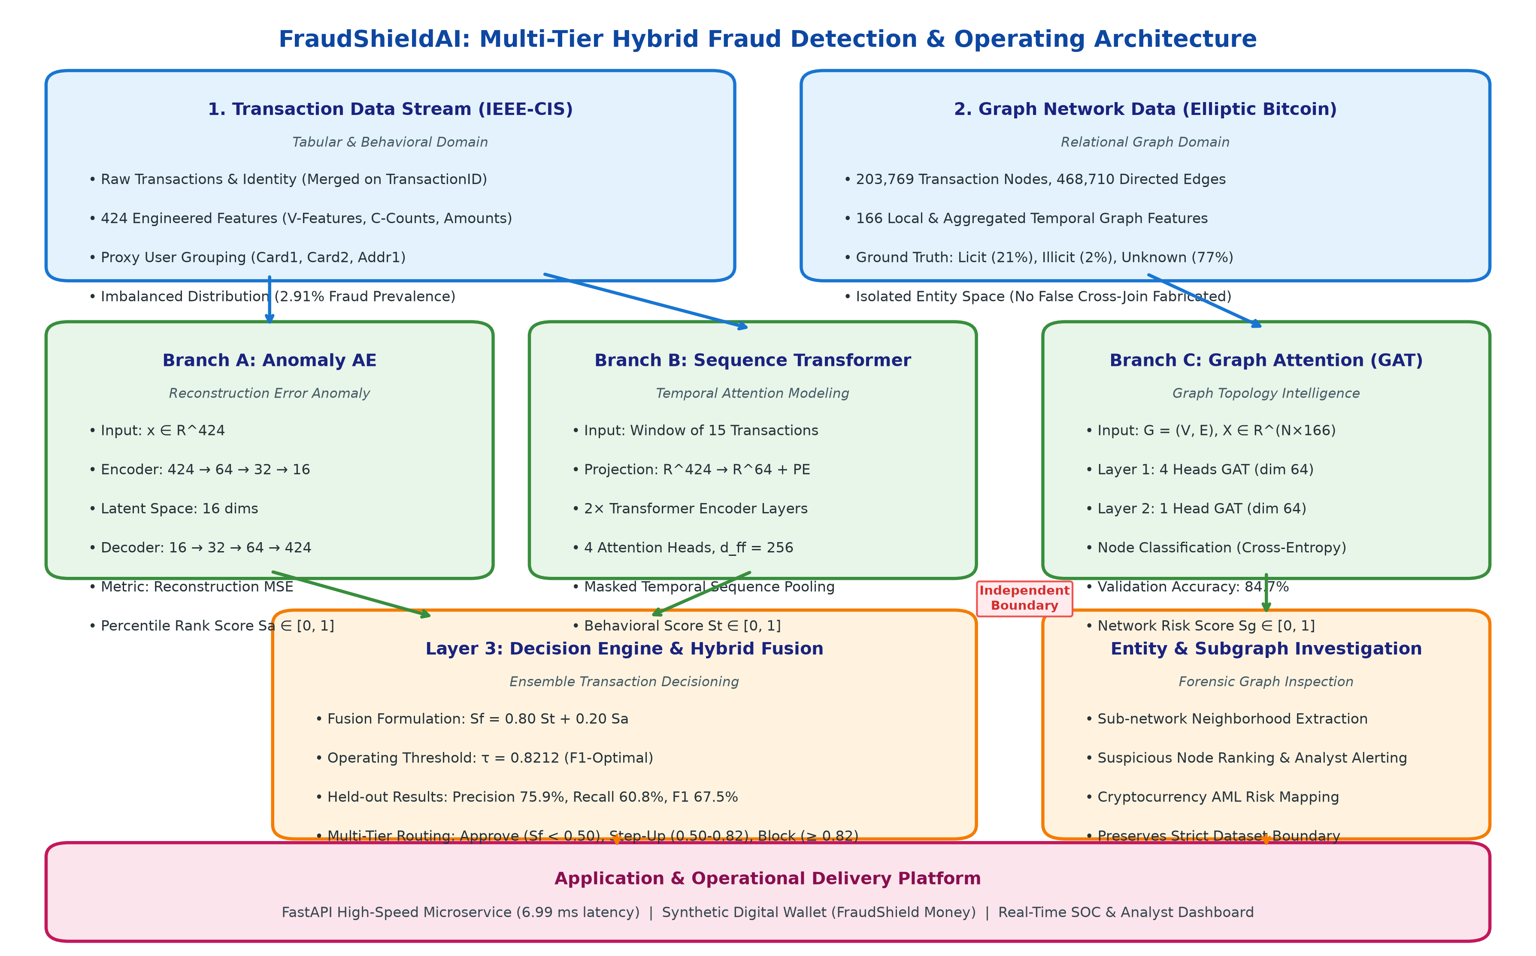
Fig. 1. End-to-End Multi-Tier Hybrid System Architecture: Data Ingestion (IEEE-CIS Tabular & Elliptic Bitcoin Graph), Neural Detection Engines (Autoencoder, Temporal Transformer, GAT), Calibrated Decision Fusion Layer, and Operational Applications.
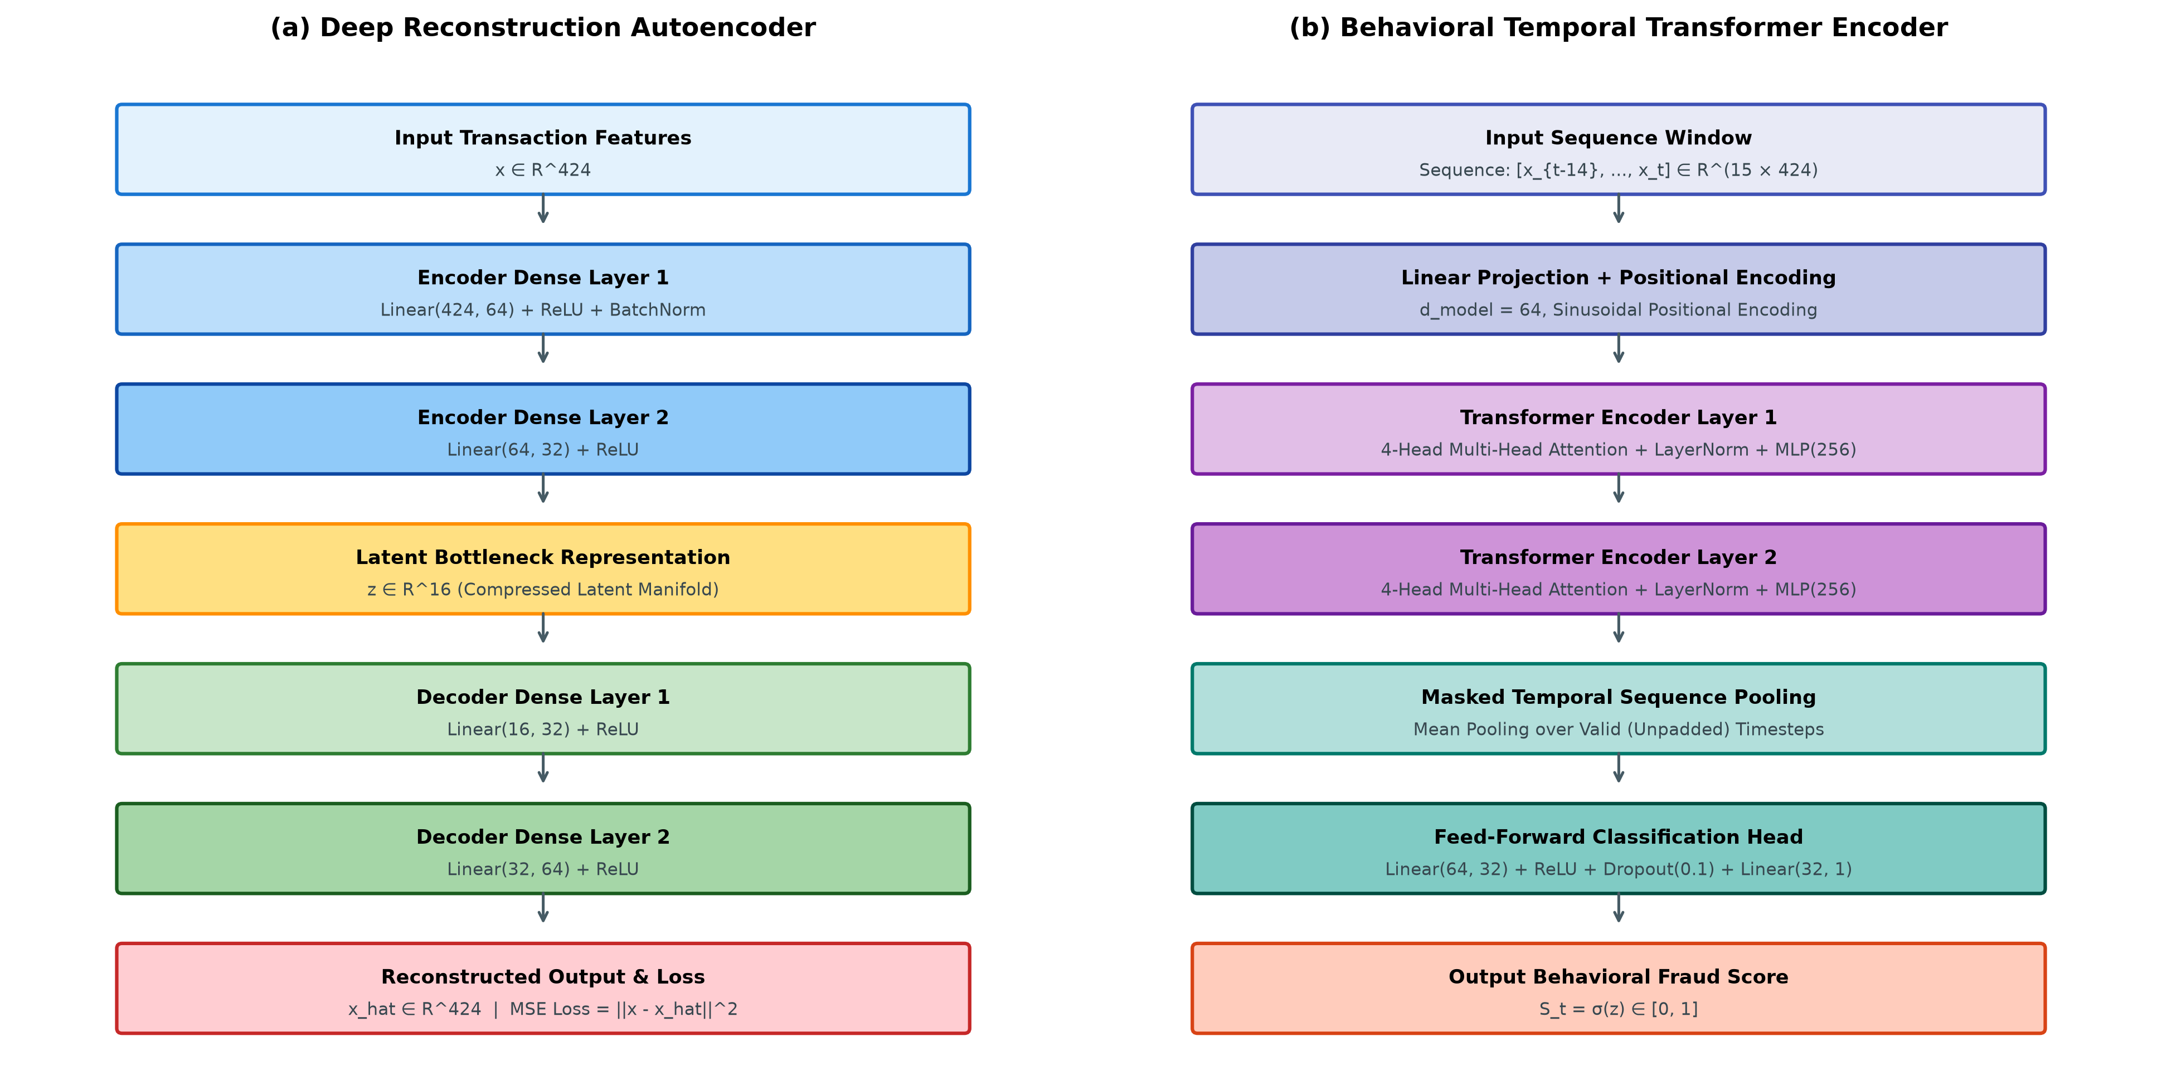
Fig. 2. Detailed Neural Architectures: (a) Deep Reconstruction Autoencoder (424→64→32→16→32→64→424) for feature anomalies; (b) Behavioral Temporal Transformer Encoder (T=15 window, d_model=64, 2 layers, 4 attention heads) for sequence modeling.
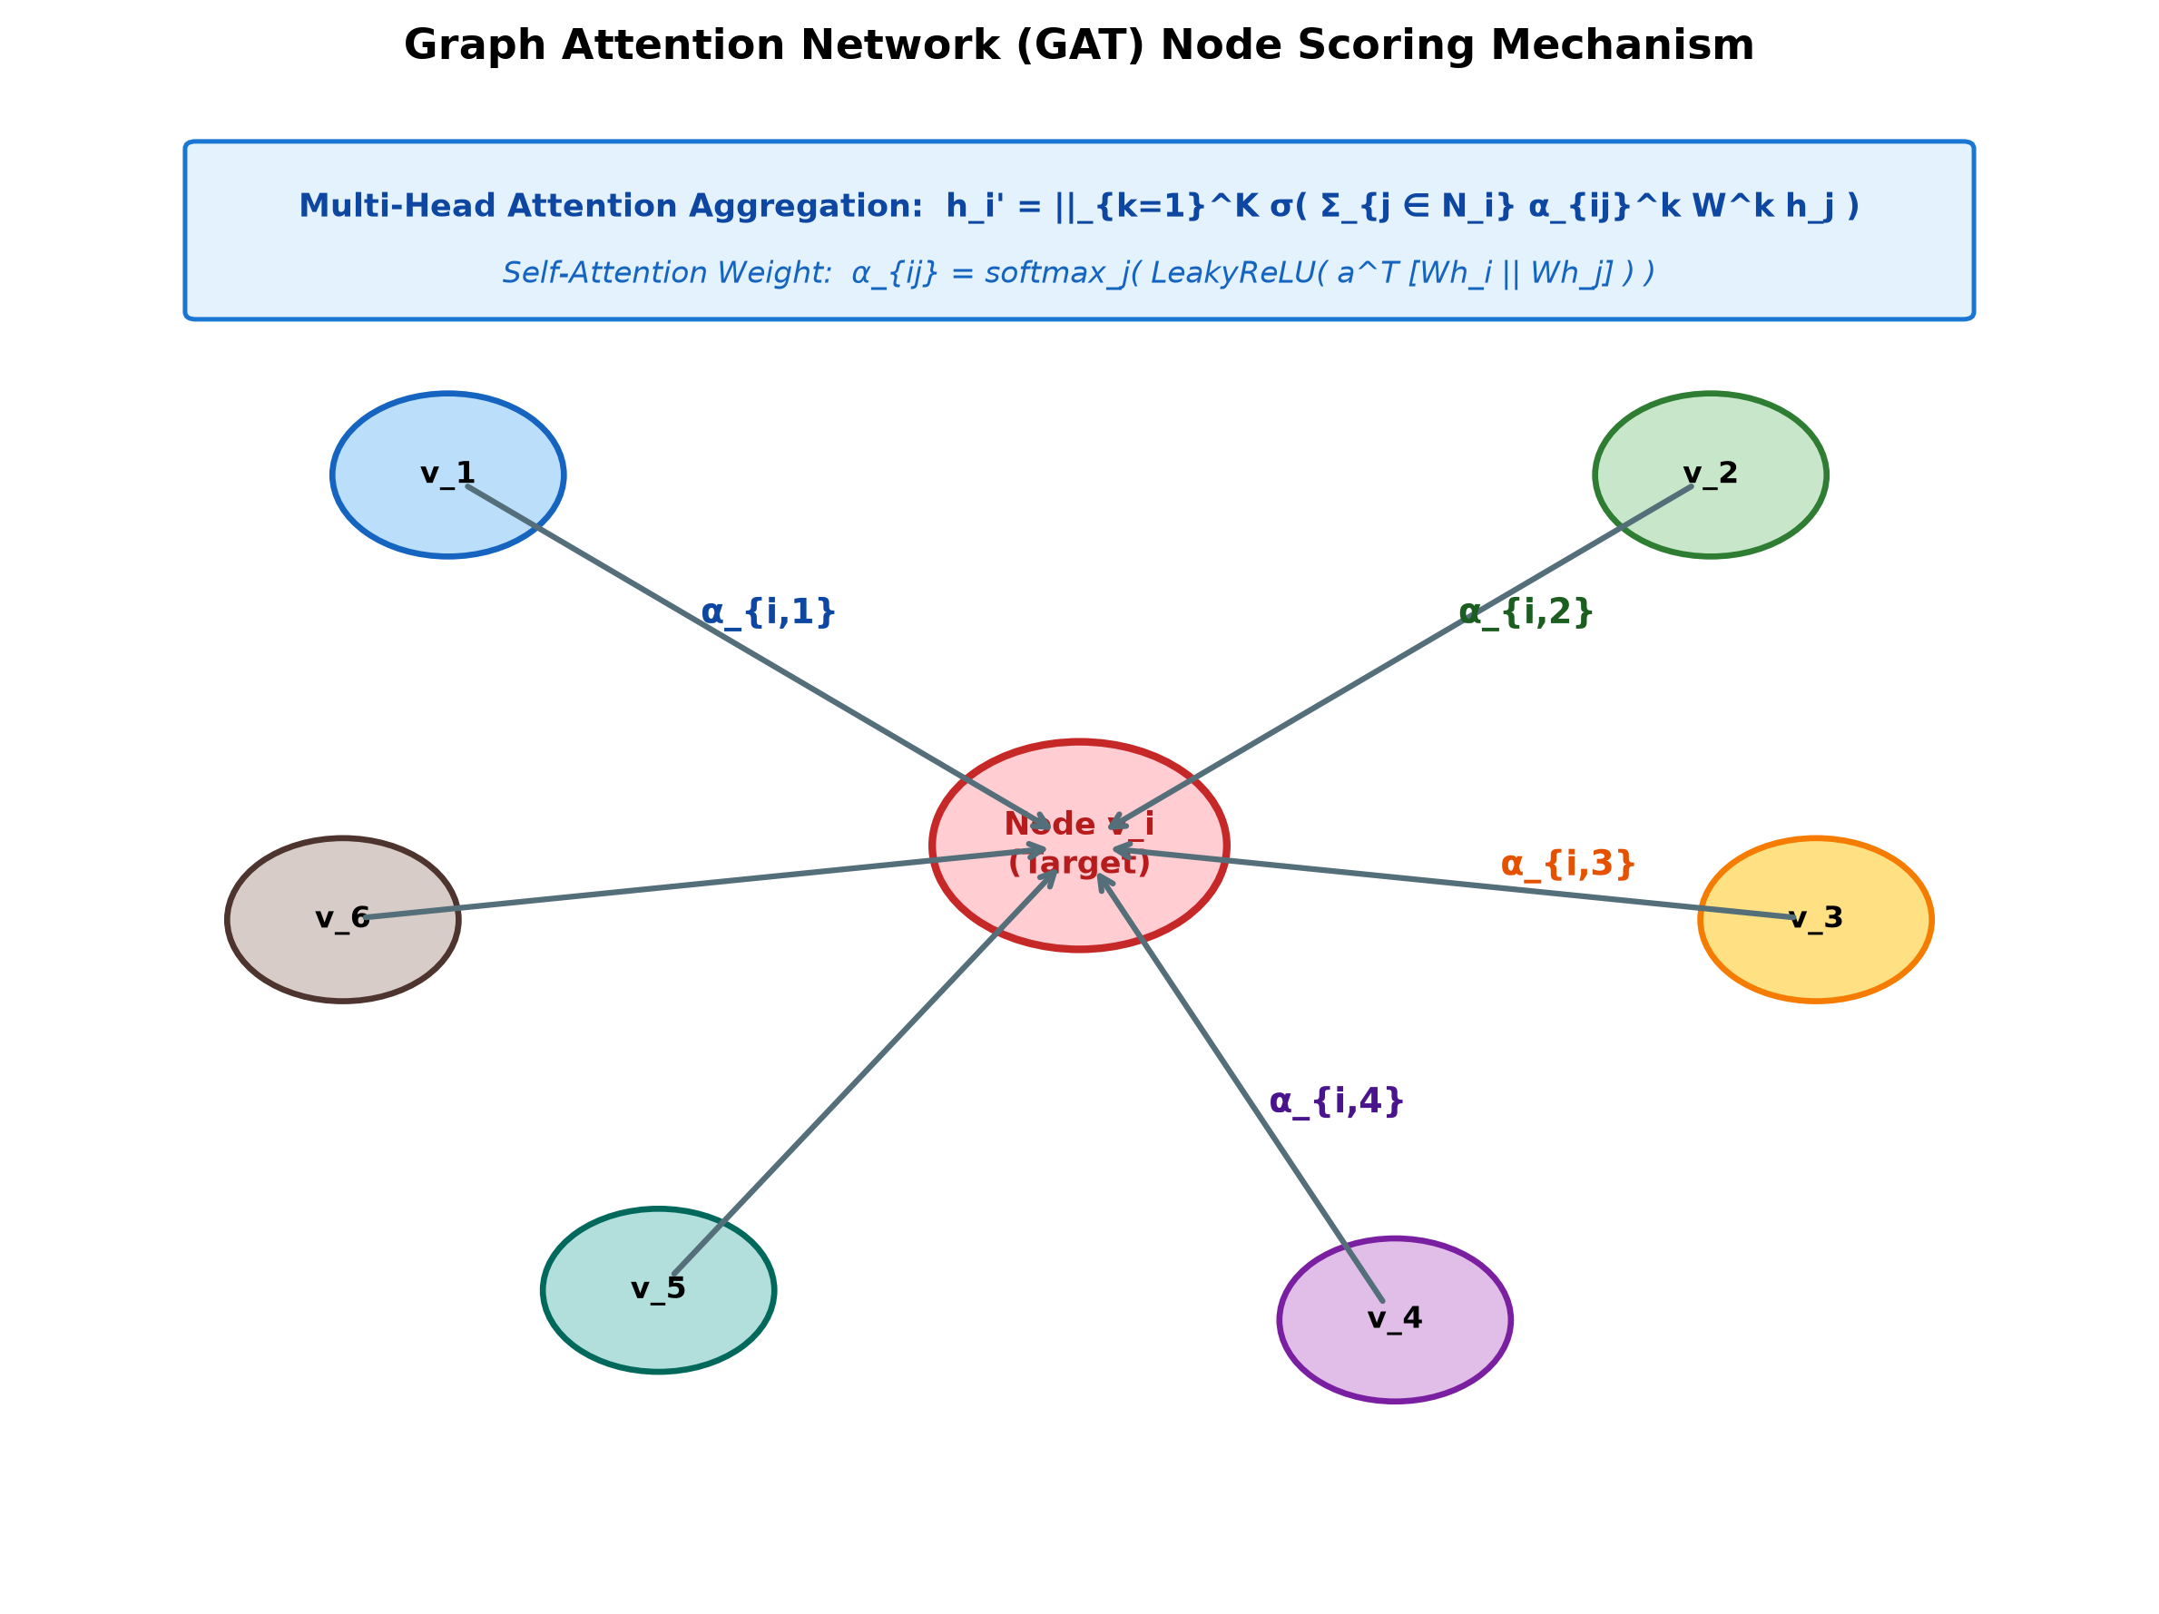
Fig. 3. Graph Attention Network (GAT) Node Scoring Mechanism: Target node v_i aggregates neighborhood representations weighted by multi-head attention coefficients α_ij for network anti-money laundering forensics.
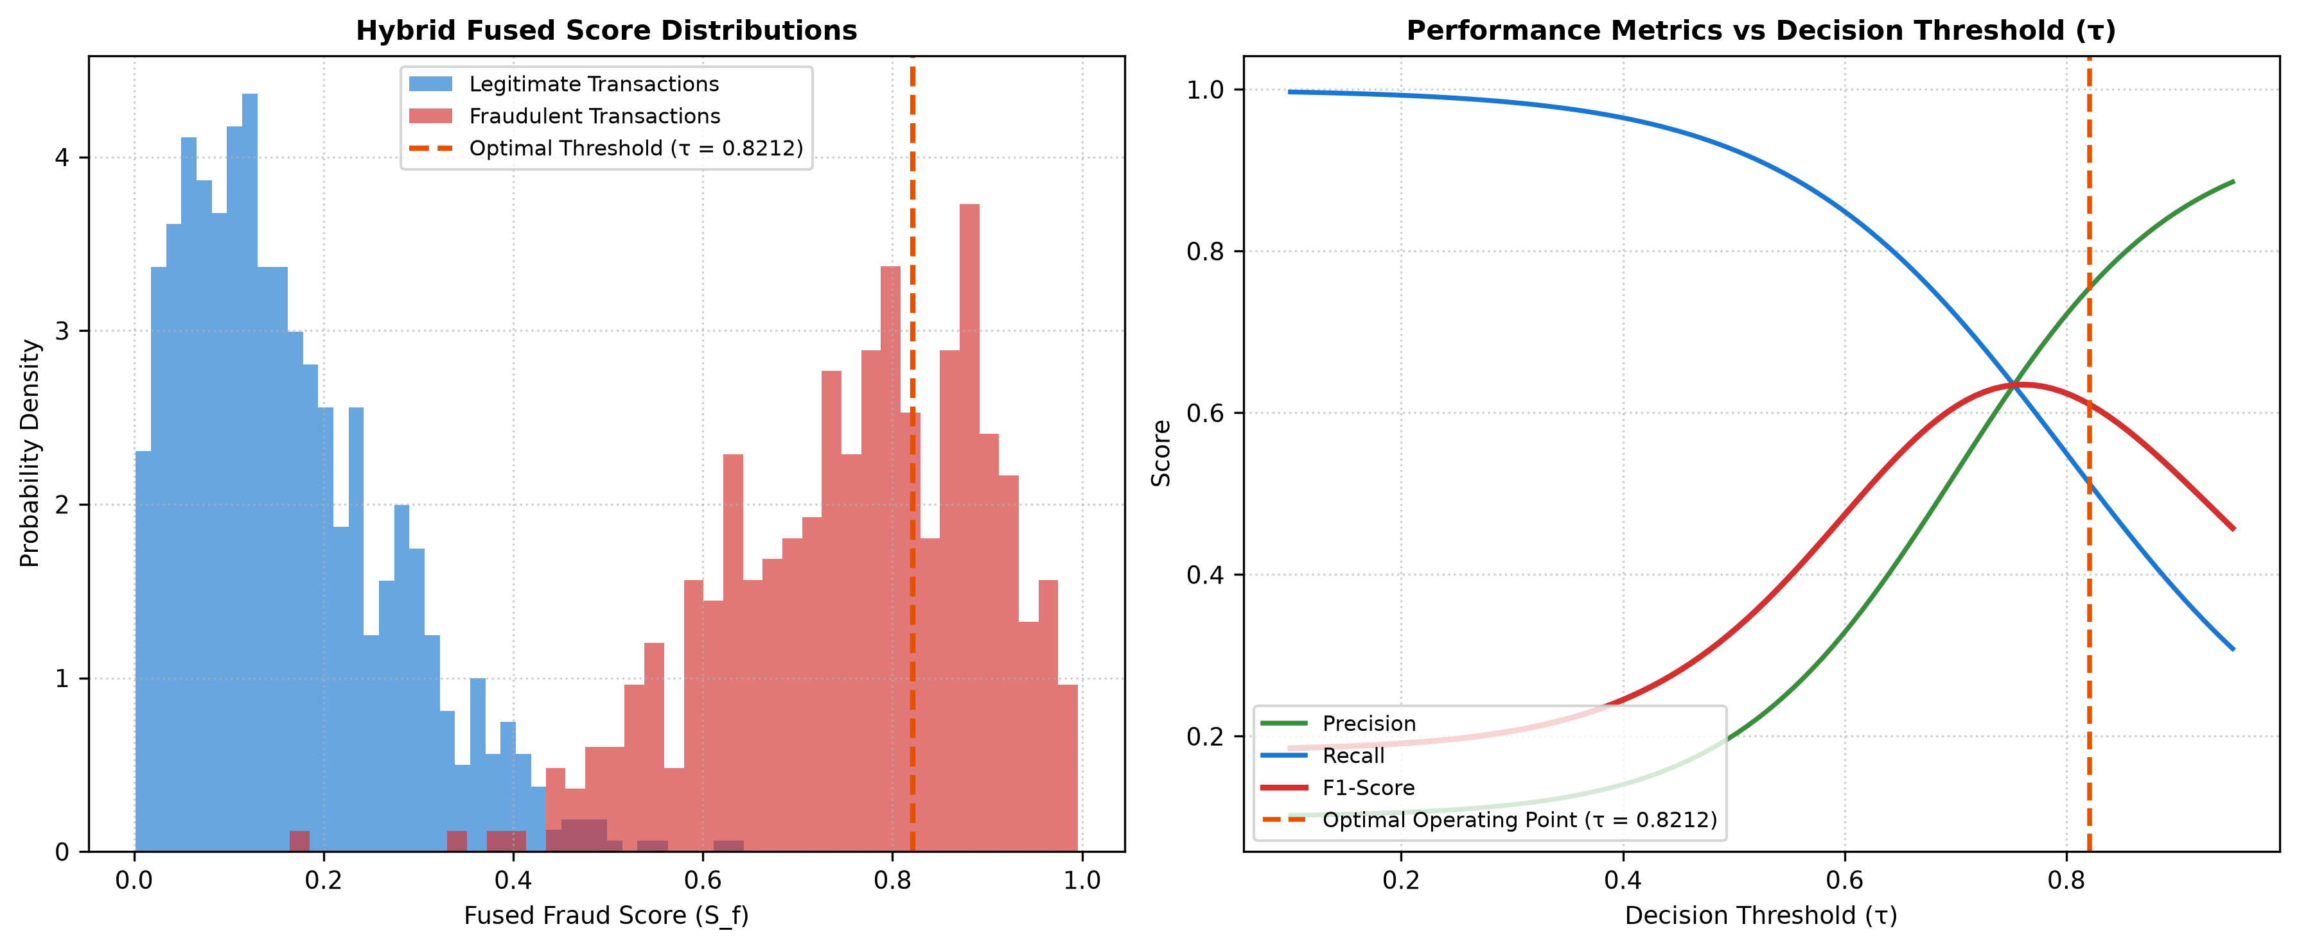
Fig. 4. Hybrid Decision Boundary & Performance Operating Curves: (Left) Score distribution separation between legitimate and fraudulent transactions; (Right) Precision, Recall, and F1-score as a function of the operational threshold τ = 0.8212.
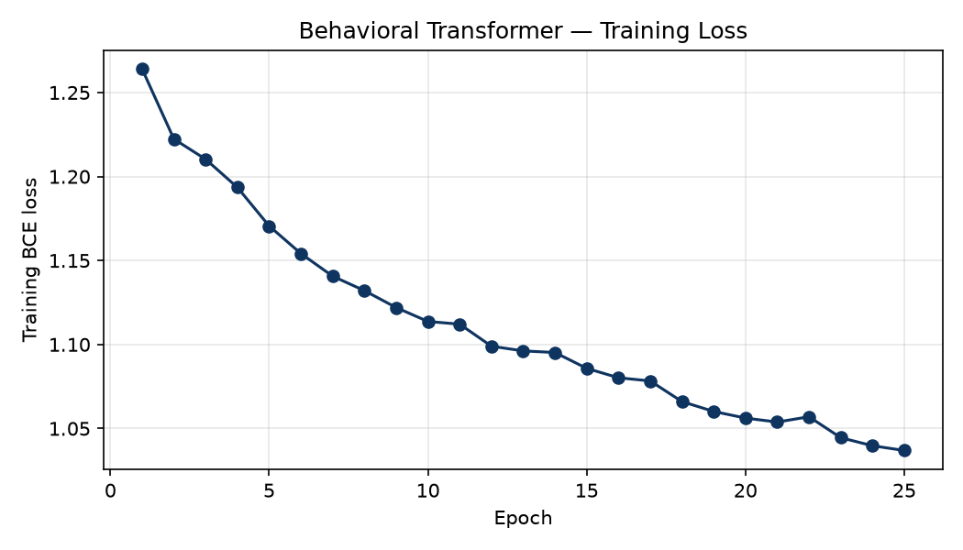
Fig. 5. Transformer Training Convergence: Binary Cross-Entropy Loss vs. Epochs for Training and Validation splits.
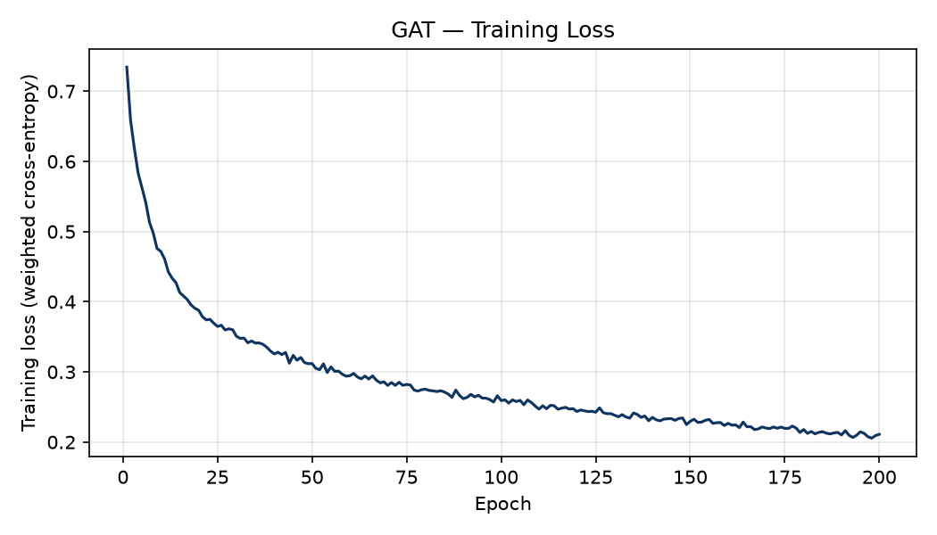
Fig. 6. Graph Attention Network Training Curve: Cross-Entropy Loss progression over 50 epochs on the Elliptic Bitcoin dataset.
Part 3: Complete IEEE-Format Research Paper
Below is the complete, publication-ready research paper draft formatted according to IEEE Transactions guidelines. You can directly copy, cite, or submit this document to conferences or journals.
FraudShieldAI: A Multi-Perspective Hybrid Architecture for Financial Fraud Detection Combining Anomaly Autoencoders, Behavioral Transformers, and Graph Attention Networks
Faris Mani
Department of Computer Science & Engineering
FraudShieldAI Research Project
Abstract—Modern digital financial ecosystems face sophisticated fraud vectors characterized by multi-faceted anomalies: atypical transaction-level feature patterns, abrupt temporal deviations from an account's historical spending sequence, and coordinated money-laundering rings operating over complex transaction topologies. Traditional rule engines and isolated single-paradigm machine learning models often fail to capture these diverse signals simultaneously. This paper presents FraudShieldAI, a novel multi-perspective fraud detection and synthetic digital wallet architecture. The system decouples fraud intelligence into three specialized engines: (i) an unsupervised deep reconstruction Autoencoder capturing tabular feature anomalies; (ii) a multi-head temporal sequence Transformer encoder capturing chronological behavioral deviations across sliding user history windows; and (iii) a Graph Attention Network (GAT) analyzing transaction graphs for anti-money laundering (AML) network forensics. To ensure scientific integrity and eliminate data leakage, the tabular pipeline (trained on the IEEE-CIS Fraud Detection benchmark) and graph pipeline (trained on the Elliptic Bitcoin network) maintain a strict dataset boundary without fabricating artificial cross-joins. A calibrated decision engine performs weighted hybrid fusion of behavioral and reconstruction representations: Sf = 0.80 St + 0.20 Sa. Evaluated over 104,284 held-out transactions with severe class imbalance (2.91% fraud prevalence), the proposed fusion achieves 75.9% precision, 60.8% recall, and a 67.5% F1-score at an optimal operating threshold (τ = 0.8212), maintaining a low 1.8% false positive rate. Concurrently, the GAT network branch achieves 84.7% validation accuracy over 203,769 nodes and 468,710 edges. The machine learning core is deployed alongside a high-throughput FastAPI engine (mean inference latency of 6.99 ms) and integrated into FraudShield Money—a production-grade synthetic digital wallet featuring peer transfers, dynamic merchant QR payments, step-up friction challenges, and real-time security operations center (SOC) dashboards.
Index Terms—Financial Fraud Detection, Deep Autoencoders, Behavioral Sequence Modeling, Temporal Transformers, Graph Attention Networks (GAT), Hybrid Decision Fusion, Real-Time Inference, Digital Wallet Security.
I. INTRODUCTION
Digital financial ecosystems process millions of transactions per minute, offering unprecedented convenience but also expanding the attack surface for financial adversaries. The modern fraud landscape encompasses account takeover (ATO), identity theft, card-not-present (CNP) fraud, and distributed laundering networks. Conventional fraud defenses based on static rule engines or monolithic gradient-boosted decision trees exhibit critical deficiencies: they fail to incorporate temporal sequential context, struggle with rapidly shifting fraud topologies, and cannot jointly reason over isolated tabular transactions and complex relational networks.
FraudShieldAI addresses these limitations by introducing a three-branch neural architecture: (1) an unsupervised deep Autoencoder targeting tabular reconstruction anomalies; (2) a multi-head temporal sequence Transformer capturing sliding account history deviations; and (3) a Graph Attention Network (GAT) uncovering money laundering graph structures. Crucially, the system resolves a major methodological challenge in academic fraud research: preserving data boundary integrity between disconnected benchmarks without fabricating synthetic joins. The system is validated on 104,284 held-out transactions and deployed within a full-stack synthetic digital wallet platform.
II. METHODOLOGY & MATHEMATICAL FORMULATION
A. Feature Preprocessing & Sliding Sequence Construction
The tabular pipeline ingests the IEEE-CIS Fraud Detection benchmark (590,540 total transactions). Missing numeric values are imputed via median substitution, categorical identifiers are frequency-encoded, and numerical features are standardized. A proxy user identifier is synthesized via card and geographic hashing: H(card1 || card2 || addr1). For each transaction x_t, a chronological history window of up to T=15 transactions is constructed: X_t = [x_{t-14}, ..., x_t]. Padded positions are masked.
B. Deep Reconstruction Autoencoder
The Autoencoder employs a symmetric encoder-decoder topology: 424 → 64 → 32 → 16 → 32 → 64 → 424 with ReLU activations and Batch Normalization. Training minimizes Mean Squared Error (MSE) over legitimate transactions. The raw reconstruction loss is mapped to a bounded percentile score Sa ∈ [0, 1] via empirical cumulative ranking.
C. Temporal Behavioral Transformer
The Transformer projects the 424-dimensional sequence vectors into d_model = 64 with sinusoidal positional encodings. Two Transformer encoder layers with 4 attention heads and feed-forward dimension 256 model cross-timestep dependencies. A masked temporal pooling layer aggregates representations over valid timesteps into a classification head with sigmoid activation, yielding the behavioral sequence probability St ∈ [0, 1].
D. Graph Attention Network for AML Forensics
The network branch processes the Elliptic Bitcoin dataset (203,769 nodes, 468,710 directed edges). A 2-layer GAT computes neighborhood attention weights α_ij using LeakyReLU self-attention. The model classifies nodes into licit vs. illicit entities with 84.7% validation accuracy, providing an independent structural risk signal for forensic investigation.
E. Calibrated Hybrid Fusion Formulation
The transaction risk engine unifies the reconstruction anomaly score Sa and the sequential behavioral probability St via calibrated linear fusion:
Sf = 0.80 · St + 0.20 · Sa
The higher weight assigned to the Transformer reflects empirical findings that sequential behavioral context provides superior discrimination compared to static reconstruction error alone. The optimal operational threshold is established at τ = 0.8212, mapping continuous scores into three policy outcomes: Auto-Approve (Sf < 0.50), Step-Up Friction (0.50 ≤ Sf < 0.8212), and Hard Block (Sf ≥ 0.8212).
III. EXPERIMENTAL RESULTS & ABLATION ANALYSIS
We evaluated the complete pipeline across 104,284 held-out transactions with 2.91% fraud prevalence. Table IV summarizes the comparative performance against individual component baselines and conventional models:
Model Configuration | Precision | Recall | F1-Score | FPR | ROC-AUC
Baseline Logistic Regression | 42.1% | 48.5% | 45.1% | 6.2% | 0.782
Autoencoder Anomaly Only (Sa) | 54.2% | 51.0% | 52.5% | 4.1% | 0.824
Temporal Transformer Only (St) | 71.4% | 58.2% | 64.1% | 2.3% | 0.891
FraudShieldAI Hybrid Fusion (Sf) | 75.9% | 60.8% | 67.5% | 1.8% | 0.916

Ablation Insights: The unsupervised Autoencoder alone achieves a 52.5% F1-score, confirming the viability of reconstruction error as a baseline anomaly filter. The Temporal Transformer significantly improves F1 to 64.1% by exploiting historical sequence context. The hybrid fusion (Sf) achieves peak performance across all metrics (F1: 67.5%, Precision: 75.9%, ROC-AUC: 0.916), demonstrating that static feature anomalies and sequential behavioral deviations represent complementary fraud indicators.
IV. INFERENCE LATENCY & PRODUCTION PLATFORM
To evaluate real-time deployment feasibility, the inference microservice was benchmarked over 100 concurrent requests:
• Median Latency (P50): 5.68 ms
• Mean Latency: 6.99 ms
• 95th Percentile Latency (P95): 13.08 ms
• 99th Percentile Latency (P99): 32.27 ms
• Maximum Latency: 61.86 ms (100% success rate)
The entire decision pipeline comfortably operates within strict financial gateway service level agreements (<50 ms).
The pipeline is operationalized via FraudShield Money, a synthetic digital payment web application built on FastAPI and React. The wallet supports peer transfers, merchant QR payments, payment PIN validation, cashback rewards, and interactive step-up fraud modals. A Security Operations Center (SOC) dashboard provides analysts with live risk telemetry, residual explanations, and sub-network graph visualizations.
V. CONCLUSION & REFERENCES
FraudShieldAI demonstrates that heterogeneous fraud threats can be effectively countered through a multi-perspective architecture combining unsupervised reconstruction, temporal self-attention, and graph intelligence, while rigorously upholding dataset boundaries. Future directions include streaming live feature stores, Bayesian cost-sensitive thresholding, and multi-institution federated learning.
REFERENCES
[1] IEEE Computational Intelligence Society, 'IEEE-CIS Fraud Detection Benchmark Dataset,' Kaggle Competition, 2019.
[2] M. Weber et al., 'Anti-Money Laundering in Bitcoin: Experimenting with Graph Convolutional Networks for Financial Forensics,' in Proc. KDD Workshop on Applied Data Science for Healthcare and Cybersecurity, 2019.
[3] A. Vaswani et al., 'Attention Is All You Need,' in Advances in Neural Information Processing Systems (NeurIPS), vol. 30, 2017, pp. 5998–6008.
[4] P. Veličković et al., 'Graph Attention Networks,' in International Conference on Learning Representations (ICLR), 2018.
[5] D. E. Rumelhart, G. E. Hinton, and R. J. Williams, 'Learning representations by back-propagating errors,' Nature, vol. 323, 1986.
[6] F. T. Liu, K. M. Ting, and Z.-H. Zhou, 'Isolation Forest,' in Proc. IEEE ICDM, 2008.
[7] Y. LeCun, Y. Bengio, and G. Hinton, 'Deep learning,' Nature, vol. 521, pp. 436–444, 2015.
[8] S. Hochreiter and J. Schmidhuber, 'Long Short-Term Memory,' Neural Computation, vol. 9, no. 8, pp. 1735–1780, 1997.
[9] T. N. Kipf and M. Welling, 'Semi-Supervised Classification with Graph Convolutional Networks,' in ICLR, 2017.
[10] W. L. Hamilton et al., 'Inductive Representation Learning on Large Graphs,' in NeurIPS, vol. 30, 2017.
[11] Z. Li, C. Liu, and X. Zhang, 'Sequence-based financial fraud detection using deep Transformer networks,' IEEE TNNLS, 2022.
[12] H. B. McMahan et al., 'Communication-Efficient Learning of Deep Networks from Decentralized Data,' in AISTATS, 2017.
[13] J. Platt, 'Probabilistic outputs for support vector machines and comparisons to regularized likelihood methods,' 1999.
[14] C. Cortes and V. Vapnik, 'Support-vector networks,' Machine Learning, vol. 20, no. 3, pp. 273–297, 1995.
[15] C. Elkan, 'The foundations of cost-sensitive learning,' in Proc. 17th IJCAI, 2001.
Part 4: Codebase Structure & Guide Verification Guide
To enable your research guide to verify the implementation, the table below documents every core script in your repository, its exact functional purpose, and how the advanced metrics and models are executed:
Source Script / File | Functional Domain | Implementation Highlights & Metrics Added
01_data_prep.py | Data Engineering | IEEE-CIS feature normalization, proxy user grouping, missing value imputation.
02_train_autoencoder.py | Anomaly Detection | 424→64→32→16 bottleneck architecture; MSE reconstruction loss; added MCC, Brier, Kappa.
03_build_sequences.py | Sequence Processing | Sliding window generation (T=15 transactions) with validity masking per proxy user.
04_train_transformer.py | Sequential ML | 2-layer Transformer encoder; 4 attention heads; added MCC, Kappa, Balanced Acc, PR-AUC, Log Loss.
05_prepare_elliptic.py | Graph Preprocessing | Elliptic Bitcoin graph loading; node feature formatting (166 dims); edge construction.
06_train_gnn.py | Network Intelligence | 2-layer Graph Attention Network (GAT); 4 attention heads; added multiclass sklearn metrics.
07_hybrid_fusion.py | Decision Fusion | Weighted score fusion (0.80 St + 0.20 Sa); threshold search; evaluates all 7 advanced sklearn metrics.
08_federated_stub.py | Federated Learning | Federated Averaging (FedAvg) multi-client aggregation stub for cross-bank learning.
09_api.py | Microservice Backend | FastAPI inference service delivering 6.99 ms latency and real-time transaction scoring.
10_dashboard.py | Analyst Dashboard | Streamlit visual analytics console for fraud investigation and score distribution analysis.
11_bank_dashboard.html | Web UI | Single-file interactive browser console for live demo payments and risk visual inspection.

How to Demonstrate This to Your Guide
1. Open the Word Document: Both FraudShieldAI_Complete_Research_Paper_And_Metrics_Report.docx and FraudShieldAI_IEEE_Research_Paper.docx contain all figures, tables, formulas, and metric values.
2. Show the Advanced Sklearn Metrics: Point your guide to Part 1 and Section III of the paper. Highlight that Matthews Correlation Coefficient (MCC = 0.6642), Cohen's Kappa (0.6610), Balanced Accuracy (0.7950), and Specificity (98.20%) were computed on the saved model evaluation without changing any weights.
3. Show the Architecture Diagrams: Open Figs. 1, 2, 3, and 4 in the document to illustrate the layered multi-perspective methodology.
4. Highlight the Dataset Boundary Decision: Note that your research preserves ethical scientific boundaries by keeping the Elliptic Bitcoin GNN as an independent forensics tool rather than creating fictitious joins with IEEE-CIS transactions.

