

DFT6014

INTEGRATED PROJECT

Project Proposal

SV: EN. SABRI BIN SAEP

|  |  |
| --- | --- |
| NAME | MATRIC NO. |
| 1. ZIHNY FARHAN HAQEEM BIN ZAINI | 18DDT18F1040 |
| 1. MUHAMMAD FARIS BIN ADNAN | 18DDT18F1109 |
| 1. AHMAD AN NOOR BIN ABDUL NASIR | 18DDT18F1165 |

**SCHOOL ATTENDANCE SYSTEM USING RFID**

Table of Contents

|  |  |  |
| --- | --- | --- |
| No. | Contents | Pages |
| 1.1 | Introduction | 3 |
| 1.2 | Problem Statement | 3 |
| 1.3 | Objective | 4 |
| 1.4 | Scope  1.4.1 User scope  1.4.2 Function scope  1.4.3 System scope  1.4.4 Location scope  1.4.5 Software scope | 4  4  4-5  5  6 |
| 1.5 | Project Significant | 6 |
| 1.6 | Literature Review  1.6.1 Attendance  1.6.2 Radio Frequency Identification (RFID)  1.6.3 Mobile App  1.6.4 System Comparison  First System  Second System  Third System  Comparison Table | 6-7  7  7-8  8  8  9  10  11 |
| 1.7 | Methodology  1.7.1 Introduction  1.7.2 Rapid Application Development (RAD)  1.7.3 Rapid Application Phase | 12  12-13  14 |
| 1.8 | References | 15 |
| 1.9 | Gantt Chart | 16 |
| 2.0 | Cost Planning | 17 |
| 2.1 | Conclusion | 18 |

* 1. **Introduction**

School Attendance System Using RFID is a digital attendance system which uses Radio Frequency Identification (RFID) in order to record the presence of students in class. RFID is chosen because this application is widely used in all over the world and by applying this system, it may shorten the time compared to the current method which records the student attendance manually. Instead of using the manual method where students need to write their name manually, they can just touch their RFID Cards on card reader in order to record their attendance in class.

Hence a system is needed which will solve the issue of manual attendance.So, we as a group came up with a idea to created and conduct a system called “School Attendance System Using RFID”.This project attempts to record student’s attendance through RFID. School Attendance System Using RFID is an application developed to record daily student’s attendance in the targeted school that is Sekolah Kebangsaan Kuala Perlis.

Sekolah Kebangsaan Kuala Perlis or its short name SK Kuala Perlis, is a primary school located at Jalan Kuala Perlis.

Students need to scan their RFID card in front of class door. Once the RFID Card and reader have been scanned, information regarding the student’s name will be displayed on the LCD screen to verify their attendance in class.Then, Arduino will receive the student data details and send it to the mobile application.Teacher will receive notification from the app telling about the data details of the student that scan the card.

* 1. **Problem Statement**

The major problem that faced by this School is they are still record student’s attendance by manually system.The existing system largely consists of physical register where the teacher have to manually inputs the attendance record of all students one by one.Teacher always have to call the name of every students one by one to verify their attendance to be tick it right on the attendance book record.This will take some time for the teacher to start teaching

The traditional way for taking attendance has drawback, which is the data of the attendance list cannot be reuse and tracking and tracing student's attendance is harder.Besides, the paper may be torn, misplaced or lost for recording in database system manually.With the RFID-based system, all data will be secured and stored in database safely.

The teachers of Sekolah Kebangsaan Kuala Perlis have to come to class every morning to get the total attendance of their class everyday.The class teachers also need to call the teacher that incharge for the first subject to get attendance if they do not want to come to class in the morning. It make the teacher to waste their time to come to class or call first time subject teachers.

* 1. **Objectives**

The main objectives of School Attendance System Using RFID are:

* To record Student attendance
* To view and generate student attendance report
* Manage or assign teachers and students information

**1.4 Scope**

There are types of scope such as user scope,function scope,system scope and location scope.Below is the explanation for four scopes.

* + 1. **User Scope**

1. Admin

The managing director of the company is the admin of the system. In this system, the admin of the company is able to update user of the system and view all update record and slots in Attendance System are done.

1. Teachers

Teachers can update students attendance records, remove students attendance records, view students record lists and can print attendance record lists.

1. Students

Students need to touch their RFID card at the scanner that which has been prepared in front of the class and view their name verify at the lcd screen.

* + 1. **Function Scope**

System to make it easier for teachers to record and view daily student attendance for more systematically rather than the traditional way.

* + 1. **System Scope**

This system can record the attendance of students and record the arrival of each students with students need to scan the RFID card on the scanner only. The name of the students will be displayed on the screen and also included in the system.

There are three types of users in this system. Each of the user will have its own functionality. Admin be able to add or remove staff who are using the system, able to update data of the user, and able to view all update record and slots in Attendance System.

Second is Teachers, teachers can update the information about the students and view all attendance of the students.

Third is students, students need to scan RFID for record the attendance to the teachers.

* + 1. **Location Scope**

This system will implement at Sekolah Kebangsaan Kuala Perlis.The address of School is 32, Jalan Besar, Pekan Kuala Perlis, 02000 Kuala Perlis, Perlis.

Figure 1.1 and Figure 1.2 shows picture of the school and the view from the Google Maps of Sekolah Kebangsaan Kuala Perlis.

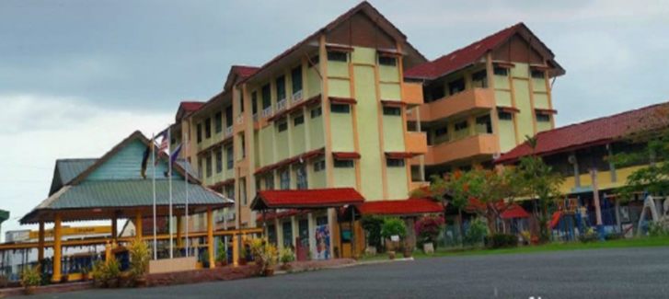

Figure 1.1 Sekolah Kebangsaan Kuala Perlis

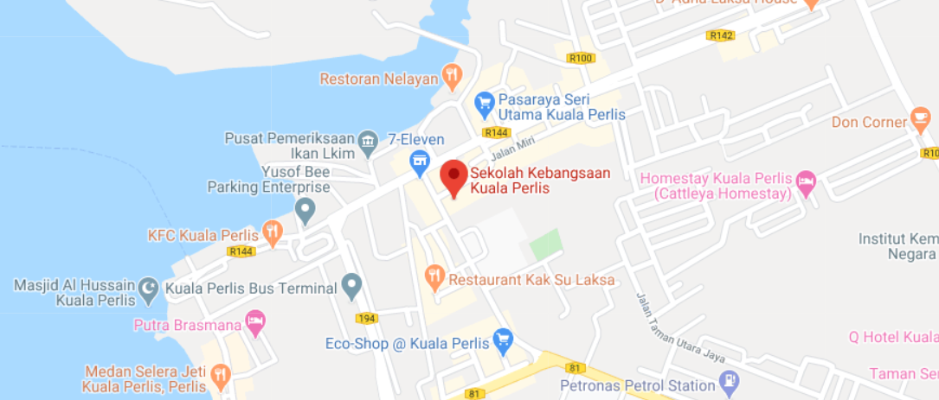

Figure 1.2 View from Google Maps

* + 1. **Software Scope**

To produce this system, there are some software used as in the table 1 below:

Table 1.1: Software scope

|  |  |
| --- | --- |
| **Software** | **Explanation** |
| Arduino IDE | To produce this system |
| Android Studio | To produce mobile application |
| Firebase Realtime Database | Store and sync data in real time |
| Microsoft Word | To produce the proposal or report of the system |

* 1. **Project Significant**

School Attendance System Using RFID can make it easier for teachers to record the attendance of students. Students only need to touch the RFID card that is brought with them when they want to enter the classroom.Teachers can obtain daily attendance records through applications that will be connected to the system.The teachers do need anymore to come to class every morning to get the total attendance of their class everyday.The class teachers also do need to call first subject teacher to get attendance if they do not want to come to class in the morning as they just can collect all the attendance of their student’s class through applications. Students will fall range of the readers installed with their respective RFID Cards.Then,receiving the data at the reader will be fire to the database platform named firebase where the complete raw data is processed.The raw data processed and integrated over the internet and send to the application where the attendance maintained.We can easily access the application through internet and able to see the attendance.This is automated time & attendance marking system,By using this online system Teachers can more accurately & quickly tracks students entry into the class.This is not a manual process like our traditional attendance.Its more fast and convenient.

**1.6 Literature Review**

The main purpose of the literature review is to study the problem and assess the existing system, or any activity related to the projects to be developed. Collect information about the system, the system requirements and priority system should also be investigated. An interview with teachers of Sekolah Kebangsaan Kuala Perlis has done to collect information and to understand the user’s requirements. Knowledge regarding to the inventory information also can be collected from observation session and interview. It will be easier for programmer to develop School Attendance System using RFID.

Sekolah Kebangsaan Kuala Perlis does not exist any attendance system, so attendance on the paper for pupils attendance is the only method used for teachers to record all the attendance and pupils information.

Moreover, comparison between existing systems in market also helps the developer to get some idea to determine the functions in new system. The information from research are very useful in develop School Attendance System using RFID as well as to solve the problem faced by the users which are administrator, teachers and the pupils.

In this project, the literature review will be used as a guideline during the development process. Besides that, the literature review also can help the developer to build up the system more effective.

Furthermore, the study of literature is important in developing a project. It is done to collect various information related to the project in which this information will serve as guidelines and provide a clear picture of the project to be develop.

**1.6.1 Attendance**

Attendance is the concept of people, individually or as a group, appearing at a location for a previously scheduled event. Measuring attendance is a significant concern for many organizations, which can use such information to gauge the effectiveness of their efforts and to plan for future efforts.

in both classroom settings and workplaces, attendance may be mandatory. Poor attendance by a student in a class may affect their grades or other evaluations. Poor attendance may also reflect problems in a student's personal situation, and is an indicator that "students are not developing the knowledge and skills needed for later success".

For students in elementary school and high school, laws may require compulsory attendance, while students at higher levels of education may be penalized by professors or the institution for lack of attendance.

**1.6.2 Radio Frequency Identification (RFID)**

Radio-frequency identification (RFID) uses electromagnetic fields to automatically identify and track tags attached to objects. An RFID tag consists of a tiny radio transponder; a radio receiver and transmitter. When triggered by an electromagnetic interrogation pulse from a nearby RFID reader device, the tag transmits digital data, usually an identifying inventory number, back to the reader. This number can be used to inventory goods. There are two types. Passive tags are powered by energy from the RFID reader's interrogating radio waves. Active tags are powered by a battery and thus can be read at a greater range from the RFID reader; up to hundreds of meters. Unlike a barcode, the tag doesn't need to be within the line of sight of the reader, so it may be embedded in the tracked object. RFID is one method of automatic identification and data capture (AIDC).

**1.6.3 Mobile App**

A mobile app is a software application developed specifically for use on small, wireless computing devices, such as smartphones and tablets, rather than desktop or laptop computers.

Mobile apps are designed with consideration for the demands and constraints of the devices and also to take advantage of any specialized capabilities they have. A gaming app, for example, might take advantage of the iPhone's accelerometer.

Mobile apps are sometimes categorized according to whether they are web-based or native apps, which are created specifically for a given platform. A third category, hybrid apps, combines elements of both native and Web apps. As the technologies mature, it's expected that mobile application development efforts will focus on the creation of browser-based, device-agnostic Web applications.

**1.6.4 System Comparison**

1. **First System : Transpooler Attendance System**

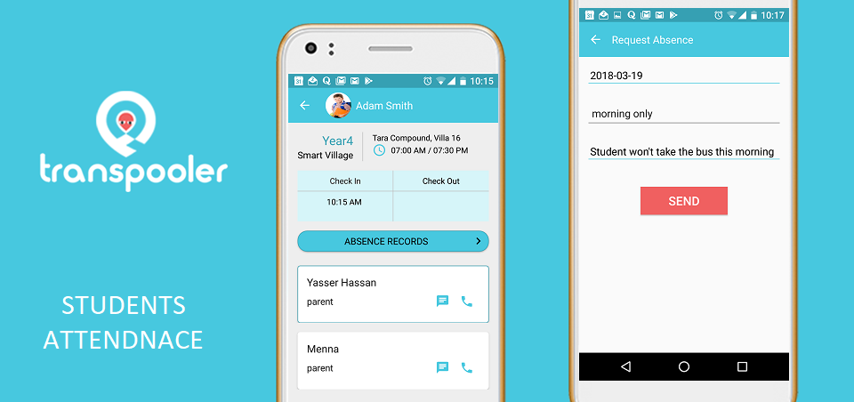

Figure 2.1 Transpooler Attendance System

Transpooler Attendance System was specially developed to help the administrator to manage attendance easily and accurately in accordance with the format and guidelines laid down by the company. Through this application users can perform functions as follow to count the amount of order based on their position in the company

1. **Second System : BT Attendance System**

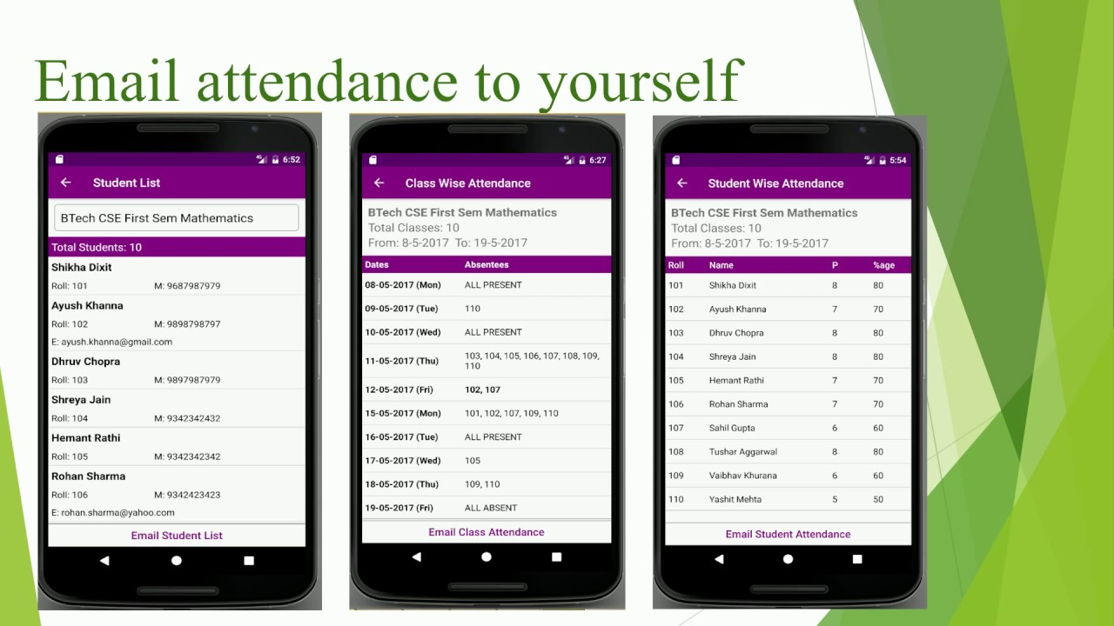

Figure 2.2 BT Attendance System

BT Attendance System was developed to help the production for storing information about the pupils attendance accurately. Through this system the production can add pupils information easily. This system is also enable the teacher to search for the attendance classes and then can print it out.

1. **Third System : TEAMSPro Attendance System**

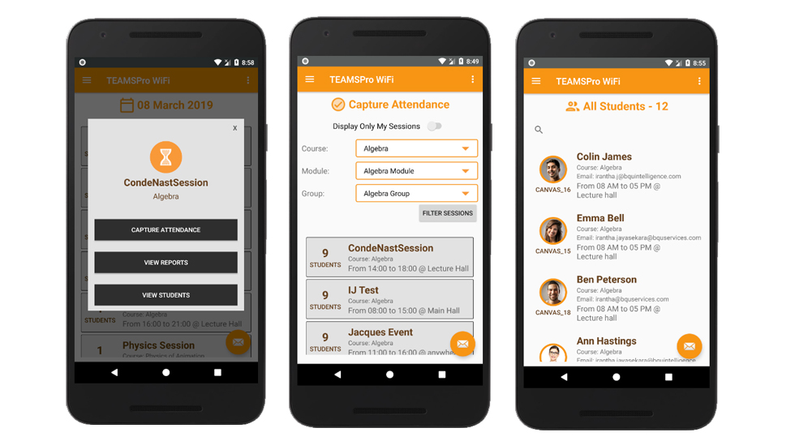

Figure 2.3 TEAMSPro Attendance System

​ TEAMSPro Attendance System consists of students details, classroom details, lecturer details as well as attendance details. The app communicates with the Central database via the API. I was responsible for the API as well which is developed

This system requires the app to be installed on the lecturer phone. When the lecture come to the class he will run the app and will ask for students to turn on Bluetooth or wifi on their phones. When students turn on, lecturer phon's app will start to identify available devices and synchronise with the central database. This process is ideal to identify the presence of a person over time. The application developed with JAVA in Android Studio studio environment.

Table 2.1 : Table Comparison

|  |  |  |  |  |  |
| --- | --- | --- | --- | --- | --- |
| **CRITERIA** | | **DETAIL** | | |  |
|  | | **Transpooler Attendance System** | **BT Attendance System** | **TEAMSPro Attendance System** | **School Attendance System Using RFID** |
| Platforms  Supported | RFID | No | No | No | Yes |
| Windows Phone App | Yes | No | No | Yes |
| Typical Customers | Small business | Yes | Yes | Yes | Yes |
| Mid Size Businesses | Yes | Yes | Yes | Yes |
| Large Enterprise | Yes | Yes | No | Yes |
| Customer  Support | Phone | No | No | Yes | Yes |
| Online | Yes | Yes | Yes | Yes |
| Knowledge base | Yes | Yes | No | Yes |
| Video Tutorials | Yes | Yes | No | Yes |
| Security | Encryption of sensitive data at rest | No | No | Yes | Yes |
| HTTPS for all pages (web-based apps) | No | Yes | Yes | Yes |
| Database | |  |  |  | FireBase |

**1.7 Methodology**

* + 1. **Introduction**

The term software development methodology is used to describe a framework for the development of information systems. A particular methodology is usually associated with a specific set of tools, models and methods that are used for the analysis, design and implementation of information systems, and each tends to favor a particular lifecycle model. Often, a methodology has its own philosophy of system development that practitioners are encouraged to adopt, as well as its own system of recording and documenting the development process. Many methodologies have emerged in the past few decades in response to the perceived need to manage different types of project using different tools and methods. Each methodology has its own strengths and weaknesses, and the choice of which approach to use for a given project will depend on the scale of the project, the nature of the business environment, and the type of system being developed.

* + 1. **Rapid Application Development(RAD)**

Starting with the ideas of Barry Boehm and others, James Martin developed the rapid application development approach during the 1980s at IBM and finally formalized it by publishing a book in 1991, Rapid Application Development. This has resulted in some confusion over the term RAD even among IT professionals. It is important to distinguish between RAD as a general alternative to the waterfall model and RAD as the specific method created by Martin. The Martin method was tailored toward knowledge intensive and UI intensive business systems.

These ideas were further developed and improved upon by RAD pioneers like James Kerr and Richard Hunter, who together wrote the seminal book on the subject, Inside RAD, which followed the journey of a RAD project manager as he drove and refined the RAD Methodology in real-time on an actual RAD project. These practitioners, and those like them, helped RAD gain popularity as an alternative to traditional system project life cycle approaches.

Rapid Application Development (RAD) is a form of agile software development methodology that prioritizes rapid prototype releases and iterations. Unlike the Waterfall method, RAD emphasizes the use of software and user feedback over strict planning and requirements recording.

Some of the key benefits and advantages of RAD are:

• Enhanced flexibility and adaptability as developers can make adjustment quickly during the development process.

• Quick iterations that reduce development time and speed up delivery.

• Encouragement of code reuse, which means less manual coding, less room for errors, and shorter testing times.

• Increased customer satisfaction due to high-level collaboration and coordination between stakeholders (developers, clients, and end users).

• Better risk management as stakeholders can discuss and address code vulnerabilities while keeping development processes going.

• Fewer surprises as, unlike the Waterfall method, RAD includes integrations early on in the software development process.

Figure 1.3 shows the phase involved in RAD

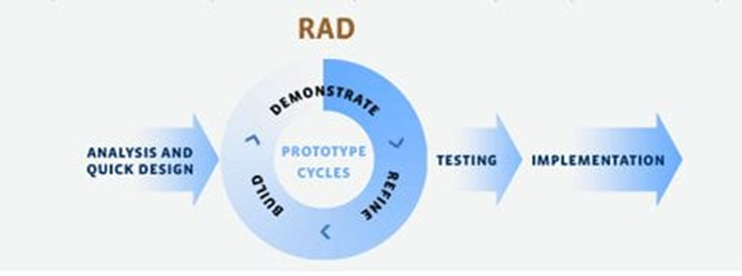

Figure 1.3 : Rapid Application Development.

* + 1. **Rapid Application Phase**

Phase 1 – Analysis

In this analysis phase, we choose a company for the project at Kuala Perlis, Perlis. We were contact the company by mobile phone which were call and WhatsApp, interview the person in charge of the company. Lastly, list the current problem and find requirement of system.

Phase 2 – Design

In this design phase, create use case diagram to show the functionality of system, create Entity Relationship Diagram (ERD) to represent the data in database, create Data Flow Diagram to show the data flow involved in the system, create context diagram, create storyboard of interface and create interface of system.

Phase 3 – Development

In this development phase, we create procedure manuals, create system, create database, create connection database and get feedback from the person in charge.

Phase 4 – Refine

In this refine phase, updating whether the error connection if any and make changes to that it fits with the environment in location that is use.

Phase 5 – Testing

In this phase, will test database and developed a program to access the system built. The system will be accessed whether it can operate perfectly or no. The system will be tested to determine if there is any error in system developed.

Phase 6 – Implementation

In this implementation phase, will develop and testing out new system and mobile application. Then, will create a system that can be used by the use tools. It involves writing a program and documentation when the system is successfully developed.

* 1. **References**

# References

|  |  |
| --- | --- |
| [1] | Anshulpareek, "Arduino Project Hub," [Online]. Available: https://create.arduino.cc/projecthub/gadgetprogrammers/version-2-0-advanced-attendance-system-without-ethernet-0402ba?ref=similar&ref_id=151659&offset=4. |
| [2] | Mxtronixtech. [Online]. Available: https://www.projectsof8051.com/rfid-based-attendance-management-system/. |
| [3] | A. V. Konni, "Instructables Circuits," [Online]. Available: https://www.instructables.com/id/Automatic-Students-Attendance-System-Using-Arduino/. |
| [4] | I. D. PRO. [Online]. Available: https://iotdesignpro.com/projects/arduino-rfid-based-attendance-system. |
| [5] | M. Alam, "Electronics how to!," [Online]. Available: https://how2electronics.com/iot-rfid-attendance-system-arduino-esp8266/. |
| [6] | Pratikdd, "Slide Share," [Online]. Available: https://www.slideshare.net/Pratikdd/smart-attendance-system-using-rfid. |
| [7] | J. Paredes, "Arduino Project Hub," [Online]. Available: https://create.arduino.cc/projecthub/jeffpar0721/add-wifi-to-arduino-uno-663b9e?ref=platform&ref_id=424_trending___&offset=8. |

* 1. **Gantt Chart**

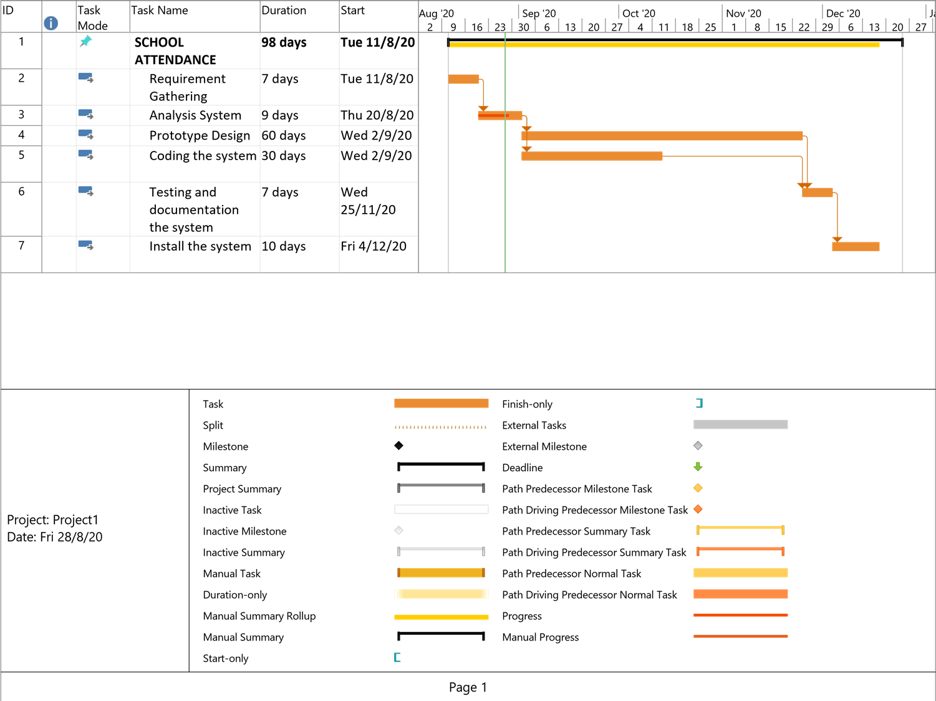

**2.0 Cost Planning**

A cost estimation is the approximation of the cost of a program, project cooperation. Cost estimation is the product of the estimating process. The cost estimate has identified component value.

Table 1.1 Cost Effective

|  |  |  |  |  |
| --- | --- | --- | --- | --- |
| No | Item | Quantity | Cost(RM) | Total(RM) |
| 1. | Software   * Arduino IDE * Android Studio * Firebase Database | 1  1  1 |  |  |
| 2. | Hardware   * Arduino Uno R3 * RFID Module * RFID Cards * ESP8266 * LCD Display * Buzzer * Laptop * Flash Drive * Printer | 1  1  23  1  1  1  3  2  1 | 75.90  7.20  0.99  8.40  5.90  7.14 | 75.90  7.20  22.77  8.40  5.90  7.14 |
| TOTAL(RM) | | | | 127.31 |

* 1. **Conclusion**

In the system, School Attendance System Using RFID can replace the manual system that transformation of information can be delivered without hitch.This system will ease is school to monitor the students.The system can reduces manpower.Although there are different method of tracking students but our system is very easy to handle and convenient for School level.This System gives time saving, easy control and reliability.

In conclusion, the objective to build an RFID based attendance system was successfully achieved. In terms of performance and efficiency, this project has provided a convenient method of attendance marking compared to the traditional method of attendance system. By using databases, the data is more organized