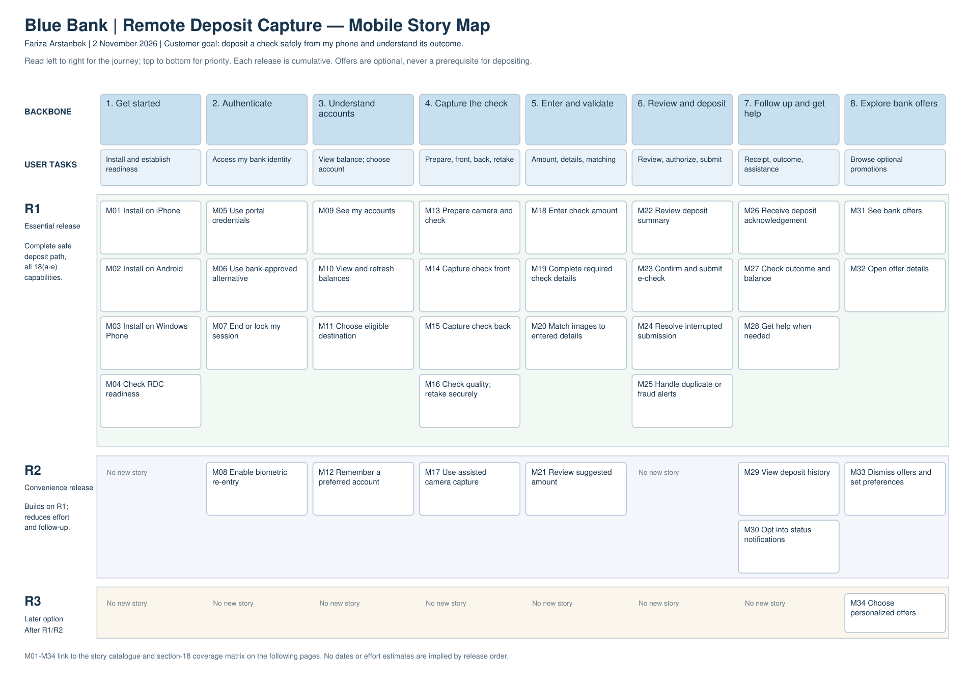

Remote Deposit Capture — Mobile Story Map
Fariza Arstanbek | 2 November 2026

Scope and assumptions
A1. The bank supplies existing account enrollment/eligibility and account APIs. The mobile app guides users to those services; creating or deleting deposit accounts belongs to the portal scope in section 20, not this assignment.
A2. Portal credentials are supported, and the bank defines at least one alternative identity-check route for M06, such as an existing verified one-time-code process. Biometric re-entry in R2 is optional and must follow bank session policy; it is not a substitute for account verification.
A3. Secure capture uses protected temporary storage, protected transport, authorized access and bank-side duplicate/tamper/fraud checks. “Fraud-proof” is treated as the case’s protective intent, not a promise that any photograph can guarantee the absence of fraud; retry uses a stable submission reference and outcome lookup.
A4. Balances, eligibility, acceptance/rejection and clearing/availability statuses come from bank systems. A submission acknowledgement does not mean the check has cleared or that funds are immediately available; the app displays the status and refresh time it receives.
A5. The bank supplies mandatory check-field rules, image-quality/endorsement rules and image-versus-entered-detail validation. M20 validates the entered amount against the images in R1; optional R2 amount prefill only reduces typing and never removes verification.
A6. Offer content and support channels are maintained by existing bank services. The app displays offers/details and provides links or a telephone action to the existing 24/7 support service; a marketing authoring console and support staffing are not mobile-app features.
A7. All three platforms named in the fictional section 18(a), including Windows Phone, remain in the map and R1 scope. This is a case-study plan, not a claim that a current Windows Phone store or supported deployment toolchain is available; a real project would resolve platform feasibility with stakeholders before committing dates.

Story catalogue

1. Get started

M01 | R1 | Install on iPhone
As a Blue Bank customer, I want to download and install the iPhone app so that I can deposit checks from my iPhone.
Trace: 18(a)

M02 | R1 | Install on Android
As a Blue Bank customer, I want to download and install the Android app so that I can deposit checks from my Android phone.
Trace: 18(a)

M03 | R1 | Install on Windows Phone
As a Blue Bank customer, I want to download and install the Windows Phone app so that I can use the platform explicitly included in the case study.
Trace: 18(a)

M04 | R1 | Check RDC readiness
As a Blue Bank customer, I want to see account eligibility and setup guidance so that I know whether my existing remote capture account is ready.
Trace: 3-4; A1

2. Authenticate

M05 | R1 | Use portal credentials
As a Blue Bank customer, I want to sign in with my existing internet portal account so that I can use my established bank identity.
Trace: 18(b)

M06 | R1 | Use bank-approved alternative
As a Blue Bank customer, I want to use a bank-approved alternative identity check so that I can authenticate through another supported route.
Trace: 18(b); A2

M07 | R1 | End or lock my session
As a Blue Bank customer, I want to sign out and have an inactive session locked so that other people cannot view my banking information on the phone.
Trace: 5,11,15; A3

M08 | R2 | Enable biometric re-entry
As a Blue Bank customer, I want to opt into supported biometric re-entry after bank authentication so that I can return conveniently without weakening the bank session policy.
Trace: A2; optional

3. Understand accounts

M09 | R1 | See my accounts
As a Blue Bank customer, I want to view accounts associated with my bank identity so that I can identify the right account before depositing.
Trace: 18(c); A1

M10 | R1 | View and refresh balances
As a Blue Bank customer, I want to see bank-provided balances and their refresh time so that I can distinguish current information from stale information.
Trace: 18(c); A4

M11 | R1 | Choose eligible destination
As a Blue Bank customer, I want to select an eligible deposit account so that my check goes to the account I intend.
Trace: 18(d)(iii)

M12 | R2 | Remember a preferred account
As a Blue Bank customer, I want to choose a preferred deposit account while confirming it each time so that repeat deposits require fewer selections.
Trace: A4; optional

4. Capture the check

M13 | R1 | Prepare camera and check
As a Blue Bank customer, I want to receive camera-permission and endorsement guidance so that I can prepare a usable check image.
Trace: 18(d)(i); A5

M14 | R1 | Capture check front
As a Blue Bank customer, I want to capture a clear front image within the app so that the bank can read and validate the check face.
Trace: 18(d)(i)

M15 | R1 | Capture check back
As a Blue Bank customer, I want to capture a clear back image within the app so that the bank receives both required sides.
Trace: 18(d)(i)

M16 | R1 | Check quality; retake securely
As a Blue Bank customer, I want to preview and retake unreadable images and protect temporary copies so that I submit usable images without exposing them in my public photo gallery.
Trace: 18(d)(i),5; A3,A5

M17 | R2 | Use assisted camera capture
As a Blue Bank customer, I want to use edge detection and optional automatic capture so that I can take clearer images with less effort.
Trace: A5; optional

5. Enter and validate

M18 | R1 | Enter check amount
As a Blue Bank customer, I want to enter the check amount explicitly so that the bank receives my intended deposit value.
Trace: 18(d)(ii)

M19 | R1 | Complete required check details
As a Blue Bank customer, I want to enter any additional check details required by bank policy so that my submission is complete before validation.
Trace: 18(d)(ii); A5

M20 | R1 | Match images to entered details
As a Blue Bank customer, I want to validate both images against my entered details and correct mismatches so that I do not submit an inconsistent amount or unreadable check.
Trace: 18(d)(iv)

M21 | R2 | Review suggested amount
As a Blue Bank customer, I want to review a suggested amount extracted from the image before accepting it so that I can reduce typing while retaining control of the declared amount.
Trace: A5; optional

6. Review and deposit

M22 | R1 | Review deposit summary
As a Blue Bank customer, I want to review the account, amount, images and bank-provided terms so that I can correct errors before authorizing submission.
Trace: 18(d)(ii-v); A5

M23 | R1 | Confirm and submit e-check
As a Blue Bank customer, I want to authorize one secure submission of the validated e-check so that the bank can receive and process my deposit.
Trace: 18(d)(v)

M24 | R1 | Resolve interrupted submission
As a Blue Bank customer, I want to check the outcome of an interrupted request before retrying so that I avoid accidentally submitting the same deposit twice.
Trace: 5,11; A3

M25 | R1 | Handle duplicate or fraud alerts
As a Blue Bank customer, I want to receive a clear bank validation result and next action so that a suspected duplicate or invalid check is not treated as a successful deposit.
Trace: 18(d)(i,iv-v); A3,A5

7. Follow up and get help

M26 | R1 | Receive deposit acknowledgement
As a Blue Bank customer, I want to receive a deposit reference and bank-reported status so that I have evidence that the bank received my request.
Trace: 18(d)(v); A4

M27 | R1 | Check outcome and balance
As a Blue Bank customer, I want to refresh the bank-reported deposit outcome and account balance so that I can tell pending processing from funds made available.
Trace: 18(c,d)(v); A4

M28 | R1 | Get help when needed
As a Blue Bank customer, I want to open bank instructions or contact the existing support service so that I can recover from setup or deposit problems.
Trace: 7; A6

M29 | R2 | View deposit history
As a Blue Bank customer, I want to review prior deposit references and outcomes so that I can find a previous transaction without submitting it again.
Trace: A4; optional

M30 | R2 | Opt into status notifications
As a Blue Bank customer, I want to opt into notifications about deposit status changes so that I can learn of a bank decision without repeatedly opening the app.
Trace: A4; optional

8. Explore bank offers

M31 | R1 | See bank offers
As a Blue Bank customer, I want to view current bank offers in the app so that I can discover relevant banking opportunities.
Trace: 18(e)

M32 | R1 | Open offer details
As a Blue Bank customer, I want to open offer conditions and the bank-approved next action so that I can decide whether to respond without interrupting a deposit.
Trace: 18(e); A6

M33 | R2 | Dismiss offers and set preferences
As a Blue Bank customer, I want to dismiss an offer or manage optional promotion settings so that I can keep the app focused on my banking task.
Trace: A6; optional

M34 | R3 | Choose personalized offers
As a Blue Bank customer, I want to opt into personalized offers with clear preferences so that I receive more relevant offers if I choose.
Trace: A6; optional

