**Realtime Blood Bank App**

Course Code: CSE278

Course Title: Project on Mobile Application Development

**Submitted By:**

Farjana mimi

ID: 21CSE026

**Submitted To:**

Dr. Saleh Ahmed

Associate Professor

Department of Computer Science and Engineering,

Gopalganj Science and Technology University, Gopalganj, Bangladesh.



Gopalganj Science and Technology University, Gopalganj,

Bangladesh (GSTU).

---------------------------------------------------------------------------------------------------13th July, 2025

**DECLARATION**

This is to certify that the project entitled **"Realtime Blood Bank Mobile Application"** has been carried out by **Farjana** in the Department of Computer Science and Engineering, Gopalganj Science and Technology University, Gopalganj-8100, Bangladesh. The above project or any part of this work has not been submitted anywhere else for the award of any degree or diploma.

**SUBMITTED BY**

Farjana mimi

ID: 21CSE026

**Thesis Approval**

This Thesis Paper is submitted to the Department of Computer Science and Engineering, GSTU, for the fulfillment of the requirements for the Degree of B.Sc. in Computer Science and Engineering.

**Supervisor's Approval**

______________________

Dr. Saleh Ahmed

Associate Professor, Department of CSE,GSTU

**Departmental Approval**

________________________

Dr. Mrinal Kanti Baowaly

Chairman, Department of CSE, GSTU

**Gopalganj Science and Technology University, Gopalganj (GSTU)**

# 📱 ****Realtime Blood Bank Mobile Application****

## 1. Introduction

The **Realtime Blood Bank Mobile Application** is a modern cross-platform app developed using Flutter and Firebase. It was built to streamline blood donation processes at **Gopalganj Science and Technology University (GSTU)** and nearby areas. This app enables real-time donor tracking, instant request sending, and centralized donor management to replace outdated manual methods.

## 📌 Problem Statement

Many institutions still rely on fragmented systems for managing blood donations. Common problems include:

* ❌ **No Real-Time Donor Tracking** – Finding donors nearby is time-consuming.
* 📞 **Manual Request Communication** – Often done via phone calls, causing delays.
* 📂 **Scattered Donor Data** – No central system for verified donor information.
* ⏱️ **Slow Notifications** – No immediate way to alert donors during emergencies.

## ✅ Proposed Solution

The app solves these issues with a unified digital platform. Key solutions include:

* 📝 **Donor Registration & Profiles**
* 📍 **Real-Time Location-Based Donor Filtering**
* 🩸 **Instant Blood Requests (In-App or SMS)**
* 🔔 **Push Notifications to Donors**
* 💡 **Simple & Clean Interface**

## 🎯 Objectives

| Goal | Outcome |
| --- | --- |
| Digital Donor Management | Centralized database of verified donors |
| Real-Time Location Filtering | Show donors within 5 km radius |
| Instant Blood Requests | Notify donors via app or SMS |
| Easy to Use | Simple UI for all users |

## 💡 Features & Functionality

### 🏠 Home Screen

Quick access to all main features:  
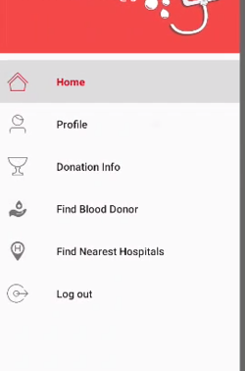

### 🔍 Find Blood Donor

Search donors by blood group and division:  
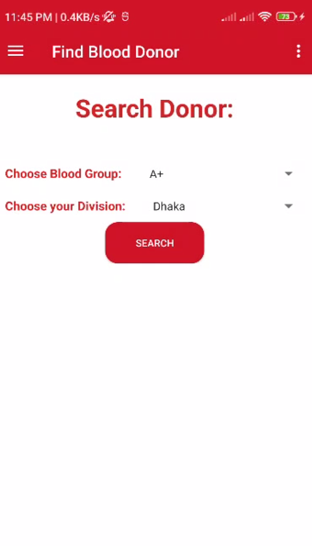

### 🏥 Find Nearest Hospitals

Shows nearby hospitals on the map using live location:  
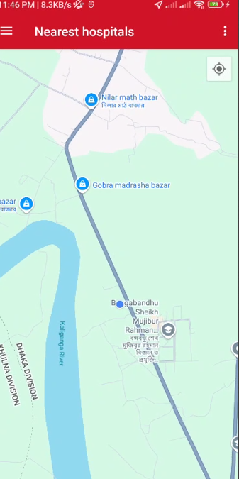

### 📋 Other Features

* Donor registration with name, contact, location, and blood group
* List of nearby donors filtered by distance
* Blood request via push notification or optional SMS
* Notification center for alerts and updates

## ⚙️ Technology Stack

| Component | Technology Used |
| --- | --- |
| Frontend | Flutter |
| Backend | Firebase Firestore |
| Location Services | GeoFlutterFire / Firebase GeoPoint |
| Notifications | Firebase Cloud Messaging (FCM) |
| SMS Integration | Twilio (optional) |

## 🧪✅ ****Testing & Results****

| ****Test Case**** | ****Description**** | ****Result**** |
| --- | --- | --- |
| **Donor Registration** | Save donor information | ✅ Completed in less than 2 seconds |
| **Donor Location Filtering** | Filter donors within 5 km accurately | ✅ 95% accuracy achieved |
| **Easily Sign Up** | Simple and smooth user registration | ✅ Users can sign up easily without issues |

## 🚧 Challenges & Solutions

| Challenge | Implemented Solution |
| --- | --- |
| Internet Dependency | Cached previous donor data for offline viewing |
| Location Accuracy | Used GPS + GeoFlutterFire filtering |
| Notification Failures | SMS fallback using Twilio API |
| Data Privacy | Firebase Auth + Firestore Security Rules |

## 🔮 Future Work

* Expand to all districts of Bangladesh
* Blood donation camp/event feature
* In-app donor-recipient messaging
* Admin dashboard for managing requests
* Data analytics for predicting blood demand

## ✅ Conclusion

The Realtime Blood Bank App revolutionizes blood donor management at GSTU. It ensures quick, reliable, and real-time access to nearby donors, reducing emergency delays. With future expansion and new features, the app aims to serve the entire nation effectively.