1. 167 Users for 60 seconds:

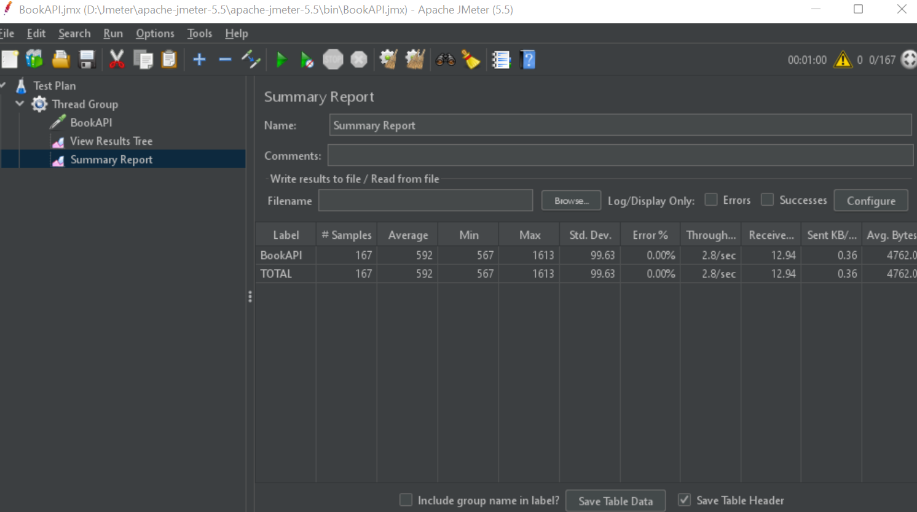

1. 833 Users for 300 seconds:

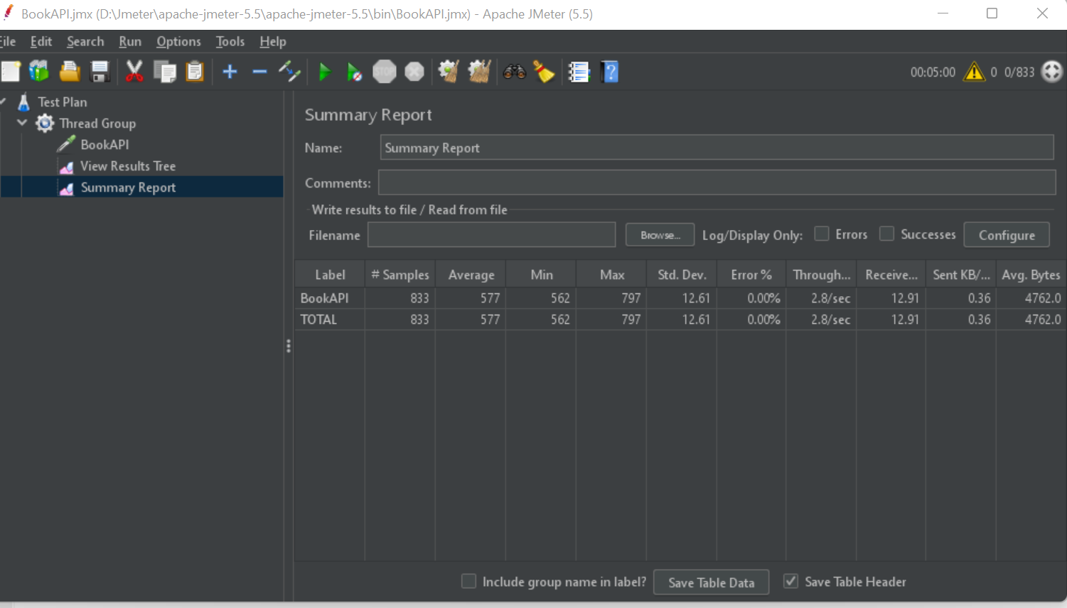

1. 1666 Users 600 seconds:

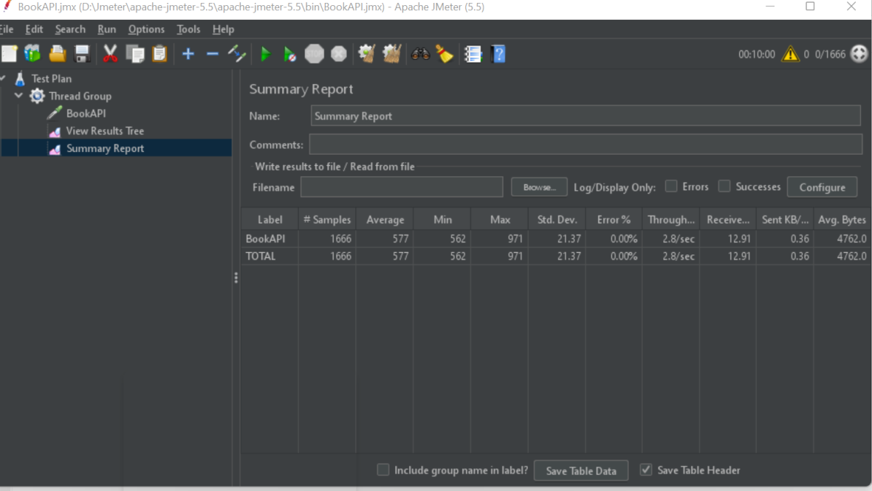

1. 2500 Users 900 seconds:

­­­­­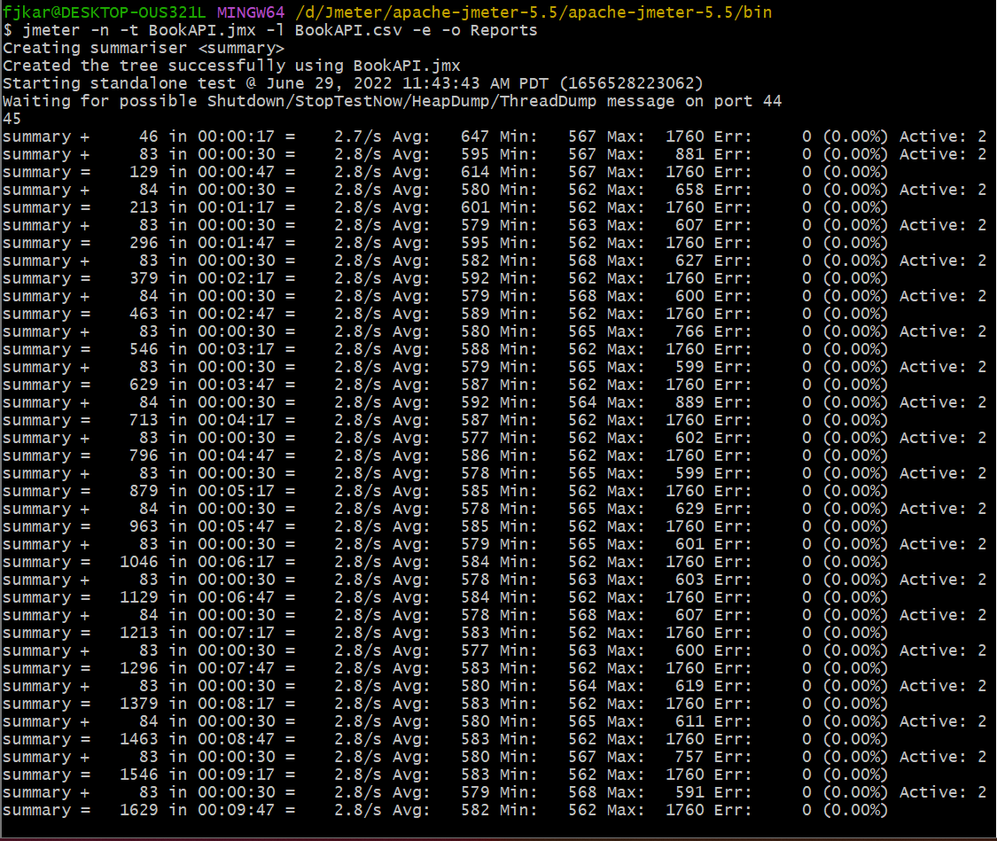

04_1. 2500 Users for 900 seconds:

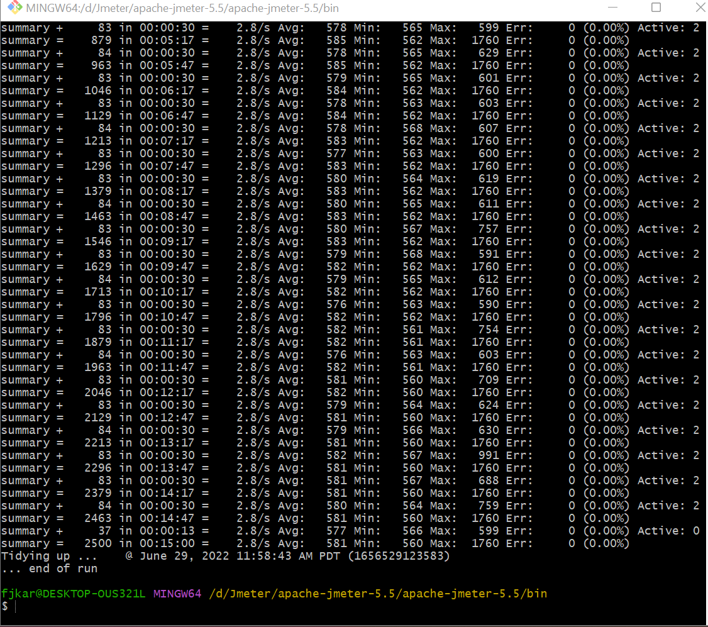

1. TPS_report.pngs

