

AMERICAN INTERNATIONAL UNIVERSITY-BANGLADESH

COMPUTER GRAPHICS – PROJECT DOCUMENTATION

|  |  |
| --- | --- |
| **Course Name** | Computer Graphics |
| **Section** | D |
| **Group No** | 4 |
| **Course Instructor** | ANEEM AL AHSAN RUPAI |

**Group Members Information:**

|  |  |
| --- | --- |
| **Name** | **ID** |
| Farjum Haider | 18-38360-2 |
| Emdadul Haque | 18-39032-3 |
| Rafeed Mohammad | 16-32845-3 |
| Tanvir Ahamed | 18-37968-2 |

**Table of Content:**

|  |  |
| --- | --- |
| **Content List** | **Page No** |
| Introduction | 03 |
| Proposal | 03 |
| Schematic Diagram | 04 |
| List of Objects | 05 |
| Functions to Represent the Objects | 06 - 07 |
| Interactive Functions | 08 |
| Task Assignment and Codes of Functions | 09 - 10 |
| Output | 11-12 |
| Conclusion | 13 |

**Introduction**

The project is about a scenario, where we have created a front view of **“Lalbagh Fort”**. In this scenario we have used several Objects where, some of are with animations and some of are without animation. We have created all the objects with a specific ID which was one of the core instructions of the project.

**Proposal**

The project about a scenario type. There will be a real life scenario of a **“Lalbagh Fort”.** There will be road, cars, cloud, sun, night stars, moon, benches, trees, building, airplane, lamp post, ships, river, field. There will be some keyboard connection which will be created. In the scenario there will be day and night view using keyboard.

**Schematic Diagram**

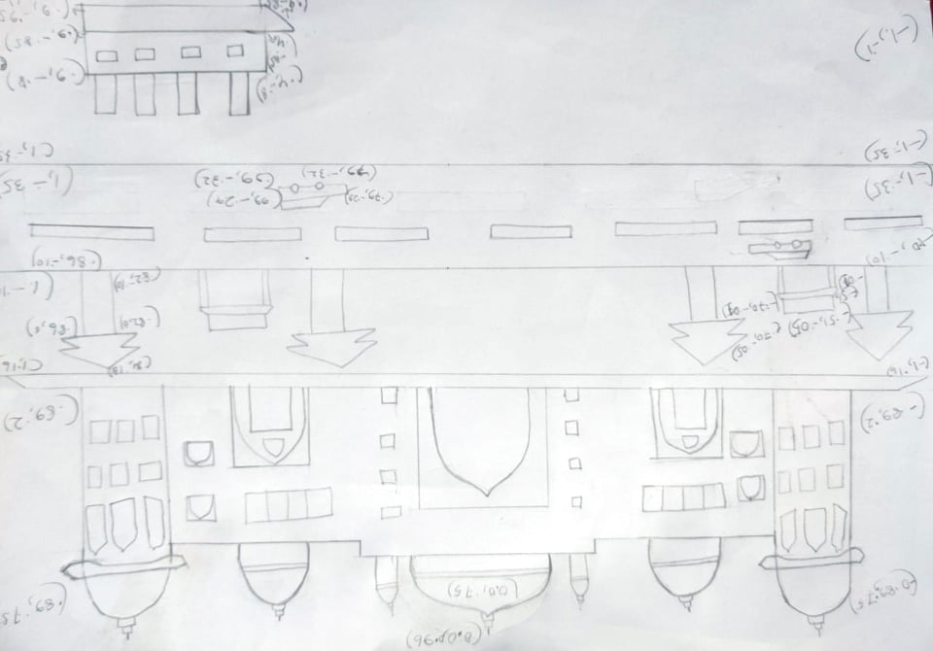

**List of Objects**

1. Clouds (Moving objects)
2. Sky
3. Field
4. Road
5. Airplane (Moving object)
6. Cars (moving objects)
7. Sun
8. Moon
9. Ships (moving objects)
10. Trees
11. Lalbagh fort building
12. Footpath
13. Benches
14. River(night mode)
15. Stars
16. Lamp post (night mode)

**Functions to Represent The Objects**

|  |  |  |
| --- | --- | --- |
| **Object** | **Function** | **ID** |
| sky | void sky() | 801 |
| sun | void sun() | 802 |
| cloud | void cloud() | 803 |
| Lalbagh Fort | void lalbaghFort() | 804 |
| field | void field() | 805 |
| footpath | void footpath() | 806 |
| lamppost | void lamppost() | 807 |
| trees | void trees() | 808 |
| bench | void bench() | 809 |
| road | Void road() | 810 |
| Cars | void Cars() | 811 |
| river | void river() | 812 |
| Ship right | void ship_right() | 813 |
| Ship left | void ship_left() | 814 |
| plane | void plane() | 815 |
| Sky night | void sky_night() | 816 |
| moon | void moon() | 817 |
| stars | void stars() | 818 |
| lalbaghFort night | void lalbaghFort_night() | 819 |
| Field night | void field_night() | 820 |
| Footpath night | void rightbench() | 821 |
| Lamppost night | void lamppost_night() | 822 |
| Trees night | void trees_night() | 823 |
| Bench night | void bench_night() | 824 |
| Road night | void road_night() | 825 |
| River night | void river_night() | 826 |

**Interactive Functions**

|  |  |  |
| --- | --- | --- |
| **Function** | **Interactive Functions** | **ID** |
| plane | move_plane, update_plane | 201 |
| Cars | move_car_right, update_car_right,  move_car_left, update_car_left | 202 |
| Ship right | move_ship_right, update_ship_righte | 203 |
| Ship left | move_ship_left, update_ship_left | 204 |
| cloud | move_cloud_left, update_cloud_left,  move_cloud_right, update_cloud_right | 205 |

**Task Assignment and Codes of Funchtions**

**Contribution Table:**

|  |  |  |  |  |
| --- | --- | --- | --- | --- |
| **Member-1** | **Member-2** | **Member-3** | **Member-4** | **TOTAL** |
| 25% | 25% | 25% | 25% | 100% |

|  |  |
| --- | --- |
| **Name**  **ID** | **Contribution in Project** |
| **Member-1**  18-38360-2 | 1. Lalbagh fort building 2. Clouds (Animation) 3. Night Effects(Lalbagh fort building) |
| **Member-2**  18-39032-3 | 1. Trees 2. Benches 3. Road 4. Stars 5. Cars(Animation) 6. Night Effects(Tress,Benches ,Road ) |
| **Member-3**  16-32845-3 | 1. Ships (Animation) 2. Airplane (Animation) 3. Sun 4. Footpath 5. Field 6. Night Effects(Footpath,Field ) |
| **Member-4**  18-37968-2 | 1.Ships (Animation)  2.Moon  3.River  4.Sky  5.Lamp post  6.Night Effects(Lamp post,sky,river ) |

**OUTPUT**

|  |  |
| --- | --- |
| **Day View** | **day** |
| **Night View** | **night** |

**Conclusion**

To conclude this project, we used simple graphics to show how the environment of Lalbagh fort looks like in a day view and night view. We used various type of polygons, various modes and to produce the necessary graphics we needed to show for our project and we successfully ended up with a nice final product which ultimately produced an animation which shows how the Lalbagh fort looks like. Due to time constraint, we could have added more things which could have showed better emphasis itself. But to end it all, we have completed all the requirements needed for the project and finished it properly. Finally, we would like to thank our honorable course instructor. We could not complete this semester and the project without his essential instructions. We wish him long life and well-being.