Hi My name is khan how are u whats going on in so called boring life…

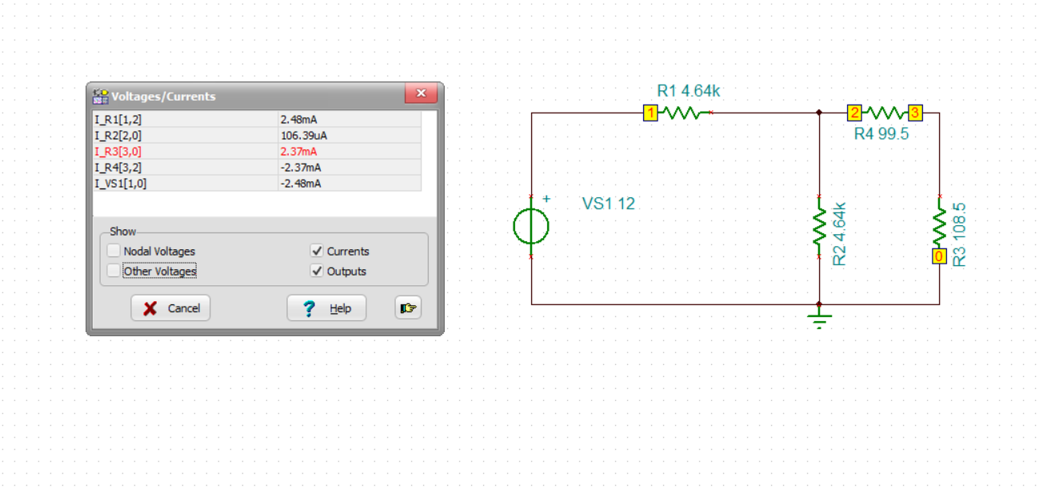

And what in the world above image indicates its just a diagram to find current voltage across different jaffoa afeuofcnda owersdajfohae aknfdoajf akfnka onbnfs ueujos cnasdfkjofja adfn.