

AN IMS [ISO 21001, ISO 9001, ISO 14001, ISO 45001] CERTIFIED TRAINING INSTITUTION

**NETTUR TECHNICAL TRAINING FOUNDATION**

**PROJECT SYNOPSIS**

On

**FARMASPHERE**

**TEAM MEMBERS**

NEC0922007 LAKSHMINARAYANAN B

NEC0922019 KUMAR R

NEC0922025 NAMEETHA R

NEC0922052 PURUSOTHAMAN D

**DIPLOMA IN INFORMATION TECHNOLOGY**

**AND DATA SCIENCE**

**NTTF ELECTRONICS CENTRE**

**ELECTRONICS CITY, BANGALORE-560100**

**2022-2025**

**. SCOPE OF THE PROJECT**

The project will enhance farmers' income by eliminating middlemen through a direct marketplace. It will improve farming efficiency using real-time weather data and crop recommendations. Tutorials and government schemes information will educate and empower farmers. A scalable platform that can grow to include AI and IoT features in the future.

**3. OBJECTIVE OF THE PROJECT**

To create a web platform that provides farmers with a direct marketplace, real-time weather and crop advisory, farming education, and updates on government schemes. To integrate a voice assistant supporting regional languages for accessibility.

**4. LITERATURE SURVEY**

**4.1 EXISTING SYSTEMS**

* **AgroStar**
* **Developer:** AgroStar was founded by Shardul Sheth and Sitanshu Sheth.
* **Launched:** 2013
* **Description:** AgroStar is an Indian agri-tech platform that allows farmers to purchase agricultural inputs (seeds, fertilizers, pesticides) directly through their mobile phones.
* **Features:**
  + Mobile-based ordering system for farming products.
  + Guidance on using purchased products for better results.
* **Limitations:**
  + No integration with real-time weather data.
  + Focuses more on product sales than providing holistic farming solutions.
  + Lack of direct marketplace for farmers to sell their produce.
* **Kisan Suvidha App**
* **Developer:** Developed by the Ministry of Agriculture and Farmers Welfare, Government of India.
* **Launched:** 2016
* **Description:** Kisan Suvidha is a mobile application designed to provide useful information to farmers about weather forecasts, crop advisories, and mandi prices.
* **Features:**
  + Provides weather updates for the next 5 days.
  + Market price details for crops in nearby mandis.
  + Pest and disease advisories for crops.
* **Limitations:**
  + Does not have a direct selling or buying marketplace.
  + Lacks interactive or personalized recommendations.
  + No integration with voice assistance or offline mode for regions with poor connectivity**.**

**4.2 RESEARCH GAP**  
 Existing platforms provide fragmented services that focus only on individual needs of farmers. These include:

* **Marketplaces without Advisory**: Platforms like AgroStar do not integrate advisory or educational support.
* **Weather Alerts Without Marketplace**: Apps like Kisan Suvidha provide weather updates but do not empower farmers to sell their produce.
* **Lack of Accessibility for Semi-Literate Farmers**: None of the existing platforms offer robust voice assistant support to make technology accessible to farmers in their regional languages.

**4.3 UNIQUENESS OF THE PROPOSED SOLUTION**

The **Farmer Resource and Marketplace Hub** aims to address these gaps by:

* Combining a **direct marketplace** with advisory and educational features.
* Offering **real-time weather updates** integrated with pest alerts and crop suggestions.
* Providing a **voice assistant** to make the platform accessible for semi-literate and non-tech-savvy users.
* Including a **government schemes module** to educate farmers about financial and policy support available to them.

**4.4 LITERATURE SURVEY (BOOKS AND RESEARCH PAPERS)**

* **"Precision Agriculture Technology for Crop Farming" by Qin Zhang**
  + Discusses using technology like weather forecasting and pest monitoring to enhance agricultural productivity.
* **"Sustainable Agriculture" by S. Singh and J.P. Mishra**
  + Highlights the importance of education in sustainable farming and modern techniques.
* **"Agricultural Marketing and Price Analysis" by Bailey Norwood**
  + Analyzes inefficiencies in current marketplaces and emphasizes the need for direct farmer-to-consumer platforms.
* **Research Paper: "Adopting Digital Agriculture: Benefits and Challenges" by A. Patel et al., 2021**
  + Explores how digital platforms transform farming and identifies gaps in current solutions.
* **"Voice Technology in Agriculture" by R. Bose, Journal of Agricultural Research, 2022**
  + Details the potential of voice assistants to make technology more accessible for semi-literate farmers.

**5. HARDWARE AND SOFTWARE REQUIREMENTS**

**5.1 HARDWARE REQUIREMENTS**

* **Processor:** Intel Core i5 or higher
* **RAM:** 8 GB or more
* **Storage**: 500 GB or more

**5.2 SOFTWARE REQUIREMENTS**

* **Frontend:** HTML, CSS, JavaScript, React.js .
* **Backend:** Django/Python, Node.js (optional)
* **Database:** MySQL or SQLite
* **APIs:** OpenWeatherMap API, Government Scheme APIs
* **Voice Assistant:** Google Text-to-Speech or Amazon Polly
* **Deployment:** Vercel

**6. TASKS AND TIMELINE**

|  |  |  |  |  |  |
| --- | --- | --- | --- | --- | --- |
| **Phase** | **Task** | **Start Date** | **End Date** | **Duration (days)** | **Dependencies** |
| Project Planning | Define project scope | 2/1/25 | 8/1/25 | 7 | None |
|  | Prepare project schedule | 9/1/25 | 15/1/25 | 7 | Define project scope |
| Requirements  Analysis | Gather Requirements | 16/1/25 | 23/1/25 | 8 | Project Planning |
|  | Analyse Requirements | 24/1/25 | 31/1/25 | 8 | Gather Requirements |
| Design | System Architecture | 3/2/25 | 12/2/25 | 10 | Requirements Analyse |
|  | UI/UX Design | 13/2/25 | 24/2/25 | 12 | Create System Architecture |
| Development | Develop Backend and Database | 25/2/25 | 2/4/25 | 37 | Develop Backend and Database |
|  | Frontend Development | 3/4/25 | 14/5/25 | 43 | Frontend Development |
| Testing | Functional Testing | 15/5/25 | 20/5/25 | 6 | Functional Testing |
|  | Performance Testing | 21/5/26 | 26/5/25 | 6 | Performance Testing |
| Deployment | Deploy Software | 27/5/25 | 30/5/25 | 4 | Software deployment |

**7. GANTT CHART**

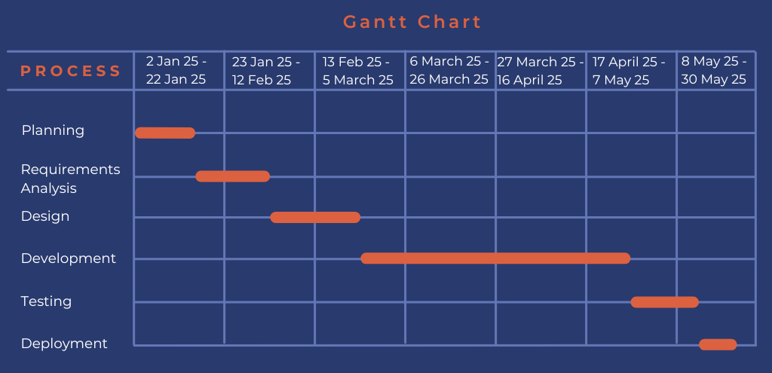

**8. CONCLUSION**

The Farmer Resource and Marketplace Hub will serve as a one-stop platform to address the challenges faced by farmers, empowering them with technology and information. The voice assistant feature ensures accessibility for those unfamiliar with digital platforms. The project has significant future potential, including AI-driven insights and IoT for advanced farming solutions.

**9.REFERENCES**

* **OpenWeatherMap API Documentation:** [https://openweathermap.org/api](%20https:/openweathermap.org/api)
* **Google Cloud Text-to-Speech Documentation:** <https://cloud.google.com/text-to-speech>
* **Article:** “Digital Platforms for Farmers” by WhatsApp, Zoom, and Microsoft Team, 2023.