**Exp. 1 - Familiarization with the Digital Trainer**

Engr 357 - Digital Design Lab

Fall 2015

Farnam Adelkhani

Sandra Hernandez

Date Experiment Performed: 8-27-2015

Date Report Submitted: 9-3-2015

Farnam Adelkhani

Sandra Hernandez

Engr 357 - Digital Design Lab - 8/28/15

Experiment #1

**Exp. 1 - Familiarization with the Digital Trainer**

**Abstract and Objective:**

The first goal of this first experiment in digital design is to gain familiarity with the Cadet II digital trainer. We begin with an introduction to basic electricity and safety procedures, such as reminding the students that the two basic quantities in electricity are current and voltage. Current is the flow of electrons through a conductor and the reader is reminded of comparisons to water flowing in pipes as an analogy for electrical current flowing through a wire. When voltage and current are multiplied we have the quantity of power generated in watts.

Now let's talk about the digital trainer and what components the student is required to become adequately familiar with. It is appropriate that we first talk about Vcc. The cadet II board has 5V Vcc outputs as well as variable outputs for setting custom voltages. Of course we cannot forgot to implement the ground poles as well that are provided on the board. The board has a variable-frequency clock source that can be used to generate sin, triangular and square functions. The frequency of the pulses can be adjusted using the knobs. The 0-1.0 frequency knob is a multiplier used to create custom frequencies. An important aspect of digital design is understanding SPST and SPDT switches. SPST switches are essentially On and Off switches while SPDT switches can provide two levels of On; such as up for red light and down for green light. Pushbutton switches are also included on the board and abbreviated as PB1 and PB2 , these buttons are used to provide momentary logic signals. Toggle switches are used to provide level signals and PB switches are appropriate when desiring to generate pulse signals.

After talking about the Cadet II features the experiment gives an overview of breadboards. The top and bottom bays are for Vcc and GND and they are separated in the middle for a total of 8 bays. The center two bays are separated by a middle channel that runs across the board. There are generally 64 columns in the bays. We cover Integrated Circuits and what each connection is used for. The basics of how to plug ICs in and how to unplug them are covered in order to prevent damage and bloody fingers. We will be using 14 and 16 pin dips in this course. The power is on the top left and the GND is on the bottom right, generally. Learning to read IC names is important, for example; 54S00 means military-grade, Schottkey and 00 represents the function code for quadruple 2-input NAND gates. Sorting our ICs onto a flat piece of foam in numerical order is recommended.

The second goal of this experiment in digital design is to become familiar with general circuit assembly techniques. Logic diagrams are used to show the logical thinking behind the design. It will not provide pin numbers for example, only a general overview of the circuit. A schematic diagram however is used to show how the circuit is to be built , and so IC device and pin numbers are all included. Also the block diagram is used to show the general form of a complex circuit and the relationships among its subunits but emits and specific details. IEEE stand logic symbols are introduced as well as the general symbols displayed on the Cadet II are explained.

**Components Used:**

Cadet II complete analog/digital electronics trainer complete with integrated breadboards

Probing Wires

Integrated Circuit (IC)

One Capacitor of unknown resistance

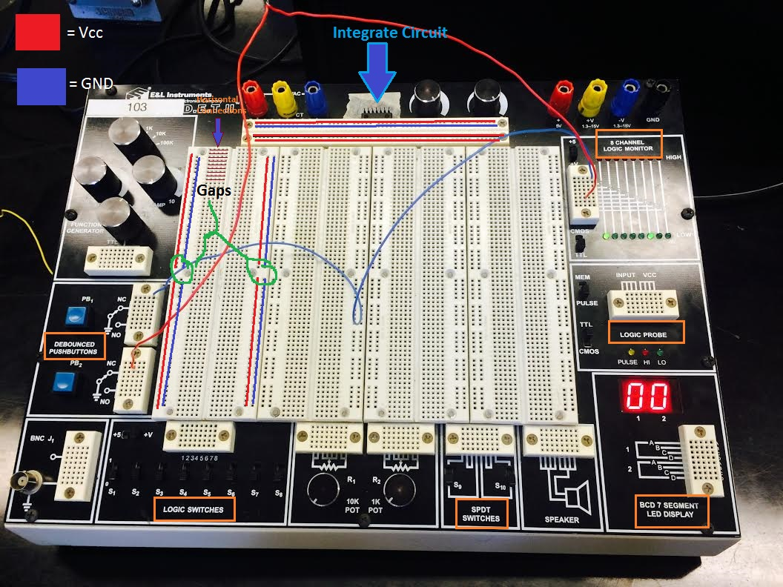**Circuit Diagram:**

**Detailed Procedure and Results:**

Laboratory Questions:

**1.** A logic probe was connected to the logic switch "S1" and then the other end was sequentially placed into each column on the bay for the 8 channel logic monitor. Each channel was tested by switching the logic switch to 1(Vcc) and 0(GND); all high and low switches lit up as expected. Red indicting "high" and red indicating "low". In order to test the floating signals, also known as "no connection", we simply made sure the indicator lights turned off upon removing the probe.

**2.** In order to test all the toggle switches we instead attached a single probe wire to channel 1 of the logic monitor and then began to connect the other end of the probe to each switch sequentially while testing both high and low. If both lights (red and green) lit up, then we knew the switch is functional. All 8 channels functioned as expected.

3. In order to test the push button switches (PB1 and PB2) on the digital trainer a probe wire was first inserted into the output of the two switches and run to the 8 channel logic monitor. If the green light were to turn on upon pushing the button, then we know the buttons are working to transmit the weak pulse signal. Sure enough the green indicator tells us that a weak signal has passed into the logic monitor. When hooking up the switches to 5V power rails and reconnecting the switch output to the logic monitor we are able to see that the red indicator lights also light up. Both switches are completely functional.

4. We setup the Vcc rail and the GND rail easily but running a probe from the power and ground poles to the upper bus rails. I probe wire was attached to both the Vcc row and the GND row and then inserted into the logic monitor to detect what kind of signal we were receiving. As expected, the Vcc rail gave a red light indicator and the GND rail gave a Green light indicator.

5. The estimated clock frequency is 5k since the Freq knob is set to 10k and the multiplier knob has been turned 50% or 1/2, so we get a 5k signal. The amp knob does not affect the frequency of the function, only the amplitude so we cannot see a visual difference in clock speed.

**Post Lab and Conclusions:**

Getting acquainted with the equipment was a challenge since we did not have any kind of manual for the equipment. It was also the first lab so we did not have a chance to read the lab assignment in advance. Most the work was done by simple guess and test. We shared success and failures with nearby groups to gain further insight. The cadet II looks like a cool piece of equipment and I look forward to gaining familiarity with it. We learned many lessons during this lab. We learned about circuit parts, setup and safety.