**Intro to AI**

**Activity 3**

**Question 1: Greedy Best-First Search**

You are an adventurer searching for a hidden treasure chest deep inside a jungle. The jungle is filled with ancient ruins, caves, rivers, and villages, and you must find the shortest path to the treasure using **Greedy Best-First Search**. Each location in the jungle is represented as a node, and paths between locations are edges. Each location has a heuristic value h(n), which estimates the straight-line distance to the treasure (T).

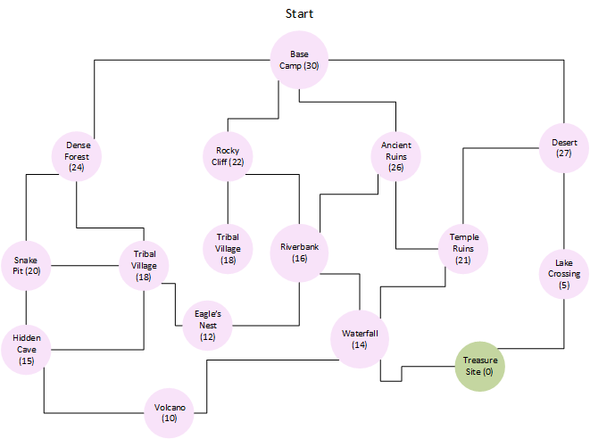

**Question2: Reverse-Engineering the Heuristic Values**

A robot was trapped in a complex escape room and used Greedy Best-First Search to find the exit. However, the heuristic values (h-values) were never recorded.

Your task is to **reverse-engineer** the heuristic values by analyzing the path the robot took.

**Escape Room Layout (Graph Representation)**

Each node represents a **chamber**, and the exit is at **E**.  
The robot started at **S** and followed this path to escape:

**Path Taken by Greedy Best-First Search:**  
S → C → H → N → E

However, there were other possible paths, such as S → B → G → M → E or S → A → D → J → O → E, but the robot did **not** choose them.

**Task**: Create the graph and assign h values to each node based on the selected path by robot and other possible paths.

Question 3: Fastest Route in Toronto

You are a food delivery driver in Toronto, and you have an urgent order to deliver from Downtown Toronto (D) to Toronto Pearson International Airport (P) .

However, not all roads are equal—some streets are congested, some routes are longer, and some highways offer shortcuts. You must find the fastest possible route using A* Search Algorithm.

**g-value**: The actual travel time (in minutes).

**h-value**: Estimated remaining time to Pearson Airport (based on straight-line distance presented into the circles).

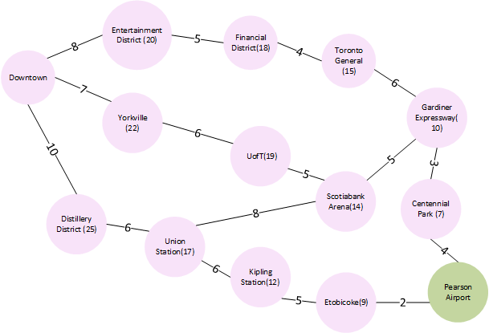

Answer:

Step 1: We will expand the Entertainment District Node.

Step 2:

Within the unexpanded nodes, the lowest f value is for Yorkville, so let's expand this.

Step 3:

