**Step 1 :** Make a WorkSpace with FileServer and FileClient java files with **PORT NO: 9848** ,and take a random image , put the image name in both Server and Client programs.

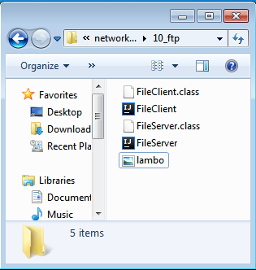

I am using **VS Code** as my editor

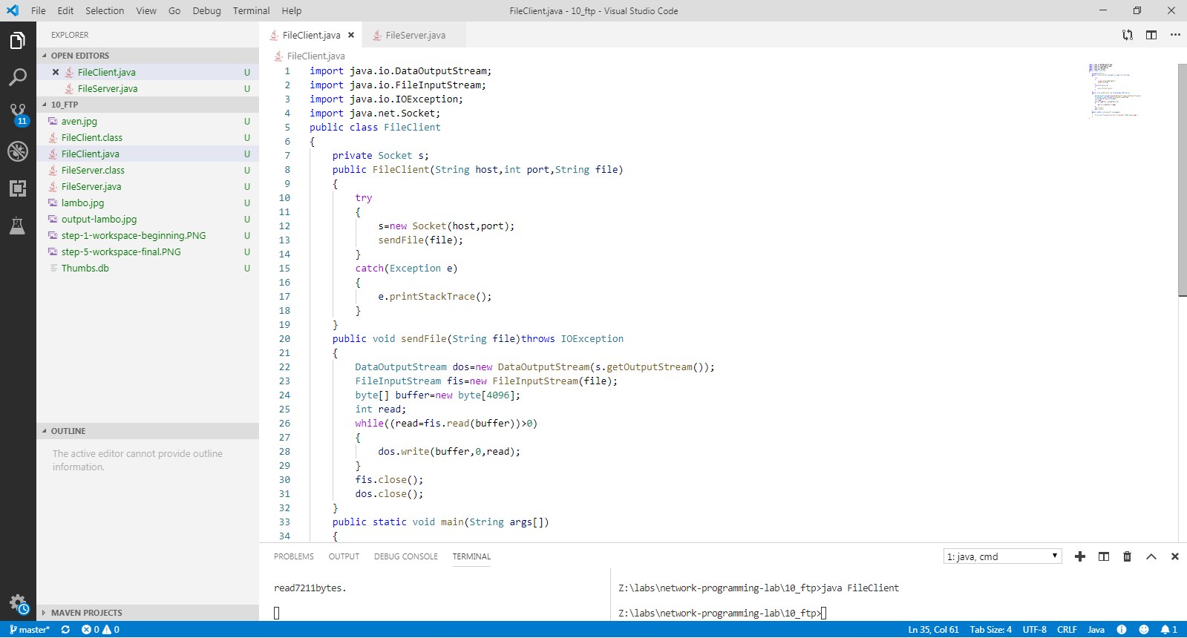

**Step 2 :** Compile and Run the FileServer.java file

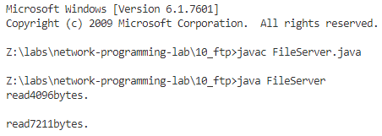

**Step 3 :** Compile and Run the FileClient.java file

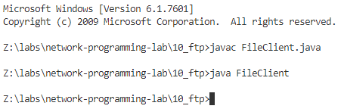

**Step 5 :** After running the file, the output image is generated in the Workspace.

.