**PUCIT**

**DELIVERABLE 2**

**Title: ATM for Cheque**

**Group Members**:

* FAROOQ HAIDER ALVI(BSEF19A029)

(**one and only**)

**Design Class Diagram:**

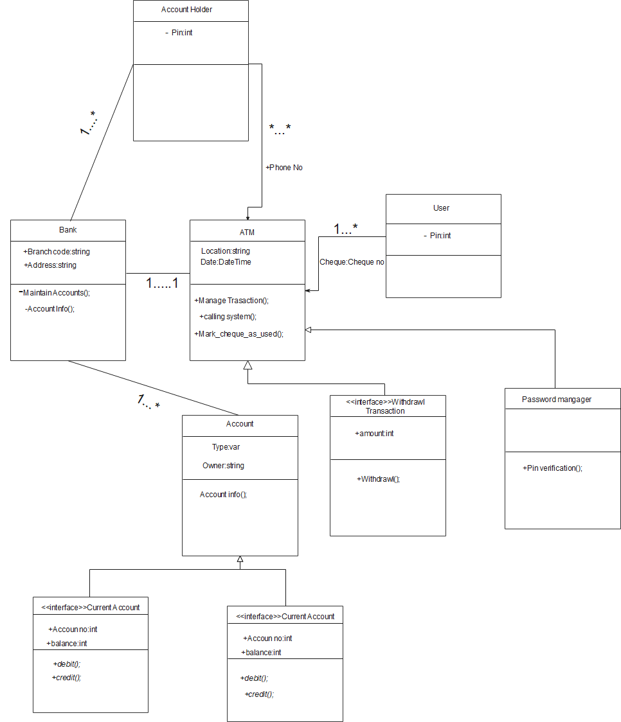

**Sequence Diagram:**

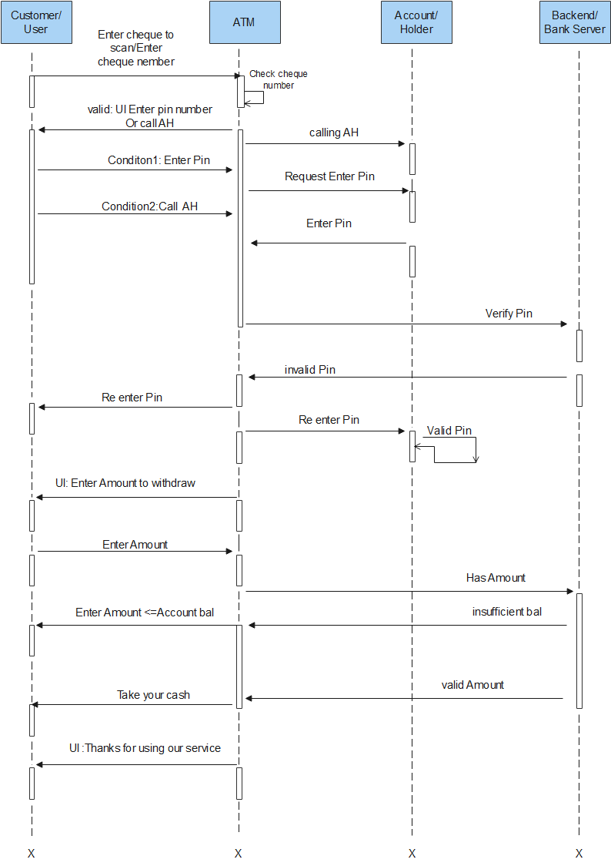

**Collaboration Diagram**

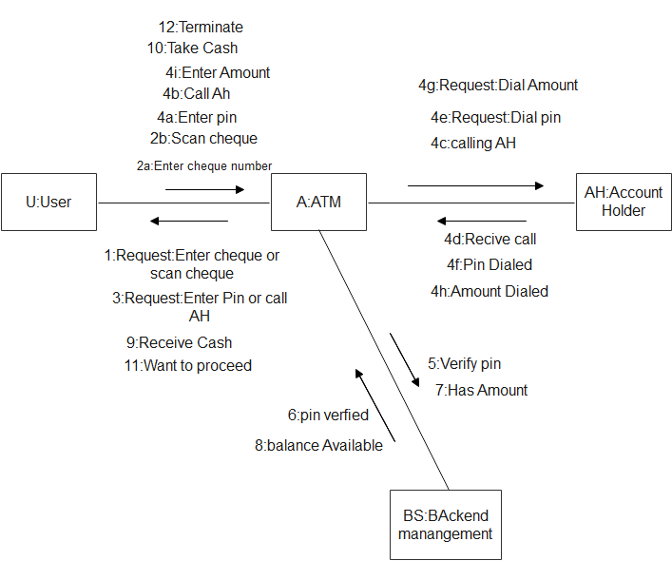

**System Sequence Diagram**

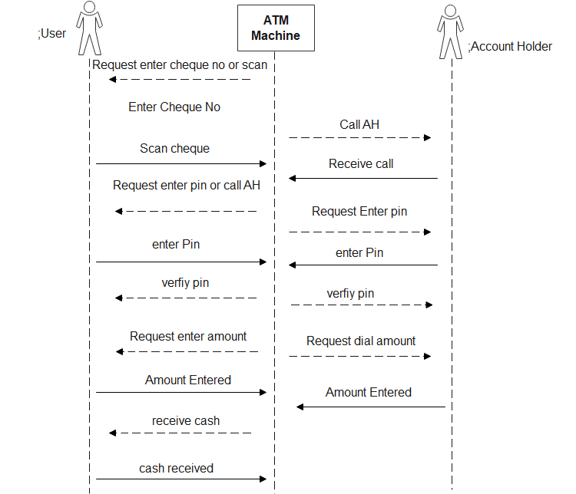

**Prototype**

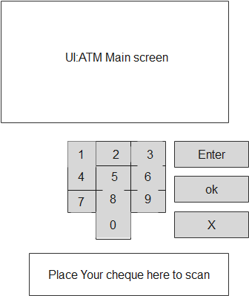

**Contract 1: Enter cheque and verify Pin**

**Pre-Condition:**

User has account in any bank

User has online banking system

**Post-Condition:**

User will place a cheque or will enter cheque

User will enter pin or will ask to call AH.

User will enter amount after entering pin

Pin will be verified

Use case Diagram:

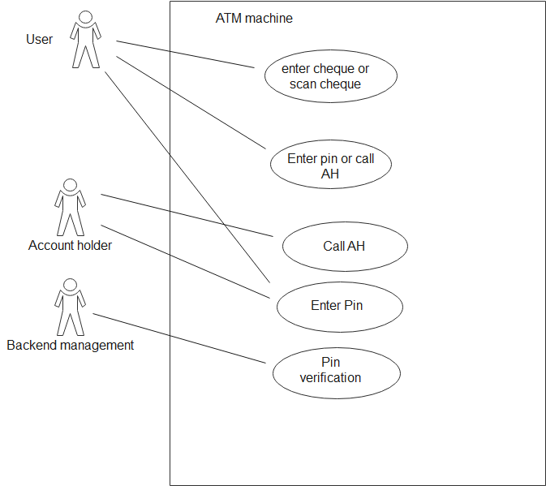

**Contract 2: With Draw Amount:**

**Pre-condition:**

User must have balance

**Post Condition:**

Use will enter amount which he /she wants to withdraw

After that user will successfully get his amount from ATM machine.

Transaction Successful message

Use case Diagram:

