|  |  |
| --- | --- |
| **Roll Number** | **22SW037 and 22SW040** |
| **Subject** | **Computer Networks** |
| **Research Work Assignment** | **5 marks** |
| **Teacher** | **Sir Qasim/Ma’am Fatima** |

***Detailed Analysis of Recent Linux System Vulnerabilities***

***Introduction***

Linux, long considered more secure than other operating systems, has seen an alarming increase in targeted attacks over the past few years, with 2023 and 2024 marking a dramatic rise. Specifically, attacks on Linux systems have tripled, driven by the growing dependence on Linux for servers, cloud computing, and containerized environments. This section will explore the recent trends in vulnerabilities in Linux and its ecosystem, highlighting the key attack vectors and the implications for organizations relying on this OS.



1. ***Rise of Linux Threats:***Historically, Linux was considered a relatively secure platform, primarily due to its open-source nature and smaller user base. However, as Linux systems now underpin the majority of server infrastructure, their attractiveness to attackers has surged. In 2023, attackers shifted their focus from Windows-based systems to *nix systems, exploiting vulnerabilities at a record pace [[Fortinet]](https://www.fortinet.com/corporate/about-us/newsroom/press-releases/2024/fortinet-threat-research-finds-cybercriminals-are-exploiting-new-industry-vulnerabilities-faster).

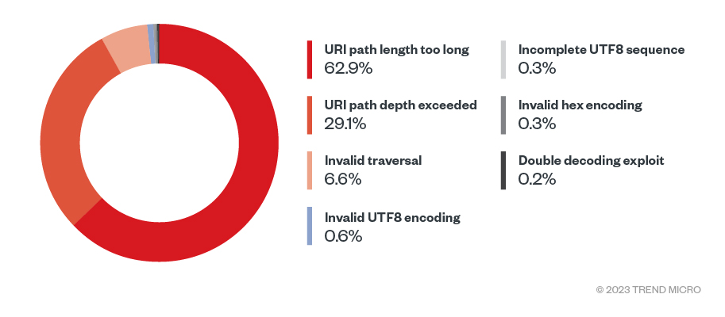

An example of this shift is the multi-year attack on the XZ utility library, a key component of many Linux distributions. In this campaign, cybercriminals injected a backdoor through an SSH vulnerability into various Linux distributions, effectively compromising critical systems [[Kaspersky]](https://www.kaspersky.com/blog/top-exploited-vulnerabilities-cve-2023-q1-2024/51317/). The breach highlights how attackers target system libraries and dependencies, elements often overlooked by system administrators.

1. ***Critical Linux CVEs in 2023:***Many of the critical vulnerabilities exploited in Linux over the past two years stemmed from core libraries, containers, and network services used in enterprise environments. Among these, CVE-2024-21626, a vulnerability in the runc container runtime, stands out. This flaw allowed attackers to escape containerized environments, giving them access to the underlying system, a critical breach in environments that rely on containers for application isolation [[Kaspersky]](https://www.kaspersky.com/blog/top-exploited-vulnerabilities-cve-2023-q1-2024/51317/).



Similarly, CVE-2023-28831 targeted Linux-based virtual environments and allowed malicious actors to perform privilege escalation attacks, a common technique that enables attackers to take over systems after a successful compromise. As Linux has become an integral part of cloud computing infrastructure, this vulnerability posed a significant threat to multi-tenant cloud environments.

1. ***Increasing Exploitation Speed:***One of the most concerning trends observed in 2023 is how rapidly new vulnerabilities in Linux are being exploited. The gap between a vulnerability's discovery and its exploitation has shrunk considerably. For instance, recent reports show that cybercriminals are exploiting newly discovered vulnerabilities within 4.76 days of disclosure [[Fortinet]](https://www.fortinet.com/corporate/about-us/newsroom/press-releases/2024/fortinet-threat-research-finds-cybercriminals-are-exploiting-new-industry-vulnerabilities-faster). This means that system administrators have less time to patch vulnerabilities before they are used in attacks, necessitating automated systems that can detect and apply patches more quickly.

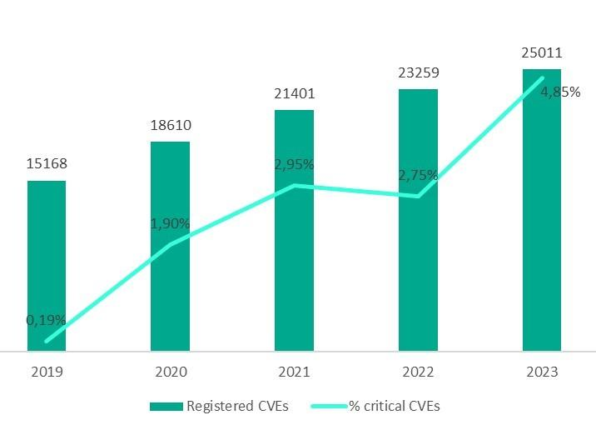

1. ***Linux Vulnerabilities in Container Environments:***With the rise of containerization technologies like Docker and Kubernetes, Linux vulnerabilities have become particularly damaging. Containers, while efficient, add another layer of complexity and potential attack vectors. CVE-2024-21626, mentioned earlier, is particularly dangerous because it allows attackers to break out of containers, a form of isolation that many organizations rely on for secure cloud operations [[Kaspersky]](https://www.kaspersky.com/blog/top-exploited-vulnerabilities-cve-2023-q1-2024/51317/). Once attackers escape the container, they can access the host machine, potentially affecting other containers and services.



In another incident, CVE-2023-29349 exposed vulnerabilities in Linux kernel's handling of network packets in containerized environments, allowing remote attackers to gain control over the host machine. This vulnerability shows how even small misconfigurations or overlooked components can result in large-scale breaches, especially when Linux is deployed in cloud-native architectures.

1. ***Underestimating the Threat to Linux Servers:***Many IT professionals and organizations still underestimate the threat posed to Linux systems, despite the clear rise in exploits. This is partly due to the misconception that Linux, being open-source and less frequently targeted than Windows, is inherently secure. However, as the number of vulnerabilities has surged, attackers have shifted to exploiting popular Linux distributions [[Kaspersky]](https://www.kaspersky.com/blog/top-exploited-vulnerabilities-cve-2023-q1-2024/51317/). Moreover, Linux environments are often the backbone of critical infrastructure and enterprise operations, making the consequences of a breach far more significant.



1. ***Challenges with Patching:***A critical issue in addressing these vulnerabilities is the challenge of patch management. Many organizations are slow to implement patches, with some vulnerabilities remaining unpatched for years. Research shows that many organizations are still dealing with vulnerabilities that are over five years old, making their systems easy targets for well-documented exploits [[Fortinet]](https://www.fortinet.com/corporate/about-us/newsroom/press-releases/2024/fortinet-threat-research-finds-cybercriminals-are-exploiting-new-industry-vulnerabilities-faster). Given that only a small percentage of Linux vulnerabilities are actively exploited, it can be tempting to delay patching, but attackers can—and do—take advantage of overlooked weaknesses.

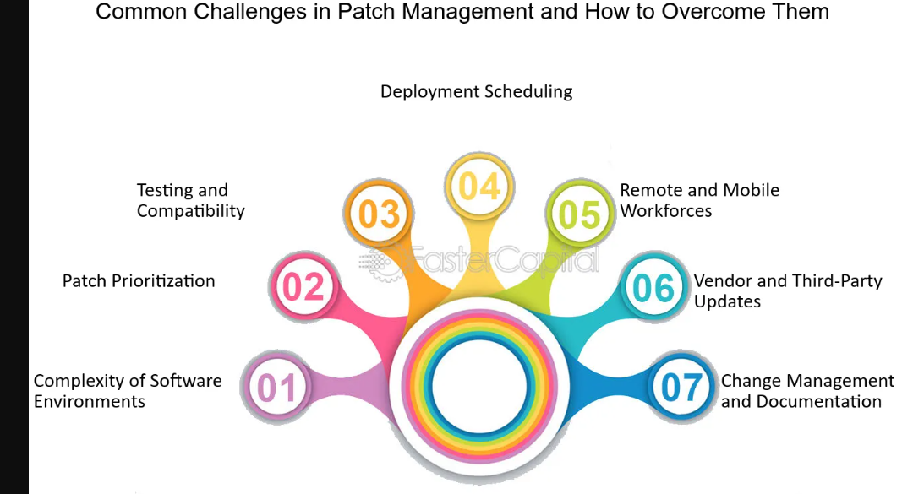

1. ***Mitigation Strategies:***  
   To mitigate these threats, organizations need to focus on proactive vulnerability management. Regularly auditing system libraries and dependencies, employing automated patching systems, and closely monitoring newly discovered vulnerabilities are essential strategies. Additionally, implementing container security best practices, such as limiting container privileges and securing communication between containers, can help reduce the risk of attacks like CVE-2024-21626 [[Kaspersky]](https://www.kaspersky.com/blog/top-exploited-vulnerabilities-cve-2023-q1-2024/51317/) [[Fortinet]](https://www.fortinet.com/corporate/about-us/newsroom/press-releases/2024/fortinet-threat-research-finds-cybercriminals-are-exploiting-new-industry-vulnerabilities-faster).



Automation tools that detect and patch vulnerabilities, such as Kaspersky’s Vulnerability Assessment and Patch Management system, are becoming critical for Linux environments [[Kaspersky]](https://www.kaspersky.com/blog/top-exploited-vulnerabilities-cve-2023-q1-2024/51317/). These tools allow organizations to quickly identify vulnerabilities and respond before attackers can exploit them.

***Conclusion***The rise of Linux-targeted attacks in 2023 and 2024 marks a significant shift in the cybersecurity landscape. Organizations relying on Linux must remain vigilant, as attackers are increasingly focusing on this platform, taking advantage of its widespread use in server and cloud environments. Swift patching, continuous monitoring, and the adoption of automated security tools will be crucial for mitigating these growing threats.***References:***1. Kaspersky (2024). The Most Dangerous CVEs of 2023 and 2024: Fix These Today.



2. Fortinet (2024). FortiGuard Labs Threat Research: Speed of Exploitation and Targeted Attacks on Industrial Sectors.

