|  |  |
| --- | --- |
| ***Roll No*** | ***22SW040 --> Section 01*** |
| ***Subject*** | ***CN_Practical_Lab_02)*** |
| ***Name*** | ***Farooque Sajjad*** |
| ***Teacher*** | ***Ma’am Aisha*** |

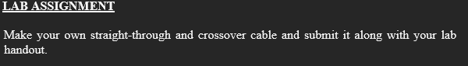

***Required tools are cat5 cable RJ45 crimping tool and pen for marking.***

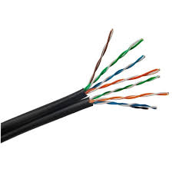

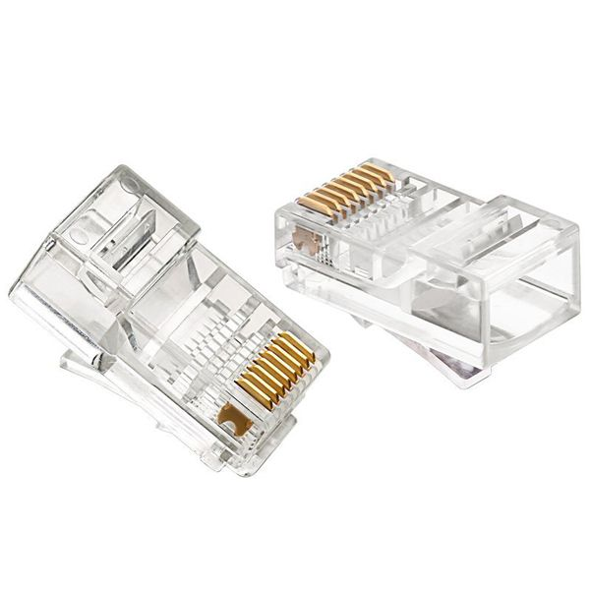

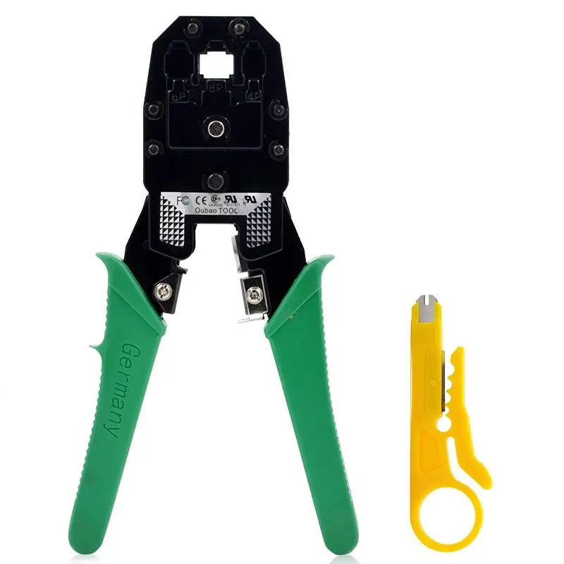

### *Straight-Through Cable (Typically for connecting devices of different types, e.g., PC to Switch)*

1. ***Prepare the Cable:*** *Cut the CAT5e or CAT6 cable to the desired length.*
2. ***Strip the Outer Jacket:*** *Use a cable stripper to remove about 1-2 inches of the outer jacket on both ends.*
3. ***Untwist and Arrange Wires:*** *Untwist the pairs and arrange them in the* ***T568B*** *order:*
   1. ***T568B Order (left to right):*** *Orange/white, Orange, Green/white, Blue, Blue/white, Green, Brown/white, Brown.*
4. ***Trim the Wires:*** *Cut the wires straight across to make them even.*
5. ***Insert Wires into RJ45 Plug:*** *Carefully push the wires into the RJ45 plug, ensuring each wire goes into its designated slot.*
6. ***Crimp the Cable:*** *Use a crimping tool to secure the RJ45 plug onto the cable. Repeat on the other end.*
7. ***Test the Cable:*** *Use a cable tester to ensure all connections are correct and the cable is functioning.*

*See the images for making …*

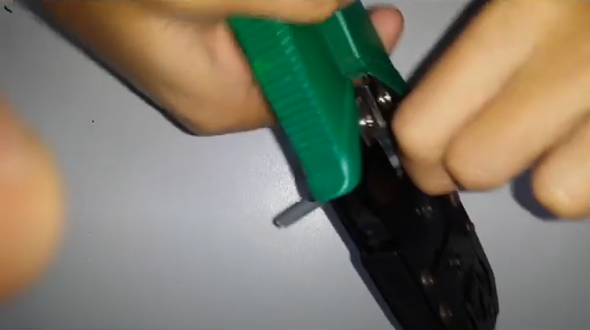

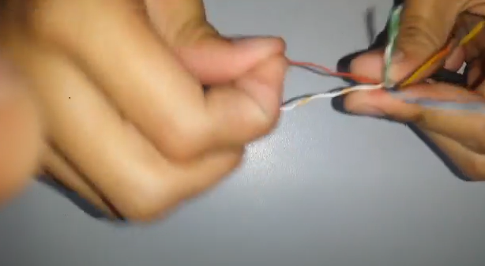

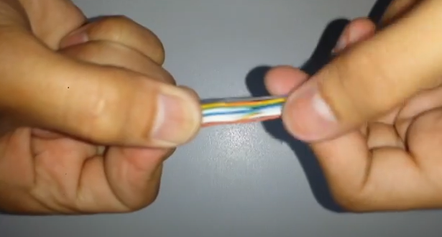

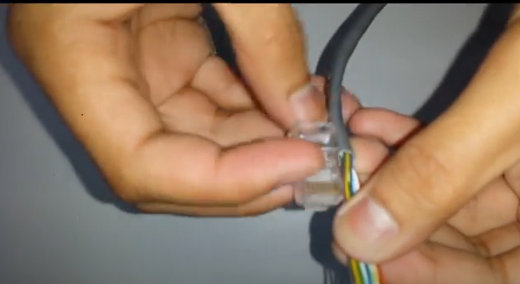

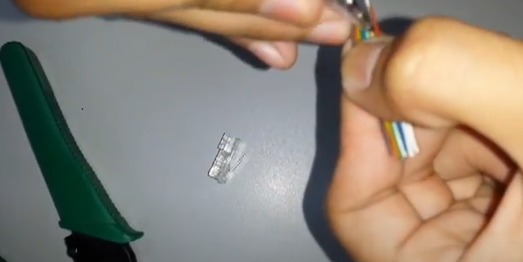

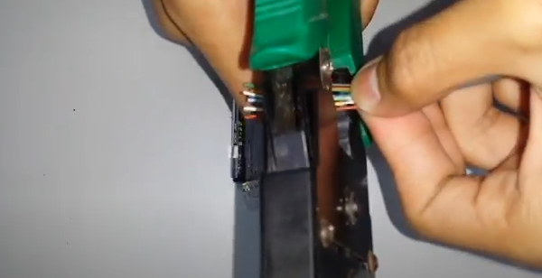

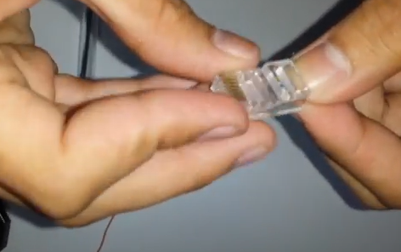

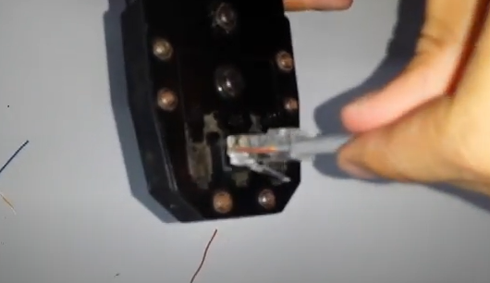

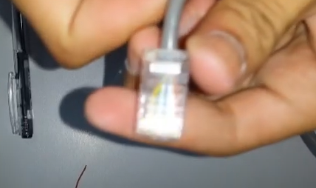

### *Cross-Over Cable (Typically for connecting similar devices, e.g., PC to PC)*

1. ***Prepare the Cable:*** *Cut the CAT5e or CAT6 cable to the desired length.*
2. ***Strip the Outer Jacket:*** *Use a cable stripper to remove about 1-2 inches of the outer jacket on both ends.*
3. ***Untwist and Arrange Wires:***
   1. ***One End (T568A Order):*** *Green/white, Green, Orange/white, Blue, Blue/white, Orange, Brown/white, Brown.*
   2. ***Other End (T568B Order):*** *Orange/white, Orange, Green/white, Blue, Blue/white, Green, Brown/white, Brown.*
4. ***Trim the Wires:*** *Cut the wires straight across to make them even.*
5. ***Insert Wires into RJ45 Plugs:*** *Push the wires into the RJ45 plugs on each end according to the T568A and T568B orders.*
6. ***Crimp the Cable:*** *Use a crimping tool to secure each RJ45 plug onto the cable ends.*
7. ***Test the Cable:*** *Use a cable tester to confirm the cross-over connections are correct and functional.*

*See the images ..*

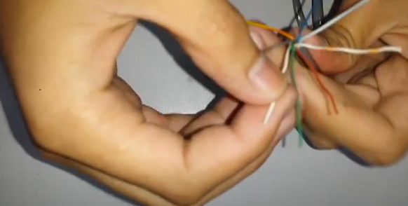

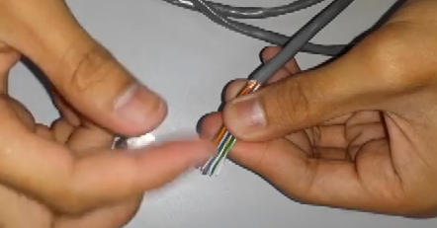

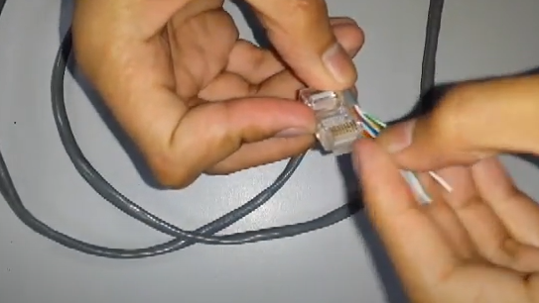

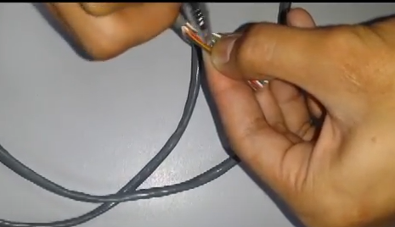

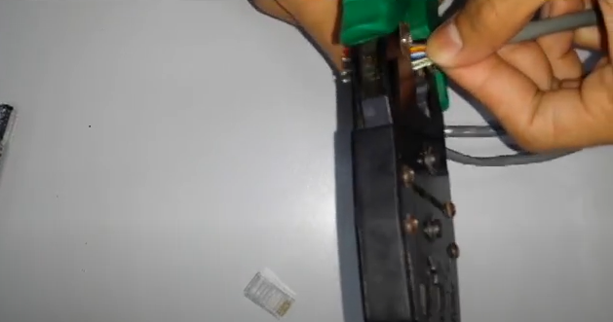

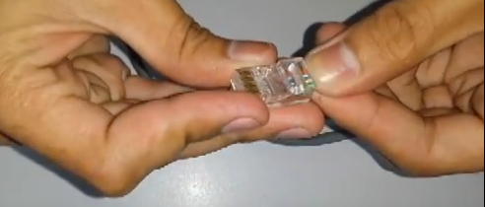

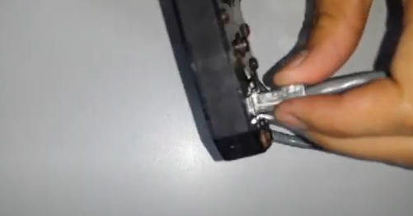

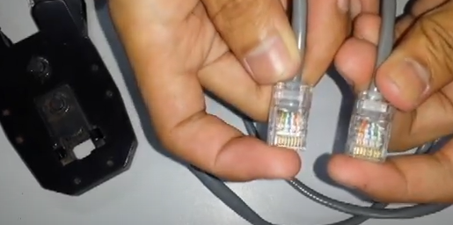

**

***Straight-through*** *and* ***cross-over*** *cables are types of Ethernet cables used to connect network devices. Their main difference lies in the wiring pattern of the twisted pairs inside the cable, which determines how the signals are sent and received. Here's a breakdown:*

### *Straight-Through Cable*

* ***Purpose:*** *Used to connect different types of devices, like a computer to a switch, router, or modem.*
* ***Wiring Pattern:*** *Both ends of the cable have the same wiring configuration, typically* ***T568B*** *on both ends.*
* ***How it Works:*** *Since different device types already have circuitry that "crosses" the signals as needed; a straight-through cable allows communication without any extra crossing of wires.*

### *Cross-Over Cable*

* ***Purpose:*** *Used to connect similar devices directly, like PC-to-PC or switch-to-switch, without needing an intermediate device.*
* ***Wiring Pattern:*** *One end is wired as* ***T568A*** *and the other as* ***T568B****, which effectively crosses the transmit and receive pairs.*
* ***How it Works:*** *The crossed wiring swaps the transmit and receives signals to ensure data can be sent and received directly between the same types of devices.*

### *Wiring Patterns:*

* ***T568A Order:*** *Green/white, Green, Orange/white, Blue, Blue/white, Orange, Brown/white, Brown.*
* ***T568B Order:*** *Orange/white, Orange, Green/white, Blue, Blue/white, Green, Brown/white, Brown.*

**

### *Advantages of STP (Shielded Twisted Pair) over UTP (Unshielded Twisted Pair):*

* ***Better Interference Protection:*** *STP has an additional shield (foil or braid) that protects against electromagnetic interference (EMI) and crosstalk.*
* ***Improved Signal Quality:*** *The shielding allows for more reliable data transmission, especially in environments with high interference.*

### *Comparison with Coaxial Cable:*

* ***STP vs. Coaxial:***
  + ***Interference Resistance:*** *Coaxial is highly resistant to EMI due to its solid shield, making it excellent for long distances but bulkier than STP.*
  + ***Flexibility:*** *STP is more flexible and easier to install in tighter spaces than coaxial.*
  + ***Data Transmission:*** *Coaxial is often slower for network data compared to twisted pairs but is still used for cable TV and some broadband.*

**

***Optical fiber*** *is widely used for backbone networks because of its:*

* ***High Bandwidth Capacity:*** *It supports extremely high data rates, ideal for heavy data traffic in backbone networks.*
* ***Long Distance Transmission:*** *Optical fiber can carry signals over long distances without significant loss or the need for repeaters.*
* ***Immunity to Interference:*** *It’s not affected by electromagnetic interference, ensuring reliable transmission in diverse environments.*
* ***Scalability:*** *Fiber networks can easily be upgraded to support future bandwidth demands, making them future proof for growing network needs.*

***Thinnet*** *and* ***Thicknet*** *are types of coaxial cables used in early Ethernet networks:*

* ***Thinnet (10BASE2):***
  + ***Diameter:*** *About 5mm (thinner and more flexible).*
  + ***Range:*** *Maximum of 185 meters between devices.*
  + ***Use:*** *Easier to install, used for small networks; connects directly to devices without needing a transceiver.*
* ***Thicknet (10BASE5):***
  + ***Diameter:*** *About 10mm (thicker and less flexible).*
  + ***Range:*** *Up to 500 meters between devices.*
  + ***Use:*** *More robust and reliable, used for network backbones; requires external transceivers to connect devices.*