|  |  |
| --- | --- |
| ***Roll No*** | ***22SW040 🡪 Section_01*** |
| ***Name*** | ***Farooque Sajjad*** |
| ***Subject*** | ***CN Practical (Lab_03)*** |
| ***Teacher*** | ***Ma’am Aisha*** |

***Class Exercise***

***Configuration Questions Mentioned in the Handout***

***What prompt does the enable command display, and what does it mean?***

*The prompt changes to Switch, indicating that you are now in Privileged EXEC mode, where advanced commands and configurations are accessible.*

***Which prompt will the switch display after typing configure terminal?***

*The prompt changes to Switch(config), meaning you are in Global Configuration Mode.*

***What does this prompt mean?***

*Global Configuration Mode allows configuration changes that affect the entire switch.*

***Which prompt will this switch display after changing the hostname to "SWR2024"?***

*The prompt changes to SWR2024(config), indicating the hostname update.*

***Why is this change in the prompt required?***

*Changing the prompt helps identify the device on a network, especially when managing multiple devices.*

***Is there an encrypted password?***

*Yes, the enabled secret password is encrypted.*

***Are there any other passwords?***

*Yes, the enable password and VTY (Telnet) line password.*

***Are any of the other passwords encrypted?***

*No, only the enable secret is encrypted by default.*

***MAC Address Table Questions Mentioned in the handout***

***How does the switch use the MAC address table to forward data?***

*The switch uses the MAC table to direct frames to the correct port associated with a device’s MAC address, avoiding unnecessary broadcasts.*

***In the MAC table, under the "Type" column, what does "dynamic" refer to?***

*"Dynamic" means the switch learned the MAC address automatically when it detected traffic from a device on a specific port.*

***Interface Status and Display Questions Mentioned in the handout***

***What will be the status of the line protocol if at the data link layer, we use two different protocols?***

*The line protocol will be down, indicating a mismatch or incompatibility in data link protocols.*

***Write the name of the IOS version.***

*The IOS version name is displayed in the output of the show version command (e.g., Cisco IOS Software Version 15.0(2)SE).(see the screenshot below)*

***What is the name of the system image (IOS) file?***

*The system image file is listed in the show version output, for example, c2950i6q4l2mz.12122.EA14.bin. (see the screenshot below)*

***Where was the switch IOS image booted from?***

*The IOS image was booted from Flash memory.*

***How many Ethernet interfaces does this switch have?***

*A Catalyst 2950 switch has 24 Fast Ethernet interfaces and 2 Gigabit Ethernet interfaces, but this can vary by model.*

***Follow the Screen shots***

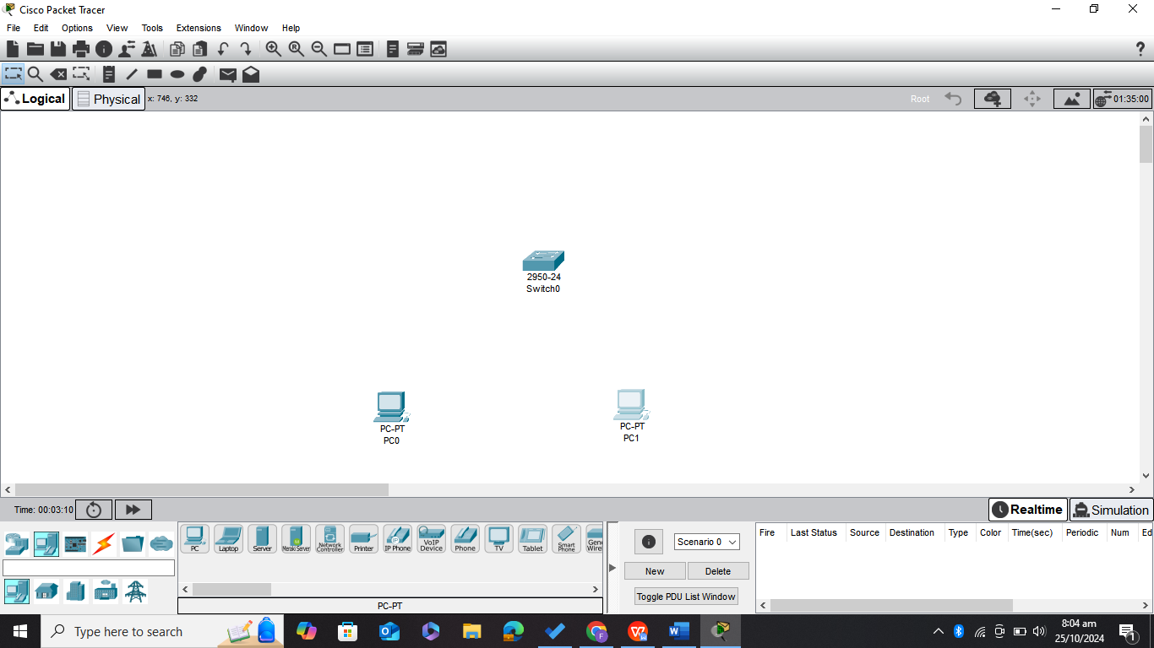

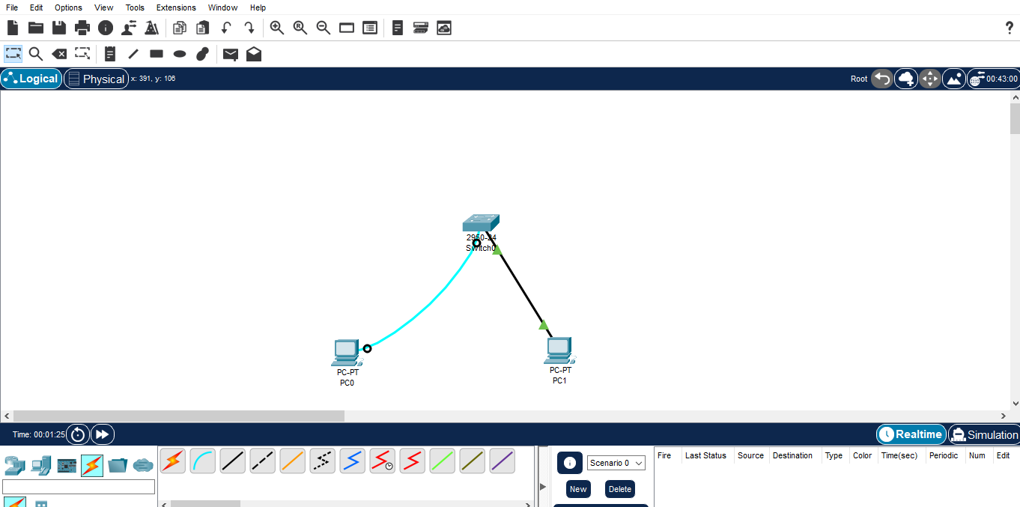

**

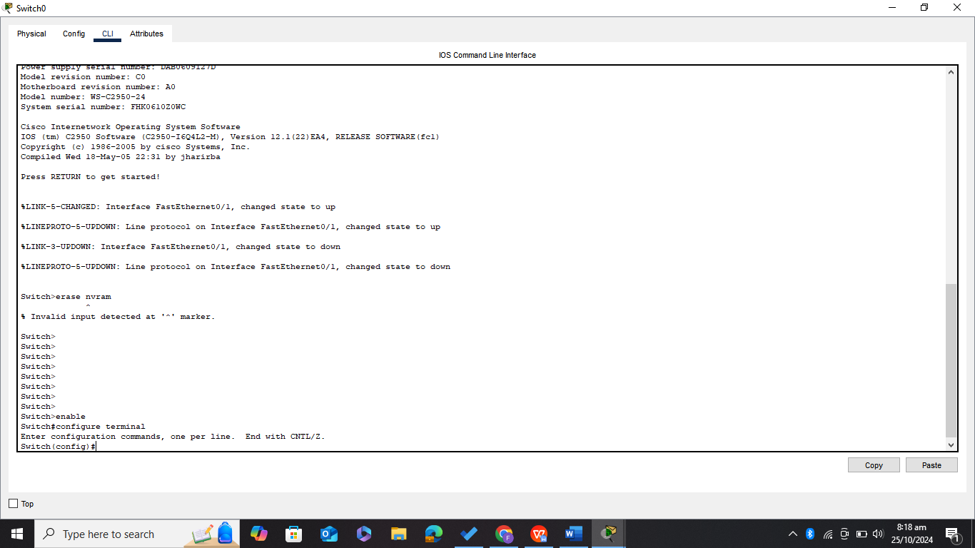

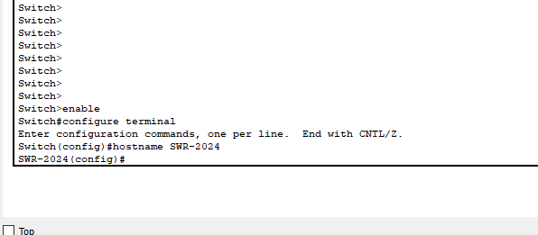

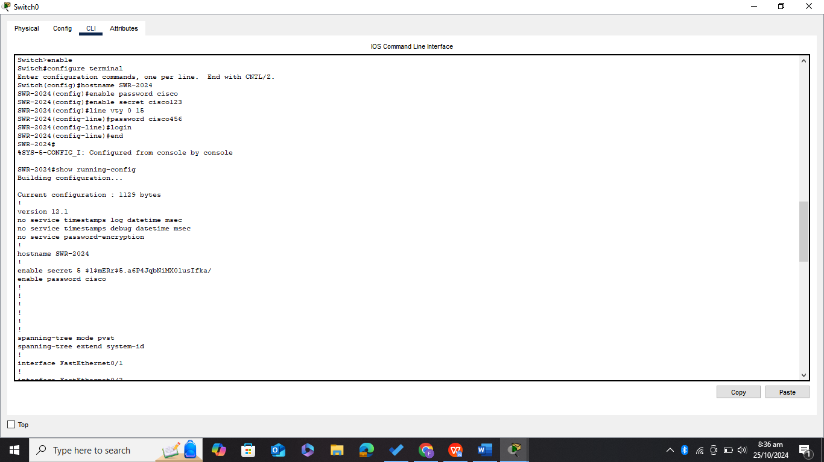

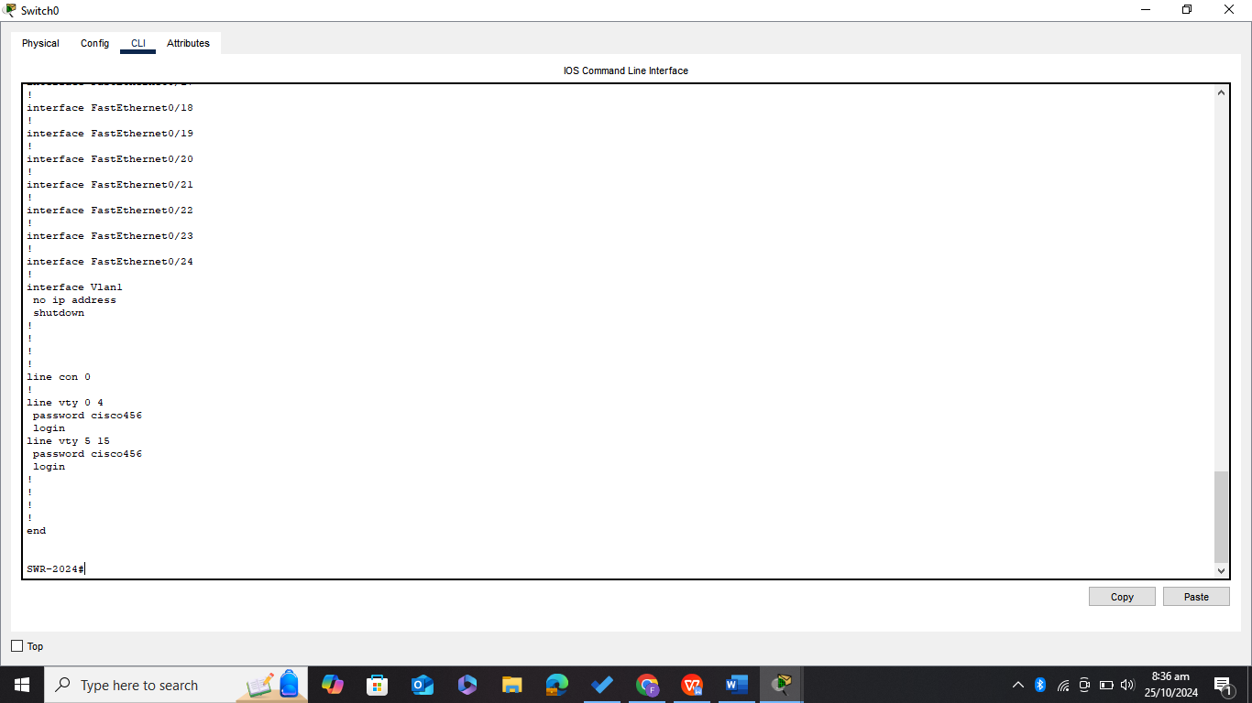

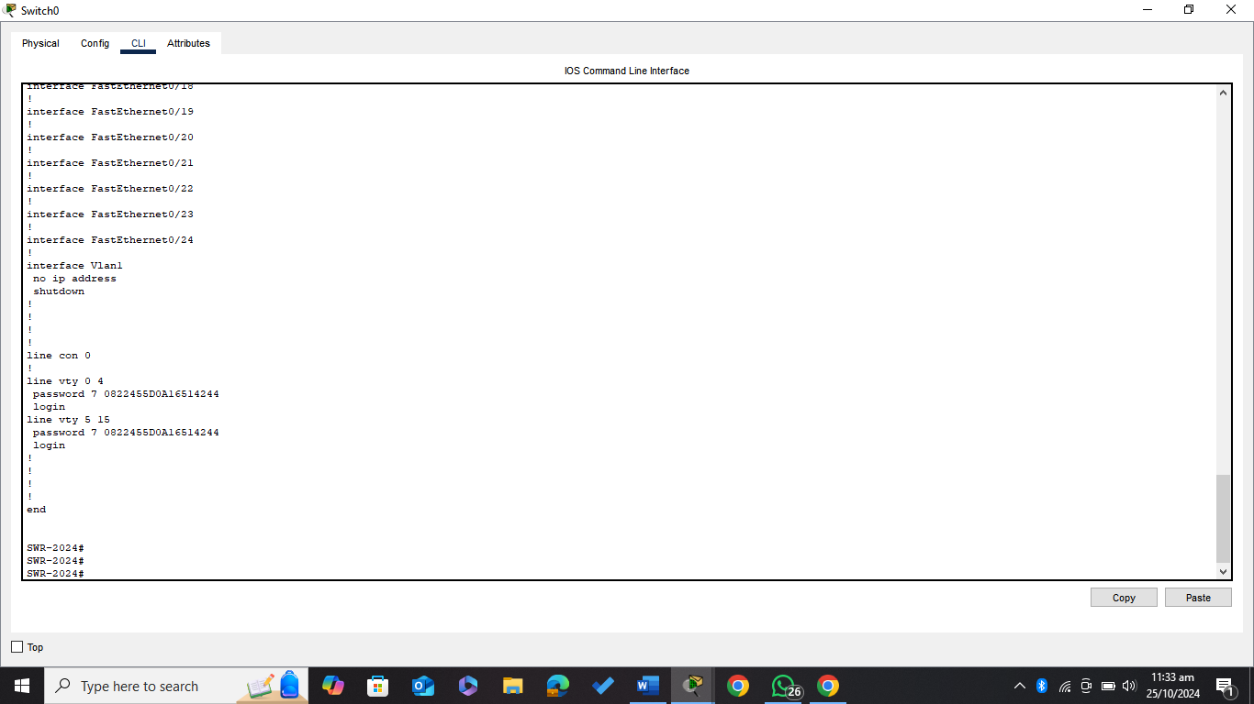

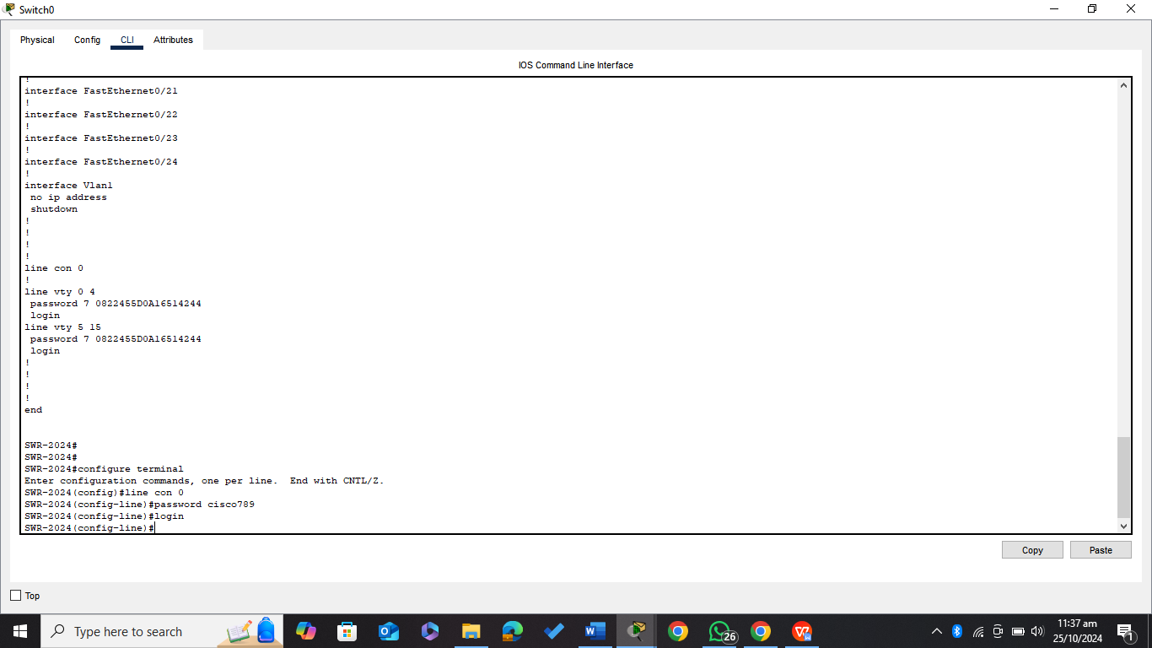

***LAB TASK***

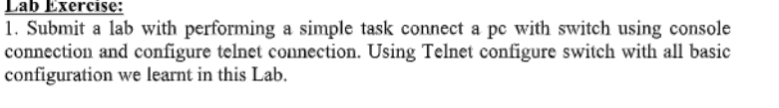

***First Setting up the console connection***

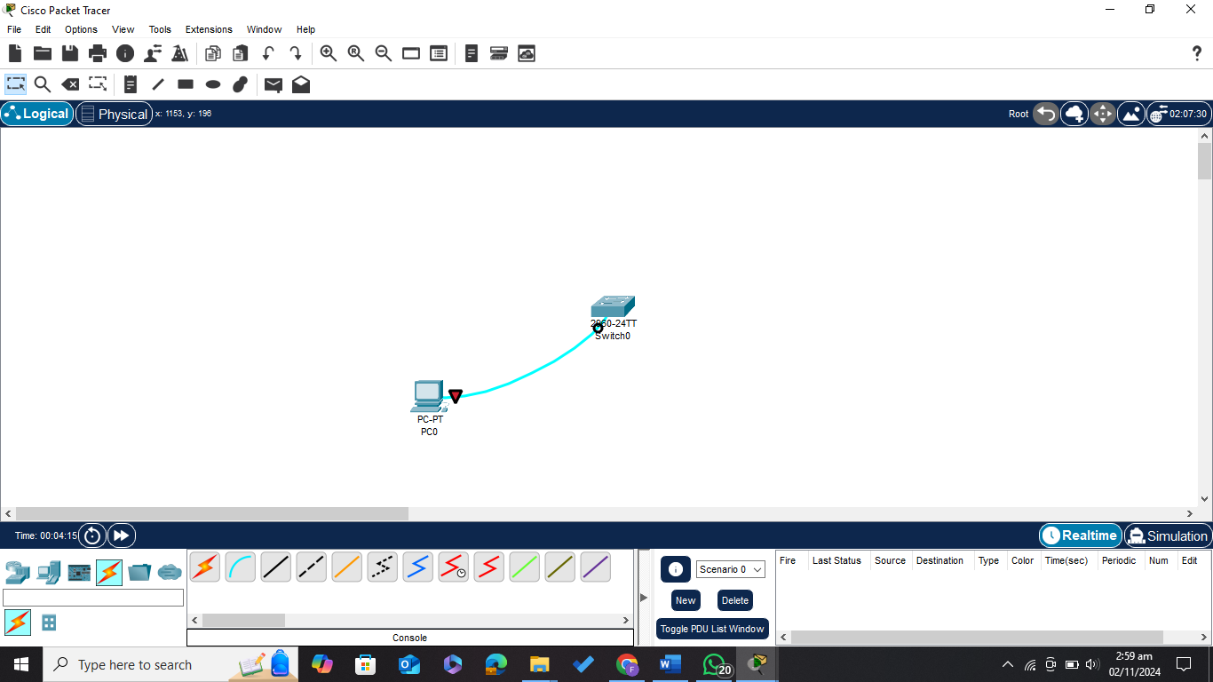

***Now configuring all the necessary things including password and encrypting it setting up default gateway and telnet connection***

***Now connection the PC to SWITCH using straight through cable for accessing telnet connection***

***Assigning IP address to the connected PC***

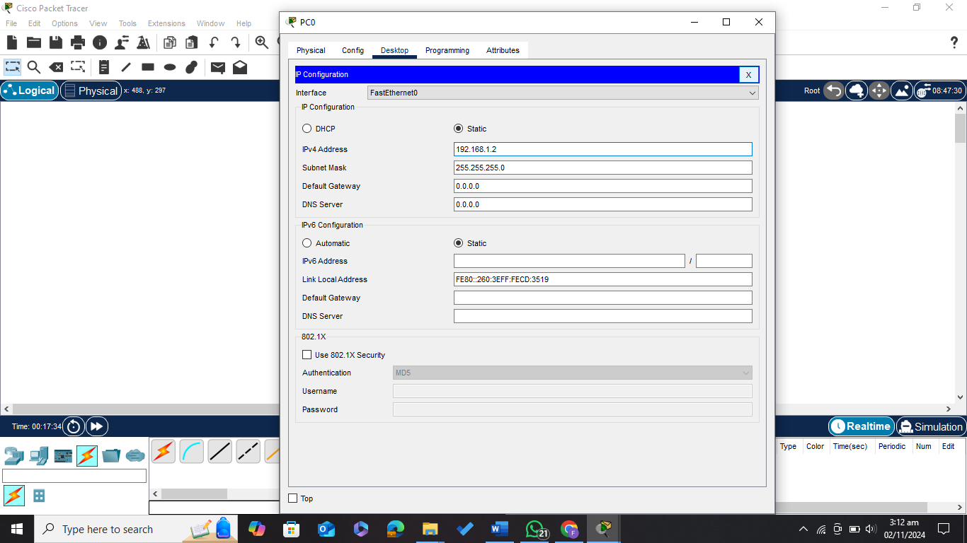

***Now I use telnet connection from the CMD of PC0***

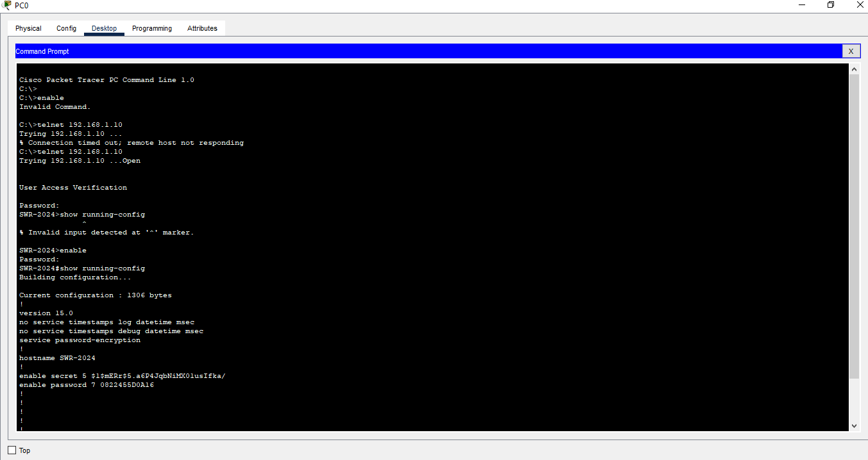

***Successfully run the ping command***

***I have Seen the MAC address table using telnet connection from PC0***

